APPLICATION FOR ASSENT
FOR PROPOSED INCLUSIONS INTO THE
SOUTHEASTERN COLORADO WATER CONSERVANCY DISTRICT
AND ABILITY TO RECEIVE OF FRYINGPAN-ARKANSAS PROJECT WATER

Please send this completed questionnaire to:

Mr. Garrett Markus
Water Resource Engineer
Southeastern Colorado Water Conservancy District
31717 United Avenue
Pueblo, CO 81001

If you have any questions regarding this questionnaire, please contact Mr. Markus at (719) 766-4261 or garrett@secwcd.com

- Proposed inclusion petitioner(s) name, address, phone number, and e-mail address (also include the proposed inclusion parcel(s) address and applicant contact information, if different than that of the petitioner(s)):

Norris Ranch Joint Venture, LLC
P.O. Box 1385
Colorado Springs, CO 80901

Craig Dossey, craig.dossey@vertexcos.com, 303-906-8800

- Commonly known name for the Inclusion (must be the official name on the ordinance for an annexation)

Karman Line

- Proposed inclusion parcel(s) legal description (Township, Range, Section and County) and proposed inclusion parcel(s) acreage:

See below for legal description for the 7 parcels.
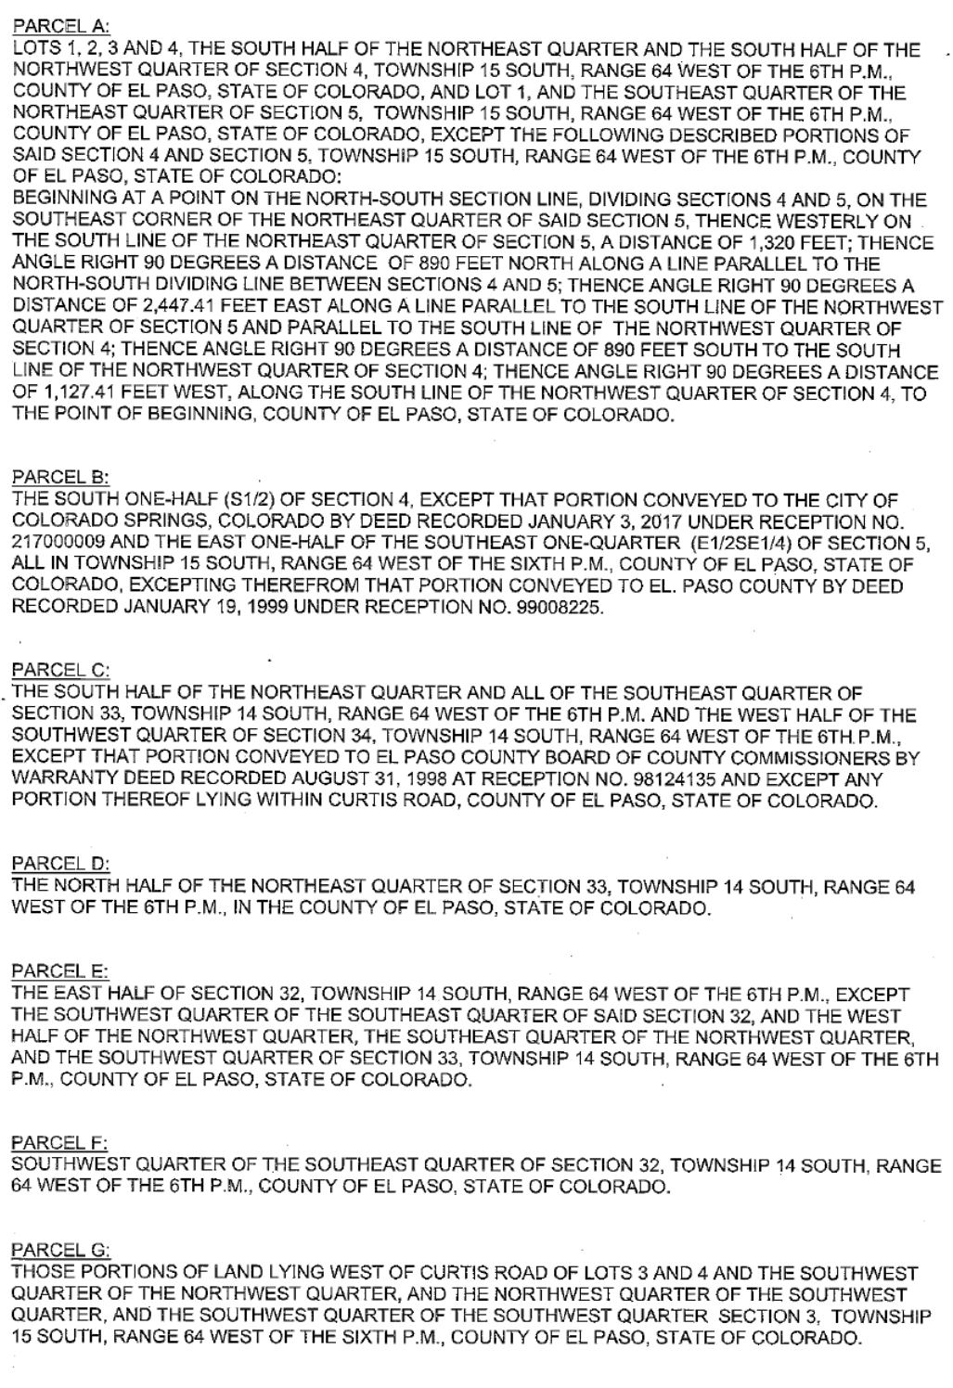

- Attach a proposed inclusion parcel(s) location map (either topographic or aerial map from appropriate county assessor’s website) showing parcel(s) boundaries. If petitioner’s county or municipality utilizes GIS, send parcel shapefile with commonly known name to margie@secwcd.com.

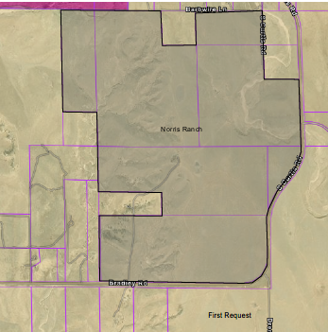

- How does the proposed inclusion parcel(s) currently receive water? For example, does the parcel(s) receive municipal or industrial water from a public water system?

Should this property be annexed into the City of Colorado Springs, it will be served water by Colorado Springs Utilities.

- Identify the water right(s) associated with the proposed inclusion parcel(s). If the parcel receives municipal and industrial water, state the water supplier. Otherwise, provide the water right decree.

Colorado Springs Utilities

- Can any or all of the proposed activities resulting from the inclusion occur without your ability to receive Fryingpan-Arkansas Project Water?

If yes, you DO NOT need to answer questions 8-15.

If no, please describe AND answer questions 8-15:

Yes

- Describe the proposed inclusion Parcel(s) current land use and/or zoning (e.g., residential, rural residential, agricultural, etc.) and any existing infrastructure (e.g., buildings, ditches, roads, etc.) within the proposed inclusion parcel(s):

N/A

- Are there any proposed changes to the proposed inclusion parcel(s) current land use and/or zoning (e.g., agricultural to residential, etc.) or any ground-disturbing activities within the proposed inclusion parcel(s) that will result from the proposed inclusion?

N/A

If yes, please describe the extent of ground disturbance (eg., excavation, trenching, tree removal, construction, demolition, etc.), the approximate dimensions of the proposed ground disturbance (eg., length, width, and depth of trenching, etc.), and attach a map showing the approximate area of disturbance within the proposed inclusion parcel(s).

- Describe how the water will be used (e.g., provide water to an existing structure, provide water to a proposed commercial/industrial development, etc.) within the proposed inclusion parcel(s):

N/A

If a pipeline is required to provide water to an existing structure, please provide the approximate length and diameter of the pipeline:

- Is there any existing infrastructure (eg., buildings, structures, canals, ditches, etc.) or are there any known archaeological sites within the proposed inclusion parcel(s) that are at least 50 years old?

N/A

If yes, please describe:

- Are there any known threatened or endangered species or their designated critical habitat within the proposed inclusion parcel(s)?

N/A

If yes, please describe:

- Are there any known wetlands within the proposed inclusion parcel(s)?

N/A

If yes, please describe:

- Are there any anticipated water quality impacts within the proposed inclusion parcel(s) resulting from the proposed inclusion (e.g., sewage disposal, construction impacts, etc.)?

N/A

If yes, please describe:

- Is there any prime and unique farmland within the proposed inclusion parcel(s)?

N/A

If yes, please describe:

