February 22, 2019
Planning and Community Development Department
Craig Dossey, Executive Director

RE: 16078 Spencer Road West – Setback Variance
Peyton, CO 80831

File: ADR-19-002, Four Corners Kennel Administrative Relief
Parcel No.: 42230-00-010

To Whom It May Concern:

This letter is to inform property owners adjacent to the above mentioned properties that the applicants, Phil and Ivonne Strevett, have requested approval of administrative relief to allow a side-yard setback of 177 feet where 200 feet is required for a kennel within the A-35 (Agricultural) zoning district. The Planning and Community Development Director may make a formal decision regarding the administrative relief request on March 13, 2019 at 4:30 P.M. Any comments or questions may be forwarded to me prior to that decision. At the discretion of the Planning and Community Development Director, the approval process may be elevated to the Board of Adjustment for consideration. Administrative approval by the Planning and Community Development Director is subject to the appeal provisions of the Land Development Code.

You may view the application documents online at www.epcdevplanreview.com. Please feel free to contact me with any questions, comments, or concerns you may have prior to the decision.

Respectfully,
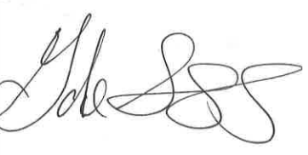

Gabe Sevigny, Planner II
El Paso County Planning and Community Development
719-520-7943
gabesevigny@elpasoco.com

