SUBDIVISION IMPROVEMENTS AGREEMENT

CIMARRON HILLS SOUTHEAST MIXED USE FILING NO. 1

THIS AGREEMENT, made between Marathon Holdings, LLP, hereinafter called “Marathon,” Jovenchi-II, LLC LLC, hereinafter called “Jovenchi”, together with Marathon hereinafter collectively called the “Subdivider,” and HP-257003 Colorado Springs, LLC, hereinafter “HP-257003,” and El Paso County, by and through the Board of County Commissioners of El Paso County, Colorado, hereinafter called the "County," shall become effective the date of approval of the Final Plat by the Board of County Commissioners.

WITNESSETH:

WHEREAS, the Subdivider, as a condition of approval of the final plat of Cimarron Hills Southeast Mixed Use Filing No. 1, wishes to enter into this Subdivision Improvements Agreement for construction of improvements for the Subdivision as provided for by Section 30-28-137 (C.R.S.), Chapter 5 of the El Paso County Engineering Criteria Manual and Chapter 8 of the El Paso County Land Development Code incorporated herein; and
WHEREAS, pursuant to the same authority, the Subdivider is obligated to provide security or collateral sufficient in the judgment of the Board of County Commissioners to make reasonable provision for completion of certain public improvements set forth on Exhibit __ attached hereto and incorporated herein; and
WHEREAS, HP-257003 wishes to provide the collateral required to secure performance of the Subdivider’s obligations to complete the public improvements set forth on Exhibits A and B attached hereto; and
WHEREAS, the parties hereto desire to set forth their understanding and agreement with regard to the construction and installation of the improvements set forth on Exhibit A attached hereto.
NOW, THEREFORE, in consideration of the following mutual covenants and agreements, the Subdivider, HP-257003, and the County agree as follows:
l. Responsibility to Construct: The Subdivider and HP-257003 agree to construct and install, at their sole expense, all of those improvements as set forth on Exhibit A attached hereto. Such obligation shall be joint and several unless otherwise set forth herein. To secure and guarantee performance of their obligations as set forth herein, HP-257003 agrees to provide collateral to remain in effect at all times until the improvements are completed and accepted in accordance with Chapter 5 of the ECM. Security and collateral for all improvements identified in Exhibit A shall be posted in the form of a performance bond issued by Philadelphia Indemnity Insurance Company in the amount of $7,676,391.50.
2. Renewal of Collateral: HP-257003, on behalf of itself and the Subdivider, is responsible for providing any renewals of collateral to ensure that there is never a lapse in security coverage. HP-257003 shall procure renewal/extension/replacement collateral at least fifteen (15) days prior to the expiration of the original or renewal/extension/replacement collateral then in effect. Failure to procure renewal/extension/replacement collateral within this time limit shall be a default under this Agreement and shall allow the County to execute on the collateral. In addition, if HP-257003 allows collateral to lapse at any time, no lots in the subdivision may be sold, conveyed or transferred, whether by Deed or Contract, after the expiration date of such collateral until the improvements identified on Exhibits A and B have been completed and final acceptance is received from the County. If replacement collateral is used for renewal, approval by the Board of County Commissioners is required.

3. Construction or Improvements or Collateral: No lots in the subdivision shall be sold, conveyed or transferred, whether by Deed or by Contract, nor shall building permits be issued until and unless the public improvements required for the subdivision have been constructed and completed in accordance with the approved construction plans and preliminary acceptance is received from the County. In the alternative, lots within the subdivision may be sold, conveyed or transferred and / or have building permits issued upon receipt of collateral acceptable to the County, pursuant to this Agreement, which is sufficient to guarantee construction of the improvements in the attached Exhibits ____.

4. Design Standards: The Subdivider and HP-257003 agree that all public improvements to be completed as identified on Exhibits _____ shall be constructed in compliance with the following:

a. All laws, resolutions and regulations of the United States, State of Colorado, El Paso County and its various agencies, affected special districts and/or servicing authorities.

b. Such other designs, drawings, maps, specifications, sketches and other matter submitted to and approved by any of the above-stated governmental entities.

5. Timing of Construction and Acceptance: All improvements shall be completed by the Subdivider and HP-257003, meeting all applicable standards for preliminary acceptance, within 24 (twenty-four) months from the date of notice to proceed in the Construction Permit for the Subdivision. If HP-257003 determines that the completion date needs to be extended for the improvements, it shall submit a written request for a change in the completion date to the ECM Administrator at least 90 days in advance of the required completion date. The request shall include the reasons for the requested change in completion date, the proposed new completion date, and prove collateral is in place to cover the extension time requested. The completion date for the Subdivision may be extended one time, for a period no longer than 6 months, at the discretion of the ECM Administrator. Any additional requests for extension of the completion date will be scheduled for hearing by the Board of County Commissioners. The ECM Administrator or the Board of County Commissioners may require an adjustment in the amount of collateral to take into account any increase in cost due to the delay including inflation.
6. Construction Criteria: The Subdivider and HP-257003 agree, and the parties acknowledge that the construction of the improvements identified and guaranteed through this Subdivision Improvements Agreement shall follow the inspection and acceptance process that is identified in Chapter 5 of the County’s Engineering Criteria Manual. This is to include among other things, a Preliminary Acceptance process, posting of appropriate Warranty collateral at that time, and a 2-year warranty period prior to final acceptance. Where any inconsistency exists between Chapter 5 of the Engineering Criteria Manual and the Land Development Code with respect to these inspections, collateral and acceptance processes, the Engineering Criteria Manual is the controlling document.
7. Plat Restriction Remedy: It is mutually agreed pursuant to the provisions of Section 30-28-137(3) C.R.S. that the County or any purchaser of any lot, lots, tract or tracts of land subject to a plat restriction which is the security portion of a Subdivision Improvements Agreement shall have the authority to bring an action in any District Court to compel the enforcement of any Subdivision Improvements Agreement on the sale, conveyance, or transfer of any such lot, lots, tract or tracts of land or of any other provision of Article 28 of Title 30, Colorado Revised Statutes. Such authority shall include the right to compel rescission of any sale, conveyance, or transfer of any lot, lots, tract or tracts of land contrary to the provisions of any such restrictions set forth on the plat or in any separate recorded instrument, but any such action shall be commenced prior to the issuance of a building permit by the County where so required or other otherwise prior to commencement of construction on any such lot, lots, tract or tracts of land.
8. Releases: It is further mutually agreed that, pursuant to the provisions of Section 30-28-137 (2) C.R.S., and Chapter 5 of the County’s Engineering Criteria Manual, as improvements are completed, the Subdivider may apply to the Board of County Commissioners for a release of part or all of the collateral deposited with said Board. Upon inspection and approval, the Board shall release said collateral. The County agrees to respond to an inspection request in a reasonable time upon receipt of the request. If the Board determines that any of such improvements are not constructed in substantial compliance with specifications it shall furnish the Subdivider and HP-257003 a list of specific deficiencies and shall be entitled to withhold collateral sufficient to ensure such substantial compliance.
If the Board of County Commissioners determines that the Subdivider or HP-257003 will not construct any or all of the improvements in accordance with all of the specifications and the provisions of this Agreement, the Board of County Commissioners may withdraw and employ from the deposit of collateral such funds as may be necessary to construct the improvements in accordance with the specifications.
9. Title Insurance: The Subdivider agrees to provide the County with a title insurance commitment at time of final platting evidencing that fee simple title of all lands in the subdivision is vested with the Subdivider.
10. Plat Approval: The County agrees to approval of the final plat of the Cimarron Hills Southeast Mixed Use Filing No. 1 Subdivision subject to the terms and conditions of this Agreement.
11. Amendment: Parties hereto mutually agree that this Agreement may be amended from time to time provided that such amendment be in writing and signed by all parties hereto.
12. Effective Date: This Agreement shall take effect on the date of approval of the Final Plat by the Board of County Commissioners.
13. Traffic Impact Fees: The Subdivider agrees for itself and its successors and assigns that Subdivider and/or its said successors and assigns shall be required to pay traffic impact fees in accordance with the El Paso County Road Impact Fee Program at or prior to the time of building permit submittals.

IN WITNESS WHEREOF, the parties have hereunto set their hands and seals the day and year below written.

BOARD OF COUNTY COMMISSIONERS OF

EL PASO COUNTY, COLORADO

__________________________ By:__________________________________
(Date Final Plat Approved) Meggan Herrington, Executive Director
Planning and Community Development Department
Authorized signatory pursuant to LDC

Approved as to form:

________________________________

County Attorney’s Office

SUBDIVIDER:

MARATHON HOLDINGS, LLP

By: __________________________________

Name: _______________________________

Title: _

JOVENCHI-II, LLC

By: __________________________________

Name: _______________________________

Title: _

HP-257003:

HP-257003 Colorado Springs, LLC

By: __________________________________

Name: _______________________________

Title: _

Exhibit A – Financial Assurances Estimate for Cimarron Hills Southeast Mixed Use Filing No. 1 (SF2420)
Scope of work includes all proposed construction shown in CD’s including
- Construction of Meadowbrook Parkway with the exception of stripping shown in Lot 1 SDP
- Construction within Peterson Road for opening of median at Meadowbrook Parkway and closing of median at Panamint Ct.
- Pond build-out minus one (1) forebay, one stretch of concrete trickle channel, and part of maintenance access path to be built by Lot 1 development.

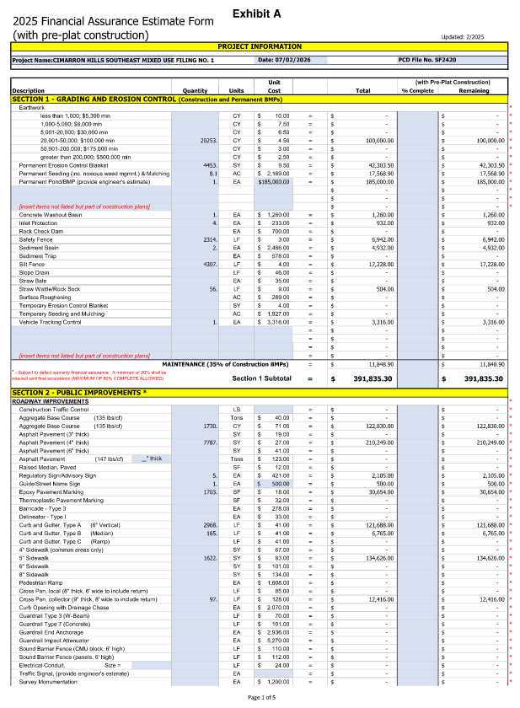
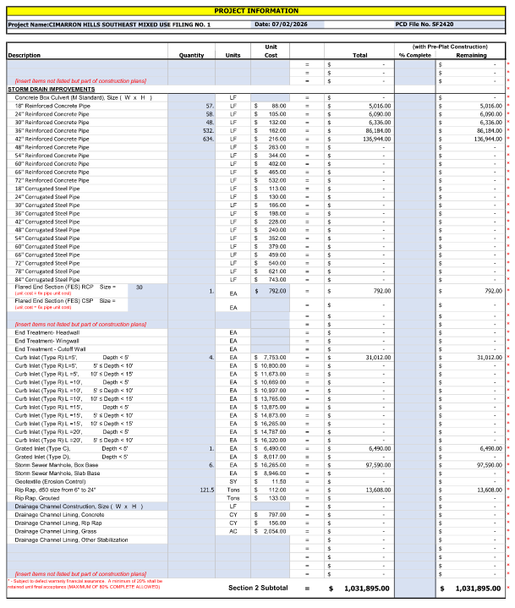

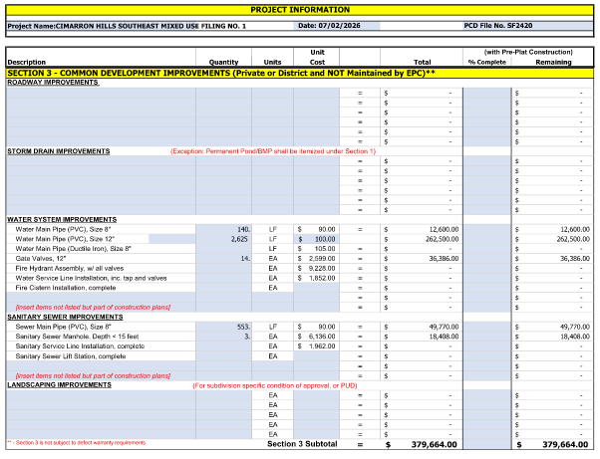

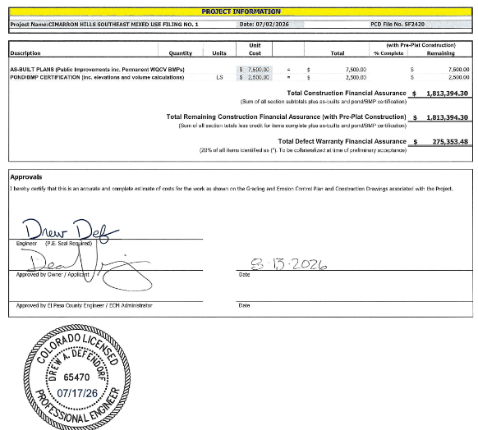

Exhibit B – Financial Assurances Estimate for the Hillpointe Apartments development (PPR-26-13)
Scope of work includes all proposed construction shown in CD’s including
- Striping of Meadowbrook Parkway
- Private access road to Lot 1 and adjacent (west) future development Tract from Meadowbrook Parkway, including public drain pan along Meadowbrook Parkway
- All Lot 1 development for Hillpointe Peterson Apartments
- Pond build-out of one (1) forebay, extension of existing concrete trickle channel, extension of existing pond maintenance path
- Secondary access from Peterson Road to Lot 1 site
- Public drain pan at Peterson Road

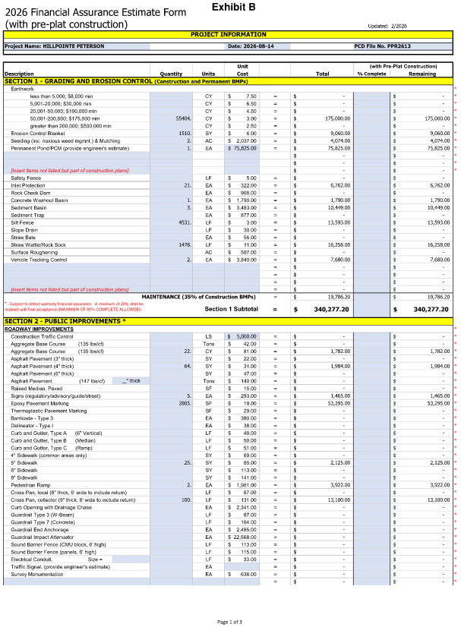
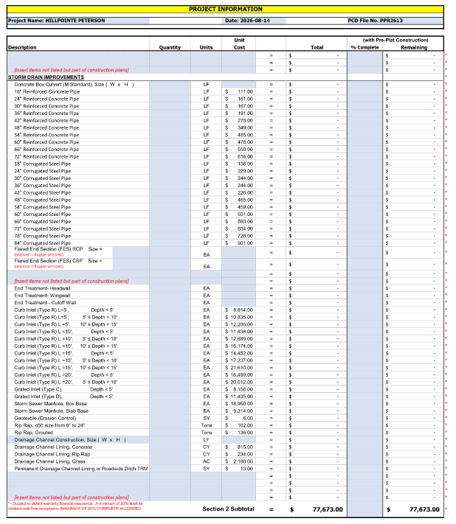

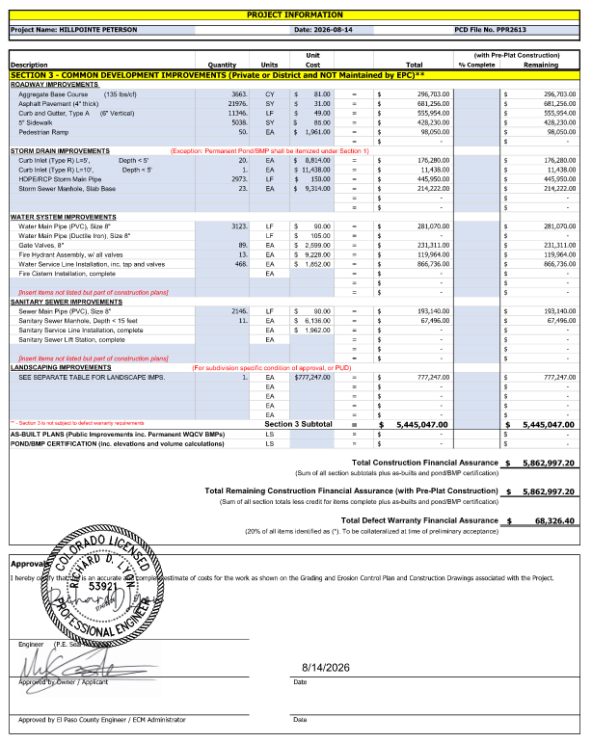

Lot 1 Hillpointe Apartments at Peterson SDP (PPR-26-13)
Highlighted Scopes of Work
(All other public subdivision improvements via SF2420)

