September 16, 2026

To: Grant Petik, Kimley-Horn & Associates: Grant.Petik@kimley-horn.com and
Town of Calhan Planning Department: jeff.liljegren@hrgreen.com

County File: ANX257 – North Tree Annexation into Calhan-Review 2
Planning Division
Process comments:
- The project proposes to annex 95 acres of land from unincorporated County to the Town of Calhan. Please provide an Annexation Impact Report meeting Chapter 10.1.4. Annexation Impact Report

(A)Submittal. A copy of the annexation impact report together with a copy of the municipality's plan for the area as required in C.R.S. § 31-12-105(1)(e)(I), shall be filed with the PCD as the designated representative of the BoCC at least 20 days prior to the annexation hearing. The 5 copies of the municipality's plan for the area may be waived if the plan is part of a larger plan developed by the municipality and such plan has been previously submitted to and reviewed by the County.(B)Annexation Impact Report Requirements. The annexation impact report, if required to be submitted, shall include the following information, at a minimum:

• A map or maps of the municipality and the adjacent territory showing present and proposed boundaries of the municipality in the vicinity of the proposed annexation, the present streets, water mains, sewer interceptors and outfalls, and other utility lines and ditches in the vicinity of the proposed annexation and the existing and proposed land use patterns in the areas to be annexed.

• A copy of any draft or final pre-annexation agreement, if available.

• A statement setting forth the plans of the municipality for extending to or otherwise providing for municipal services.

• A statement setting forth a method under which the municipality plans to finance the extension of municipal services.

• A statement identifying existing districts within the area to be annexed.

• A statement regarding the effect of the annexation upon local public school district systems, including the estimated number of students generated and the capital construction required to educate such students.

- Please note this request for Annexation will be presented to the Board of County Commissioners; please provide the expected date the application will be heard by the Calhan Town Council.

Development Plan Comments:
- No buffering from the existing A-35 (Agricultural) zoned parcels is proposed on the western and northern boundaries. A transition of density from rural-agricultural land uses to the proposed urban land uses, as depicted on the development plan, should be incorporated to the design to ensure compatibility. At a minimum, a zone boundary buffer should be provided. 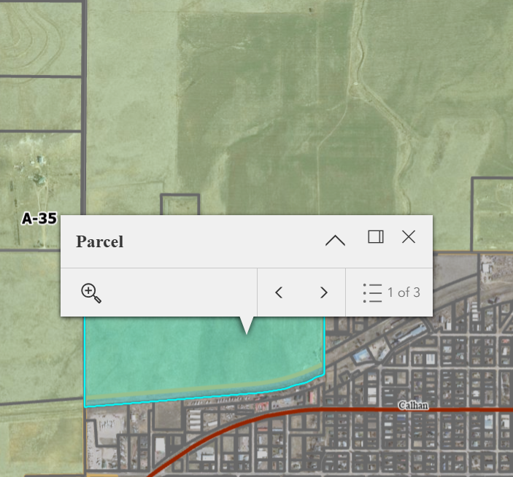
Zoning Map

- The Your El Paso County Master Plan identifies this parcel as a Rural Center.
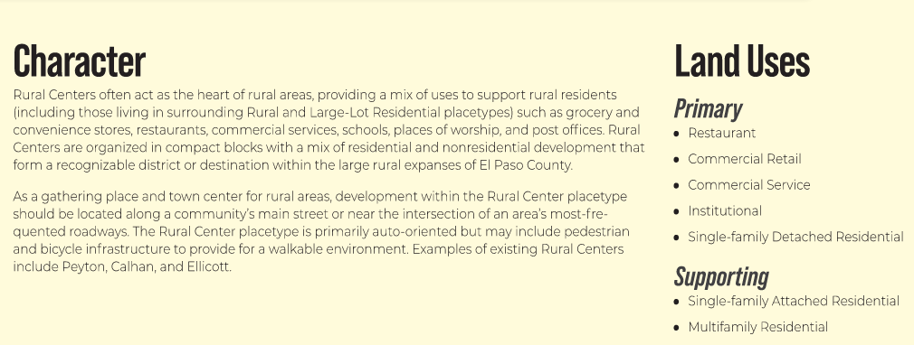
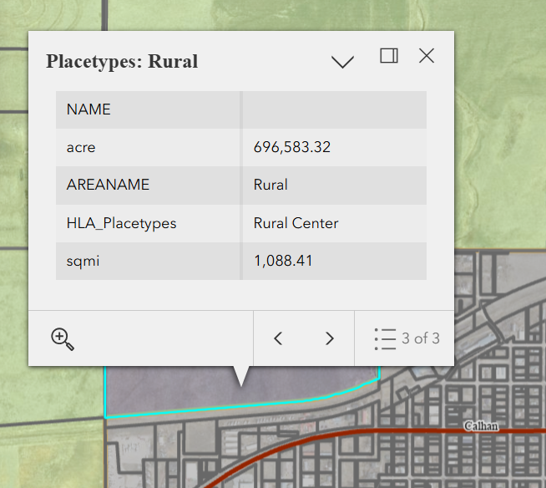
Placetype Map

- Additionally, the Plan identifies this are as an Area of Change: New Development
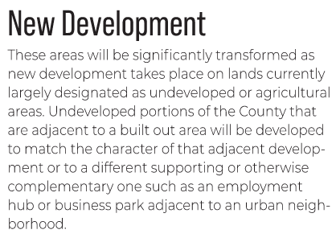
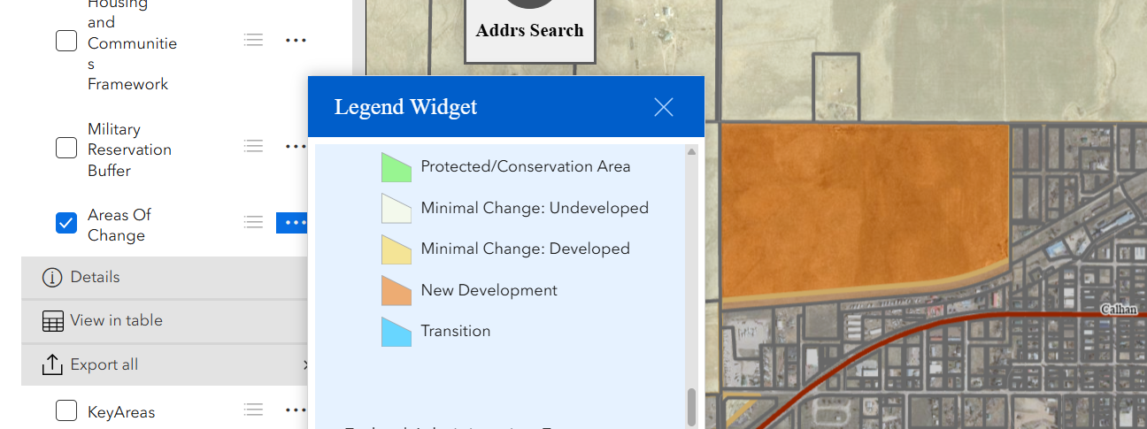
Area of Change Map

- The site is not within a Key Area or a Military Buffer Zone.

- A portion of the property may be within aviation Part 77 surfaces which may be impacted by aircraft. 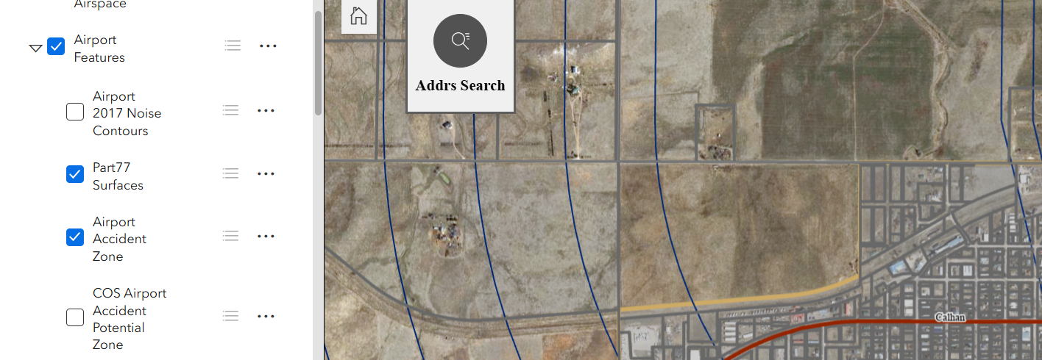
Unofficial Airport Features Map

- County Planning and DPW staff would like the opportunity to review the future zoning and subdivision entitlements submitted to Calhan, not limited to, the drainage and traffic reports.

Reviewed by: Kari Parsons, Principal Planner

Department of Public Works Division
Engineering Division
Please note that these comments are based on how the county would proceed through the development process with the various applications. As the property in question is planning to annex into Calhan, the town may have different requirements or criteria as to how they would proceed with the various application processes that differ from the County.

- County’s involvement with McClasky Road – an unimproved county road on the north edge of the proposed annexation and development – What needs to be discussed with the County in improving this road with the suggested development?

This road should be annexed along with the property parcels. Normally, this would put it under review, ownership and maintenance of the city. However, it appears the county continues to maintain McClasky even as it runs through Calhan, but design and ownership would be through Calhan. ROW for the road will need to be officially dedicated with the project plat. Improvements to the road would be determined when the project is submitted for official review.

A traffic engineer would prepare a traffic report, and based on the traffic determined for the project, during short- and long-term range, would dictate what improvements are needed (turn lanes, road classification, etc.). The traffic engineer, if following county criteria, would need to follow Chapter 2 and appendix B of the Engineering Criteria Manual. Note the current classification of McClasky Road is Rural-Major collector and the trigger for upgrading from a gravel to paved roadway is 200 daily trips.

Please also note that on the west side of the property, ROW for Eurich Road continues south of McClasky Road and will need to be preserved. The current layout shows lots extending all the way to the property line. Lots will need to be moved to the east to preserve the ROW.

- Whether a new bridge will need to be replaced on McClasky Road per the County Transportation plan, relative to this proposed development . . .

County transportation plan does not look at drainage structures. The 2024 Major Transportation Corridor Plan (MTCP) does show N Calhan Highway from US 24 to Pain Mine Road as being upgraded to a 2-lane Rural-Minor collector. It appears that the current box culverts under McClasky Road may be designated to be upgraded in the MTCP. However, the MTCP does not provide any information about this. As the possible drainage structure is listed as a county improvement and the proximity between the culverts and the project, it is unlikely that this project would trigger the upgrade project. If, however, upon actual submittal of the project with a drainage report or traffic report, it is determined that the project does trigger the structure replacement, whether through drainage flow increases or additional traffic impacts over the structure, there would likely be some sort of reimbursement available. That would be a bigger conversation to be had once actual plans have been provided for the overall project to be reviewed.

- The south edge of the parcel that would be annexed is adjacent the historic Rock Island R.R. row, where the county has envisioned a regional trail in your transportation plan. Are there opportunities to partner with county parks and trails to extend the Rock Island Regional bike trail here from Peyton?

I will leave this question to be answered by our Parks and Recreation department.

- We envision this applicant will most likely need to process an annexation, a rezoning (PUD most likely), and create a Preliminary Plan before any platting, filing, or permitting would occur on this proposed development. Could you please inform us of what County would want to comment on specifically with each of these entitlement processes so that we have clear expectations of what should be considered by the county with each entitlement process? If drainage matters when would you comment, if hazard mitigation matters when would you comment . . . etc.

At the zoning application, the county would be begin looking at traffic, ensuring accesses meet spacing requirements, seeing how much traffic is generated and begin the process of determining any improvements to existing roads and construction/classification of new roads. At the PUD or preliminary plan stage, we would begin to look at the drainage for the project, determining drainage flows, project is graded in such a fashion that flows can be treated by water quality/detention pond, # of ponds needed, etc. With the final plat, the drainage and traffic will be finalized and all design elements determined. This will dictate the construction drawings that will be part of a final plat submittal.

Even with McClasky being annexed into the Town of Calhan, prior to the town limits, McClasky Road is a county road. El Paso County would provide an Outside Agency Review (OAR) for the project applications. With these submittals, the County would look at the impacts to the County portion of the road, as well as drainage impacts to the county storm infrastructure. Based on these items, EPC may make requests for improvements to roads or storm facilities as needed. However, these items would not be known until design and reports have been submitted for review and comments.

Please note that a private easement and agreement will need to be granted by the current land owner where the WQ/detention pond is being proposed, since it is not located on the project property.

If there are any additional or specific questions that are still outstanding, please feel free to reach out to County staff.

Reviewed by:
Charlene Durham, PE
charlenedurham@elpasoco.com
719-520-7951

Stormwater Division
EPC DPW Stormwater
Note: If the parcel is annexed and the site development proceeds, provide the final design plans and drainage report for County review for potential impacts to County jurisdiction.

Reviewed by:
Mikayla Hartford, P.E.
Engineer - Stormwater
719.339.5053
MikaylaHartford@elpasoco.com

EPC Parks Department
UPDATE: Staff received communication from the applicant in which the applicant offered to work with El Paso County Parks to construct the Rock Island Regional Trail from Peyton to Calhan. Due to the fact that the 2022 master planned alignment of the Rock Island Regional Trail is NOT impacted by this project, that the current alignment is located within East Highway 24 CDOT right-of-way, and that planning and construction costs would be prohibitive, EPC Parks cannot enter into a Regional Trail Agreement (RTA) with the applicant for the construction of the regional trail. At this time, the following previously-submitted comments are still valid for this project going forward:

The 2022 El Paso County Parks Master Plan shows no impacts to existing or proposed parks, trails, or open space related to this annexation. As such, so park land or trail easement dedications will be necessary as this project moves forward. If annexation does not take place, this high-density residential development will be subject to EPC Parks agency review, including the review of allocated open space and neighborhood park lands, and calculation of regional and urban park fees, which would be applicable at time of the recording of the final plats. Annexation applications do not require endorsement from the EPC Park Advisory Board, so as such, these comments are being provided administratively. Thank you!
Ashlyn Mathey, Parks Planner
_____________________________________________________________________________________________________________
Please send the Impact Report when available for review.
Kari Parsons
El Paso County Planning and Community Development
2880 International Circle, Colorado Springs, CO, 80910
(719) 520-6449

