STREET AND STORM SEWER CALCULATIONS

STREET | LOCATION | DISTANCE | ELEVATION  & SLOPE |  | TOTAL  RUNOFF | STREET FLOW  / CAPACITY | PIPE  FLOW | TYPE PIPE, CATCH BASIN & SLOPE %
EXIST OUTLET |  |  | TOP=82.84 |  | 19.1/41.5 |  | 49.9 | 5’ DIA RCP VERT, d=0.90’
 |  |  | WS 84.02  S=0.94% |  |  |  | 49.9 | 8” PVC, CAP = 1.52 REPLACE  30” RCP S=0.97% MIN hi=1.65 WS=84.85
STREET AND STORM SEWER CALCULATIONS PROJECT: 16140 OLD DENVER ROAD  BY: O.E. WATTS DATE: 1-27-17, 1-5-18 |  |  |  | OLIVER E. WATTS, CONSULTING ENGINEER, INC.  614 ELKTON DRIVE COLORADO SPRINGS, CO 80907 |  |  |  |  | Page: 2 Of Pages7

Stormwater Detention and Infiltration Design Data Sheet | Stormwater Detention and Infiltration Design Data Sheet
Workbook Protected Worksheet Protected

Stormwater Facility Name: 16140 Old Denver Road, All About Outdoor Storage, El Paso County Facility Location & Jurisdiction: Full Spectrum Detention Pond O.E. Watts 1-8-18
User Input: Watershed Characteristics
User Defined | User Defined | User Defined | User Defined
Stage [ft] | Area [ft^2] | Stage [ft] | Discharge [cfs]
0.00 | 0 | 0.00 | 0.00
0.01 | 3,340 | 0.01 | 0.05
0.50 | 3,718 | 0.50 | 0.05
1.00 | 4,112 | 1.00 | 0.05
1.50 | 4,522 | 1.50 | 0.05
1.84 | 4,812 | 1.84 | 0.05
2.00 | 4,984 | 2.00 | 2.49
2.50 | 8,381 | 2.50 | 20.89
3.00 | 13,262 | 3.00 | 35.56
3.50 | 13,942 | 3.50 | 40.51
4.00 | 14,636 | 4.00 | 44.92
4.50 | 15,345 | 4.50 | 48.93
5.00 | 16,068 | 5.00 | 52.63

0.024
1130
11.56
48.0%
0.0%
100.0%
0.0%

100YR IN
45
100YR OUT

40 50YR IN

50YR OUT

Watershed Slope = Watershed Length = Watershed Area = Watershed Imperviousness =
Percentage Hydrologic Soil Group A = Percentage Hydrologic Soil Group B = Percentage Hydrologic Soil Groups C/D =
Location for 1-hr Rainfall Depths (use dropdown):
User Input
17
ft/ft ft acres
percent percent percent percent
35 10YR IN
10YR OUT
Doing_Clear_FoYes

CountA= 1
30
5YR IN

5YR OUT
25
FLOW [cfs]
2YR IN

20 2YR OUT

WQCV Treatment Method =
40.00 hours
Extended Deten | tion

WQCV IN
15
WQCV OUT

10

5

After completing and printing this worksheet to a pdf, go to: https://maperture.digitaldataservices.com/gvh/?viewer=cswdif create a new stormwater facility, and
attach the pdf of this worksheet to that record.

3.5

3

2.5
PONDING DEPTH [ft]

2

1.5

0
0.1

100YR

50YR

10YR

5YR

2YR WQCV
TIME1 [hr] 10

Design Storm Return Period = One-Hour Rainfall Depth = Calculated Runoff Volume =
Routed Hydrograph Results

1
Area
0 1 2 3
#N/A #N/A
0 1 2 3
#N/A #N/A
Discharge
Check Data Set 1 Check Data Set 1
WQCV | 2 Year | 5 Year | 10 Year | 50 Year | 100 Year
0.53 | 1.19 | 1.50 | 1.75 | 2.25 | 2.52
0.191 | 0.489 | 0.762 | 0.994 | 1.600 | 1.912
0.191 | 0.488 | 0.762 | 0.993 | 1.600 | 1.911
42.3 | 40.3 | 38.3 | 36.7 | 32.3 | 30.1
43.3 | 42.7 | 42.1 | 41.5 | 40.1 | 39.4
1.86 | 2.15 | 2.33 | 2.45 | 2.81 | 2.97
0.111 | 0.137 | 0.165 | 0.184 | 0.260 | 0.297
0.173 | 0.207 | 0.234 | 0.256 | 0.334 | 0.380

in
acre-ft

OPTIONAL Override Runoff Volume = acre-ft

Inflow Hydrograph Volume = Time to Drain 97% of Inflow Volume = Time to Drain 99% of Inflow Volume = Maximum Ponding Depth = Maximum Ponded Area =
Maximum Volume Stored =
acre-ft hours hours ft acres acre-ft
0.5

0

0.1 1 10 100

DRAIN TIME [hr]

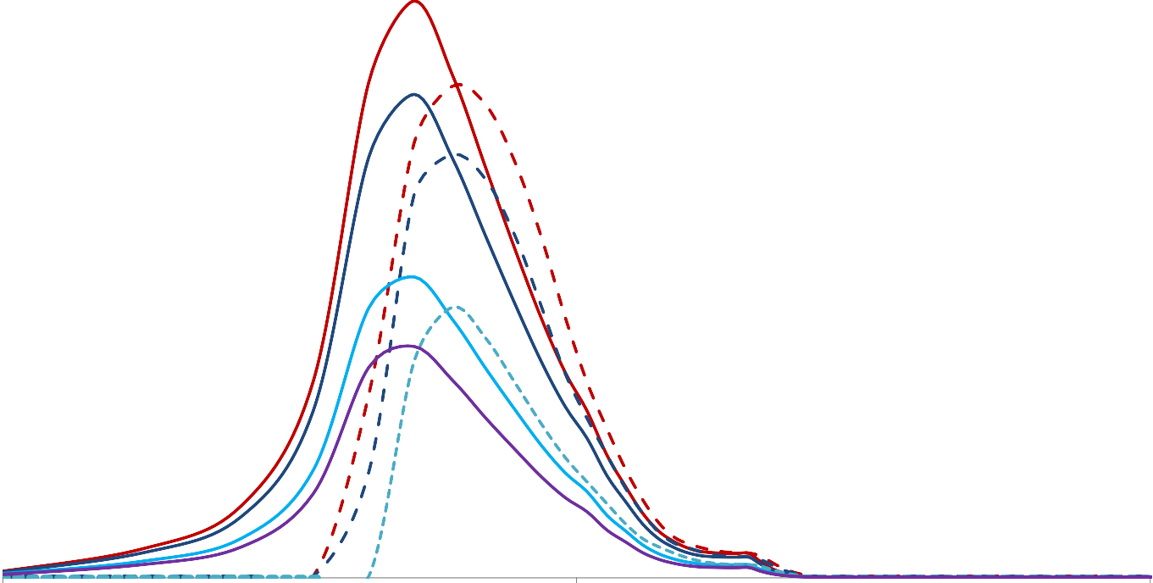

1-8-18 SDI_Design_Data_v1.04.xlsm, Design Data 1/8/2018, 2:53 PM

DETENTION BASIN STAGE-STORAGE TABLE BUILDER
UD-Detention, Version 3.07 (February 2017)
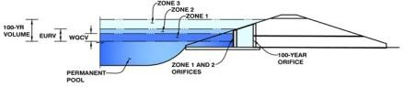
Project: All About Outdoor Storage, 16140 Old Denver Road, El Paso County, Colorado Basin ID: Full Spectrum Detention Pond

Example Zone Configuration (Retention Pond)

Required Volume Calculation
SF
11.55
1,130
0.024
48.00%
0.0%
100.0%
0.0%
12.0

Selected BMP Type = Watershed Area = Watershed Length = Watershed Slope =
Watershed Imperviousness =
Percentage Hydrologic Soil Group A = Percentage Hydrologic Soil Group B = Percentage Hydrologic Soil Groups C/D = Desired WQCV Drain Time =
Location for 1-hr Rainfall Depths = User Input
0.155
0.591
0.474
0.650
0.887
1.253
1.505
1.836
0.000
0.444
0.610
0.814
0.894
0.935
1.049

acres 1130
ft ft/ft
Depth Increment = | 0.5 | ft
Stage - Storage Description | Stage (ft) | Optional Override  Stage (ft) | Length (ft) | Width (ft) | Area (ft^2) | Optional Override  Area (ft^2) | Area (acre) | Volume (ft^3) | Volume (ac-ft)
Media Surface | -- | 0.00 | -- | -- | -- | 3,341 | 0.077
 | -- | 0.50 | -- | -- | -- | 3,718 | 0.085 | 1,727 | 0.040
 | -- | 1.00 | -- | -- | -- | 4,112 | 0.094 | 3,681 | 0.085
 | -- | 1.50 | -- | -- | -- | 4,522 | 0.104 | 5,835 | 0.134
 | -- | 2.00 | -- | -- | -- | 4,948 | 0.114 | 8,199 | 0.188
 | -- | 2.50 | -- | -- | -- | 8,381 | 0.192 | 11,580 | 0.266
 | -- | 3.00 | -- | -- | -- | 13,262 | 0.304 | 16,991 | 0.390
 | -- | 3.50 | -- | -- | -- | 13,942 | 0.320 | 23,792 | 0.546
 | -- | 4.00 | -- | -- | -- | 14,636 | 0.336 | 30,937 | 0.710
 | -- | 4.50 | -- | -- | -- | 15,345 | 0.352 | 38,432 | 0.882
 | -- | 5.00 | -- | -- | -- | 16,068 | 0.369 | 46,285 | 1.063
 | -- |  | -- | -- | --
 | -- |  | -- | -- | --
 | -- |  | -- | -- | --
 | -- |  | -- | -- | --
 | -- |  | -- | -- | --
 | -- |  | -- | -- | --
 | -- |  | -- | -- | --
 | -- |  | -- | -- | --
 | -- |  | -- | -- | --
 | -- |  | -- | -- | --
 | -- |  | -- | -- | --
 | -- |  | -- | -- | --
 | -- |  | -- | -- | --
 | -- |  | -- | -- | --
 | -- |  | -- | -- | --
 | -- |  | -- | -- | --
 | -- |  | -- | -- | --
 | -- |  | -- | -- | --
 | -- |  | -- | -- | --
 | -- |  | -- | -- | --
 | -- |  | -- | -- | --
 | -- |  | -- | -- | --
 | -- |  | -- | -- | --
 | -- |  | -- | -- | --
 | -- |  | -- | -- | --
 | -- |  | -- | -- | --
 | -- |  | -- | -- | --
 | -- |  | -- | -- | --
 | -- |  | -- | -- | --
 | -- |  | -- | -- | --
 | -- |  | -- | -- | --
 | -- |  | -- | -- | --
 | -- |  | -- | -- | --
 | -- |  | -- | -- | --
 | -- |  | -- | -- | --
 | -- |  | -- | -- | --
 | -- |  | -- | -- | --
 | -- |  | -- | -- | --
 | -- |  | -- | -- | --
 | -- |  | -- | -- | --
 | -- |  | -- | -- | --
 | -- |  | -- | -- | --
 | -- |  | -- | -- | --
 | -- |  | -- | -- | --
 | -- |  | -- | -- | --
 | -- |  | -- | -- | --
 | -- |  | -- | -- | --
 | -- |  | -- | -- | --
 | -- |  | -- | -- | --
 | -- |  | -- | -- | --
 | -- |  | -- | -- | --
 | -- |  | -- | -- | --
 | -- |  | -- | -- | --
 | -- |  | -- | -- | --
 | -- |  | -- | -- | --
 | -- |  | -- | -- | --
 | -- |  | -- | -- | --
 | -- |  | -- | -- | --
 | -- |  | -- | -- | --
 | -- |  | -- | -- | --
 | -- |  | -- | -- | --
 | -- |  | -- | -- | --
 | -- |  | -- | -- | --
 | -- |  | -- | -- | --
 | -- |  | -- | -- | --
 | -- |  | -- | -- | --
 | -- |  | -- | -- | --
 | -- |  | -- | -- | --
 | -- |  | -- | -- | --
 | -- |  | -- | -- | --
 | -- |  | -- | -- | --
 | -- |  | -- | -- | --
 | -- |  | -- | -- | --
 | -- |  | -- | -- | --
 | -- |  | -- | -- | --
 | -- |  | -- | -- | --
 | -- |  | -- | -- | --
 | -- |  | -- | -- | --
 | -- |  | -- | -- | --
 | -- |  | -- | -- | --
 | -- |  | -- | -- | --
 | -- |  | -- | -- | --
 | -- |  | -- | -- | --
 | -- |  | -- | -- | --
 | -- |  | -- | -- | --
 | -- |  | -- | -- | --
 | -- |  | -- | -- | --
 | -- |  | -- | -- | --

percent percent percent percent hours

Water Quality Capture Volume (WQCV) = Excess Urban Runoff Volume (EURV) = 2-yr Runoff Volume (P1 = 1.19 in.) =
5-yr Runoff Volume (P1 = 1.5 in.) = 10-yr Runoff Volume (P1 = 1.75 in.) = 25-yr Runoff Volume (P1 = 2 in.) = 50-yr Runoff Volume (P1 = 2.25 in.) =
100-yr Runoff Volume (P1 = 2.52 in.) =
acre-feet acre-feet acre-feet acre-feet acre-feet acre-feet acre-feet acre-feet
Optional User Override 1-hr Precipitation
inches inches inches inches inches inches
1.19
1.50
1.75
2.00
2.25
2.52

500-yr Runoff Volume (P1 = 0 in.) = Approximate 2-yr Detention Volume = Approximate 5-yr Detention Volume = Approximate 10-yr Detention Volume = Approximate 25-yr Detention Volume = Approximate 50-yr Detention Volume = Approximate 100-yr Detention Volume =

Stage-Storage Calculation
Zone 1 Volume (WQCV) = Zone 2 Volume (EURV - Zone 1) =
Zone 3 Volume (100-year - Zones 1 & 2) = Total Detention Basin Volume = Initial Surcharge Volume (ISV) = Initial Surcharge Depth (ISD) =
Total Available Detention Depth (Htotal) = Depth of Trickle Channel (HTC) = Slope of Trickle Channel (STC) = Slopes of Main Basin Sides (Smain) = Basin Length-to-Width Ratio (RL/W) =

Initial Surcharge Area (AISV) = Surcharge Volume Length (LISV) = Surcharge Volume Width (WISV) = Depth of Basin Floor (HFLOOR) = Length of Basin Floor (LFLOOR) = Width of Basin Floor (WFLOOR) = Area of Basin Floor (AFLOOR) = Volume of Basin Floor (VFLOOR) = Depth of Main Basin (HMAIN) = Length of Main Basin (LMAIN) = Width of Main Basin (WMAIN) = Area of Main Basin (AMAIN) = Volume of Main Basin (VMAIN) =
Calculated Total Basin Volume (Vtotal) =
acre-feet inches
acre-feet acre-feet acre-feet acre-feet acre-feet acre-feet

acre-feet acre-feet acre-feet acre-feet ft^3
0.155
0.436
0.458
1.049
N/A
N/A
user
N/A
N/A
user
user

ft ft ft
ft/ft H:V

ft^2 ft
user
user
user
user
user
user
user
user
user
user
user
user
user
user

ft ft ft ft
ft^2 ft^3 ft
ft ft
ft^2 ft^3
acre-feet

4-17 UD-Detention_v3.07.xlsm, Basin 1/8/2018, 3:14 PM

Area (acres)
Length, Width (ft.)
Volume (ac-ft)
Area (sq.ft.)
DETENTION BASIN STAGE-STORAGE TABLE BUILDER
UD-Detention, Version 3.07 (February 2017)
1 User Defined Stage-Area Boolean for Message
1 Equal Stage-Area Inputs Watershed L:W
1 CountA

0 Calc_S_TC

H_FLOOR

L_FLOOR_OTHER

0.00 ISV 0.00 ISV
0.00 Floor 0.00 Floor
1.69 Zone 1 (WQCV) 1.69 Zone 1 (WQCV)
3.64 Zone 2 (EURV) 3.64 Zone 2 (EURV)
4.97 Zone 3 (100-yea 4.97 Zone 3 (100-year)
20
400
15
300
10
200
5
100
0
0
0.00 1.50
3.00
Stage (ft)
4.50
6.00
Length (ft)
Width (ft)
Area (sq.ft.)
0.380
1.080
0.285
0.810
0.190
0.540
0.095
0.270
0.000
0.000
0.00 1.50
3.00
Stage (ft.)
4.50
6.00
Area (acres)
Volume (ac-ft)

4-17 UD-Detention_v3.07.xlsm, Basin 1/8/2018, 3:14 PM

