Early Assistance Meeting Number: EA2694
Project Name: Bailey Minor Plat
Project Location: 4820 Walker Road Colorado Springs, CO 80908
Project Parcel Nos. 6100000477
Project Description: Property owners are interested in exploring the feasibility of creating 16- five acre lots on 80 acres. Access is off Walker Road via a recorded 60-wide easement. 300-year water supply has been adjudicated.
Meeting Date: 8/24/2026, 3 PM

El Paso County Planning & Community Development Planning Checklist

Request – Map Provided by Applicant
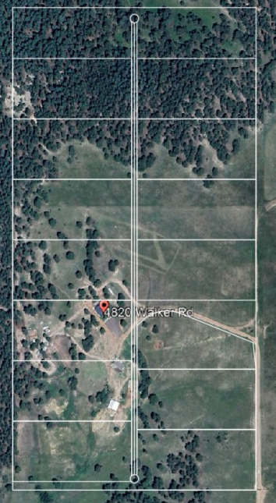

Zoning District(s)
Zone | Name
Existing
RR-5 | Rural Residential

Zone Map (existing conditions of approval)
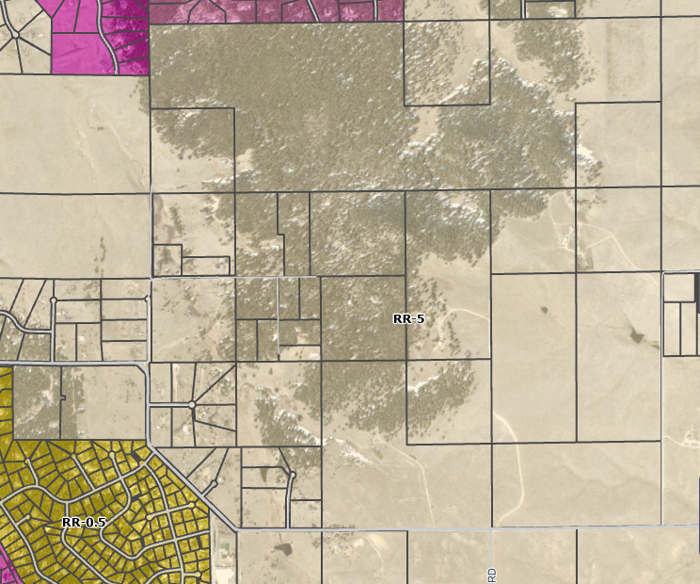
Acres: 80
Access proposed through existing 60-ft access easement to Walker Road
Existing: Ag residence(s)

Zoning Analysis
Zoning
RR-5 requires 5 acres per lot.
Application Processes
- Final Plat – after submittal, 21 day review, revisions by you, re-submittal, 14 day review periods thereafter
- Final plat without Preliminary Plan goes to 2 public hearings: Planning Commission for recommendation to Board, then BoCC Public Hearing for final approval.

Links to guidance documents and forms
(not all submittal requirements have available guidance documents, see EDARP project page for full list of documents required)
Final Plat application checklist
- Application form
- Road Impact Fee Acknowledgement Form
- Mineral Rights Certification
- Wastewater Disposal checklist
- Water Resources Report requirements
- Subdivision Improvements Agreement

Zoning District Standards
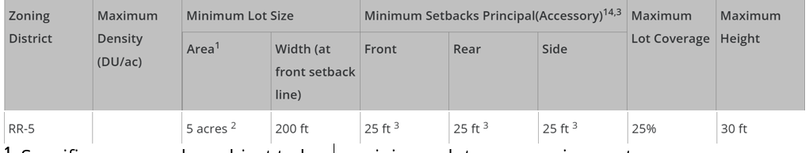
¹ Specific uses may be subject to larger minimum lot area requirements.
² In the event that the land to be partitioned, platted, sold or zoned abuts a section line County road, the minimum lot area for lots abutting the road shall be 4.75 acres and minimum lot width shall be 165 ft.
³ Agricultural stands shall be setback a minimum of 35 feet from all property lines.
¹⁴ If no separate setback is shown in parentheses for accessory structures, the principal structure setback applies to accessory structures.

Plat Map or Parcel Map (conditions of approval):
Unplatted – N/A

Application Type(s) Hearing: Required/ Optional/ No
Final Plat | Yes – PC & BoCC

Approval Criteria:
7.2.1 D. (3) Final Plat
(f) Criteria for Approval. In approving a final plat, the approving authority shall find that:
- The subdivision is in conformance with the goals, objectives, and policies of the Master Plan;
- The subdivision is in substantial conformance with the approved preliminary plan;
- The subdivision is consistent with the subdivision design standards and regulations and meets all planning, engineering, and surveying requirements of the County for maps, data, surveys, analyses, studies, reports, plans, designs, documents, and other supporting materials;
- Either a sufficient water supply has been acquired in terms of quantity, quality, and dependability for the type of subdivision proposed, as determined in accordance with the standards set forth in the water supply standards [C.R.S. § 30-28-133(6)(a)] and the requirements of Chapter 8 of this Code, or, with respect to applications for administrative final plat approval, such finding was previously made by the BoCC at the time of preliminary plan approval;
- A public sewage disposal system has been established and, if other methods of sewage disposal are proposed, the system complies with State and local laws and regulations, [C.R.S. § 30-28-133(6)(b)] and the requirements of Chapter 8 of this Code;
- All areas of the proposed subdivision which may involve soil or topographical conditions presenting hazards or requiring special precautions have been identified and that the proposed subdivision is compatible with such conditions [C.R.S. § 30-28-133(6)(c)];
- Adequate drainage improvements are proposed that comply with State Statute [C.R.S. § 30-28-133(3)(c)(VIII)] and the requirements of this Code and the ECM;
- Legal and physical access is provided to all parcels by public rights-of-way or recorded easement, acceptable to the County in compliance with this Code and the ECM;
- Necessary services, including police and fire protection, recreation, utilities, and transportation systems, are or will be made available to serve the proposed subdivision;
- The final plans provide evidence to show that the proposed methods for fire protection comply with Chapter 6 of this Code;
- Off-site impacts were evaluated and related off-site improvements are roughly proportional and will mitigate the impacts of the subdivision in accordance with applicable requirements of Chapter 8;
- Adequate public facilities or infrastructure, or cash-in-lieu, for impacts reasonably related to the proposed subdivision have been constructed or are financially guaranteed through the SIA so the impacts of the subdivision will be adequately mitigated;
- The subdivision meets other applicable sections of Chapter 6 and 8; and
- The extraction of any known commercial mining deposit shall not be impeded by this subdivision [C.R.S. §§ 34-1-302(1), et seq.]

Processing Issues and Options
Where is subdivision access taken? Public or Private roads?
- Private Roads require waiver, and easement (likely private)
- Public Roads require dedication

Relevant Past History:
Existing structures will need to meet zoning district standards.

Design and Landscaping
Site Design/Layout (Lot pattern, circulation/road design, open space, preservation of natural features, compatibility internally and with adjacent land uses)

Landscaping
☐ | Expressway, Principal arterial area depth – 25’-Trees required 1 per 20’
☐ | Urban interchange/Intersection area depth – 25’- N/A
☐ | Minor arterial area depth 20’ – Trees required 1 per 25’
☐ | Non-arterial area depth 10’ – Trees required 1 per 30’
☐ | Parking lot landscaping required
☐ | Buffer between non-residential and residential districts separated by a non-arterial road or public alley

Signage:

Parking Requirements:

Lighting:
Photometric Plan reuired | ☐

Site Characteristics\ Constraints\ Environmental Standards:
Areas with 30% slope

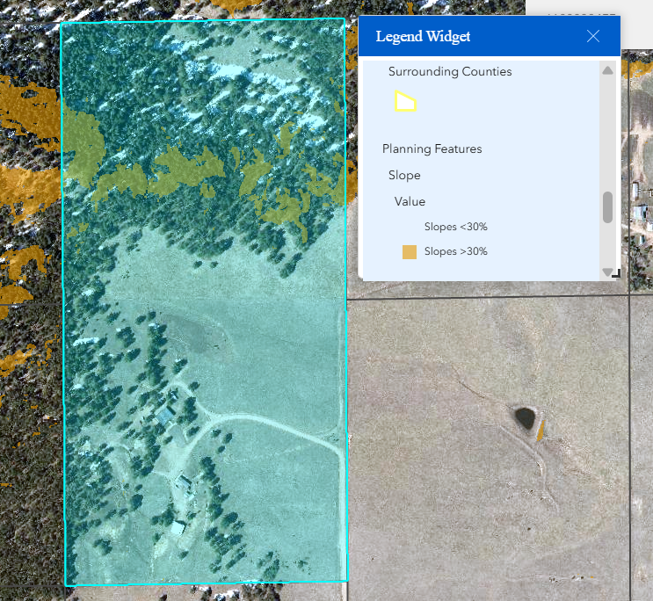

Areas subject to WRC enforced by the Tri-Lakes Monument Fire Protection District

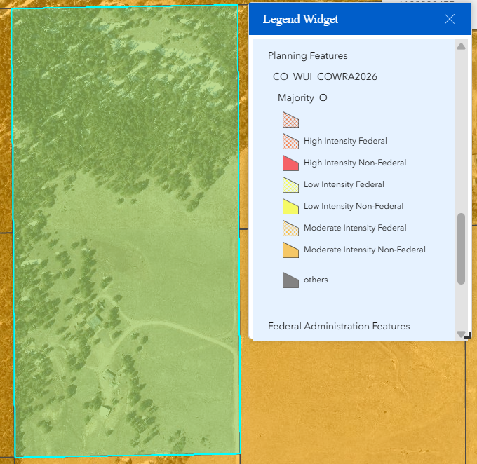

- Take a look at Appendix E of the Land Development Code

Areas with Geologic Hazards (plat notes may be required)

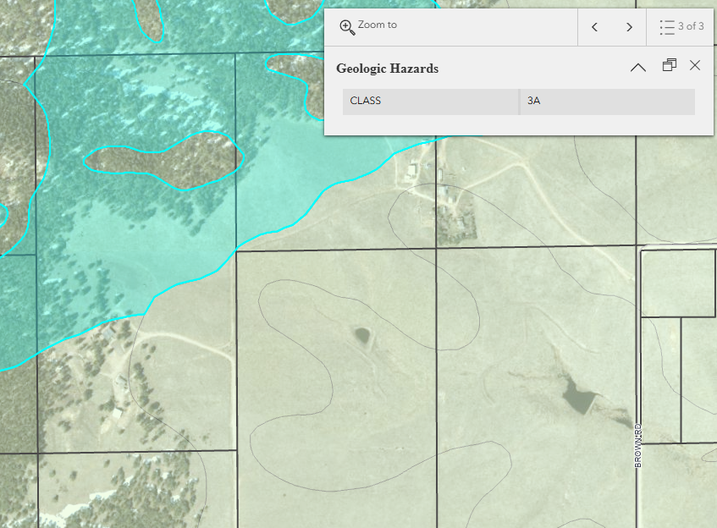
3-A Stable alluvium, colluvium, and bedrock on moderate to steep slopes (12%-24%). Includes some old alluvium fans along mountain front that have been dissected by modern streams. Emphasis on drainage, slope, bedrock structure and design of cuts. 3-B Expansive and potentially expansive soil and bedrock on flat to moderate slopes (0-12%). Emphasis on potential for swell, depth of bedrock, design of foundation and drainage.

Areas with Geologic Hazards (plat notes may be required)

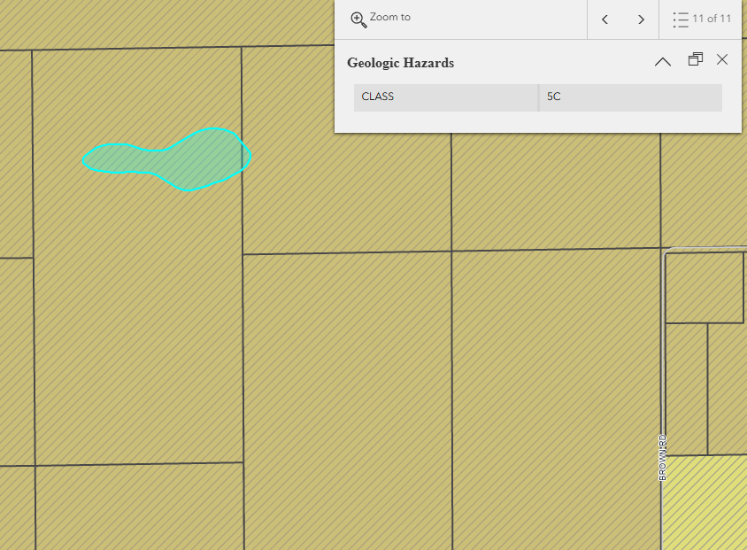 5-C Unstable or potentially unstable colluvium or bedrock on steep slopes. Emphasis on slope stability, control of cuts and surface drainage.

☒ | 30% or greater slope | Topography comment: | 30% slope areas must be noted on the plat as no-build
☒ | CGS review required (separate fee to CGS) | Soils/geology comment: | You’ll need to submit your plat for review to CGS directly, then provide the invoice for this submittal.  - CGS Land Use Review here  - FYI, CGS fees are $125 for first submittal plus $950 for subdivisions less than 100 acres
☐ | Floodplain | Floodplain comment:
☐ | Noise mitigation required | Noise comment:
☒ | Preble’s mouse | Preble’s comment: | Block Clearance letter required from US FWS
☒ | Fire Protection Report | FPR comment: | A Fire Protection Report is required for any subdivision application and shall include an analysis of compliance with this Code, the applicable fire code, and at a minimum the following:  - Description of proposed development to include acreage, number of lots/dwelling units, etc.  - Water supply to be used for fire suppression (fire hydrants, dry hydrants, cisterns, automatic sprinkler system, etc.).  - Maintenance plan if cisterns and dry hydrants will be used.  - Information regarding the internal and external roadways and if an emergency vehicle can utilize those roadways.  - Information on any emergency access roads and/or gates.  - The fire intensity classification when located within the wildland urban interface area and an analysis of compliance with Appendix E (when applicable).  List of Qualified Professionals to prepare report available (not required to use these, but they are confirmed as qualified)
☐ | Wildfire Mitigation Plan | WMP comment:

Air/Visual Quality:

Districts
Taxing Entities
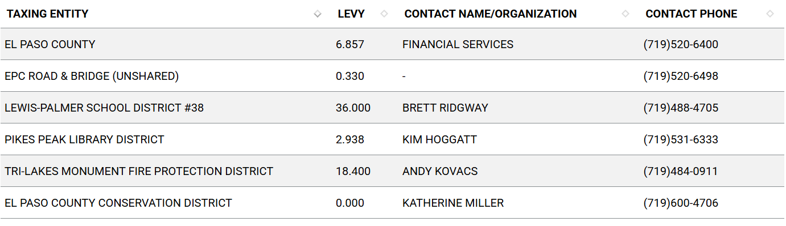
Proposed source of water |  |  | Proposed method of wastewater disposal
☐ | Central System |  | ☐ | Central System
District Name: |  |  | District Name:

Water/wastewater comments
Final plat requires a finding of 300 year water sufficiency, for the total density proposed.
- Applicant’s request states that water rights adjudicated, but I don’t see any records in the DWR database. You will need to consult with a water attorney for water rights when subdividing, as existing water right does not cover subdivision.

See section 8.4.7. Water Supply Standards for Water Resources Report requirements

For subdivisions with 4 lots or more whose water supply consists of wells, and particularly where there are water augmentation or replacement obligations, the applicant shall establish an HOA or other entity approved by the CAO that shall be responsible to carry out the obligations under the water court decree, Colorado Groundwater Determination, and any related augmentation or replacement plans. For subdivisions with 3 lots or less, while creation of an HOA is preferred, responsibility for the obligations may be placed on the individual lot owners in the covenants or in a Joint Use Well-Sharing and Easement Agreement. Unless the water court or Colorado Groundwater Commission authorizes differently, no more than 6 lots shall share a well in a joint-use well sharing arrangement. Plat notes concerning the responsibility for the obligations and for conveyances of water rights shall be included on the face of the final plat. Prior to recording the final plat for any such subdivision, the applicant shall provide to PCD and the CAO for review and approval documents including, but not limited to, water court decrees and plans for augmentation signed by the Water Judge; determinations of water rights and replacement plans signed by the Colorado Groundwater Commission; deeds to cure defects in title to water rights; form deeds conveying water rights to individual lot owners; deeds conveying water rights for augmentation or replacement to the HOA (or to lot owners for subdivisions with 3 lots or less); Joint Use Well Sharing and Easement Agreements (where applicable); restrictive covenants; and documents creating the HOA including articles of incorporation, certificate of incorporation by the Secretary of State, and bylaws.
  - HOA example: Water Covenants in https://epcdevplanreview.com/Public/ProjectDetails/197127

Fire District:
County Fire Protection standards can be found in Code Amendments not yet Codified. Tri-Lakes Monument will review for WRC standards.

Tri-Lakes Monument Fire Protection District (see taxing entities for contact information)
- This is a Moderate Intensity WUI Area for CO Wildfire Resiliency Code
  - Moderate and high intensity areas (Orange and Red areas on the map) must meet Class I and Class II requirements of Appendix E.
- Please note that when a development/property is located within the boundaries of a fire district, the applicable fire district is responsible for determining compliance with their adopted WRC.
- Applications requiring fire district signoff cannot be approved until the fire district has approved.
  - This may cause a delay in processing of applications. Applicants shall be directed to contact the fire district with any concerns.

Emergency Services Issues:

Commissioner District: 1

Code Waivers:
7.3 Waiver Requests

(E) Private Road Allowances.
(1) Use of Private Roads Generally Limited. Private roads shall normally be confined to closed loops and dead-end roads not likely to be needed for the convenience and safety of the general public.
(2) Private Roads Require Waiver. The use of private roads is limited and allowed only by waiver. In granting a waiver to allow private roads, the BoCC shall make written findings supporting the use of private roads and may require the owner to enter into a Private Road Maintenance Agreement or create covenants whereby the lot owners are required to maintain the private roads.
(3) Private Roads to Meet County Standards. Generally, private roads shall be constructed and maintained to ECM standards except as may be otherwise determined in the waiver. Private road waivers may only include design standards for the following:
- Right-of-way width where suitable alternative provisions are made for pedestrian walkways and utilities;
- Design speed where it is unlikely the road will be needed for use by the general public;
- Standard section thickness minimums and pavement type where suitable and perpetual maintenance provisions are made;
- Maximum and minimum block lengths; and
- Maximum grade.

(4) Private Roads Determined to Comply with Access Requirements. In cases where private roads are approved, the private roads shall be deemed to comply with the access and frontage requirements of this Code as if the private roads were public roads.
(5) Private Roads Posted. Private roads shall be posted and identified on the plat.

Parks and trails:
Park and School fees due at Platting, prior to recordation of Mylar.
Regional Park fees: $467.00 per Unit of Density (lot)
School fees: $308 per Unit of Density (lot)

Annexations/Intergovernmental/ Jurisdictional Access issues:

Road Impact Fee Program (PID Inclusion):

Your El Paso Master Plan

Placetype: Rural
Character:

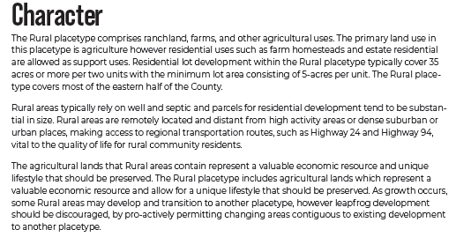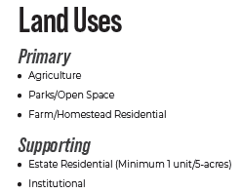

Area of Change Designation: Minimal Change, Developed
Description:
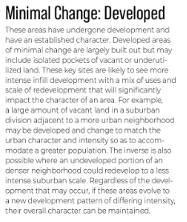

Priority Development Area: Large Lot Residential
Description:

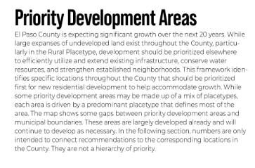

Water Master Plan Area:
Water Region 2
Guidance on what we look at in a water resources report, among other Code criteria:
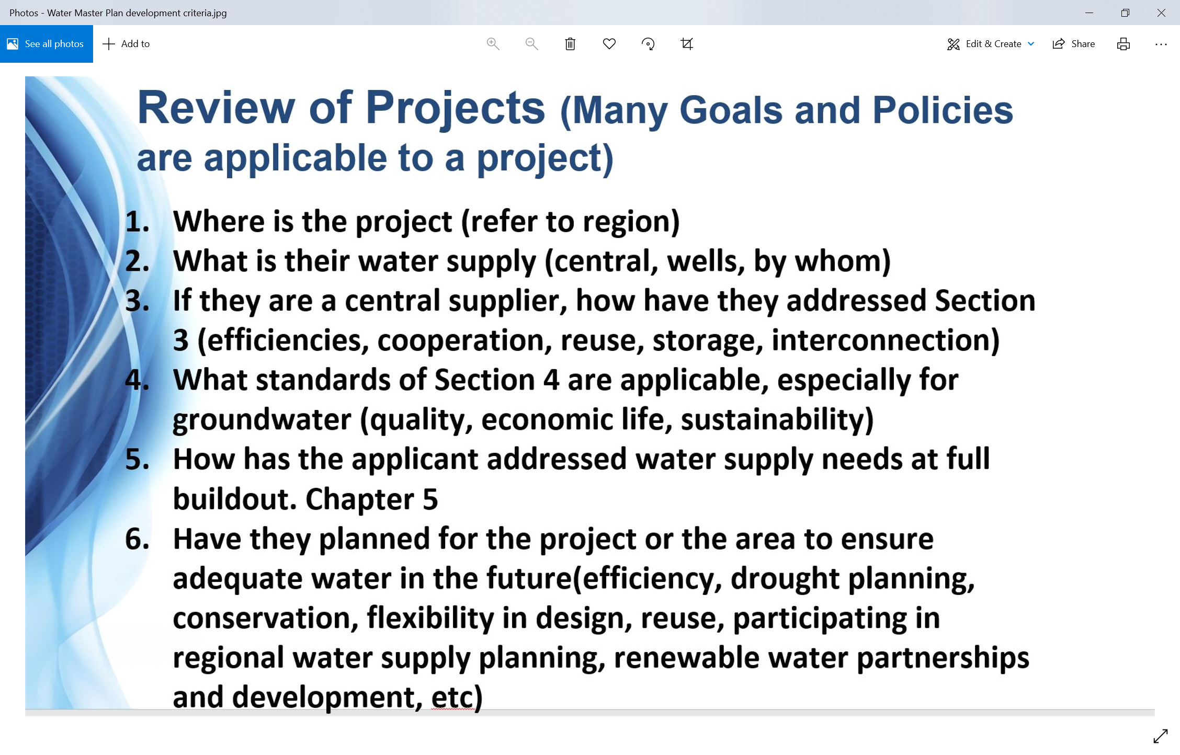

Wildlife impact
Moderate, 3

Helpful Links

Planning Website: https://planningdevelopment.elpasoco.com/

El Paso County Master Plan: https://planningdevelopment.elpasoco.com/#1510603950097-f5d985dc-35b2
Water Master Plan: https://planningdevelopment.elpasoco.com/#1515613078151-9a697e85-b1a7
Parks Master Plan: https://parks.elpasoco.com/parks-and-recreation/park-planning/
Mineral Extraction Master Plan: https://planningdevelopment.elpasoco.com/#1515613078151-9a697e85-b1a7

Forms and Templates: https://planningdevelopment.elpasoco.com/forms-and-affidavits/

Applications and Checklists: https://planningdevelopment.elpasoco.com/applications-and-checklists/

Land Development Code: https://library.municode.com/co/el_paso_county/codes/land_development_code

EDARP: https://epcdevplanreview.com/

Public GIS: https://experience.arcgis.com/experience/94cea8ccda3d4806a3fd500d2b5a4433?draft=true

Wrap Up
-If subdivision is proposed, recording fees, park and school fees and road impact fees may apply.

-Fees are subject to change. The fees at the time of application apply.

-Road Impact Fees
Please see the following website for information on the EPC Road Impact Fee Project. https://publicworks.elpasoco.com/road-impact-fees/ to include fee schedule.
As of December 15, 2016, per Resolution 16-454, on and after January 1, 2020, property in the unincorporated area of the county that receives a Land Use Approval either in a public hearing or administratively, is subject to the payment of Road Impact Fees. After December 31, 2024, in accordance with BoCC Resolution 24-377 the fee is paid for new residential and non-residential uses and structures and expansions of non-residential uses and structures. Road Impact fees are typically paid at time of building permit. If no building permit is being obtained for a particular Land Use application, then Road Impact Fees must be paid at the time of Site Development Plan or Special Use approval. If there are questions about EPC Road Impact program or fees, please contact DPW Development Review Services and the Engineer of the Day.

- Engineering Criteria Manual (ECM) Deviations.
The fee for any additional ECM deviation requests (more than two per land use application) - $1483.00 each per current Fee Schedule. Please note ECM deviation requests may result in additional processing and project review time. ECM Deviations should be submitted prior to the initial Site Development Plan or Final Plat submittal to preclude changes having to be made to engineering plans and documents if the deviation is not approved. Submission of an ECM deviation request does not imply or guarantee that the deviation will be approved. An ECM Deviation form must be submitted to include complete exhibits and justification excluding cost with supporting engineering criteria. If there are questions about ECM Deviation requests, please contact DPW Development Review Services and the Engineer of the Day.

-The fee for any additional waiver/deviation requests (more than two) - $550.00 each. Please note that requests for waivers and/or deviations may result in additional processing/review delay.

-All items requested must accompany the submittal for it to be complete, prior to payment request or the submittal will not be complete and ready for review agencies.

-A temporary use permit shall be applied for and approved for any staging area associated with development, such as a sales office, construction trailer, or contractor's equipment yard, prior to scheduling of the pre-construction meeting with El Paso County Planning and Community Development. If a Planned Unit Development is proposed, the temporary staging area should be shown on the development guideline and phasing plan.

-All prospective timelines for review are subject to departmental staffing and workload.

-Early Assistance is valid for 12 months from submittal of the EA application. If a project submittal is not received within 12 months, a new EA meeting may be required. An audio/video copy of the meeting is available in EDARP within the EA folder.

- Applications scheduled for public hearings may be heard as a regular item at the request of staff or a hearing body member.

- Any comments or commitments made by any member of the County Staff during this early assistance meeting are only preliminary in nature and should not be relied upon by the applicant. All prospective applicants should be informed that formal comments cannot be made by staff until after the application is submitted.

