File No. EA2694
Bailey Minor Plat
4820 Walker Road Colorado Springs, CO 80908
Engineering Meeting Notes
EA Meeting Date/Time: | Monday, 8/24/2026 3:00
Parcel Number: | Parcel 4319001043
Address/Plat No./Acre: | 4820 Walker Road Colorado Springs, CO 80908  / NA / 80.00 Acre
Project Manager/Phone: | Jen Uhler (719) 520-7952
Development Services Engineer/Phone: | Jalal Saleh, PE (719) 520-7550
Stormwater Engineer/Phone | Zachary Jannusch (719) 500-3170
Application/Land Use Type: | Plating / Existing zoning RR-5 / Proposed zoning RR-5

IMPORTANT NOTE:
These Engineering meeting notes are based on the information provided by the Applicant and reasonable preliminary research. The County requirements and policies in effect at the time of the meeting may change prior to the project submittal date, and the requirements and policies in effect at the date of submittal shall apply. Based on the applicant-provided information and preliminary research, these notes are the best estimate of the requirements expected to be met by the Applicant. The actual requirements may change based on project revisions, new information, or constraints that were unavailable or overlooked at the time of the Early Assistance meeting. It is solely the Applicant’s responsibility to research and be familiar with state and federal laws and permitting requirements; the County’s regulations, codes and criteria; the requirements of other applicable local, state or federal agencies; and any governing documents that apply to the project, including previous drainage and transportation studies and previous land use approvals and conditions. Reference links are provided at the end of this document.

REQUEST:
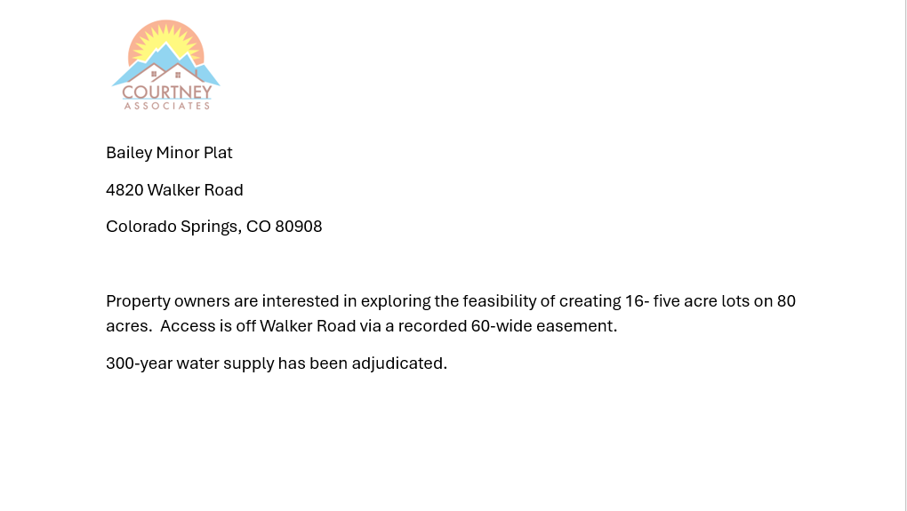

Site Map:
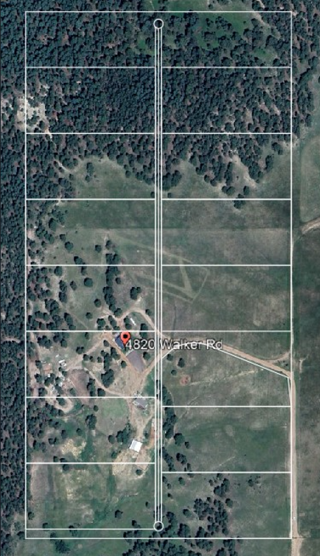

Area Mao

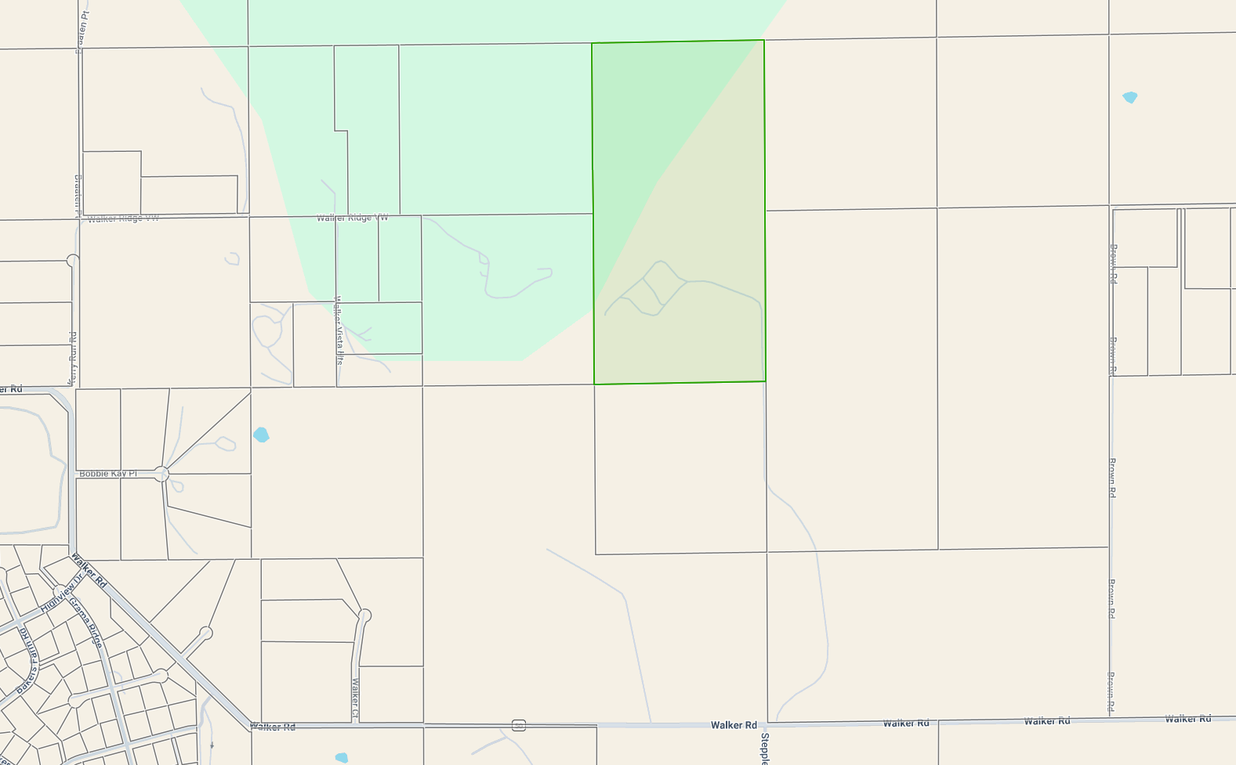
EPC AERIAL MAP:

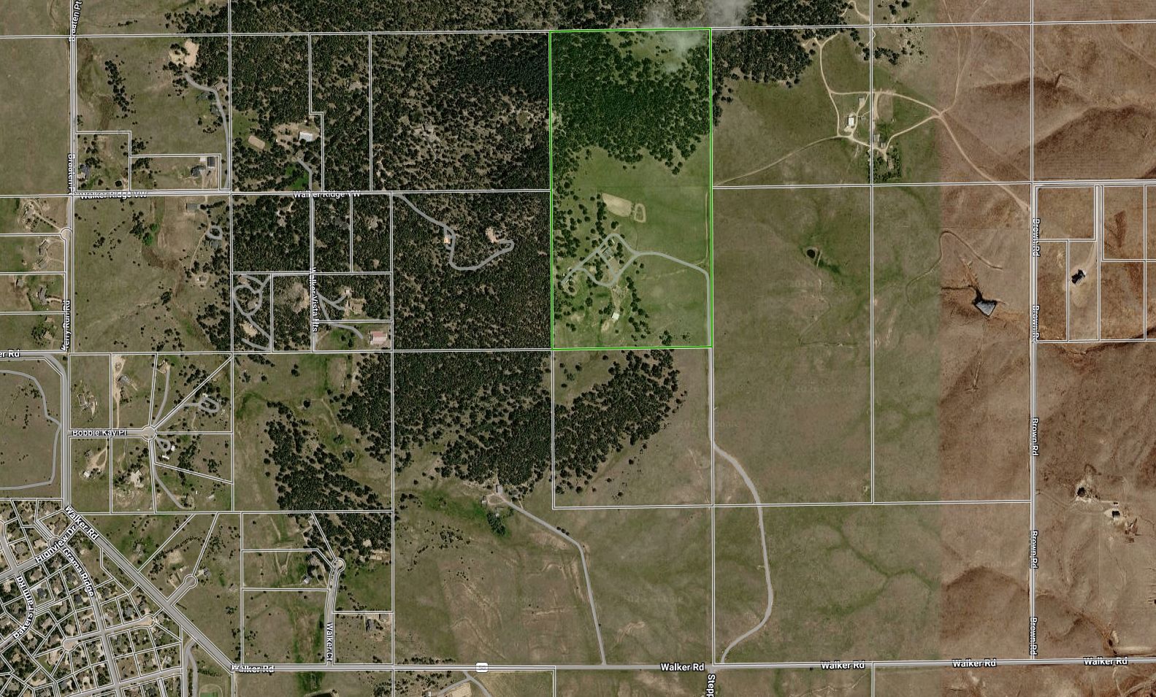

DISPATCH USA TOPO MAP:
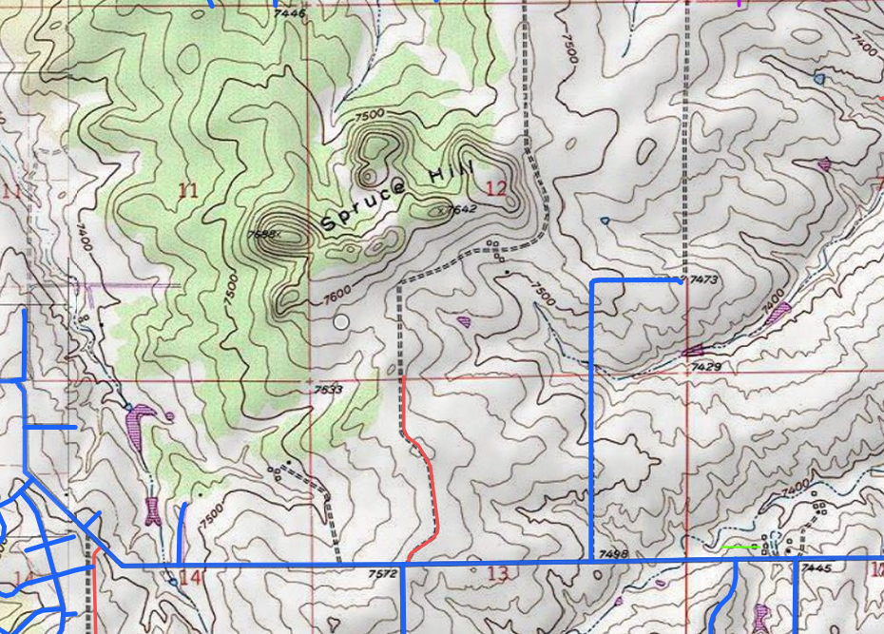

FEMAP MAP:

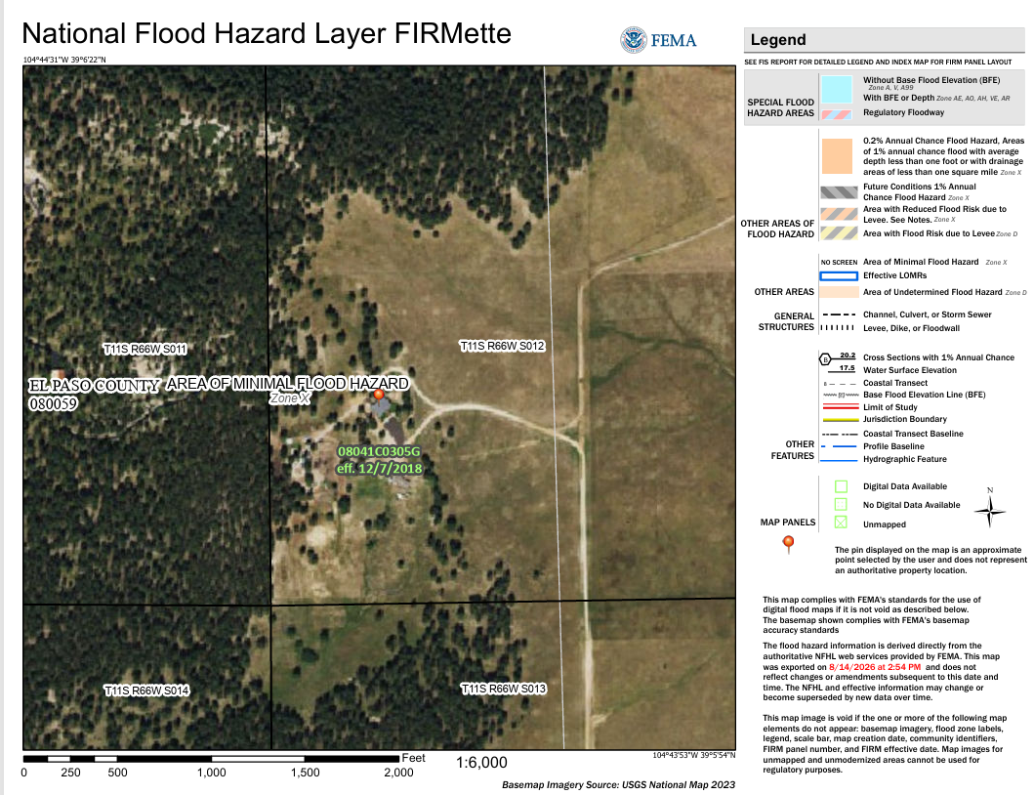

Drainage Impacts
Requirements
Documents |  | Design Elements
☐ | Drainage Basin Planning Study (DBPS) for a whole basin | ☒ | Full Spectrum Detention / Discuss detention in the Final Drainage Report/Letter
☐ | Master Development Drainage Plan (MDDP) for a big Development | ☒ | Permanent Water Quality
☒ | Preliminary/Final Drainage Report/Letter | ☒ | Downstream Conveyance Analysis (to include possible offsite improvements)
☒ | Financial Assurance Estimate (FAE) Form | ☐ | Floodplain Impacts: Contact Floodplain Administrator, the Floodplain Administrator name and phone number are indicated on page 16 below in purple; provide BFE’s (If the floodplain is encroaching to the parcel to be plated. Depict the UPDATED floodplain limits which is coordinated with the floodplain Administrator on the plat because it is a plating requirement).
☒ | Erosion and Stormwater Quality Control Permit (ESQCP) If disturbed area greater than 1 Ac. | ☒ | Public Improvements including Dedication/easement/s to provide access from Walker Road to the subdivision.
☐ | Builders Erosion and Stormwater Quality Control Permit (BESQCP)
☒ | Grading & Erosion Control (GEC) Plan & GEC Checklist | Miscellaneous
☒ | Stormwater Management Plan (SWMP) & SWMP Checklist | ☐ | Construction Activity Permit/ CDPHE Discharge Permit/CDPHE APEN Fee
☒ | PCM Applicability Form (PCM: The same as BMP) | ☐ | Special Districts/Water Quality Authority Areas
☒ | PCM Maintenance Agreement and O&M Manual
☒ | MHFD-Detention Basin Design Workbook or SDI Sheet (MHFD: Mile High Flood District.
☐ | Pre-Subdivision Site Grading Form
☐ | Deviation Request

Basin Name/Studied | Basin Fee^{1, 2} | Bridge Fee¹
WEST CHERRY CREEK | NA | NA
¹ Per impervious acre, collected prior to recordation of Final Plat.
² A 25% fee reduction applies for low density residential lots (2.5 acres and greater lot sizes). The reduction only applies to the basin fee.

Drainage Notes:
- The flood map for the selected area is number 08041C0305G, effective on 12/7/2018, it is in zone X.
- A GEOTECH report is required with new borings are required on new lots and on Public Improvements and on Stormwater Quality facilities. See ECM Appendix C for GEOTECH report standards.
- A final drainage report is required. The final drainage report must be prepared by a professional engineer licensed in the state of Colorado.
- Drainage basin fee and Bridge fee are NOT applicable.
Land disturbance: If you disturb 1 acre or more or 500 cy or more, the following will apply:
- ESQCP
- GEC plans, GEC checklist, BMP agreement, FAE, PCM app, SWMP, and SWMP checklist
- and water quality, SDI sheet
- Full spectrum detention

Stormwater/MS4 (Zach Jannusch):
- An EPC Stormwater Permit (ESQCP) will be needed if/when one of the following criteria are triggered:
  - Project has >1 ac of soil disturbance, or:
  - Project has <1 ac of soil disturbance and is part of a Larger Common Plan of Development, or:
  - Cut and/or fill >500 cubic yards of soil, or:
  - The site is located in or adjacent to a sensitive area.
- If/when the site disturbs >1 ac of soil, and >1 ac of the site is not excluded, a stormwater quality treatment facility (PCM) will be needed for the runoff from the non-excluded areas. Exclusions can be found in our PCM Applicability Form and ECM Appendix I.6.1.B
  - Anticipated Exclusion: Large Lot Single Family Sites (ECM Appendix I.6.1.B.5)
    - “A single-family residential lot, or agricultural zoned lands, greater than or equal to 2.5 acres in size per dwelling and having a total lot impervious area of less than 10 percent.”

Traffic Impacts
Requirements
☒ | Traffic Memorandum | ☒ | Road Impact Fee | ☒ | Joint Access Easement
☒ | Road Construction Plans | ☒ | Road Impact Fee Acknowledgement Form. | ☐ | County/CDOT project coordination required
☒ | Public Improvements | ☒ | Driveway Access Permit | ☐ | Outsourcing of Traffic Impact Study
☒ | Deviation Request / Additional cul-de-Sac’s will be required due to the length of Public / Private Road (No guarantee to approval of the Deviation Request). | ☐ | Signal Warrant Study | ☒ | New Road Access Permit for Private Road

Adjacent Road Name |  | Ex. ROW (ft) | Surface | PCI Rating |  | 2045 MTCP |  |  | 2065 MTCP |  |  | Required Intersection Spacing (ft)
 |  |  |  |  |  | Classification | ROW | Dedication | Classification | ROW | Potential Preservation | Required Intersection Spacing (ft)
Walker Rd |  | 60’  Rural – Major Collector  (2 lane) | Paved | 85 |  | Rural – Major Collector  (2 lane) | 90’ | 15’ | Rural – Major Collector  (2 lane) | 90’ | N/A | 1320
 |  |  | Other (i.e. multi-jurisdictional):
Metro District |  |  |  |  | Choose an item.

Traffic Notes:
- Traffic Memorandum is required.
- An Access permit is required from Walker Road.
- EPC Road Impact fee will apply for all new homes. Also, discuss this item briefly in the LOI and discuss this in the Traffic Memorandum. Paid at time of building permit https://publicworks.elpasoco.com/road-impact-fees/
- EPC RIF Single Family Detached Dwelling fee $4,101 . Letter of Intent to detail if PID will be requested. If not doing a PID then paid at time of home building permit to RBD.
- A shared access easement and maintenance agreement for the private drive will be required; show the private road easement on the plat, indicate the reception number on the plat, and indicate detailed plat notes on the plat.
- The private road access and the private road design to meet LDC and fire district standards per LDC Chpt 6 and Chpt 8 (The private road must be constructed to El Paso County standards).
- Fire District to review driveway design and turn around/s.
- If FD requires a cistern, then a cistern easement must be depicted on the plat and a plat note added. Access easement must be provided to the FD for the cistern.
- Plat to show all easements to include MVEA.
- Sight Distance. Sight distance concerns that are anticipated or observed may impact access, intersection, or roadway operation and safety need to be discussed in the Traffic Memorandum. Recommendations regarding stopping sight distance, intersection sight distance need to be provided for detailing on the final development, site plan, or final construction plans.
- Dedication (Walker Road): No dedication is required on Walker Road because the project site is not abutting Walker Road (Dedication to the Public Road maybe required or ROW Easement maybe required to the Private Road, an Access permit AP will be issued for the Private Road.

Anticipated Engineering Review and Construction Permit Fees

Engineering Application | Review Fee¹

¹ Fee amounts are based on the current fee schedule at the time of the Early Assistance meeting. Fees are subject to change.

Full Fee Schedule: https://planningdevelopment.elpasoco.com/#1515613078895-69552b09-44a4

INFORMATIONAL ITEMS:
- Road design requirement per CHPT 6 of the LDC
- Roads. This Section shall apply to all roads providing access to a planned building area whether or not they are dedicated as public roads.
- (a)
- Roads Constructed to County Standards. All roads, including private roads and emergency vehicle access roads, shall be designed and constructed according to this Code and the ECM. Emergency vehicle access roads shall, at a minimum, be constructed to the County's gravel road standard if open to the public. Emergency vehicle access roads which are not open to public travel shall meet the non-road access standards
- (b)
- Roads within 150 Feet of Development. Roads or emergency vehicle lanes shall be provided within 150 feet of all development except single family residential development.
- (c)
- Two Access Routes Required. Access to a planned building area shall be provided by a minimum of 2 separate routes in accordance with the requirements of this Code and the ECM if the cul-de-sac exceeds the length allowed by the ECM.
- (d)
- Turnaround Required on Dead-End Roads. Every dead-end road more than 300 feet in length shall be provided with a roadway termination meeting ECM standards.
- (e)
- Road Grades in Wildland Fire Areas. Within wildland fire areas, road grades steeper than 10 percent may be permitted where the Fire Authority and ECM Administrator recommend that the mitigation measures are adequate and the approval authority approves the mitigation measure.
- (3)
- Non-Road Access. The following minimum standards shall apply to emergency vehicle lanes, driveways, and parking lot drive lanes serving as emergency vehicle lanes.
- (a)
- Emergency Access Provided. Access for emergency responders, ingress, egress, and evacuation shall be provided for all buildings.
- (b)
- Driveways Required. Where any point of a building is greater than 150 feet from a road, a driveway meeting these standards shall be provided to within 150 feet of the furthest point on the building.
- (c)
- Emergency Vehicle Lanes Required. The Fire Authority may recommend emergency vehicle lanes be provided. Emergency vehicle lanes shall be provided as required by the approval authority.
- (d)
- Emergency Access Lane Design. An emergency vehicle lane shall be designed and constructed to enable fire-fighting apparatus to maneuver broadside or directly forward within a minimum of 5 feet and a maximum of 25 feet of structures.
- (e)
- Width of Driveway and Emergency Vehicle Lanes. Where the driveway is greater than 150 feet in length, it shall be not less than 10 feet in unobstructed width. Emergency vehicle lanes providing one-way travel shall be a minimum of 16 feet in width, and fire lanes with two-way travel shall be a minimum of 24 feet in width.
- (f)
- Vertical Clearance. At least 13 feet 6 inches of vertical clearance shall be provided and maintained over the full width of an emergency vehicle lane or driveway.
- (g)
- Turns. Required driveways shall be designed, constructed, and maintained to accommodate the turning radius of the largest apparatus typically used to respond to that location. A turn in an emergency vehicle lane shall be constructed with a minimum radius of 25 feet at the inside curb line and a minimum radius of 50 feet at the outside curb line.
- (h)
- Grades. Road grades steeper than 10 percent may be permitted where the Fire Authority and ECM Administrator recommend that the mitigation measures are adequate and the approval authority approves the mitigation measure.
- (i)
- Emergency Vehicle Lanes Connecting to Roads. Emergency vehicle lanes connecting to roads shall be provided with curb cuts extending at least 2 feet beyond each edge of the fire lane.
- (j)
- Turnouts and Turnarounds Required.
- (i)
- Driveways. Where the required driveway is greater than 300 feet, it shall be provided with turnouts or turnarounds at locations approved by the approval authority with recommendation from the Fire Authority.
- (ii)
- Turnarounds Required. The fire authority may provide a recommendation regarding turnarounds. Dead-end emergency vehicle lanes in excess of 300 feet in length shall be provided with turnouts and turnarounds as approved by the approval authority. The turnaround at the terminus shall have a minimum radius of 50 feet. The approval authority shall be authorized to approve, as an alternative, a "hammerhead" turnaround to provide emergency vehicles with a three-point turnaround.
- (k)
- Load Design. Emergency vehicle lanes and required driveways shall be designed, constructed, and maintained to accommodate the load of the largest apparatus typically used to respond to that location.
- (l)
- Bridges or Drainage Crossings. A bridge or drainage crossing on an emergency vehicle lane or required driveway shall be designed to accommodate the load of the largest apparatus typically used to respond to that location. The load limit shall be clearly posted at the approaches to the bridge.
COUNTY CODES AND CRITERIA:
El Paso County Land Development Code (LDC) (2016): https://planningdevelopment.elpasoco.com/land-development-code/
El Paso County Engineering and Drainage Criteria Manuals (ECM) (2020) & (DCM) Volumes 1 and 2 and Update:
https://planningdevelopment.elpasoco.com/planning-community-development/engineering/#1519834440345-f2ddfd20-0d90
El Paso County 2024 Major Transportation Corridors Plan Update (MTCP): El Paso County 2045 Major Transportation Corridors Plan (MTCP) (2045mtcp.com)
El Paso County Road Impact Fee Program: https://publicworks.elpasoco.com/road-impact-fees/
El Paso County Development Fees: https://planningdevelopment.elpasoco.com/#1515613078895-69552b09-44a4
El Paso County Projects (EDARP): https://epcdevplanreview.com/Public
El Paso County Municode Library: https://library.municode.com/co/el_paso_county
Planning and Community Development: https://planningdevelopment.elpasoco.com/planning-development-forms/#1643393391537-a0dac52d-1b3b
El Paso County Stormwater Page: https://publicworks.elpasoco.com/stormwater/
Assessor’s Information
Assessor’s Data: https://property.spatialest.com/co/elpaso/#/ Assessor’s Map: https://community.spatialest.com/co/elpaso/#/Property-Search/
Drainage Links:
Mile High Flood District: http://MHFD.org
Detention Pond Compliance Website: https://maperture.digitaldataservices.com/gvh/?viewer=cswdif
State DWR: http://water.state.co.us/SURFACEWATER/DAMSAFETY/Pages/DamSafety.aspx
NOAA Rainfall: https://hdsc.nws.noaa.gov/hdsc/pfds/pfds_map_cont.html?bkmrk=co
Floodplain: https://www.pprbd.org/Download/Floodplain#floodplainHandouts
https://pprbd.maps.arcgis.com/apps/webappviewer/index.html?id=1d9243f3606542159a0a418070b08686
https://msc.fema.gov/portal/advanceSearch
Fountain Creek Watershed: http://www.fountain-crk.org/
Upper Black Squirrel Creek Ground Water Management District Mapping Study: https://upperblacksquirrelcreekwater.com/waterStudies.php
Water Rights:
Colorado Division of Natural Resources: https://dwr.state.co.us/Portal/dwr/AskDWR
State Transportation Links
Colorado Department of Transportation (CDOT) M&S Standards and Specifications, Access Code and Permit:
  - https://www.codot.gov/business/designsupport/standard-plans
  - https://www.codot.gov/business/permits/accesspermits
  - https://www.codot.gov/business/permits/accesspermits/references

Local Governing Authorities
City of Colorado Springs: https://coloradosprings.gov/
City of Fountain: https://www.fountaincolorado.org/
Town of Calhan: http://calhan.co/
Green Mountain Falls: https://gmfco.elpasoco.com/
Town of Monument: http://www.townofmonument.org/
Town of Palmer Lake: http://www.townofpalmerlake.com/
Contact Information
CDOT R2 Permits Program Manager | (719)562-5540
Work in Right of Way Permit | (719)520-6869
Right of Way Vacation | (719)520-6897
Floodplain Administrator (Mr. Keith Curtis) | (719)327-2898
EPC Public Health | (719)578-3199
CDPHE Air Quality Division | (303)692-3100
CDPHE Water Quality Division | (303)692-3500
Cherry Creek Basin Water Quality Authority | (303)239-5400

Traffic Information
Traffic Impact Study (ECM Appendix B)*
Full TIS | ADT > 1,000 or Pk Hr > 100
Intermediate TIS | ADT < 1,000 or Pk Hr < 100
Traffic Memo | ADT ≤ 500 or Pk Hr ≤ 50
No TIS | ADT < 100 or Pk Hr < 10
*An approved TIS that has been prepared in the last three years may be revised or updated where a proposed access is changed or a change in the proposed action may result in a new trip generation that exceeds the original trip generation estimates. An amendment letter is required.
**If the original TIS is older than three years, an entirely new TIS shall be prepared.
***Any submitted TIS is subject to third party review based on size and complexity, in which additional fees will be assessed to the applicant.
The applicant is responsible for obtaining any necessary approvals for impacts within other jurisdictions. It is recommended that the applicant approach the jurisdiction early in the development process for any additional requirements. If the proposal is impacted by an El Paso County Department of Public Works project, coordination with DPW is required.
Pavement Condition Index
The Pavement Condition Index (PCI) is a numerical rating system that measures the condition of a road's pavement on a scale of 0 to 100. A score of 100 indicates a newly paved road, while 0 is the worst possible condition. The PCI is calculated based on the type and severity of distresses observed on the pavement surface, such as cracking, rutting, scaling, and spalling. Other factors that can affect the PCI score include Pavement age, Climate and precipitation, Traffic loads, and maintenance.

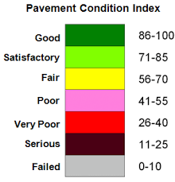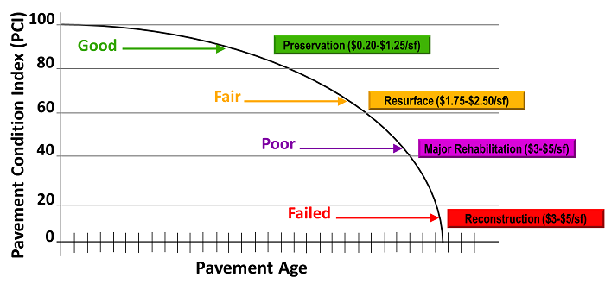
Drainage Report/Plan Information
Drainage Basin Planning Study (DBPS) – May be required with a very large development
Master Development Drainage Plan (MDDP) – Required with phased development greater than 10 acres (may be required with Sketch Plan) (DCM Section 4.2)
Drainage Letter Report – With a Re-plat, Minor Sub or Plot Plan (DCM Section 4.5) where a final drainage report has previously been approved.
Preliminary Drainage Report (PDR) – Required with a Preliminary Plan (DCM Section 4.3)
Final Drainage Report (FDR) – Required with a Final Plat (DCM Section 4.4)
Drainage Master Plan/Floodplain Information
If it is undetermined at this time if an adopted Drainage Basin Planning Study (DBPS) or Master Plan exists in this area, the applicant is responsible for researching the appropriate information.
If the subdivision application impacts the FEMA floodplain, a FEMA Letter of Map Revision may be required. If the site is in or near a floodplain, contact the Regional Floodplain Administrator for allowed floodplain uses and procedural requirements. It is the Applicant’s responsibility to research the effects and implications of developing in or near a floodplain, including limited uses, floodplain development permits, geotechnical, wetland and wildlife studies, structural requirements, flood insurance and potential future floodplain mapping updates. FEMA's FIRM maps may be out of date or at a low level of accuracy.
If the site lies within the Cherry Creek Basin Water Quality Authority area and is not rural density, the applicant should discuss any concerns related to the development with the CCBWQA’s consultant.
If the site lies within the Fountain Creek watershed, the District has authority over the floodplain impacts and is advisory to the County on uses outside of the floodplain. The applicant should discuss any concerns related to the development with District staff.
Detention/Water Quality PCM & Downstream Conveyance Information
Per ECM Chapter 3.2.8.B: “The proposed project or developed land use shall not change historical runoff values, cause downstream damage, or adversely impact adjacent properties.”
The project must provide an acceptable method of storm drainage conveyance and may be required to construct (or contribute an equitable share to the construction of) a storm conveyance or collector system.
If the site conveys storm drainage flows through or across an adjacent private property, then the applicant is responsible for obtaining off-site drainage easements in accordance with the Engineering Criteria Manual Section 3.3.3.K. Any offsite easements necessary for the development shall be recorded prior to County Plan approvals.
If on-site facilities are required, the applicant will be required to provide access and drainage easements in accordance with Section 11.2.2 of the Drainage Criteria Manual.
If a water quality and/or detention facility is applicable, some or all of the following documents may be required: Operation and Maintenance (O&M) Manual, Private Detention Basin / Stormwater Quality BMP (ie: PCM) Maintenance Agreement, and Stormwater Detention and Infiltration (SDI) Form.
For post-construction water quality PCM requirements, see Appendix I of the Engineering Criteria Manual. If/when the site disturbs >1ac of non-excluded areas, a stormwater quality treatment facility (ie: PCM) will be needed for the runoff from the non-excluded areas. Exclusions can be found in our PCM Applicability Form and ECM Appendix I.7.1.
State Engineer’s requirements regarding dams and water rights apply. Jurisdictional/Non-Jurisdictional dam construction forms are typically required for detention facilities. If applicable, provide proof of submittal of the State’s “Notice of Intent to Construct a Non-Jurisdictional Water Impoundment Structure” form.

Grading, Erosion, and Sediment Control Information
The Grading and Erosion Control (GEC) Plan must be prepared in accordance with Drainage Criteria Manual Vol. 2, Chapter 3 and the County’s GEC Checklist.
An Erosion and Stormwater Quality Control Permit (ESQCP) and Permanent Control Measure are required for the following conditions per ECM Appendix I.4:
- Construction activities that result in land disturbance of greater than or equal (≥) to one acre, or
- Construction activities that result in less than (<) one acre if the activity is part of a larger “Common Plan of Development or Sale” (ECM Chapter 1.22) that would disturb one acre or more of ground surface
An ESQCP may be required as determined by the ECM Administrator for the following conditions per ECM Appendix I.4:
- Construction activities that are located in or adjacent to a Sensitive Area, or
- Cut and/or fill greater than (>) 500 cubic yards of soil
See the three ESQCP exclusions listed in ECM Chapter 5.6.3.
An application for an ESQCP shall be accompanied by the following:
- Drainage Report  - ESQCP Form  - Financial Surety  - GEC Plan and GEC Checklist | - PCM Applicability Form  - Stormwater Management Plan (SWMP) and SWMP Checklist  - O&M Manual (for sites requiring a PCM)  - PCM Maintenance Agreement (for sites requiring a PCM
A Builder’s Erosion and Stormwater Quality Control Permit (BESQCP) is required for residential building lots with < 1 acre of disturbed areas and does not meet any of the criteria for an ESQCP listed above.
Construction activities that disturb >1ac of soil are required by the Environmental Protection Agency (EPA) to obtain a Construction Stormwater Permit through the Colorado Department of Public Health & Environment (CDPHE) Water Quality Control Divisions. For projects with soil disturbances >1ac but <25ac, a County Construction Activity Permit is required, contact El Paso County’s Public Health Department for further information regarding the permit. All land development activities greater than twenty-five (25) acres or with construction duration longer than six (6) months must obtain an Air Pollution Emission Notice and Emissions Permit through CDPHE’s Air Quality Control Division.
Deviations
All engineering designs and studies shall be performed in conformance with adopted codes, standards and criteria. Any deviations are to be formally identified and requested in writing, with justification provided per ECM Section 5.8. All deviation requests must be approved by the ECM Administrator prior to submitting the application for review, or delays in the review and additional fees may result. The Applicant must submit adequate justification for consideration of the request(s).
Public Improvements Information
If public improvements are required, the applicant will be required to enter into a Subdivision Improvement Agreement (SIA) or a development agreement (if the project is not a subdivision) with the County. Refer to the El Paso County Land Development Code for information on the SIA and the ECM for the required format of the associated Financial Assurance Estimate. All forms are available online.
Construction drawings for the required public improvements must be reviewed and approved by PCD and the County Engineer. All Construction drawing submittals shall adhere to the criteria set forth in the ECM. A construction plan review fee will be assessed when the plans are submitted for review.
Geotechnical reports for earthwork and pavement designs must be reviewed and approved. All submittals must adhere to the criteria set forth in the ECM.
Any work within the Right of Way will require a permit from El Paso County Department of Public Works.
Any Fire cistern(s) and mailbox kiosks need to be shown on the construction drawings.
Metro District Fees
Woodmen Road Metro District | Central Marksheffel Metro District | Lorson Ranch Metro District | Constitution Heights Metro District
- Property in district pays no fee  - After December 31, 2020 no property in the Amended Service Area shall be permitted to join the WRMD, and shall participate fully in the Fee Program.  - As of January 1, 2021 and until either bonds retire or December 31, 2027, whichever occurs sooner, El Paso County must pay a portion of the Road Impact Fee it collects from property in the Amended Service Area that receives final plat approval to WRMD. | - Property in district pays no fee  - District granted $2.9 million in Fee Program Credit  - Fee Program will pay annual credit reimbursements to District, or can sell credits | - Property in district pays full fee  - District granted $4.1 million in credit  - Credits used toward future development, can apply for reimbursement, can sell credits | - Property in district pays full fee  - District granted $3.1 million in credit  - Used toward future development, can sell credits, NO reimbursement  - County will collect building permit fees for reimbursement of PPRTA improvements to Marksheffel Road from property within District and some property outside District – Credit given toward Impact Fee for amount of building permit fee paid.
*Properties within the Meridian Crossing subdivision are not subject to the county wide road impact fee.

