Early Assistance (EA) Meeting Number: EA2614
Project Name: Honor Charter School/ D49 Authorized Carter School
Project Location: Bent Grass Meadows Dr., Peyton, CO
Project Parcel No.: 5301000038
Project Description: Honor Development intends to construct a new K-8, 2-story educational facility at Bent Grass Meadows Dr., Peyton, CO (Parcel no. 5301000038). Preliminary programming of facility has been completed. The overall square footage to be approximately 40,000 sf; providing 27 classrooms (3 per grades K-8), elective classrooms serving Art, Science, and Music, 3 small group classrooms for pull-out/support services, media center, MS regulation size Multipurpose gym/cafeteria with divider curtain, warming kitchen, offices, group and staff restrooms, nurse, conference room, lobby and staff support areas. This school design will be functional and easily maintained. The site design will allow adequate parking, onsite traffic management, and exterior play fields, with care towards storm water management. Intentional planning during concept design will allow for potential expansion, should enrollment or facility needs evolve.

EA Meeting Date: 2/17/26 at 2:30 P.M.
Planning and Community Development: Jen Uhler (jenuhler@elpaso.com)

El Paso County Planning & Community Development Planning Checklist

Request -
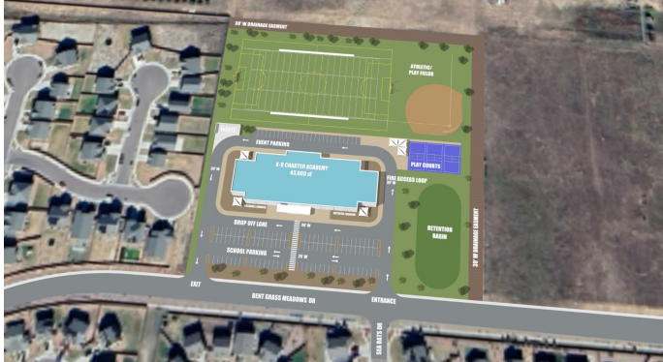

Existing Zoning
District |  | Name
PUD |  | Bent Grass Planned Unit Development (PUD142)

Zoning Analysis

PUD Design Guidelines

B. Development Regulations



A= Allowed Use, S = Special Use
The subject property, Tract W, is designated as a School Site via PUD142, approved by the BoCC. Therefore, an Approval of Location is not required. A Site Development Plan will be required prior to School improvements.

(LDC Table 5-4, Density and Dimensional Standards Link)
Proposed Use:
Educational Institution — Educational institution shall mean public schools, non-public schools, and schools administered and operated by the State. The following definitions shall apply to the various types of educational institutions: (a) "Public schools" shall mean those schools administered by legally organized school districts; (b) "Non-public schools" shall mean all private, parochial and independent schools which provide education of compulsory school age pupils comparable to that provided in the public schools of the State.
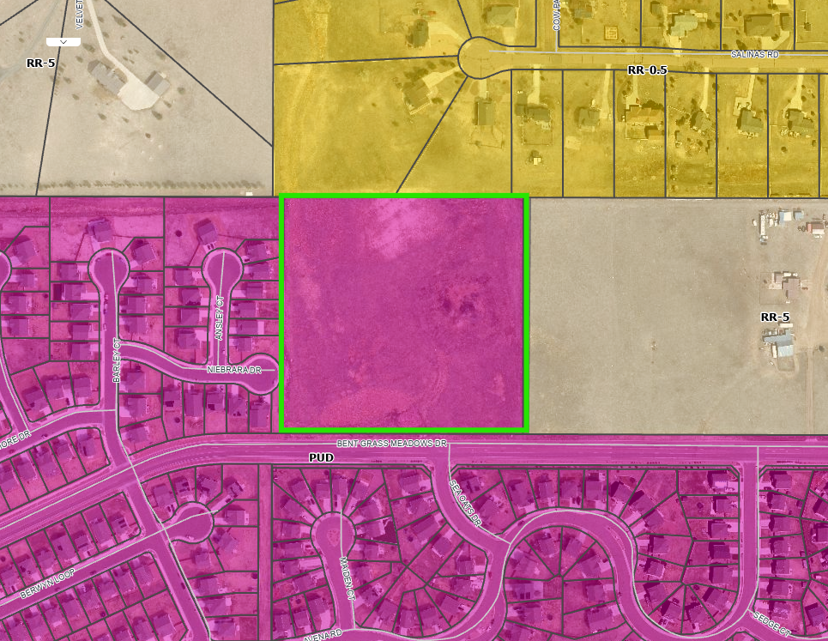
Zoning Map

Map of Platted Lot/ Tract (check plat notes & conditions of approval):
N/a

Application Type(s): Public Hearing:
Site Development Plan (PPR) | Required/ Optional/ NO

Processing Issues and Options

Relevant Past History:
PUD060004 – BENT GRASS OVERALL PUD
PUD142 – BENT GRASS MAJOR PUD AMENDMENT

Design and Landscaping.
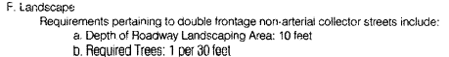

(12) Landscaping. Landscaping and any landscaping design guidelines established within the development plan or development guide shall conform to the requirements of this Code, with the exception of local residential roads pursuant to the Landscaping Section of Chapter 6 of this Code. No building permit shall be issued for any building or any portion of a PUD district until the landscaping required by the landscape plan is in place or a landscaping completion agreement has been entered into which complies with the requirements of Chapter 6 of this Code.

Show the site design/layout (lot pattern, circulation/road design, open space, preservation of natural features, compatibility internally and with adjacent land uses).
(Chapter 6 Link) 6.1.3. Americans with Disabilities Act (ADA) Site Accessibility
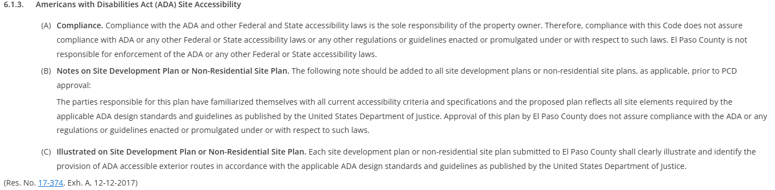

Fencing/Walls: (If proposed, follow these development standards.) Identify height and opacity. **

(Chapter 6 Link) 6.2.1. Fences, Walls, and Hedges
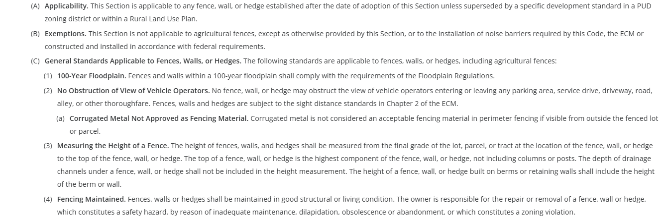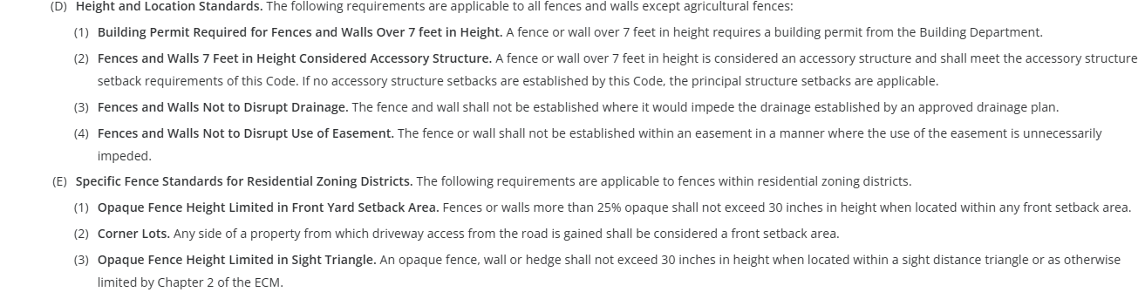
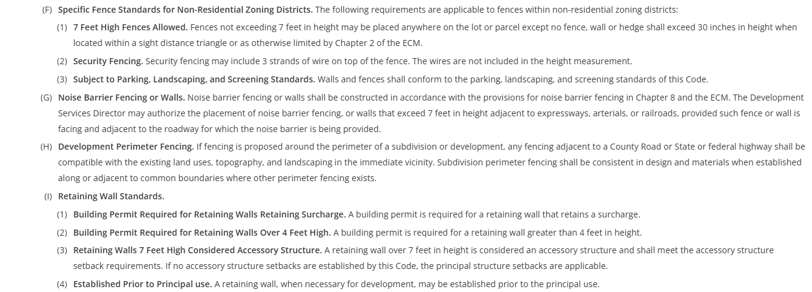

Landscaping: (required)

Check one: (already provided, distance)
☐ | Expressway, Principal Arterial - required depth 25’ - Trees required: 1 per 20’
☐ | Urban Interchange/Intersection - required depth 25’- Trees required: 1 per 20’
☐ | Minor arterial - required depth 20’ - Trees required: 1 per 25’
☐ | Non-arterial - required depth 10’ 15’ - Trees required: 1 per 30’ 15’ and min 50% evergreen.
Also required:
☒ | Parking lot landscaping required (trees, landscape islands, screening)
☐ | Buffer between non-residential and residential districts separated by a non-arterial road or public alley
☐ | Zone Boundary Buffer  - 15’ when adjacent to residential zones  - clustering is ok, utilizing existing vegetation towards count is ok – identify any of these in your Site Dev Plan & LOI

(Table 6-1)

(Chapter 6 Link) 6.2.2. Landscape Requirements
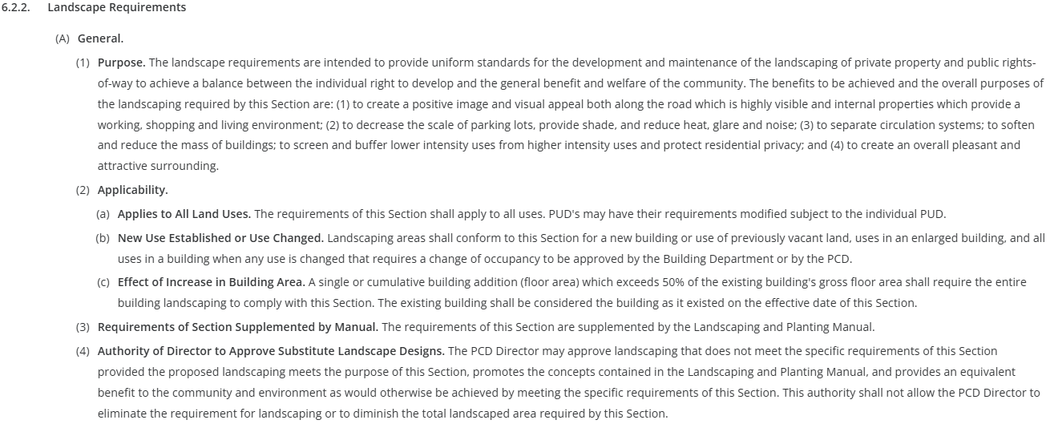
(B) Roadway Landscaping Requirements
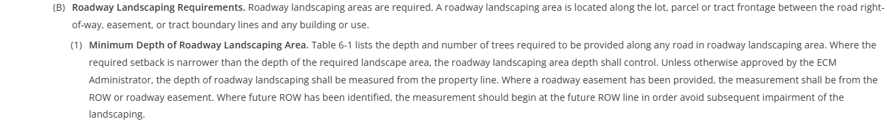
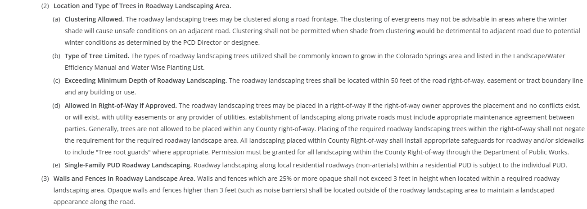
(C) Parking Lot Landscape Requirements
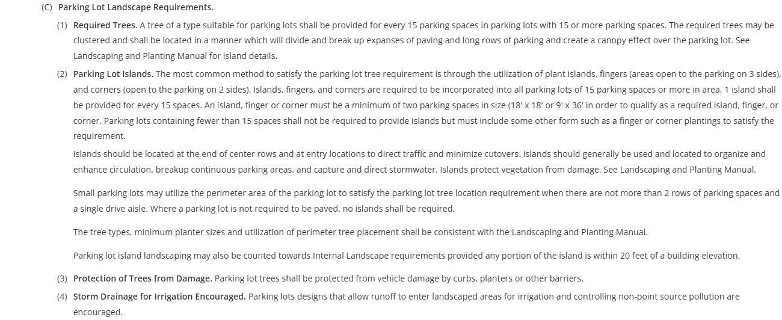
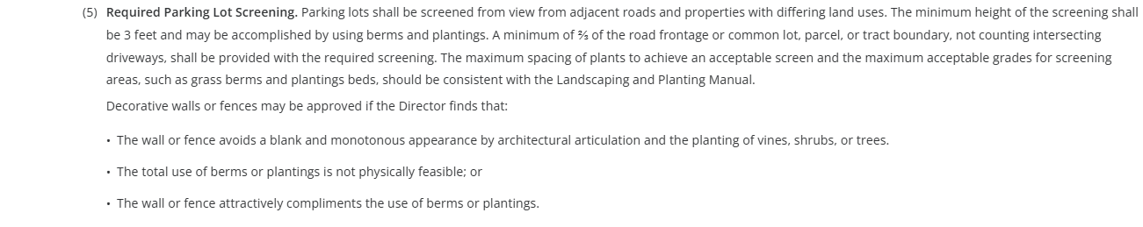
(D) Required Buffer and Screen Areas
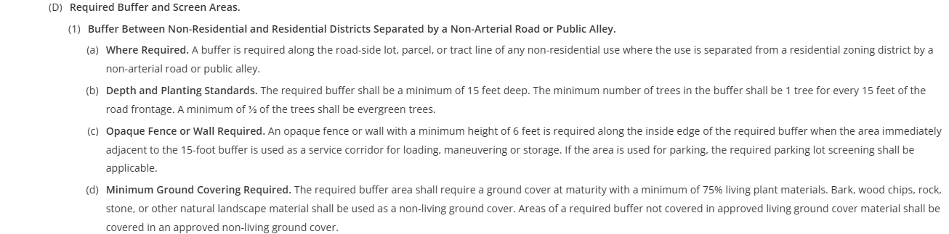
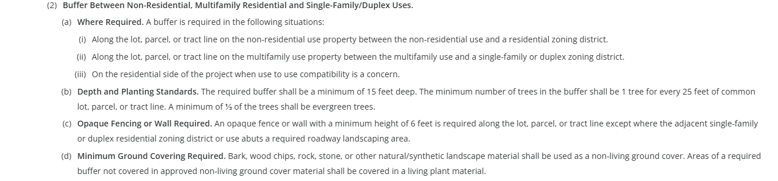
(E) Internal Landscaping required
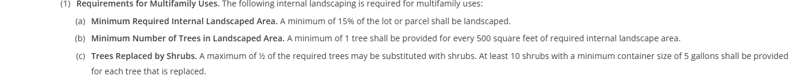
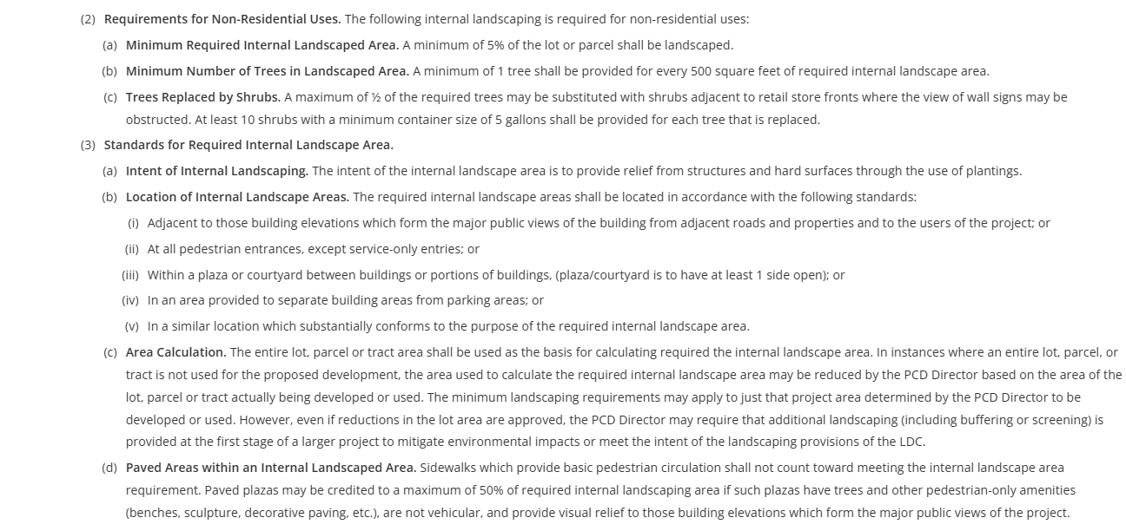
(F) Minimum Plant Sizes and Percentage of Live Ground Cover
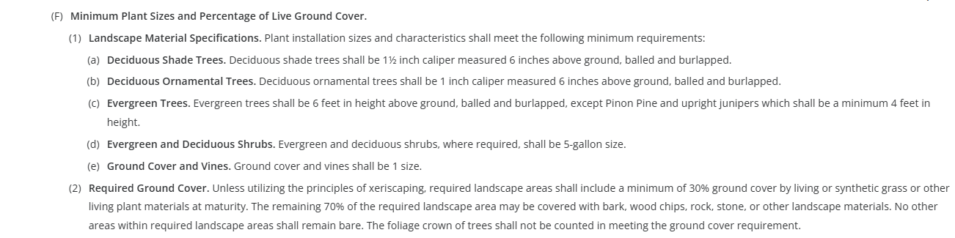

(G) Other Required Landscape Areas
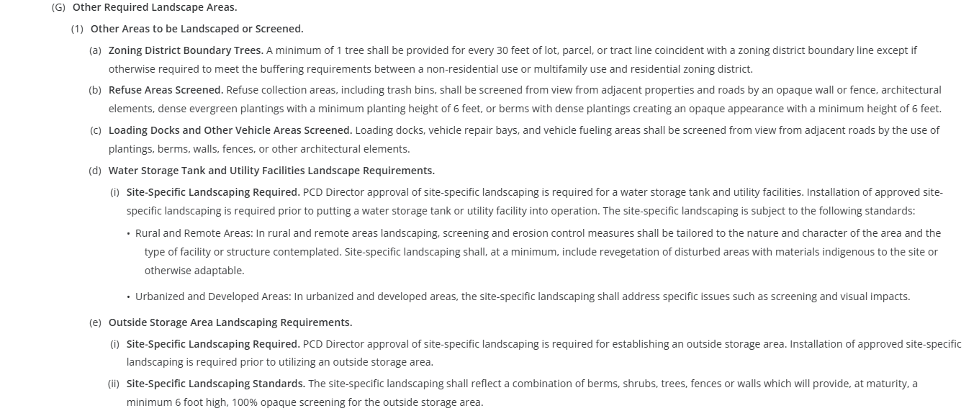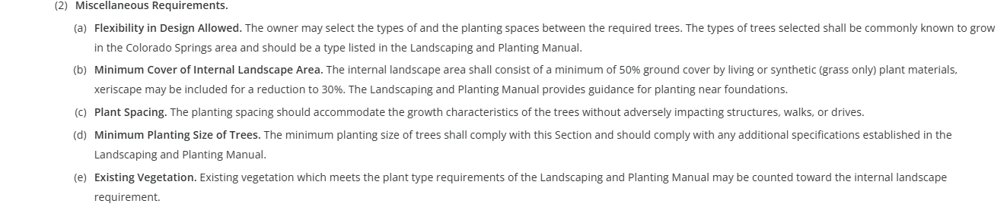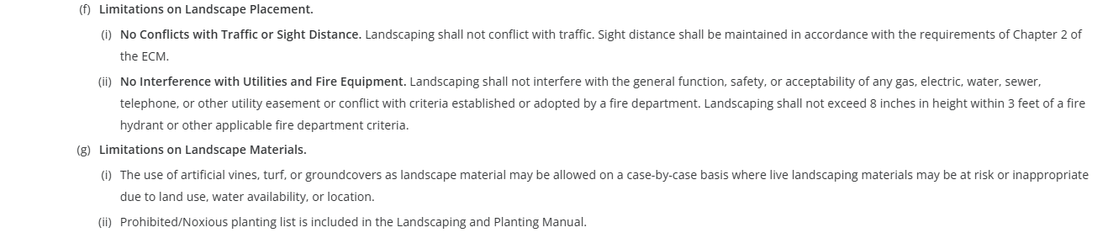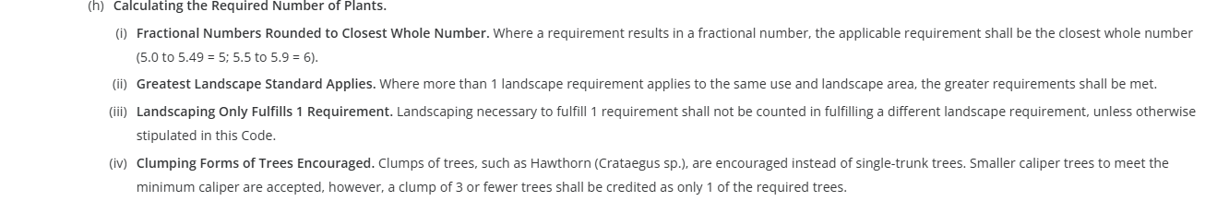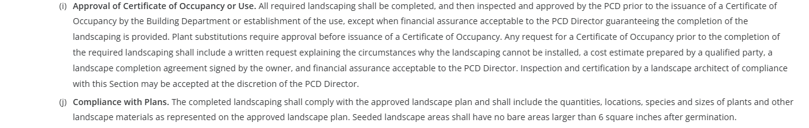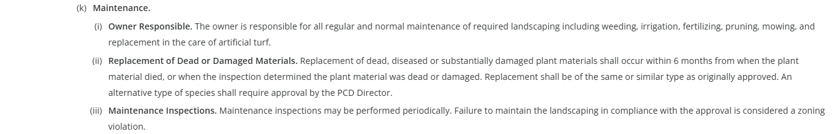 Appendix D (Link) – Landscaping and Planting Manual

Parking: (required)

(Chapter 6 Link) 6.2.5 Parking, Loading, and Maneuvering Standards

(Table 6-2)

(A) General.
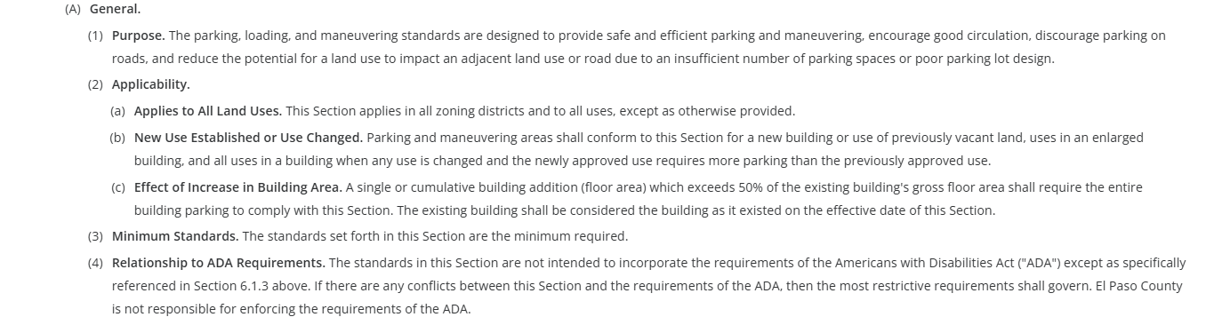

(B) General Parking Standards.
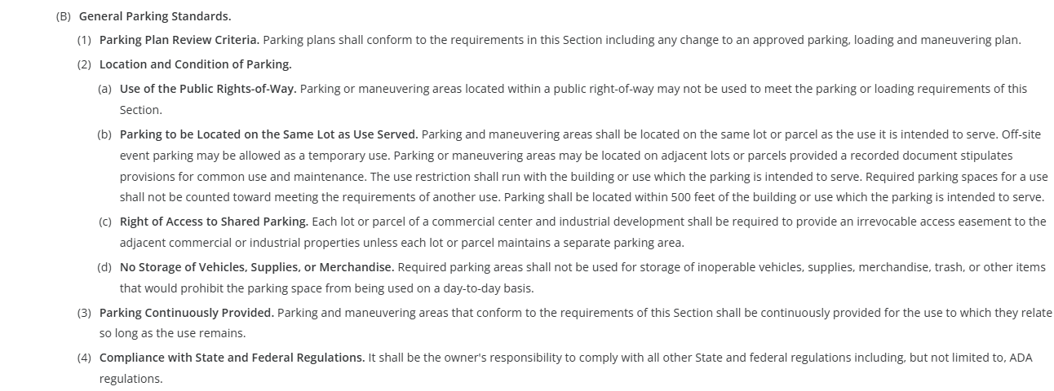
(C) Parking Design Standards.
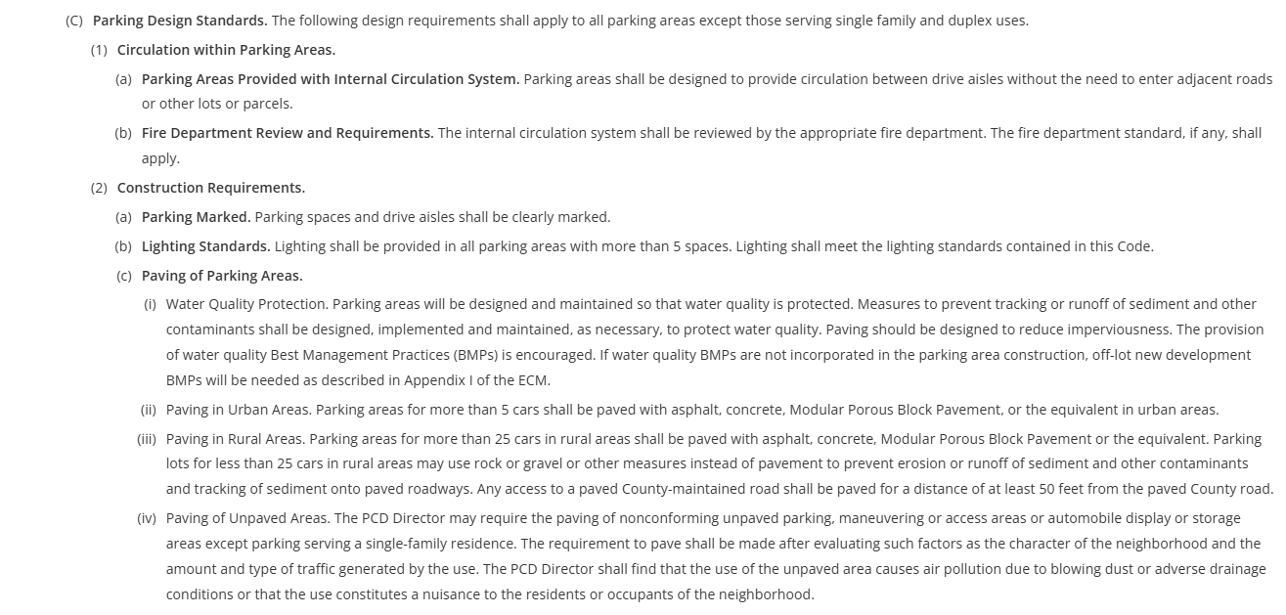
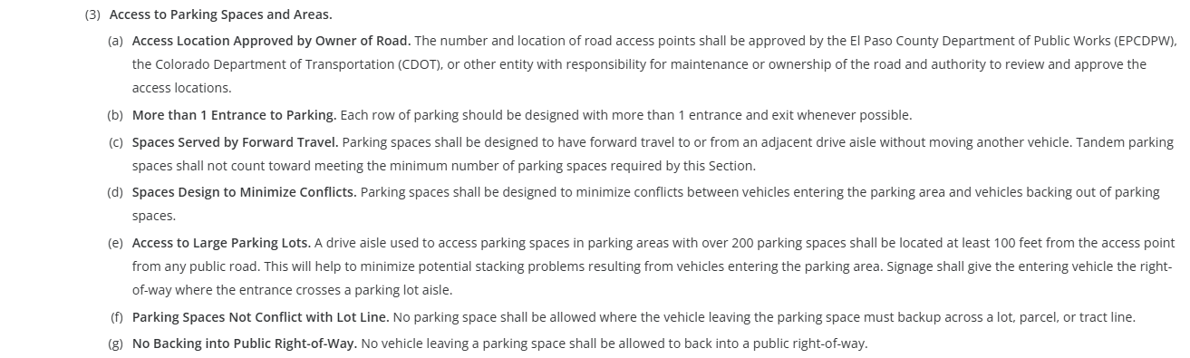
(D) Parking Space Requirements (Table 6-2 above)
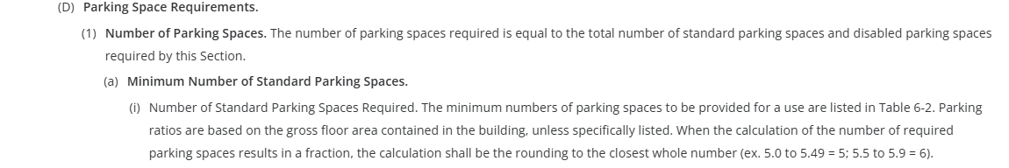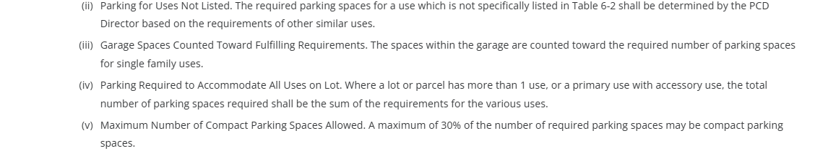
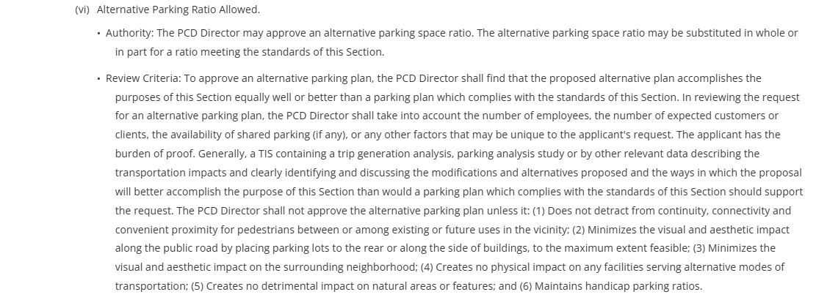
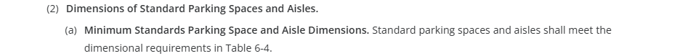
Refer to Table 6-4 for Parking Space Dimensional Requirements
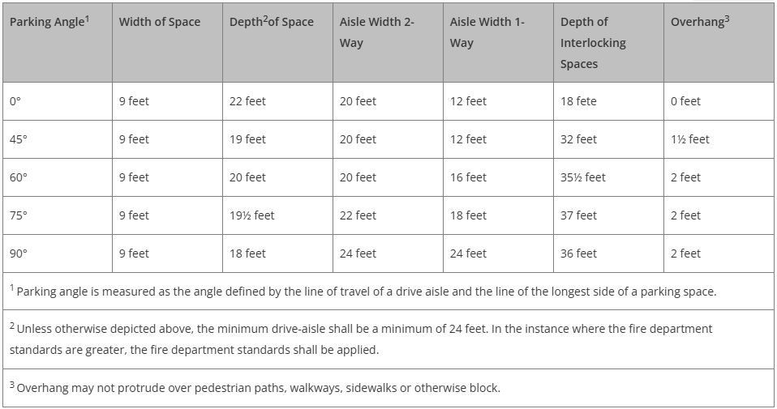
Refer to Table 6-5 for Dimensional Requirements for Compact Spaces
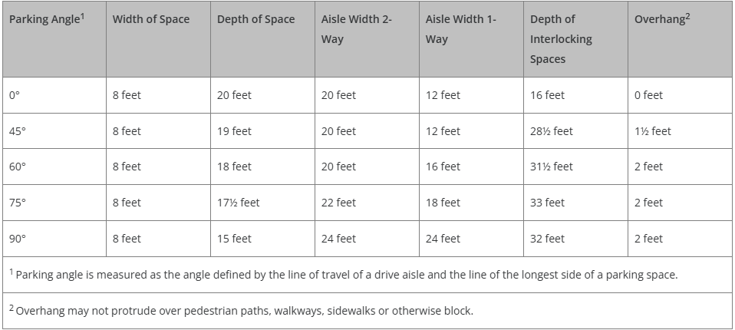
Refer to Table 6-3 for Disabled Parking Space Requirements
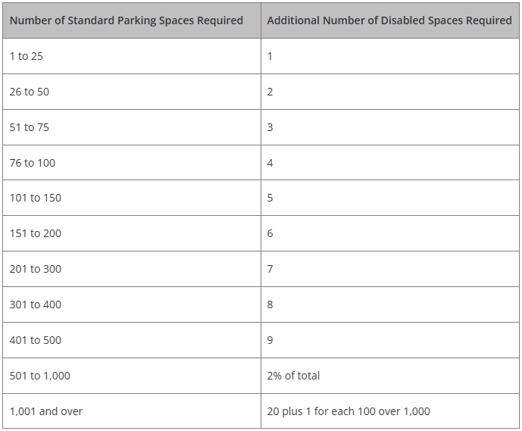
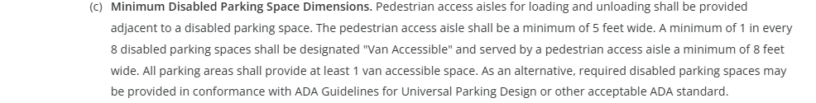
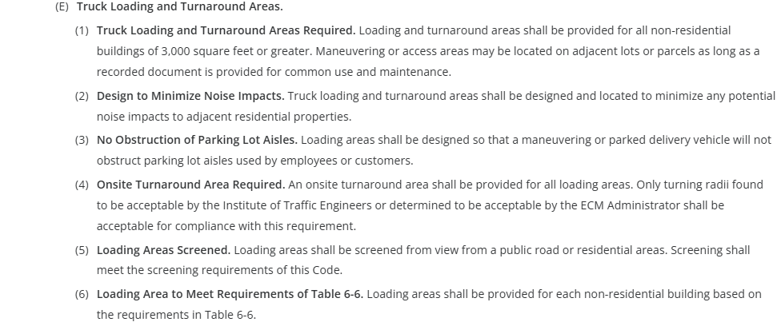
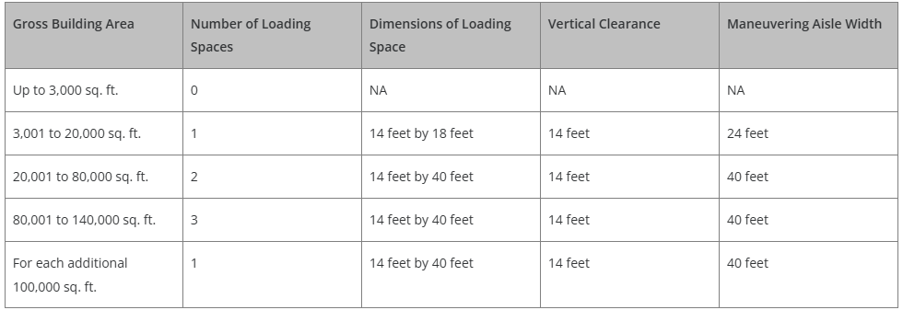
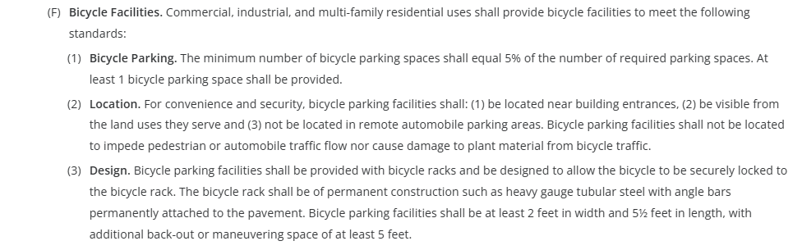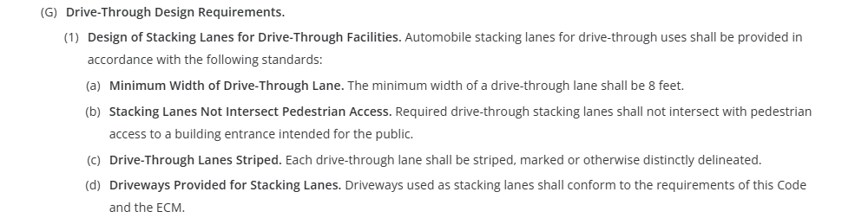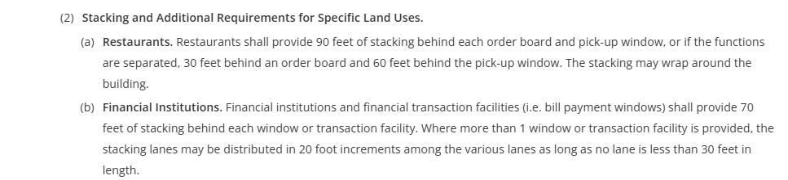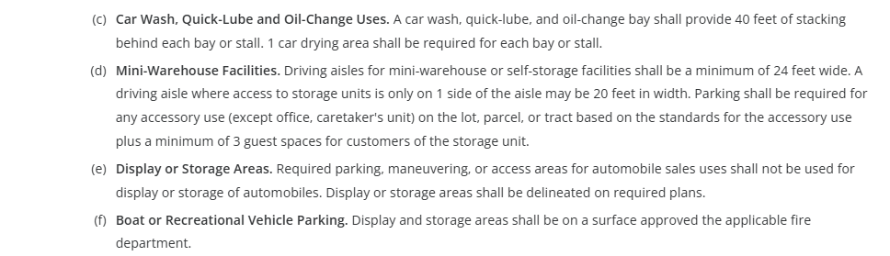

Lighting: (required in parking areas, all other locations must also adhere to the following standards)

(Chapter 6 Link) 6.2.3 Lighting
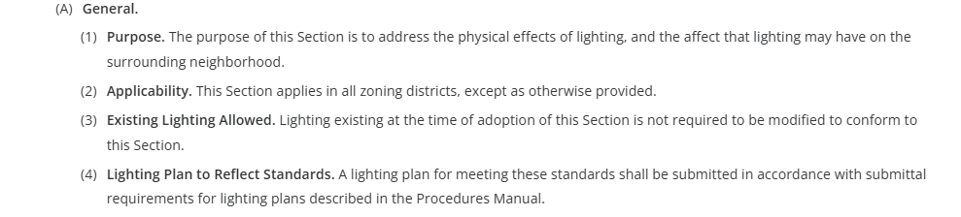
(B) Design Standards and Requirements
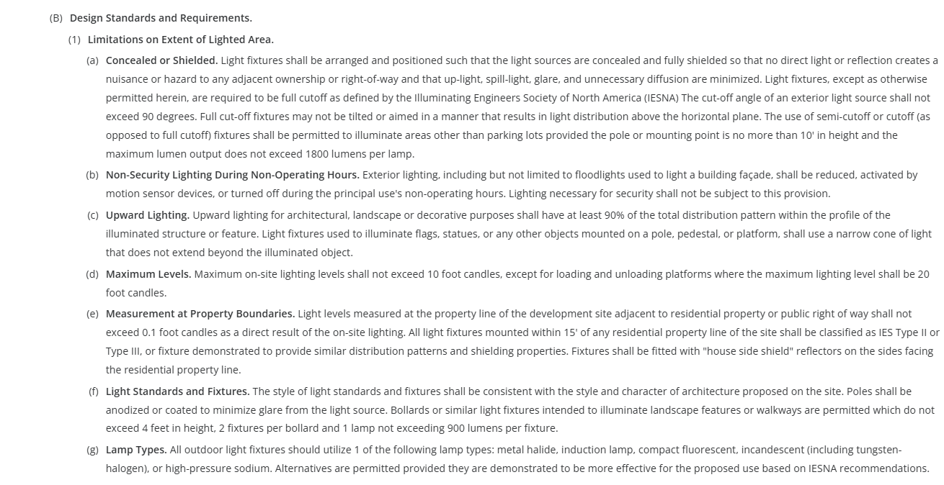
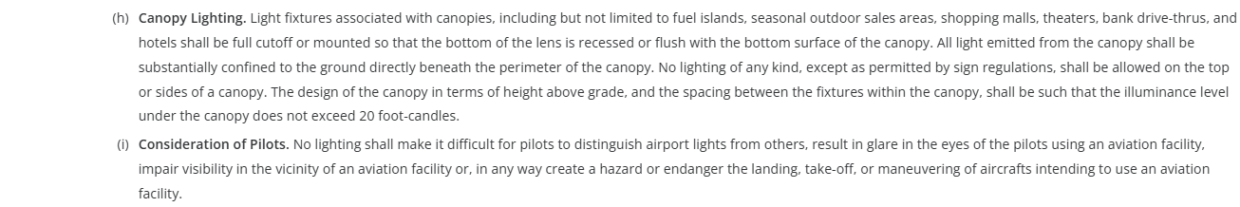
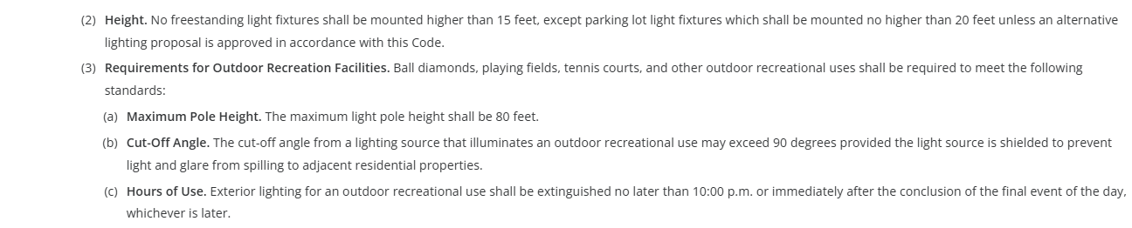
(C) Prohibited Lighting
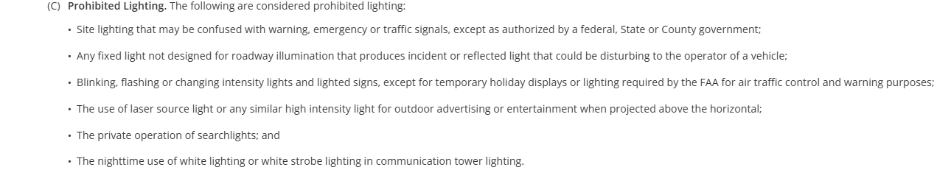
(D) Exemptions
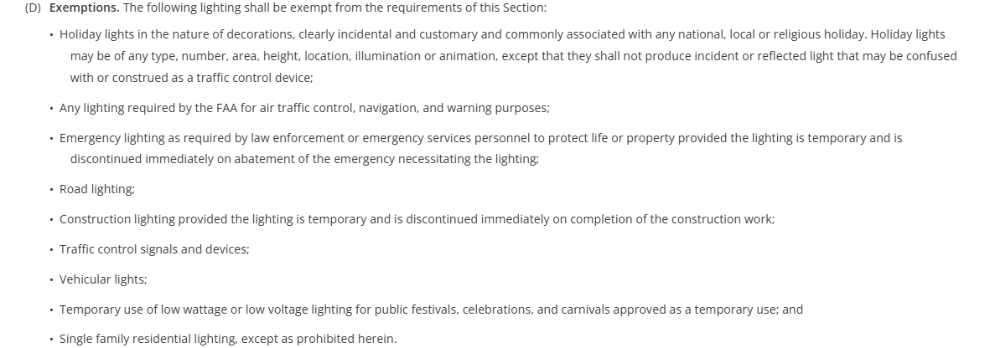
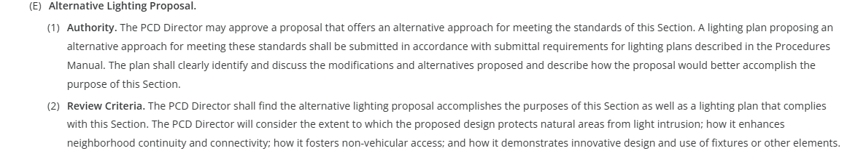
☒ Photometric Plan Required Example: Lighting Plan under Review Docs of EDARP File No. PPR2413

(Chapter 6 Link) General Development Standards
6.2.7. Operational Standards (Dust and Debris Control, Noise, etc.)
6.2.8. Maintenance Plans

(Chapter 6.3 Link) Environmental Standards
6.3.1. Air Quality Standards
6.3.2. Drainage and Floodplain
6.3.3. Fire Protection and Wildfire Mitigation
6.3.4. Forestry
6.3.5. Grading and Erosion Control
6.3.7. Noxious Weeds
6.3.8. Wetlands
6.3.9. Wildlife

☐ | 30% or greater slope | Comments: | N/A
☐ | CGS review
☐ | Floodplain |  | N/A – southeast of development area
☐ | Noise mitigation required |  | N/A
☐ | Preble’s mouse |  | N/A – within block clearance

Signage: (if proposed, follow these development standards)

(Chapter 6 Link)
6.2.10. Signs, On-Premise
Show on site development plan, but separate permits will be required if proposed. (after Site Dev Plan).

Districts/Taxing Entities:
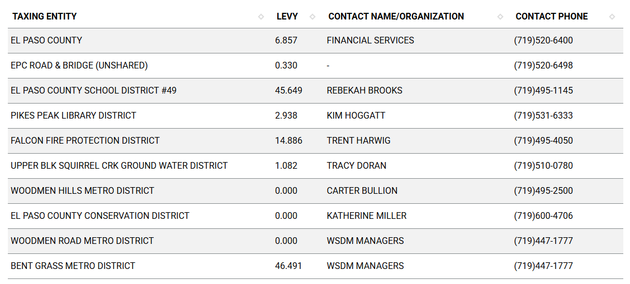
Road Impact Fees: (Engineering Discussion)
BOCC Res. No. 24-377 – fee is applied at the time of building permit
The Engineering team will provide the $ amount during review of the Site Dev Plan.

Proposed source of water |  |  | Proposed method of wastewater disposal
☐ | Central System |  | ☐ | Central System
District Name: |  | Woodmen Hills Metro District | District Name: |  | Woodmen Hills Metro District

Public Health: With any questions on the below standard public health items, please contact Kat McGarvy in public health katmcgarvy@elpasoco.com

Woodmen Hills Metropolitan District has sufficient water and wastewater treatment capacity for the proposed school.

Plans for the school must be reviewed by our department for the school, food service areas and several other areas that are governed by the State of Colorado School Sanitation Regulations.

Stormwater control

Radon construction practices

Construction Activity Permit for dust control

Science Lab chemical storage

Walkability features for connections to the surrounding neighborhoods

Fire District: (Concerns/Emergency Service Issues, etc.)
Falcon Fire Protection District

The FPD will be a reviewing agency – all returned comments will be made available in EDARP.
No Hazard in County Fire Hazard Vegetation Classification Map.

Class 2 - Moderate Hazard – Colorado Wildfire Resiliency Code
Wildland Fire and Hazard Mitigation Plan will likely be a required submittal document.
https://dfpc.colorado.gov/WRCB

They’ll review: site access, landscaping for hazard mit meeting WRC, water plan for fire hazard mit
COS Fire
26’ drive lane width requirement
2021 Fire Code edition
- Will need an example of wildfire mitigation plan + guidelines (attached in follow up email)
- Curtis has resources as well for plan

Commissioner District: 2

Alternative Design Discussion:
(landscaping)
(parking)
(lighting)

Parks and Trails:
No County parks or trails were identified on the property.

Review Comment entered on EA Meeting request:
El Paso County Parks Department. The 2022 El Paso County Parks Master Plan shows no impacts by this proposed project to existing or proposed parks, trails, or open space. As such, no parkland or trail easement dedications will be necessary as this project moves forward. El Paso County Parks staff does not need to attend this Early Assistance meeting. Thank you!

Annexations/Intergovernmental/ Jurisdictional Access Issues:
NOTE: This property is within the City of Colorado Springs Annexation Area of Interest.

Moving Forward:
Access EDARP project to begin submitting documents for Site Development Plan Review:

Required documents for Site Development Plan:
(Planning Documents Here) (Engineering Documents Here) (Stormwater Documents Here)
- Application/Petition Form
- Letter of Intent (address traffic, including total sq ft of buildings to be removed)
- Site Development Plan (address imperviousness)
- Floor Plans
- Elevation Plans
- Landscape Plan
- Lighting Plan
- Parking Plan (include in Site Dev Plan sheets)
- Erosion and Stormwater Quality Control Permit (ESQCP)
- Grading & Erosion Control (GEC) Checklist
- Grading & Erosion Control (GEC) Plan
- Financial Assurance Forms
- PCM Applicability Form
- Storm Water Management Plan (SWMP)
- SWMP Checklist
- Drainage Report - Final
- Road Impact Fee Acknowledgement Form (upload blank)
- Traffic Impact Study
- CDs for road improvements
- Driveway Access permit
- Subdivision Improvements Agreement
- Wildland Fire and Hazard Mitigation Plan (Moderate Hazard)
- Fire Protection Report

Notes:
Drainage
- Drainage basin study may contain some background info
- Church property in as Site Dev Plan application – account for that property and under meridian ditch in drainage report
- Past drainage reports are available - Will be in Engineering checklist if so
- Church drainage report available?
- Roadside ditch until pipe? Possible
- Drainage docs available on website
Transportation
- Sidewalk: off site devel’t ok with missing sidewalk? Reach out to HOA/MD on reserve funds
- Deviation request for driveway access spacing
- Existing traffic studies on bent grass meadows (church) to reference
- Meridian / Bent Grass intersection -

Helpful Links

Planning Website

El Paso County Master Plan
Parks, Mineral and Water Master Plan

Forms and Templates

Land Development Code

EDARP

Public GIS

Wrap Up
-If subdivision is proposed, recording fees, park and school fees and road impact fees apply.
-Fees are subject to change. The fees at the time of application apply.
-Pursuant to the adopted El Paso County Road Impact Fee Program (Res. No. 12-382), a transportation impact fee, calculated on a per trip basis, may be due at the time of building permit issuance. Starting January 1, 2020, the transportation impact fee will be due for all new construction (Res. No. 19-471) (Res. No. 24-377).
-The fee for any additional waiver/deviation requests (more than two) - $550.00 each. Please note that requests for waivers and/or deviations may result in additional processing/review delay.
-All items requested must accompany the submittal for it to be complete, prior to payment request or the submittal will not be complete and ready for review agencies.
-A temporary use permit shall be applied for and approved for any staging area associated with development, such as a sales office, construction trailer, or contractor's equipment yard, prior to scheduling of the pre-construction meeting with El Paso County Planning and Community Development. If a Planned Unit Development is proposed, the temporary staging area should be shown on the development guidelines and phasing plan.
-All prospective timelines for review are subject to departmental staffing and workload.
-EA is valid for 12 months from submitting the EA application. If a project submittal is not received within 12 months, a new EA meeting may be required. An audio/video copy of the meeting is available in EDARP within the EA folder.
- Applications scheduled for public hearing may be heard as a regular item at staff or Board discretion.
- Any comments or commitments made by any member of the County Staff during this EA meeting are only preliminary in nature and should not be relied upon by the applicant. All prospective applicants should be informed that formal comments cannot be made by staff until after the application is submitted.

