Grant Subdivision
Wildland Fire & Hazard Mitigation Plan

July 13, 2017

GENERAL DESCRIPTION
This Wildland Fire and Hazard Mitigation Report will include information for the proposed Grant Subdivision, located in northern El Paso County, Colorado. The address of the property is 1315 Walsen Road, Colorado Springs, CO 80921.

The Grant Subdivision site is located as follows: the Southwest One-quarter (SW1/4) of the Northeast One-Quarter (NE1/4) Section 22, Township 12 South (T12S), Range 66 West (R66W) of the 6th P.M. County of El Paso, State of Colorado. The El Paso County Assessor’s schedule number for this property is 6205000029. The property comprises approximately 41 acres, with the proposed subdivision into 2 parcels: one parcel including 11 acres on which the owners’ house is located, and a second parcel of 30 acres of bare land. A vicinity map obtained from the County Assessor website is included as Appendix 1. The current owners of the overall 41 acres do not plan any improvements or change of use for the 30-acre parcel that will be for sale. The land is zoned RR-5 which is not intended to change. The property is located within the Donald Westcott Fire Protection District, and Chief Vincent Burns has issued a signed letter of commitment for fire protection. The closest fire station is 1.7 miles away, staffed 24 hours per day, 365 days per year. He has also offered to visit the property for fire mitigation recommendations.

ACCESS, INGRESS, EGRESS AND EVACUATION
Public vehicular access to the 2 parcels will be via Walsen Road, owned and maintained by El Paso County. Access to the 11-acre lot will continue to be the present driveway, and a permission form has been signed and submitted to allow shared use of the driveway access, with a separate split off of the driveway to the 30-acre parcel if desired and constructed by the new owner. A reduced-size copy of the subdivision plat is appended (Appendix 2) demonstrating Walsen Road, the existing driveway on the 11-acre parcel, and possible split off of the driveway to serve the 30-acre parcel.

WATER SUPPLY
The current owner’s house has an existing well. Water rights for the 30-acre parcel are in process and will be submitted with the entire proposal once secured.

FIRE MITIGATION
Removing trees, fallen limbs, dead leaves, and other small organic debris is prudent within 50 feet of structures. Adequate thinning is reached when the outer edge of tree crowns are at least 10-12 feet apart. Occasional clumps of 2-3 trees are acceptable if more space surrounds them. Small patches of brush or shrubs may be left if they are separated by at least 10 feet of irrigated grass or noncombustible material. Removal of dead limbs, leaves, and other ground litter with the defensible 50 feet is appropriate. Maintain an irrigated greenbelt immediately around the home. Prune branches from trees within the defensible space to a minimum of 6 feet above the ground. Trim branches that extend over the eaves of the roof. Remove branches within 15 feet of a chimney. Reduce the density of the surrounding forest at least 100 feet from the home.
To this end the owners contracted with a professional tree service to perform appropriate mitigation within approximately 200 feet of the house on the existing 41 acres.

FIRE HAZARD ASSESSMENT UTILIZING THE COLORADO WILDFIRE RISK ASSESSMENT PROJECT

Using the Public Viewer of the Colorado Wildfire Risk Assessment Portal (CO-WRAP), a brief summary of which is provided below, several factors important in assessing risk of wildfire are provided, specifically involving the 41 acres of the Grant Subdivision (each image has the Grant Subdivision acreage outlined). In combination, the 41 acres Grant Subdivision has a comparatively low overall wildfire risk.
These include:
- Fire Intensity—Appendix 3
- Wildland Urban Interface—Appendix 4
- Vegetation—Appendix 5
- Surface Fuels—Appendix 6
- Wildland Urban Interface Risk—Appendix 7
- Values at Risk Rating—Appendix 8
An explanation of all of these factors as well as the entire project is included after the summary of the Portal. It has been edited in size and scope for ease of review relative specifically to this report.

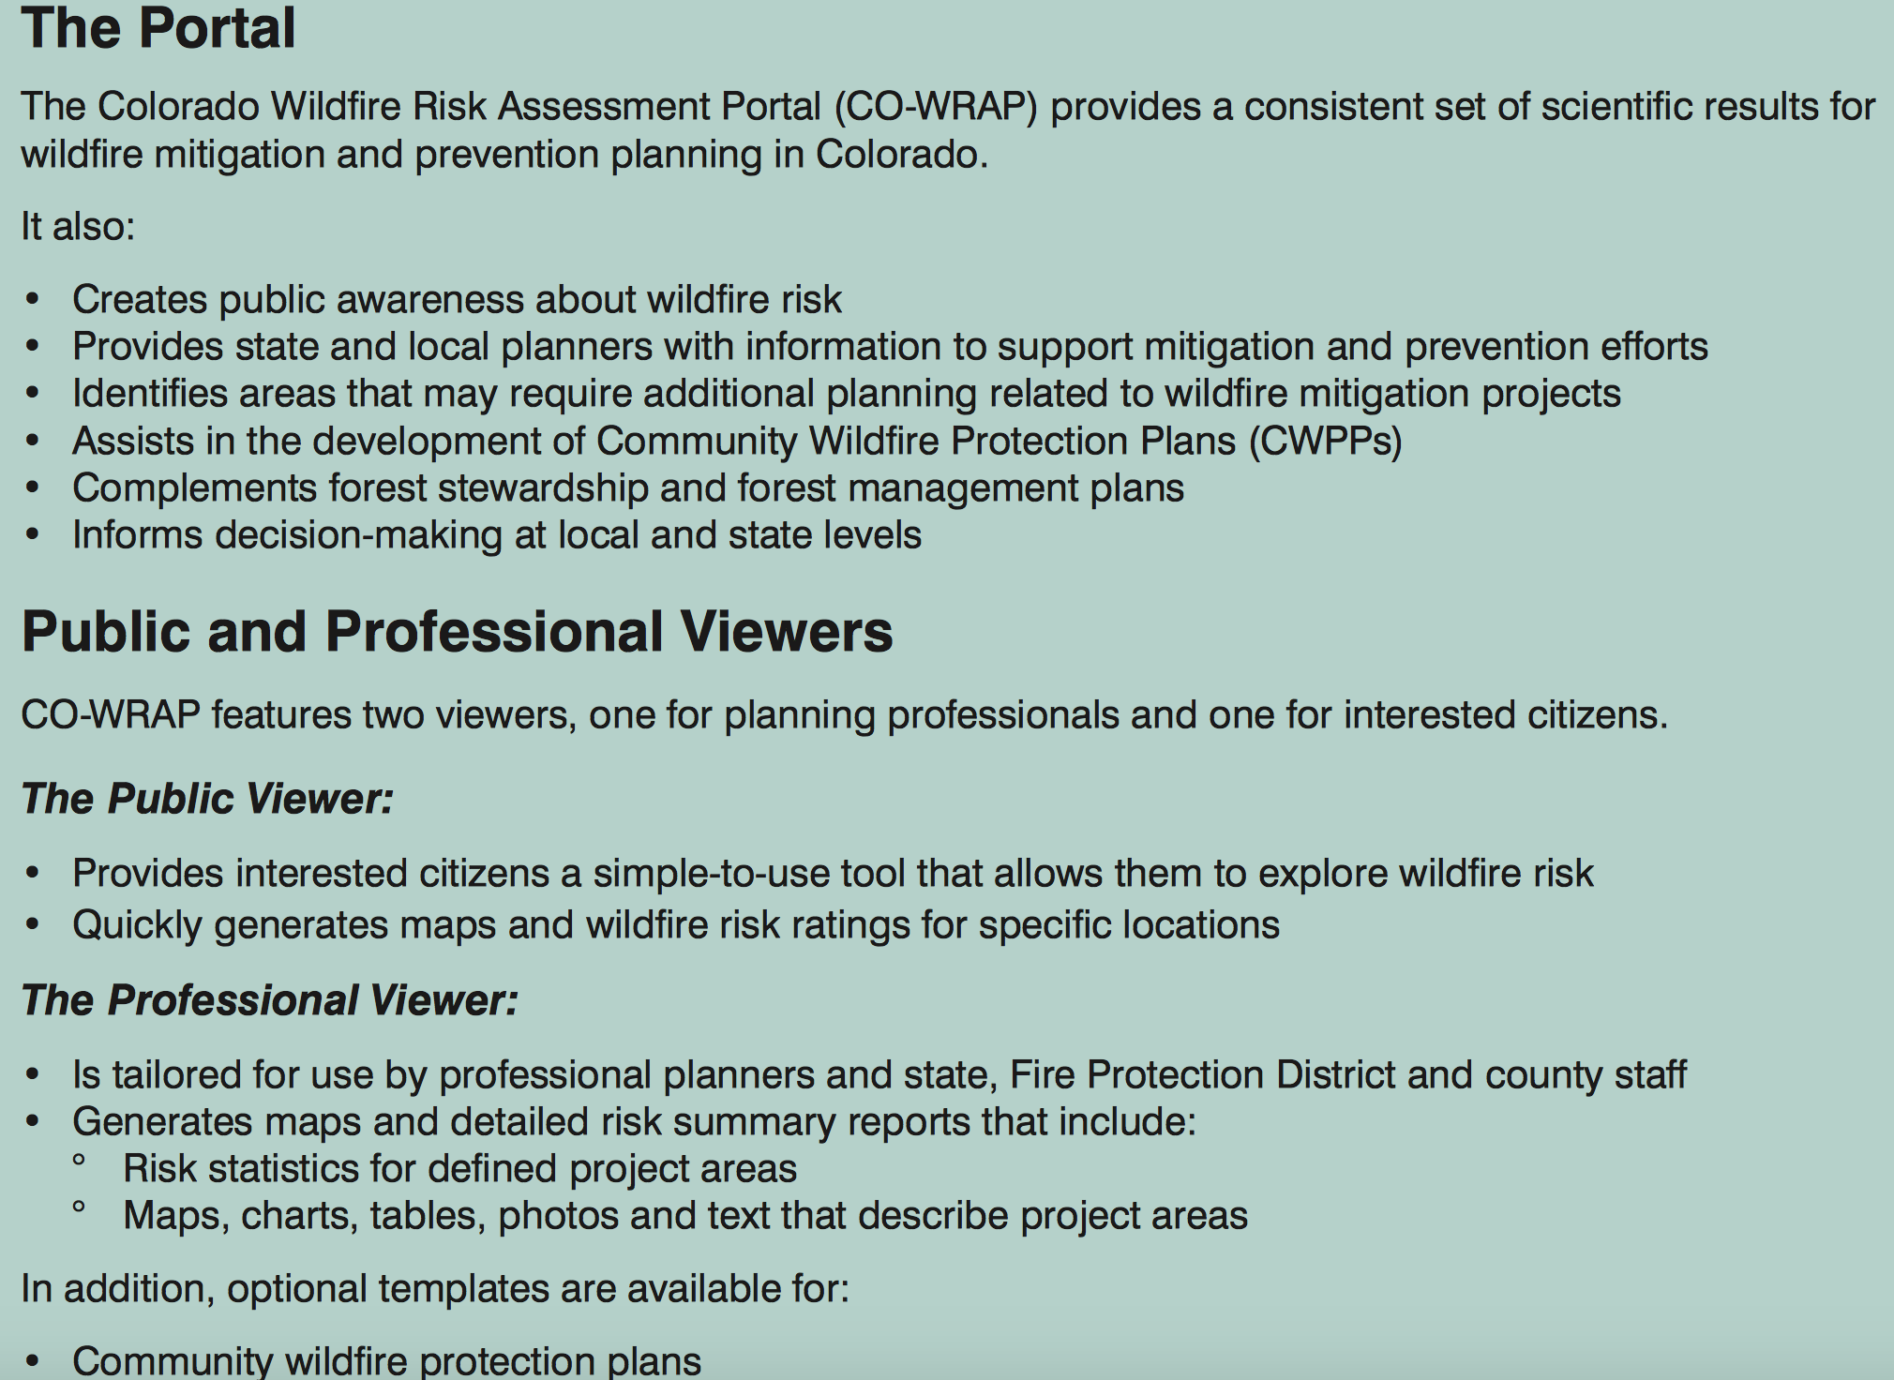

COLORADO WILDFIRE RISK ASSESSMENT PROJECT

This project involved developing an updated Colorado statewide wildfire risk assessment. This process of calibrating and adjusting WWA data to reflect Colorado conditions, requirements and priorities is referred to as the Colorado WRA project. This resulted in a set of wildfire risk assessment outputs that focus on specific conditions and requirements within Colorado. Colorado WRA project does heavily leverage the technical methods and standards developed in the WWA project, ensuring that the outputs are based on a scientifically sound, defendable and robust approach. Building on the technical foundation and achievements of the State of Texas Wildfire Risk Assessment Portal, CSFS embarked on implementing a suite of interactive web mapping applications to facilitate dissemination of assessment outputs to the public and local planners.1 This website is referred to as the Colorado Wildfire Risk Assessment Portal, or CO-WRAP.
Fire Intensity Scale (FIS)
The Fire Intensity Scale (FIS) quantifies potential fire intensity based on high to extreme weather conditions, fuels, and topography. It is similar to the Richter scale for earthquakes, providing a standard scale to measure potential wildfire intensity by magnitude. Each unit increase in FIS is a meaningful ten-fold increase in fireline intensity. FIS values range from just less than 1 (10 kW/m) to just over 5 (100,000 kW/m), suggesting a classification by orders of magnitude that lends itself to a multi-class dataset. The benefit of using FIS for the CO-WRAP Public Viewer What's Your Risk? tool is that it provides a description of the potential fire conditions that the user can understand, in units the user can understand. In addition, given the fire conditions associated with each FIS class, CSFS was able to accommodate a general description of prevention recommendations as guidance for the user. This provides the two basic bits of information the public needs: 1) a description of potential fire conditions, and 2) a description of prevention recommendations. We consider this a significant achievement (not included in the WWA) that provides much greater utility to the risk assessment outputs to support public awareness and education. FIS consist of 5 classes where the order of magnitude between classes is ten-fold. The minimum class, Class 1, represents very low wildfire intensities and the maximum class, Class 6, represents extreme wildfire intensities. In Colorado, only classes 1 through 5 exist.

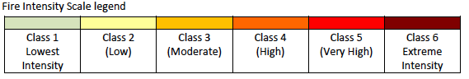
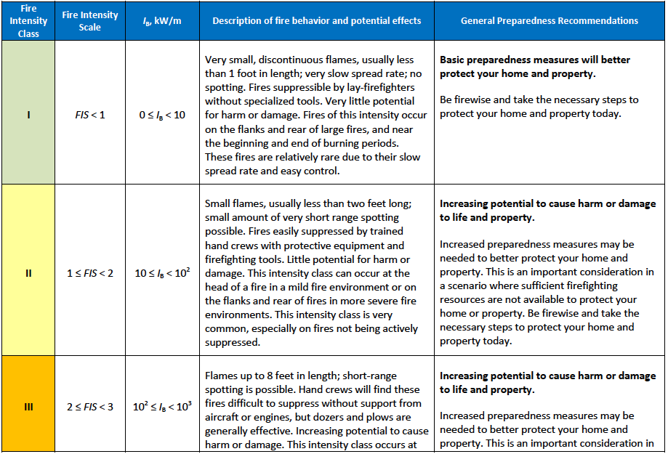
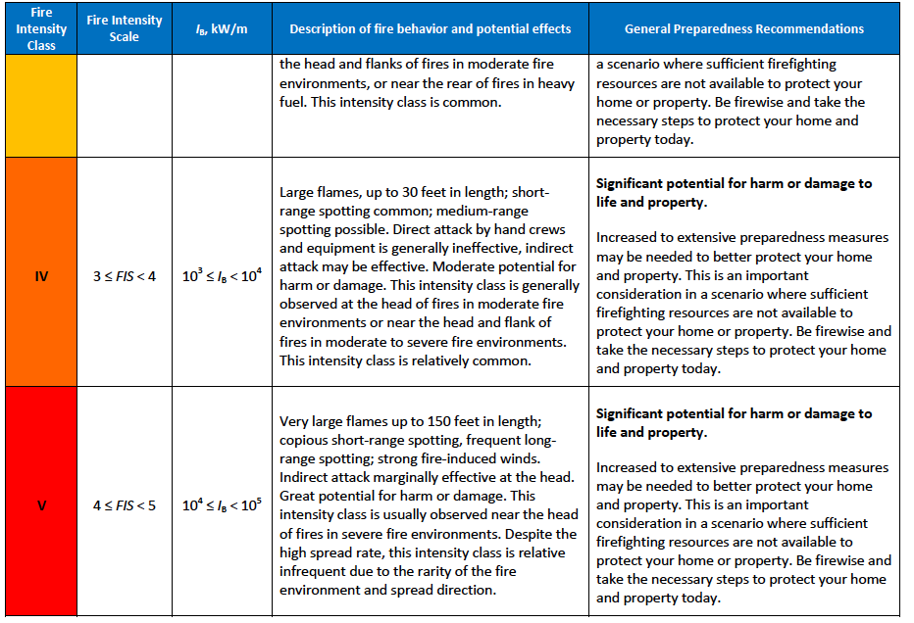
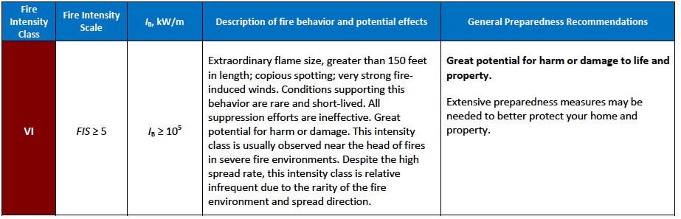

3. Adjusting Response Function Assignments to Derive Wildfire Effects Outputs
Overview of Response Function Approach
The primary underpinning of the Wildfire Effects model is based on the use of “response functions”. Response Functions are a method of assigning a rating of net change to a resource value or asset based on susceptibility to fire intensity. These impacts can be negative or positive. For the WWA and Colorado Wildfire Effects model only adverse effects are being considered at this time, although the model has been designed to accommodate positive effects in the future if desired.10
Calculating risk at a given location requires spatially defined estimates of the likelihood and intensity of fire integrated with the identified resource/asset value. This interaction is quantified through the use of response functions that estimate expected benefits and losses to values/assets at the specified fire intensities. The measure of fire intensity used in the model is Flame Length. Specific classes of Flame Length have been defined that reflect key thresholds for damage from wildfire to the resource values.
For the CSFS model, response functions are defined for each category of the resource value inputs, for each given flame length category. Flame length categories were defined by the fire experts that reflect key thresholds for rating impacts. Positive response functions indicate a benefit or increase in value to the resource; negative response function values indicate a loss in resource value.
The CSFS model response function uses a value range of +9 to -9. This 1 to 9 range is typical for suitability modeling and provides a consistency with previous risk modeling methods. With this scale, a value of 0 represents no measureable impact; -1 the least negative impact, ramping to a -9 where the worst possible impact or loss occurs. The higher the flame length the worse the impact on people and their homes. This could also be interpreted as the higher the value the more susceptible to wildfire. Areas with high population/structure density would result in more people/homes impacted while areas with low density would result in less people/homes impacted. The user defined response function value (-1 to -9) would only be applied to areas where the WUI and Flame Length overlap and both occur in the same area.
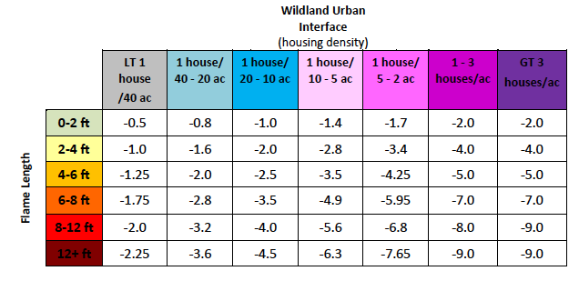
Response functions represent mathematical relationships between fire characteristics (intensity) and fire outcome. Although fire outcomes could be related to any fire characteristic, response is typically related to some measure of fire intensity, e.g., flame length (Ager and others 2007; Finney 2005). Accordingly, the Colorado Wildfire Effects model uses response functions that correspond to the following flame length classes:
• _Low = 0 to 2 ft,
• _Low to Moderate = greater than 2 to 4 ft,
• _Moderate = greater than 4 to 6 ft,
• _Moderate to High = greater than 6 to 8 ft,
• _High = greater than 8 to 12 ft, and
• _Very High = greater than 12 ft.

4.0 Colorado Wildfire Risk Assessment Portal - CO-WRAP
4.1 Overview
In response to increasing demand for more accurate and up-to-date wildfire risk information across the state, the Colorado State Forest Service (CSFS) established the 2012 Colorado Wildfire Risk Assessment Project (Colorado WRA 2012). The goal of the project is to provide a consistent, comparable set of scientific results to be used as a foundation for wildfire mitigation and prevention planning in Colorado. The results were completed in December 2012. The CSFS developed the Colorado Wildfire Risk Assessment Portal (CO-WRAP) in order to deliver the information quickly and seamlessly to stakeholders. Through CO-WRAP, the CSFS is creating awareness among the public and providing state and local government planners with information to support mitigation and prevention efforts.
CO-WRAP is the primary mechanism for the Colorado State Forest Service to deploy risk information and create awareness about wildfire issues across the state.
CO-WRAP is the primary mechanism for the Colorado State Forest Service to deploy risk information and create awareness about wildfire issues across the state.

Appendix A: Description of Outputs
This appendix provides a description of the Colorado WRA key output datasets (in alphabetical order). Please refer to the WWA Final Report for a description of all WWA datasets.
Wildfire Risk
Represents the possibility of loss or harm occurring from a wildfire
Wildfire Risk represents the possibility of loss or harm occurring from a wildfire. It is the primary output of the Colorado Wildfire Risk Assessment. Risk is derived by combining the Wildfire Threat and the Fire Effects assessment outputs. It identifies areas with the greatest potential impacts from a wildfire – i.e. those areas most at risk.
Wildfire Risk combines the likelihood of a fire occurring (threat), with those areas of most concern that are adversely impacted by fire (fire effects), to derive a single measure of wildfire risk. Since all areas in Colorado have risk calculated consistently, it allows for comparison and ordination of areas across the entire state. For example, a high risk area in Southern Colorado is equivalent to a high risk area in Northern Colorado.
Fire Effects is a key component of Wildfire Risk. Fire Effects is comprised of several inputs focusing on values impacted. The purpose of Fire Effects is to identify those areas that have important values or assets that would be adversely impacted by a wildfire. Fire Effects inputs include Where People Live (derived from 2012 LandScan data for Colorado),Colorado Forest Assets, Riparian Assets and Drinking Water value layers. The Colorado component is a key element of Fire Effects since it represents where people live in the wildland and urban fringe areas.
The risk map is derived at a 30-meter resolution. This scale of data was chosen to be consistent with the accuracy of the primary LANDFIRE surface fuels dataset used in the assessment. While not appropriate for site specific analysis, it is appropriate for regional, county or local planning efforts.
Wildfire Threat
Represents the likelihood of an acre burning.
Threat is derived by combining a number of landscape characteristics including surface fuels and canopy fuels, resultant fire behavior, historical fire occurrence, percentile weather derived from historical weather observations, and terrain conditions. These inputs are combined using analysis techniques based on established fire science.
The measure of wildfire threat used in the Colorado WRA is called Fire Threat Index (FTI). FTI combines the probability of an acre igniting (Fire Occurrence) and the expected final fire size based on rate of spread in four weather percentile categories. Since all areas in Colorado have FTI calculated consistently, it allows for comparison and ordination of areas across the entire state. For example, a high threat area in East Colorado is equivalent to a high threat area in West Colorado.
To aid in the use of Wildfire Threat for planning activities, the output values are categorized into five (5) classes. These are given general descriptions from Lowest to Highest Threat.
Fire Intensity Scale
Quantifies the potential fire intensity by orders of magnitude.
Fire Intensity Scale (FIS) specifically identifies areas where significant fuel hazards and associated dangerous fire behavior potential exist. Similar to the Richter scale for earthquakes, FIS provides a standard scale to measure potential wildfire intensity. FIS consists of five (5) classes where the order of magnitude between classes is ten-fold. The minimum class, Class 1, represents very low wildfire intensities and the maximum class, Class 5, represents very high wildfire intensities.
1. Class 1, Lowest Intensity: Very small, discontinuous flames, usually less than 1 foot in length; very low rate of spread; no spotting. Fires are typically easy to suppress by firefighters with basic training and non-specialized equipment.
2. Class2, Low: Small flames, usually less than two feet long; small amount of very short range spotting possible. Fires are easy to suppress by trained firefighters with protective equipment and specialized tools.
3. Class 3, Moderate: Flames up to 8 feet in length; short-range spotting is possible. Trained firefighters will find these fires difficult to suppress without support from aircraft or engines, but dozer and plows are generally effective. Increasing potential for harm or damage to life and property.
4. Class 4, High: Large Flames, up to 30 feet in length; short-range spotting common; medium range spotting possible. Direct attack by trained firefighters, engines, and dozers is generally ineffective, indirect attack may be effective. Significant potential for harm or damage to life and property.
5. Class 5, Highest Intensity: Very large flames up to 150 feet in length; profuse short-range spotting, frequent long-range spotting; strong fire-induced winds. Indirect attack marginally effective at the head of the fire. Great potential for harm or damage to life and property.

Wildfire Threat and Fire Intensity Scale are designed to complement each other. Unlike Wildfire Threat, the Fire Intensity Scale does not incorporate historical occurrence information. It only evaluates the potential fire behavior for an area, regardless if any fires have occurred there in the past. This additional information allows mitigation planners to quickly identify areas where dangerous fire behavior potential exists in relationship to nearby homes or other valued assets.
Since all areas in Colorado have fire intensity scale calculated consistently, it allows for comparison and ordination of areas across the entire state. For example, a high fire intensity area in Eastern Colorado is equivalent to a high fire intensity area in Western Colorado.

Fire intensity scale is a fire behavior output, which is influenced by three environmental factors - fuels, weather, and topography. Weather is by far the most dynamic variable as it changes frequently. To account for this variability, four percentile weather categories were created from historical weather observations to represent low, moderate, high, and extreme weather days for each weather influence zone in Colorado. A weather influence zone is an area where, for analysis purposes, the weather on any given day is considered uniform. There are 11weather influence zones in Colorado. The FIS represents the weighted average for all four weather percentiles.
Wildfire Effects Themes
Values At Risk Rating
Represents those values or assets that would be adversely impacted by a wildfire
The Values At Risk Rating (VAR) is an overall Fire Effects rating that combines the risk ratings for Wildland Urban Interface (WUI), Forest Assets, Riparian Assets, and Drinking Water Importance Areas into a single measure of values-at-risk. The individual ratings for each value layer were derived using a Response Function approach.
Response functions are a method of assigning a net change in the value to a resource or asset based on susceptibility to fire at different intensity levels. A resource or asset is any of the Fire Effects input layers, such as WUI, Forest Assets, etc. These net changes can be adverse (negative) or positive (beneficial).
Calculating the VAR at a given location requires spatially defined estimates of the intensity of fire integrated with the identified resource value. This interaction is quantified through the use of response functions that estimate expected impacts to resources or assets at the specified fire intensity levels. The measure of fire intensity level used in the Colorado assessment is flame length for a location. Response Function outputs were derived for each input data set and then combined to derive the Values Impacted Rating.
Different weightings are used for each of the input layers with the highest priority placed on protection of people and structures (i.e. WUI). The weightings represent the value associated with those assets. Weightings were developed by a team of experts during the assessment to reflect priorities for fire protection planning in Colorado. Refer to the Colorado WRA Final Report for more information about the layer weightings.
Since all areas in Colorado have the VAR calculated consistently, it allows for comparison and ordination of areas across the entire state. The VAR data was derived at a 30-meter resolution.
Suppression Difficulty Index
Reflects the difficulty or relative cost to suppress a fire given the terrain and vegetation conditions that may impact machine operability.
This layer is an overall index that combines the slope steepness and the fuel type characterization to identify areas where it would be difficult or costly to suppress a fire due to the underlying terrain and vegetation conditions that would impact machine operability (in particular Type II dozer).
The rating was calculated based on the fireline production rates for hand crews and engines with modifications for slope, as documented in the NWCG Fireline Handbook 3, PMS 401-1.
The burnable fuel models in the Colorado WRA were grouped into three categories: slow (0-66 feet), medium (67-165 feet) and fast (greater than 165 feet).
Fireline production capability on five slope classes was used as the basic reference to obtain the suppression difficulty score. To remain constant with the Value Impacted Rating output values, a response function (-1 to –9) is assigned to each combination of fuel model group (slow, medium and fast) and slope category.

Wildland Urban Interface Risk Index
A measure of the potential impact on people and their homes from wildfire.
The Wildland-Urban Interface (WUI) Risk Index layer is a rating of the potential impact of a wildfire on people and their homes. The key input, WUI, reflects housing density (houses per acre) consistent with Federal Register National standards. The location of people living in the wildland-urban interface and rural areas is essential for defining potential wildfire impacts to people and homes.
The WUI Risk Index is derived using a response function modeling approach. Response functions are a method of assigning a net change in the value to a resource or asset based on susceptibility to fire at different intensity levels, such as flame length.
To calculate the WUI Risk Index, the WUI housing density data was combined with flame length data and response functions were defined to represent potential impacts. The response functions were defined by a team of experts led by Colorado State Forest Service mitigation planning staff. By combining flame length with the WUI housing density data, it is possible to determine where the greatest potential impact to homes and people is likely to occur.
The range of values is from -1 to -9, with -1 representing the least negative impact and -9 representing the most negative impact. For example, areas with high housing density and high flame lengths are rated -9, while areas with low housing density and low flame lengths are rated -1.
The WUI Risk Index has been calculated consistently for all areas in Colorado, which allows for comparison and ordination of areas across the entire state. Data is modeled at a 30-meter cell resolution, which is consistent with other Colorado WRA layers.
Drinking Water Risk Index
A measure of the risk to Drinking Water Importance Areas based on the potential negative impacts from wildfire
In areas that experience low-severity burns, fire events can serve to eliminate competition, rejuvenate growth and improve watershed conditions. But in landscapes subjected to high, or even moderate-burn severity, the post-fire threats to public safety and natural resources can be extreme. High-severity wildfires remove virtually all forest vegetation – from trees, shrubs and grasses down to discarded needles, decomposed roots and other elements of ground cover or duff that protect forest soils. A severe wildfire also can cause certain types of soil to become hydrophobic by forming a waxy, water-repellent layer that keeps water from penetrating the soil, dramatically amplifying the rate of runoff.
The loss of critical surface vegetation leaves forested slopes extremely vulnerable to large-scale soil erosion and flooding during subsequent storm events. In turn, these threats can impact the health, safety and integrity of communities and natural resources downstream. The likelihood that such a post-fire event will occur in Colorado is increased by the prevalence of highly erodible soils in several parts of the state, and weather patterns that frequently bring heavy rains on the heels of fire season.
In the aftermath of the 2002 fire season, the Colorado Department of Health estimated that 26 municipal water storage facilities were shut down due to fire and post-fire impacts. The potential for severe soil erosion is a consequence of wildfire because as a fire burns, it destroys plant material and the litter layer. Shrubs, forbs, grasses, trees and the litter layer disperse water during severe rainstorms. Plant roots stabilize the soil, and stems and leaves slow the water to give it time to percolate into the soil profile. Fire can destroy this soil protection.
The range of values is from -1 to -9, with -1 representing the least negative impact and -9 representing the most negative impact.
Riparian Assets Risk Index
A measure of the risk to riparian areas based on the potential negative impacts from wildfire.
This layer identifies those riparian areas with the greatest potential for adverse effects from wildfire.
The range of values is from -1 to -9, with -1 representing the least negative impact and -9 representing the most negative impact.
The risk index has been calculated by combining the Riparian Assets data with a measure of fire intensity using a Response Function approach. Those areas with the highest negative impact (-9) represent areas with high potential fire intensity and high importance for ecosystem services. Those areas with the lowest negative impact (-1) represent those areas with low potential fire intensity and a low importance for ecosystem services.
This risk output is intended to supplement the Drinking Water Risk Index by identifying wildfire risk within the more detailed riparian areas.
Forest Assets Risk Index
A measure of the risk to forested areas based on the potential negative impacts from wildfire.
This layer identifies those forested areas with the greatest potential for adverse effects from wildfire. The range of values is from -1 to -9, with -1 representing the least negative impact and -9 representing the most negative impact.
The risk index has been calculated by combining the Forest Assets data with a measure of fire intensity using a Response Function approach. Those areas with the highest negative impact (-9) represent areas with high potential fire intensity and low resilience or adaptability to fire. Those areas with the lowest negative impact (-1) represent those areas with low potential fire intensity and high resilience or adaptability to fire.
This risk output is intended to provide an overall forest index for potential impact from wildfire. This can be applied to consider aesthetic values, ecosystem services, or economic values of forested lands.
Primary Input Layers
Surface Fuels
Fire behavior fuel models that contain the parameters needed to calculate fire behavior outputs
Surface fuels, or fire behavior fuel models as they are technically referred to, contain the parameters required by the Rothermel (1972) surface fire spread model to compute surface fire behavior characteristics, including rate of spread, flame length, fireline intensity and other fire behavior metrics. As the name might suggest, surface fuels account only for surface fire potential. Canopy fire potential is computed through a separate but linked process. The Colorado WRA accounts for both surface and canopy fire potential in the fire behavior outputs. However, only surface fuels are shown in this report.
Surface fuels typically are categorized into one of four primary fuel types based on the primary carrier of the surface fire: 1) grass, 2) shrub/brush, 3) timber litter, and 4) slash. Two standard fire behavior fuel model sets have been published. The Fire Behavior Prediction System 1982 Fuel Model Set (Anderson, 1982) contains 13 fuel models, and the Fire Behavior Prediction System 2005 Fuel Model Set (Scott & Burgan, 2005) contains 40 fuel models. The Colorado WRA uses fuel models from the 2005 Fuel Model Set.
The LANDFIRE Program Refresh 2008 version of data products was used to compile the Surface Fuels data for the West Wide Risk Assessment and the Colorado Wildfire Risk Assessment. This reflects data through 2008. Some modifications were completed to reflect recent disturbances, such as large wildfires and pine beetle infestations, prevalent in central Colorado over recent years. These updates reflect changes in the landscape that represent conditions through 2010.
Vegetation
General vegetation and land cover types
The Vegetation map describes the general vegetation and landcover types across the state of Colorado. In the Colorado WRA, the Vegetation dataset is used to support the development of the Surface Fuels, Canopy Cover, Canopy Stand Height, Canopy Base Height, and Canopy Bulk Density datasets.
The LANDFIRE program Refresh version of data products (Existing Vegetation Type) was used to compile the Vegetation data for the West Wide Risk Assessment and the Colorado WRA. This reflects data current to 2008. Some modifications were completed to reflect recent disturbances such as large wildfires and pine beetle infestations prevalent in central Colorado over recent years. The LANDFIRE EVT data was classified to reflect general vegetation cover types for representation with CO-WRAP.
Wildland Urban Interface
Reflects housing density depicting where humans and their structures meet or intermix with wildland fuels.
Colorado is one of the fastest growing states in the Nation, with much of this growth occurring outside urban boundaries. This increase in population across the state will impact counties and communities that are located within the Wildland Urban Interface (WUI). The WUI is described as the area where structures and other human improvements meet and intermingle with undeveloped wildland or vegetative fuels. Population growth within the WUI substantially increases the risk from wildfire.
The Wildland Urban Interface (WUI) layer reflects housing density depicting where humans and their structures meet or intermix with wildland fuels. In the past, conventional wildland-urban interface data sets, such as USFS SILVIS, have been used to reflect these concerns. However, USFS SILVIS and other existing data sources did not provide the level of detail needed by the Colorado State Forest Service and local fire protection agencies.
The new WUI data set is derived using advanced modeling techniques based on the Where People Live data set and LandScan USA population count data available from the Department of Homeland Security, HSIP Freedom data set. WUI is simply a subset of the Where People Live data set. The primary difference is populated areas surrounded by sufficient non-burnable areas (i.e. interior urban areas) are removed from the Where People Live data set, as these areas are not expected to be directly impacted by a wildfire.

Drinking Water Importance Areas
A measure of quality and quantity of public surface drinking water categorized by watershed
This layer identifies an index of surface drinking water importance, reflecting a measure of water quality and quantity, characterized by Hydrologic Unit Code 12 (HUC 12) watersheds. The Hydrologic Colorado State Forest Service
Colorado State Forest Service Wildfire Risk Assessment - Final Report Page 75

Unit system is a standardized watershed classification system developed by the USGS. Areas that are a source of drinking water are of critical importance and adverse effects from fire are a key concern.
The U.S. Forest Service Forests to Faucets (F2F) project is the primary source of the drinking water data set. This project used GIS modeling to develop an index of importance for supplying drinking water using HUC 12 watersheds as the spatial resolution. Watersheds are ranked from 1 to 100 reflecting relative level of importance, with 100 being the most important and 1 the least important.
Several criteria were used in the F2F project to derive the importance rating including water supply, flow analysis, and downstream drinking water demand. The final model of surface drinking water importance used in the F2F project combines the drinking water protection model, capturing the flow of water and water demand, with a model of mean annual water supply. The values generated by the drinking water protection model are simply multiplied by the results of the model of mean annual water supply to create the final surface drinking water importance index.
Water is critical to sustain life. Human water usage has further complicated nature’s already complex aquatic system. Plants, including trees, are essential to the proper functioning of water movement within the environment. Forests receive precipitation, utilize it for their sustenance and growth, and influence its storage and/or passage to other parts of the environment.
Four major river systems – the Platte, Colorado, Arkansas and Rio Grande – originate in the Colorado mountains and fully drain into one-third of the landmass of the lower 48 states. Mountain snows supply 75 percent of the water to these river systems.
Approximately 40 percent of the water comes from the highest 20 percent of the land, most of which lies in national forests. National forests yield large portions of the total water in these river systems. The potential is great for forests to positively and negatively influence the transport of water over such immense distances.
Riparian Assets
Forested riparian areas characterized by functions of water quantity and quality, and ecology
This layer identifies riparian areas that are important as a suite of ecosystem services, including both terrestrial and aquatic habitat, water quality, water quantity, and other ecological functions. Riparian areas are considered an especially important element of the landscape in the west. Accordingly, riparian assets are distinguished from other forest assets so they can be evaluated separately.
The process for defining these riparian areas involved identifying the riparian footprint and then assigning a rating based upon two important riparian functions – water quantity and quality, and ecological significance. A scientific model was developed by the West Wide Risk Assessment technical team with in-kind support from CAL FIRE state representatives. Several input datasets were used in the model including the National Hydrography Dataset and the National Wetland Inventory.
The National Hydrography Data Set (NHD) was used to represent hydrology. A subset of streams and water bodies, which represents perennial, intermittent, and wetlands, was created. The NHD water bodies’ data set was used to determine the location of lakes, ponds, swamps, and marshes (wetlands).
Forest Assets
Forested areas categorized by height, cover, and susceptibility/response to fire
This layer identifies forested land categorized by height, cover and susceptibility or response to fire. Using these characteristics allows for the prioritization of landscapes reflecting forest assets that would be most adversely affected by fire. The rating of importance or value of the forest assets is relative to each state’s interpretation of those characteristics considered most important for their landscapes.
Canopy cover from LANDFIRE was re-classified into two categories, open or sparse and closed. Areas classified as open or sparse have a canopy cover less than 60%. Areas classified as closed have a canopy cover greater than 60%.
Canopy height from LANDFIRE was re-classified into two categories, 0-10 meters and greater than 10 meters.
Response to fire was developed from the LANDFIRE existing vegetation type (EVT) dataset. There are over 1,000 existing vegetation types in the project area. Using a crosswalk defined by project ecologists, a classification of susceptibility and response to fire was defined and documented by fire ecologists into the three fire response classes.
These three classes are sensitive, resilient and adaptive.
• _Sensitive = These are tree species that are intolerant or sensitive to damage from fire with low intensity.
• _Resilient = These are tree species that have characteristics that help the tree resist damage from fire and whose adult stages can survive low intensity fires.
• _Adaptive = These are tree species adapted with the ability to regenerate following fire by sprouting or serotinous cones

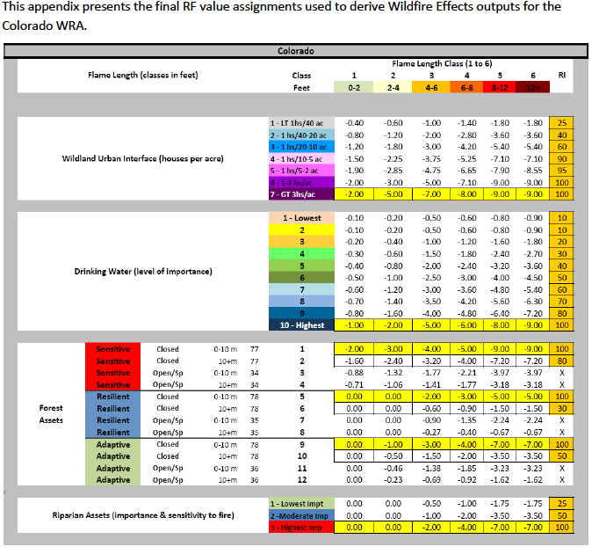

Appendix 1 Vicinity View of the Grant Subdivision

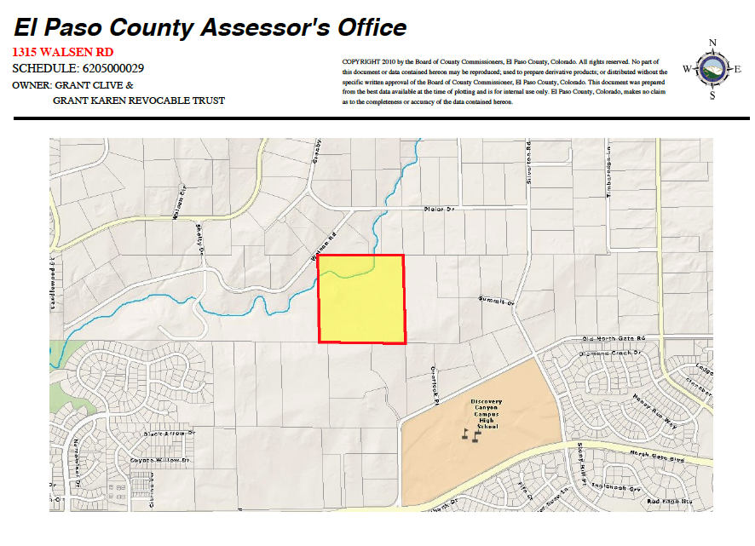

Appendix 2. Plat of Grant Subdivision into 11- and 30-acre parcels

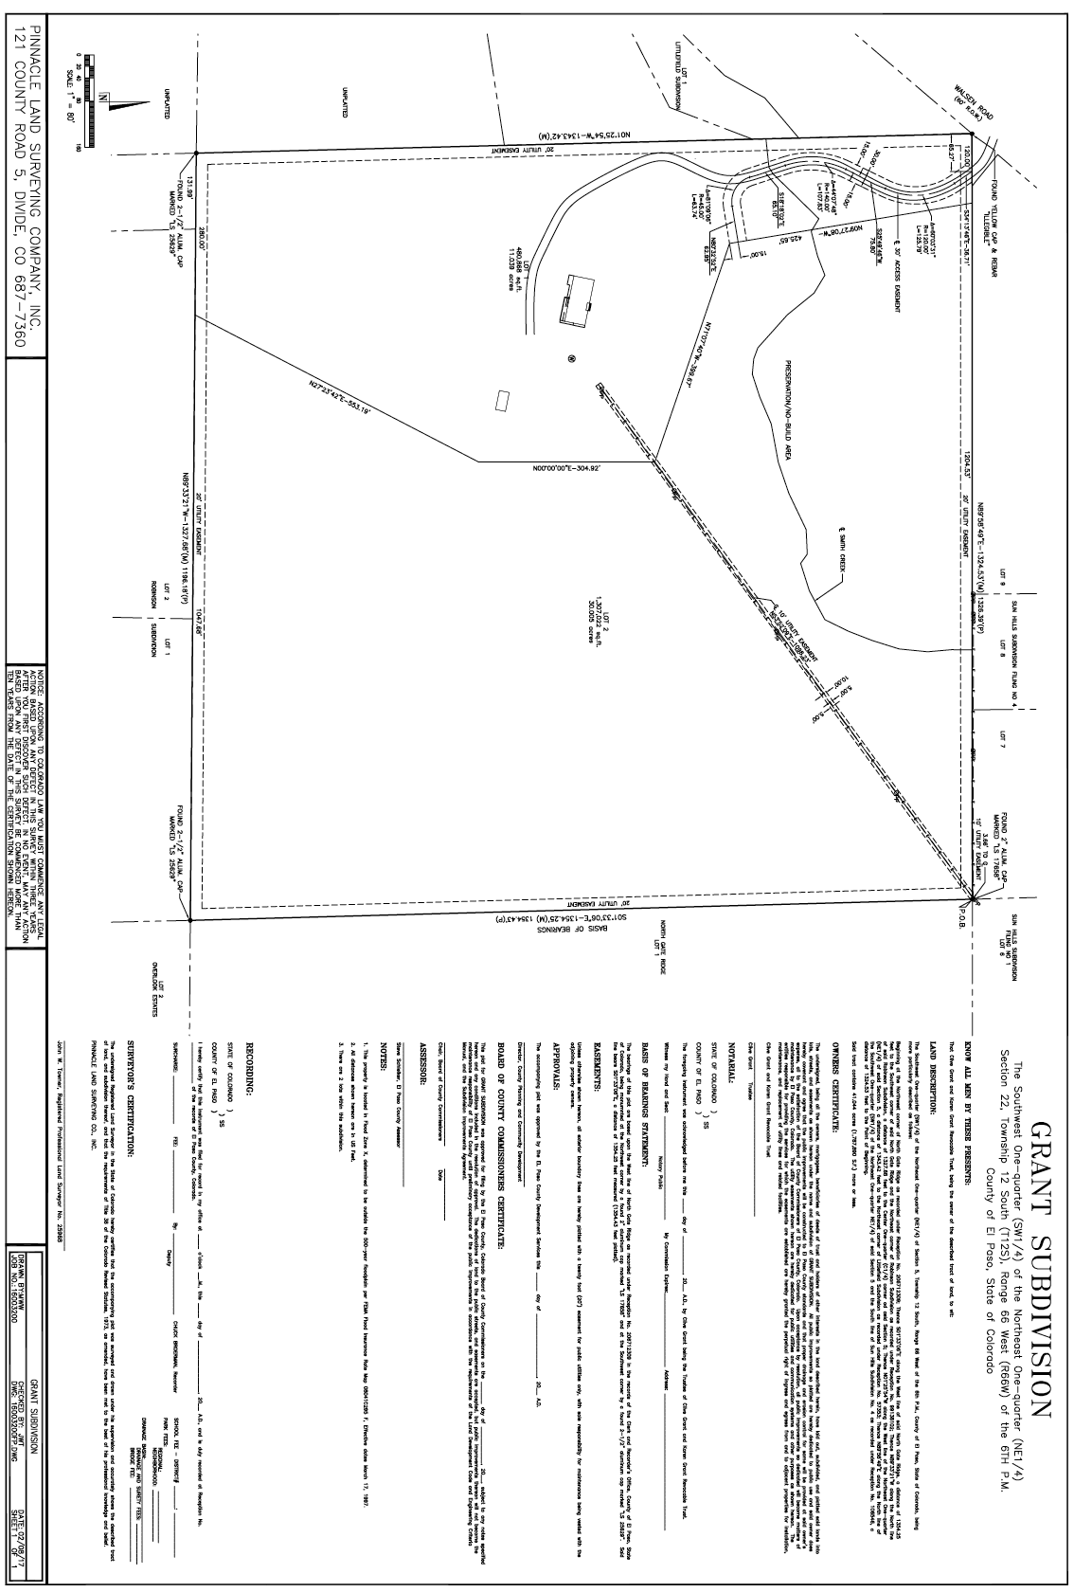
Appendix 3. Fire Intensity

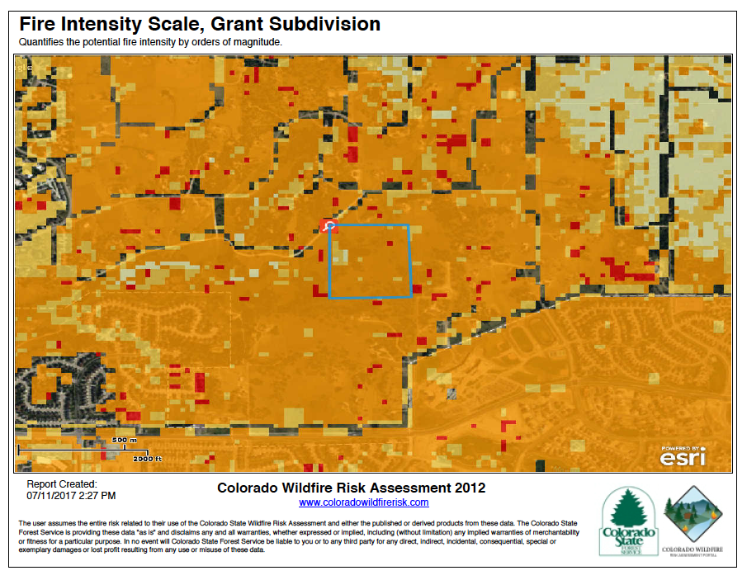
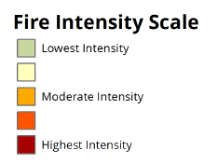

Appendix 4. Wildland Urban Interface

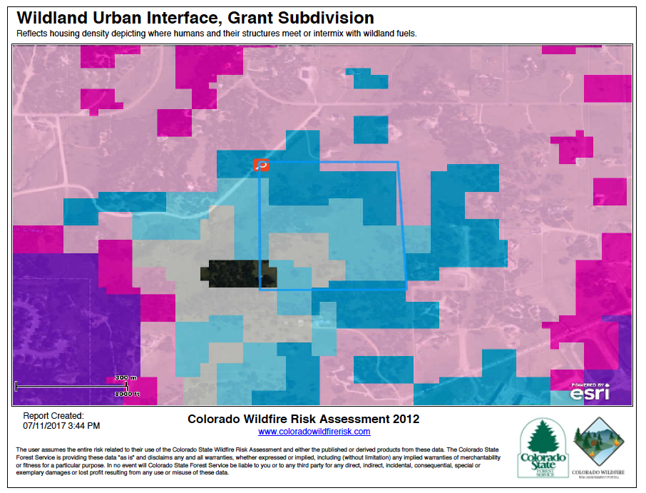

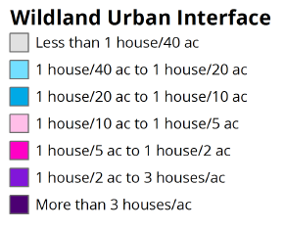

Appendix 5. Vegetation

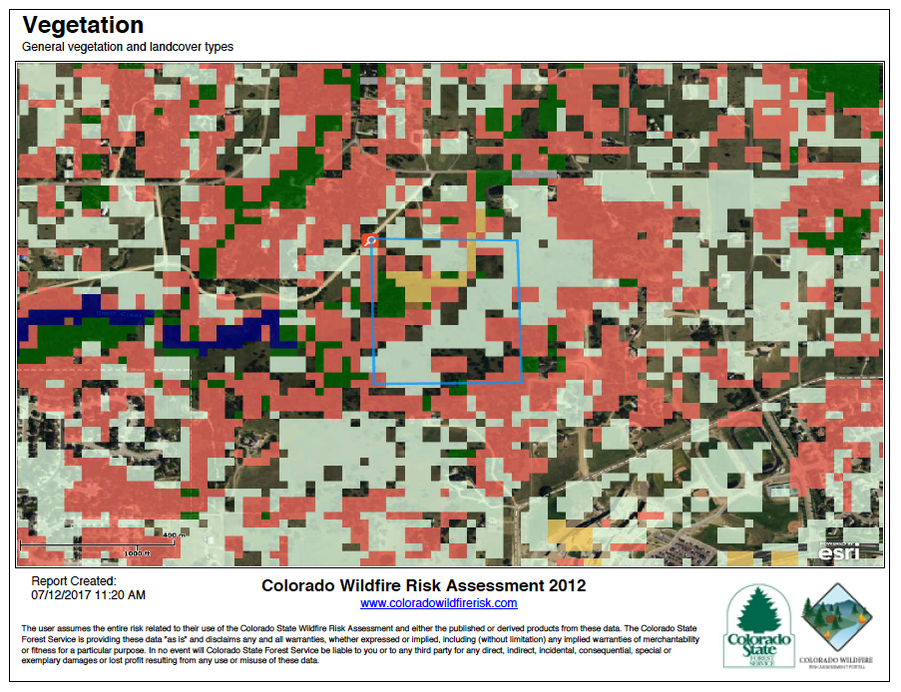

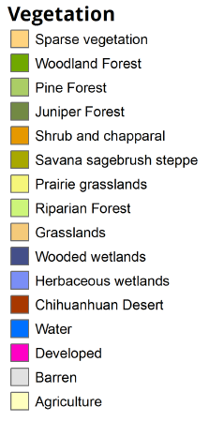
Appendix 6. Surface Fuels

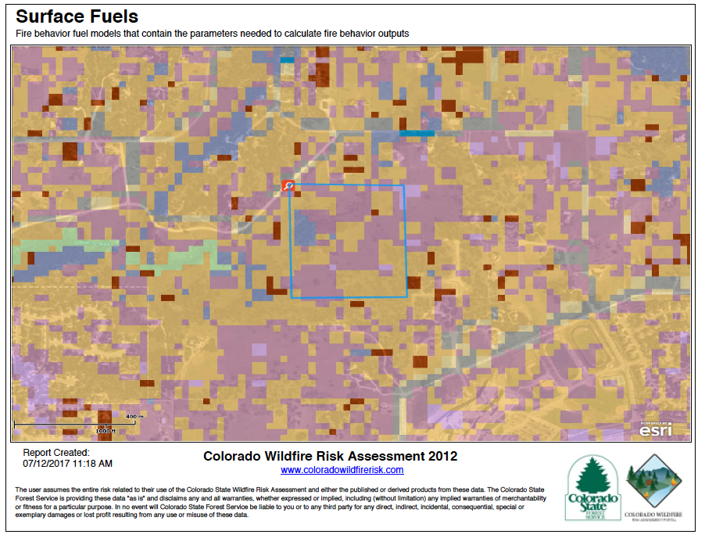
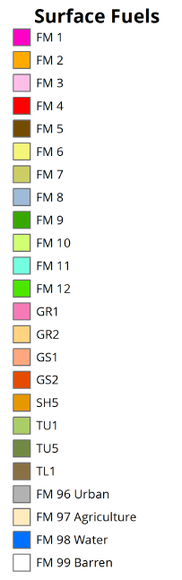

Appendix 7. Wildland Urban Interface Risk
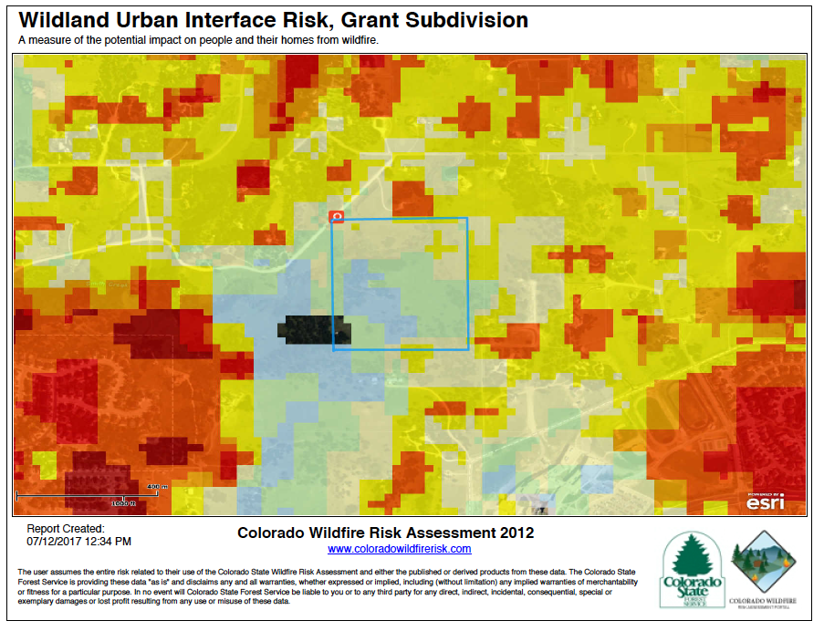
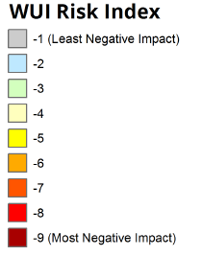

Appendix 8. Values At Risk Rating

