COLORADO GEOLOGICAL SURVEY

Land Use Review Program
1801 19th Street
Golden, Colorado 80401
303-384-2655
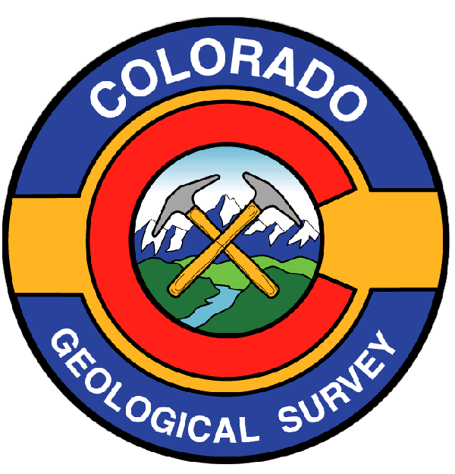

Karen Berry
State Geologist

R E C E I P T

Receipt acknowledging payment for land use review performed by the Colorado Geological Survey.

Applicant: Clive Grant

Project Name: Grant Minor Subdivision

Colorado Geological Survey Unique No. EP-18-0004

Payment received: $600.00

Payee: Clive Grant

Date: July 24, 2017

Should you have questions regarding this receipt, please contact:

Debbie Cockburn
Program Assistant
Colorado Geological Survey
303-384-2647
dcockbur@mines.edu

