April 18, 2025

County File: OAR254

Re: OAR : DR2025-001 Cross Mountain

To: Douglas County Planning
C Boyd ( cboyd@douglas.co.us )

Planning Division
Note that El Paso County does not have land use authority over property within the City of Colorado Springs; however, it is recommended that the development follow these regulations for this site to ensure that proper measures are taken to ensure compatibility between the proposed use within the City and the existing neighborhood and surrounding properties in the County.

An annexation has been submitted to the county for this area. That annexation project will require an annexation impact report. Additionally, annexation must be approved and completed prior to this project or any other project to the area can be approved.

Section 6.2.2.B Landscape Requirements:
(B)Roadway Landscaping Requirements. Roadway landscaping areas are required. A roadway landscaping area is located along the lot, parcel or tract frontage between the road right-of-way, easement, or tract boundary lines and any building or use.

(1)Minimum Depth of Roadway Landscaping Area.

Table 6-1 lists the depth and number of trees required to be provided along any road in roadway landscaping area. Where the required setback is narrower than the depth of the required landscape area, the roadway landscaping area depth shall control. Unless otherwise approved by the ECM Administrator, the depth of roadway landscaping shall be measured from the property line. Where a roadway easement has been provided, the measurement shall be from the ROW or roadway easement. Where future ROW has been identified, the measurement should begin at the future ROW line in order avoid subsequent impairment of the landscaping.

Table 6-1. Roadway Landscaping Required by Roadway Classification

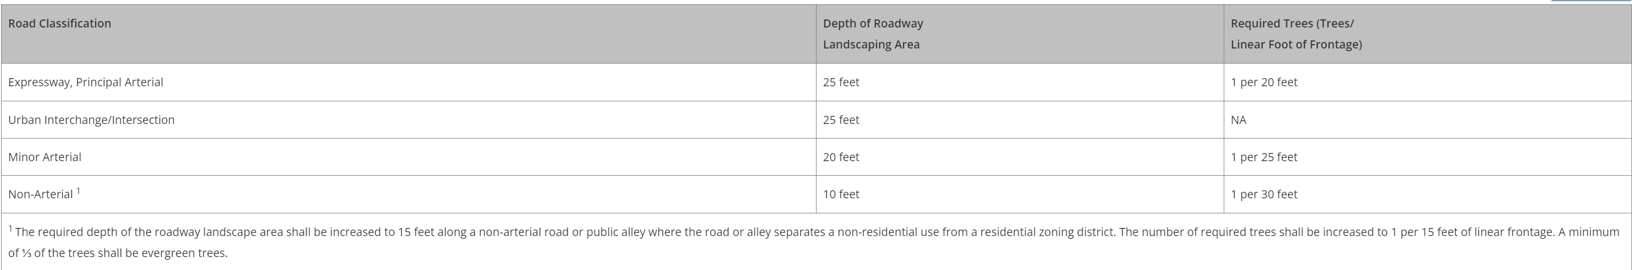

1 The required depth of the roadway landscape area shall be increased to 15 feet along a non-arterial road or public alley where the road or alley separates a non-residential use from a residential zoning district. The number of required trees shall be increased to 1 per 15 feet of linear frontage. A minimum of ⅓ of the trees shall be evergreen trees.

(2)Location and Type of Trees in Roadway Landscaping Area.

(a)Clustering Allowed. The roadway landscaping trees may be clustered along a road frontage. The clustering of evergreens may not be advisable in areas where the winter shade will cause unsafe conditions on an adjacent road.

(b)Type of Tree Limited. The types of roadway landscaping trees utilized shall be commonly known to grow in the Colorado Springs area and listed in the Landscape and Water Conservation.

(c)Exceeding Minimum Depth of Roadway Landscaping. The roadway landscaping trees shall be located within 50 feet of the road right-of-way, easement or tract boundary line and any building or use.

(d)Allowed in Right-of-Way if Approved. The roadway landscaping trees may be placed in a right-of-way if the right-of-way owner approves the placement and no conflicts exist, or will exist, with utility easements or any provider of utilities. Generally, trees are not allowed to be placed within any County right-of-way. Placing of the required roadway landscaping trees within the right-of-way shall not negate the requirement for the required roadway landscape area.

(e)Single-Family PUD Roadway Landscaping. Roadway landscaping is not required along local residential roadways (non-arterials) within a residential PUD.

(3)Walls and Fences in Roadway Landscape Area. Walls and fences which are 25% or more opaque shall not exceed 3 feet in height when located within a required roadway landscaping area. Opaque walls and fences higher than 3 feet (such as noise barriers) shall be located outside of the roadway landscaping area to maintain a landscaped appearance along the road.

Section 6.2.2.E
(E)Internal Landscaping.

The following internal landscaping is required:(1)Requirements for Multifamily Uses. The following internal landscaping is required for multifamily uses:

(a)Minimum Required Internal Landscaped Area. A minimum of 15% of the lot or parcel shall be landscaped.

(b)Minimum Number of Trees in Landscaped Area. A minimum of 1 tree shall be provided for every 500 square feet of required internal landscape area.

(2)Requirements for Non-Residential Uses. The following internal landscaping is required for non-residential uses.

(a)Minimum Required Internal Landscaped Area. A minimum of 5% of the lot or parcel shall be landscaped.

(b)Minimum Number of Trees in Landscaped Area. A minimum of 1 tree shall be provided for every 500 square feet of required internal landscape area.

(c)Trees Replaced by Shrubs. A maximum of ½ of the required trees may be substituted with shrubs adjacent to retail store fronts where the view of wall signs may be obstructed. At least 10 shrubs with a minimum container size of 5 gallons shall be provided for each tree that is replaced.

Reviewed by: Ashlyn Mathy, Planner
Ashlynmathy2@elpasoco.com

Engineering Division
EPC Engineering has no comments.

Reviewed by:
Charlene Durham, PE
charlenedurham@elpasoco.com
County Engineer (Public Works)
Additional comments may be provided by the County Engineer.

Ashlyn Mathy, Planner
El Paso County Development Services
2880 International Circle, Colorado Springs, CO, 80910
(719) 520-6447

