DEVELOPMENT AGREEMENT

WILLIAMS CREEK GENERATING STATION

This Development Agreement (“Agreement”) is entered into this day of , 2026 (“Effective Date”) by and between El Paso County, by and through the Board of County Commissioners of El Paso County, Colorado, a statutory county and political subdivision of the State of Colorado (“County”) and Colorado Springs Utilities, a municipal utility, (“Utilities”). County and Utilities may be referred to herein individually as a “Party” and collectively as the “Parties.”

RECITALS

- Utilities desires to construct and operate in unincorporated El Paso County a natural gas-fired electrical generation facility known as the Williams Creek Generating Station (“Project”) on Property legally described in Exhibit A attached hereto and a map of which is set forth in Exhibit B attached hereto. The Property is owned by the City of Colorado Springs.
- The Project falls within the scope of the County’s authority under Guidelines and Regulations for Areas and Activities of State Interest of El Paso County, contained in Appendix B of the El Paso County Land Development Code (“1041 Regulations”). The Project specifically falls within the scope of and must obtain a 1041 Permit under Chapter 5, Site Selection and Construction of Major Facilities of a Public Utility, of the 1041 Regulations.

- The Parties recognize that the Project will create impacts on public infrastructure and property and that the purpose of this Agreement is to provide for the identification and mitigation of those impacts that can be quantified and to estimate in good faith a monetary value for any impacts that may not be readily identifiable or quantifiable under the 1041 Permit process.

AGREEMENT

NOW, THEREFORE, for and in consideration of the mutual promises contained here and other good and valuable consideration, the receipt and sufficiency of which are hereby acknowledged, the Parties agree as follows:

- Incorporation of Recitals. The Recitals set forth above shall be incorporated by reference into this Agreement as if fully stated herein.

- General Project Description. The Project is a 400 MW natural gas-fired powerplant and associated infrastructure improvements.

- Compliance with Applicable Laws. Utilities must comply with all applicable federal, state, and local laws, ordinances, rules, and regulations and all applicable approvals, permits, and licenses in the construction, operation, and decommissioning of the Project. Utilities may not commence any construction or installation activity related to the Project until obtaining all necessary approvals, permits, and licenses required to be obtained prior to such commencement of construction or installation. Without limiting the generality of the foregoing, Utilities shall obtain approval of the Site Development Plan and provide appropriate documentation from the U.S. Fish & Wildlife Service and Colorado Parks & Wildlife in a form reasonably satisfactory to the County regarding threatened and endangered species and providing proof of the same to the County.

- Time Limit on Installation and Construction. Utilities shall initiate construction of the Project within one (1) year of the Effective Date and shall have four (4) years from the Effective Date to achieve Substantial Completion. For purposes of this Agreement, Substantial Completion means that the Project has completed construction activities, including restoration of any required areas, and is generating electricity. If the Utilities does not begin construction within two (2) years of the Effective Date, then the Board of County Commissioners, at an open and public hearing following legal published notice, may elect to revoke or suspend the 1041 Permit pursuant to Section 2.508 of the 1041 Regulations. Said one (1) and four (4) year periods shall be extended for any delays arising by an event of force majeure. In the event Utilities has not achieved Substantial Completion by the end of the 4-year period, including any extensions arising from the application of an event of force majeure, the County may require Utilities to seek an extension and/or an amendment to the 1041 Permit.

- Project Facilities Repair, Maintenance, and Replacement. Utilities shall be permitted to repair and maintain the Project Facilities without any further approval from the County or amendment to this Agreement, and to replace any element of the Project Facilities with a comparable element that is within the size limits and general configuration defined in the 1041 Permit, is located in the same location as the element being replaced, and meets the Development Standards in the 1041 Permit. The transportation and construction-related activities associated with the Project Facilities replacement process may require Utilities to obtain additional administrative permits prior to initiating construction.

- Identification of Haul Route. The Parties agree that the Project, particularly during construction, will impact County paved and unpaved roads based on the number of anticipated trips per day and the weight of the vehicles making such trips. Utilities has identified a single Haul Route along public roads to and from the Project site. The Haul Route exits I-25 at Old Pueblo Road and continues along Old Pueblo Road and Birdsall Road, which are County maintained roads, to a private road which accesses the Project site. This is the Oversize Load Route which is to be used to haul materials and equipment to the Project site. The Haul Route is depicted in Exhibit C, attached hereto. Hauling on this Route will be subject to an approved County Haul Permit, and will depend on trucking requirements for turn radii. This route is to be used to transport oversize loads. The Oversize Load Route may be referred to herein as the "Restricted Route.”

- Identification of Impacts to Haul Routes.

  - Utilities shall prepare or cause to be prepared Road Condition Surveys for the Oversize Load Route prior to commencing construction of the Project, one year after commencement of construction, and after Substantial Completion of the Project. Each Road Condition Survey shall be conducted in accordance with the Road Condition Survey Work Plan attached hereto as Exhibit D and shall be shared with the County within three (3) business days of completion.
  - Once construction commences and until Substantial Completion of the Project, Utilities shall also make visual observations of the Oversize Load Route following each day of use and complete a Road Report, attached hereto as Exhibit E, documenting such observations, comparing them to prior observations and the most recent Road Condition Survey, and identifying any new damage to the roads and rights-of-way. Utilities shall share such Road Report with the County within two (2) business days of completion.

  - County staff may also conduct periodic inspections of the Haul Routes at their discretion and shall complete a Road Report if any damage to a road or right-of-way is observed. Such Road Reports shall be shared with the other Parties within two
(2) business days of completion.

- Mitigation of Impacts to Haul Routes.
  - Road Damage During Construction. Should any Road Report or Road Condition Survey completed by any Party identify new damage to a road or right-of-way along a Haul Route, Utilities and the County shall make best efforts to meet within three (3) business days to determine whether such damage was caused wholly or partially by Utilities’ activities related to the Project and, if so, whether the damage shall be repaired by Utilities or the County. If the damage is to be repaired by the Utilities, Utilities must obtain all appropriate permits and approvals, including but not limited to a County Work-in-the-Right-of-Way permit, prior to conducting such work. If the damage is to be repaired by the County, the funds necessary to reimburse for the cost of such repairs may be withdrawn from the funds provided by Utilities pursuant to paragraphs 8.b. below, as applicable.
  - Long-Term Maintenance Impacts to County Roads. County and Utilities agree that the projected use of the County roads located within the Restricted Route by construction and other heavy vehicles will shorten the useful life of the County roads on such routes in a manner that is not easily identified or quantified. The County and Utilities agree that a reasonable estimate of the cost of such long-term impacts is $______________. Utilities shall deposit this sum with the County in connection with approval of the Site Development Plan, and the County shall keep the funds in a restricted account separate from its general fund.

If road damage identified pursuant to paragraph 8.a. above is repaired by the County, the County may withdraw from the County Road Funds the amount necessary to reimburse itself for the cost of such repairs. If no County Road Funds are available due to previous reimbursements, Utilities shall reimburse the County for road damage repairs within thirty (30) days of receiving an invoice for such repairs. If Utilities repairs road damage to a County road pursuant to paragraph 8.a. above, and the County-approved scope of such work exceeds that necessary to repair road damage wholly caused by Utilities’ Project activities, the County may authorize the return to Utilities of escrow funds for the additional work. If any County Road Funds remain after Substantial Completion of the Project, the County shall be entitled

to retain such moneys as liquidated damages for the negative impacts to the useful life of the County roads located within the Restricted Route.
  - Use of Alternate Routes by Construction Traffic. The Parties agree that use of any route other than the Restricted Routes by heavy vehicles hauling materials and equipment to the Project site may result in damage to public roads and may shorten the useful life of such roads. The Parties also agree that this Agreement does not account for those damages and impacts on public roads outside the Restricted Route. Utilities shall be held responsible for the use of any road other than the Restricted Route by its employees, contractors, and agents driving heavy vehicles to and from the Project site (“Unauthorized Use”). Should an Unauthorized Use be observed by County employees or documented by photo, video, or other corroboration of an observation by a member of the public or other third party, the Utilities shall pay to the County _____ Dollars ($______) for each day such Unauthorized Use occurs as liquidated damages for any resulting damage or negative impact to the public roads used. Utilities shall pay such liquidated damages to the County within fourteen (14) days of receiving notice, along with any supporting evidence, of an Unauthorized Use.

- Contacts/Party Representatives. The Parties designate the following representatives to receive all Road Reports and other notices and communications related to this Agreement. A Party may substitute its representative by providing written notice to the other Parties.
For the County: For the City:
For the Developer:

For the County:

For Utilities:
Colorado Springs Utilities
1521 Hancock Expressway
Colorado Springs, CO 80903
Attn: Mike Myers, General Manager
Telephone: (719) 668-8766
Email: mmyers@csu.org

- El Paso County Road Impact Fee. Utilities understands and agrees that the Project is subject to the provisions of the El Paso County Road Impact Fee and that the imposition of such Road Impact Fee is separate and does not arise from the 1041 Permit or this Agreement. The Road Impact Fee shall be assessed at the time of Site Development Plan approval.

- General Provisions.

  - Indemnity. The Utilities and its successors and assigns shall indemnify and hold harmless the County and the County’s elected officials and employees, agents, and contractors from and against any and all losses, injuries, damages, claims, demands, suits, liabilities, causes of action, settlements, costs, or expenses that are caused by or result from the acts and omissions of Utilities or its employees, officer, or agents arising from the installation, construction, operation, maintenance, repair, and decommissioning of the Project. Nothing in this paragraph shall be interpreted to limit or waive any of the immunities, rights, limitations of liability and defenses afforded the County under the Colorado Governmental Immunity Act, C.R.S. 24-10-101, et seq.

  - Amendment. This Agreement may be amended by mutual agreement of the Parties only by a writing signed by all Parties.

  - Assignment. No Party may assign its rights and obligations under this Agreement without the prior written consent of all other Parties, which consent shall not be unreasonably withheld.

  - Binding Effect. This Agreement shall be binding upon and inure to the benefit of the Parties and their respective personal representatives, heirs, successors, and assigns.

  - Waiver. No delay in exercising any right or remedy under this Agreement shall constitute a waiver thereof by any Party hereto, and no waiver by the Parties of a

breach of any provision of this Agreement shall be construed as a waiver of any subsequent breach hereunder.

  - Colorado Law and Venue. This Agreement shall be interpreted and enforced in accordance with the laws of the State of Colorado. In the event of any litigation that may arise hereunder, the Parties agree that jurisdiction and venue shall lie in the District Court of El Paso County, Colorado.

  - Counterparts. This Agreement may be executed in two or more counterparts, each of which shall be deemed an original, but all of which together shall constitute one and the same instrument. The signature pages from one or more counterparts may be removed from such counterparts and such signature pages shall be attached to a single instrument.

  - Severability/Integrated Terms and Conditions. Because compliance with the terms and conditions of this Agreement is a condition of the 1041 Permit, its terms and conditions are integrated into the 1041 Permit. Therefore, if any provisions of this Agreement are determined by a court of competent jurisdiction to be unenforceable or invalid, the 1041 Permit and this Agreement shall be rescinded or suspended unless the Board of County Commissioners, in its sole subjective discretion, approves an amendment to the 1041 Permit and/or this Agreement.

  - No Third-Party Beneficiary. This Agreement is made and entered into for the sole protection and benefit of the Parties hereto and their respective successors and assigns. Nothing in this Agreement is intended to create or grant to any third party or person any right or claim for damages or the right to bring or maintain any action at law or equity.

  - Entire Agreement. This Agreement, together will all exhibits attached hereto, constitutes the entire agreement between the Parties. This Agreement is specifically intended by the Parties to supersede all prior agreements, whether written or oral.

  - Recording. This Agreement shall be recorded in the public records of the El Paso County Clerk and Recorder.

In witness of the foregoing provisions, the Parties have executed this Agreement as of the Effective Date Above.

BOARD OF COUNTY COMISSIONERS
ATTEST: OF EL PASO COUNTY

___________________________ By: _______________________________
Steve Schleiker Carrie Geitner, Chair
County Clerk and Recorder

Approved as to form:

___________________________
County Attorney’s Office

COLORADO SPRINGS UTILITIES

By: ______________________________
Name:
Title:

EXHIBIT A

A TRACT OF LAND BEING A PORTION OF THE SOUTHEAST QUARTER OF SECTION 23, A PORTION OF THE NORTHWEST QUARTER OF SECTION 25, A PORTION OF THE NORTHEAST QUARTER OF SECTION 26, TOWNSHIP 16 SOUTH, RANGE 65 WEST OF THE SIXTH PRINCIPAL MERIDIAN, COUNTY OF EL PASO, STATE OF COLORADO, MORE PARTICULARLY DESCRIBED AS FOLLOWS:

BASIS OF BEARINGS: THE SOUTH LINE OF NORTHEAST QUARTER OF SECTION 26, TOWNSHIP
16 SOUTH, RANGE 65 WEST OF THE SIXTH PRINCIPAL MERIDIAN, BEING MONUMENTED ON THE EASTERLY END BY A 2-1/2” ALUMINUM CAP STAMPED” JR ENG T16S R65W S ¼ S26 S25 1990 RlS 10377” 0.3’ ABOVE GRADE AND AT THE WESTERLY END BY A NO. 6 REBAR AT GRADE, BEING ASSUMED TO BEAR S88°50’27”W A DISTANCE OF 2,634.15 FEET.

COMMENCING AT THE CENTER ONE-QUARTER CORNER OF SECTION 26, TOWNSHIP 16 SOUTH, RANGE 65 WEST OF THE SIXTH PRINCIPAL MERIDIAN, COUNTY OF EL PASO STATE OF COLORADO, SAID POINT BEING THE POINT OF BEGINNING; THENCE N00°37’37”W ON THE WEST LINE OF THE NORTHEAST QUARTER OF SAID SECTION 26 A DISTANCE OF 2,639.87FEET TO THE SOUTH QUARTER CORNER OF SECTION 23, TOWNSHIP 16 SOUTH, RANGE 65 WEST OF THE SIXTH PRINCIPAL MERIDIAN; THENCE N00°54’15”W ON THE WEST LINE OF THE SOUTHEAST QUARTER OF SAID SECTION 23 A DISTANCE OF
329.15 FEET; THENCE N89°05’45”E A DISTANCE OF 386.15 FEET TO A POINT ON THE BOUNDARY OF LESS AND EXCEPT PARCEL 8 DESCRIPTION AS DESCRIBED IN THE DOCUMENT RECORDED UNDER RECEPTION NUMBER 224021775; THENCE ON THE BOUNDARY OF SAID LESS AND EXCEPT PARCEL 8 DESCRIPTION THE FOLLOWING FIVE (5) COURSES:
- S55°34’44”E A DISTANCE OF 394.67 FEET;
- S57°14’24”E A DISTANCE OF 597.66 FEET;
- N37°53’41”E A DISTANCE OF 94.28 FEET;
- S60°55’39”E A DISTANCE OF 185.55 FEET;
- N89°28’27”E A DISTANCE OF 670.32 FEET;

THENCE N90°00’00”E A DISTANCE OF 782.17 FEET TO A POINT ON THE BOUNDARY OF LESS AND EXCEPT PARCEL 3 DESCRIPTION AS DESCRIBED IN THE DOCUMENT RECORDED UNDER RECEPTION NUMBER 224021775; THENCE ON THE BOUNDARY OF SAID LESS AND EXCEPT PARCEL 3 DESCRIPTION THE FOLLOWING SIX (6) COURSES:
- S00°31’31E A DISTANCE OF 52.71 FEET;
- S11°42’17”E A DISTANCE OF 245.67 FEET;
- S44°10’34”E A DISTANCE OF 936.30 FEET;
- S55°34’42”E A DISTANCE OF 379.58 FEET;
- S00°31’31”E A DISTANCE OF 682.37 FEET;
- N89°28’29”E A DISTANCE OF 47.20 FEET;
THENCE S00°31’28”E A DISTANCE OF 175.54 FEET TO A POINT ON THE BOUNDARY OF LESS AND EXCEPT PARCEL 4 DESCRIPTION AS DESCRIBED IN THE DOCUMENT RECORDED UNDER RECEPTION NUMBER 224021775; FEET; THENCE S00°31’28”E ON THE BOUNDARY OF SAID LESS AND EXCEPT PARCEL 4 DESCRIPTION A DISTANCE OF 122.76 FEET; THENCE CONTINUING S00°31’28”E A DISTANCE OF 182.95 FEET TO A POINT ON THE SOUTH LINE OF THE NORTHWEST QUARTER OF SECTION 25 TOWNSHIP 16 SOUTH, RANGE 65 WEST OF THE SIXTH PRINCIPAL MERIDIAN; THENCE S88°58’49”W ON SAID SOUTH LINE A DISTANCE OF 1,293.10 FEET THE EAST QUARTER CORNER OF SAID SECTION 26; THENCE S88°50’27”W ON THE SOUTH LINE OF THE NORTHEAST QUARTER OF SAID SECTION 26 A DISTANCE OF 2,634.15 FEET TO THE POINT OF BEGINNING.

CONTAINING A CALCULATED AREA OF 8,963,181 SQUARE FEET OR 205.766 ACRE

EXHIBIT B

Map of Project Site Location

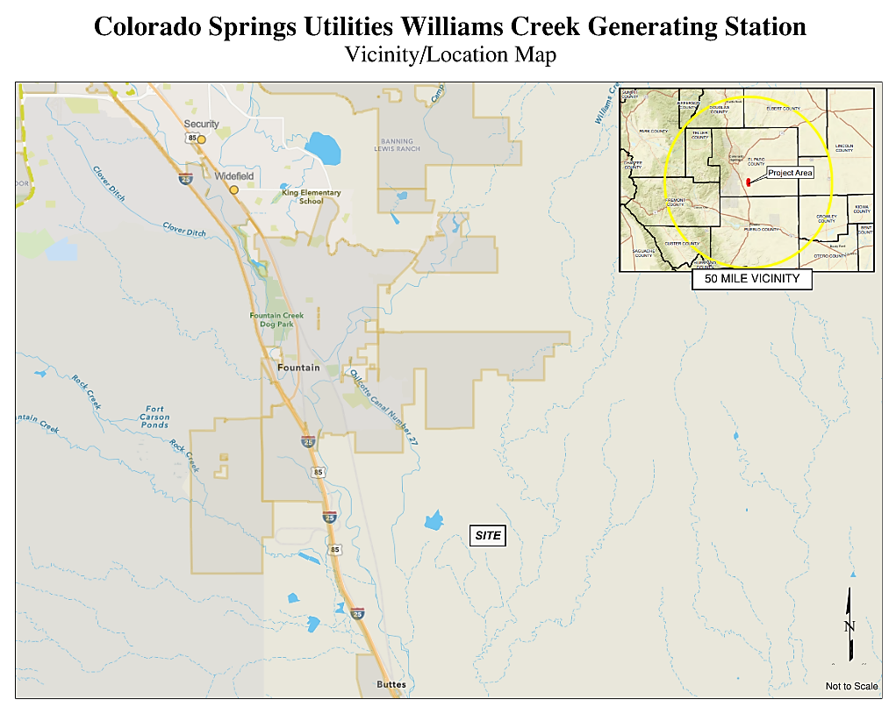

EXHIBIT C

Map Identifying Haul Route

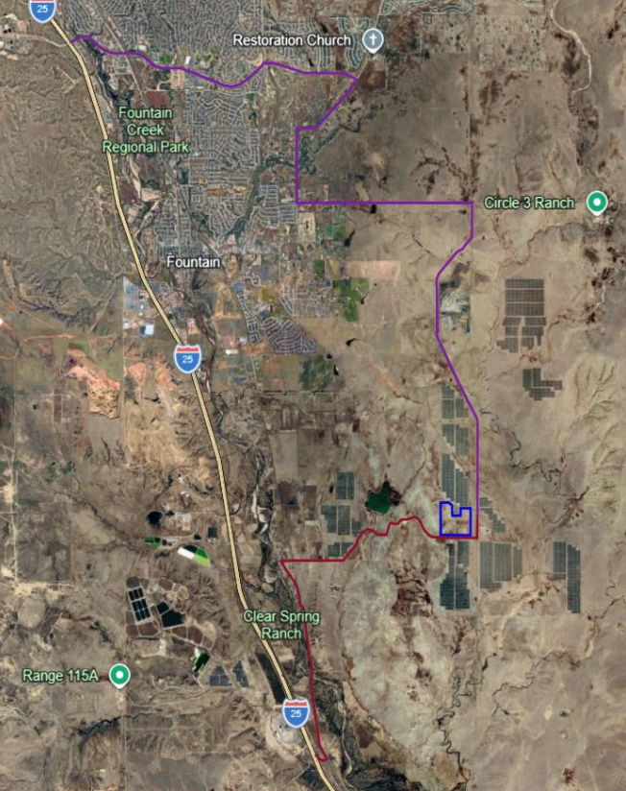

EXHIBIT D

(Road Condition Survey Work Plan)

(TBD)

EXHIBIT E

WILLIAMS CREEK GENERATING STATION ROAD REPORT

Background
Date | Enter date of observation | Time | Enter time of observation
Name | Enter name of inspector | Organization | Enter inspector’s organization
Road Name | Enter name of assessed road | Weather Conditions | Briefly describe current
temperature and precipitation

Attach a map showing the location of the observation
Description of Observations

Provide a detailed description of observations, including any damage noted.

Is any of the damage new since the last Road Report / Road Condition Survey?
Photo Log

Photo Description Image Name

