Early Assistance Meeting Number: EA2639
Project Name: CMD PFAS Treatment Plant
Project Location: 23838 HIGHWAY 94
Project Parcel No. 2400000270
Parcel size: 77 acres
Project Description: Cherokee Metro District’s proposed new water treatment facility to treat emerging PFAS drinking water standards.
Gallons – 8.6 MGD design capacity (assuming 6000gpm)
Height – Approximately 30’
floor plan SF – approximately 15,700 sq..ft. building
new lines diameter –24-30” diameter to match existing lines in Hwy 94.
new or replacement infrastructure - Mostly existing, with some new to connect existing to facility.
Population to be served if new or existing – Unchanged (approximately 29,000)

Meeting Date: 4/1/26 11am

El Paso County Planning & Community Development Planning Checklist

Request – Map Provided by Applicant
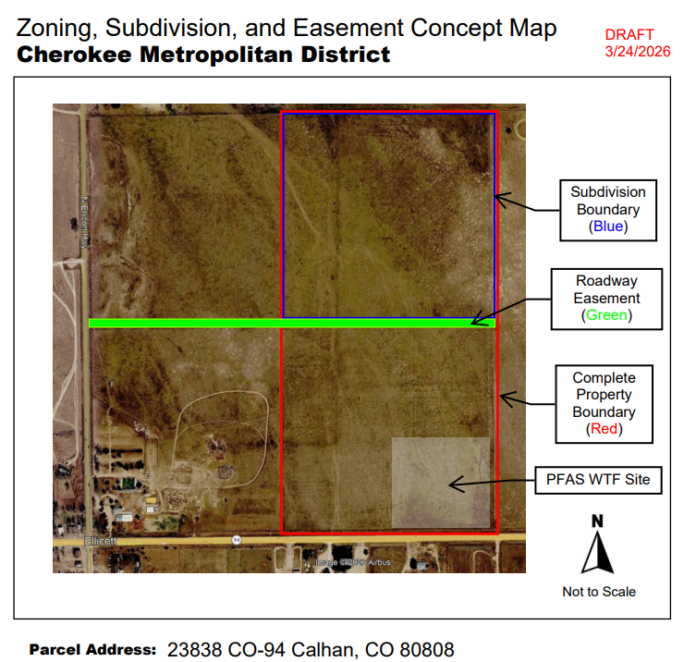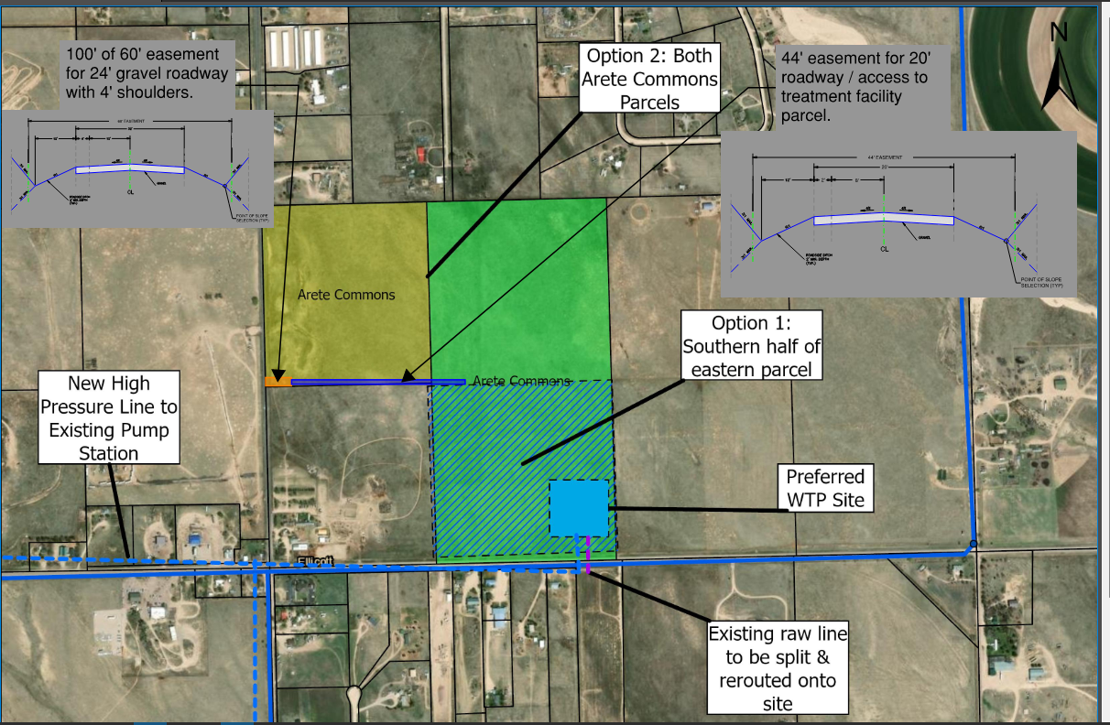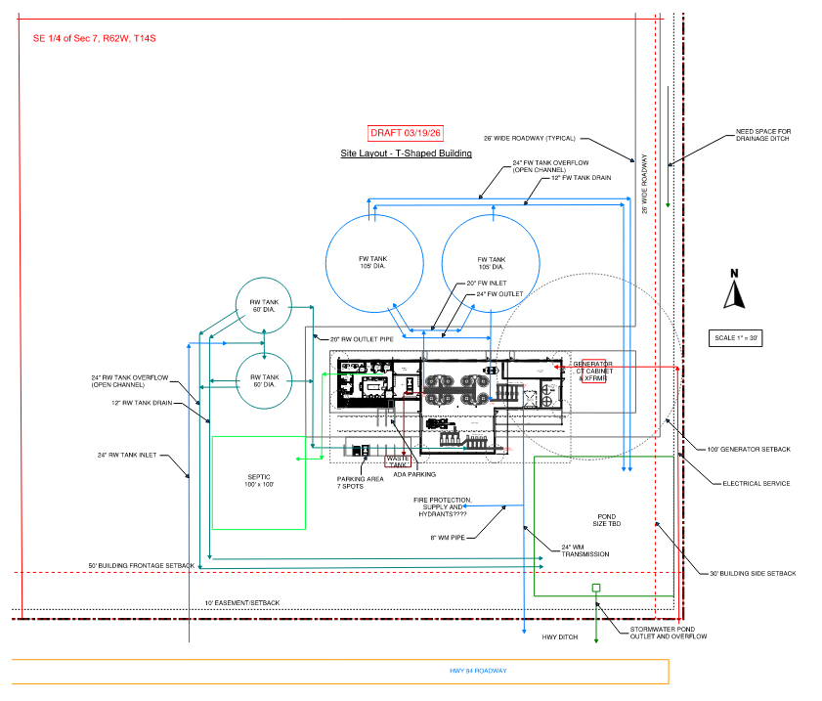
77 acres may be split w/o subdivision as long as 35-acre minimum parcels via land survey deposit
What are the Tank Heights 40’
Pipeline maps to connect to new verses old in 1041

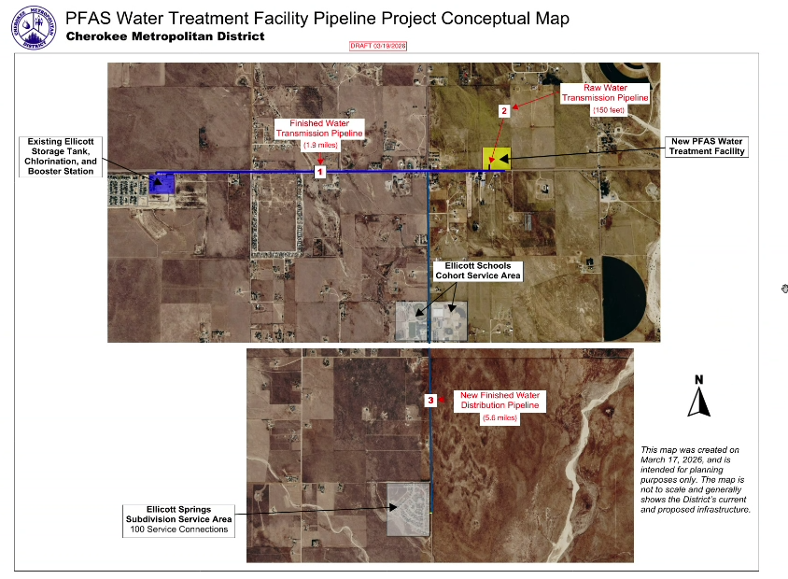

Zoning
Existing Zone(s)
 |  | Name
A35 |  | Agricultural
Proposed Zone(s)
Zone |  | Name
No Change

Zone Map (existing conditions of approval)
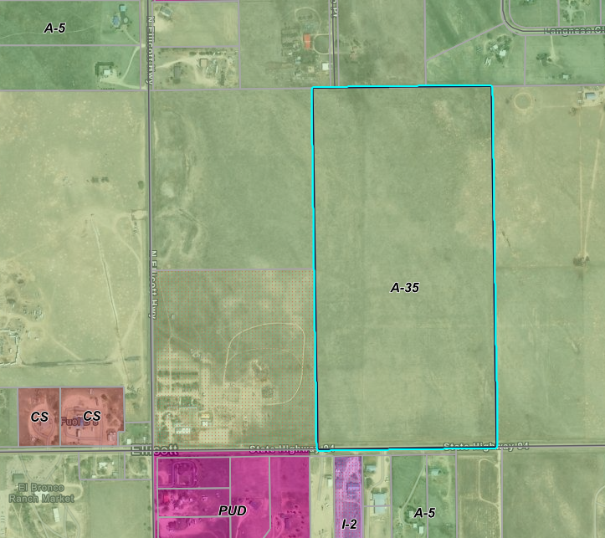

Zoning Analysis
1041 to site utility; No Rezoning for utility location pursuant to 1041 approval;

2.103. Permit Authority Established
(1) The El Paso County Permit Authority is hereby established, the members of which shall be the Board of County Commissioners.
(2) Except as otherwise specifically set forth in these Regulations, the Permit Authority shall exercise all powers and duties described in this Chapter 2.

2.104. Permit or Administratively Approved Permit Required
(1) No person may conduct a designated activity of state interest, or develop in a designated area of state interest, without first obtaining an Administratively Approved Permit, a Permit, or a Permit amendment under these Regulations.
(2) No Permit for a permanent use in a County right-of-way or on County owned properties and no grading Permit, excavation Permit or building Permit shall be issued by the County for the purposes of development in an area of state interest and/or conduct of a designated activity of state interest without first obtaining an Administratively Approved Permit pursuant to these Regulations.
(3) When approval is sought to conduct more than one activity of state interest and/or engage in development in more than one area of state interest, the application may be completed for all such activities or developments and may be reviewed simultaneously and a single Permit issued.

Zoning District Requirements (density, lot size, lot design standards, building setbacks)
Establish in the 1041 in addition to the A35

Plat Map or Parcel Map (conditions of approval):
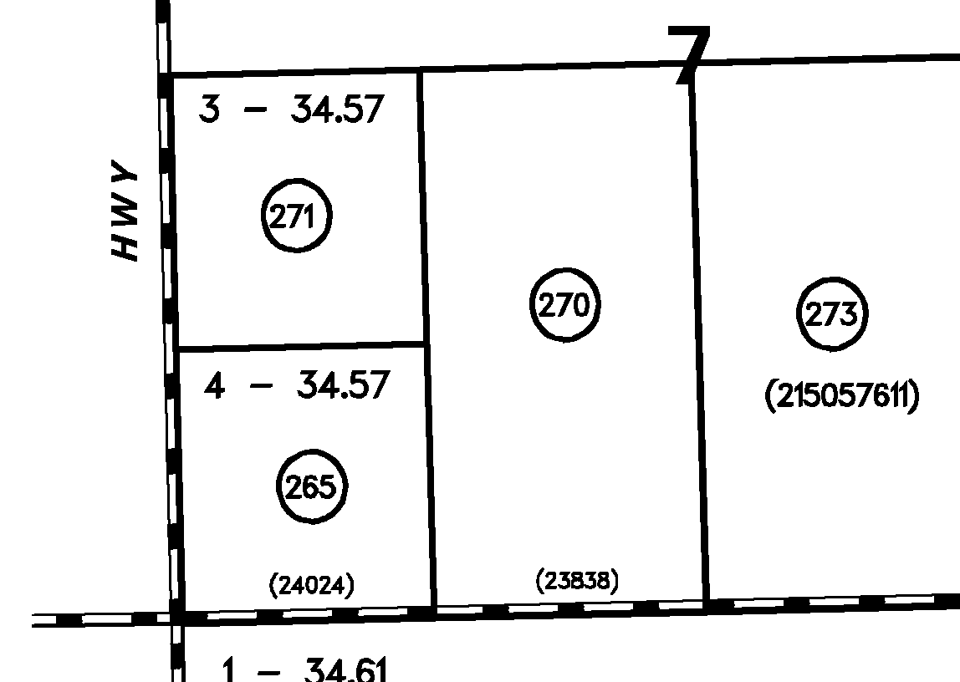

HEALTH DEPT: OWTS Engineer design; Construction Activity permit
Septic to serve admin building; 1041 Waste Tank- EPA class 5 injection well permit- may be needed to address criteria (check with EPA).

Application Type(s) Hearing: Required/ Optional/ No
Land Survey Deposit/Deed to divide property outside of PCD or Exemption Plat for Utilities
1041 REQUIRED HEARING
Site Development Plan

Approval Criteria:
A land survey Deposit/Deed is done via a survey and deposited in Clerk and Recorder outside of PCD; OR
Exemption Plat:
(5)Right-of-Way, Utility, and Open Space Exemptions.
(a)Purpose. The purpose of this Section is to establish a process for the PCD acknowledgement that the proposed or actual acquisition or conveyance action is in conformance with these regulations and to document the changes to the affected parcels to ensure that any resulting nonconformities are recognized and that the development rights of the lot or parcel owner is documented.
(b)Applicability. The acknowledgement provided by this Section shall be applicable to the division of a lot or parcel of land which is the direct result of the acquisition by condemnation or otherwise, of any federal, State or local government road rights-of-way, acquisition by federal, state, or local government of land for open space or parks, and any parcel of land divided into 2 or more separate interests, 1 being the interest of the fee owner of the parcel and the other being easements or land granted for purposes of public or private utility lines entering or crossing the parcel.
(c)Criteria for Approval. The PCD Director, in approving a right-of-way, utility or open space exemption, shall find:
• The request serves a legitimate government or utility purpose; and
• There will be no impact on the status of the lot or parcel as a conforming lot or parcel, and if a nonconformity will result that the nonconforming lot or parcel will be deemed conforming with respect to lot size and will be eligible to apply for a variance in the event they do not meet the development standards of the applicable zone district.
(d)Completed Action. The establishment of right-of-way, utilities easements, or open space parcels shall be considered completed and in effect when an approved deed and graphical depiction, and any nonconforming lot determination necessary to document the rights associated with any nonconforming lot or parcel created are formally accepted by the BoCC. The documents shall be filed for recording with the Clerk and Recorder.

Processing Issues and Options/ Submittal Requirements/ Approval Criteria
1041 APPENDIX B - GUIDELINES AND REGULATIONS FOR AREAS AND ACTIVITIES OF STATE INTEREST

Chapter 2. Permit Regulations
2.303. Submission Requirements for All Permit Applications;
2.405. Review Criteria for All Applications

CHAPTER 3. - EFFICIENT UTILIZATION OF MUNICIPAL AND INDUSTRIAL WATER PROJECTS (3)Municipal and industrial water project: A water supply system and all related components through which a water supply from either surface or subsurface, alluvial or groundwater, renewable or non-renewable sources is derived for municipal or industrial uses or both. A water supply system includes wells, diversion facilities, pumps, conduits, canals, pipes, ditches, storage tanks, reservoirs or other impoundments, through which a water supply is obtained directly or by trade, substitution, augmentation or exchange, and also includes those components for returning unconsumed flows back to the stream system. The filing of an application in court or with the Colorado Ground Water Commission to adjudicate the use of water and obtaining a decree or determination, in and of itself, shall not constitute the development of a water project.(4)Municipal use: use of water by the general public whether supplied by a municipality or by private or special district providers.)
3.201 Application Submission Requirements
3.202. Review Criteria

Chapter 4. Site Selection & Construction of Major New Domestic Water and Sewage Treatment Systems and Major Extensions of Existing Domestic Water and Sewage Treatment Systems

4.201. Application Submission Requirements
4.202. Review Criteria

Relevant Past History:
Neighborhood meeting: Will start

Design and Landscaping

Site Design/Layout (Lot pattern, circulation/road design, open space, preservation of natural features, compatibility internally and with adjacent land uses)
Restore disturbance; rural in character for any above ground; construction hours; Parking towards interior; opaque fencing: brick stucco concrete include in 1041: over 7’ site in 1041

Landscaping
☐ | Expressway, Principal arterial area depth – 25’-Trees required 1 per 20’
☐ | Urban interchange/Intersection area depth – 25’- N/A
☐ | Minor arterial area depth 20’ – Trees required 1 per 25’
☐ | Non-arterial area depth 10’ – Trees required 1 per 30’
☐ | Parking lot landscaping required
☐ | Buffer between non-residential and residential districts separated by a non-arterial road or public alley

(d)Water Storage Tank and Utility Facilities Landscape Requirements.
(i)Site-Specific Landscaping Required. PCD Director approval of site-specific landscaping is required for a water storage tank and utility facilities. Installation of approved site-specific landscaping is required prior to putting a water storage tank or utility facility into operation. The site-specific landscaping is subject to the following standards:
• Rural and Remote Areas: In rural and remote areas landscaping, screening and erosion control measures shall be tailored to the nature and character of the area and the type of facility or structure contemplated. Site-specific landscaping shall, at a minimum, include revegetation of disturbed areas with materials indigenous to the site or otherwise adaptable.

• Urbanized and Developed Areas: In urbanized and developed areas, the site-specific landscaping shall address specific issues such as screening and visual impacts.

Signage:
See Chapter 6

Parking Requirements:
Shall meet ADA.
Identify parking needed for all uses in Site Dev Plan letter of Intent based on TIS
2-3 operators & admin daily

Lighting:
If lighting then
(e)Measurement at Property Boundaries. Light levels measured at the property line of the development site adjacent to residential property or public right of way shall not exceed 0.1 foot candles as a direct result of the on-site lighting. All light fixtures mounted within 15' of any residential property line of the site shall be classified as IES Type II or Type III, or fixture demonstrated to provide similar distribution patterns and shielding properties. Fixtures shall be fitted with "house side shield" reflectors on the sides facing the residential property line.
(f)Light Standards and Fixtures. The style of light standards and fixtures shall be consistent with the style and character of architecture proposed on the site. Poles shall be anodized or coated to minimize glare from the light source. Bollards or similar light fixtures intended to illuminate landscape features or walkways are permitted which do not exceed 4 feet in height, 2 fixtures per bollard and 1 lamp not exceeding 900 lumens per fixture.
Rural lighting required. Emergency and night lighting Plan required.
Photometric Plan Required | ☒

Site Characteristics\ Constraints\ Environmental Standards:
Site does not appear to have constraints above ground.

Based on Placetype Architecture may be used to offsite industrial use (Teller County)

☐ | 30% or greater slope | Topography:
☒ | CGS review required (separate fee to CGS) | Soils/geology: |  | 1041 review by CGS
☐ | Floodplain | Floodplain comment: |  | No Floodplain
☒ | Noise mitigation required | Noise comment: |  |  | Address Noise in 1041
☐ | Preble’s mouse

Air/Visual Quality: Address permanent above ground structures from residents. Fence maintenance/ screening
Address Odor/ noise visual impacts in supporting 1041 documentation and question responses
Construction traffic/ detours

Districts

Taxing Entities
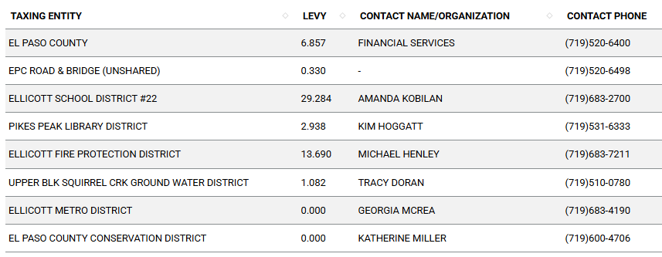

Proposed source of water |  |  | Proposed method of wastewater disposal
☒ | Central System |  | ☒ | Central System
District Name: |  | Cherokee | District Name: |  | Cherokee

Water/wastewater comments
Water sufficiency not reviewed w 1041 or exemption;
Has CDPHE process started?

Fire District:
Ellicott Fire- Please work with District and address criteria for review 1041 with reports backing the statements.
District statements in EA summary:
Hazardous Material Diesel
Water suppression water quantity- water would come from treatment plant itself; tank as part of fire suppression system;
Appendix D- widths of roads; 2 means of access; co wildfire resiliency Code; structure hardening; landscape, etc 5B building?
HWY 9 access to south can be emergency access only gate padlock keyswitch.

Wildland Fire and Hazard Mitigation Plan & Analysis:
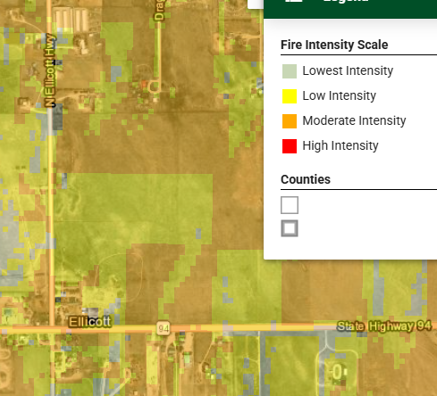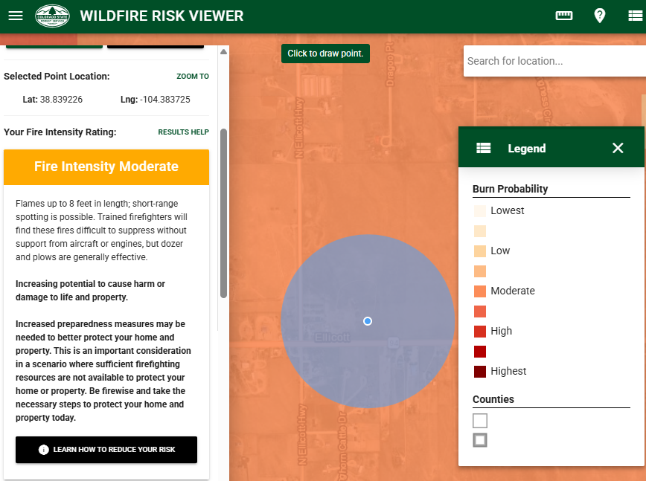
Provide with 1041; look at chapter 6 to craft reports; work with Fire Districts to get commitment to serve…
Hydrants along new lines?

Emergency Services Issues:
Work with Fire District to develop ER plan during and post construction

Commissioner District: 2 (Hwy 94 dividing line between 2 and 4)

Code Waivers:

Parks and trails:
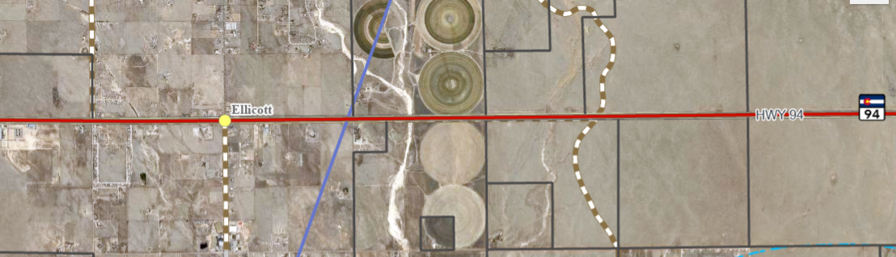

Annexations/Intergovernmental/ Jurisdictional Access issues:
CDOT HWY 94
Military Base outside of 306th group and outside Part 77
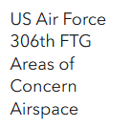
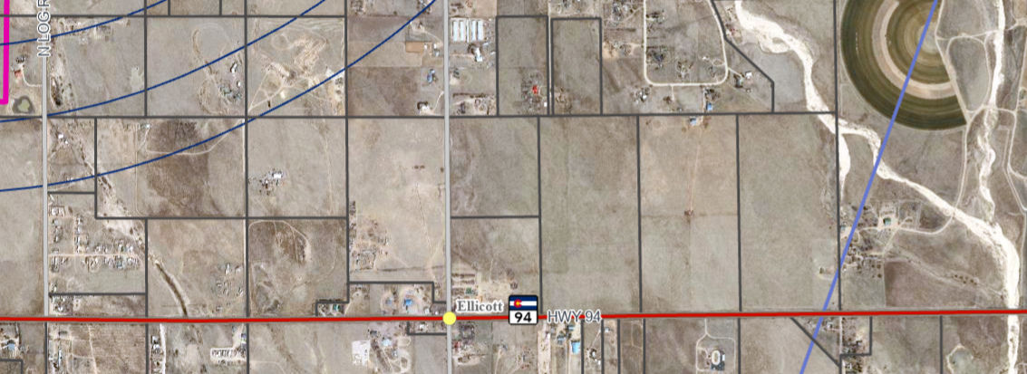

Road Impact Fee Program (PID Inclusion):
Address fee due in LOI for site development plan

Your El Paso Master Plan

Placetype:
Character: Rural
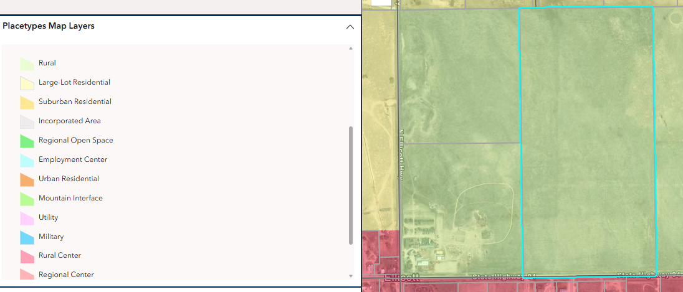

Recommended Land Uses:
- 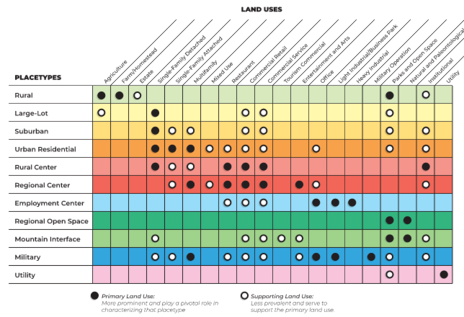

Goals, Objectives, Strategies:
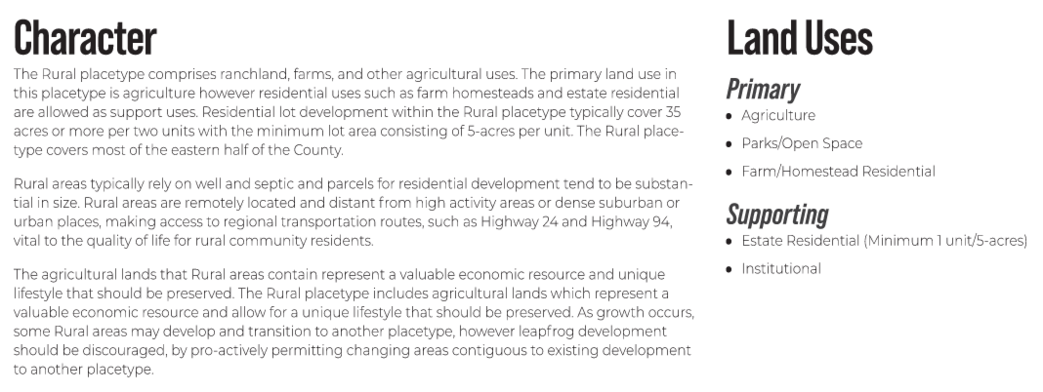
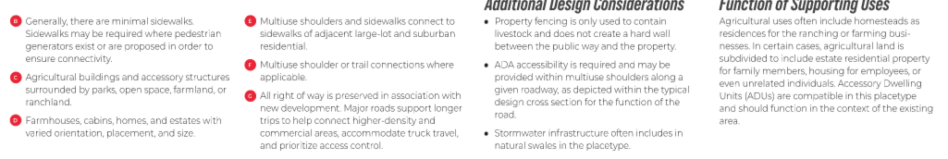
Area of Change Designation: Minimal Change Undeveloped
Description:
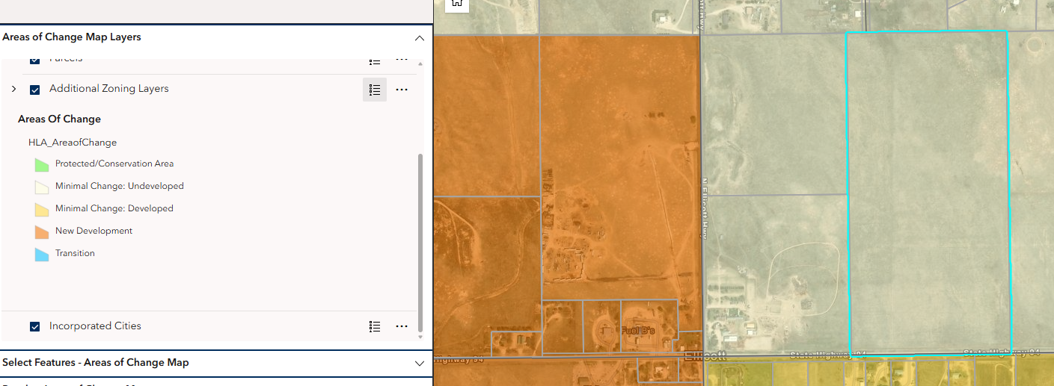

Goals, Objectives, Strategies:
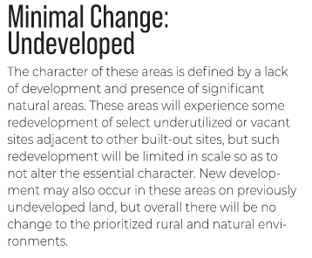

Key Area: None

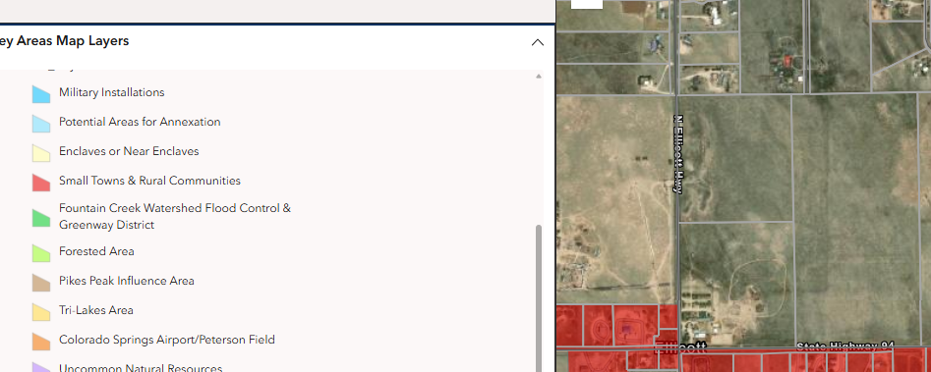

Additional Placetype for comparison:
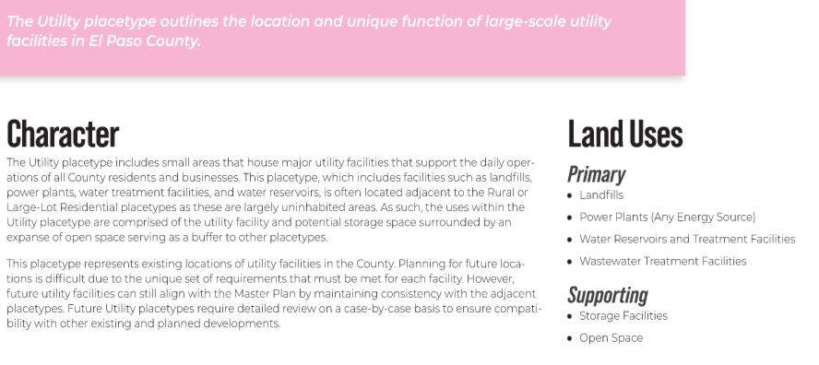

Water Master Plan Area:
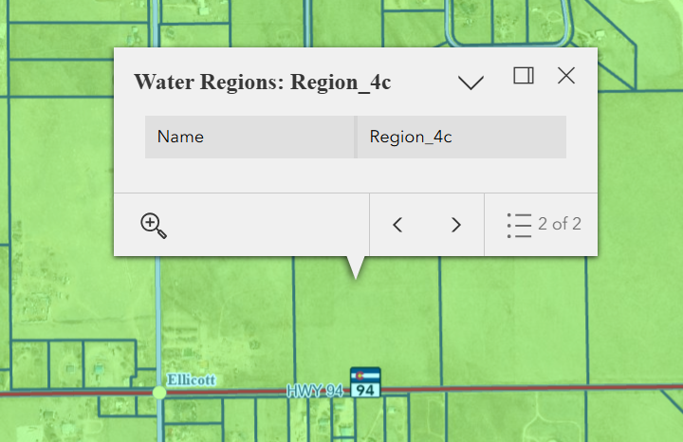

Recommendations:
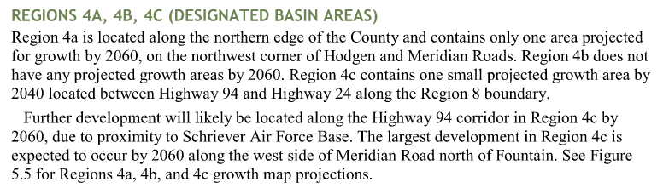

Wildlife impact
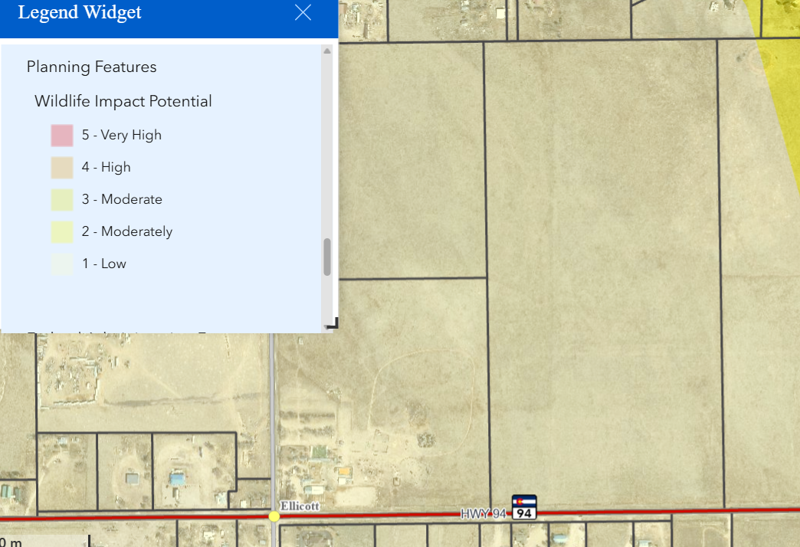

Helpful Links

SAMPLE 1041 https://epcdevplanreview.com/Public/ProjectDetails/187047

Planning Website: https://planningdevelopment.elpasoco.com/

El Paso County Master Plan: https://planningdevelopment.elpasoco.com/#1510603950097-f5d985dc-35b2
Water Master Plan: https://planningdevelopment.elpasoco.com/#1515613078151-9a697e85-b1a7
Parks Master Plan: https://parks.elpasoco.com/parks-and-recreation/park-planning/
Mineral Extraction Master Plan: https://planningdevelopment.elpasoco.com/#1515613078151-9a697e85-b1a7

Forms and Templates: https://planningdevelopment.elpasoco.com/forms-and-affidavits/

Applications and Checklists: https://planningdevelopment.elpasoco.com/applications-and-checklists/

Land Development Code: https://library.municode.com/co/el_paso_county/codes/land_development_code

EDARP: https://epcdevplanreview.com/

Public GIS: https://experience.arcgis.com/experience/94cea8ccda3d4806a3fd500d2b5a4433?draft=true

Wrap Up
-If subdivision is proposed, recording fees, park and school fees and road impact fees may apply.

-Fees are subject to change. The fees at the time of application apply.

-Road Impact Fees
Please see the following website for information on the EPC Road Impact Fee Project. https://publicworks.elpasoco.com/road-impact-fees/ to include fee schedule.
As of December 15, 2016, per Resolution 16-454, on and after January 1, 2020, property in the unincorporated area of the county that receives a Land Use Approval either in a public hearing or administratively, is subject to the payment of Road Impact Fees. After December 31, 2024, in accordance with BoCC Resolution 24-377 the fee is paid for new residential and non-residential uses and structures and expansions of non-residential uses and structures. Road Impact fees are typically paid at time of building permit. If no building permit is being obtained for a particular Land Use application, then Road Impact Fees must be paid at the time of Site Development Plan or Special Use approval. If there are questions about EPC Road Impact program or fees, please contact DPW Development Review Services and the Engineer of the Day.

- Engineering Criteria Manual (ECM) Deviations.
The fee for any additional ECM deviation requests (more than two per land use application) - $1483.00 each per current Fee Schedule. Please note ECM deviation requests may result in additional processing and project review time. ECM Deviations should be submitted prior to the initial Site Development Plan or Final Plat submittal to preclude changes having to be made to engineering plans and documents if the deviation is not approved. Submission of an ECM deviation request does not imply or guarantee that the deviation will be approved. An ECM Deviation form must be submitted to include complete exhibits and justification excluding cost with supporting engineering criteria. If there are questions about ECM Deviation requests, please contact DPW Development Review Services and the Engineer of the Day.

-The fee for any additional waiver/deviation requests (more than two) - $550.00 each. Please note that requests for waivers and/or deviations may result in additional processing/review delay.

-All items requested must accompany the submittal for it to be complete, prior to payment request or the submittal will not be complete and ready for review agencies.

-A temporary use permit shall be applied for and approved for any staging area associated with development, such as a sales office, construction trailer, or contractor's equipment yard, prior to scheduling of the pre-construction meeting with El Paso County Planning and Community Development. If a Planned Unit Development is proposed, the temporary staging area should be shown on the development guideline and phasing plan.

-All prospective timelines for review are subject to departmental staffing and workload.

-Early Assistance is valid for 12 months from submittal of the EA application. If a project submittal is not received within 12 months, a new EA meeting may be required. An audio/video copy of the meeting is available in EDARP within the EA folder.

- Applications scheduled for public hearings may be heard as a regular item at the request of staff or a hearing body member.

- Any comments or commitments made by any member of the County Staff during this early assistance meeting are only preliminary in nature and should not be relied upon by the applicant. All prospective applicants should be informed that formal comments cannot be made by staff until after the application is submitted.

