PRIVATE DETENTION BASIN /

STORMWATER QUALITY BEST MANAGEMENT PRACTICE

MAINTENANCE AGREEMENT AND EASEMENT

This PRIVATE DETENTION BASIN / STORMWATER QUALITY BEST MANAGEMENT PRACTICE MAINTENANCE AGREEMENT AND EASEMENT (Agreement) is made by and between El Paso County by and through THE BOARD OF COUNTY COMMISSIONERS OF EL PASO COUNTY, COLORADO (Board or County), Challenger Communities LLC (Developer), Haven Valley Metropolitan District (Metro District), a quasi-municipal corporation and political subdivision of the State of Colorado, and Good Shepherd United Methodist Church (Adjacent Owner). The above may occasionally be referred to herein singularly as “Party” and collectively as “Parties.”

Recitals
A. WHEREAS, the Metro District provides various municipal services to certain real property in El Paso County, Colorado referred to as Haven Valley; and

B. WHEREAS, Developer is the owner of certain real estate (the Property or Subdivision) in El Paso County, Colorado, which Property is legally described in Exhibit A attached hereto and incorporated herein by this reference; and

C. WHEREAS, Developer desires to plat and develop on the Property a subdivision to be known as Haven Valley; and

D. WHEREAS, the development of this Property will substantially increase the volume of water runoff and will decrease the quality of the stormwater runoff from the Property, and, therefore, it is in the best interest of public health, safety and welfare for the County to condition approval of this subdivision on Developer’s promise to construct adequate drainage, water runoff control facilities, and stormwater quality structural Best Management Practices (“BMPs”) for the subdivision; and

E. WHEREAS, Chapter 8, Section 8.4.5 of the El Paso County Land Development Code, as periodically amended, promulgated pursuant to Section 30-28-133(1), Colorado Revised Statutes (C.R.S.), requires the County to condition approval of all subdivisions on a developer’s promise to so construct adequate drainage, water runoff control facilities, and BMPs in subdivisions; and

F. WHEREAS, the Drainage Criteria Manual, Volume 2, as amended by Appendix I of the El Paso County Engineering Criteria Manual (ECM), as each may be periodically amended, promulgated pursuant to the County’s Colorado Discharge Permit System General Permit (MS4 Permit) as required by Phase II of the National Pollutant Discharge Elimination System (NPDES), which MS4 Permit requires that the County take measures to protect the quality of stormwater from sediment and other contaminants, requires subdividers, developers, landowners, and owners of facilities located in the County’s rights-of-way or easements to provide adequate permanent stormwater quality BMPs with new development or significant redevelopment; and

G. WHEREAS, Section 2.9 of the El Paso County Drainage Criteria Manual provides for a developer’s promise to maintain a subdivision’s drainage facilities in the event the County does not assume such responsibility; and

H. WHEREAS, developers in El Paso County have historically chosen water runoff detention basins as a means to provide adequate drainage and water runoff control in subdivisions, which basins, while effective, are less expensive for developers to construct than other methods of providing drainage and water runoff control; and

I. WHEREAS, Developer desires to construct for the subdivision one (1) detention basin/stormwater quality BMP(s) (“detention basin/BMP(s)”) as the means for providing adequate drainage and stormwater runoff control and to meet requirements of the County’s MS4 Permit, and to provide for operating, cleaning, maintaining and repairing such detention basin/BMP(s); and

J. WHEREAS, Developer desires to construct the detention basin/BMP(s) within its existing easement located on property owned by Adjacent Owner and described in that Detention Pond Easement recorded in the records of the El Paso County Clerk and Recorder at Reception No. 206107057 (“Easement”), which Easement is legally described in Exhibit B attached hereto; and

K. WHEREAS, Developer shall be charged with the duty of constructing the detention basin/BMP(s) and the Metro District shall be charged with the duties of operating, maintaining and repairing the detention basin/BMP(s) on the Easement described in Exhibit B; and

L. WHEREAS, it is the County’s experience that subdivision developers and property owners historically have not properly cleaned and otherwise not properly maintained and repaired these detention basins/BMPs, and that these detention basins/BMPs, when not so properly cleaned, maintained, and repaired, threaten the public health, safety and welfare; and

M. WHEREAS, the County, in order to protect the public health, safety and welfare, has historically expended valuable and limited public resources to so properly clean, maintain, and repair these detention basins/BMPs when developers and property owners have failed in their responsibilities, and therefore, the County desires the means to recover its costs incurred in the event the burden falls on the County to so clean, maintain and repair the detention basin/BMP(s) serving this Subdivision due to the Developer’s or the Metro District’s failure to meet its obligations to do the same; and

N. WHEREAS, the County conditions approval of this Subdivision on the Developer’s promise to so construct the detention basin/BMP(s), and further conditions approval on the Metro District’s promise to reimburse the County in the event the burden falls upon the County to so clean, maintain and/or repair the detention basin/BMP(s) serving this Subdivision; and

O. WHEREAS, the County could condition subdivision approval on the Developer’s promise to construct a different and more expensive drainage, water runoff control system and BMPs than those proposed herein, which more expensive system would not create the possibility of the burden of cleaning, maintenance and repair expenses falling on the County; however, the County is willing to forego such right upon the performance of Developer’s and the Metro District’s promises contained herein; and

P. WHEREAS, the County, in order to secure performance of the promises contained herein, conditions approval of this Subdivision upon the Adjacent Owner’s and Developer’s grant herein of a perpetual Easement over a portion of the Property for the purpose of allowing the County to periodically access, inspect, and, when so necessary, to clean, maintain and/or repair the detention basin/BMP(s); and

Q. WHEREAS, Pursuant to Colorado Constitution, Article XIV, Section 18(2) and Section 29-1-203, Colorado Revised Statutes, governmental entities may cooperate and contract with each other to provide any function, services, or facilities lawfully authorized to each.

Agreement

NOW, THEREFORE, in consideration of the mutual Promises contained herein, the sufficiency of which are hereby acknowledged, the Parties agree as follows:

1. Incorporation of Recitals: The Parties incorporate the Recitals above into this Agreement.

2. Covenants Running with the Land: Developer and the Metro District agree that this entire Agreement and the performance thereof shall become a covenant running with the land, which land is legally described in Exhibit A attached hereto, and that this entire Agreement and the performance thereof shall be binding upon themselves, their respective successors and assigns.

3. Construction: Developer shall construct on that portion of the Property described in Exhibit B attached hereto and incorporated herein by this reference, one (1) detention basin/BMP(s). Developer shall not commence construction of the detention basin/BMP(s) until the El Paso County Planning and Community Development Department (PCD) has approved in writing the plans and specifications for the detention basin/BMP(s) and this Agreement has been signed by all Parties and returned to the PCD. Developer shall complete construction of the detention basin/BMP(s) in substantial compliance with the County-approved plans and specifications for the detention basin/BMP(s). Failure to meet these requirements shall be a material breach of this Agreement and shall entitle the County to pursue any remedies available to it at law or in equity to enforce the same. Construction of the detention basin/BMP(s) shall be substantially completed within one (1) year (defined as 365 days), which one year period will commence to run on the date the approved plat of this Subdivision is recorded in the records of the El Paso County Clerk and Recorder. Rough grading of the detention basin/BMP(s) must be completed and inspected by the El Paso County Planning and Community Development Department prior to commencing road construction.

In the event construction is not substantially completed within the one (1) year period, then the County may exercise its discretion to complete the project and shall have the right to seek reimbursement from the Developer and its respective successors and assigns, for its actual costs and expenses incurred in the process of completing construction. The term actual costs and expenses shall be liberally construed in favor of the County, and shall include, but shall not be limited to, labor costs, tool and equipment costs, supply costs, and engineering and design costs, regardless of whether the County uses its own personnel, tools, equipment and supplies, etc. to correct the matter. In the event the County initiates any litigation or engages the services of legal counsel in order to enforce the Provisions arising herein, the County shall be entitled to its damages and costs, including reasonable attorney fees, regardless of whether the County contracts with outside legal counsel or utilizes in-house legal counsel for the same.

4. Maintenance: The Metro District agrees for itself and its successors and assigns, that it will regularly and routinely inspect, clean and maintain the detention basin/BMP(s) in compliance with the County-reviewed Operations and Maintenance Manual attached hereto as Exhibit C and incorporated herein by reference, and otherwise keep the same in good repair, all at its own cost and expense. No trees or shrubs that will impair the structural integrity of the detention basin/BMP(s) shall be planted or allowed to grow on the detention basin/BMP(s).

5. Creation of Easement: Adjacent Owner and Developer hereby grant the County and the Metro District a non-exclusive perpetual easement upon and across the Easement described in Exhibit B. The purpose of the easement is to allow the County and the Metro District to access, inspect, clean, repair and maintain the detention basin/BMP(s); however, the creation of the easement does not expressly or implicitly impose on the County a duty to so inspect, clean, repair or maintain the detention basin/BMP(s).

6. County’s Rights and Obligations: Any time the County determines, in the sole exercise of its discretion, that the detention basin/BMP(s) is not properly cleaned, maintained and/or otherwise kept in good repair, the County shall give reasonable notice to the Developer, the Metro District and their respective successors and assigns, that the detention basin/BMP(s) needs to be cleaned, maintained and/or otherwise repaired. The notice shall provide a reasonable time to correct the problem(s). Should the responsible parties fail to correct the specified problem(s), the County may enter upon the Property to so correct the specified problem(s). Notice shall be effective to the above by the County’s deposit of the same into the regular United States mail, postage pre-paid. Notwithstanding the foregoing, this Agreement does not expressly or implicitly impose on the County a duty to so inspect, clean, repair or maintain the detention basin/BMP(s).

7. Reimbursement of County’s Costs / Covenant Running With the Land: The Developer and the Metro District agree and covenant, for themselves, their respective successors and assigns, that they will reimburse the County for its costs and expenses incurred in the process of completing construction of, cleaning, maintaining, and/or repairing the detention basin/BMP(s) pursuant to the provisions of this Agreement.

The term “actual costs and expenses” shall be liberally construed in favor of the County, and shall include, but shall not be limited to, labor costs, tools and equipment costs, supply costs, and engineering and design costs, regardless of whether the County uses its own personnel, tools, equipment and supplies, etc. to correct the matter. In the event the County initiates any litigation or engages the services of legal counsel in order to enforce the provisions arising herein, the County shall be entitled to its damages and costs, including reasonable attorney’s fees, regardless of whether the County contracts with outside legal counsel or utilizes in-house legal counsel for the same.

8. Contingencies of Subdivision Approval: Developer’s and the Metro District’s execution of this Agreement is a condition of subdivision approval. Additional conditions of this Agreement include, but are not limited to, the following:

a. A copy of the Covenants of the Subdivision, if applicable, establishing that the Metro District is obligated to inspect, clean, maintain, and repair the detention basin/BMP(s).

The County shall have the right, in the sole exercise of its discretion, to approve or disapprove any documentation submitted to it under the conditions of this Paragraph, including but not limited to, any separate agreement or amendment, if applicable, identifying any specific maintenance responsibilities not addressed herein. The County’s rejection of any documentation submitted hereunder shall mean that the appropriate condition of this Agreement has not been fulfilled.

9. Agreement Monitored by El Paso County Planning and Community Development Department and/or El Paso County Department of Public Works: Any and all actions and decisions to be made hereunder by the County shall be made by the Director of the El Paso County Planning and Community Development Department and/or the Director of the El Paso County Department of Public Works. Accordingly, any and all documents, submissions, plan approvals, inspections, etc. shall be submitted to and shall be made by the Director of the Planning and Community Development Department and/or the Director of the El Paso County Department of Public Works.

10. Indemnification and Hold Harmless: To the extent authorized by law, Developer and the Metro District agree, for themselves, their respective successors and assigns, that they will indemnify, defend, and hold the County harmless from any and all loss, costs, damage, injury, liability, claim, lien, demand, action and causes of action whatsoever, whether at law or in equity, arising from or related to their respective intentional or negligent acts, errors or omissions or that of their agents, officers, servants, employees, invitees and licensees in the construction, operation, inspection, cleaning (including analyzing and disposing of any solid or hazardous wastes as defined by State and/or Federal environmental laws and regulations), maintenance, and repair of the detention basin/BMP(s), and such obligation arising under this Paragraph shall be joint and several. Nothing in this Paragraph shall be deemed to waive or otherwise limit the defense available to the County pursuant to the Colorado Governmental Immunity Act, Sections 24-10-101, et seq. C.R.S., or as otherwise provided by law.

11. Severability: In the event any Court of competent jurisdiction declares any part of this Agreement to be unenforceable, such declaration shall not affect the enforceability of the remaining parts of this Agreement.

12. Third Parties: This Agreement does not and shall not be deemed to confer upon or grant to any third party any right to claim damages or to bring any lawsuit, action or other proceeding against either the County, the Developer, the Metro District, the Adjacent Owner, or their respective successors and assigns, because of any breach hereof or because of any terms, covenants, agreements or conditions contained herein.

13. Solid Waste or Hazardous Materials: Should any refuse from the detention basin/BMP(s) be suspected or identified as solid waste or petroleum products, hazardous substances or hazardous materials (collectively referred to herein as “hazardous materials”), the Developer and the Metro District shall take all necessary and proper steps to characterize the solid waste or hazardous materials and properly dispose of it in accordance with applicable State and/or Federal environmental laws and regulations, including, but not limited to, the following: Solid Wastes Disposal Sites and Facilities Acts, §§ 30-20-100.5 – 30-20-119, C.R.S., Colorado Regulations Pertaining to Solid Waste Disposal Sites and Facilities, 6 C.C.R. 1007-2, et seq., Solid Waste Disposal Act, 42 U.S.C. §§ 6901-6992k, and Federal Solid Waste Regulations 40 CFR Ch. I. The County shall not be responsible or liable for identifying, characterizing, cleaning up, or disposing of such solid waste or hazardous materials. Notwithstanding the previous sentence, should any refuse cleaned up and disposed of by the County be determined to be solid waste or hazardous materials, the Developer and the Metro District, but not the County, shall be responsible and liable as the owner, generator, and/or transporter of said solid waste or hazardous materials.

14. Applicable Law and Venue: The laws, rules, and regulations of the State of Colorado and El Paso County shall be applicable in the enforcement, interpretation, and execution of this Agreement, except that Federal law may be applicable regarding solid waste or hazardous materials. Venue shall be in the El Paso County District Court.

15. Limitation on Developer’s Obligation and Liability: The obligation and liability of the Developer hereunder shall only continue until such time as the Final Plat as described in Paragraph Three (3) of the Recitals set forth above is recorded and the Developer completes the construction of the detention basin/BMP(s) and transfers all applicable maintenance and operation responsibilities to the Metro District. By execution of this agreement, the Metro District agrees to accept all responsibilities and to perform all duties assigned to it, including those of the Developer, as specified herein, upon transfer of Easement described in Exhibit B from Developer to the Metro District.

IN WITNESS WHEREOF, the Parties affix their signatures below.

Executed this _________ day of _________________, 20___, by:
Challenger Communities LLC

By: ________________________________________________
James Byers, Vice President of Community Development

The foregoing instrument was acknowledged before me this _______ day of ______________, 20___, by James Byers, Vice President of Community Development, Challenger Communities LLC

Witness my hand and official seal.
My commission expires: _____________________________________

__________________________________________
Notary Public

Executed this _________ day of _________________, 20___, by:
Haven Valley Metropolitan District

By: __________________________________________
Manager

Attest:
By: __________________________________________
,
Name Title

The foregoing instrument was acknowledged before me this _______ day of ______________,

20___, by Manager, Haven Valley Metropolitan District.

Witness my hand and official seal.
My commission expires: _____________________________________

_____________________________________________
Notary Public

Executed this _________ day of _________________, 20___, by:
Good Shepherd United Methodist Church

By: __________________________________________
Board of Trustees Chairperson

The foregoing instrument was acknowledged before me this _______ day of ______________, 20___, by Board of Trustees Chairperson, Good Shepherd United Methodist Church

Witness my hand and official seal.
My commission expires: _____________________________________

__________________________________________
Notary Public

Executed this ________ day of _______________________, 20___, by:

BOARD OF COUNTY COMMISSIONERS
OF EL PASO COUNTY, COLORADO

By: _____________________________
Gilbert LaForce, Engineering Manager
Development Services, Department of Public Works
Designee of Joshua Palmer, County Engineer
Authorized signatory pursuant to Resolution No. 24-145

The foregoing instrument was acknowledged before me this _______ day of ______________, 20___, by __________________, Engineering Manager, El Paso County Department of Public Works.

Witness my hand and official seal.
My commission expires: ____________________

_________________________________________
Notary Public

Approved as to Content and Form:
______________________________________
Assistant County Attorney

Exhibit A
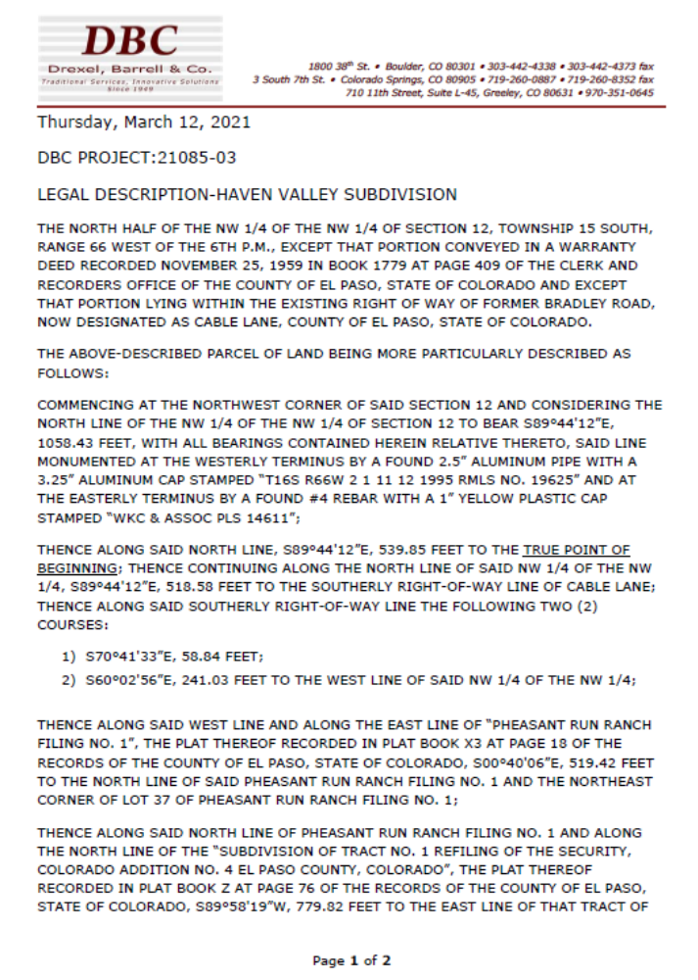
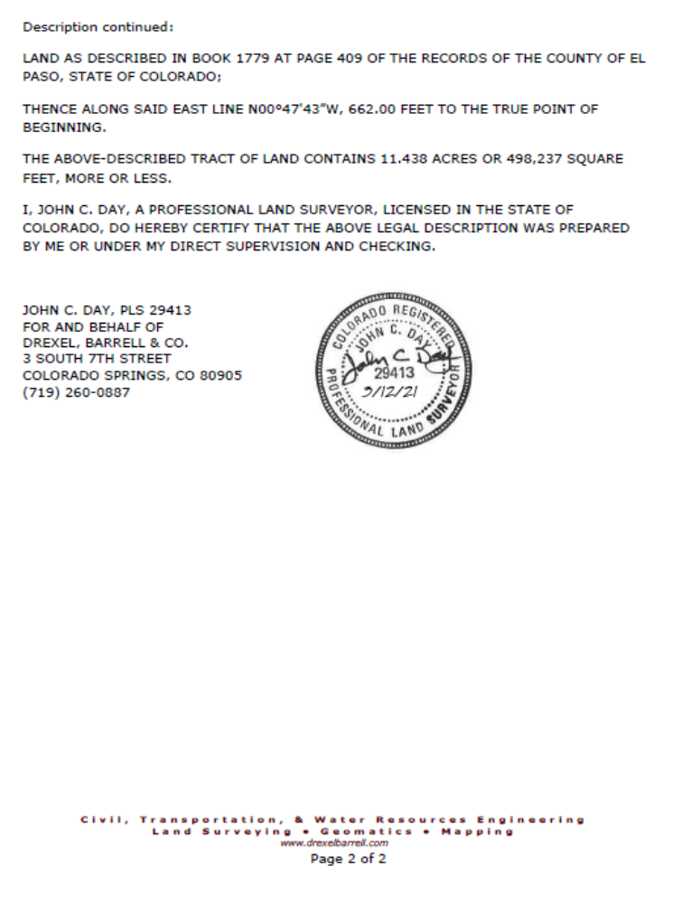
Exhibit B

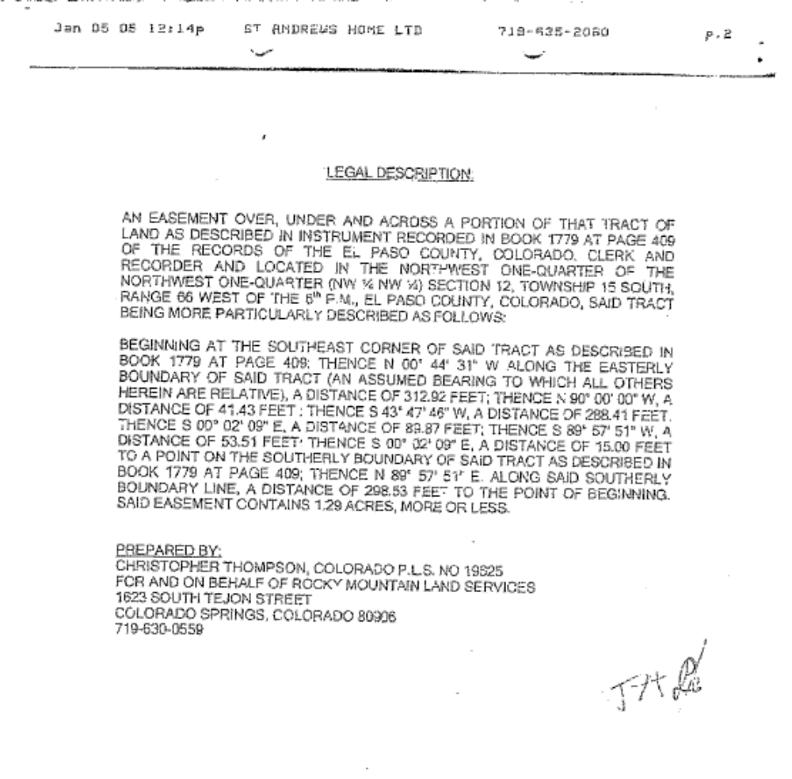

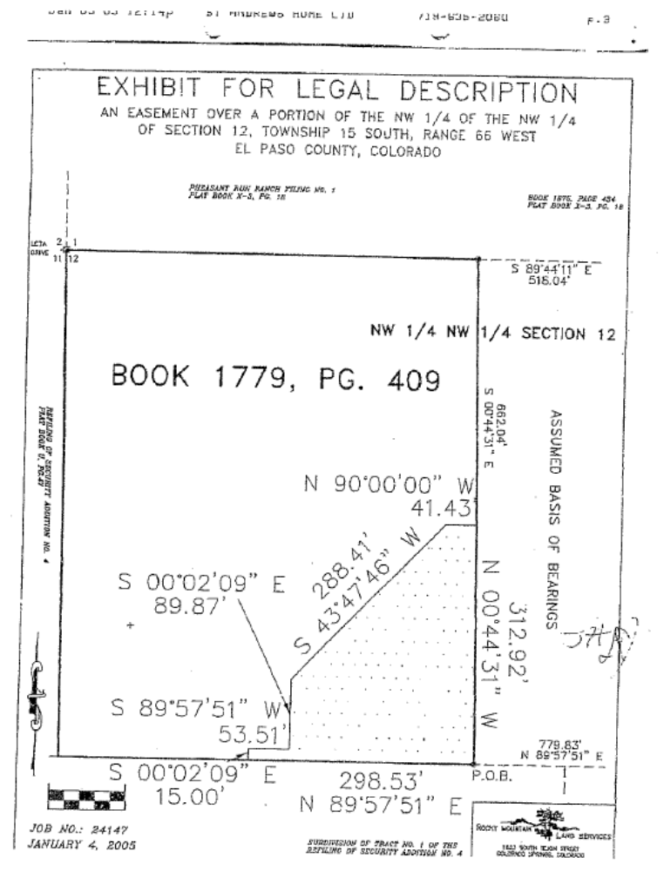
Exhibit C

