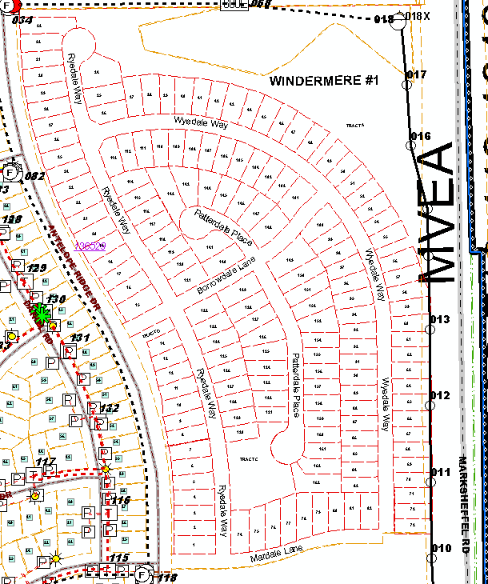
= Lights
With the use of the information contained in this file you are accepting the following terms and conditions. This file is provided on an "as is" basis. MVEA makes no warranties, expressed or implied as to its accuracy. MVEA reserves the right to update, revise, or change any information contained herein without any obligation to notify any person, organization, or other entity. In no event shall MVEA be held liable for damages arising from the use of any of the information contained herein. Additionally, any transmission lines shown in this file may belong to organizations other than MVEA and are in no way to be interpreted as existing or accurately located. No part of this documentation has been surveyed for accuracy and is not georeferenced

