Early Assistance Meeting Number:EA2653
Project Name: Falcon Fire Training Complex
Project Location: 6840 MERIDIAN SOL DRIVE
Project Parcel Nos. 5312402022
Project Description: Create a training complex
Meeting Date: 5 20 26 11am

El Paso County Planning & Community Development Planning Checklist

Request – Map Provided by Applicant
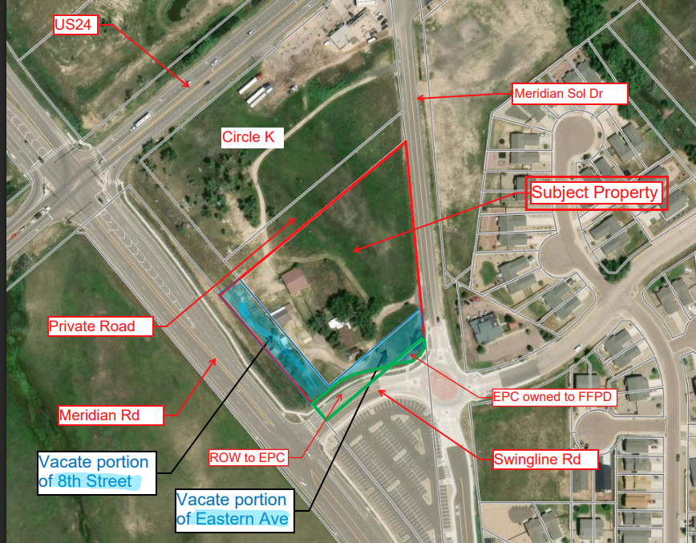

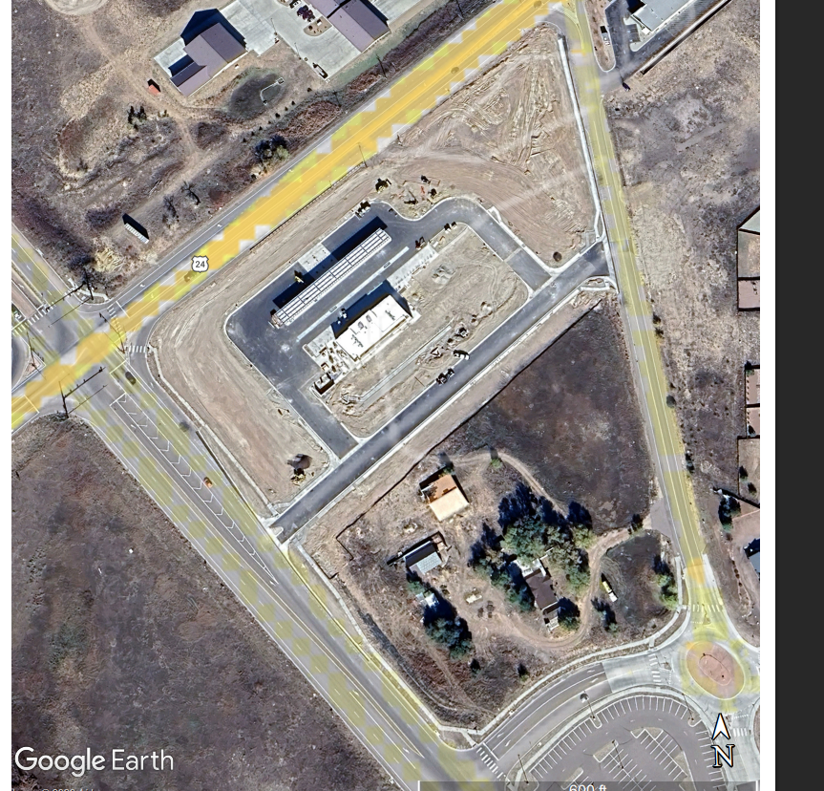
Add sidewalk with PPR

Zoning
Existing Zone(s)
Zone |  | Name
CS |  | Commercial Service
Proposed Zone(s)
Zone |  | Name
NA

Zone Map (existing conditions of approval)
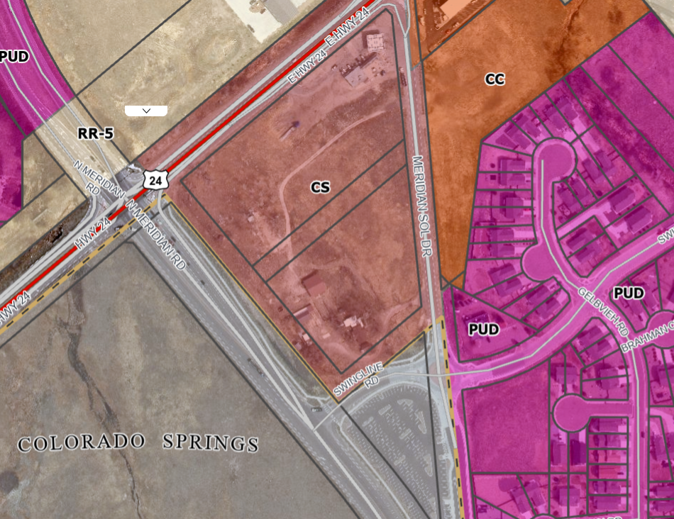

Zoning Analysis
5.3.3. Approval of Location

(A)Purpose. The purpose of this Section is to determine if a public use, structure or utility proposed for location in unincorporated El Paso County conforms to the adopted Master Plan, and to provide procedures for the timely review of the Approval of Location of public facilities or uses as provided by C.R.S. §§ 30-28-110, et seq.
(B)Determination of Public Use. A public use is considered to be any activity primarily funded by taxes, or of an entity which has the capability to levy taxes, or is of benefit to the public such as airports, schools, parks, utilities, and other similar public areas or structures.
(C)Applicability. The Planning Commission is required to review and approve construction of or plans for the construction of any road, park, or other public way, ground, or space, public building or structure, or public utility, whether publicly or privately owned prior to the construction of any facility. This procedure shall not apply to the following:
• Where such activity is subject to the provisions of Appendix B Guidelines and Regulations for Areas and Activities of State Interest of El Paso County (hereinafter "Appendix B" Guidelines and Regulations); and

• Routine extensions of public utility lines and minor modifications to existing uses or facilities.

The following projects require Approval of Location review to the extent they are not subject to Appendix B Guidelines and Regulations:

• Public schools (including Charter Schools);

• Public roads, public parks, trails and trail heads, public ways, grounds and spaces, public buildings and structures and utilities, whether public or privately owned;

• Public building where the building, facility or use provides or fulfills a governmental function the governmental unit is legally authorized to provide including publicly-owned jail or prison facilities;

Zoning District Requirements (density, lot size, lot design standards, building setbacks)
The CS (Commercial
Service) zoning district density and dimensional standards are as follows:
• Minimum lot size: None
• Minimum width at the front setback line: None
• Minimum setback requirement: 25 feet for front, rear, and side yard * ** *** ****
• Maximum lot coverage: None
• Maximum height: 45 feet
*Gasoline pumps and canopies shall be at least 15 feet from the front property line
or public right-of-way, except where the landscaping regulations require a greater
setback.
**The minimum setback is 25 feet from the perimeter boundary of the district, but
no minimum setback is required from any internal side or rear lot line within the
same district.
***Temporary uses shall be setback at least 25 feet from all property lines and 100
feet from Residential zoning districts.
****If the building is established as or converted to condominium units in
accordance with Chapter 7 of this Code, the building and lot shall meet the
minimum lot area and setbacks, but the individual units are not required to meet
the minimum lot area, maximum lot coverage, or setback requirements

Projections allowed
(G)Maximum Structure Height. The maximum height of structures is listed in Table 5-4 and 5-5. The method of measurement is detailed within the definition in Chapter 1.
(1)Exceptions to Height Limits.
(a)Height Limits Not Applicable to Architectural Features. The maximum height limitations of this Code do not apply to church spires, belfries, cupolas, chimneys and other similar design or architectural features or other appurtenances that are usually installed above roof level.
(b)Height Limits Superseded by Specific Use Standards. The maximum height limitations of this Code do not apply or are superseded by the specific use or development standards of this Code, or land use approval actions that apply to water tanks, public buildings antennas, utility poles, utility facilities, wind generators, amateur radio towers, and commercial towers and similar facilities.

Plat Map or Parcel Map (conditions of approval):
CDOT letter of acceptance on access permit. No water quality monitoring wells on Circle K property- none on fire property.
VR2203
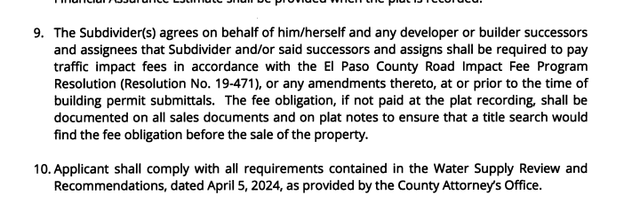
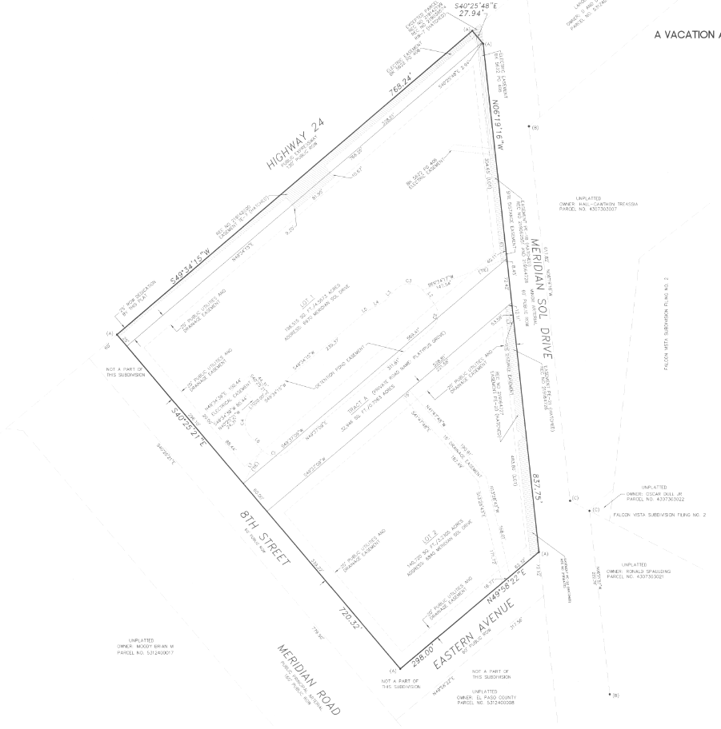
Vacate ROW 8th
City doesn’t want
Vacate ROW 50/50 split

Application Type(s) Hearing: Required/ Optional/ No
1-2 Approval of Location PC only | Yes
4. Site Dev Plan  3. VR to vacate easements and replat easements and include vacated ROW No Hearing | No
1 Vacation of ROW by Resolution | Yes BOCC

Approval Criteria: 5.3.3. Approval of Location
(J)Review Standards. The application for a public use, structure or utility is reviewed for conformity with the submittal and processing requirements included within this Code and Procedures Manual and for conformity with the adopted Master Plan.

Processing Issues and Options
Vacation by Resolution for Roads 8th and Swingline BOCC only
VR for removal of easements, including drainage and relocation of said easements, and include the vacated ROW
Approval of Location
Site Development Plan

Relevant Past History:
Plat recorded

Design and Landscaping

Site Design/Layout (Lot pattern, circulation/road design, open space, preservation of natural features, compatibility internally and with adjacent land uses)
(G)Maximum Structure Height. The maximum height of structures is listed in Table 5-4 and 5-5. The method of measurement is detailed within the definition in Chapter 1.(1)Exceptions to Height Limits. (a)Height Limits Not Applicable to Architectural Features. The maximum height limitations of this Code do not apply to church spires, belfries, cupolas, chimneys and other similar design or architectural features or other appurtenances that are usually installed above roof level.(b)Height Limits Superseded by Specific Use Standards. The maximum height limitations of this Code do not apply or are superseded by the specific use or development standards of this Code, or land use approval actions that apply to water tanks, public buildings antennas, utility poles, utility facilities, wind generators, amateur radio towers, and commercial towers and similar facilities.

Landscaping
☐ | Expressway, Principal arterial area depth – 25’-Trees required 1 per 20’
☐ | Urban interchange/Intersection area depth – 25’- N/A
☒ | Minor arterial area depth 20’ – Trees required 1 per 25’
☒ | Non-arterial area depth 10’ – Trees required 1 per 30’
☒ | Parking lot landscaping required
☐ | Buffer between non-residential and residential districts separated by a non-arterial road or public alley

Minor Arterial 20 feet 1 per 25 feet
Non-Arterial 1 10 feet 1 per 30 feet
1 The required depth of the roadway landscape area shall be increased to 15 feet along a non-arterial road or public alley where the road or alley separates a non-residential use from a residential zoning district. The number of required trees shall be increased to 1 per 15 feet of linear frontage. A minimum of ⅓ of the trees shall be evergreen trees.

G)Other Required Landscape Areas.
(1)Other Areas to be Landscaped or Screened.
(a)Zoning District Boundary Trees. A minimum of 1 tree shall be provided for every 30 feet of lot, parcel, or tract line coincident with a zoning district boundary line except if otherwise required to meet the buffering requirements between a non-residential use or multifamily use and residential zoning district.
(b)Refuse Areas Screened. Refuse collection areas, including trash bins, shall be screened from view from adjacent properties and roads by an opaque wall or fence, architectural elements, dense evergreen plantings with a minimum planting height of 6 feet, or berms with dense plantings creating an opaque appearance with a minimum height of 6 feet.

Signage:

Parking Requirements:
Unique use – justify parking amounts in letter of intent; is this to be used as community center also?
ADA 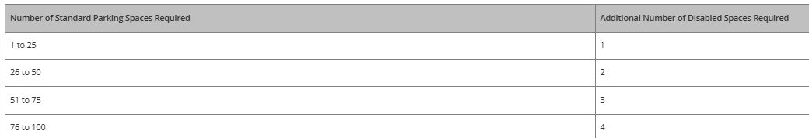

Lighting:
(B)Design Standards and Requirements.
(1)Limitations on Extent of Lighted Area.
(a)Concealed or Shielded. Light fixtures shall be arranged and positioned such that the light sources are concealed and fully shielded so that no direct light or reflection creates a nuisance or hazard to any adjacent ownership or right-of-way and that up-light, spill-light, glare, and unnecessary diffusion are minimized. Light fixtures, except as otherwise permitted herein, are required to be full cutoff as defined by the Illuminating Engineers Society of North America (IESNA) The cut-off angle of an exterior light source shall not exceed 90 degrees. Full cut-off fixtures may not be tilted or aimed in a manner that results in light distribution above the horizontal plane. The use of semi-cutoff or cutoff (as opposed to full cutoff) fixtures shall be permitted to illuminate areas other than parking lots provided the pole or mounting point is no more than 10' in height and the maximum lumen output does not exceed 1800 lumens per lamp.
(b)Non-Security Lighting During Non-Operating Hours. Exterior lighting, including but not limited to floodlights used to light a building façade, shall be reduced, activated by motion sensor devices, or turned off during the principal use's non-operating hours. Lighting necessary for security shall not be subject to this provision.
(c)Upward Lighting. Upward lighting for architectural, landscape or decorative purposes shall have at least 90% of the total distribution pattern within the profile of the illuminated structure or feature. Light fixtures used to illuminate flags, statues, or any other objects mounted on a pole, pedestal, or platform, shall use a narrow cone of light that does not extend beyond the illuminated object.
(d)Maximum Levels. Maximum on-site lighting levels shall not exceed 10 foot candles, except for loading and unloading platforms where the maximum lighting level shall be 20 foot candles.
(e)Measurement at Property Boundaries. Light levels measured at the property line of the development site adjacent to residential property or public right of way shall not exceed 0.1 foot candles as a direct result of the on-site lighting. All light fixtures mounted within 15' of any residential property line of the site shall be classified as IES Type II or Type III, or fixture demonstrated to provide similar distribution patterns and shielding properties. Fixtures shall be fitted with "house side shield" reflectors on the sides facing the residential property line.
(f)Light Standards and Fixtures. The style of light standards and fixtures shall be consistent with the style and character of architecture proposed on the site. Poles shall be anodized or coated to minimize glare from the light source. Bollards or similar light fixtures intended to illuminate landscape features or walkways are permitted which do not exceed 4 feet in height, 2 fixtures per bollard and 1 lamp not exceeding 900 lumens per fixture.
(g)Lamp Types. All outdoor light fixtures should utilize 1 of the following lamp types: metal halide, induction lamp, compact fluorescent, incandescent (including tungsten-halogen), or high-pressure sodium. Alternatives are permitted provided they are demonstrated to be more effective for the proposed use based on IESNA recommendations.
(h)Canopy Lighting. Light fixtures associated with canopies, including but not limited to fuel islands, seasonal outdoor sales areas, shopping malls, theaters, bank drive-thrus, and hotels shall be full cutoff or mounted so that the bottom of the lens is recessed or flush with the bottom surface of the canopy. All light emitted from the canopy shall be substantially confined to the ground directly beneath the perimeter of the canopy. No lighting of any kind, except as permitted by sign regulations, shall be allowed on the top or sides of a canopy. The design of the canopy in terms of height above grade, and the spacing between the fixtures within the canopy, shall be such that the illuminance level under the canopy does not exceed 20 foot-candles.
(i)Consideration of Pilots. No lighting shall make it difficult for pilots to distinguish airport lights from others, result in glare in the eyes of the pilots using an aviation facility, impair visibility in the vicinity of an aviation facility or, in any way create a hazard or endanger the landing, take-off, or maneuvering of aircrafts intending to use an aviation facility.
(2)Height. No freestanding light fixtures shall be mounted higher than 15 feet, except parking lot light fixtures which shall be mounted no higher than 20 feet unless an alternative lighting proposal is approved in accordance with this Code.

Photometric Plan Required | ☒

Site Characteristics\ Constraints\ Environmental Standards:
High groundwater

☐ | 30% or greater slope | Topography: | NO
☐ | CGS review required (separate fee to CGS) | Soils/geology: |  | NO
☐ | Floodplain | Floodplain comment: |  | NO
☐ | Noise mitigation required | Noise comment: |  |  | Will Noise meet Code requirements (sirens); address in letter of intent
☐ | Preble’s mouse | NA

Air/Visual Quality:
Address in Letter of Intent

Districts

Taxing Entities
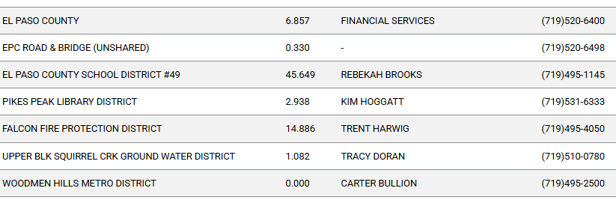
Proposed source of water |  |  | Proposed method of wastewater disposal
☒ | Central System |  | ☒ | Central System
District Name: |  | Woodmen Hills MD | District Name: |  | Woodmen Hills MD

Water/wastewater comments: None
Verify water does not exceed allocation with final plat- address in Letter of Intent

Fire District:
Districts proposing facility

Wildland Fire and Hazard Mitigation Plan:
Not in County mapped vegetation area; See State Map below

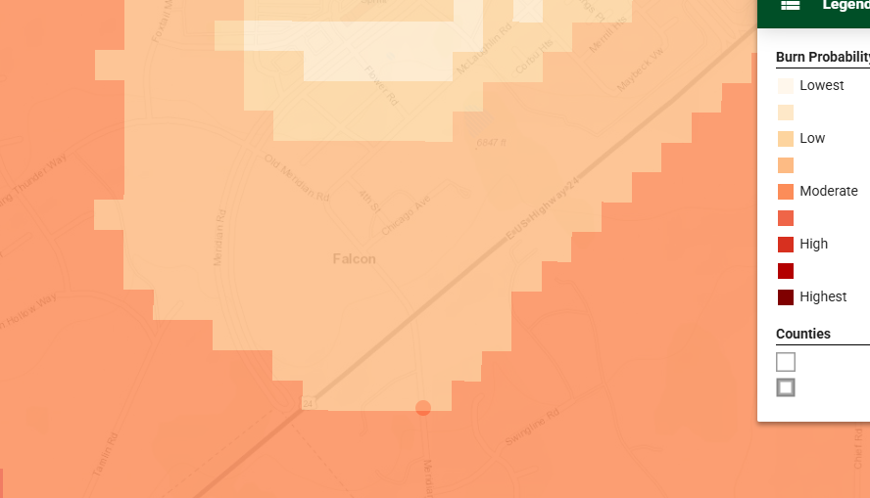

Emergency Services Issues:
Access points
Major CDOT construction 2027 and 2028; coordinate with CDOT on construction due to CDOT projects- Andy w/ CDOT

Commissioner District: 2

Code Waivers:
Alternative landscape likely. Height for tower?

Parks and trails:
Park and Ride is adjacent. Connect sidewalks

Annexations/Intergovernmental/ Jurisdictional Access issues:
City owns Meridan Road to west and adjacent.

Road Impact Fee Program (PID Inclusion):
Applicable. Pid upfront

Your El Paso Master Plan

Placetype:
Character: Regional Center
The fundamental purpose of a Regional Center is to provide access to necessary
and desired commercial goods and services in El Paso County through a unique
mix of uses. This placetype differs from Rural Centers by providing a level of goods
and services that attract people from across the County, and depending on
location, from adjacent counties. Regional Centers often incorporate a lifestyle
live-work-play environment and can include multifamily housing elements in their
design as standalone apartments or part of mixed-use developments.
This placetype includes large-scale shopping centers that house a variety of
commercial businesses and support a high activity of users on a regular basis
such as grocery stores, pharmacies, clothing stores, automotive centers,
restaurants, entertainment opportunities, home improvement stores, and other
major retailers. Multifamily apartments provide commercial businesses direct
access to potential customers.
Regional Centers are major commercial destinations for residents and are easily
accessible from major transportation routes throughout the County. Regional
Centers in El Paso County are surrounded by Urban Residential, Suburban
Residential, and Employment Center placetypes. In addition, Regional Centers
can also be extensions of commercial areas within incorporated municipalities
such as the Gleneagle area.

Recommended Land Uses:
- Recommended Land Uses:
- Primary
- • Restaurant
- • Commercial Retail
- • Commercial Service
- • Entertainment
- • Multifamily Residential
- Supporting
- • Office
- • Institutional
- • Mixed Use
- • Single-family Attached Residential

Objective LU4-2 – The Regional Center placetype should include large scale
shopping centers that house a variety of commercial businesses and support
a high activity of users on a regular basis such as grocery stores, pharmacies,
clothing stores, automotive centers, restaurants, entertainment
opportunities, home improvement stores, and other major retailers.
Objective ED1-6 – Large employers should be located on major roadways
to improve connectivity and minimize their impact on daily traffic.
Goal ED3-3 – Emphasize the development of grocery stores, restaurants
(both drive-thru and sit-down), gas stations, pharmacies, and
neighborhood-scale services along Highway 24.

Area of Change Designation:
Description: Transition
Transition areas are fully developed parts of the County that may completely or
significantly change in character. In these areas, redevelopment is expected to
be intense enough to transition the existing development setting to an entirely
new type of development. For example, a failing strip of commercial
development could be redeveloped with light industrial or office uses that result
in a transition to an employment hub or business park. Another example of such
a transition would be if a blighted suburban neighborhood were to experience
redevelopment with significant amounts of multifamily housing or commercial
development of a larger scale in line with a commercial center.

Key Area: Potential for Annexation

A significant portion of the County’s expected population growth will be located
in one of the eight incorporated municipalities. As the largest municipality in El
Paso County, Colorado Springs is expected to grow in population over the next
several decades. As a result of this growth, Colorado Springs, and other
municipalities including Fountain and Monument, will need to annex parts of
unincorporated County to plan for and accommodate new development. This
will either occur through new development within existing municipal limits or
the annexation of subdivisions in unincorporated parts of the County.
This Key Area outlines the portions of the County that are anticipated to be
annexed as development occurs. It is imperative that the County continue to
coordinate with the individual cities and towns as they plan for growth.
Collaboration with the individual communities will prevent the unnecessary
duplication of efforts, overextension of resources, and spending of funds. The
County should coordinate with each of the municipalities experiencing substantial
growth the development of an intergovernmental agreement similar to that
developed with Colorado Springs.

Water Master Plan Area:
The Water Master Plan includes demand and supply projections for central water
providers in multiple regions throughout the County. The property is located within
Planning Region 3 of the Plan, which is an area anticipated to experience growth by
2040.

Recommendations:
The following information pertains to water demands and supplies in Region
3 for central water providers:

The Plan identifies the current demand for Region 3 to be 4,494 acre-feet
per year (AFY) (Figure 5.1) with a current supply of 7,164 AFY (Figure 5.2).
The projected demand in 2040 for Region 3 is at 6,403 AFY (Figure 5.1)
with a projected supply of 7,921 AFY (Figure 5.2) in 2040. The projected
demand at build-out in 2060 for Region is 3 is at 8,307 AFY (Figure 5.1)
with a projected supply of 8,284 AFY (Figure 5.2) in 2060. This means that
by 2060 a surplus of 32 AFY is anticipated for Region 3.

Wildlife impact
low wildlife impact potential

Parks Master Plan:
El Paso County Parks Department. The 2022 El Paso County Parks Master Plan shows no impacts by this project to any existing or proposed parks, trails, or open space. As such, no parkland or trail easement dedications will be necessary as this project moves forward. As this is an Early Assistance meeting for a proposed site development plan, no regional park fees will be applicable.

Helpful Links

Planning Website: https://planningdevelopment.elpasoco.com/

El Paso County Master Plan: https://planningdevelopment.elpasoco.com/#1510603950097-f5d985dc-35b2
Water Master Plan: https://planningdevelopment.elpasoco.com/#1515613078151-9a697e85-b1a7
Parks Master Plan: https://parks.elpasoco.com/parks-and-recreation/park-planning/
Mineral Extraction Master Plan: https://planningdevelopment.elpasoco.com/#1515613078151-9a697e85-b1a7

Forms and Templates: https://planningdevelopment.elpasoco.com/forms-and-affidavits/

Applications and Checklists: https://planningdevelopment.elpasoco.com/applications-and-checklists/

Land Development Code: https://library.municode.com/co/el_paso_county/codes/land_development_code

EDARP: https://epcdevplanreview.com/

Public GIS: https://experience.arcgis.com/experience/94cea8ccda3d4806a3fd500d2b5a4433?draft=true

Wrap Up
-If subdivision is proposed, recording fees, park and school fees and road impact fees may apply.

-Fees are subject to change. The fees at the time of application apply.

-Road Impact Fees
Please see the following website for information on the EPC Road Impact Fee Project. https://publicworks.elpasoco.com/road-impact-fees/ to include fee schedule.
As of December 15, 2016, per Resolution 16-454, on and after January 1, 2020, property in the unincorporated area of the county that receives a Land Use Approval either in a public hearing or administratively, is subject to the payment of Road Impact Fees. After December 31, 2024, in accordance with BoCC Resolution 24-377 the fee is paid for new residential and non-residential uses and structures and expansions of non-residential uses and structures. Road Impact fees are typically paid at time of building permit. If no building permit is being obtained for a particular Land Use application, then Road Impact Fees must be paid at the time of Site Development Plan or Special Use approval. If there are questions about EPC Road Impact program or fees, please contact DPW Development Review Services and the Engineer of the Day.

- Engineering Criteria Manual (ECM) Deviations.
The fee for any additional ECM deviation requests (more than two per land use application) - $1483.00 each per current Fee Schedule. Please note ECM deviation requests may result in additional processing and project review time. ECM Deviations should be submitted prior to the initial Site Development Plan or Final Plat submittal to preclude changes having to be made to engineering plans and documents if the deviation is not approved. Submission of an ECM deviation request does not imply or guarantee that the deviation will be approved. An ECM Deviation form must be submitted to include complete exhibits and justification excluding cost with supporting engineering criteria. If there are questions about ECM Deviation requests, please contact DPW Development Review Services and the Engineer of the Day.

-The fee for any additional waiver/deviation requests (more than two) - $550.00 each. Please note that requests for waivers and/or deviations may result in additional processing/review delay.

-All items requested must accompany the submittal for it to be complete, prior to payment request or the submittal will not be complete and ready for review agencies.

-A temporary use permit shall be applied for and approved for any staging area associated with development, such as a sales office, construction trailer, or contractor's equipment yard, prior to scheduling of the pre-construction meeting with El Paso County Planning and Community Development. If a Planned Unit Development is proposed, the temporary staging area should be shown on the development guideline and phasing plan.

-All prospective timelines for review are subject to departmental staffing and workload.

-Early Assistance is valid for 12 months from submittal of the EA application. If a project submittal is not received within 12 months, a new EA meeting may be required. An audio/video copy of the meeting is available in EDARP within the EA folder.

- Applications scheduled for public hearings may be heard as a regular item at the request of staff or a hearing body member.

- Any comments or commitments made by any member of the County Staff during this early assistance meeting are only preliminary in nature and should not be relied upon by the applicant. All prospective applicants should be informed that formal comments cannot be made by staff until after the application is submitted.

