Letter of Intent
Required:
Owner/applicant & consultant:
DeMarco & Amanda Williams
6765 Gun Club Trail
Colorado Springs, CO 80908
719-308-7444
info@frenchiesnaturally.com
PCD File No. AL-21-20

Site location, size, zoning:
Location:
6765 Gun Club Trail
Colorado Springs, CO 80908
Size: 2000-7000sq ft bed and breakfast inn addition with walkway, kitchen, and 5 additional rooms with the potential to add an additional 5 rooms in the future.
Current Zoning: RR-5
Property Tax Schedule Number: 5207003001

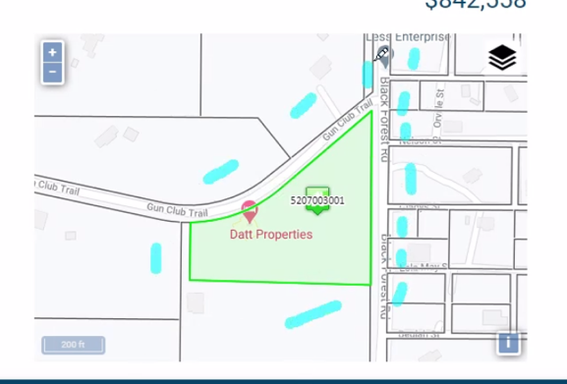

Request & Justification:
We are requesting an approval for our land to be used as an up to 5 bedroom bed and breakfast inn initially with the potential to add up to 5 rooms in the future with up to 4 employees. A resident innkeeper will reside on property. Meals will be served to guests only. The maximum number of nights a guest may stay is 30 days. The addition will be consistent with the style of the current stucco home and if live landscaping added it will be native to our area in order to be in harmony with the character of the neighborhood. Signage will follow the rules indicated in 5.2/12.E. We will have up to five guest rooms available initially (up to ten in the future) in which we will provide one parking spot per room plus three extra parking spots decreasing the amount of traffic to and from. The parking area will meet the standards specified for rural areas and stay within the character of the neighborhood. Each guest room will be provided with a smoke detector. Emergency lighting for emergency exits will also be installed. The bed and breakfast inn will obtain and maintain all required licenses and pay applicable sales tax.

Guests of the guests must sign in and numbers will be carefully monitored. Our quiet hours will be from 10pm-7am which will be strictly enforced by us and we live on property. We will have a few outdoor sensor lights and solar lights for guests to see but not too much in order to prevent light pollution. The proposed use will not adversely impact adjacent properties or existing drainage patterns.

Existing & proposed facilities, structures, roads, driveways:
There is an existing driveway going to the side of the house with parking sites available. The current walkout basement will be used as part of the bed and breakfast with the addition of an attached walkway, 3-5 bedrooms with bathrooms, and a kitchen/common area. The addition of a septic system with a precise location to be determined by engineer.
Land Disturbance:
In the future, up to 5 bedrooms may be added onto the bed and breakfast (max of 10 rooms). The total land disturbance for building will be 0.142 acres (6200 square foot). In the future, bedrooms 1 & 2 of the current basement may be used for our aging parents and may not be used for the bed & breakfast. That is why there’s an additional room in the future plans. This is not certainty but just a possibility and am mentioning this for your information in considering our proposal. Again, only a max of 10 rooms will be used for the bed & breakfast.
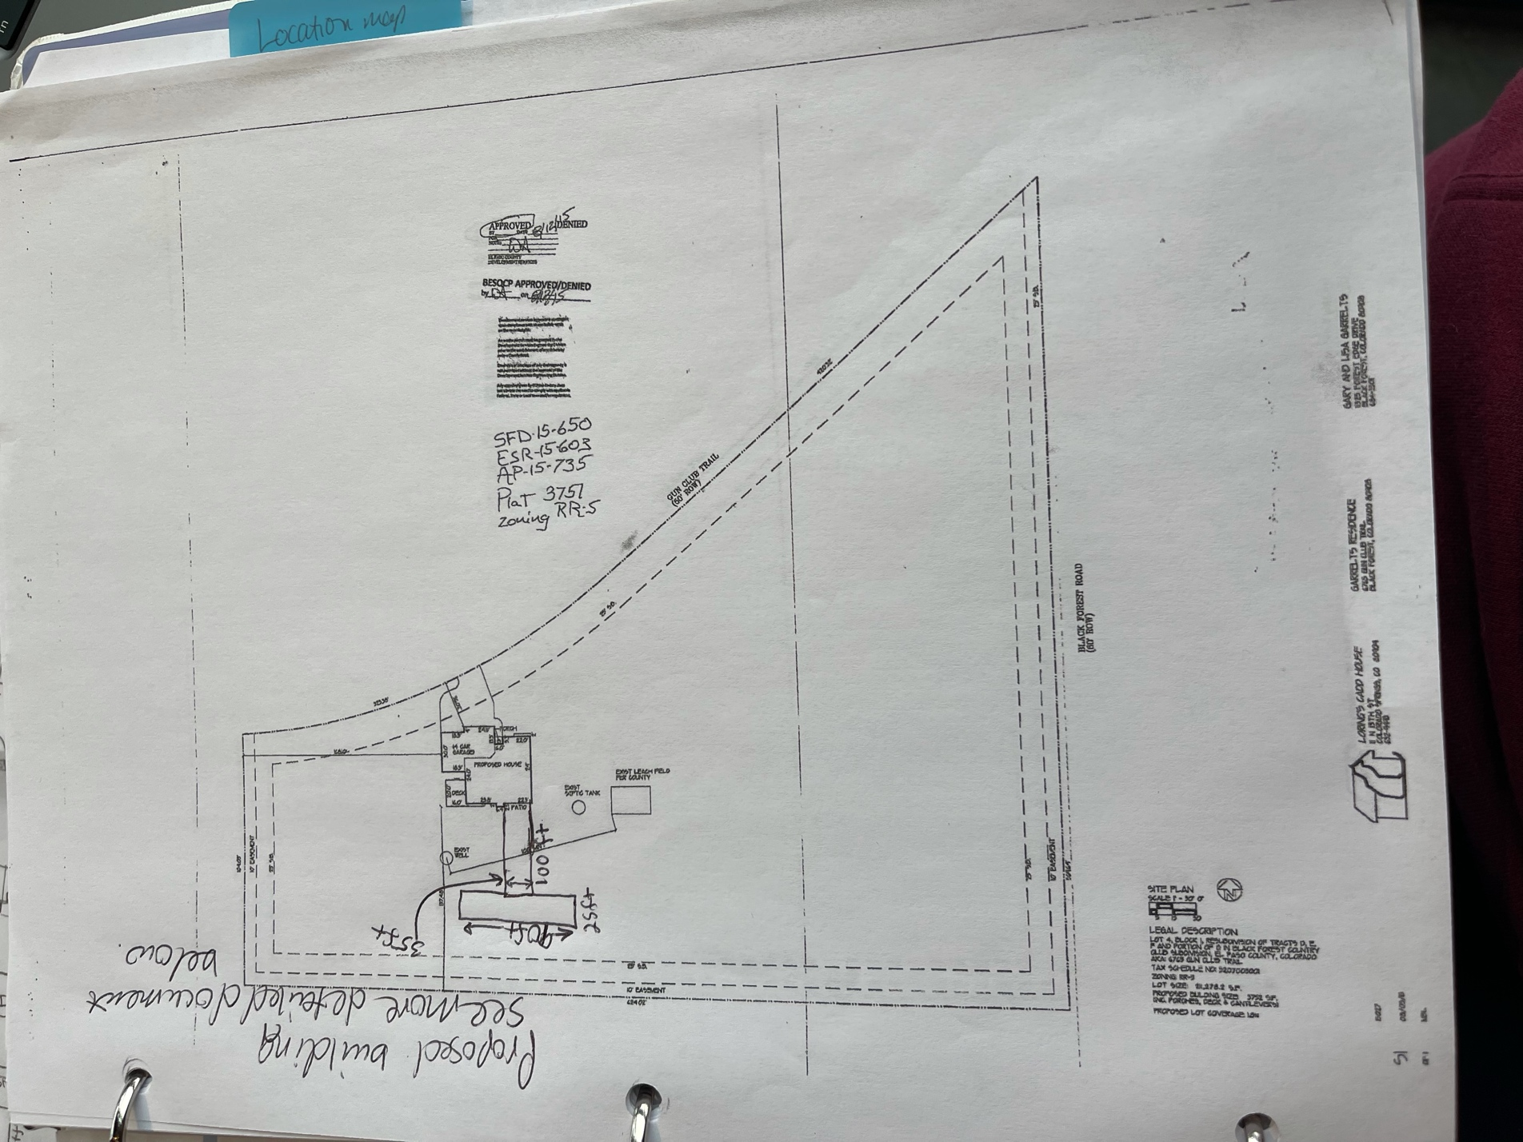
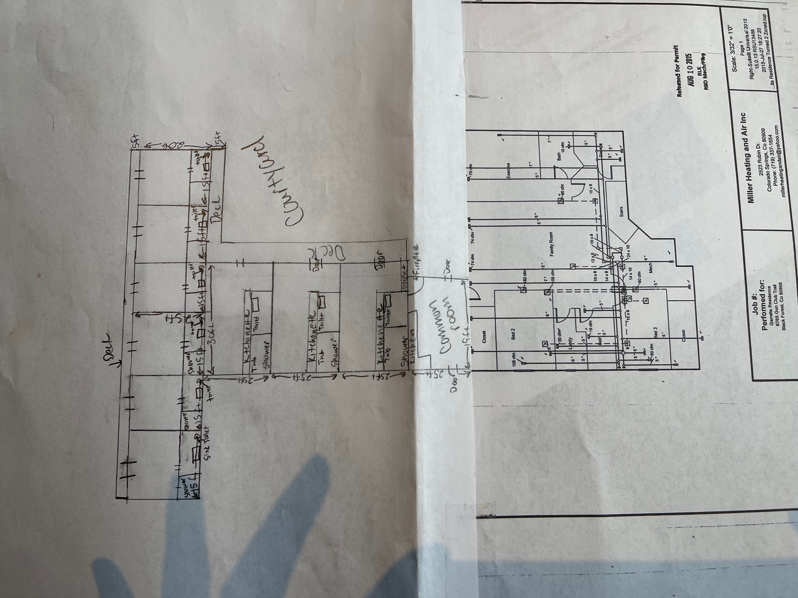Average Daily Trips:
If the bed and breakfast is at full capacity with each room having one car, it is presumed there will be an average of 4 trips per guest per day. At full capacity, we expect approximately 80 trips per day. Please keep in mind, some guests never even leave their rooms and we do not expect full capacity 100% of the time. Breakfast starts at 8am, check out is 10am, and check-in will start at 1pm. It is expected that peak hour trips between 7am-9am and 4pm-6pm will be less than 10 trips per, day. The project meets the criteria for no traffic impact study being required due to the above stated trips are under 100 per day with less than peak hour trips per day, there are no proposed minor or major roadway intersections, arterials, or State Highways, the traffic generated will not adversely affect the traffic currently planned for and accommodated within, and adjacent to the property, an acceptable LOS on the adjacent public roadways, accesses, and intersections will be maintained, no roadway or intersection in the immediate vicinity has a history of safety or accident problems, and there is no change of land use with access to a State Highway.

Waiver requests and justification: None

Phased Construction: First Phase: The addition of a common area and up to 5 additional rooms. Second Phase: The addition of up to 5 additional rooms may be added based on the success of the first 5 rooms for a total of up to 10 rooms.

Areas of required landscaping: Landscaping will be designed and developed upon completion of the addition. We will be xeriscaping to reduce water use and planting local plants to keep with the natural look of the area.

Water and Septic: The current well will be used for water and the addition of a new septic tank will be added with the precise location determined by engineer.

