TO: Mr. John Green, Planner / Reviewer II, El Paso Planning & Community Development
FROM: Angela Jackson-Butler and Michael Butler, Home Owner(s)
DATE: May 4, 2021
SUBJECT: Letter of Intent for Garage Build
Dear Mr. Green,
I am writing this letter to inform you and the El Paso Planning & Community Development Team of my intent to build a garage on my property located at 520 Empress Street, Colorado Springs, CO 80911. I have two issues I need to resolve prior to building the garage: (1) Front yard setbacks 16’ 8” in lieu of the required 25 feet and (2) Utility Easement Vacate.
Project Information:
Parcel Number: 5519403015
Legal Description: Lot 7A, Wilson’s Widefield Addition No. 7, No. 2, County of El Paso, State of Colorado
Lot Size: .24 acres (10,454.4 SG FT)
Lot Zoning: RS-5000 (Residential Suburban)
House Measurements: 55.2” x 46.3 = 2555.76 SQ FT
Garage Size: 24’ x 24’ (576 SQ FT)
Current Lot Coverage: 2555.76 / 10,454.4 = .244 (24%)
Project Lot Coverage with Garage: 2555.76 + 576 / 10,454.4 = .299 (30%) 40% lot coverage authorized
Project Issue Areas due to Pie Shape of Lot (creating a hardship):

ISSUE #1: Front yard setbacks.
I plan to build a garage on the West side of my home. My home sits in the center of the lot, making the front yard setbacks a problem. The guidelines state front yard setbacks will be 25’ and if the build goes into these established setbacks, the home owner must ask for approval before building any permanent structures on their property. I have been working with an architect and the preliminary DRAFT sketch below shows the right, front corner of the garage going into the required 25 feet setback. The front corner of the garage will set 16’ 8” from the designated setback road line. Because of this, I am asking for an administrative waver to gain approval to build the garage on my property.
ISSUE #2: Utility Easement.
There is a “Utility Easement” that was established on the West side of my lot when the neighborhood and home were initially developed. Because of the placement of my home on the lot, the pie shape of my lot and size of the garage, I will need to build 3’ into the 8’ Utility Easement. This would leave 5’ between my garage and the property line of my neighbor. Because of this, I am looking to “vacate” the Utility Easement. I would like to vacate the entire easement but understand if only the 3 feet required for the garage build is all that is allowed to be vacated. I have started the vacation process by contacting all utility companies that affect my property, in order to obtain a letter of consent for vacating the easement. Once I have all the letters I will move forward with requesting approval to vacate the easement in order to build the garage.

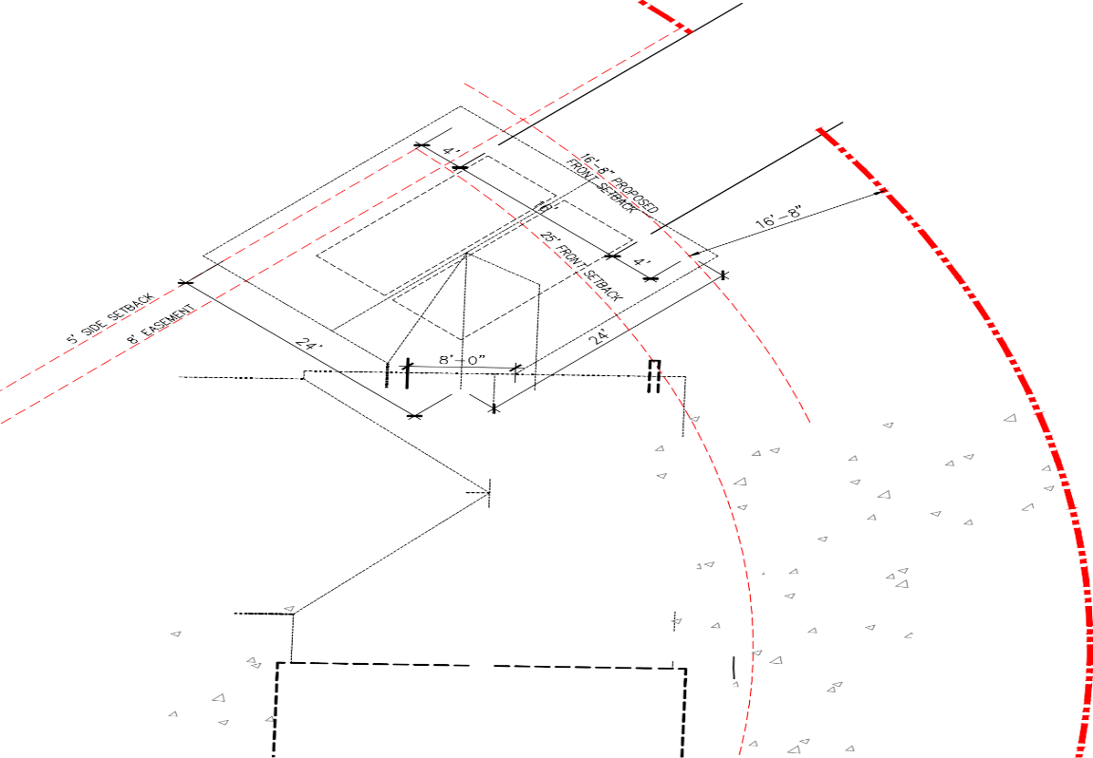
Current Home on Lot
55.2’
46.3’
Front Yard Setbacks – The front right corner of the garage will sit 16’ 8” from the front yard setback. It will be 8’ 2” over the guideline 25’ setback and 3’ 2” over the 20’ Administrative Waver approval guideline.
Utility Easement – The left side of the garage will sit 3’ into the current utility easement on my property leaving 5’ between the garage and my neighbor’s property.

Additional Information:
There will be no adverse impact to the surrounding properties if the Administrative Relief and Utility Easement Vacate are approved.
To include:
- All surrounding neighbors have been notified of the requested changes due to the garage build and no neighbors have expressed concern regarding the distance from their property or any view concerns.
- Granting the Administrative Relief will not increase the number of dwellings units on the parcel.
- Granting the Easement Vacate will not interfere with or affect utility company access to their utilities.
I am requesting an Administrative Relief of my front yard setbacks and Utility Easement Vacate of the easement on my property.
Please contact me with any questions. You can reach me at my office number (719)503-0337, Monday – Friday (8:00 AM – 5:00 PM), my cell phone number (254)681-5945, Monday – Friday (after 5:00 PM; and all day on the weekends) or via email at angela.jacksonbutler@gmail.com. Thank you for your time and help.

v/r,
Angela Jackson-Butler

