Early Assistance Meeting Number: EA2699
Project Name: Leach - Outbuilding
Project Location: 11005 Huntsman Road
Project Parcel No. 5221302006
Project Description: Add an accessory building in PUD. Plan #: R215142
Meeting Date: 08/26/26 at 11 am

El Paso County Planning & Community Development Planning Checklist

Request – Map Provided by Applicant
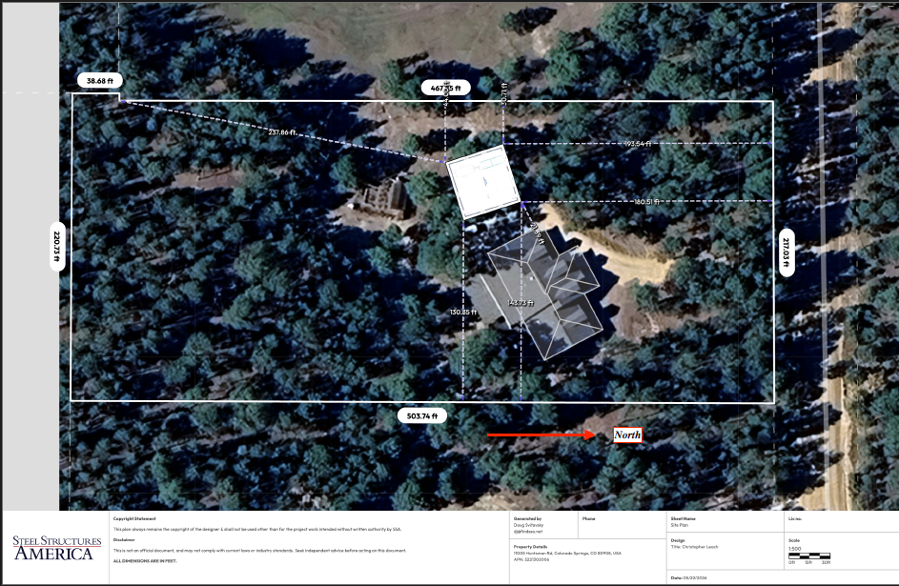

Zoning
Existing Zone(s)
Zone |  | Name
PUD |  | Planned Unit Development
Proposed Zone(s)
Zone |  | Name

Zone Map (existing conditions of approval)
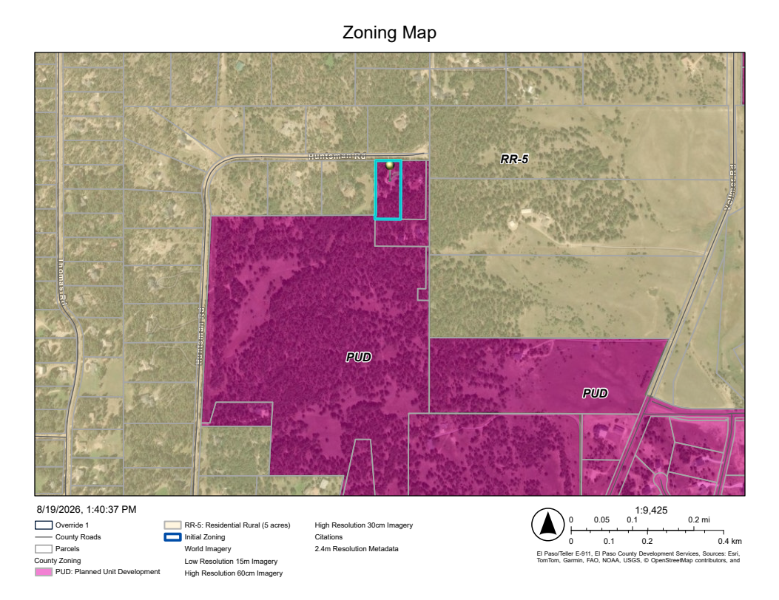

Zoning Analysis
4.2.6. PUD, Planned Unit Development District
(B)Allowed, Special, Accessory, and Temporary Uses. The allowed, special, accessory, and temporary uses in the PUD zoning district are established by the approval of the PUD zoning and the associated development plan and development guide. All uses identified within a PUD are subject to corresponding use specific development standards in the Land Development Code, as amended, unless otherwise modified by the PUD. Some uses may be subject to additional local, State, and/or federal regulation(s) which the BoCC may use as a basis to deny requests for PUD modification.

Accessory structures, and the development standards development/dimensional standards, are not included within the Ranch 51 PUD Residential Low Density (RLD).
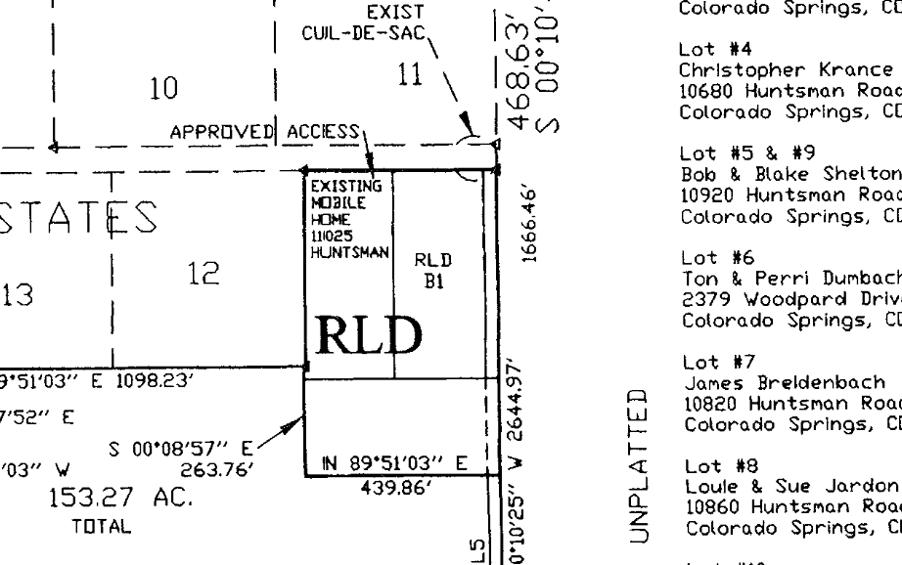
EPC Staff review comments dated April 10, 2007. https://epcdevplanreview.com/Public/ProjectDetails/10192
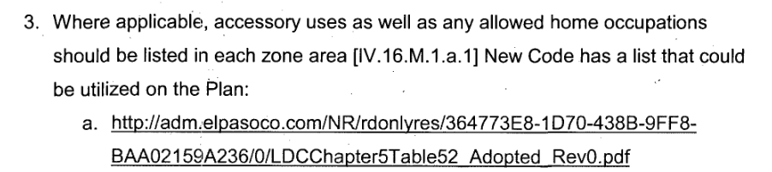
EPC staff comment #3 “accessory uses …should be listed in each zone area.” A minor PUD amendment is required to clarify dimensional standards/allowance of accessory structures in the PUD.
This note references the previous Land Development Code. The relevant sections mentioned are now in Chapter 4 (PUD), Chapter 7 (Rules Governing Divisions of Land), and Chapter 8 (Subdivision Design Improvements and Dedications).

(H) Actions Amending a PUD Zoning District. The Planning and Community Development Director may approve a minor amendment to an approved PUD which is determined will have no foreseeable effect beyond the property boundary, such as minor changes in the siting of buildings, changes to landscape features in the interest of public safety, or the alignment of utilities and the alignment of interior roadways and parking areas. No such changes shall significantly increase the size or height of structures, significantly reduce the efficiency or number of public facilities serving the PUD, significantly reduce or increase parking areas, or significantly encroach on natural features proposed by the plan to be protected.

Zoning District Requirements (density, lot size, lot design standards, building setbacks)
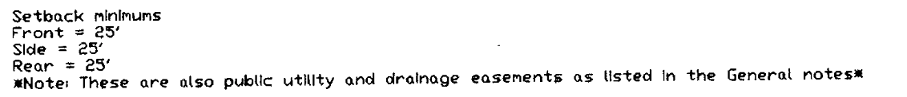
For clarification, it is recommended to include accessory structure setbacks and height restrictions in the PUD amendment.

Plat Map or Parcel Map (conditions of approval):
https://epcdevplanreview.com/Public/ProjectDetails/10192
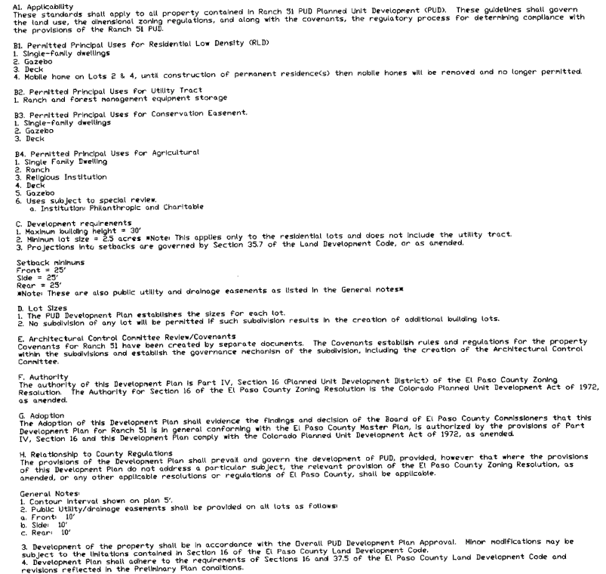

Application Type(s) Hearing: Required/ Optional/ No
Minor PUD Amendment | No

Approval Criteria:
4.2.6. PUD, Planned Unit Development District
(D) Approval Criteria For PUD Zoning. The Planning Commission and BoCC shall determine that the following criteria have been met to approve a PUD zoning district:
- The proposed PUD District zoning advances the stated purposes set forth in this Section;
- The application is in general conformity with the Master Plan;
- The proposed development is in compliance with the requirements of this Code and all applicable statutory provisions and will not otherwise be detrimental to the health, safety, or welfare of the present or future inhabitants of El Paso County;
- The subject property is suitable for the intended uses and the use is compatible with both the existing and allowed land uses on the neighboring properties, will be in harmony and responsive with the character of the surrounding area and natural environment; and will not have a negative impact upon the existing and future development of the surrounding area;
- The proposed development provides adequate consideration for any potentially detrimental use to use relationships (e.g. commercial use adjacent to single family use) and provides an appropriate transition or buffering between uses of differing intensities both on-site and off-site which may include innovative treatments of use to use relationships;
- The allowed uses, bulk requirements and required landscaping and buffering are appropriate to and compatible with the type of development, the surrounding neighborhood or area and the community;
- Areas with unique or significant historical, cultural, recreational, aesthetic or natural features are preserved and incorporated into the design of the project;
- Open spaces and trails are integrated into the development plan to serve as amenities to residents and provide a reasonable walking and biking opportunities;
- The proposed development will not overburden the capacities of existing or planned roads, utilities and other public facilities (e.g., fire protection, police protection, emergency services, and water and sanitation), and the required public services and facilities will be provided to support the development when needed;
- The proposed development would be a benefit through the provision of interconnected open space, conservation of environmental features, aesthetic features and harmonious design, and energy efficient site design;
- The proposed land use does not permit the use of any area containing a commercial mineral deposit in a manner which would unreasonably interfere with the present or future extraction of such deposit unless acknowledged by the mineral rights owner;
- Any proposed exception or deviation from the requirements of the zoning resolution or the subdivision regulations is warranted by virtue of the design and amenities incorporated in the development plan and development guide; and
- The owner has authorized the application.

Options:
(E)Basis for Standards. The use, dimensional, and development standards established within a PUD development plan and development guide should generally be based on existing zoning districts in the LDC. The use, dimensional, and development standards from an existing LDC base zoning district may be applied by the PCD Director in the event of inadvertent omission of a required use, dimensional, and development standard.

On the original PUD development plan please add a note to the effect that states:

Accessory structures for RLD Lots are permitted and must be the dimensional standards as follows:
-Front 25ft
-Side 15ft
-Rear 25ft

Relevant Past History:

Design and Landscaping

Site Design/Layout (Lot pattern, circulation/road design, open space, preservation of natural features, compatibility internally and with adjacent land uses)

Landscaping
☐ | Expressway, Principal arterial area depth – 25’-Trees required 1 per 20’
☐ | Urban interchange/Intersection area depth – 25’- N/A
☐ | Minor arterial area depth 20’ – Trees required 1 per 25’
☐ | Non-arterial area depth 10’ – Trees required 1 per 30’
☐ | Parking lot landscaping required
☐ | Buffer between non-residential and residential districts separated by a non-arterial road or public alley

Site Characteristics\ Constraints\ Environmental Standards:

☐ | 30% or greater slope | Topography:
☐ | CGS review required (separate fee to CGS) | Soils/geology:
☐ | Floodplain | Floodplain comment:
☐ | Noise mitigation required | Noise comment:
☐ | Preble’s mouse

Air/Visual Quality:

Districts

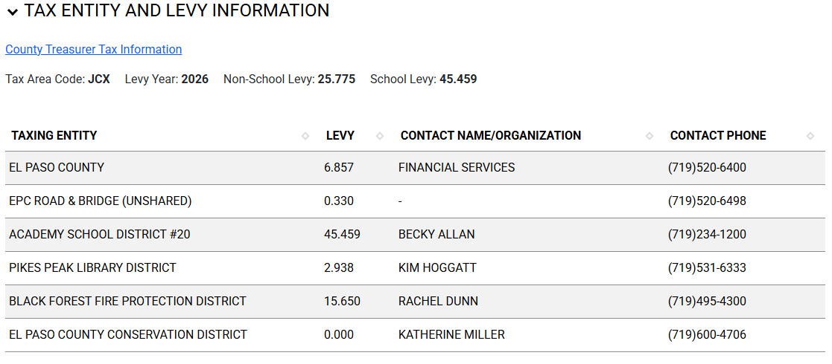
Proposed source of water |  |  | Proposed method of wastewater disposal
☐ | Central System |  | ☐ | Central System
District Name: |  |  | District Name:

Water/wastewater comments

Fire District:
Black Forest Fire District
(719)495-4300
https://www.bffire.org

Emergency Services Issues:

Commissioner District: 1

Code Waivers:
Subdivision waivers are not applicable to this request.

Parks and trails:
The 2022 El Paso County Parks Master Plan shows no impacts to existing or proposed parks, trails, or open space. As such no trail easement dedications will be necessary for this project. Regional park fees will be assessed upon review of the forthcoming platting actions.
It is not necessary for EPC Parks staff to attend this early assistance meeting.
Thank you!
Ashlyn Mathy
Parks Planner
Park Planning Division
El Paso County Parks Department
Office 719.520.6978

Road Impact Fee Program (PID Inclusion):
The Road Impact Fee is applicable at building permit and is administered by the Public Works Department and will be addressed during the engineering checklist section of the EA.

Your El Paso Master Plan

Placetype: Large-Lot Residential
Character:
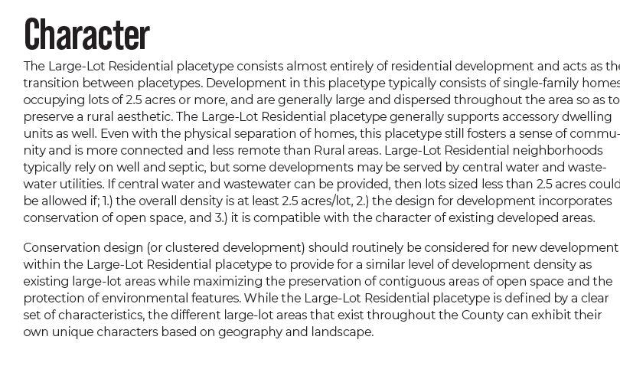

Recommended Land Uses:
- 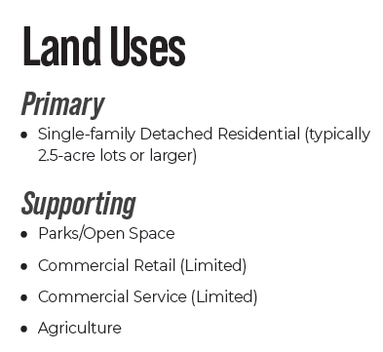

Goals, Objectives, Strategies:

Area of Change Designation: Minimal Change: Undeveloped
Description:
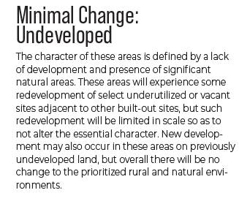

Goals, Objectives, Strategies:

Key Area: Forested Area

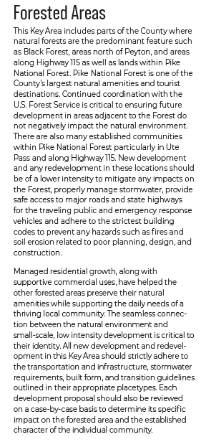

Goals, Objectives, Strategies:

Wildlife impact
1-Low

Helpful Links

Planning Website: https://planningdevelopment.elpasoco.com/

El Paso County Master Plan: https://planningdevelopment.elpasoco.com/#1510603950097-f5d985dc-35b2
Water Master Plan: https://planningdevelopment.elpasoco.com/#1515613078151-9a697e85-b1a7
Parks Master Plan: https://parks.elpasoco.com/parks-and-recreation/park-planning/
Mineral Extraction Master Plan: https://planningdevelopment.elpasoco.com/#1515613078151-9a697e85-b1a7

Forms and Templates: https://planningdevelopment.elpasoco.com/forms-and-affidavits/

Applications and Checklists: https://planningdevelopment.elpasoco.com/applications-and-checklists/

Land Development Code: https://library.municode.com/co/el_paso_county/codes/land_development_code

EDARP: https://epcdevplanreview.com/

Public GIS: https://experience.arcgis.com/experience/94cea8ccda3d4806a3fd500d2b5a4433?draft=true

Wrap Up
-If subdivision is proposed, recording fees, park and school fees and road impact fees may apply.

-Fees are subject to change. The fees at the time of application apply.

-Road Impact Fees
Please see the following website for information on the EPC Road Impact Fee Project. https://publicworks.elpasoco.com/road-impact-fees/ to include fee schedule.
As of December 15, 2016, per Resolution 16-454, on and after January 1, 2020, property in the unincorporated area of the county that receives a Land Use Approval either in a public hearing or administratively, is subject to the payment of Road Impact Fees. After December 31, 2024, in accordance with BoCC Resolution 24-377 the fee is paid for new residential and non-residential uses and structures and expansions of non-residential uses and structures. Road Impact fees are typically paid at time of building permit. If no building permit is being obtained for a particular Land Use application, then Road Impact Fees must be paid at the time of Site Development Plan or Special Use approval. If there are questions about EPC Road Impact program or fees, please contact DPW Development Review Services and the Engineer of the Day.

- Engineering Criteria Manual (ECM) Deviations.
The fee for any additional ECM deviation requests (more than two per land use application) - $1483.00 each per current Fee Schedule. Please note ECM deviation requests may result in additional processing and project review time. ECM Deviations should be submitted prior to the initial Site Development Plan or Final Plat submittal to preclude changes having to be made to engineering plans and documents if the deviation is not approved. Submission of an ECM deviation request does not imply or guarantee that the deviation will be approved. An ECM Deviation form must be submitted to include complete exhibits and justification excluding cost with supporting engineering criteria. If there are questions about ECM Deviation requests, please contact DPW Development Review Services and the Engineer of the Day.

-The fee for any additional waiver/deviation requests (more than two) - $550.00 each. Please note that requests for waivers and/or deviations may result in additional processing/review delay.

-All items requested must accompany the submittal for it to be complete, prior to payment request or the submittal will not be complete and ready for review agencies.

-A temporary use permit shall be applied for and approved for any staging area associated with development, such as a sales office, construction trailer, or contractor's equipment yard, prior to scheduling of the pre-construction meeting with El Paso County Planning and Community Development. If a Planned Unit Development is proposed, the temporary staging area should be shown on the development guideline and phasing plan.

-All prospective timelines for review are subject to departmental staffing and workload.

-Early Assistance is valid for 12 months from submittal of the EA application. If a project submittal is not received within 12 months, a new EA meeting may be required. An audio/video copy of the meeting is available in EDARP within the EA folder.

- Applications scheduled for public hearings may be heard as a regular item at the request of staff or a hearing body member.

- Any comments or commitments made by any member of the County Staff during this early assistance meeting are only preliminary in nature and should not be relied upon by the applicant. All prospective applicants should be informed that formal comments cannot be made by staff until after the application is submitted.

