

Department of Public Works
Kevin Mastin, Executive Director  719-520-6460  Public Works  3275 Akers Dr.  Colorado Springs, CO 80922  www.ElPasoCo.com |  | Board of County Commissioners  Holly Williams, District 1  Carrie Geitner, District 2  Stan VanderWerf, District 3  Longinos Gonzalez, Jr., District 4  Cami Bremer, District 5

Preliminary Acceptance Punch List
Date:
Subdivision: Falcon Meadows at Bent Grass Fil 4
October 29 ,2025
EDARP File #: CON2433 Completion date:
Developer: Challenger Communities, LLC
Address: 8605 Explorer Dr, Suite 250, Colorado Springs, CO 80920

Dear Challenger Communities,

Following our recent inspection, we have developed a punch list of deficiencies per the approved construction plans. Please have all necessary repairs completed within 6 months from the date of this punch list if they are not complete within 6 months a new inspection and punch list will be required. Once these issues have been resolved, please contact me for a reinspection, once we have done a reinspection and we are satisfied that all repairs are completed on this punch list and the stormwaters punch list, and all required As Builts and Surveys are received by El Paso County we will move forward with your request for Preliminary Acceptance.

If you have any questions or if I can be of any assistance, please don’t hesitate to contact me.

Sincerely,

Edward Skelton
Engineering Inspections
El Paso County Department of Public Works
719-439-3958

- Original set of plans marked up as As-Built Plans
  - Even if nothing has changed, we need an electronic PDF set Signed, Dated and Stamped with “As Built” or “Record Drawing” on each page.
- Utility Company acceptance letters
- Engineer stamped pond certification letter.
- Pond surveys for all ponds
  - Pond volume
  - Outlet structure
    - Orifice plate elevations
    - Orifice plate orifice hole sizes
    - Overflow elevations
    - Emergency spillway
      - Elevations and Dimensions
  - 4 stones remove and replace 20’ North of Henzlee Pl and Nico Dr.
  - Clean the inlets on both sides of the street on Lemon Grass Dr. and Bent Grass Meadows Dr. (Sediment and trash will need to be removed from inside of the inlets)

Inlet at Lemon Grass Rd. Exhibit
  - 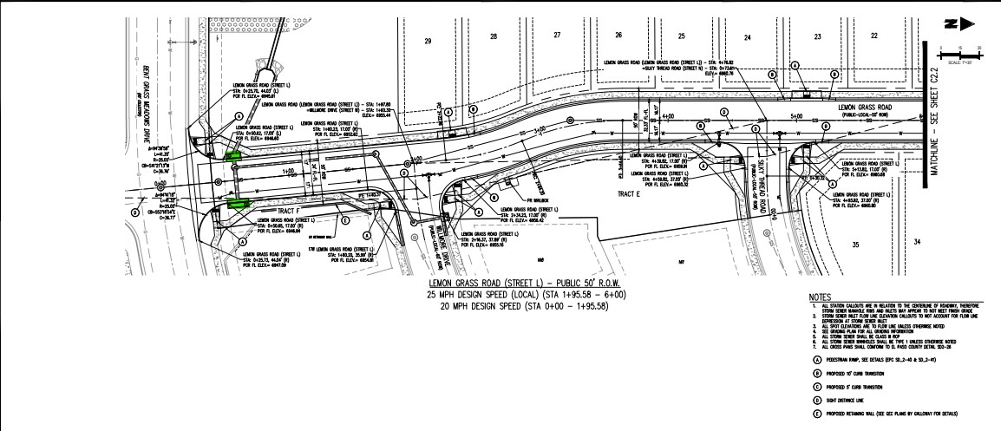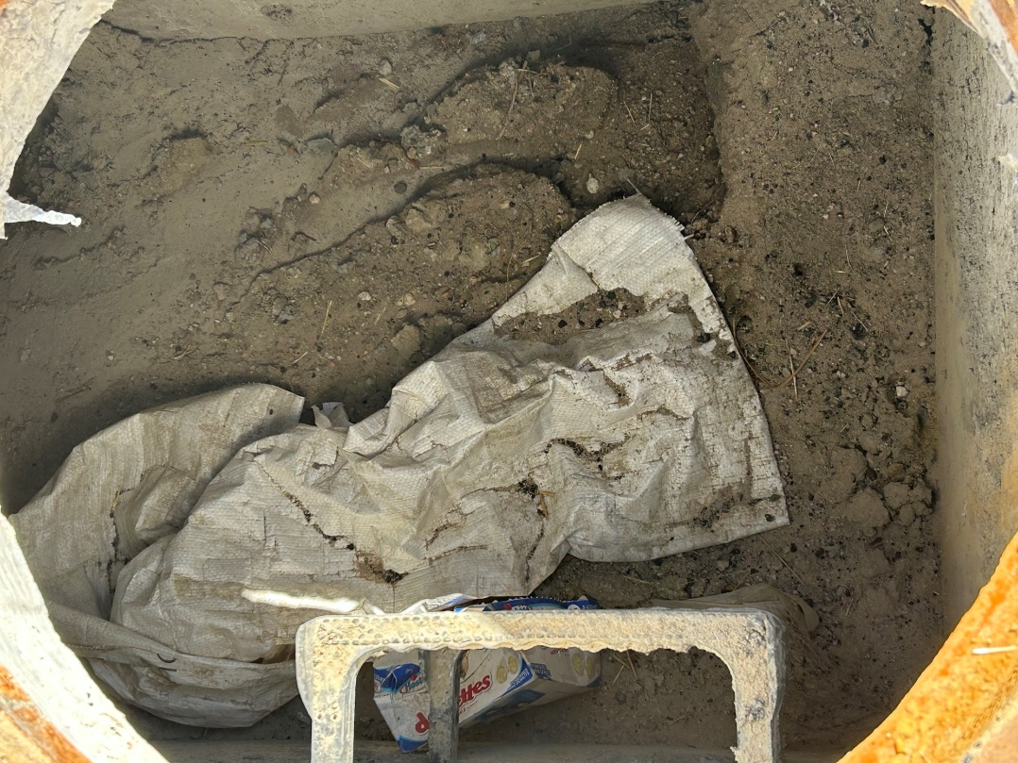

Any changes identified in the survey need to be put into a comparison table, and they need to be plug back into the model and provide the county with updated outflows.

ECM requirements for the above are:

5.10.6. Engineering Record Drawings

A. Record Drawing Required. Engineering Record Drawings are required for all projects that include public improvements or common development improvements, including but not limited to roadway improvements, public sidewalks and trails, storm drainage facilities, and utility infrastructure on public property or on private property within public easements or rights-of-way. Engineering Record Drawings are necessary for inclusion of public improvements into the El Paso County Asset Management System, to serve as a basis to plan and design future projects in the same area, to demonstrate ADA compliance, and to document compliance with permitting requirements such as the County's MS4 permit. Engineering Record Drawings shall be submitted in an electronic format acceptable to the ECM Administrator as described below in Section 5.10.6.D.

B. Reflect Changes to Construction Plans. Engineering Record Drawings are a record of any substantial variations or changes to the original intended physical product of the approved construction plans, based upon visual field observations or field survey data. The revisions shall be shown on a copy of the original approved construction plans that are filed with the County. Engineering Record Drawings submitted for County review may be the same drawings as the original approved plan drawing if no substantial variation to the original approved design occurred. Engineering Record Drawings shall be accompanied by a certification letter from the Engineer of Record which shall state that the site and adjacent properties (as affected by work performed under the County permit) are stable with respect to settlement and subsidence, sloughing of cut and fill slopes, revegetation or other ground cover, and that the improvements (public improvements, common development improvements, site grading and paving) meet or exceed the minimum design requirements .
For sites including detention and/or water quality facilities , the certification letter shall include a statement that the facilities provide the required storage volume and will meet the required release rates, as documented by an attached UDFCD design form submitted with the original application, the stage areas, elevations and outlet dimensions. If the detention/WQCV facility cannot be modeled with UDFCD spreadsheets due to a large contributing area, other verified stage/storage/discharge tables for the applicable design storms shall be provided with the certification letter .
At the initiation of the Preliminary Acceptance process, Engineering Record Drawings shall be submitted for review and approval by the ECM Administrator.

C. Record Drawings Approval Process. To facilitate the approval process of Engineering Record drawings, the following procedure shall be followed:
• The permit holder's engineer of record shall submit the Engineering Record Drawings for ECM Administrator review in the applicable formats specified below.
• The ECM Administrator will review the drawings and redline any necessary changes . The engineer of record shall update the drawings and resubmit the drawings for approval.
• Upon ECM Administrator approval of the final Engineering Record Drawings, the drawings will be uploaded to the El Paso County Planning and Community Development (PCD) Electronic Development Application Review Program (EDARP). If there are multiple hardcopy sets the County will retain one set.
• The Engineering Record Drawings shall clearly indicate the completed state of construction for the project. Each sheet of the record drawings shall be designated as "Engineering Record Drawings" and signed and dated by the engineer of record.
• Financial assurances for the Engineering Record Drawings line item in the project Financial Assurance Estimate will not be released until the Engineering Record Drawings are submitted, verified and approved, nor will partial releases of any line item be reduced to less than 20%. It is recommended that the required format of drawings and certification letter be submitted at least one month prior to the developer's request for Preliminary Acceptance to expedite the County acceptance process.

D. Required Engineering Record Drawings Format
1. A complete construction plan set, including the plat or parcel boundaries as applicable, conforming to the minimum requirements in this section is required. Hard copy drawings will only be accepted in special cases as approved by the ECM Administrator.
2. For projects submitted on or after July 1, 2019, Electronic CAD files shall be in AutoCAD format (.DWG) 2016 or newer or in .PDF file format.

