Early Assistance (EA) Meeting Number: EA2636
Project Name: Lot 111 Commercial Subdivision
Project Location: 3415 Double Tree Court 80921
Project Parcel No.: 6122007015
Project Description: Review and discuss the requirements to subdivide Lot 111 into three commercial (or residential) lots and review potential development options with the existing PUD zoning. A commercial use concept sketch is attached as an example. A preliminary grading and stormwater infrastructure plan is also attached.

1. Explore the option to subdivide into three commercial or residential lots or keep as one Lot 111.
2. Also to discuss and obtain guidance for potential use opportunities.
- Restaurant Event center could be used for community events, weddings, etc. similar to the “Barn” at Woodmoor.
- L shaped multi-tenant retail leased (or condo) to multiple small shops; e.g. baker, butcher, florist, farmers produce, exercise, etc.
- Fuel/Convenience and car wash would be for the public. There is no F/C along Highway 83 from Franktown until Flying Horse at Northgate Boulevard.

EA Meeting Date: 4/13/2026 at 1:00 P.M.

El Paso County Planning & Community Development Planning Checklist

Zoning Map
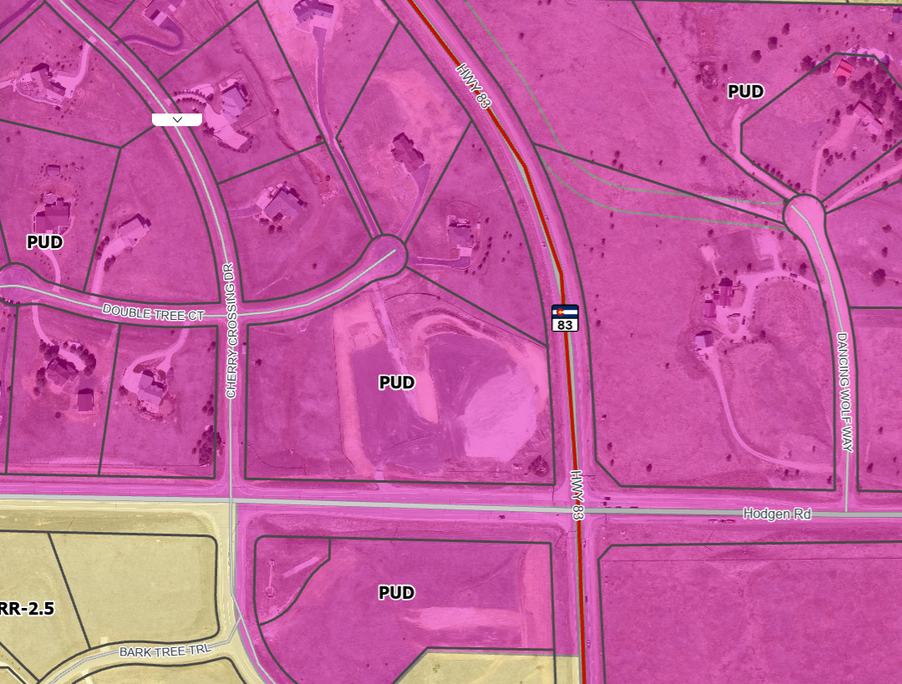

Existing Zoning (No Overlay)
PUD |  | Planned Unit Development

https://epcdevplanreview.com/Public/ProjectDetails/34876

https://epcdevplanreview.com/Public/ProjectDetails/33752

Zoning District Analysis:
PUD deferred to the Neighborhood Business District Zoning District for uses and standards. NBD is now Commercial Community. 
Business event center / Community Building allowed in CC

Commercial or Retail as Part of
Overall Shopping Center/ Convenience Store/ Gas Station allowed in CC

Single-Family Multi-Family Residential Not allowed would require a Rezoning

Zoning District Requirements (density, lot size, lot design standards, building setbacks)
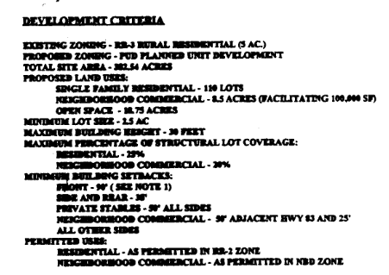
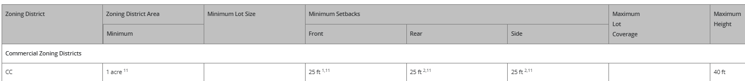

Commercial Community: The CC zoning district is intended to accommodate retail sales and service establishments that generally require freestanding or small center type buildings and that primarily serve adjoining neighborhoods.

25’ setbacks all sides except internal zone boundary lots. 40’ height max

1 Gasoline pumps and canopies shall be at least 15 feet from the front property line or public right-of-way, except where the landscaping regulations require a greater setback.
2 The minimum setback is 25 feet from the perimeter boundary of the district, but no minimum setback is required from any internal side or rear lot line within the same district.
11 If the building is established as or converted to condominium units in accordance with Chapter 7 of this Code, the building and lot shall meet the minimum lot area and setbacks, but the individual units are not required to meet the minimum lot area, maximum lot coverage, or setback requirements.

Map of Platted Lot/ Tract:
`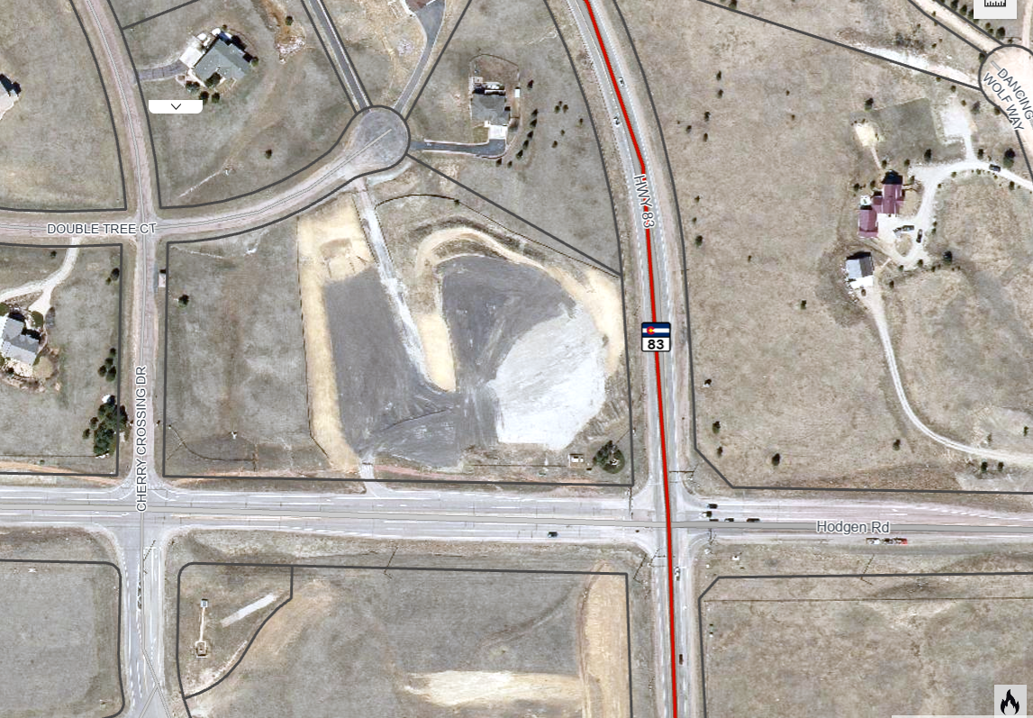
15’ Buffer from residential
15’ Buffer from residential
25’ Roadway landscape
Road Classification Depth of Roadway Landscaping Area Required Trees (Trees/ Foot of Frontage)
Expressway, Principal Arterial 25 feet 1 per 20 feet
Urban Interchange/Intersection 25 feet 1 per 20 feet
(Substitute shrubs for visibility)
Minor Arterial 20 feet 1 per 25 feet
Non-Arterial 1 10 feet 1 per 30 feet
1 The required depth of the roadway landscape area shall be increased to 15 feet along a non-arterial road or public alley where the road or alley separates a non-residential use from a residential zoning district. The number of required trees shall be increased to 1 per 15 feet of linear frontage. A minimum of ⅓ of the trees shall be evergreen trees.

See all Chapter 6 for additional Landscape requirements.
Encourage a roadway and buffer landscape plan with Plat then site-specific lots have individual parking lot and an internal landscape for center continuity.
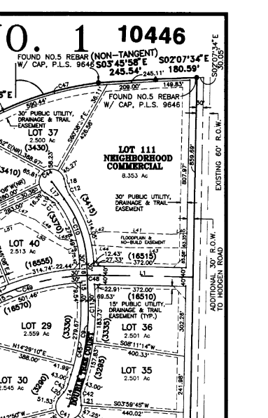
FDR address location of swale; FEMA not showing up
Trail sign closed due to damage area and unbuilt trail; applicant contact Ashlyn prior to grading

EDARP Records:

Plat Notes: 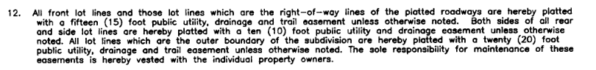
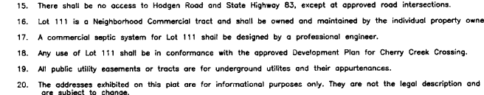

Application Type(s) Hearing: Required / Optional / Not Required
Public Hearings Required (PC and BOCC)

Land Development Code Applications & Checklists Link
Chapter 7, Rules Governing Divisions of Land
Section 7.2.3, Actions Vacation or Altering a Recorded Plat (LDC Link)
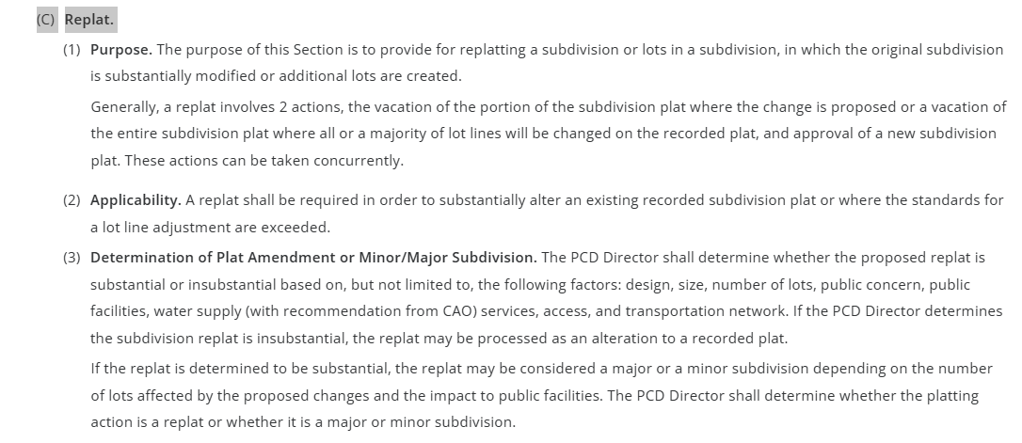
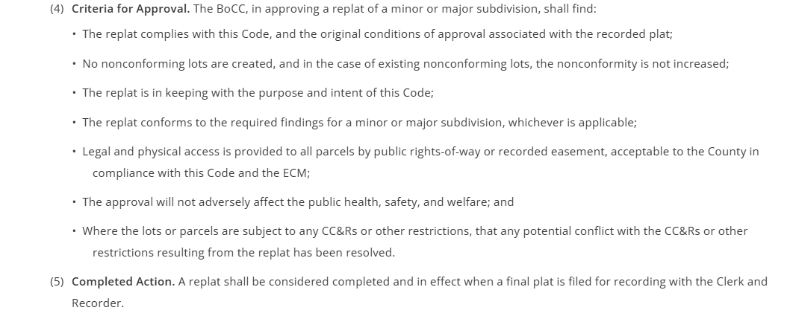
Section 7.2.1, Subdivisions (VR- criteria for approval #4 above)

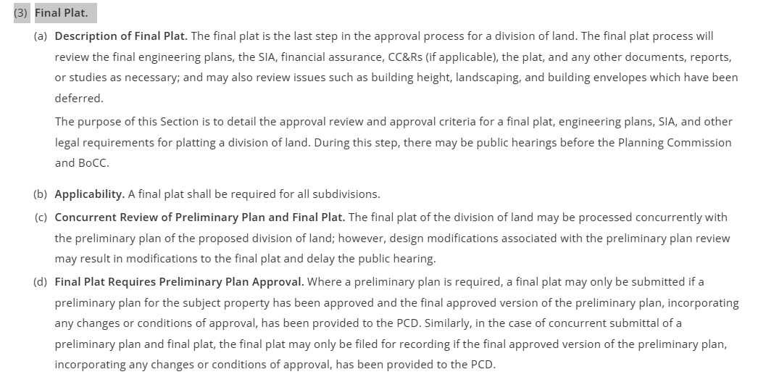
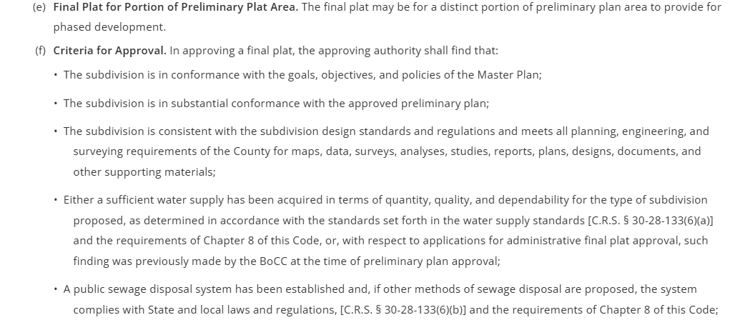
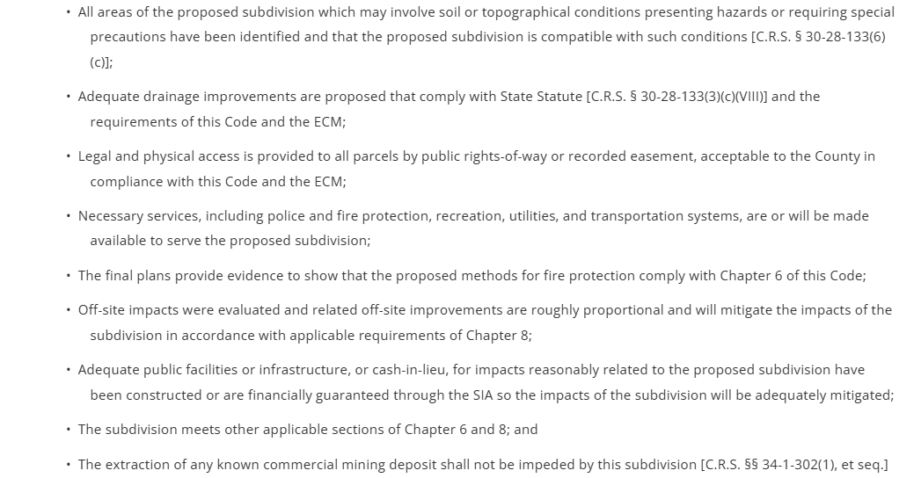

Processing Issues and Options:
All new structures and uses will require a Site Dev Plan in accordance with Chapter 6;
If lots are created a final plat is required. One final Plat for project – 3 lots

Relevant History/Discussion at EA:
Previous PUD zoning
EPC Health 2000 gallons per day per lot; if pad sites one lot exceeding 2000 gallons per day may implement policy 6 zone of influence cant overlap no more than 6000 gallons per day; higher level treatments for commercial in this area a larger footprint is common due to soil; gas station high strength waste system ; systems have to modified as use changes so build to best highest use… professional design required for commercial systems- paper products may not impact flow significantly for restaurant; well required to be 100 feeet outside of zone of influence areas. Advanced filter could reduce w? Variance of Board Examiners to 75’- CDPHE non-community groundwater regs.;
Parking not allowed over septic systems.
Septic systems not allowed under detention – 50’ distance from drainage system crest
3:1 or 4:1 sloped are evaluated by an engineered septic designer.

CDOT access permit review TIS- applicant not directly accessing HWY 83 but will access Hodgen road connecting to Hwy 83.
Applicant proposing Right In and Right Out – DPW responds. Deviation ri/ro denied in 2000? Spacing short.

EPC Parks- 25 ‘ trail easement for Fox Run (runoff concerns to trail)

Property Conditions
☐ | 30% or greater slope | Comments: | N/A
☐ | CGS review |  | Required see 8.4.9 of Code
☐ | Floodplain |  | N/A
☐ | Noise mitigation required |  | N/A
☐ | Preble’s mouse |  | N/A
☐ | High-Hazard Vegetation |  | (Green)
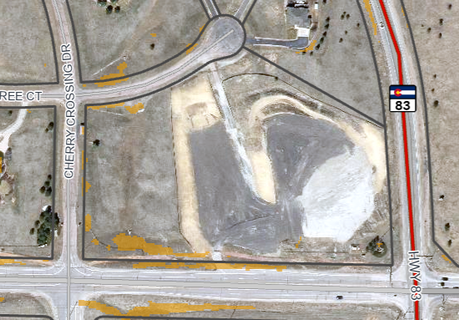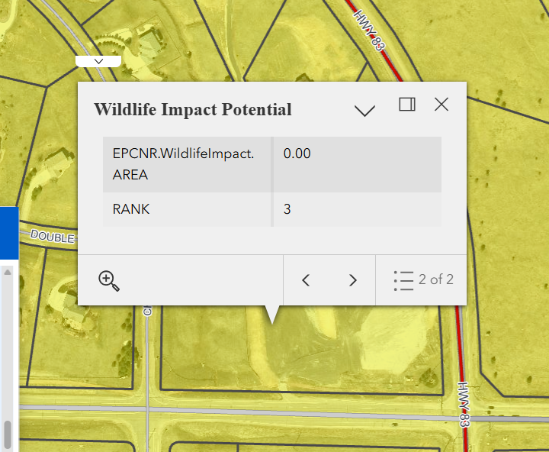

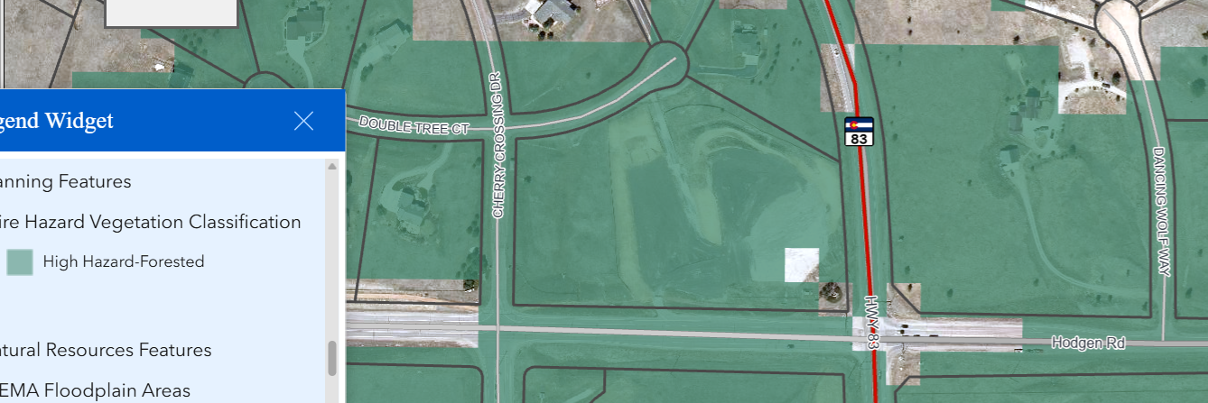
Direct Link to PCD Fire Safety and Wildfire Mitigation Resources:
https://planningdevelopment.elpasoco.com/#1747935923000-7c355148-4705
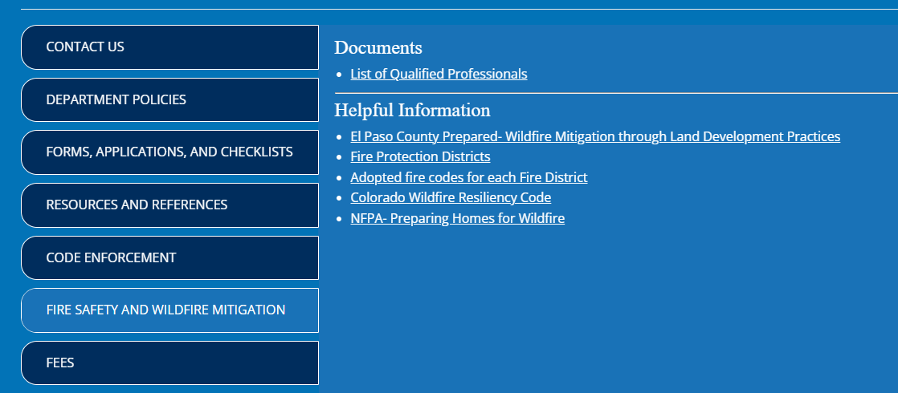

Land Development Code, Section 6.3.3:
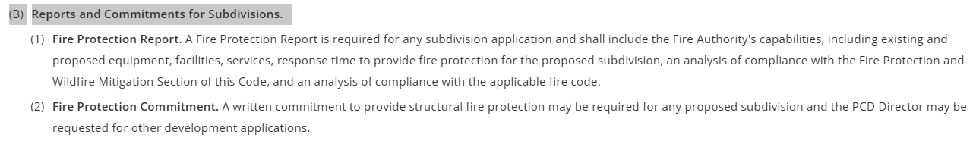
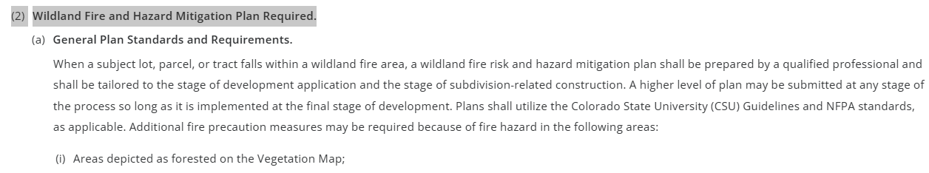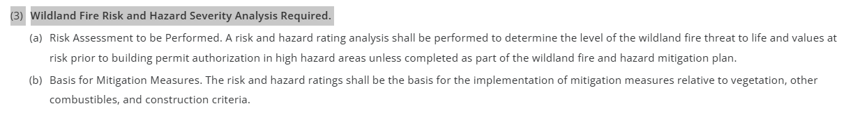
Land Development Code, Section 6.3.7:
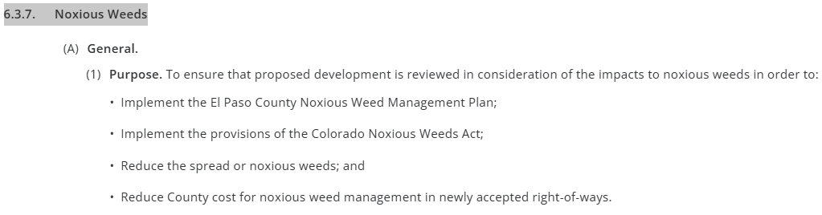
Review all of Land Development Code, Chapter 8
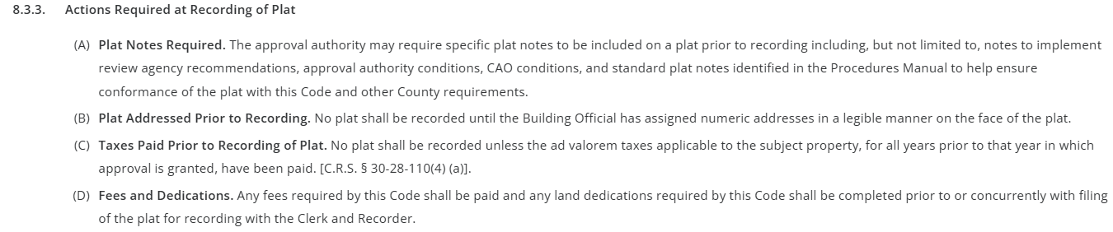

8.4.1. Planning Considerations

8.4.2. Environmental Considerations

8.4.3. Division of Land, Block, Lot, and Tract Layout Standards
8.4.4. Transportation System Considerations and Standards

8.4.5. Drainage Considerations and Standards (Easements)
Standard drainage easement width for rural lots: 10 feet on all sides.
8.4.6. Utilities Considerations and Standards (Easements)
Standard utility easement width for rural lots: 10 feet on all sides.
8.4.7. Water Supply Standards
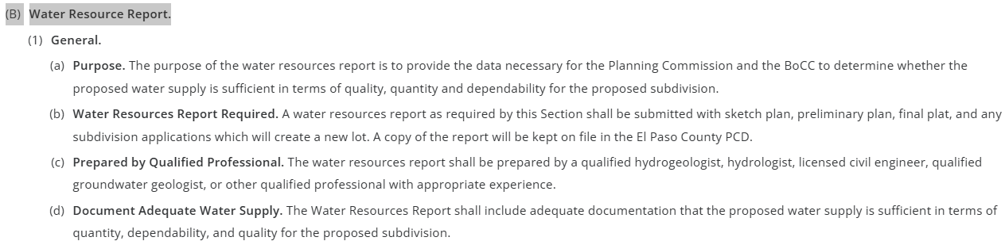
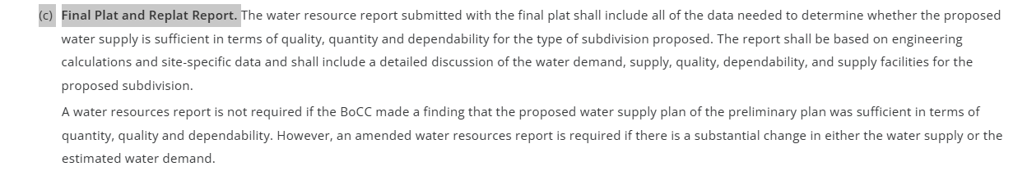
8.4.8. Wastewater Disposal
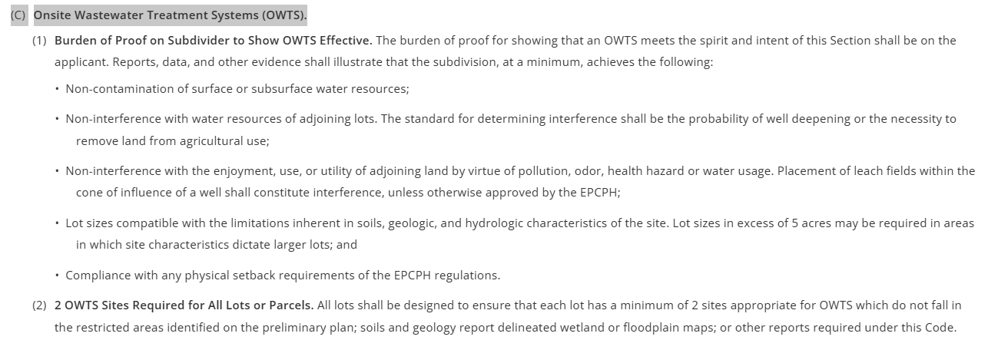
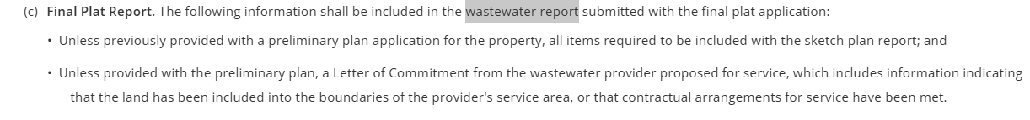
8.4.9. Geology and Soils Standards and Reports
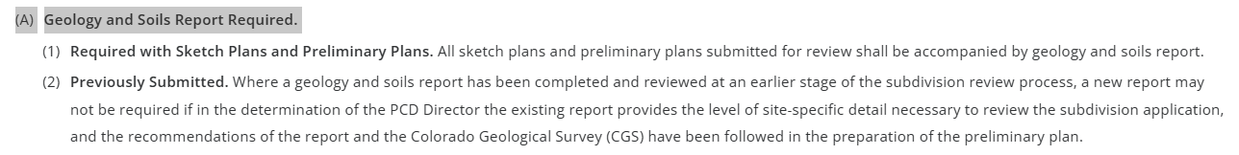

8.5. - DEDICATION AND FEE STANDARDS AND REQUIREMENTS
8.6. - CONSTRUCTION AND ACCEPTANCE OF REQUIRED IMPROVEMENTS
8.7. - PUBLIC INFRASTRUCTURE FINANCING PROVISIONS

Taxing Entities
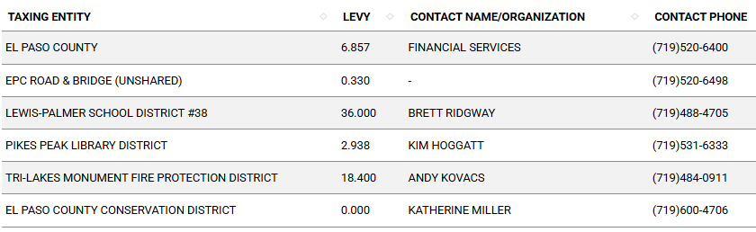

Road Impact Fees:
PID application? Apply to County Attorney

Proposed source of water |  |  | Proposed method of wastewater disposal
☐ | Central System |  | ☐ | Central System
District Name: |  | N/A - Well 11.2 ac ft / year | District Name: |  | N/A - Septic
Fire District - Design Concerns/Emergency Services Issues:
TriLakes Protection District

The FPD will be a review agency – all returned comments will be made available in EDARP.

Commissioner District: 1 (Commissioner Williams)

Waivers: (not anticipated)
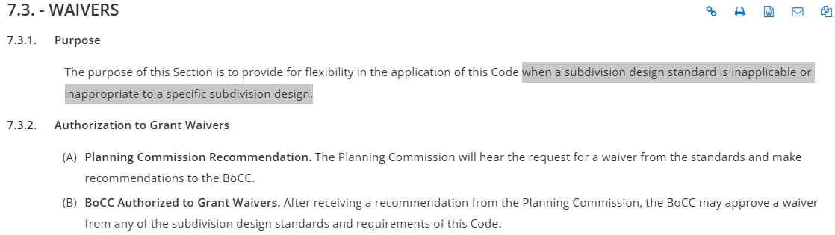
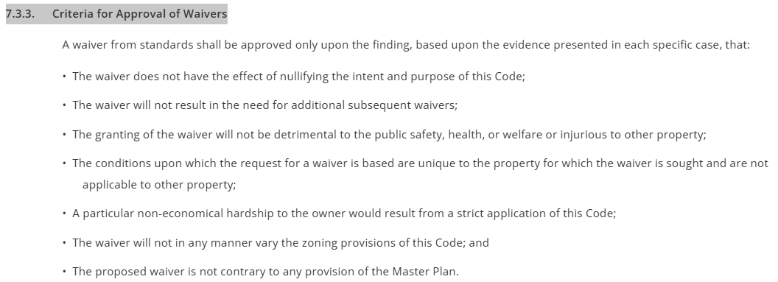
https://library.municode.com/co/el_paso_county/codes/land_development_code?nodeId=CH7RUGODILA_7.3WA

Parks and trails:
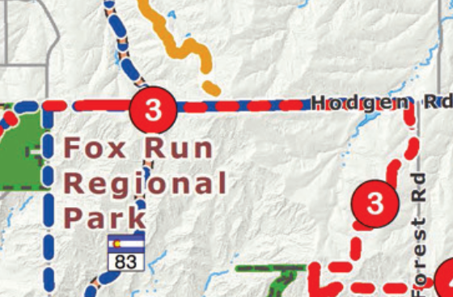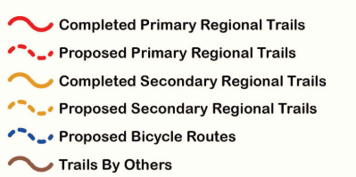 The 2022 El Paso County Parks Master Plan identifies impacts to a proposed trail within this property. The Fox Run Primary Regional Trail is planned to pass through the site, creating a connection between the existing segment and the west side of Cherry Creek Road. The proposed alignment falls within a utility easement, and the County would like the trail to continue through the property as planned.

Staff requests that a 25-foot trail easement be dedicated and clearly labeled as a County trail on the plat, along with an accompanying plat note.

Additionally, for any grading proposed on the property, staff requests that it be conducted in a sustainable manner that supports the long-term viability of the trail corridor and avoids creating negative impacts.

Regional park fees will be assessed upon review of the forthcoming preliminary plans and final plats.

EPC Parks staff will attend this early assistance meeting, please send an invite to ashlynmathy@elpasoco.com.

Thank you!

Ashlyn Mathy
Parks Planner
Park Planning Division
El Paso County Parks Department
ashlynmathy@elpasoco.com

Annexations/Intergovernmental/ Jurisdictional Access issues:
CDOT

Your El Paso Master Plan:

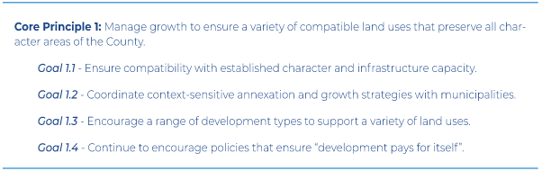

Placetype: Large Lot Residential

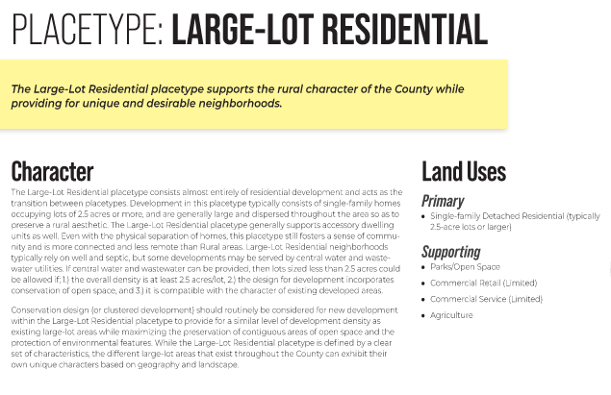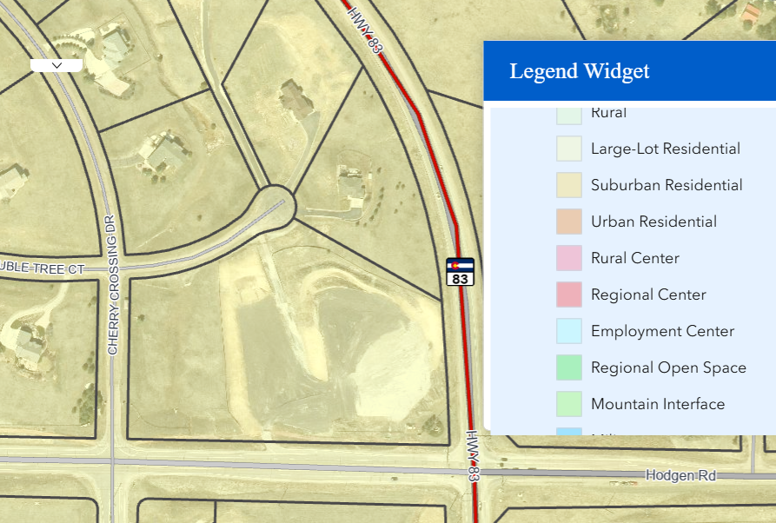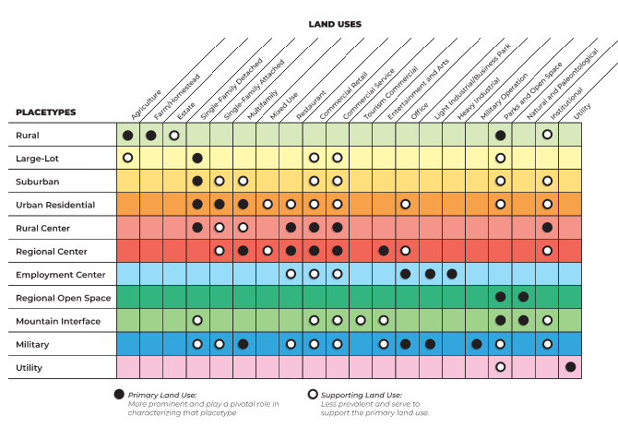

Key Areas: Tri Lakes
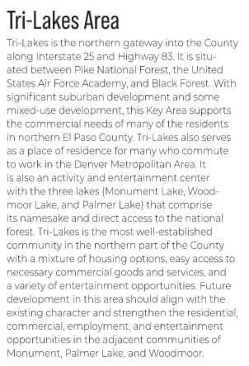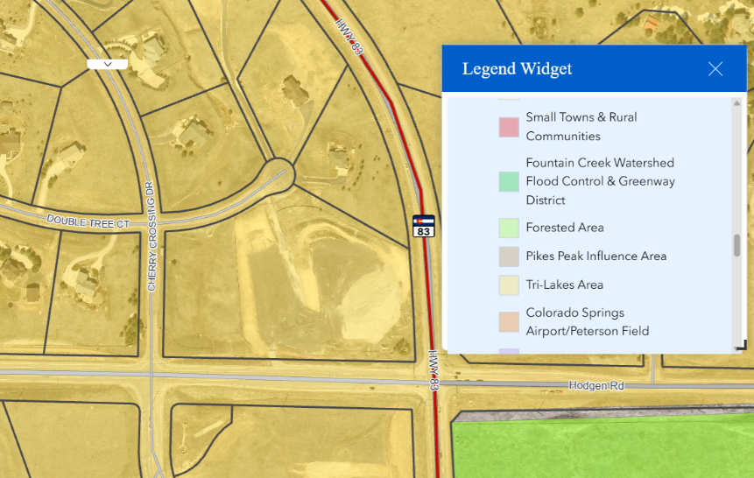

Area of Change: Minimal Changed Developed
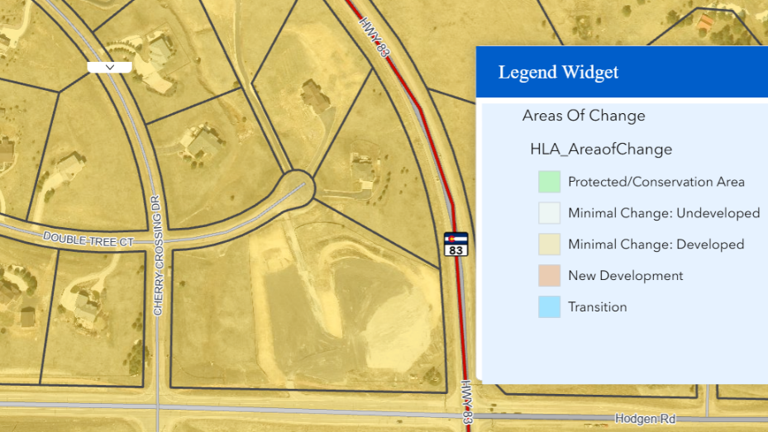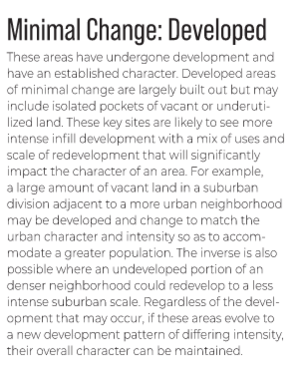

WATER MASTER PLAN
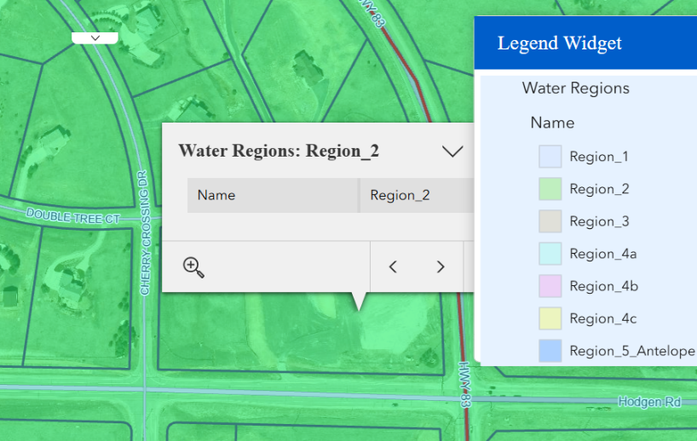

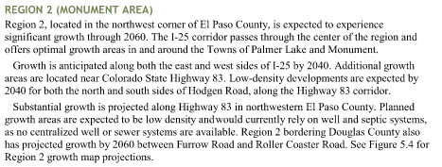

Helpful Links:

Engineering Docs: https://publicworks.elpasoco.com/department-public-works/county-engineer/

Stormwater Docs: https://publicworks.elpasoco.com/stormwater/

Planning Docs: https://planningdevelopment.elpasoco.com/planning-development-forms/#1510677560407-ff8cfff5-69b2716b-00f9cbba-0c21

Planning Website: https://planningdevelopment.elpasoco.com/

El Paso County Master Plan: https://planningdevelopment.elpasoco.com/#1510603950097-f5d985dc-35b2
Parks, Mineral and Water Master Plans: https://planningdevelopment.elpasoco.com/resources-and-references/#1516982531779-52cc0e87-01af

Land Development Code: https://library.municode.com/co/el_paso_county/codes/land_development_code

EDARP: https://epcdevplanreview.com/

Public GIS: https://elpasoco.maps.arcgis.com/apps/View/index.html?appid=5be6431018594c67b035ad0aad3e7e8a

Wrap Up:
- If subdivision is proposed, recording fees, park and school fees and road impact fees apply.
- Fees are subject to change. The fees at the time of application apply.
- Pursuant to the adopted El Paso County Road Impact Fee Program (Resolution No. 12-382), a transportation impact fee, calculated on a per trip basis, may be due at the time of building permit issuance. Starting January 1, 2020, the transportation impact fee will be due for all new construction (Resolution No. 19-471), as amended.
- The fee for any additional waiver/deviation requests (more than two) - $550.00 each. Please note that requests for waivers and/or deviations may result in additional processing/review delay.
- All items requested must accompany the submittal for it to be complete, prior to payment request or the submittal will not be complete and ready for review agencies.
- A temporary use permit shall be applied for and approved for any staging area associated with development, such as a sales office, construction trailer, or contractor's equipment yard, prior to scheduling of the pre-construction meeting with El Paso County Planning and Community Development. If a Planned Unit Development is proposed, the temporary staging area should be shown on the development guidelines and phasing plan.
- All prospective timelines for review are subject to departmental staffing and workload.
- Applications scheduled for public hearings may be heard as a regular item at the request of staff or the hearing body.
- Any comments or commitments made by any member of the County Staff during this early assistance meeting are only preliminary in nature and should not be relied upon by the applicant. All prospective applicants should be informed that formal comments cannot be made by staff until after the application is submitted.
- Early Assistance is valid for 12 months from submitting the EA application. If a project submittal is not received within 12 months, a new EA meeting may be required. An audio/video copy of this meeting is available in EDARP within the EA project folder.

