PRIVATE STORMWATER FACILITY

MAINTENANCE AGREEMENT AND EASEMENT

This PRIVATE STORMWATER FACILITY MAINTENANCE AGREEMENT AND EASEMENT (“Agreement”) is made by and between El Paso County by and through THE BOARD OF COUNTY COMMISSIONERS OF EL PASO COUNTY, COLORADO (“County”); CS 2005 Investments III, LLC, its successors and assigns (“Owner”); TTRES CO Colorado Springs Venetucci Blvd, LLC (“Developer”); THE CITY OF FOUNTAIN, COLORADO (“Fountain”), and South Academy STATION Metropolitan District No. 2 (“Metro District”). The above may occasionally be referred to herein singularly as “Party” and collectively as “Parties.”

Recitals
- WHEREAS, Metro District was organized and exists pursuant to the Colorado Special District Act, §§ 32-1-101, et. seq., C.R.S., to provide certain public improvements, facilities, and services to and for the use and benefit of its residents, taxpayers, and property owners and the public as set forth in the Service Plan for South Academy Station Metropolitan District Nos. 1-5 (the “Service Plan”), approved by the County on August 30, 2007; and

- WHEREAS, pursuant to § 32-1-1001(1)(d), C.R.S., Metro District is empowered to enter into contracts and agreements affecting its affairs; and

- WHEREAS, Owner is the owner of certain real estate (the “Subject Property”) in El Paso County, Colorado, which property is legally described in Exhibit A attached hereto and incorporated herein by this reference; and

- WHEREAS, Owner desires to plat and develop on the Subject Property, a Subdivision to be known as “Venture on Venetucci Filing No. 1” (referred to herein as the “Subdivision”); and

- WHEREAS, a portion of the Subdivision will be sold to Developer, as described in Exhibit B attached hereto and incorporated herein by this reference (the “TTRES Property”); and

- WHEREAS, development of the Subdivision, will materially increase the volume and decrease the quality of stormwater runoff from the Subject Property; therefore, it is in the best interest of the public health, safety and welfare for the County to condition approval of the Subdivision on Owner’s and Developer’s promise to construct and maintain adequate stormwater control facilities including permanent stormwater quality structural control measures (“BMPs”) for the Subject Property; and

- WHEREAS, the El Paso County Land Development Code, as periodically amended, requires the construction and maintenance of detention ponds and other drainage facilities adequate to maintain historic stormwater flow patterns, protect natural and man-made drainage conveyances, and prevent property damage in connection with land development and subdivisions, and further requires that developers enter into maintenance agreements and easements with the County for such drainage facilities; and

- WHEREAS, the El Paso County Drainage Criteria Manual, Volume 2, as amended by Appendix I of the El Paso County Engineering Criteria Manual (“ECM”), as each may be periodically amended, promulgated pursuant to the County’s Colorado Discharge Permit System General Permit (“MS4 Permit”), which MS4 Permit requires that the County take measures to protect the quality of stormwater from sediment and other contaminants, requires subdividers, developers, landowners, and owners of facilities located in the County’s rights-of-way or easements to provide adequate permanent stormwater quality facilities and BMPs with new development or significant redevelopment and to enter into maintenance agreements and easements with the County for such facilities and BMPs; and

- WHEREAS, Section 2.9 of the El Paso County Drainage Criteria Manual, Volume 1 provides for a developer’s promise to maintain a development’s drainage facilities in the event the County does not assume such responsibility; and

- WHEREAS, pursuant to the terms of a development agreement with Owner (“Development Agreement”), Developer desires to be jointly and severable responsible for the construction of drainage conveyance facilities including channel stabilization improvements (collectively, “Stormwater Facilities”) as the means for providing adequate drainage and stormwater runoff control for the Subject Property and to meet the requirements of the County’s MS4 Permit; and

- WHEREAS, Developer and Owner desire to construct the Stormwater Facilities on the Stormwater Facilities Area as set forth on Exhibit C, attached hereto and incorporated herein by this reference; and

- WHEREAS, Owner shall be charged herein with the duty of providing Metro District and the County with necessary easements and access to the Stormwater Facilities in the portions of the Stormwater Facilities Area identified as Tracts B and C of the Subdivision, as identified in Exhibit C; and

- WHEREAS, Fountain shall be charged herein with the duty of providing Metro District and the County with necessary easements and access to the Stormwater Facilities in the portion of the Stormwater Facilities lying within the Venetucci Boulevard right-of-way, as identified in Exhibit C; and

- WHEREAS, the easements granted herein will allow Metro District and the County the access to operate, maintain, and repair Stormwater Facilities as set forth in this Agreement; and

- WHEREAS, Metro District, for the benefit of its residents, taxpayers, property owners and the public, desires to operate, maintain, and repair the Stormwater Facilities as set forth this Agreement; and

- WHEREAS, Owner desires to meet Clean Water Act Section 404 requirements, as set forth in the U.S. Army Corps of Engineers Permit (SPA-2024-00262), attached hereto as Exhibit D and incorporated herein by this reference; and

- WHEREAS, Metro District shall be charged with the duties of operating, maintaining, protecting, and repairing Stormwater Facilities on the Stormwater Facilities Area in accordance with all applicable federal, State, and County requirements; and

- WHEREAS, the County, in order to protect the public health, safety and welfare, desires the means to access, construct, maintain, and repair the Stormwater Facilities, and to recover its costs incurred in connection therewith, in the event the Owner, Developer, or Metro District fails to meet its obligations to do the same; and

- WHEREAS, the County conditions approval of the Subdivision on Developer’s and Owner’s promise to construct the Stormwater Facilities , Metro District’s promise to operate, maintain and repair the Stormwater Facilities, and on Owner’s, Developer’s, and Metro District’s promise to reimburse the County in the event the burden falls upon the County to construct, clean, maintain or repair the Stormwater Facilities serving the Subdivision; and

- WHEREAS, the County, in order to secure performance of the promises contained herein, conditions approval of this Subdivision upon Owner’s and Fountain’s grant herein of a perpetual Easement over the Stormwater Facilities Area as described in Exhibit C for the purpose of allowing the County access to construct, upgrade, clean, maintain and/or repair the Stormwater Facilities, and allowing the County to periodically access and inspect the Stormwater Facilities and, when necessary, to construct, clean, maintain or repair the Stormwater Facilities.

Agreement

NOW, THEREFORE, in consideration of the mutual Promises contained herein, the sufficiency of which are hereby acknowledged, the Parties agree as follows:

- Incorporation of Recitals: The Parties incorporate the Recitals above into this Agreement.

- Covenants Running with the Land: Owner and Developer agree that this entire Agreement and the performance thereof shall become a covenant running with the land, which land is legally described in Exhibit A attached hereto, and that this entire Agreement and the performance thereof shall be binding upon itself and its successors and assigns, including individual lot owners within the Subdivision.

- Construction: Developer and Owner shall construct the following Stormwater Facilities on the Stormwater Facilities Area described in Exhibit C: Fishers Canyon tributary and main channel improvements in accordance with the Fishers Canyon Creek Channel Improvement Plans dated 08/12/2025 and approved on 08/28/2025. Such obligation shall be joint and several as to the County. Nothing herein shall be interpreted to impose an obligation upon the County to enforce or incorporate into this Agreement the Development Agreement.

Developer and Owner shall not commence construction of the Stormwater Facilities until El Paso County has approved in writing the plans and specifications for the Stormwater Facilities and this Agreement has been signed by all Parties and returned to the County. Developer and Owner shall complete construction of the Stormwater Facilities in substantial compliance with the County-approved plans and specifications for the Stormwater Facilities and shall provide certification from a Colorado registered Professional Engineer that the Stormwater Facilities were constructed in compliance with and provide the volume and capacity required by such plans and specifications in accordance with ECM requirements. Failure to meet these requirements shall be a material breach of this Agreement and shall entitle the County to pursue any remedies available to it at law or in equity to enforce the same. Construction of the Stormwater Facilities shall be substantially completed within one (1) year (defined as 365 days), which one-year period will commence to run on the earlier of 1) the date the approved plat of the Subdivision is recorded in the records of the El Paso County Clerk and Recorder or 2) the date of issuance of Notice to Proceed for construction of the Stormwater Facilities by the County.

In the event construction is not substantially completed within the one (1) year period and permits, or if the Subdivision is in violation of its ESQCP terms and conditions and Owner has not made an effort to remedy the violation in a reasonable amount of time as determined by the County, then the County may exercise its discretion to complete the Stormwater Facilities and shall have the right to seek reimbursement from the Owner and Developer and their respective successors and assigns for its actual costs and expenses incurred in the process of completing construction.

If Owner is required by the U.S. Army Corps of Engineers or other agency to construct and/or mitigate wetlands on the Subject Property, the wetlands mitigation plan shall be provided to the County after completion of construction, representing the as-built conditions.

To secure and guarantee performance of its obligations as set forth herein, Developer and Owner agree to provide collateral to remain in effect at all times until the improvements are completed and accepted in accordance with Chapter 5 of the ECM.

- Maintenance of Stormwater Facilities and Wetlands: Owner, Developer, and Metro District agree for themselves and their respective successors and assigns that they will regularly and routinely inspect, clean, and maintain or cause to be inspected, cleaned, and maintained all of the Stormwater Facilities in compliance with the County-reviewed Operation and Maintenance Manual, attached hereto and incorporated herein by this reference as Exhibit E, and otherwise keep the same in good repair, all at their own individual cost and expense as set forth in this Agreement. No trees or shrubs that will impair the structural integrity of the Stormwater Facilities shall be planted or allowed to grow within or adjacent to the Stormwater Facilities.

Owner and Metro District agree for themselves and their respective successors and assigns that they will maintain and properly manage the grasses, wetlands and other vegetation in the Stormwater Facilities Area in compliance with the USACE conditions, the “Routine Maintenance Activities” specified in Exhibit E and other requirements or conditions of approval. Such obligation with respect to the Stormwater Facilities Area shall continue even after closure of the USACE permit as structural stability of the channel is dependent on proper maintenance of all vegetated areas.

If the County maintains or repairs any wetlands or non-structural vegetated areas in the course of properly maintaining the structural Stormwater Facilities or to protect the structural facilities from erosion or other hazards, the provisions described in Section 6 of this Agreement may apply.

- Creation of Easements: Owner hereby grants the County and Metro District a non-exclusive perpetual easement upon and across the portions of the Stormwater Facilities Area identified in Exhibit C as under its ownership. Fountain hereby grants the County and Metro District a non-exclusive perpetual easement upon and across the portions of the Stormwater Facilities identified in Exhibit C as under its ownership. The purposes of these easements are for access, inspection, construction, cleaning, maintenance and repair of the Stormwater Facilities and any appurtenant improvements and wetlands. The creation of the County easement does not expressly or implicitly impose on the County a duty to inspect, construct, clean, repair or maintain the Stormwater Facilities, the wetlands, or any appurtenant improvements.

- County’s Rights and Obligations: Any time the County reasonably determines, in the sole exercise of its discretion, that the Stormwater Facilities have not been properly cleaned, maintained, or otherwise kept in good repair, the County shall give reasonable notice of such to the responsible Party and its successors and assigns. The notice shall allow thirty (30) days for the responsible Party to correct the problems, unless the County determines that public safety concerns warrant a shorter deadline. Should the responsible Party fail to correct the specified problems, the County may enter upon the property described in Exhibit C to perform the needed work and shall have the right to seek reimbursement from the responsible Parties for its actual costs and expenses in performing the work. Notice shall be effective to the above by the County’s deposit of the same into the regular United States mail, postage pre-paid. Notwithstanding the foregoing, this Agreement does not expressly or implicitly impose on the County a duty to inspect, construct, clean, repair or maintain the Stormwater Facilities.

- Actual Costs and Expenses: The Owner, Metro District, and Developer with respect to construction only, agree and covenant, for themselves and their respective successors and assigns, that they will reimburse the County for its actual costs and expenses incurred in the process of completing construction of, as applicable, cleaning, maintaining, or repairing the Stormwater Facilities, wetlands, or non-structural vegetated areas pursuant to the provisions of this Agreement.

The Parties agree that the District’s obligations under this Agreement shall extend only to monies appropriated for the purposes of this Agreement and shall not constitute a mandatory charge, requirement, or liability in any ensuing fiscal year beyond the then-current fiscal year. No provision of this Agreement shall be construed or interpreted as a delegation of governmental powers by the District, or as creating a multiple-fiscal year direct or indirect debt or other financial obligation whatsoever of the District or statutory debt limitation, including, without limitation, Article X, Section 20 or Article XI, Section 6 of the Constitution of the State of Colorado. No provision of this Agreement shall be construed to pledge or to create a lien on any class or source of District funds. The District’s obligations under this Agreement exist subject to annual budgeting and appropriations and shall remain subject to the same for the entire term of this Agreement. The District agrees to make good faith attempts each fiscal year to budget and appropriate sufficient funds to meet its obligations under this Agreement.

The term “actual costs and expenses” as used in this Agreement shall be liberally construed in favor of the County, and shall include, but shall not be limited to, labor costs, tools and equipment costs, supply costs, engineering and design costs, and costs to contract with specialized professionals or consultants, including but not limited to wetlands scientists, regardless of whether the County uses its own personnel, tools, equipment and supplies, etc. to perform the work. In the event the County initiates any litigation or engages the services of legal counsel in order to enforce the provisions arising herein, the County shall be entitled to its damages and costs, including reasonable attorney’s fees, regardless of whether the County contracts with outside legal counsel or utilizes in-house legal counsel for the same.

- Contingencies of Land Use/Land Disturbance Approval: Owner’s, Developer’s, Fountain’s, and Metro District’s execution of this Agreement is a condition of subdivision, land use, or land disturbance approval. The County shall have the right, in the sole exercise of its discretion, to approve or disapprove any documentation submitted to it under the conditions of this Paragraph, including but not limited to, any separate agreement or amendment, if applicable, identifying any specific maintenance responsibilities not addressed herein. The County’s rejection of any documentation submitted hereunder shall mean that the appropriate condition of this Agreement has not been fulfilled.

- Agreement Monitored by El Paso County Planning and Community Development Department and/or El Paso County Department of Public Works: Any and all actions and decisions to be made hereunder by the County shall be made by the Executive Director of the El Paso County Planning and Community Development Department and/or the Executive Director of the El Paso County Department of Public Works. Accordingly, any and all documents, submissions, plan approvals, inspections, etc. shall be submitted to and shall be made by the Executive Director of the Planning and Community Development Department and/or the Executive Director of the El Paso County Department of Public Works.

- Indemnification and Hold Harmless: To the extent allowed by law and without waiving governmental immunity and the protections afforded a political subdivision of the State of Colorado, Owner, Developer with respect to construction only, and Metro District agree, for themselves and their respective successors and assigns, that they will indemnify, defend, and hold the County and Fountain harmless from any and all loss, costs, damage, injury, liability, claim, lien, demand, action and causes of action whatsoever, whether at law or in equity, arising from or related to its intentional or negligent acts, errors or omissions or that of their agents, officers, servants, employees, invitees and licensees in the construction, operation, inspection, cleaning (including analyzing and disposing of any solid or hazardous wastes as defined by State and/or Federal environmental laws and regulations), maintenance, and repair of the Stormwater Facilities or wetlands. Nothing in this Paragraph shall be deemed to waive or otherwise limit the defense available to the County or Fountain pursuant to the Colorado Governmental Immunity Act, Sections 24-10-101, et seq. C.R.S., or as otherwise provided by law.

To the extent allowed by law and without waiving governmental immunity and the protections afforded a political subdivision of the State of Colorado, Owner, and Fountain agree, for themselves and their respective successors and assigns, that they themselves and their respective successors and assigns will indemnify, defend, and hold Metro District harmless from any and all loss, costs, damage, injury, liability, claim, lien, demand, action and causes of action whatsoever, whether at law or in equity, including reasonable legal expenses and attorneys’ fees actually incurred, arising from or related to its intentional or negligent acts, errors or omissions or that of their agents, officers, servants, employees, invitees and licensees in the construction, operation, inspection, cleaning (including analyzing and disposing of any solid or hazardous wastes as defined by State and/or Federal environmental laws and regulations), maintenance, and repair of the Stormwater Facilities or grasses, wetlands and other vegetation in the Stormwater Facilities Areas. Nothing in this Paragraph shall be deemed to waive or otherwise limit the defense available to Metro District pursuant to the Colorado Governmental Immunity Act, Sections 24-10-101, et seq. C.R.S., or as otherwise provided by law.

- Severability: In the event any Court of competent jurisdiction declares any part of this Agreement to be unenforceable, such declaration shall not affect the enforceability of the remaining parts of this Agreement.

- Third Parties: This Agreement does not and shall not be deemed to confer upon or grant to any third party any right to claim damages or to bring any lawsuit, action or other proceeding against the County, the Owner, Developer, Fountain, Metro District, or their respective successors and assigns, because of any breach hereof or because of any terms, covenants, agreements or conditions contained herein.

- Solid Waste or Hazardous Materials: Should any refuse from the Stormwater Facilities be suspected or identified as solid waste or petroleum products, hazardous substances or hazardous materials (collectively referred to herein as “hazardous materials”), Owner, Developer, and Metro District shall take all necessary and proper steps to characterize the solid waste or hazardous materials and properly dispose of it in accordance with applicable State and/or Federal environmental laws and regulations, including, but not limited to, the following: Solid Wastes Disposal Sites and Facilities Acts, §§ 30-20-100.5 – 30-20-119, C.R.S., Colorado Regulations Pertaining to Solid Waste Disposal Sites and Facilities, 6 C.C.R. 1007-2, et seq., Solid Waste Disposal Act, 42 U.S.C. §§ 6901-6992k, and Federal Solid Waste Regulations 40 CFR Ch. I. The County shall not be responsible or liable for identifying, characterizing, cleaning up, or disposing of such solid waste or hazardous materials. Notwithstanding the previous sentence, should any refuse cleaned up and disposed of by the County be determined to be solid waste or hazardous materials, the Owner, Developer, and Metro District, not the County, shall be responsible and liable as the owner, generator, and/or transporter of said solid waste or hazardous materials.

- Applicable Law and Venue: The laws, rules, and regulations of the State of Colorado and El Paso County shall be applicable in the enforcement, interpretation, and execution of this Agreement, except that Federal law may be applicable regarding solid waste or hazardous materials. Venue shall be in the El Paso County District Court.

- Limitation on Owner’s Obligation and Liability: The obligation and liability of the Owner and Developer hereunder shall only continue until such time as the Final Plat, as described in the third Recital set forth above, is recorded and the Owner and Developer complete or cause to have completed the construction of the Stormwater Facilities and transfers all applicable maintenance and operation responsibilities to Metro District.

16. Limitation on Metro District’s Obligation and Liability: The obligation and liability of Metro District hereunder shall commence at such time as Metro District fully accepts, via resolution, the completed Stormwater Facilities and all applicable maintenance and operation responsibilities.

[Remainder of page intentionally left blank]

IN WITNESS WHEREOF, the Parties affix their signatures below.

Executed this _________ day of _________________, 2025, by:
CS 2005 Investments III, LLC, a Colorado limited liability corporation

By: __________________________________________
___________________, President

The foregoing instrument was acknowledged before me this _______ day of ______________, 20___, by ______________________, President of CS 2005 Investments III, LLC.

Witness my hand and official seal.
My commission expires: ___________________

____________________________________
Notary Public

Executed this _________ day of _________________, 2025, by:
TTRES CO Colorado Springs Venetucci Blvd, LLC
a Delaware limited liability company

By: __________________________________________
Name: ________________________________________
Title: _________________________________________

STATE OF INDIANA )
) SS
COUNTY OF ___________ )

Before me the undersigned, a Notary Public for __________ County, State of Indiana, personally appeared ________________, to me known to be the __________ of TTRES CO Colorado Springs Venetucci Blvd, LLC, a Delaware limited liability company, who executed the foregoing Agreement for and on behalf of such limited liability company.

Dated:

________________________________
, Notary Public
My Commission expires: _____________
My County of residence: _____________

Executed this _________ day of _________________, 2025, by
The City of Fountain, Colorado

By: _________________________________
Name: _______________________________
Title: ________________________________

The foregoing instrument was acknowledged before me this _______ day of ______________, 20___, by ______________, of the City of Fountain, Colorado.

Witness my hand and official seal.
My commission expires: ________________

________________________________
Notary Public

Executed this _________ day of _________________, 2025, by:
South Academy Station Metropolitan District No. 2

By: __________________________________________
___________________, President

Attest:
By: ___________________________________________
___________________, _____________ (title)

The foregoing instrument was acknowledged before me this _______ day of ______________, 20___, by ______________________, President, and _________________________, ____________, of South Academy Metropolitan District No. 2.

Witness my hand and official seal.
My commission expires: ___________________

____________________________________
Notary Public

Executed this _______ day of _____________________, 2025, by:

BOARD OF COUNTY COMMISSIONERS
OF EL PASO COUNTY, COLORADO
By: _________________________________
Christina Prete, Stormwater Operations & Compliance Manager
Engineering Division, Department of Public Works
Designee of Joshua Palmer, County Engineer
Authorized signatory pursuant to Resolution No. 24-145

The foregoing instrument was acknowledged before me this _______ day of ______________, 20___, by __________________, Stormwater Operations & Compliance Manager, El Paso County Department of Public Works.

Witness my hand and official seal.
My commission expires: ________________

________________________________
Notary Public

Approved as to Content and Form:

_____________________________
Assistant County Attorney

EXHIBIT A
Subject Property

A PORTION OF SECTION 4, TOWNSHIP 15 SOUTH, RANGE 66 WEST OF THE SIXTH PRINCIPAL MERIDIAN, COUNTY OF EL PASO, STATE OF COLORADO, BEING MORE PARTICULARLY DESCRIBED AS FOLLOWS:

COMMENCING AT THE SOUTHEAST CORNER OF SAID SECTION 4, AS MONUMENTED BY A RECOVERED 2-1/2" ALUMINUM CAP, 0.1 FEET ABOVE GRADE, STAMPED "ASC 1999 PLS 28651", WHENCE THE EAST QUARTER CORNER OF SAID SECTION 4, AS MONUMENTED BY A RECOVERED 2-1/2" ALUMINUM CAP STAMPED "ASC 1999 PLS 28651", IN RANGE BOX, BEARS N 01°01'43" W, FOR A DISTANCE OF 2633.35 FEET, SAID LINE FORMING THE BASIS OF BEARINGS FOR THIS DESCRIPTION;

THENCE N 74°01'44" W, A DISTANCE OF 2749.72 FEET TO THE NORTH LINE OF SOUTH ACADEMY HIGHLANDS FILING NO. 4 AS RECORDED AT RECEPTION NO. 222714970 IN THE RECORDS OF EL PASO COUNTY AND THE POINT OF BEGINNING;

THENCE COINCIDENT WITH SAID NORTH LINE THE FOLLOWING THREE (3) COURSES:
1) S 89°29'47" W, A DISTANCE OF 46.61 FEET;
2) ALONG A TANGENT CURVE TO THE LEFT WITH A CENTRAL ANGLE OF 35°30'48", A RADIUS OF 238.00 FEET, AN ARC LENGTH OF 147.52 FEET, AND A CHORD BEARING AND DISTANCE OF S 71°44'24" W, 145.17 FEET;
3) S 53°58'49" W, A DISTANCE OF 417.13 FEET TO THE EAST LINE OF THAT LAND SWAP PARCEL DESCRIBED AT IN RECEPTION
NO. 208073825 OF SAID RECORDS;

THENCE COINCIDENT WITH SAID EAST LINE AND EXTENSION THEREOF N 20°35'36" W, A DISTANCE OF 323.82 FEET TO THE EAST LINE OF COLLEGE VIEW ESTATES FILING NO. 1 AS RECORDED AT RECEPTION NO. 939597 OF SAID RECORDS;
THENCE COINCIDENT WITH THE EASTERLY AND NORTHERLY LINES OF SAID COLLEGE VIEW ESTATES FILING NO. 1 THE FOLLOWING FOUR (4) COURSES:
1) N 26°45'06" W, A DISTANCE OF 387.24 FEET;
2) N 06°18'58" W, A DISTANCE OF 399.22 FEET;
3) N 00°05'23" W, A DISTANCE OF 275.67 FEET;
4) S 84°11'53" W, A DISTANCE OF 10.88 FEET TO THE EASTERLY SOUTHEAST CORNER OF STRATMOOR SOUTH SUBDIVISION
FILING NO. 2 AS RECORDED AT RECEPTION NO. 694403 OF SAID RECORDS;

THENCE COINCIDENT WITH THE EASTERLY AND NORTHERLY LINES OF SAID STRATMOOR SOUTH SUBDIVISION FILING NO. THE FOLLOWING THREE (3) COURSES:
1) N 06°37'33" W, A DISTANCE OF 276.00 FEET;
2) S 83°22'27" W, A DISTANCE OF 220.00 FEET;
3) S 89°24'32" W, A DISTANCE OF 594.35 FEET TO THE SOUTHEAST CORNER OF COLLEGE PARK SUBDIVISION NO. 1 AS RECORDED AT RECEPTION NO. 1103838 OF SAID RECORDS;
THENCE COINCIDENT WITH THE EAST LINE OF SAID COLLEGE PARK SUBDIVISION NO. 1 THE FOLLOWING TWO (2) COURSES:
1) N 09°39'09" W, A DISTANCE OF 450.06 FEET;
2) N 40°46'49" E, A DISTANCE OF 159.53 FEET TO THE SOUTHWEST CORNER OF THAT PARCEL DESCRIBED IN THE QUIT-CLAIM DEED RECORDED AT BOOK 1934, PAGE 271 OF SAID RECORDS;
THENCE COINCIDENT WITH THE SOUTH LINE OF SAID QUIT-CLAIM DEED PARCEL N 71°47'34" E, A DISTANCE OF 193.43 FEET TO THE SOUTHWEST CORNER OF THAT PARCEL DESCRIBED IN THE SPECIAL WARRANTY DEED RECORDED AT BOOK 6477, PAGE 1057 OF SAID RECORDS;
THENCE COINCIDENT WITH THE SOUTHEASTERLY AND NORTHEASTERLY LINES OF SAID SPECIAL WARRANTY DEED THE FOLLOWING TWO (2) COURSES:
1) N 55°35'45" E, A DISTANCE OF 213.09 FEET;
2) N 32°25'12" W, A DISTANCE OF 100.23 FEET TO THE SOUTHEAST CORNER OF THAT PARCEL DESCRIBED IN THE WARRANTY DEED RECORDED AT BOOK 3427, PAGE 262 OF SAID RECORDS;
THENCE COINCIDENT WITH THE SOUTHEASTERLY LINE OF SAID WARRANTY DEED PARCEL N 57°25'35" E, A DISTANCE OF 357.90 FEET TO THE SOUTHWESTERLY LINE OF THAT PARCEL DESCRIBED IN THE SPECIAL WARRANTY DEED RECORDED AT RECEPTION NO. 208033081 OF SAID RECORDS;
THENCE COINCIDENT WITH THE PERIMETER OF SAID SPECIAL WARRANTY DEED PARCEL THE FOLLOWING TWO (2) COURSES:
1) S 44°27'36" E, A DISTANCE OF 77.76 FEET;
2) N 48°07'27" E, A DISTANCE OF 86.57 FEET TO THE SOUTHWEST CORNER OF THAT PARCEL DESCRIBED AT IN PERSONAL REPRESENTATIVE’S DEED RECORDED AT BOOK 3423, PAGE 81 OF SAID RECORDS;
THENCE COINCIDENT WITH THE PERIMETER OF SAID PERSONAL REPRESENTATIVE'S DEED PARCEL THE FOLLOWING THREE (3) COURSES:
1) S 65°41'10" E, A DISTANCE OF 119.19 FEET;
2) N 10°47'44" E, A DISTANCE OF 270.82 FEET;
3) N 24°11'37" W, A DISTANCE OF 141.26 FEET TO THE SOUTH LINE OF B STREET AS CONVEYED IN THE RIGHT OF WAY DEED RECORDED AT BOOK 1005, PAGE 166 OF SAID RECORDS;
THENCE COINCIDENT WITH SAID RIGHT OF WAY DEED SOUTH LINE THE FOLLOWING TWO (2) COURSES:
1) ALONG A NON-TANGENT CURVE TO THE RIGHT WITH A CENTRAL ANGLE OF 09°32'56", A RADIUS OF 2,815.00 FEET, AN ARC LENGTH OF 469.15 FEET, AND A CHORD BEARING AND DISTANCE OF N 80°14'03" E, 468.61 FEET;
2) THENCE N 85°05'41" E, A DISTANCE OF 392.04 FEET TO THE NORTHWEST CORNER OF SOUTH ACADEMY HIGHLANDS FILING NO. 1 AS RECORDED AT RECEPTION NO. 214713425 OF SAID RECORDS;
THENCE COINCIDENT WITH THE WEST LINE OF SAID SOUTH ACADEMY HIGHLANDS FILING NO. 1 THE FOLLOWING EIGHT (8) COURSES:
1) S 04°48'42" W, A DISTANCE OF 431.95 FEET;
2) ALONG A NON-TANGENT CURVE TO THE RIGHT WITH A CENTRAL ANGLE OF 17°17'50", A RADIUS OF 560.00 FEET, AN ARC LENGTH OF 169.06 FEET, AND A CHORD BEARING AND DISTANCE OF S 13°25'34" W, 168.42 FEET;
3) S 22°09'19" W, A DISTANCE OF 70.68 FEET;
4) ALONG A TANGENT CURVE TO THE LEFT WITH A CENTRAL ANGLE OF 17°01'06", A RADIUS OF 1,240.00 FEET, AN ARC LENGTH OF 368.31 FEET, AND A CHORD BEARING AND DISTANCE OF S 13°38'46" W, 366.96 FEET;
5) S 05°08'13" W, A DISTANCE OF 574.45 FEET;
6) ALONG A TANGENT CURVE TO THE LEFT WITH A CENTRAL ANGLE OF 27°13'21", A RADIUS OF 605.00 FEET, AN ARC LENGTH OF 287.45 FEET, AND A CHORD BEARING AND DISTANCE OF S 08°28'27" E, 284.75 FEET;
7) S 22°05'08" E, A DISTANCE OF 501.71 FEET;
8) ALONG A TANGENT CURVE TO THE RIGHT WITH A CENTRAL ANGLE OF 03°52'19", A RADIUS OF 560.00 FEET, AN ARC LENGTH OF 37.84 FEET, AND A CHORD BEARING AND DISTANCE OF S 20°08'58" E, 37.84 FEET TO THE NORTH CORNER OF THAT PARCEL DESCRIBED IN THE SPECIAL WARRANTY DEED RECORDED AT RECEPTION NO. 213146604 OF SAID RECORDS;
THENCE COINCIDENT WITH THE WEST LINE OF SAID SPECIAL WARRANTY DEED PARCEL THE FOLLOWING EIGHT (8) COURSES:
1) S 12°22'00" W, A DISTANCE OF 5.95 FEET;
2) ALONG A NON-TANGENT CURVE TO THE RIGHT WITH A CENTRAL ANGLE OF 07°30'59", A RADIUS OF 557.00 FEET, AN ARC LENGTH OF 73.07 FEET, AND A CHORD BEARING AND DISTANCE OF S 13°55'54" E, 73.02 FEET;
3) ALONG A COMPOUND CURVE TO THE RIGHT WITH A CENTRAL ANGLE OF 17°31'05", A RADIUS OF 43.00 FEET, AN ARC LENGTH OF 13.15 FEET, AND A CHORD BEARING AND DISTANCE OF S 01°24'52" E, 13.10 FEET;
4) S 07°20'54" W, A DISTANCE OF 128.67 FEET;
5) ALONG A NON-TANGENT CURVE TO THE LEFT WITH A CENTRAL ANGLE OF 07°51'01", A RADIUS OF 77.00 FEET, AN ARC LENGTH OF 10.55 FEET, AND A CHORD BEARING AND DISTANCE OF S 03°25'17" W, 10.54 FEET;
6) S 00°30'13" E, A DISTANCE OF 116.24 FEET;
7) S 29°29'47" W, A DISTANCE OF 7.17 FEET;
8) S 00°30'13" E, A DISTANCE OF 34.55 FEET TO THE POINT OF BEGINNING.

CONTAINING A CALCULATED AREA OF 2,731,049 SQUARE FEET OR 62.6963 ACRES, MORE OR LESS.
EXHIBIT B
Plat Area

LOT 1, VENTURE ON VENETUCCI FILING NO. 1 AS RECORDED AT RECEPTION NO. _________ IN THE RECORDS OF EL PASO COUNTY, BEING A PORTION OF THE SOUTH HALF OF SECTION 4, TOWNSHIP 15 SOUTH, RANGE 66 WEST OF THE SIXTH PRINCIPAL MERIDIAN, COUNTY OF EL PASO, STATE OF COLORADO, BEING MORE PARTICULARLY DESCRIBED AS FOLLOWS:
COMMENCING AT THE SOUTHEAST CORNER OF SAID SECTION 4, AS MONUMENTED BY A RECOVERED 2-1/2" ALUMINUM CAP, 0.1 FEET ABOVE GRADE, STAMPED "ASC 1999 PLS 28651", WHENCE THE EAST QUARTER CORNER OF SAID SECTION 4, AS MONUMENTED BY A RECOVERED 2-1/2" ALUMINUM CAP STAMPED "ASC 1999 PLS 28651”, IN RANGE BOX, BEARS N 01°01'43" W, FOR A DISTANCE OF 2633.35 FEET, FORMING THE BASIS OF BEARINGS FOR THIS DESCRIPTION;
THENCE N 74°01'44" W, A DISTANCE OF 2749.72 FEET TO THE NORTH LINE OF SOUTH ACADEMY HIGHLANDS FILING NO. 4 AS RECORDED AT RECEPTION NO. 222714970 IN SAID RECORDS AND THE POINT OF BEGINNING;
THENCE COINCIDENT WITH SAID NORTH LINE THE FOLLOWING THREE (3) COURSES:
1) S 89°29'47" W, A DISTANCE OF 46.61 FEET;
2) ALONG A TANGENT CURVE TO THE LEFT WITH A CENTRAL ANGLE OF 35°30'48", A RADIUS OF 238.00 FEET, AN ARC LENGTH OF 147.52 FEET, AND A CHORD BEARING AND DISTANCE OF S 71°44'24" W, 145.17 FEET;
3) S 53°58'49" W, A DISTANCE OF 190.82 FEET;
THENCE N 36°03'36" W, A DISTANCE OF 155.64 FEET;
THENCE N 21°58'50" W, A DISTANCE OF 272.69 FEET;
THENCE N 02°31'59" W, A DISTANCE OF 127.26 FEET;
THENCE N 21°58'47" W, A DISTANCE OF 284.99 FEET;
THENCE N 08°14'28" W, A DISTANCE OF 450.13 FEET;
THENCE N 18°57'10" E, A DISTANCE OF 224.76 FEET;
THENCE N 68°01'13" E, A DISTANCE OF 452.74 FEET TO THE WEST LINE OF SOUTH ACADEMY HIGHLANDS FILING NO. 1 AS RECORDED AT RECEPTION NO. 214713425 OF SAID RECORDS;
THENCE COINCIDENT WITH SAID WEST LINE THE FOLLOWING FOUR (4) COURSES:
- S 05°08'13" W, A DISTANCE OF 273.60 FEET;
- ALONG A TANGENT CURVE TO THE LEFT WITH A CENTRAL ANGLE OF 27°13'21", A RADIUS OF 605.00 FEET, AN ARC LENGTH OF 287.45 FEET, AND A CHORD BEARING AND DISTANCE OF S 08°28'27" E, 284.75 FEET;
- S 22°05'08" E, A DISTANCE OF 501.71 FEET;
- ALONG A TANGENT CURVE TO THE RIGHT WITH A CENTRAL ANGLE OF 03°52'19", A RADIUS OF 560.00 FEET, AN ARC LENGTH OF 37.84 FEET, AND A CHORD BEARING AND DISTANCE OF S 20°08'58" E, 37.84 FEET TO THE NORTH CORNER OF THAT PARCEL DESCRIBED IN THE SPECIAL WARRANTY DEED RECORDED AT RECEPTION NO. 213146604 OF SAID RECORDS;
THENCE COINCIDENT WITH THE WEST LINE OF SAID SPECIAL WARRANTY DEED PARCEL THE FOLLOWING EIGHT (8) COURSES:
- S 12°22'00" W, A DISTANCE OF 5.95 FEET;
- ALONG A NON-TANGENT CURVE TO THE RIGHT WITH A CENTRAL ANGLE OF 07°30'59", A RADIUS OF 557.00 FEET, AN ARC LENGTH OF 73.07 FEET, AND A CHORD BEARING AND DISTANCE OF S 13°55'54" E, 73.02 FEET;
- ALONG A COMPOUND CURVE TO THE RIGHT WITH A CENTRAL ANGLE OF 17°31'05", A RADIUS OF 43.00 FEET, AN ARC LENGTH OF 13.15 FEET, AND A CHORD BEARING AND DISTANCE OF S 01°24'52" E, 13.10 FEET;
- S 07°20'54" W, A DISTANCE OF 128.67 FEET;
- ALONG A NON-TANGENT CURVE TO THE LEFT WITH A CENTRAL ANGLE OF 07°51'01", A RADIUS OF 77.00 FEET, AN ARC LENGTH OF 10.55 FEET, AND A CHORD BEARING AND DISTANCE OF S 03°25'17" W, 10.54 FEET;
- S 00°30'13" E, A DISTANCE OF 116.24 FEET;
- S 29°29'47" W, A DISTANCE OF 7.17 FEET;
- S 00°30'13" E, A DISTANCE OF 34.55 FEET TO THE POINT OF BEGINNING.

CONTAINING AN AREA OF 702,150 SQ. FT. OR 16.1192 ACRES, MORE OR LESS.

EXHIBIT C
Stormwater Facilities Area

TRACT B AND TRACT C, VENTURE ON VENETUCCI FILING NO. 1 AS RECORDED AT RECEPTION NO. _________ IN THE RECORDS OF EL PASO COUNTY, BEING A PORTION OF SECTION 4, TOWNSHIP 15 SOUTH, RANGE 66 WEST OF THE SIXTH PRINCIPAL MERIDIAN, COUNTY OF EL PASO, STATE OF COLORADO, BEING MORE PARTICULARLY DESCRIBED AS FOLLOWS:
BASIS OF BEARINGS:
BEARINGS ARE BASED ON THE EAST LINE OF THE SOUTHEAST QUARTER OF SAID SECTION 4, AS MONUMENTED AT THE SOUTHEAST CORNER BY A RECOVERED 2-1/2" ALUMINUM CAP, 0.1 FEET ABOVE GRADE, STAMPED "ASC 1999 PLS 28651", AND AS MONUMENTED AT THE EAST QUARTER CORNER OF SAID SECTION 4 BY A RECOVERED 2-1/2" ALUMINUM CAP STAMPED "ASC 1999 PLS 28651”, IN RANGE BOX, BEARING NORTH 01°01'43" WEST, FOR A DISTANCE OF 2633.35 FEET.
TRACT B:
COMMENCING AT SAID SOUTHEAST CORNER OF SECTION 4;
THENCE NORTH 62° 41’40” WEST, A DISTANCE OF 3884.15 FEET TO THE SOUTH CORNER OF SAID TRACT B AND THE POINT OF BEGINNING;
THENCE COINCIDENT WITH THE PERIMETER OF SAID TRACT B THE FOLLOWING FOURTEEN (14) COURSES:
- NORTH 39°58'26" WEST, A DISTANCE OF 92.21 FEET;
- NORTH 40°55'36" EAST, A DISTANCE OF 143.56 FEET;
- NORTH 05°43'38" WEST, A DISTANCE OF 155.24 FEET;
- NORTH 47°44'56" EAST, A DISTANCE OF 192.27 FEET;
- NORTH 13°31'18" EAST, A DISTANCE OF 398.58 FEET;
- NORTH 11°42'40" WEST, A DISTANCE OF 29.01 FEET;
- NORTH 78°17'00" EAST, A DISTANCE OF 105.78 FEET;
- SOUTH 30°05'18" EAST, A DISTANCE OF 44.47 FEET;
- SOUTH 05°11'00" WEST, A DISTANCE OF 388.73 FEET;
- SOUTH 27°44'59" WEST, A DISTANCE OF 189.26 FEET;
- SOUTH 39°18'58" WEST, A DISTANCE OF 57.92 FEET;
- SOUTH 68°01'13" WEST, A DISTANCE OF 46.82 FEET;
- SOUTH 18°57'10" WEST, A DISTANCE OF 64.62 FEET;
- SOUTH 39°18'58" WEST, A DISTANCE OF 237.48 FEET TO THE POINT OF BEGINNING.
TRACT B CONTAINS 132,541 SQUARE FEET OR 3.0427 ACRES, MORE OR LESS.
TRACT C:
COMMENCING AT SAID SOUTHEAST CORNER OF SECTION 4;
THENCE NORTH 40°20’17” WEST, A DISTANCE OF 4132.62 FEET TO THE WEST LINE OF TRACT A, SOUTH ACADEMY HIGHLANDS FILING NO. 1 AS RECORDED AT RECEPTION NO. 214713425, SAID POINT ALSO BEING THE SOUTH CORNER OF SAID TRACT C AND THE POINT OF BEGINNING;
THENCE COINCDENT WITH THE PERIMETER OF SAID TRACT C THE FOLLOWING FOUR (4) COURSES:
- NORTH 53°56'57" WEST, A DISTANCE OF 118.73 FEET;
- NORTH 05°08'15" WEST, A DISTANCE OF 95.31 FEET;
- SOUTH 79°46'31" EAST, A DISTANCE OF 118.51 FEET TO SAID WEST LINE OF TRACT A;
- COINCIDENT WITH SAID WEST LINE SOUTH 04°48'42" WEST, A DISTANCE OF 144.27 FEET TO THE POINT OF BEGINNING.
TRACT C CONTAINS 12,768 SQUARE FEET OR 0.2931 ACRE, MORE OR LESS.

EXHIBIT D
U.S. Army Corps of Engineers Permit (SPA-2024-00262)

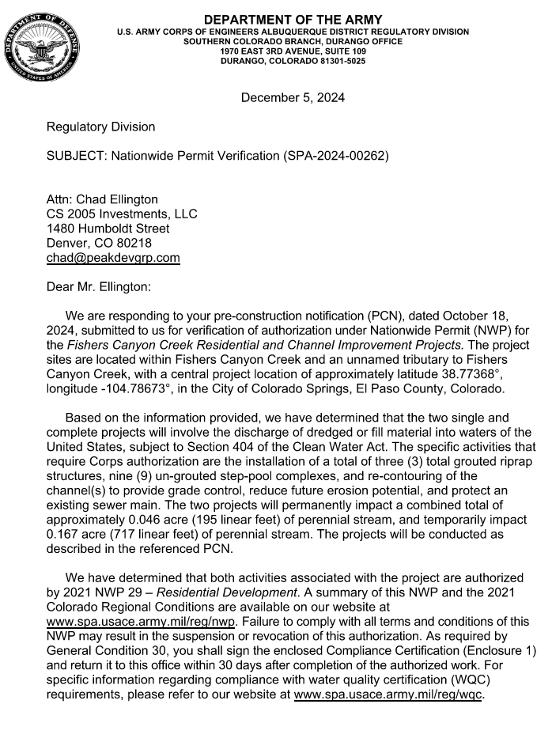
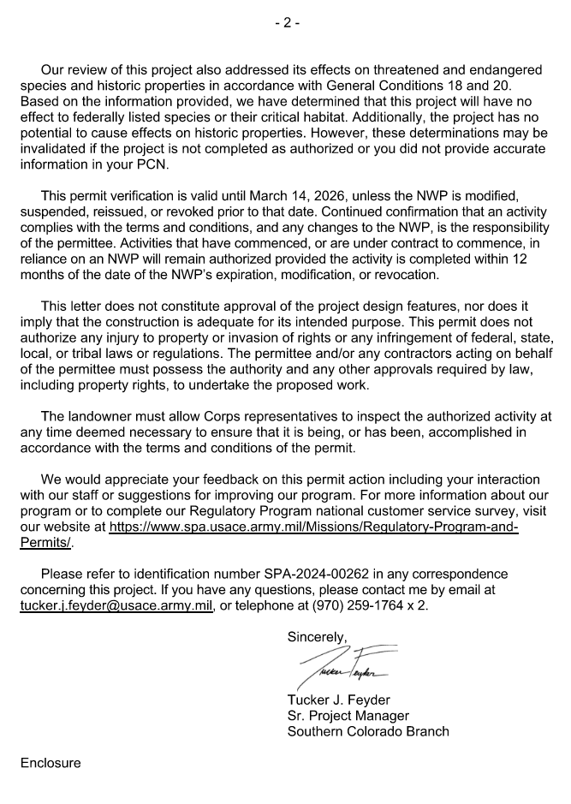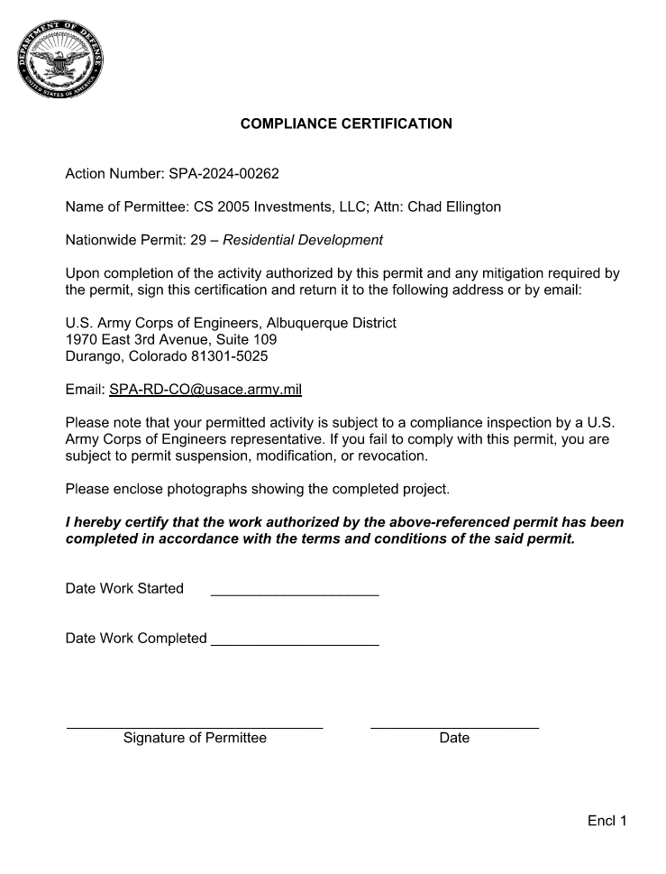

EXHIBIT E
Operations and Maintenance Manual

Open Drainage Channel Inspections, Operations and Maintenance (O&M)
Fishers Canyon Creek Upstream of Venetucci Blvd and Fishers Canyon Creek Tributary

Routine maintenance of the open drainage channel system consists of litter and debris pickup, vegetation management, erosion control, and sediment removal when necessary. Removal of excessive shrubs and trees is required to ensure that the channel will flow in conformance with the original design. Mowing and vegetation management are not required with the exception of formal concrete or asphalt trails. If mowing is performed it should be done with care to ensure that soils remain stable and prevent erosion. Noxious weed management shall be performed as necessary and as required under project approval conditions. All dead trees and trees growing in the flowline of a structure such as a bridge or culvert shall be removed. Trees and dead trees in open channels with grasses and riparian vegetation zones are not required to be removed as they provide habitat and protection. Trees and dead trees in concrete channels shall be removed. For Fishers Canyon Creek and the tributary to Fishers Canyon Creek, there are no concrete lined channels.

It is not anticipated that sediment removal will be necessary for the Fishers Canyon Creek and tributary to Fishers Canyon Creek. If it is determined sediment removal is required, removal of sediment shall be performed with the use of equipment such as a skid steer, backhoe, and front-end loader. The removed materials shall be hauled to an acceptable landfill site unless otherwise legally permitted to be utilized elsewhere. Materials are not to be stored onsite. Equipment shall utilize the designated access roads and shall not be used in a manner to cause damage to adjacent vegetated and stable areas to the extent possible. If drainage channels contain wetlands many activities, including maintenance, may be subject to regulation and permitting.

Erosion control and restoration work such as side slope reconstruction, revegetation, riprap installation, and other stabilization methods will require the use of heavy equipment.

Maintaining altered watercourses is a minimum requirement of the National Flood Insurance Program (NFIP). In fact, failure to maintain such watercourses may result in a revision to the community’s Flood Insurance Rate Map (FIRM). If a stream is altered after the community’s FIRM is published, the NFIP requires the community to ensure that the channel’s carrying capacity is not adversely altered. This is required in 44 CFR 60.3(b)(7) of the Federal Emergency Management Agency’s (FEMA’s) NFIP regulations.

Table 1 – General Channel Maintenance Guidelines
Activity | Maintenance Action | Frequency of Action
Mowing, vegetation management, and lawn care | Occasional mowing to limit unwanted vegetation. | Limited mowing is expected as there are no formal trails.
Debris and litter removal | Remove debris and litter from the entire channel to improve flow characteristics and aesthetics. Dispose of as appropriate. | Routine – including annual, pre-storm season (April and May) and following significant rainfall events.
Erosion and sediment control | Repair and revegetate eroded areas in the channel. | Non-routine –as necessary based on inspection.
Structural | Repair inflow structures, grouted boulder structures, and energy dissipation structures as needed. | Non-routine – repair as needed based on regular inspections.
Inspections | Inspect channel to ensure continued function as initially intended. Check for erosion, slumping, excessive sedimentation, overgrowth, embankment and inflow integrity, and damage to any structural elements. Report any illicit discharge immediately. | Routine – annual inspection of hydraulic and structural facilities. Also check for obvious problems during routine maintenance visits.
Nuisance control | Address odor, insects, and other issues associated with stagnant or standing water. | Non-routine –as necessary per inspection or complaint.
Sediment removal | Remove accumulated sediment from the channel bottom. | Non-routine –as necessary per inspection.

Routine Maintenance Activities
The majority of this work consists of litter and debris pickups for the drainage channel during the growing season. It also includes activities such as weed control. These activities normally will be performed numerous times during the year. These items typically do not require any prior correspondence with EPC, however, completed inspection and maintenance forms shall be retained and submitted to EPC for each inspection and maintenance upon request. The Routine Maintenance Activities are summarized below and further described in the following sections.

Table 2 – Summary of Routine Maintenance Activities
Activity | Maintenance Action | Look for: | Minimum Frequency
Litter / Debris Removal | Remove and dispose of litter and debris | Litter / debris in drainage channel | Routine – twice annually
Woody growth control / weed removal | Treat w/herbicide or hand pull | Noxious weeds, undesirable vegetation | Routine – minimum twice annually

Properly dispose of litter and debris materials at an approved landfill or recycling facility. It should be noted that major debris removal may require other regulatory permits prior to completing the work.

Noxious weeds and other unwanted vegetation must be treated as needed throughout the drainage channel. This activity can be performed either through mechanical means (mowing/pulling) or with herbicide. Consultation with the County Environmental Division is recommended prior to the use of herbicide. Herbicides should be utilized sparingly and as a last resort. All herbicide applications should be in accordance with the manufacturer’s recommendations.

Minor Maintenance Activities
This work consists of a variety of isolated or small-scale maintenance/operational problems. Most of this work can be completed by a small crew, hand tools, and small equipment. These items may require prior approval from EPC depending on the scope of work. Completed inspection and maintenance forms shall be retained for each inspection and maintenance period. In the event that the drainage channel needs to be dewatered, care should be given to ensure sediment, filter material and other pollutants are not discharged. The appropriate permits shall be obtained prior to any dewatering activity.

Table 3 – Summary of Minor Maintenance Activities
Activity | Maintenance Action | Look for: | Minimum Frequency
Sediment/Pollutant Removal | Remove and dispose of accumulated sediment from the channel bottom. | Minor sediment and pollution build-up in channel bottom; potential decrease in channel flow rate | Non-routine – as needed based on inspection.
Erosion Repair | Repair eroded areas and revegetate; address cause. | Rills/gullies on sides of channel | Non-routine – as needed, based on inspection.

Major Maintenance Activities
This work consists of larger maintenance/operational problems and failures within the stormwater drainage facilities. This work will likely require approval from EPC Engineering to ensure the proper maintenance is performed. This work requires that Engineering Staff review the original design and construction drawings to assess the situation and necessary maintenance activities. This work may also require more specialized maintenance equipment, design plans/details, surveying, and assistance through private contractors and consultants. In the event that the drainage channel needs to be dewatered, care should be given to ensure sediment, filter material and other pollutants are not discharged. The appropriate permits shall be obtained prior to any dewatering activity.

Table 4 – Summary of Major Maintenance Activities
Activity | Maintenance Action | Look for: | Minimum Frequency
Major Sediment / Pollutant Removal | Remove and dispose of sediment. Repair vegetation as necessary | Large quantities of sediment in the channel and reduced conveyance rate/capacity | Non-routine –as necessary based on inspection.
Major Erosion Repair | Repair erosion – find cause of problem and address to avoid future erosion | Severe erosion including gullies, excessive soil displacement, unusual areas of settlement, holes | Non-routine –as necessary based on inspection.
Structural Repair | Structural repair to restore portions of the channel to its original design | Deterioration and/or damage to structural components – broken concrete, damaged pipe, drop/check structures or dissipators | Non-routine –as necessary based on inspection.
Drainage Channel Rebuild | Contact EPC Engineering | Overall channel failure | Non-routine –as needed due to complete failure of drainage channel

Inspection Procedures
Periodic inspections of drainage channels and associated stormwater control measures in developed areas are needed in every community to prevent the accumulation of debris deposited by storms, dumping, or natural processes. Inspections must be conducted at least once each year and after each storm that could adversely impact the drainage system. Inspections are also needed in response to citizen complaints.

Conduct annual visual inspections during the dry season to determine if there are problems where sediment/trash or other pollutants accumulate. Inspection and maintenance records should be used to determine problem areas that may need to be checked more often. Appropriate action must be taken after an inspection identifies the need for maintenance or cleaning.

The attached form includes the typical information necessary for and during an inspection. Similar forms or electronic record keeping may be utilized if all relevant information is recorded. The entity responsible for channel maintenance is required to submit the periodic inspection reports upon request by County Staff. Inspections involving decisions about structural issues shall be signed by a licensed professional engineer.

Inspections of inflow structures including detention spillways and water quality outlet pipes discharging to the channel shall be coordinated with channel inspections.

Illicit discharges such as dumping of home goods or garbage, appliances, yard wastes, paint spills, abandoned oil containers and other pollutants shall be immediately reported to EPC Staff and other agencies as appropriate. Reference El Paso County Ordinance No. 07-01, as amended. EPC recommends that the responsible entity encourage public reporting of improper waste disposal by posting “No Dumping” signs, neighborhood notices, and/or social media when available, with contact information to report violations.

Wetlands
If drainage channels contain wetlands many activities, including maintenance, may be subject to regulation and permitting. The responsible maintenance entity shall maintain wetlands vegetation as appropriate and in consultation with the proper authorities including the U.S. Army Corps of Engineers when applicable. The responsible maintenance entity shall ensure proper training / licensing of contractors and staff to minimize the potential for damages to the wetlands.

All applicable safety and environmental considerations with regards to the application of any pesticides or herbicides shall be verified. It is also strongly encouraged that the responsible entity employ or consult a wetlands specialist or certified arborist with the ability to identify invasive/exotic species. Due to the sensitive nature of using chemicals near water bodies, a written Quality Assurance/Quality Control (QA/QC) plan shall be implemented.

Employees shall be trained in accordance with any local, state, and federal regulations and laws prior to any application of chemicals. A copy of the QA/QC plan must be submitted to the County Environmental Division prior to any chemical applications. In addition to the QA/QC plan, copies of the Safety Data Sheets (SDS) for all the chemicals being used shall be provided upon request.

The Clean Water Act (CWA) establishes the basic structure for regulating discharges of pollutants into the waters of the United States and regulating quality standards for surface waters. The basis of the CWA was enacted in 1948 and was called the Federal Water Pollution Control Act, but the Act was significantly reorganized and expanded in 1972. "Clean Water Act" became the Act's common name with amendments in 1972.

Section 404 - establishes a program to regulate the discharge of dredged and fill material into waters of the United States, including wetlands. CWA Section 404(b)(1) Guidelines – U.S. Environmental Protection Agency (EPA) (Although they are called “guidelines,” these criteria are established in regulations (40 CFR Part 230) and are legally binding.)
https://www.epa.gov/cwa-404/clean-water-laws-regulations-and-executive-orders-related-section-404

Open Drainage Channel Inspection Report Form

Date: __________________________ Inspector: _________________________________

Type of inspection: Post-Storm ______ Complaint ______ Routine ______

Location: (Identify stream or basin name, downstream and upstream streets or reference points, and location of problem. Provide sketch as needed.)

__________________________________________________________________________

__________________________________________________________________________

__________________________________________________________________________

Type of problem: Litter ___ Minor ___ Obstruction ___ Structural ___ Illicit Discharge** ___

Recommended maintenance: _________________________________________________

__________________________________________________________________________

__________________________________________________________________________

Is equipment needed? ______ If so, list equipment needed: __________________________

__________________________________________________________________________

Date: __________________________ Offsite Right of entry needed? __________________

Work order description: _______________________________________________________

__________________________________________________________________________

__________________________________________________________________________

__________________________________________________________________________

__________________________________________________________________________

State permit(s) needed? _____ Work order number: __________________________

Date: Crew chief: ____________________________

Maintenance performed: ______________________________________________________

__________________________________________________________________________

__________________________________________________________________________

__________________________________________________________________________

Inspected by: _______________________________________________________________

Use other side for additional recommendations for this site.
**Report illicit discharges to the County and appropriate agencies.

EXHIBIT F
Stormwater Facilities
