LETTER OF INTENT

Owner
Phelps Family Security Trust
17925 E. Highway 24
Peyton, CO 80831-8622
719-749-2597
bailey@blphelps.com

Applicant
New Cingular Wireless, PCS, LLC
10225 Lenox Park Blvd. NE, 3rd Floor
Atlanta, GA 30319

Consultant
Nexius
Susan Lombardi
7025 S. Fulton Street, #100
Centennial, CO 80112
303-641-2871
Susan.lombardi@nexius.com

Site Location
17925 E. Highway 24, Peyton, CO 80831-8622, specifically depicted on the Site Plans dated May 24, 2019 and included in our Zoning Application. Overall parcel is 40 acres; leased parcel is 50’ x 50’.

Zoning
A-35

Setbacks
250 feet from Residential Zoning District

Height
199 feet

Proposed facilities
New Cingular Wireless PCS, LLC by AT&T Mobility (“AT&T”) is seeking approval of a Special Use Permit to construct and operate a 199-foot self-supported telecommunication tower (“Proposed Tower”). The Proposed Tower will be located on a small 50’ x 50’ leased area and it will meet the 250 feet setback requirements if the property adjoins a Residential Zone District. The overall parcel is 40 acres and zoned A-35.
The Proposed Tower is necessary to provide network coverage for AT&T subscribers in El Paso County in the vicinity between US Highway 24 and Peyton Highway where there are significant gaps in its network coverage. There are 9 AT&T telecommunication facilities in this vicinity, however, all of the facilities are southwest of the proposed site and the closest facility is approximately 6 miles away from the target area. (Exhibit 1, “General Area Overview Map with AT&T Sites”). This telecommunication facility is designed to be an integral component in AT&T’s network and it will help to better serve El Paso County residents, businesses and visitors.
The Proposed Tower will support AT&T’s equipment, including 12 antennas, 18 remote radio heads, 3 squids, as well as an equipment cabinet and a generator. (See Site Plans dated May 24, 2019 included in the Application).
Permit Co-location
The Proposed Tower will also accommodate co-location of additional wireless carriers. It is AT&T’s intention to accommodate co-location of a minimum of two additional wireless carriers. The Proposed Tower will allow for additional antennas reasonably spaced to prevent interference. The leased area will also accommodate the ground equipment of additional carriers.

Co-Location
AT&T considered co-locating onto the existing American Tower telecommunication facility (“ATC Tower”), but the physical and technological constraints made it impracticable to co- locate on the ATC Tower. The ATC Tower is over a half mile to the northeast from the Proposed Tower, thus it is further from the target area. The topography near the ATC Tower also makes it more difficult to provide coverage to the target area. In addition, the ATC Tower is 100 feet tall with an existing carrier on the top RAD. (Exhibit 2, ATC Tower). If AT&T co-located onto the ATC Tower, AT&T’s antennas would be lower than 100 feet, which further limits network coverage. So, the distance from the Proposed Tower, the height of ATC’s Tower and the existing topography made this site physically and technologically infeasible. AT&T is proposing a 199 foot tower closer to the target area. This will improve AT&T’s overall network coverage in the target area.

Access
The Proposed Tower will be accessed from Highway 24 and will connect to a proposed 15’ access easement.

Land Disturbance
The property is 40 acres and AT&T will lease a 50’ x 50’ area (2500 square feet). We will not disturb an acre of land (43560 square feet).

Traffic
Construction will take between 30 and 45 days. During this time, traffic to the site will consist of heavy equipment and construction trucks. After the Proposed Tower is completed, traffic to the site will be minimal; there will be three to four visits a year for maintenance purposes.

Signal Non-interference Letter
AT&T’s Proposed Tower will meet the current standards and regulations of the Federal Aviation Administration (FAA), the FCC and any other federal government agency with the authority to regulate telecommunication towers. If such standards and regulations are changed, then the owners of the Proposed Tower shall bring such facility into compliance with such revised standards and regulations within the time period mandated by the controlling federal agency.

Sincerely,

Susan Lombardi
Zoning and Permitting Specialist
susan.lombardi@nexius.com
nexius.com
303-641-2871

EXHIBIT 1

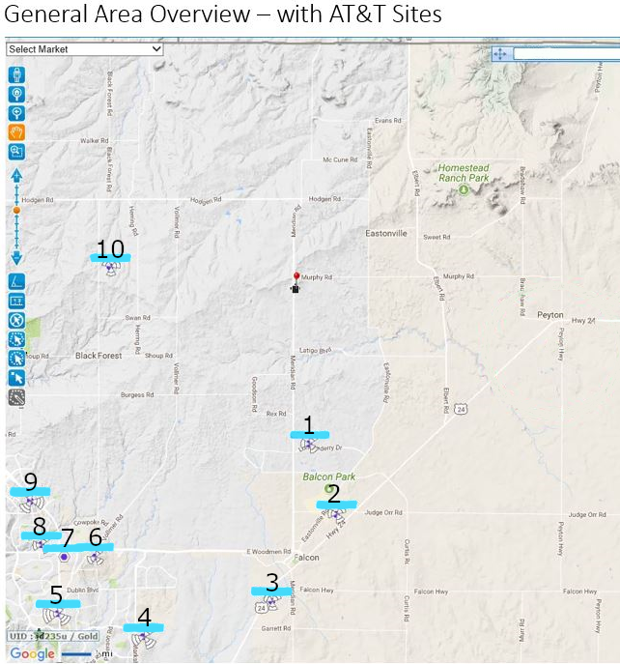

EXHIBIT 2
ATC TOWER
