Planning and Community Development Department
Craig Dossey, Executive Director

8/20/2019

RE: Administrative Special Use Request for AT&T 199' Monopole

File: AL-19-020
Parcel ID No.: 3200000405

To Whom It May Concern:

This letter is to inform property owners adjacent to 17925 E Highway 24 that the applicant, Nexius Solutions for AT&T Mobility, has requested approval of a special use application to allow for a 199’ tall freestanding Commercial Mobile Radio Service Facility (CMRS) within the A-35 (Agricultural) zoning district.

The Planning and Community Development Director may make a formal decision regarding the request on 9/12/2019. Any comments or questions may be forwarded to me prior to that decision. At the discretion of the Planning and Community Development Director, the approval process may be elevated to the Board of County Commissioners for consideration. Administrative approval by the Planning and Community Development Director is subject to the appeal provisions of the Land Development Code.

You may view the application documents online at www.epcdevplanreview.com. Please feel free to contact me with any questions, comments, or concerns you may have prior to the decision.

Respectfully,

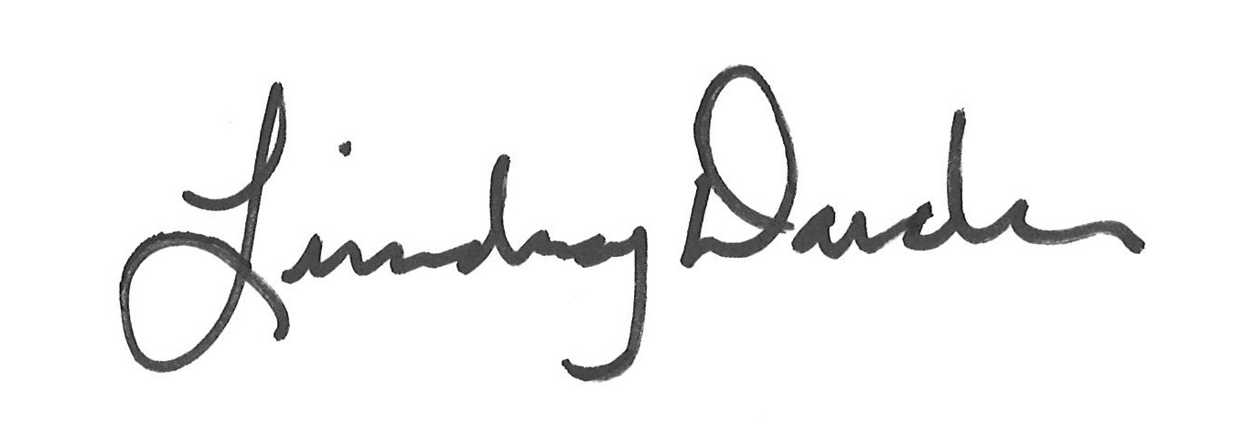

Lindsay Darden, Planner II
El Paso County Planning and Community Development
719-520-6302
Lindsaydarden@elpasoco.com

