Early Assistance Meeting Number: EA-23-46 & EA2619
Project Name: Sundance Asphalt Hot Mix at Daniels Sand Pit
Project Description: Hot-Mix Asphalt Plant at Holcim's Daniels Sand facility. Daniels Sand is located at 3710 Bradley Rd on Parcel 6502000126.
Meeting Date: 5/11/2023 and 2/19/2026

El Paso County Planning & Community Development Planning Checklist

Zoning
Existing Zone(s)
A-5
Proposed Zone(s)
Zone |  | Name

Zoning Analysis
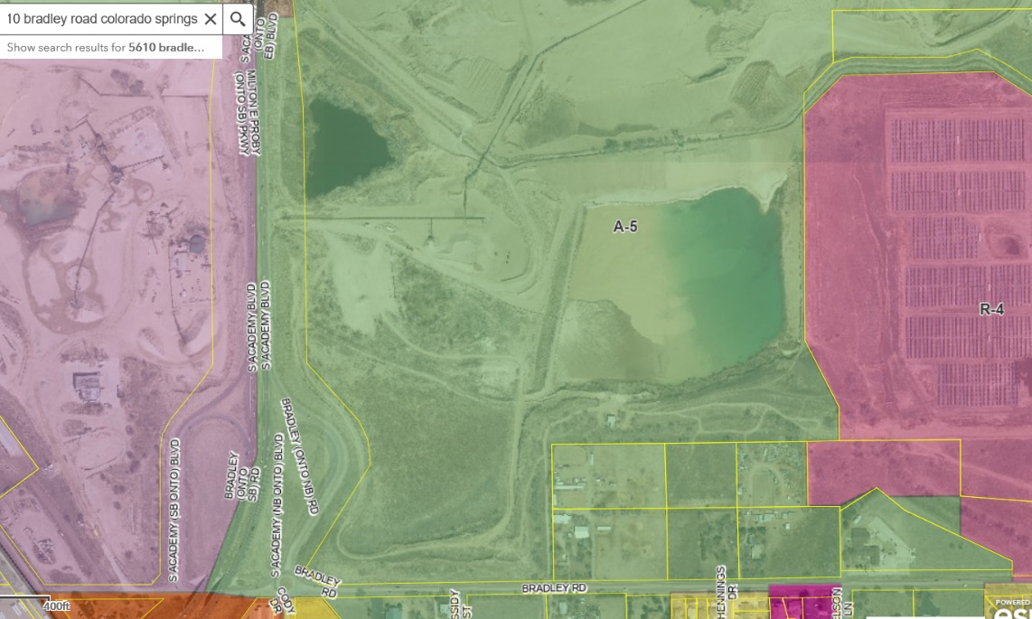
Batch Plant -permanent- Variance
of Use in A-5; HOWEVER
MINING Operation and Processing
Special Use permitted in 1993

Special Use in I-3, however if
sited in “processing areas as
depicted in 1993 special use,
can be accessory

Temp Batch Plant-Allowed
A temporary batch plant associated with a federal, State, or local construction public improvement project is subject to the following requirements.

(A)Adjacent to Project. The plant shall be located on, adjacent to, or in the immediate proximity of the right-of-way being improved.(B)Hours of Operation Limited. A temporary batch plant shall only be operated between 7 a.m. to 7 p.m.(C)Repair of Road Damage. Damage to any roads that provide access to the temporary batch plant that may be attributable to the use of the site for a temporary batch plant shall be repaired by the temporary batch plant owner or operator to the satisfaction of the ECM Administrator. Financial Assurance may be required by the ECM Administrator to cover potential repair costs.(D)Other Permits Required. A construction permit, work in the right-of-way permit, and ESQCP shall be obtained from the ECM Administrator prior to the issuance of a temporary use permit authorizing the use of the subject property for a temporary batch plant.(E)Hauling Routes. The ECM Administrator may limit hauling routes and the size of loads to protect the general welfare of the citizens in accordance with the ECM.(F)Duration of Use. The duration of time the batch plant is operated shall be limited to the duration of the associated public improvement project.(G)Use of Asphalt or Concrete. The use of any asphalt or concrete produced at the temporary batch plant shall be limited to the public improvement project described in the temporary use permit.

Batch Plant — Processing plant, together with its accessory facilities, for the manufacturing of concrete or asphalt and related materials and products.

Zoning District Requirements (density, lot size, lot design standards, building setbacks)

A-5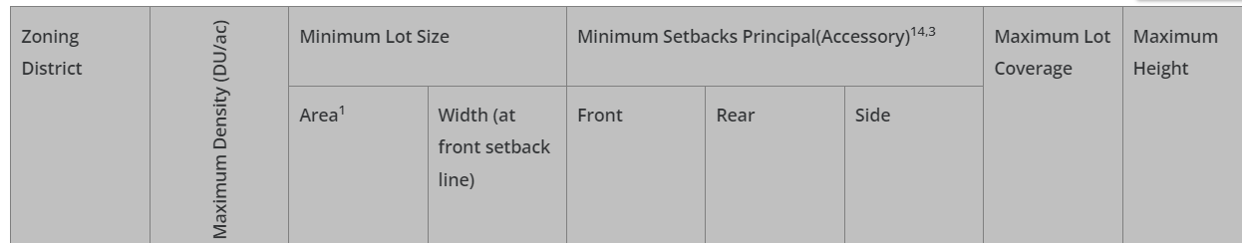

Use Standards

Fee(s)
Application Type
- SIT DEV PLAN if CDRS and DPW docs needed;
- Haul Route Agreement;
- TIS;
- FDR

Approval Criteria:
Site Dev Plan- - Chapter 5 and 6 apply

Processing Issues and Options
HOWEVER; processing was depicted on site plan for special use in LOI in designated area; AND HOWEVER in 2006 staff Deputy Director approved a Batch Plant for Transit Mix as a part of the included Mining Special Use under the processing component west of Academy ; QUESTION is the a replacement or second plant ? SDP per; COM06016 file …

Relevant Past History:
Previous parcels – 6500000002 &6500000092; AL93021 established Mineral extraction – speculated 50-60yrs year life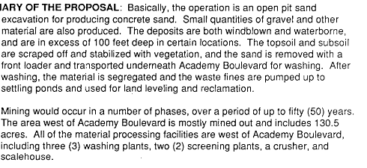 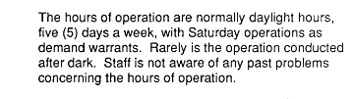
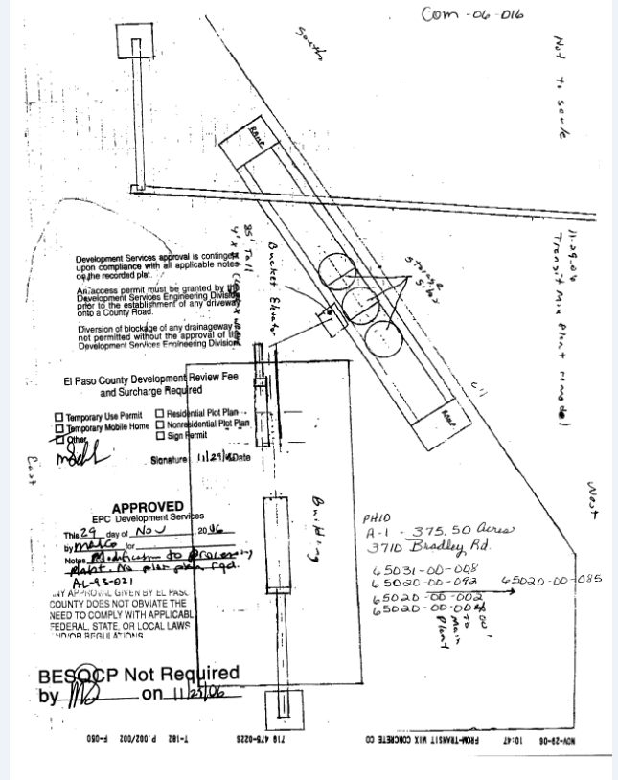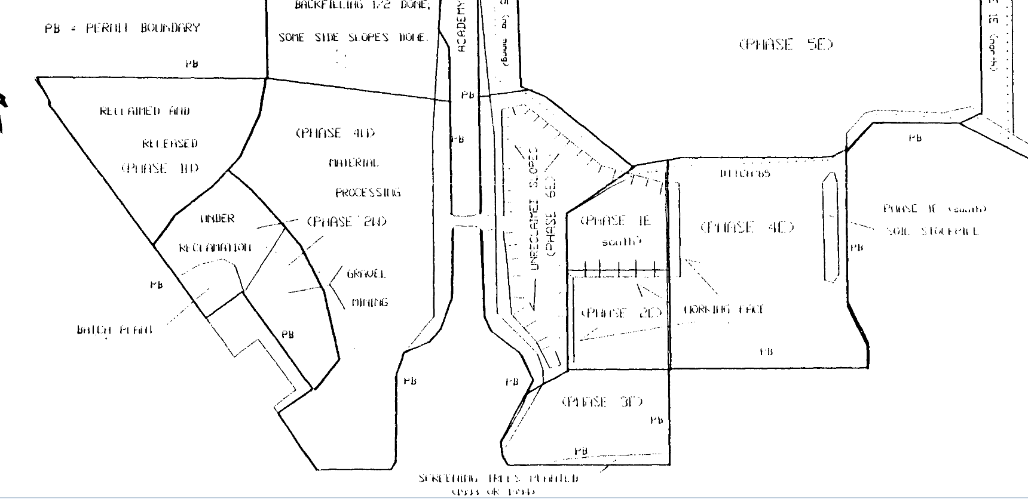
Processing in AL permit
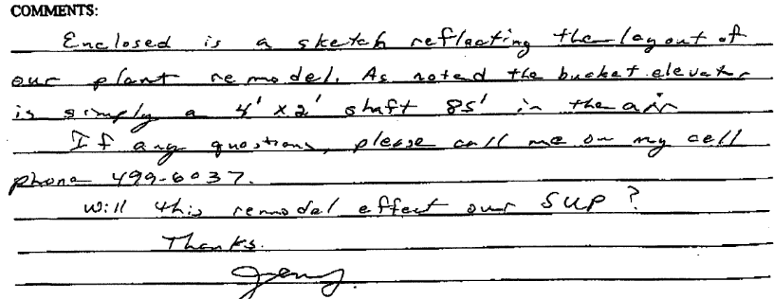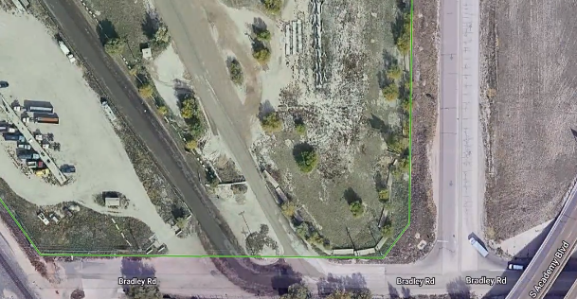
80-100 trips per day; using existing access points- per applicant; long term;
Design and Landscaping

Site Design/Layout (Lot pattern, circulation/road design, open space, preservation of natural features, compatibility internally and with adjacent land uses)
Interior to Mining site; NO additional Access Points; applicant will move plant to disturbed areas; out of reclaimed area and land to be reclaimed areas.

Landscaping
☐ | Expressway, Principal arterial area depth – 25’-Trees required 1 per 20’
☐ | Urban interchange/Intersection area depth – 25’- N/A
☐ | Minor arterial area depth 20’ – Trees required 1 per 25’
☐ | Non-arterial area depth 10’ – Trees required 1 per 30’
☐ | Parking lot landscaping required
☐ | Buffer between non-residential and residential districts separated by a non-arterial road or public alley

NA/ For existing- minor COM (Site Dev Plan If interior to MINE)

Signage: Internal signage no exterior expansion of operation per special use

Lighting:
YES REQUIRED must not exceed property boundaries
Photometric Plan Required | ☒

Site Characteristics & Constraints:
Limited access to Academy Blvd and Bradley

Water/Air/Visual Quality:
Existing condition with dust.

Water/wastewater comments
FMIC water ditch interrelated to mining operation.

Fire District:
Security Fire- Contact them for chemical storage requirements

Emergency Services Issues:
Safety ER Plan in Site dev plan

Commissioner District: 2

Code Waivers:
NONE

Parks and trails: NO issues at this time

Annexations/Intergovernmental issues:
Academy Blvd Road Impacts

Your El Paso Master Plan

Placetype:
Character:
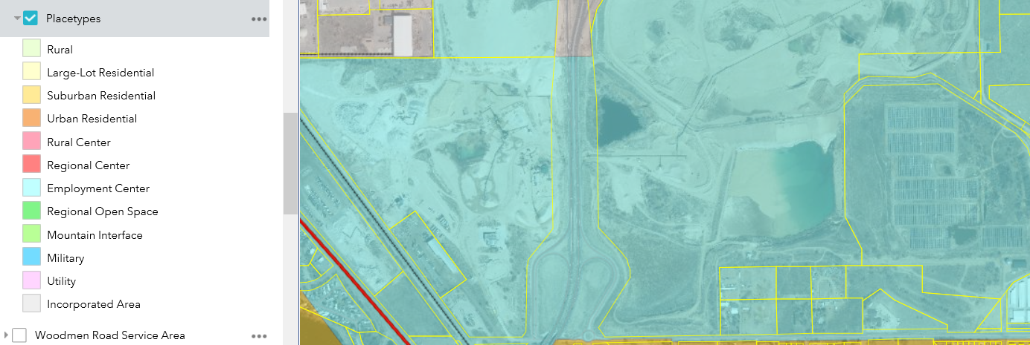

Recommended Land Uses:
Character
Employment Centers comprise land for industrial, office, business park, manufacturing, distribution,
warehousing, and other similar business uses. The priority function of this placetype is to provide space
for large-scale employers to establish and expand in El Paso County. They are typically located on or
directly adjacent to Interstate 25 and/or other regional corridors to ensure business and employee
access. Proximity to other transportation hubs, such as Meadowlake Airport, and rail lines is also appropriate for an Employment Center. Uses in this placetype often require large swaths of land and opportunity to expand and grow to meet future needs and demands. Transitional uses, buffering, and screening
should be used to mitigate any potential negative impacts to nearby residential and rural areas. Some
Employment Centers are located in Foreign Trade, Commercial Aeronautical, and Opportunity Zones to
help incentivize development.

Primary
• • Light Industrial/Business Park
• • Heavy Industrial
• • Office
Supporting
• • Commercial Retail
• • Commercial Service
• • Restauran

Goals, Objectives, Strategies:
3. Economic Development
Core Principle: Strengthen the economy with a
skilled workforce and targeted investment.

Area of Change Designation:
Description:
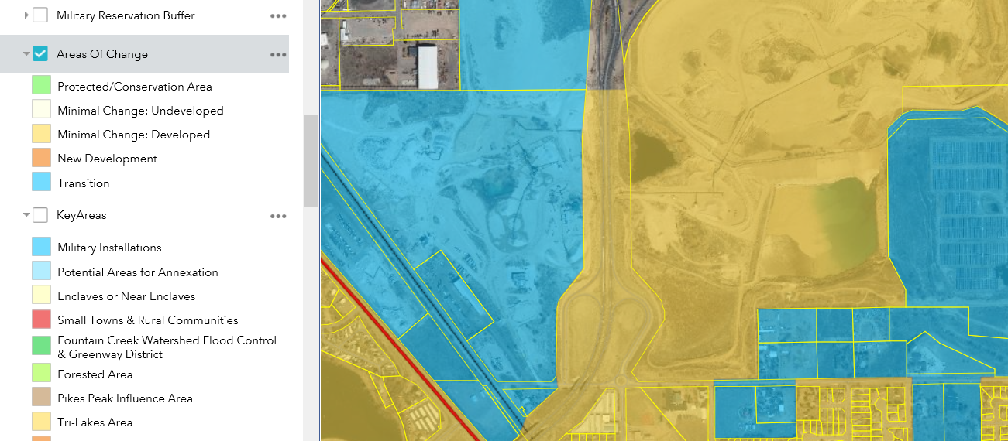

Goals, Objectives, Strategies:
Minimal Change: Developed
These areas have undergone development and have an established character. Developed areas
of minimal change are largely built out but may include isolated pockets of vacant or underutilized
land. These key sites are likely to see more intense infill development with a mix of uses and
scale of redevelopment that will significantly impact the character of an area. For example,
a large amount of vacant land in a suburban division adjacent to a more urban neighborhood
may be developed and change to match the urban character and intensity so as to accommodate
a greater population. The inverse is also possible where an undeveloped portion of an
denser neighborhood could redevelop to a less intense suburban scale. Regardless of the development
that may occur, if these areas evolve to a new development pattern of differing intensity,
their overall character can be maintained.

Key Area: NOT Included

Water Master Plan Area:
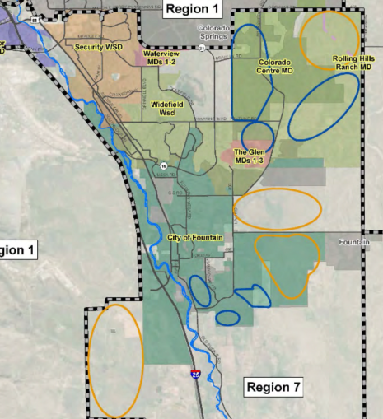REGION 7

Recommendations:
Region 7 could experience the largest demand growth in the County by 2060. Areas projected to
develop by 2040 are located south of Fountain on the north and south sides of Link Road. Areas
northwest of Fountain along the east and west sides of Marksheffel Road are also expected to
grow by then, as well as the area south of Fountain on the west side of I‐25. Directly west of
Fountain, areas north and south of Squirrel Creek Road are expected to grow by 2060. One large
development is expected south of Fountain by 2060, along the west side of I‐25. Another is
expected in the northeast corner of Region 7, along both sides of Bradley Road. See Figure 5.6
for the Region 7 growth map.

Wildlife impact
IT was listed as HIGH how mining has changed character

Master plan for mineral extraction:
Valued mineral deposits

Parks master plan:

Helpful Links

Planning Website: https://planningdevelopment.elpasoco.com/

El Paso County Master Plan: https://planningdevelopment.elpasoco.com/#1510603950097-f5d985dc-35b2

Parks, Mineral and Water Master Plan: https://assets-planningdevelopment.elpasoco.com/wp-content/uploads/ResourcesReference/MasterPlan/master-plan-for-mineral-extraction.pdf

Forms and Templates: https://planningdevelopment.elpasoco.com/planning-development-forms/#1522879386032-8c72372e-2696

Land Development Code: https://library.municode.com/co/el_paso_county/codes/land_development_code

EDARP: https://epcdevplanreview.com/

Public GIS: https://elpasoco.maps.arcgis.com/apps/View/index.html?appid=5be6431018594c67b035ad0aad3e7e8a

Parks Master Plan 2023

https://communityservices.elpasoco.com/parks-planning/

Wrap Up
-If subdivision is proposed, recording fees, park and school fees and road impact fees apply.
-Fees are subject to change. The fees at the time of application apply.
-Pursuant to the adopted El Paso County Road Impact Fee Program (Resolution No. 12-382), a transportation impact fee, calculated on a per trip basis, may be due at the time of building permit issuance. Starting January 1, 2020 the transportation impact fee will be due for all new construction (Resolution No. 19-471).
-The fee for any additional waiver/deviation requests (more than two) - $550.00 each. Please note that requests for waivers and/or deviations may result in additional processing/review delay.
-Upon the actual submittal, the title commitment must be dated within 30 days of the submittal date.
-All items requested must accompany the submittal for it to be complete or the submittal will be denied.
-A temporary use permit shall be applied for and approved for any staging area associated with development, such as a sales office, construction trailer, or contractor's equipment yard, prior to scheduling of the pre construction meeting with El Paso County Planning and Community Development. If a Planned Unit Development is proposed, the temporary staging area should be shown on the development guideline and phasing plan.
-All prospective timelines for review are subject to departmental staffing and workload.
-Early Assistance is valid for 12 months from submittal of the EA application. If a project submittal is not received within 12 months, a new EA meeting will be required. An video copy of the meeting is available in the EA file in EDARP.
-Hearing based projects are approved by he hearing bodies , not PCD staff.

