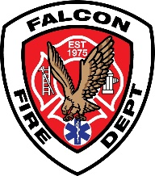

FALCON FIRE PROTECTION DISTRICT
Fire Prevention Division
7030 Old Meridian Road
Falcon, Colorado 80831
Business Number: 719-495-4050 Business Fax: 719-495-3112



Lieutenant/Fire Marshal Curtis L. Kauffman
Email: ckauffman@falconfirepd.org Cell #: 719-641-2139

Date: July 22, 2026

To: EDARP
C/O: Kylie Bagley
Planning & Community Development
2882 International Circle, Suite 110
Colorado Springs, CO 80910
Phone: 719-520-
Email: kyliebagley@elpasoco.com

Project Name: Amen Parcels Vollmer Road
File Prefix: V-Vacation
Parcel/s: 5121001020
Zone: RR-5
File Number: V261

Falcon Fire Protection District has no concerns with the vacation of the right-a way on the adjacent parcels 5100000305, 5121001020, 5122001002, and 5121001002. We have current access to all the properties/addresses via Vollmer Road or Southwood Drive.

Please let me know if there are any questions and/or concerns. You may contact me via email at the top of the letter.

Sincerely,

Curtis L. Kauffman

Curtis L. Kauffman
Fire Prevention Division
Lieutenant/Fire Marshal

