Early Assistance Meeting Number: EA2611
Project Name: Calhan Vet Clinic Rezone and Subdivision
Project Location: 13425 North Calhan Highway
Project Parcel Nos. 2200000172
Project Description: plat the subject property to separate the existing vet clinic business from the rest of the property. Applicant would like to discuss options/recommendations for new property line locations.
Meeting Date: February 25, 2026

El Paso County Planning & Community Development Planning Checklist

Request – Map Provided by Applicant
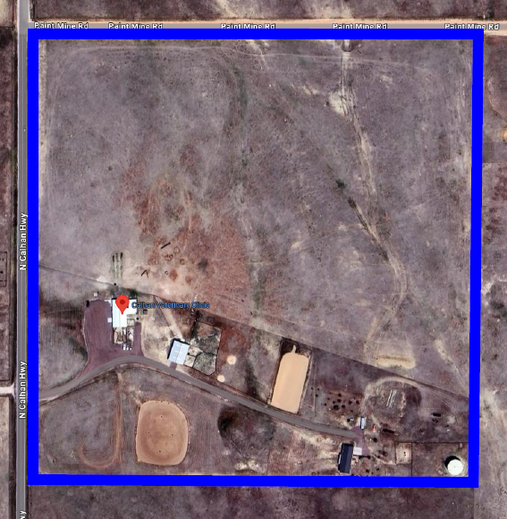

Zoning
Existing Zone(s)
Zone |  | Name
A-35 |  | Agricultural (lot size minimum 35 acres)
Proposed Zone(s)
Zone |  | Name
A-5, RR-5, |  | Agricultural or Residential Rural (lot size minimum 5 acres)

Zone Map (existing conditions of approval)
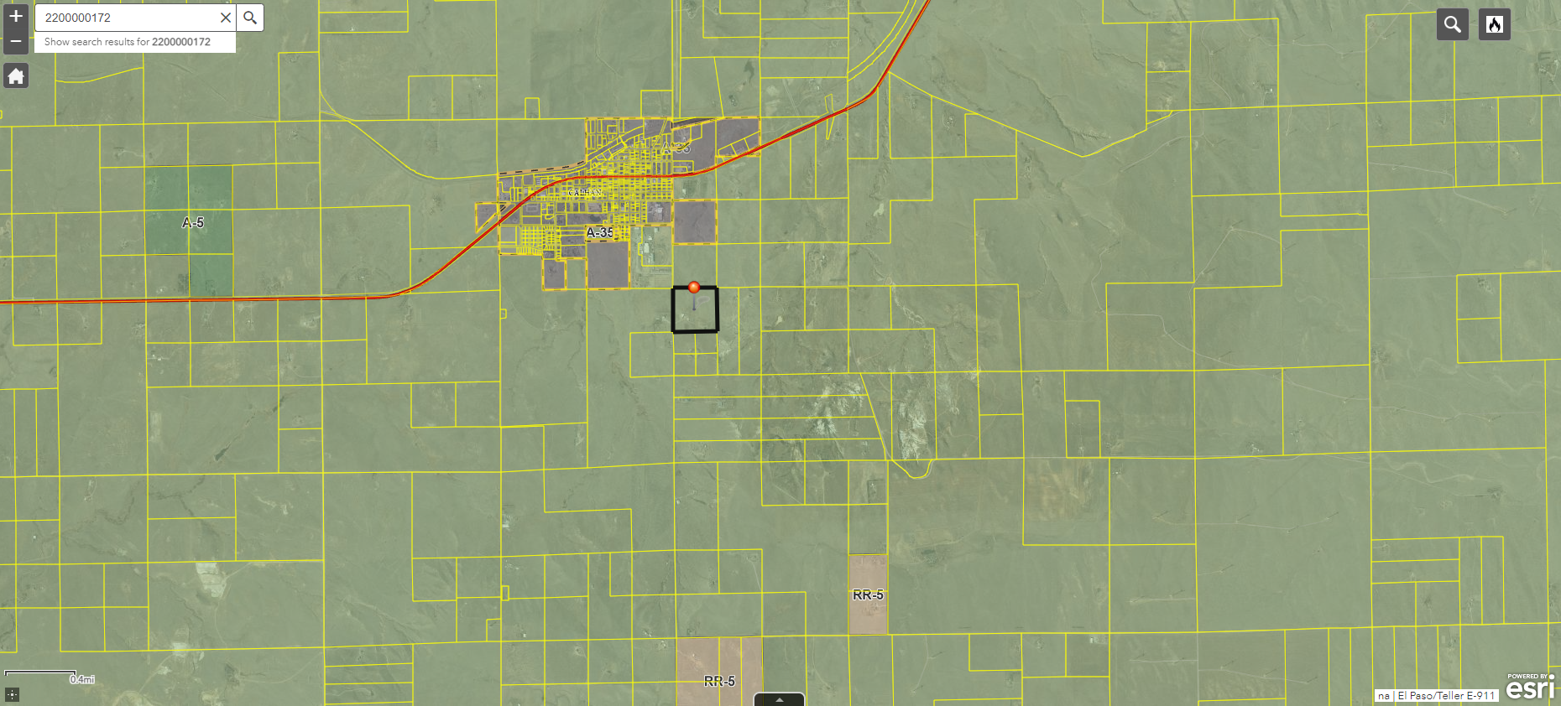

Green = A-35
Small areas of RR-5 to the southeast and directly south
Area to the north is Town of Calhan (separate zoning standards)

Zoning Analysis
Rezoning to a commercial zoning district would be spot zoning and could be potentially challenging. We are encouraging to rezone to A-5 or RR-5. Based upon the Veterinary, Hospital existing prior to the establishment of zoning in 1999 and we will not require additional permits/applications beyond rezone and final plat.

Options:

- Rezone and plat the 5 acre area of land desired with the animal hospital. The 35 acre parcel surrounding it will not have to be rezoned or platted. PCD Staff will complete an administrative relief due to .5 acre lot difference due to the subdivision exemption.

- Rezone the entire property to A-5 and divide the parcel further. This will require a final plat for the entire property depicting the new lots being created.

The existing Veterinary, Hospital was constructed/established in 1994 which would make the land use legal non-conforming as the property was initially zoned on 3/24/1999.

The use existed prior to zoning and is presumed to have approval. Special use permit will not be required.

See Table 5.2 in the Land Use Code for accessory uses in each zoning district, when considering future uses for future buyers.

Hospital, Veterinary — A facility where animals requiring medical care are treated, or temporarily housed. The facilities may include veterinarian offices, administrative offices, space for examination, surgery, recovery, and may include boarding of animals while under treatment, but does not include animal boarding generally.

Hospital, Veterinary is allowed as a ‘Special Use’ in the following zoning districts:

- A-5 (Agricultural)
  - The A-5 zoning district is a 5 acre district primarily intended to conserve agricultural resources and ranching operations and accommodate limited residential use.

- RR-5 (Residential Rural)
  - The RR-5 zoning district is a 5 acre district intended to accommodate low-density, rural, single-family residential development.

5 acres visual reference (existing conditions must meet dimensional standards, or be proposed to meet dimensional standards)

- Joint Access Easement required if you don’t want to move the driveway, and keep existing access orientation.

Zoning District Requirements (density, lot size, lot design standards, building setbacks)
 | Existing Zoning District: A-35 | Proposed Zoning District: A-5 | Proposed Zoning District: RR-5
Maximum Density
Minimum Lot Size | 35 acres | 5 acres | 5 acres
Minimum Width at Front Setback | 500 feet | 200 feet | 200 feet
Front Setback | 25 feet | 25 feet | 25 feet
Rear Setback | 25 feet | 25 feet | 25 feet
Side Setback | 25 feet | 25 feet | 25 feet
Maximum Lot Coverage | None | None | 25%
Maximum Height | 30 feet | 30 feet | 30 feet

Application Type(s) Hearing: Required/ Optional/ No
Rezone (Map Amendment) | YES (PC & BoCC)
Subdivision (Final Plat) | YES (PC & BoCC)

Approval Criteria:
5.3.5. Map Amendment (Rezoning)
(B) Criteria for Approval. In approving a Map Amendment, the following findings shall be made:
- The application is in general conformance with the El Paso County Master Plan including applicable Small Area Plans or there has been a substantial change in the character of the neighborhood since the land was last zoned;
- The rezoning is in compliance with all applicable statutory provisions, including but not limited to C.R.S. § 30-28-111 § 30-28-113, and § 30-28-116;
- The proposed land use or zone district is compatible with the existing and permitted land uses and zone districts in all directions; and
- The site is suitable for the intended use, including the ability to meet the standards as described in Chapter 5 of the Land Development Code, for the intended zone district.

Final Plat approval criteria:
- The proposed subdivision is in general conformance with the goals, objectives, and policies of the Master Plan.
- The subdivision is consistent with the purposes of the Land Development Code (“Code”).
- The subdivision is in conformance with the subdivision design standards and regulations and meets all planning, engineering, and surveying requirements of the County for maps, data, surveys, analysis, studies, reports, plans, designs, documents, and other supporting materials.
- A sufficient water supply has been acquired in terms of quantity, quality, and dependability for the type of subdivision proposed, as determined in accordance with the standards set forth in the water supply standards [C.R.S. § 30-28-133(6)(a)] and the requirements of Chapter 8 of the Code.
- A public sewage disposal system has been established and, if other methods of sewage disposal are proposed, the system complies with state and local laws and regulations, [C.R.S. § 30-28-133(6) (b)] and the requirements of Chapter 8 of the Code.
- All areas of the proposed subdivision, which may involve soil or topographical conditions presenting hazards or requiring special precautions, have been identified and the proposed subdivision is compatible with such conditions. [C.R.S. § 30-28-133(6)(c)].
- Adequate drainage improvements complying with State law [C.R.S. § 30-28-133(3)(c)(VIII)] and the requirements of the Code and the Engineering Criteria Manual (“ECM’”) are provided by the design.
- The location and design of the public improvements proposed in connection with the subdivision are adequate to serve the needs and mitigate the effects of the development.
- Legal and physical access is or will be provided to all parcels by public rights-of-way or recorded easement, acceptable to the County and in compliance with the Code and the ECM.
- The proposed subdivision has established an adequate level of compatibility by (1) incorporating natural physical features into the design and providing sufficient open spaces considering the type and intensity of the subdivision; (2) incorporating site planning techniques to foster the implementation of the County's plans, and encourage a land use pattern to support a balanced transportation system, including auto, bike and pedestrian traffic, public or mass transit if appropriate, and the cost effective delivery of other services consistent with adopted plans, policies and regulations of the County; (3) incorporating physical design features in the subdivision to provide a transition between the subdivision and adjacent land uses; (4) incorporating identified environmentally sensitive areas, including but not limited to, wetlands and wildlife corridors, into the design; and (5) incorporating public facilities or infrastructure, or provisions therefor, reasonably related to the proposed subdivision so the proposed subdivision will not negatively impact the levels of service of County services and facilities.
- Necessary services, including police and fire protection, recreation, utilities, open space and transportation system, are or will be available to serve the proposed subdivision.
- The subdivision provides evidence to show that the proposed methods for fire protection comply with Chapter 6 of the Code.
- The proposed subdivision meets other applicable sections of Chapters 6 and 8 of the Code.
- Off-site impacts were evaluated, and related off-site improvements are roughly proportional and will mitigate the impacts of the subdivision in accordance with applicable requirements of Chapter 8 of the Code.
- Adequate public facilities or infrastructure, or cash-in-lieu, for impacts reasonably related to the proposed subdivision have been constructed or are financially guaranteed through the SIA so the impacts of the subdivision will be adequately mitigated.
- The extraction of any known commercial mining deposit shall not be impeded by this subdivision [C.R.S. §§ 34-1-302(1), et seq.].
LDC Sections 7.2.1(D)(2)(e) & 7.2.1 (D)(3)(f)

Processing Issues and Options
An administrative error occurred when the subdivision exemption file (EX00002) was approved by the BoCC and then recorded. The Assessor’s Office has been notified of the issue.

To keep the large parcel 35 acres PCD Staff will do an administrative relief for lot size. There will not be action required on the applicant.

- Reduction in Lot Area, Setbacks, and Lot Width. A maximum of a 20% reduction in lot area, setbacks and lot width from the amount required in the zoning district in which the subject property is located may be approved.

If the larger parcel is proposed to be lower than 34.5 acres, the larger parcel will also have to be rezoned and platted.

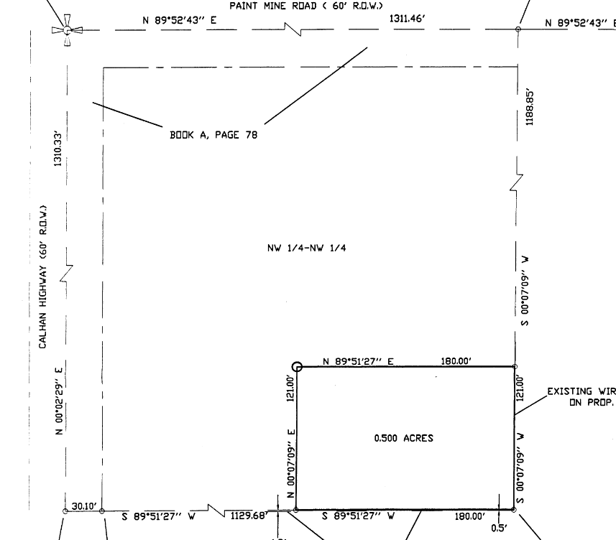

Relevant Past History:
Town of Calhan Water Tank project files:
- Approval of Location File No. U00010
- Subdivision Exemption File No. EX00002

Design and Landscaping

Site Design/Layout (Lot pattern, circulation/road design, open space, preservation of natural features, compatibility internally and with adjacent land uses)

Landscaping
☐ | Expressway, Principal arterial area depth – 25’-Trees required 1 per 20’
☐ | Urban interchange/Intersection area depth – 25’- N/A
☐ | Minor arterial area depth 20’ – Trees required 1 per 25’
☒ | Non-arterial area depth 10’ – Trees required 1 per 30’
☐ | Parking lot landscaping required
☐ | Buffer between non-residential and residential districts separated by a non-arterial road or public alley

Landscaping Code can be viewed at:
https://planningdevelopment.elpasoco.com/code-admendments/
&
https://library.municode.com/co/el_paso_county/codes/land_development_code?nodeId=SUHITA

Options for landscaping:
- Roadway along Calhan Highway
- Along entire property boundary of 5-acre lot for Zoning District buffering

For water conservation purposes, you are encouraged to submit an alternative landscaping plan because your property is on a well.

Site Characteristics\ Constraints\ Environmental Standards:
https://msc.fema.gov/portal/search?AddressQuery
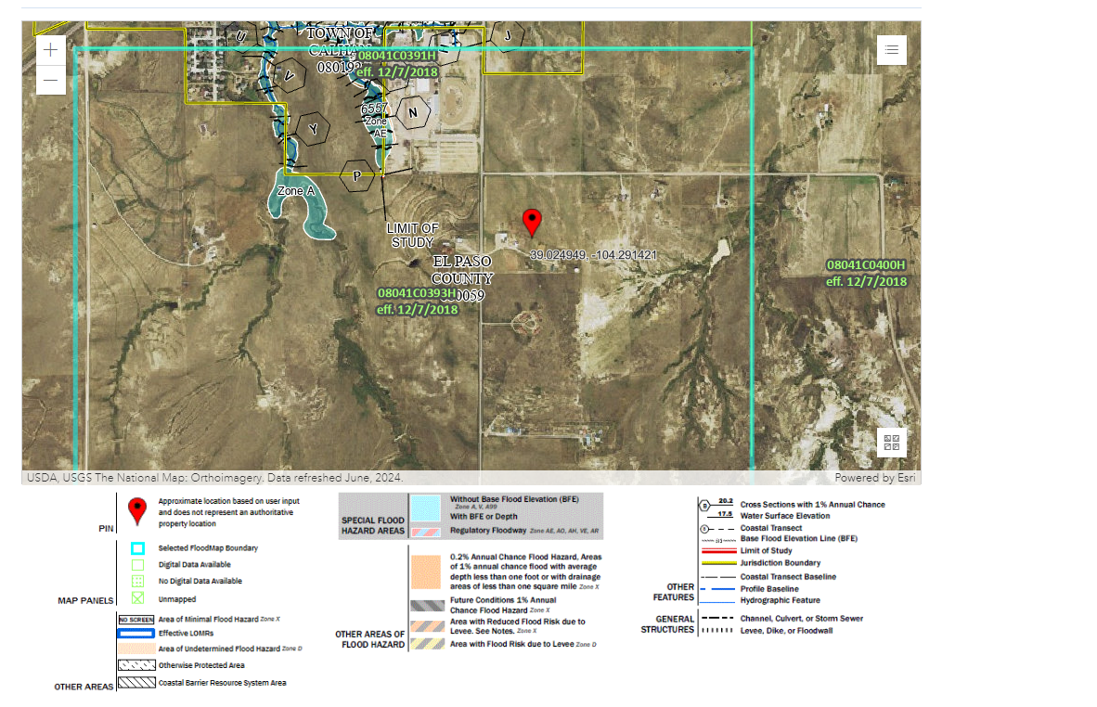
The property is not located in a floodplain.
There is a small area of slope on the southeast side of property and shall be detailed in the soils and geology report.

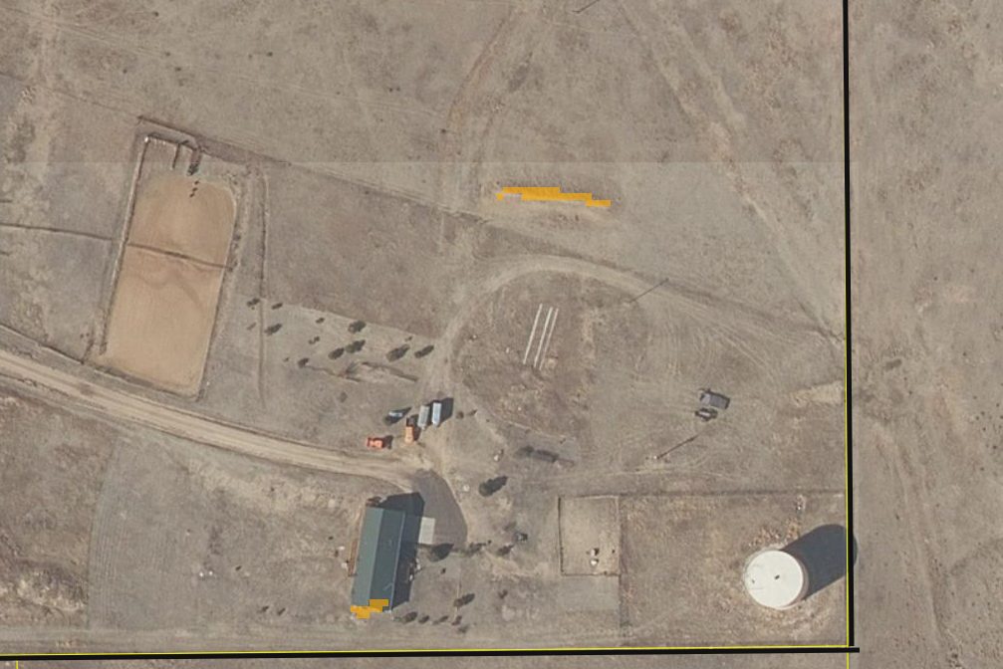

☒ | 30% or greater slope | Topography:
☒ | CGS review required (separate fee to CGS) | Soils/geology: |  | Soils and Geology report required
☐ | Floodplain | Floodplain comment:
☐ | Noise mitigation required | Noise comment:
☐ | Preble’s mouse

Districts

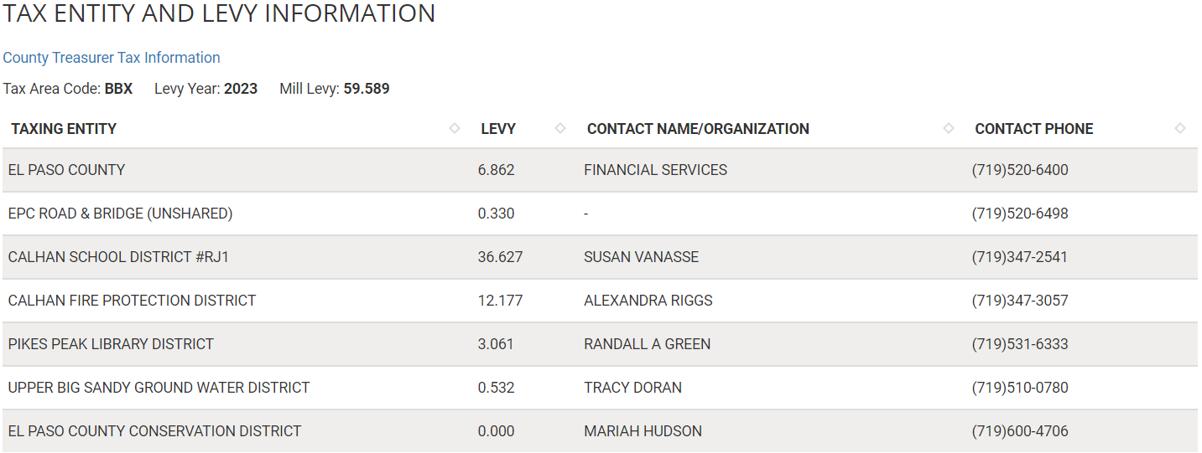

Proposed source of water |  |  | Proposed method of waste water disposal
☐ | Central System |  | ☒ | Central System
District Name: |  | Well/city | District Name:

Water/wastewater comments
Talk to the State Division of Water Resources regarding well permits, water rights, status of well. Plat Water Documents required regardless of source (town well, new well, existing).

8.4.7 (4)(a) General Provisions.
The Planning Commission shall, as part of its deliberations, make a recommendation regarding the sufficiency of the proposed water supply. The BoCC shall determine the sufficiency of the proposed water supply in terms of quantity, dependability, and quality based on the information presented and the recommendation of the Planning Commission.

In determining the sufficiency of a proposed water supply, the BoCC shall, at a minimum, consider the Water Resources Report, data and recommendations from the State Engineer's Office, CAO, EPCPH, and the County staff, the recommendations of the Planning Commission, and public comment. In all cases the burden of proof in demonstrating sufficiency rests with the applicant, and it shall be the applicant's sole responsibility to document in the Water Resources Report that the proposed water supply is sufficient in terms of quantity, dependability, and quality.

8.4.7 (B)(1) Water Resource Report.
(b) Water Resources Report Required. A water resources report as required by this Section shall be submitted with sketch plan, preliminary plan, final plat, and any subdivision applications which will create a new lot. A copy of the report will be kept on file in the El Paso County PCD.
(c) Prepared by Qualified Professional. The water resources report shall be prepared by a qualified hydrogeologist, hydrologist, licensed civil engineer, qualified groundwater geologist, or other qualified professional with appropriate experience.
(d) Document Adequate Water Supply. The Water Resources Report shall include adequate documentation that the proposed water supply is sufficient in terms of quantity, dependability, and quality for the proposed subdivision.

(c) Final Plat and Replat Report. The water resource report submitted with the final plat shall include all of the data needed to determine whether the proposed water supply is sufficient in terms of quality, quantity and dependability for the type of subdivision proposed. The report shall be based on engineering calculations and site-specific data and shall include a detailed discussion of the water demand, supply, quality, dependability, and supply facilities for the proposed subdivision.
A water resources report is not required if the BoCC made a finding that the proposed water supply plan of the preliminary plan was sufficient in terms of quantity, quality and dependability. However, an amended water resources report is required if there is a substantial change in either the water supply or the estimated water demand.
8.4.7(B)(5) Finding of Sufficient Dependability. The proposed water supply shall meet the following criteria to be found sufficient in terms of dependability:
- The supply is of sufficient quantity to meet the needs of the proposed subdivision for 300 years;
- The proposed water supply system and water supply is capable of meeting the average annual and peak daily demand of the proposed subdivision; and
The applicant has provided adequate evidence of ownership or the right of acquisition or use of existing or proposed water rights sufficient in quantity, dependability, and quality to serve the proposed uses within the subdivision; and (1) the legal capability to accomplish any changes in the uses or points of diversion of the rights with quantities and dependability necessary to serve the proposed subdivision without material injury to vested water rights; or (2) adequate evidence that the public or private water provider can and will supply the proposed subdivision with water of adequate quality, quantity and dependability.

8.4.8 Wastewater Disposal
(B) Minimum Standards.
(b) Compliance with EPCPH Regulations. All wastewater disposals systems shall comply with the EPCPH regulations and the CDPHE guidelines, as applicable.
i. An OWTS with design capacity less than or equal to 2,000 GPD must comply with regulations adopted by El Paso County Board of Health (EPCBoH) pursuant to this regulation and the OWTS Act. Within the jurisdiction of EPCBoH and EPCPH, the regulations promulgated by the EPCBoH govern all aspects of OWTS permits, performance, location, construction, alteration, installation, and use.
ii. An OWTS with design capacity greater than 2,000 GPD must comply with this regulation, site location and design approval in section 25-8-702, C.R.S., and the discharge permit requirements in the Water Quality Control Act, 25-8-501, et seq. C.R.S. OWTS with design capacity greater than 2,000 GPD must also comply with Appendix B of this Code.

(c) Favorable Recommendation from EPCPH Required. The EPCPH is considered the County's expert concerning the adequacy of a proposed sewage treatment system. No sketch or preliminary plan or final plat shall receive the approval of the BoCC unless EPCPH has made a favorable recommendation regarding the proposed method of sewage disposal.

(2) 2 OWTS Sites Required for All Lots or Parcels. All lots shall be designed to ensure that each lot has a minimum of 2 sites appropriate for OWTS which do not fall in the restricted areas identified on the preliminary plan; soils and geology report delineated wetland or floodplain maps; or other reports required under this Code.

Fire District:
Calhan Fire Protection District
(719)347-3057

Emergency Services Issues:
N.A

Commissioner District: 2

Code Waivers:
See Land Development Code Sec. 7.3

Parks and trails:

Annexations/Intergovernmental/ Jurisdictional Access issues:
N.A

Your El Paso Master Plan

Placetype: Rural
Character:
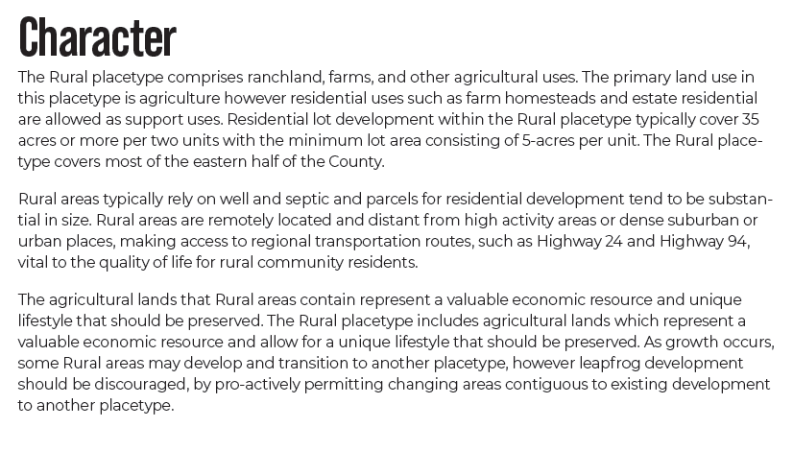

Recommended Land Uses:
- 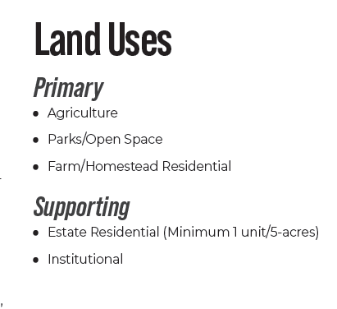

Area of Change Designation: Minimal Change: Undeveloped
Description:
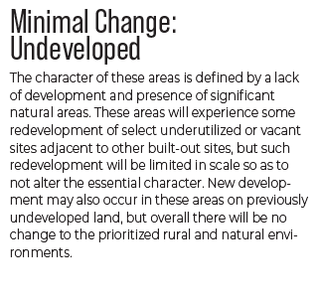

Goals, Objectives, Strategies:
Water Master Plan Area: Region_4b
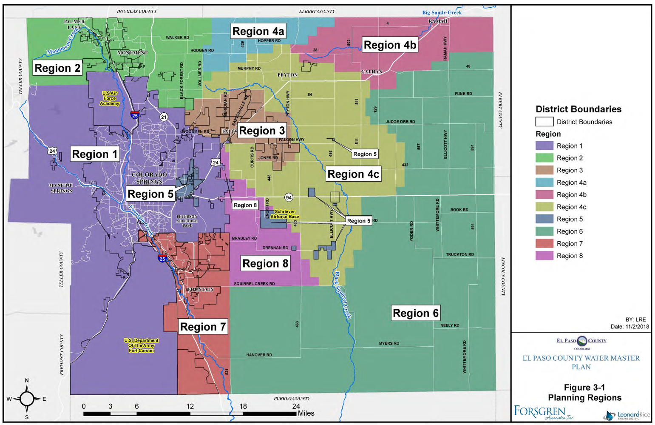

How to address water plan in letter of intent: 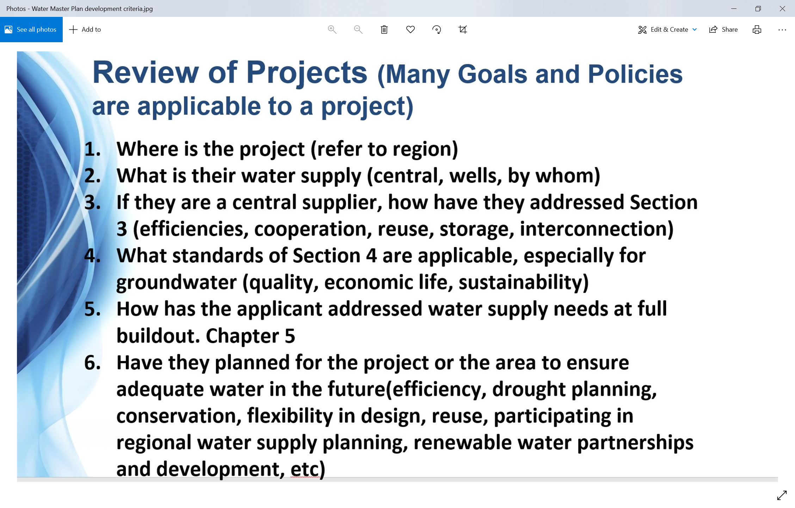

Recommendations:

Wildlife impact
1 - Low

Parks Master Plan:

Helpful Links

Planning Website: https://planningdevelopment.elpasoco.com/

El Paso County Master Plan: https://planningdevelopment.elpasoco.com/#1510603950097-f5d985dc-35b2
Parks, Mineral and Water Master Plan: https://planningdevelopment.elpasoco.com/resources-and-references/#1516982531779-52cc0e87-01af

Forms and Templates: https://planningdevelopment.elpasoco.com/planning-development-forms/#1510677560407-ff8cfff5-69b2716b-00f9cbba-0c21

Land Development Code: https://library.municode.com/co/el_paso_county/codes/land_development_code

EDARP: https://epcdevplanreview.com/

Public GIS: https://elpasoco.maps.arcgis.com/apps/View/index.html?appid=5be6431018594c67b035ad0aad3e7e8a

Wrap Up
-If subdivision is proposed, recording fees, park and school fees and road impact fees apply.
-Fees are subject to change. The fees at the time of application apply.
-Pursuant to the adopted El Paso County Road Impact Fee Program (Resolution No. 12-382), a transportation impact fee, calculated on a per trip basis, may be due at the time of building permit issuance. Starting January 1, 2020 the transportation impact fee will be due for all new construction (Resolution No. 19-471).
-The fee for any additional waiver/deviation requests (more than two) - $550.00 each. Please note that requests for waivers and/or deviations may result in additional processing/review delay.
-All items requested must accompany the submittal for it to be complete, prior to payment request or the submittal will not be complete and ready for review agencies.
-A temporary use permit shall be applied for and approved for any staging area associated with development, such as a sales office, construction trailer, or contractor's equipment yard, prior to scheduling of the pre-construction meeting with El Paso County Planning and Community Development. If a Planned Unit Development is proposed, the temporary staging area should be shown on the development guideline and phasing plan.
-All prospective timelines for review are subject to departmental staffing and workload.
-Early Assistance is valid for 12 months from submittal of the EA application. If a project submittal is not received within 12 months, a new EA meeting may be required. An audio/video copy of the meeting is available in EDARP within the EA folder.

- Applications scheduled for public hearings may be heard as a regular item at the request of staff or a hearing body member.

- Any comments or commitments made by any member of the County Staff during this early assistance meeting are only preliminary in nature and should not be relied upon by the applicant. All prospective applicants should be informed that formal comments cannot be made by staff until after the application is submitted.

