- Revise the site plan to show any existing gravel roads or other improvements that were not part of previously approved site development plan as “proposed.” They must be shown as proposed so we can retroactively review and approve them, and for the purpose of tabulating the total proposed disturbance. This applies to both parcels associated with this project.
  - Existing and proposed labels updated on the plans. We have added the reseeding note for the 3 acres as discussed to the approximate laydown area.
  - 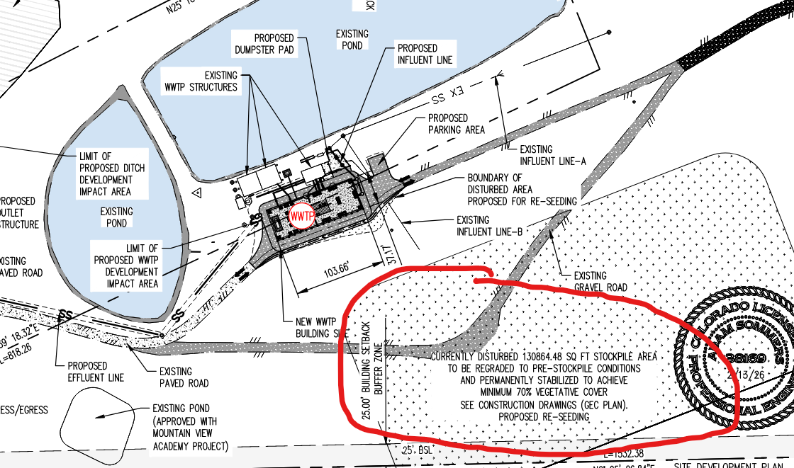
- road name
  - Road Name is included on the updated Site Development Plan
  - 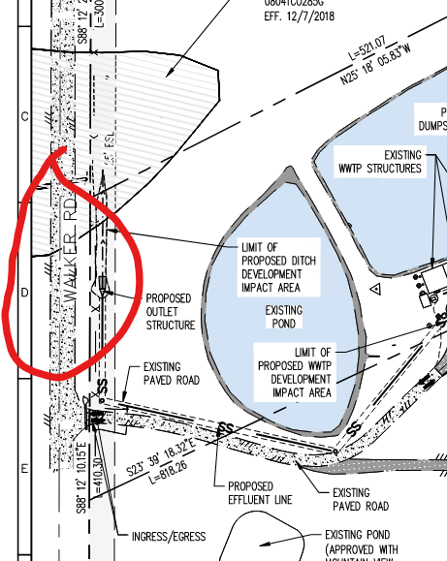
- Include the area disturbed for the installation of this pipe
  - Notation and linework added for area disturbed with pipe installation
  - 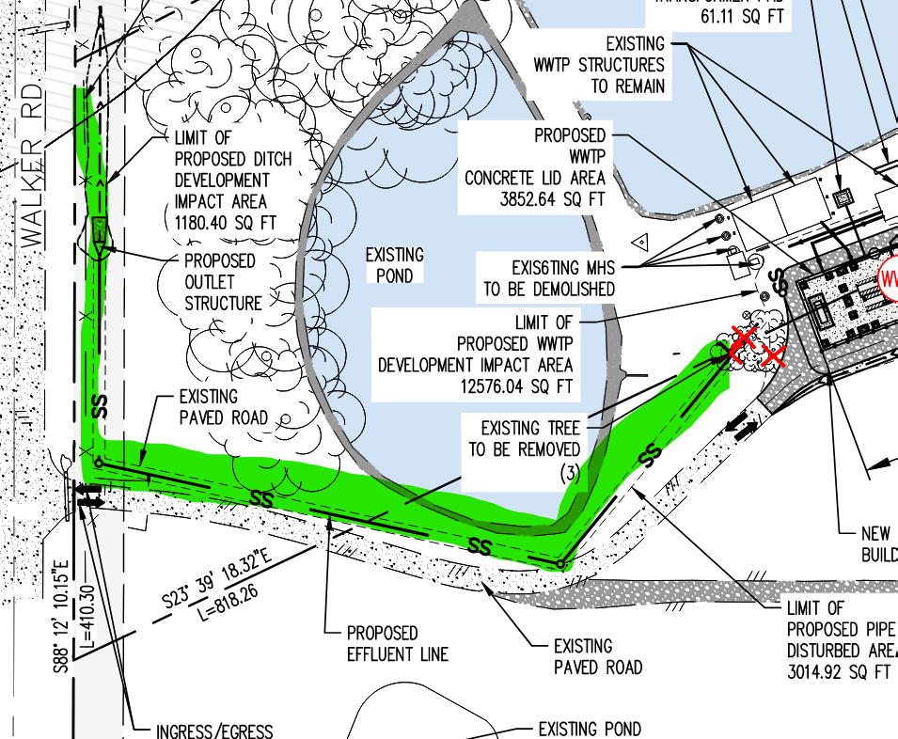
- Show existing pond (approved with mountain view academy project)
  - Limits of existing pond approval shown on plans.
  - 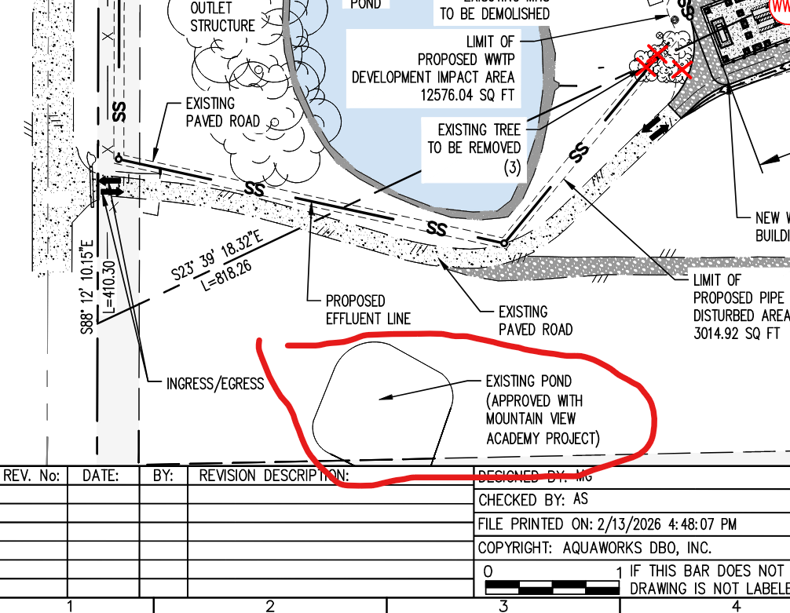
- Show culvert near entrance
  - There is no existing culvert near entrance per site survey
- What is this? Utility easement? is there a trail around pond or sidewalks on site?
  - This is an existing shed to remain that houses various existing treatment equipment.
- denote existing WWTP structures to be decommissioned or removed
  - Denotations added also see sheet C2 in the full plan set for addition demolition information.
- parking shall be depicted per checklist
  - Parking has been relocated and labeled on new plan
  - 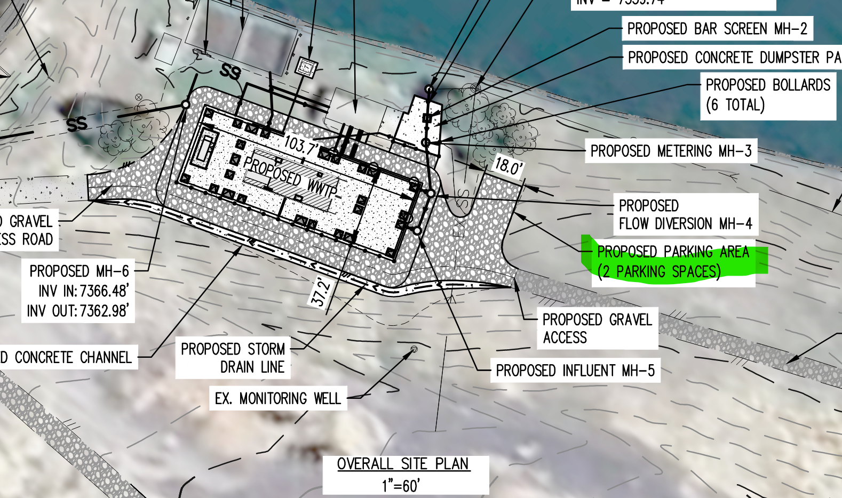
- call out sqft size of new buildings that match the elevation plans
  - The proposed two shipping containers are approximate 620 sqft in total. We normally call out the entire concrete slab. Label is located in image below.
  - 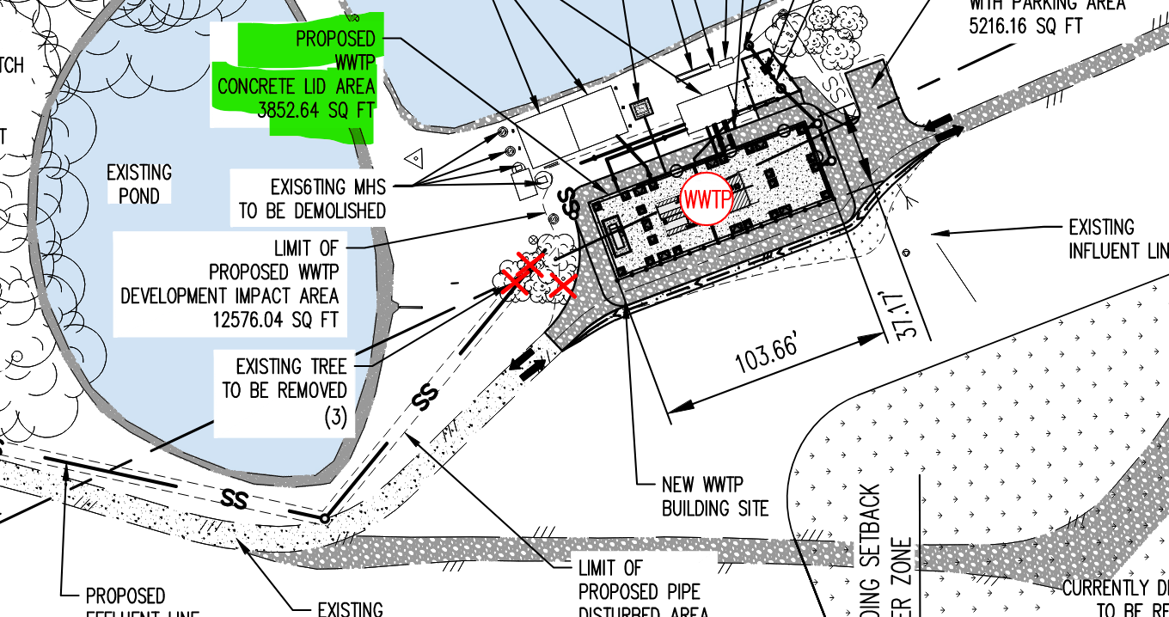
- Show current disturbed area and label it as to be reseeded
  - All reseed areas are add to the site development plan and erosion control plans on sheets C5.1 and C5.2
- Clarify what you mean by lot coverage? Is coverage the impervious area or something else?
  - Yes the lot coverage is meant to be the total impervious area of the parcel.
- Include all previously unapproved development that will not be removed with this project in the proposed section. Please add a chart similar to this for soil disturbance for before (existing disturbance), during (existing that has not been re-vegetated + disturbance from construction) and after construction (disturbance after re-vegetation).
  - A second table was added to the second site development sheet. See below
  - 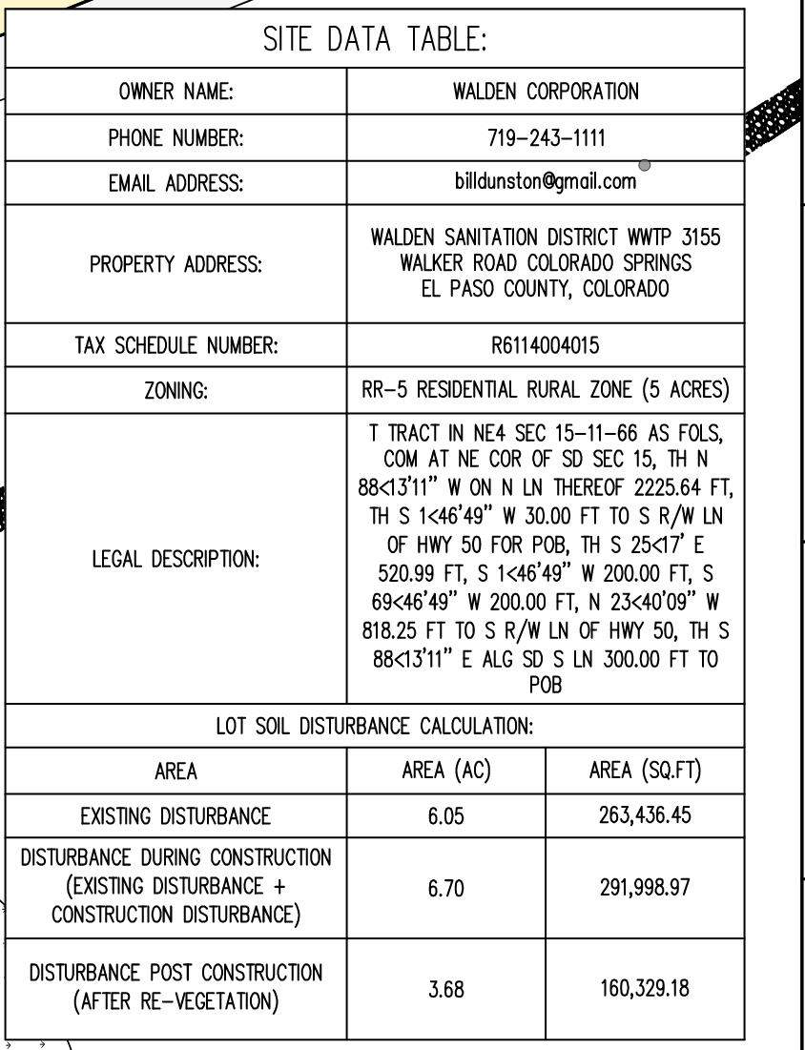
- PCD File PPR2538
  - Project number updated
- Site Development Plan
  - Sheet title updated
- is the road/ drive really a hair pin triangle turn or is there more road ?
  - This was the drive isles mapped by the existing topography.
- 2 sheets may be needed so the drawing will be legible after all items are added as required per the checklist
  - Second Site development shet added.
- where is this tank at- LOI should provide a more detailed description about what is existing, to be demolished and to be built?
  - LOI to be provided on this next submission.
- The owner (s) agree on behalf of him/herself and any developer of builder successors and assignees that the owner and/or said successors and assigns shall be required to pay traffic impact fees in accordance with the El Paso County Road Impact Fee Program (Resolution No. 25-337), or any amendments thereto, at or prior to the time of building permit submittals. The fee obligation, if not paid at final plat recording, shall be documents on all sales documents and in plat notes to ensure that a title search would find the fee obligation before sale of the property.
  - Understood

