Letter of Intent

Owner:
Richmond American Homes
Represented by: Jason Pock
Director of Entitlements
4350 S. Monaco Street, Denver, CO 80237
Office: (720) 977-3827
Cell: (720) 335-8854
Fax: (303) 488-4831
Email: Jason.Pock@mdch.com

Applicant:
Hayley Young, PE
B&J Surveying, Inc.
6841 S. Yosemite Street; Suite 100
Centennial, CO 80112
Phone: 303.850.0559
hyoung@bjsurvey.net

Site Location:
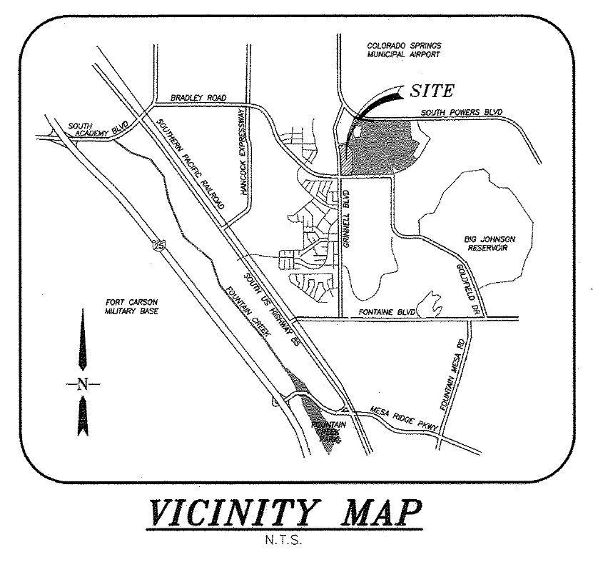
Lot 64 of Springs at Waterview F1
(parcel 5507222030)
Size and Zoning:
Lot 64 of Springs at Waterview Filing No. 1, otherwise known as 7168 Passing Sky Drive. It is on the cul-de-sac at the south end of Passing Sky Drive. Said parcel 5507222030 is 7,598 square feet or 0.1744 acres in size. The current zoning of the parcel is RS 5000. Per the El Paso Development Code in Section 5.4.2, Table 5-4, the setbacks are as follows:
Front (to garage): 25’
Front (to living): 25’
Side: 5’
Rear: 25’
Hardship request:
The purpose for this application is to request administrative relief from the corner lot setback for lot 64 of Springs at Waterview – Filing No. 1. The hardship is that the rear setback of 25’ that overly restricts the lot so that no available plan can be built within the setbacks. Our proposed request/remedy for lot 64 is a 20% administrative reduction in the rear lot setback of 25’ for this lot. By reducing the Rear Lot setback from 25’ to 20’ (20%), Richmond would be able to fit their floor plan with the smallest footprint (the “903” plan) on this lot.

The requested adjustment of setbacks outlined above to consist of as follows:
Front: 25.0’
Side (interior): 5’
Rear: 20.0’ (20% reduction)

Request and Justification:
Each item per the El Paso County LDC criteria is addressed below. Required factors are listed first.
Criteria: The strict application of the standard in question is unreasonable or unnecessary given the development proposal or the measures proposed by the applicant; or that the property has extraordinary or exceptional physical conditions that do not generally exist in nearby properties in the same zoning district
Justification: The standard rear setback for this lots is unreasonable due to the shape of the flag lot and would only allow for a 37’ buildable depth on the left side of the lot. This is unnecessary in this case as only a small portion of the house will need to encroach into the rear setback.
Criteria: The intent of this Code and the specific regulation in question is preserved
Justification: Overall, this gives an aesthetically pleasing frontage matching nearby homes as well as a highly useable rear yard, being that the average rear setback is well over the standard 25’, preserving the intent.
Criteria: The granting of the administrative relief will not result in an adverse impact on surrounding properties
Justification: Granting administrative relief on this lot has absolutely no adverse impact on surrounding properties and allows this lot to be constructed by the same builder as adjacent lots. This lot was purchased only after confirming the ability to construct with the constraint of administrative relief previously communicated with El Paso County.
Criteria: The granting of the administrative relief will not allow an increase in the number of dwelling units on a parcel.
Justification: There is no plan for additional dwelling units on this parcel.

Existing and Proposed Facilities:
Subdivision infrastructure has been completed, including roads and walk surrounding the lot. Utility stubs have been provided to the lot. The lot has been graded to over-lot conditions and there is an existing electric ped within the lot boundaries. A house is planned on the lot per the specifications of the side plan which shows final proposed grading conditions.
No other waivers or requests are anticipated. Please contact me if there are any questions or concerns.

Sincerely,

Hayley Young, PE
B&J Surveying, Inc.

