Early Assistance Meeting Number: EA25103
Project Name: Old Denver Storage
Project Location: 16050 Old Denver Road
Project Parcel Nos. 7126004010
Project Description: Subdividing the 8 acre property into 2 or 3 lots and developing the northwest portion 2.5 to 3 acres into an outdoor RV & boat storage facility on a recycled asphalt parking lot out of and above the 100 year floodplain.
Meeting Date: September 29

El Paso County Planning & Community Development Planning Checklist

Request – Map Provided by Applicant
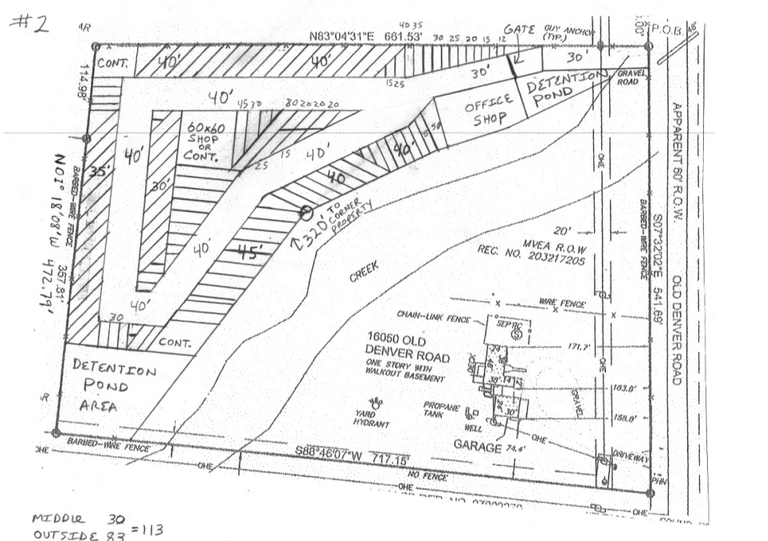

Zoning
Existing Zone(s)
Zone |  | Name
CS
Proposed Zone(s)
Zone |  | Name
-

Zone Map (existing conditions of approval)
Resolution 24-187

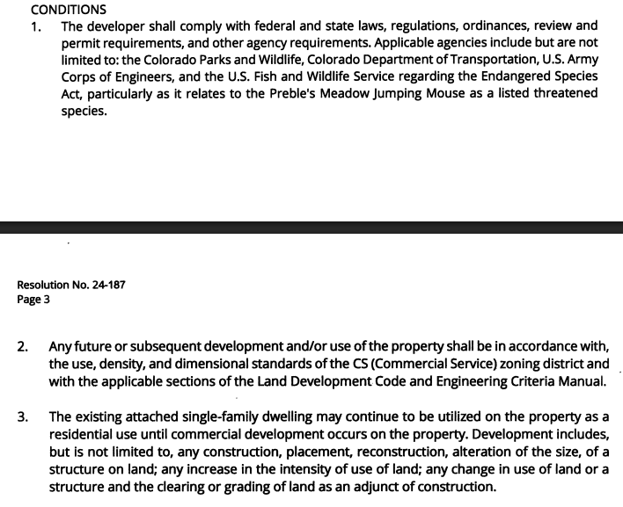

Zoning Analysis

Zoning District Requirements (density, lot size, lot design standards, building setbacks)
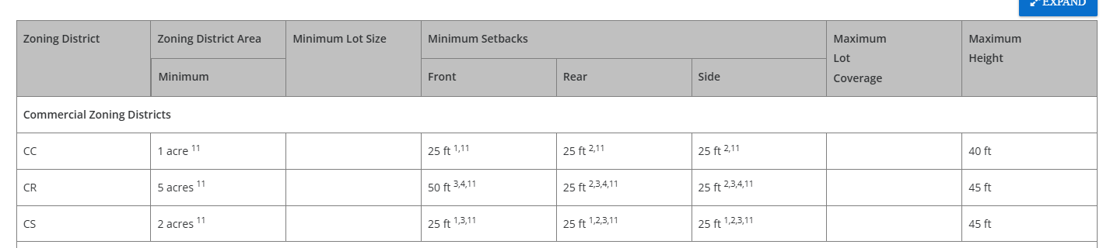

Plat Map or Parcel Map (conditions of approval):
Exemption plat

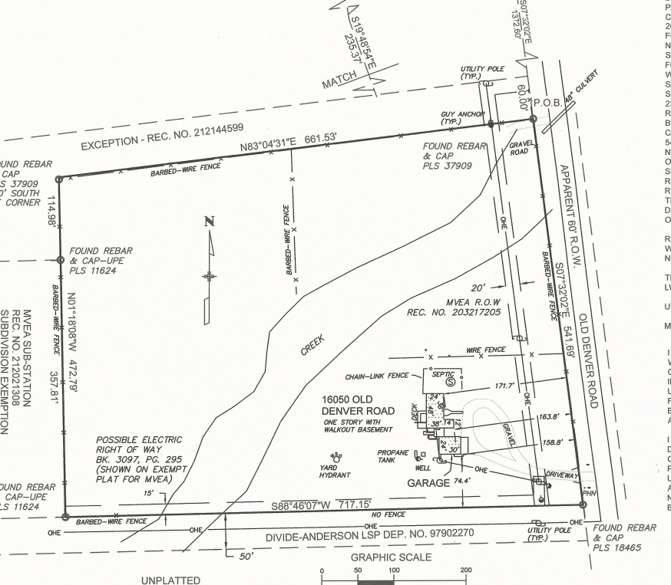

Application Type(s) Hearing: Required/ Optional/ No
Final Plat | Yes
Site Development Plan | No

Approval Criteria:

Processing Issues and Options

Relevant Past History:
Exemption plat

Rezone approved with conditions regarding the existing duplex

Design and Landscaping

Site Design/Layout (Lot pattern, circulation/road design, open space, preservation of natural features, compatibility internally and with adjacent land uses)
5.2.40. Outside Storage
(A) Applicability. All outside storage is subject to the requirements of this Section.
(B) Outside Storage Standards. Outside storage shall meet the following standards.
(1) Materials to be Stored and Principal Use Required. Outside storage may include vehicles, raw materials, supplies, finished or semi-finished products or equipment used in conjunction with, and specifically accessory to, an allowed principal use conducted on the premises unless listed as a principal use. Outside storage of inoperable vehicles or equipment in a location other than the salvage yard is only permitted to the extent allowed in the Parking, Storage and Repair of Vehicles and Machines, Personal Section of Chapter 5 of this Code, provided the standards of that section are met. Employee or customer parking or outdoor sales and display areas shall not be considered outside storage.
(2) Materials Screened by Solid Fence or Vegetation. Outside storage shall be enclosed and concealed by a solid fence or wall at least 6 feet in height or any combination of berming, shrubs, trees fencing or walls which will provide at maturity a minimum of 6 feet of height and 100% opaque screening for the area utilized for outside storage.
(3) Outside Storage Not to Exceed Height of Screening. Outside storage or stacked materials shall not exceed the height of the screening fence except for operable vehicles, trailers, or other equipment designed to be towed or lifted as a single component.
(4) Storage of Equipment and Vehicles Exceeding Height of Fence. All equipment and vehicles exceeding the height of the fence shall be stored on the rear ⅓ of the property except when adjacent to a residential zoning district, in which case the equipment or vehicles shall be a minimum 50 feet from the residential zoning district boundary.

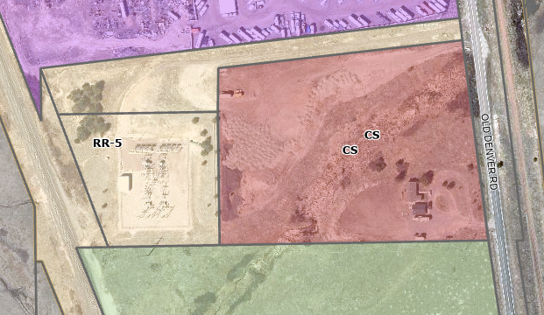

(5) Storage Adjacent to Road. Outside storage is allowed within the required setback area from a road provided that the storage area does not occupy more than 50% of the lineal frontage at the right-of-way.
(6) No Storage in Required Landscape Area. Outside storage shall not be allowed within any required landscaped area.
(7) Screening Fence Waived Between Adjacent Storage Areas. When outside storage areas abut each other and are not visible from public areas, administrative relief may be sought from the requirement for a solid fence between the outdoor storage areas.
(8) Salvage Yards and Solid Waste Landfills. Salvage yards and solid waste landfills are not regarded as outside storage, but salvage yards are required to meet the screening standards of this Section.
(9) Temporary Storage. Administrative relief from the outside storage standards may be sought in association with approved temporary uses.
(10) Landscaping Requirements to be Met. Outside storage shall comply with the landscaping requirements in this Chapter.
(C) Relationship to Site Development Plan. Outside storage areas shall be so identified on the site development plan prior to the establishment of the outside storage use.

Landscaping
☐ | Expressway, Principal arterial area depth – 25’-Trees required 1 per 20’
☐ | Urban interchange/Intersection area depth – 25’- N/A
☐ | Minor arterial area depth 20’ – Trees required 1 per 25’
☐ | Non-arterial area depth 10’ – Trees required 1 per 30’
☐ | Parking lot landscaping required
☐ | Buffer between non-residential and residential districts separated by a non-arterial road or public alley

6.2.2 Landscaping will apply

(e) Outside Storage Area Landscaping Requirements.
(i) Site-Specific Landscaping Required. PCD Director approval of site-specific landscaping is required for establishing an outside storage area. Installation of approved site-specific landscaping is required prior to utilizing an outside storage area.
(ii) Site-Specific Landscaping Standards. The site-specific landscaping shall reflect a combination of berms, shrubs, trees, fences or walls which will provide, at maturity, a minimum 6 foot high, 100% opaque screening for the outside storage area.

Signage:

Parking Requirements:
Vehicle storage requires 3 spaces

Lighting:
6.2.3 Lighting Standards will also apply

Photometric Plan Required | ☒

Site Characteristics\ Constraints\ Environmental Standards:
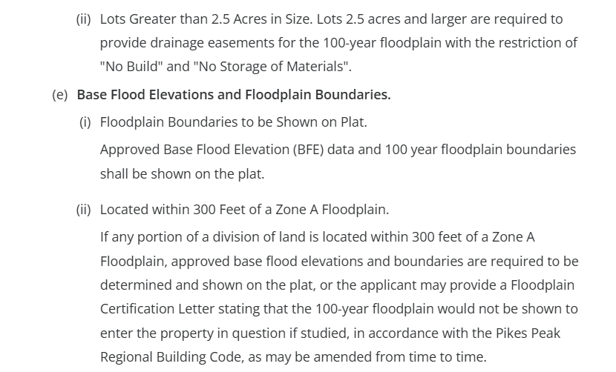

☒ | 30% or greater slope | Topography: | 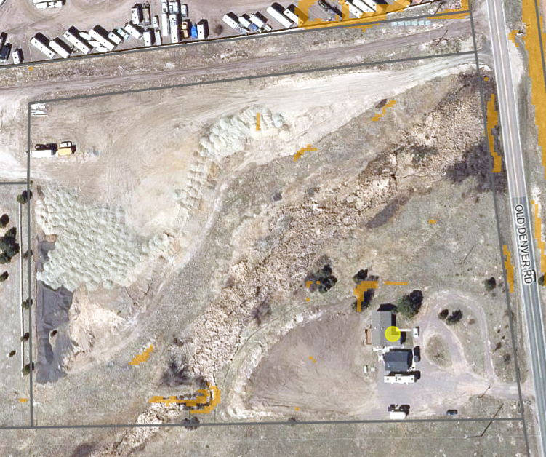
☒ | CGS review required (separate fee to CGS) | Soils/geology:
☒ | Floodplain | Floodplain comment: |  | 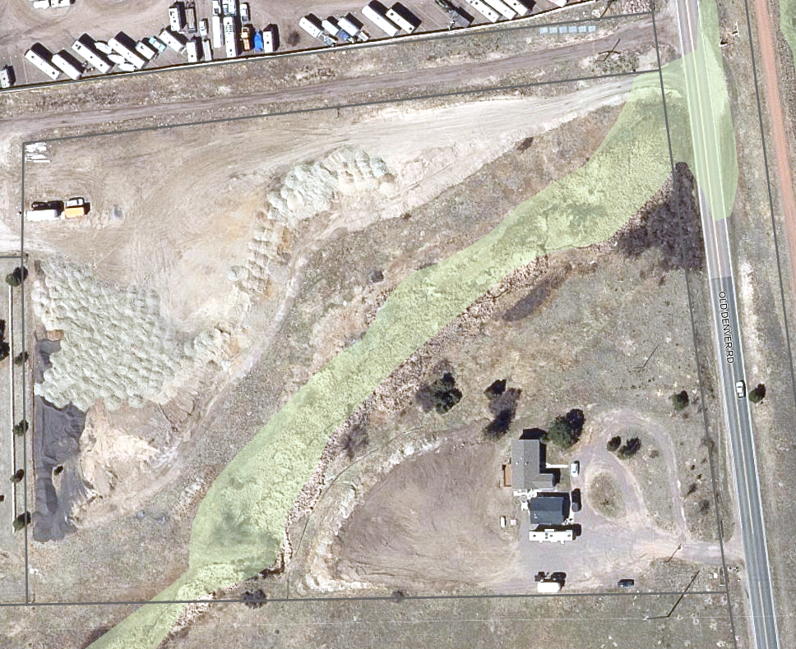
 |  |  |  | Zone AE
☐ | Noise mitigation required | Noise comment:
☒ | Preble’s mouse | 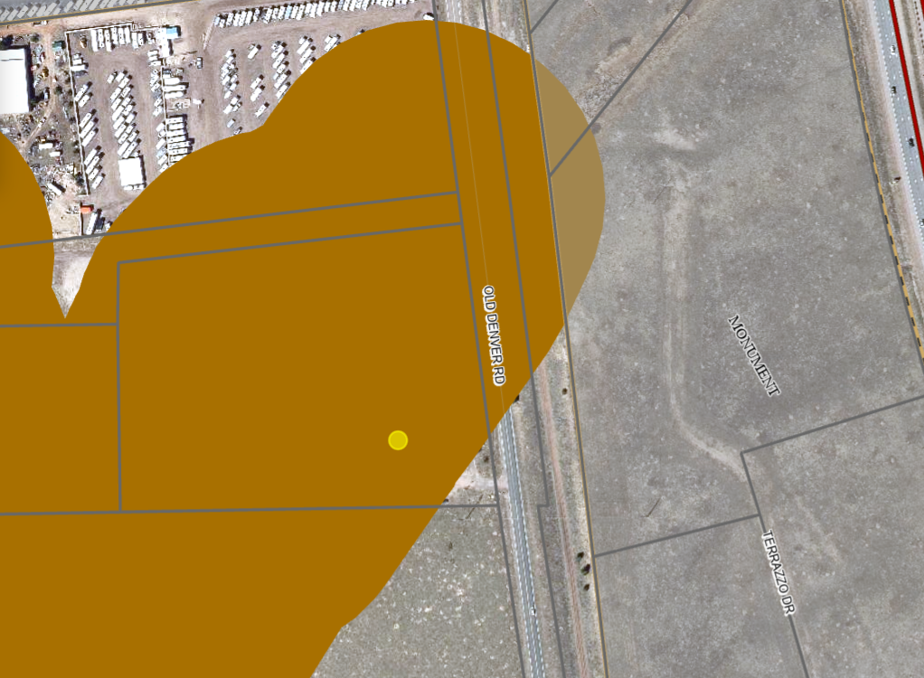  Brown area on the map shows the occupied range for the Prebles Mouse

Air/Visual Quality:

Districts

Taxing Entities
El Paso County
EPC Road & Bridge
Lewis-Palmer School District #38
Pikes Peak Library
Tri-Lakes Monument Fire Protection
El Paso County Conservation

Proposed source of water |  |  | Proposed method of wastewater disposal
☐ | Central System |  | ☐ | Central System
District Name: |  |  | District Name:

Water/wastewater comments
Property is currently on well and septic. Your property is not within a metro district. A commitment letter can only be obtained if the property is within a metro district that provides water services.

Need to meet section 8.4.7 for water supply. Provide a water resources report that states adequate water supply. Must be prepared by a qualified hydrogeologist, hydrologist, licensed civil engineer, qualified groundwater geologist, or other qualified professional with appropriate experience.

Need to meet section 8.4.8 for water supply.
(B) Minimum Standards.
(1) General.
(a) Central Wastewater System Required. A central wastewater system is the required method of wastewater collection and treatment in all new subdivisions or zoning districts with a density greater than 1 dwelling unit per 2½ acres or where lot sizes are less than 2½ acres. Every reasonable effort shall be made to provide a central wastewater system.
(b) Compliance with EPCPH Regulations. All wastewater disposals systems shall comply with the EPCPH regulations and the CDPHE guidelines, as applicable.
i. An OWTS with design capacity less than or equal to 2,000 GPD must comply with regulations adopted by El Paso County Board of Health (EPCBoH) pursuant to this regulation and the OWTS Act. Within the jurisdiction of EPCBoH and EPCPH, the regulations promulgated by the EPCBoH govern all aspects of OWTS permits, performance, location, construction, alteration, installation, and use.
ii. An OWTS with design capacity greater than 2,000 GPD must comply with this regulation, site location and design approval in section 25-8-702, C.R.S., and the discharge permit requirements in the Water Quality Control Act, 25-8-501, et seq. C.R.S. OWTS with design capacity greater than 2,000 GPD must also comply with Appendix B of this Code.
(c) Favorable Recommendation from EPCPH Required. The EPCPH is considered the County's expert concerning the adequacy of a proposed sewage treatment system. No sketch or preliminary plan or final plat shall receive the approval of the BoCC unless EPCPH has made a favorable recommendation regarding the proposed method of sewage disposal.
(d) Wastewater Treatment to Meet Requirements of this Section. In addition to the requirements of the EPCPH, the provisions of this Section shall be used to evaluate the adequacy of the wastewater treatment system intended to serve a proposed subdivision.
(e) New and Replacement Systems Designed to Minimize Flood Impacts. New and replacement wastewater systems shall be designed to minimize or eliminate infiltration of flood waters into the systems and discharge from the systems into flood water.
(C) Onsite Wastewater Treatment Systems (OWTS).
(1) Burden of Proof on Subdivider to Show OWTS Effective. The burden of proof for showing that an OWTS meets the spirit and intent of this Section shall be on the applicant. Reports, data, and other evidence shall illustrate that the subdivision, at a minimum, achieves the following:
• Non-contamination of surface or subsurface water resources;
• Non-interference with water resources of adjoining lots. The standard for determining interference shall be the probability of well deepening or the necessity to remove land from agricultural use;
• Non-interference with the enjoyment, use, or utility of adjoining land by virtue of pollution, odor, health hazard or water usage. Placement of leach fields within the cone of influence of a well shall constitute interference, unless otherwise approved by the EPCPH;
• Lot sizes compatible with the limitations inherent in soils, geologic, and hydrologic characteristics of the site. Lot sizes in excess of 5 acres may be required in areas in which site characteristics dictate larger lots; and
• Compliance with any physical setback requirements of the EPCPH regulations.
(2) 2 OWTS Sites Required for All Lots or Parcels. All lots shall be designed to ensure that each lot has a minimum of 2 sites appropriate for OWTS which do not fall in the restricted areas identified on the preliminary plan; soils and geology report delineated wetland or floodplain maps; or other reports required under this Code.

Fire District:
Tri-Lakes Monument
The nearest fire hydrant is approximately 1200’ away.
The required water per the LDC is 5400 gallons which is less than the 6,000 gallons Monument Fire arrives with on first alarm.

Wildland Fire and Hazard Mitigation Plan:
WRC Map:
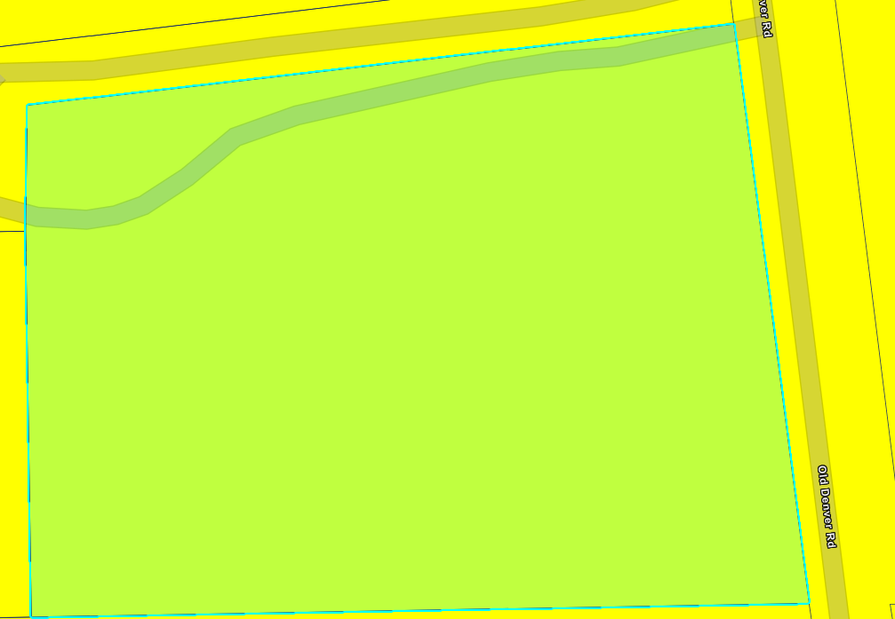

CSFS Map:


A Fire Protection Report and a Wildland Fire and Hazard Mitigation Report are required. This is in a low fire intensity area.

Emergency Services Issues:

Commissioner District: 3

Code Waivers:

Parks and trails:
El Paso County Parks Department. The 2022 El Paso County Parks Master Plan shows no impacts to existing or proposed parks, trails, or open space. As such, no trail easement dedications will be necessary for this project. As this is a commercial development, no regional park fees are applicable, although changes to the El Paso County Land Development Code over the next year or so may or may not change this guideline. It is not necessary for EPC Parks staff to attend this early assistance meeting. Thank you!

Annexations/Intergovernmental/ Jurisdictional Access issues:
You are close to the Town of Monument

Road Impact Fee Program (PID Inclusion):
Road Impact Fees will apply to any new development on the property, this will include the proposed RV Storage.

Your El Paso Master Plan

Placetype:
Character: Rural
The Rural placetype comprises ranchland, farms, and other agricultural uses. The primary land use in this placetype is agriculture however residential uses such as farm homesteads and estate residential are allowed as support uses. Residential lot development within the Rural placetype typically cover 35 acres or more per two units with the minimum lot area consisting of 5-acres per unit. The Rural placetype covers most of the eastern half of the County.

Rural areas typically rely on well and septic and parcels for residential development tend to be substantial in size. Rural areas are remotely located and distant from high activity areas or dense suburban or urban places, making access to regional transportation routes, such as Highway 24 and Highway 94, vital to the quality of life for rural community residents.

The agricultural lands that Rural areas contain represent a valuable economic resource and unique lifestyle that should be preserved. The Rural placetype includes agricultural lands which represent a valuable economic resource and allow for a unique lifestyle that should be preserved. As growth occurs, some Rural areas may develop and transition to another placetype, however leapfrog development should be discouraged, by pro-actively permitting changing areas contiguous to existing development to another placetype.

Recommended Land Uses:
Primary
- Agriculture
- Parks/Open Space
- Farm/Homestead Residential

Supporting
- Estate Residential (Minimum 1 unit/5-acres)
- Institutional

Goals, Objectives, Strategies:

Area of Change Designation:
Description: Minimal Change Developed
These areas have undergone development and have an established character. Developed areas of minimal change are largely built out but may include isolated pockets of vacant or underutilized land. These key sites are likely to see more intense infill development with a mix of uses and scale of redevelopment that will significantly impact the character of an area. For example, a large amount of vacant land in a suburban division adjacent to a more urban neighborhood may be developed and change to match the urban character and intensity so as to accommodate a greater population. The inverse is also possible where an undeveloped portion of an denser neighborhood could redevelop to a less intense suburban scale. Regardless of the development that may occur, if these areas evolve to a new development pattern of differing intensity, their overall character can be maintained.

Goals, Objectives, Strategies:

Key Area: Tri-Lakes

Tri-Lakes is the northern gateway into the County along Interstate 25 and Highway 83. It is situated between Pike National Forest, the United States Air Force Academy, and Black Forest. With significant suburban development and some mixed-use development, this Key Area supports the commercial needs of many of the residents
in northern El Paso County. Tri-Lakes also serves as a place of residence for many who commute to work in the Denver Metropolitan Area. It is also an activity and entertainment center with the three lakes (Monument Lake, Wood-moor Lake, and Palmer Lake) that comprise its namesake and direct access to the national forest. Tri-Lakes is the most well-established community in the northern part of the County with a mixture of housing options, easy access to necessary commercial goods and services, and a variety of entertainment opportunities. Future development in this area should align with the existing character and strengthen the residential, commercial, employment, and entertainment opportunities in the adjacent communities of Monument, Palmer Lake, and Woodmoor.

Goals, Objectives, Strategies:

Water Master Plan Area:
Region 2

Recommendations:

Wildlife impact
2 - Moderate

Helpful Links

Planning Website: https://planningdevelopment.elpasoco.com/

El Paso County Master Plan: https://planningdevelopment.elpasoco.com/#1510603950097-f5d985dc-35b2
Parks, Mineral and Water Master Plan: https://planningdevelopment.elpasoco.com/resources-and-references/#1516982531779-52cc0e87-01af

Forms and Templates: https://planningdevelopment.elpasoco.com/planning-development-forms/#1510677560407-ff8cfff5-69b2716b-00f9cbba-0c21

Land Development Code: https://library.municode.com/co/el_paso_county/codes/land_development_code

EDARP: https://epcdevplanreview.com/

Public GIS: https://elpasoco.maps.arcgis.com/apps/View/index.html?appid=5be6431018594c67b035ad0aad3e7e8a

Wrap Up
-If subdivision is proposed, recording fees, park and school fees and road impact fees may apply.

-Fees are subject to change. The fees at the time of application apply.

-Road Impact Fees
Please see the following website for information on the EPC Road Impact Fee Project. https://publicworks.elpasoco.com/road-impact-fees/ to include fee schedule.
As of December 15, 2016, per Resolution 16-454, on and after January 1, 2020, property in the unincorporated area of the county that receives a Land Use Approval either in a public hearing or administratively, is subject to the payment of Road Impact Fees. After December 31, 2024, in accordance with BoCC Resolution 24-377 the fee is paid for new residential and non-residential uses and structures and expansions of non-residential uses and structures. Road Impact fees are typically paid at time of building permit. If no building permit is being obtained for a particular Land Use application, then Road Impact Fees must be paid at the time of Site Development Plan or Special Use approval. If there are questions about EPC Road Impact program or fees, please contact DPW Development Review Services and the Engineer of the Day.

- Engineering Criteria Manual (ECM) Deviations.
The fee for any additional ECM deviation requests (more than two per land use application) - $1483.00 each per current Fee Schedule. Please note ECM deviation requests may result in additional processing and project review time. ECM Deviations should be submitted prior to the initial Site Development Plan or Final Plat submittal to preclude changes having to be made to engineering plans and documents if the deviation is not approved. Submission of an ECM deviation request does not imply or guarantee that the deviation will be approved. An ECM Deviation form must be submitted to include complete exhibits and justification excluding cost with supporting engineering criteria. If there are questions about ECM Deviation requests, please contact DPW Development Review Services and the Engineer of the Day.

-The fee for any additional waiver/deviation requests (more than two) - $550.00 each. Please note that requests for waivers and/or deviations may result in additional processing/review delay.

-All items requested must accompany the submittal for it to be complete, prior to payment request or the submittal will not be complete and ready for review agencies.

-A temporary use permit shall be applied for and approved for any staging area associated with development, such as a sales office, construction trailer, or contractor's equipment yard, prior to scheduling of the pre-construction meeting with El Paso County Planning and Community Development. If a Planned Unit Development is proposed, the temporary staging area should be shown on the development guideline and phasing plan.

-All prospective timelines for review are subject to departmental staffing and workload.

-Early Assistance is valid for 12 months from submittal of the EA application. If a project submittal is not received within 12 months, a new EA meeting may be required. An audio/video copy of the meeting is available in EDARP within the EA folder.

- Applications scheduled for public hearings may be heard as a regular item at the request of staff or a hearing body member.

- Any comments or commitments made by any member of the County Staff during this early assistance meeting are only preliminary in nature and should not be relied upon by the applicant. All prospective applicants should be informed that formal comments cannot be made by staff until after the application is submitted.

