
MATRIX DESIGN GROUP, INC. 2435 RESEARCH PARKWAY, SUITE 300 COLORADO SPRINGS, CO 80920
O 719.575.0100
F 719.575.0208 MATRIXDESIGNGROUP.COM

EXHIBIT A LAND DESCRIPTION
A PARCEL OF LAND SITUATED IN THE SOUTHWEST QUARTER OF SECTION 8, TOWNSHIP 14 SOUTH, RANGE 65 WEST OF THE 6TH PRINCIPAL MERIDIAN, COUNTY OF EL PASO, STATE OF COLORADO, MORE PARTICULARLY DESCRIBED AS FOLLOWS WITH BEARINGS REFERENCED TO THE WEST LINE OF THE SOUTHWEST QUARTER OF SAID SECTION 8, BEING MONUMENTED AT THE SOUTHWEST CORNER OF SAID SOUTHWEST QUARTER BY A 3.25" ALUMINUM CAP STAMPED "LS 22573" IN RANGE BOX AND MONUMENTED AT THE WEST QUARTER CORNER OF SAID SOUTHWEST QUARTER BY A 3.25" ALUMINUM CAP STAMPED "BUREAU OF LAND MANAGEMENT U.S. DEPT. OF THE INTERIOR", AS BEARING OF NORTH 00°23'14" WEST, A DISTANCE OF 2,641.77 FEET;

COMMENCING AT THE SOUTHWEST CORNER OF THE SOUTHWEST QUARTER OF SECTION 8; THENCE NORTH 00°23’14” WEST, ALONG THE WEST LINE OF SAID SOUTHWEST QUARTER, A DISTANCE OF 449.46 FEET; THENCE NORTH 89°36’46” EAST, A DISTANCE OF 30.00 FEET TO THE SOUTHWEST CORNER OF SOFTBALL WEST SUBDIVISION NO. 2, THENCE NORTH 89°36’45” EAST, ALONG THE SOUTH LINE OF SAID SUBDIVISION, A DISTANCE OF 634.38 FEET TO THE POINT OF BEGINNING;
THENCE NORTH 00°23'14" WEST, A DISTANCE OF 209.00 FEET; THENCE SOUTH 89°36'45" WEST, A DISTANCE OF 131.18 FEET;
THENCE NORTH 00°23'14" WEST, A DISTANCE OF 665.83 FEET TO A NON-TANGENT CURVE TO THE LEFT HAVING A RADIUS OF 440.00 FEET;

THENCE NORTHEASTERLY AND COINCIDENT WITH SAID NON-TANGENT CURVE, THROUGH A CENTRAL ANGLE OF 52°26'35", AN ARC DISTANCE OF 402.73 FEET AND HAVING A CHORD THAT BEARS NORTH 58°40'55" EAST, A DISTANCE OF 388.82 FEET;

THENCE NORTH 32°27'38" EAST, A DISTANCE OF 40.86 FEET TO A TANGENT CURVE TO THE RIGHT, HAVING A RADIUS OF 360.00 FEET;

THENCE NORTHEASTERLY AND COINCIDENT WITH SAID TANGENT CURVE, THROUGH A CENTRAL ANGLE OF 56°28'31", AN ARC DISTANCE OF 354.84 FEET AND HAVING A CHORD THAT BEARS NORTH 60°41'53" EAST, A DISTANCE OF 340.65 FEET TO THE EAST LINE OF SAID SOFTBALL WEST SUBDIVISION NO. 2;
THENCE SOUTH 03°28'07" WEST, COINCIDENT WITH SAID EAST LINE, A DISTANCE OF 1,227.76 FEET TO THE SOUTHEAST CORNER OF SAID SOFTBALL WEST SUBDIVISION NO. 2 AND A NON-TANGENT CURVE TO THE RIGHT HAVING A RADIUS OF 1,780.00 FEET;

THENCE COINCIDENT WITH THE SOUTH LINE OF SAID SOFTBALL WEST SUBDIVISION NO. 2, THE FOLLOWING TWO (2) COURSES:

S:\24.1382.003 Peterson Road and Meadowbrook Parkway Overall Development\400 Survey\400 CADD\407 LEGAL DESCRIPTIONS\LOT 1\1382-LOT 1-LD.docx

LAND DESCRIPTION CONT.
- WESTERLY AND COINCIDENT WITH SAID NON-TANGENT CURVE, THROUGH A CENTRAL ANGLE OF 13°33'05", AN ARC DISTANCE OF 421.00 FEET AND HAVING A CHORD THAT BEARS SOUTH 82°56'54" WEST, A DISTANCE OF 420.02 FEET;
- SOUTH 89°36'45" WEST, A DISTANCE OF 22.95 FEET TO THE POINT OF BEGINNING.

THE ABOVE DESCRIPTION CONTAINS A CALCULATED AREA OF 613,849 SQUARE FEET OR (14.09 ACRES), MORE OR LESS.
ALEXANDER AGUILAR, PLS 38858
PREPARED FOR AND ON BEHALF OF MATRIX DESIGN GROUP 2435 RESEARCH PARKWAY, SUITE 300
COLORADO SPRINGS, CO. 80920

W 1/4 COR SEC 8
MEADOWBROOK
PARKWAY

UNPLATTED LAND EAST FORK SAND CREEK
R=360.00 Δ=56°28'31" L=354.84' CH=N60°41'53"E 340.65'

N32°27'38"E 40.86'
10' ELECTRIC ESMT
BK 2362, PG 549
CROSSORADS MIXED USE FILING NO. 1

R=440.00 Δ=52°26'35" L=402.73' CH=N58°40'55"E 388.82'
30' SSE
REC. NO. 207095288
S00°23'14"E 2641.77' PETERSON ROAD (BASIS OF BEARINGS)
W LINE SW 1/4 SEC 8
REC. NO. 222714975

LOT 1 SOFTBALL WEST SUBDIVISION NO. 2
REC. NO. 1001074
LOT 1 SOFTBALL WEST SUBDIVISION NO. 2
REC. NO. 1001074

PARCEL CONTAINS
LOT 1

N00°23'14"W 665.83'
S03°28'07"W 1227.76'
±613,849 S.F.
(100' PUBLIC R.O.W.)
±14.09 AC.

LOT 2
SOFTBALL WEST SUBDIVISION NO. 2
REC. NO. 1001074
10' UTILITY ESMT
BK 2164 PG 598
BK 2248 PG 497 (CORRECTED)
TRACT A

UNPLATTED LAND
N89°36'46"E 30.00'
S89°36'45"W
131.18'
N00°23'14"W
209.00'

POINT OF BEGINNING
LOT 2 SOFTBALL WEST SUBDIVISION NO. 2
REC. NO. 1001074
REC. NO. 204138478
TRACT B

N89°36'45"E 634.38'
SEC. 8
N00°23'14"W 449.46'
S89°36'45"W 22.95'
U.S. HIGHWAY 24 (PUBLIC R.O.W. WIDTH VARIES)
POINT OF COMMENCING
SW COR SEC 8

R=1780.00 Δ=13°33'05" L=421.00'
CH=S82°56'54"W 420.02'

PREPARED BY:
SCALE: 1" = 200' DRAWN BY: JS
EXHIBIT A LAND DESCRIPTITON

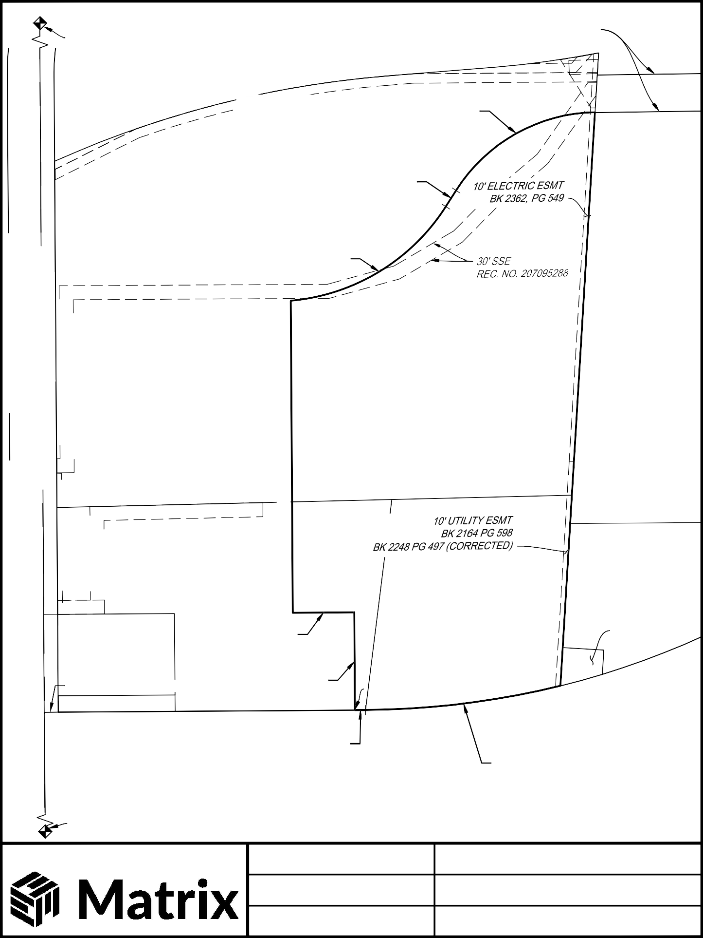
CHECKED BY: AA
FILE LOCATION: S:\24.1382.003 Peterson Road and Meadowbrook Parkway Overall Development\400 Survey\400 CADD\406 GRAPHICS\1382-Lot 1-GR.dwg
DATE: 07/13/2026
SHEET 3 OF 3

