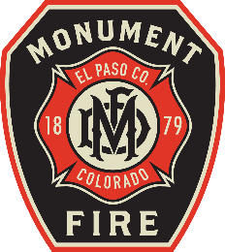
MONUMENT FIRE DISTRICT
19775 Mitchel Ave
Mitchell Ave
Monument, CO 80132
(719) 484-0911

www.monumentfire.org
Proudly serving the Tri-Lakes Region

Project
Project Name
4082 Pinehurst Circle Plat Note Waiver
File Number
WV261
Project Manager
Jen Uhler ( JenUhler@elpasoco.com )
(719) 520-7952
Applicant
Vertex Consulting Services, LLC

This review is based on the 2021 International Fire Code (IFC), as adopted and amended by Monument Fire District, including all applicable policies and standards. This review is limited to fire and life safety considerations and does not constitute approval of structural, electrical, plumbing, or other disciplines. Monument Fire District has the following comments:

There are no comments pertinent to this project.

Thank you for your submittal

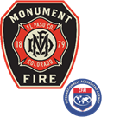 | Scott Benson  Deputy Fire Marshal  19775 Mitchell Avenue  Monument, CO 80132  O (719)484-0911  M (970)445-8748  Proudly serving the Tri-Lakes Region  Monument Fire District serves and safeguards our community every day, every call, everybody

