Early Assistance Meeting Number:
Project Name:
Project Location:
Project Parcel Nos.
Project Description:
Meeting Date:

El Paso County Planning & Community Development Planning Checklist

Request – Map Provided by Applicant
Potential rezone – zoning district not specified – may need commercial or residential designation

Zoning
Existing Zone(s)
Zone |  | Name
I-3
Proposed Zone(s)
Zone |  | Name
?

Zoning Analysis
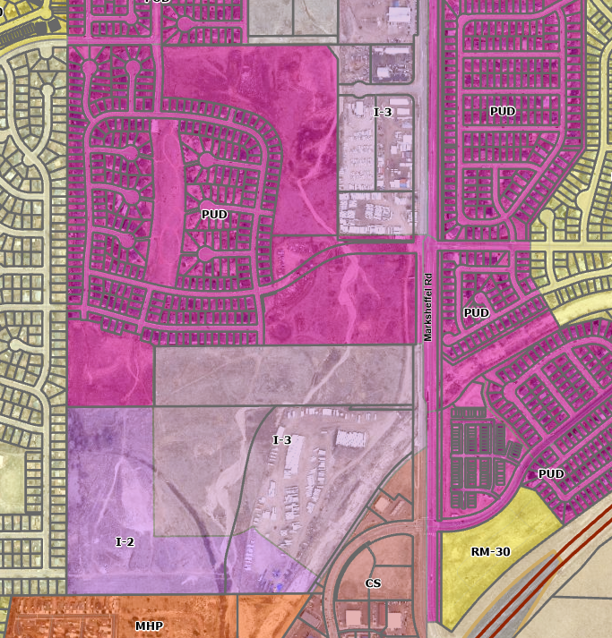

Zoning District Requirements (density, lot size, lot design standards, building setbacks)

Plat Map or Parcel Map (conditions of approval):

Application Type(s) Hearing: Required/ Optional/ No
Rezone?
Subdivision?
Site Development Plan?

Approval Criteria:
Rezone Sec. 5.3.5
• The application is in general conformance with the El Paso County Master Plan including applicable Small Area Plans or there has been a substantial change in the character of the neighborhood since the land was last zoned;
• The rezoning is in compliance with all applicable statutory provisions, including but not limited to C.R.S. § 30-28-111 § 30-28-113, and § 30-28-116;
• The proposed land use or zone district is compatible with the existing and permitted land uses and zone districts in all directions; and
• The site is suitable for the intended use, including the ability to meet the standards as described in Chapter 5 of the Land Development Code, for the intended zone district.

Preliminary Plan Sec. 7.2.1.D.2
• The proposed subdivision is in general conformance with the goals, objectives, and policies of the Master Plan;
• The subdivision is consistent with the purposes of this Code;
• The subdivision is in conformance with the subdivision design standards and any approved sketch plan;
• A sufficient water supply has been acquired in terms of quantity, quality, and dependability for the type of subdivision proposed, as determined in accordance with the standards set forth in the water supply standards [C.R.S. § 30-28-133(6)(a)] and the requirements of Chapter 8 of this Code (this finding may not be deferred to final plat if the applicant intends to seek administrative final plat approval);
• A public sewage disposal system has been established and, if other methods of sewage disposal are proposed, the system complies with state and local laws and regulations, [C.R.S. § 30-28-133(6) (b)] and the requirements of Chapter 8 of this Code;
• All areas of the proposed subdivision, which may involve soil or topographical conditions presenting hazards or requiring special precautions, have been identified and the proposed subdivision is compatible with such conditions. [C.R.S. § 30-28-133(6)(c)];
• Adequate drainage improvements complying with State law [C.R.S. § 30-28-133(3)(c)(VIII)] and the requirements of this Code and the ECM are provided by the design;
• The location and design of the public improvements proposed in connection with the subdivision are adequate to serve the needs and mitigate the effects of the development;
• Legal and physical access is or will be provided to all parcels by public rights-of-way or recorded easement, acceptable to the County in compliance with this Code and the ECM;
• The proposed subdivision has established an adequate level of compatibility by (1) incorporating natural physical features into the design and providing sufficient open spaces considering the type and intensity of the subdivision; (2) incorporating site planning techniques to foster the implementation of the County's plans, and encourage a land use pattern to support a balanced transportation system, including auto, bike and pedestrian traffic, public or mass transit if appropriate, and the cost effective delivery of other services consistent with adopted plans, policies and regulations of the County; (3) incorporating physical design features in the subdivision to provide a transition between the subdivision and adjacent land uses; (4) incorporating identified environmentally sensitive areas, including but not limited to, wetlands and wildlife corridors, into the design; and (5) incorporating public facilities or infrastructure, or provisions therefore, reasonably related to the proposed subdivision so the proposed subdivision will not negatively impact the levels of service of County services and facilities;
• Necessary services, including police and fire protection, recreation, utilities, open space and transportation system, are or will be available to serve the proposed subdivision;
• The subdivision provides evidence to show that the proposed methods for fire protection comply with Chapter 6 of this Code; and
• The proposed subdivision meets other applicable sections of Chapter 6 and 8 of this Code.

Final Plat Sec. 7.2.1.D.3
• The subdivision is in conformance with the goals, objectives, and policies of the Master Plan;
• The subdivision is in substantial conformance with the approved preliminary plan;
• The subdivision is consistent with the subdivision design standards and regulations and meets all planning, engineering, and surveying requirements of the County for maps, data, surveys, analyses, studies, reports, plans, designs, documents, and other supporting materials;
• Either a sufficient water supply has been acquired in terms of quantity, quality, and dependability for the type of subdivision proposed, as determined in accordance with the standards set forth in the water supply standards [C.R.S. § 30-28-133(6)(a)] and the requirements of Chapter 8 of this Code, or, with respect to applications for administrative final plat approval, such finding was previously made by the BoCC at the time of preliminary plan approval;
• A public sewage disposal system has been established and, if other methods of sewage disposal are proposed, the system complies with State and local laws and regulations, [C.R.S. § 30-28-133(6)(b)] and the requirements of Chapter 8 of this Code;
• All areas of the proposed subdivision which may involve soil or topographical conditions presenting hazards or requiring special precautions have been identified and that the proposed subdivision is compatible with such conditions [C.R.S. § 30-28-133(6)(c)];
• Adequate drainage improvements are proposed that comply with State Statute [C.R.S. § 30-28-133(3)(c)(VIII)] and the requirements of this Code and the ECM;
• Legal and physical access is provided to all parcels by public rights-of-way or recorded easement, acceptable to the County in compliance with this Code and the ECM;
• Necessary services, including police and fire protection, recreation, utilities, and transportation systems, are or will be made available to serve the proposed subdivision;
• The final plans provide evidence to show that the proposed methods for fire protection comply with Chapter 6 of this Code;
• Off-site impacts were evaluated and related off-site improvements are roughly proportional and will mitigate the impacts of the subdivision in accordance with applicable requirements of Chapter 8;
• Adequate public facilities or infrastructure, or cash-in-lieu, for impacts reasonably related to the proposed subdivision have been constructed or are financially guaranteed through the SIA so the impacts of the subdivision will be adequately mitigated;
• The subdivision meets other applicable sections of Chapter 6 and 8; and
• The extraction of any known commercial mining deposit shall not be impeded by this subdivision [C.R.S. §§ 34-1-302(1), et seq.]

Processing Issues and Options
For adjacent developments to connect to Rowley property, sec. 8.4.1.E:
Continuation of Roads and Other Linear Facilities. Divisions of land shall be designed to accommodate the continuation of roads, trails, pedestrian access, utilities and drainage facilities into adjacent property unless there is sufficient justification for an alternative design. The connection shall provide a logical, safe and convenient circulation link for vehicular, bicycle, pedestrian, or equestrian traffic with existing or planned circulation routes and, in particular, to destinations such as schools, parks and business or commercial centers.

Relevant Past History:
ADM2236 – determination of lot legality and stormwater issues
EA2233 – meeting with County staff regarding code enforcement

Design and Landscaping

Site Design/Layout (Lot pattern, circulation/road design, open space, preservation of natural features, compatibility internally and with adjacent land uses)

Landscaping
☐ | Expressway, Principal arterial area depth – 25’-Trees required 1 per 20’
☐ | Urban interchange/Intersection area depth – 25’- N/A
☐ | Minor arterial area depth 20’ – Trees required 1 per 25’
☐ | Non-arterial area depth 10’ – Trees required 1 per 30’
☐ | Parking lot landscaping required
☐ | Buffer between non-residential and residential districts separated by a non-arterial road or public alley

Signage:

Parking Requirements:

Lighting:
Photometric Plan Required | ☐

Site Characteristics\ Constraints\ Environmental Standards:
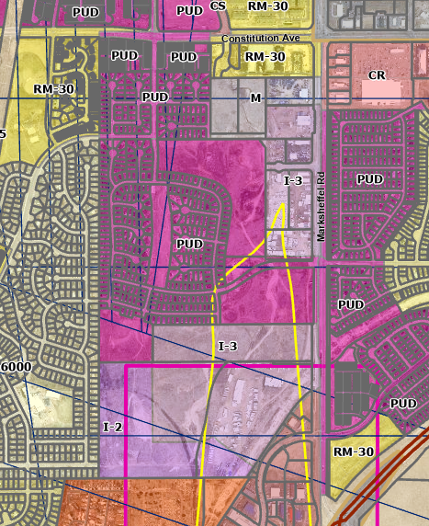
Property located in APZ-2 (pink line) and ADNL (yellow line) subzone.

ADNL Rezoning. Land should not be rezoned to a residential or multifamily district which allows a higher density than the current zoning of the property. In the event of a rezoning or variance action to allow a residential zoning with a higher density than the current zoning of the property, the BoCC shall include specific findings relative to airport noise within the approval resolution and shall require appropriate noise mitigation measures.

☐ | 30% or greater slope | Topography:
☐ | CGS review required (separate fee to CGS) | Soils/geology:
☒ | Floodplain | Floodplain comment: |  |  | LOMR
☒ | Noise mitigation required | Noise comment: |  |  |  | If residential proposed in ADNL
☐ | Preble’s mouse

Districts
Taxing Entities – North Property
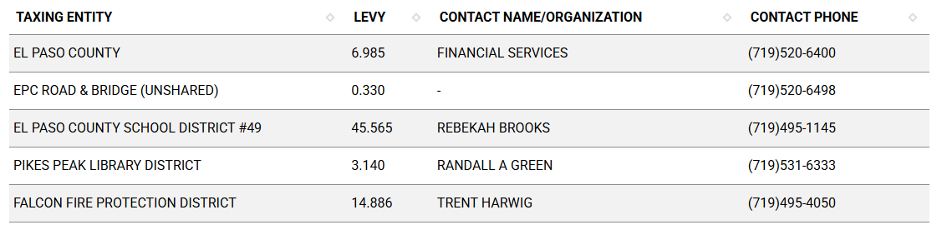

Taxing Entities – South Property
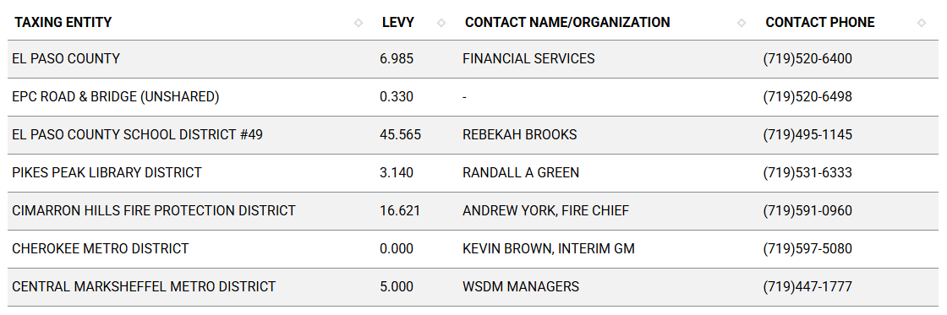

Proposed source of water |  |  | Proposed method of wastewater disposal
☐ | Central System |  | ☐ | Central System
District Name: |  |  | District Name:

Water/wastewater comments

Fire District:

Wildland Fire and Hazard Mitigation Plan:

Road Impact Fee Program (PID Inclusion):

Your El Paso Master Plan

Placetype:
North Property
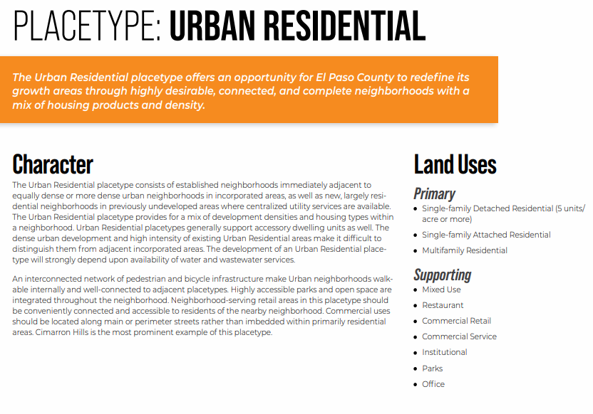
South Property
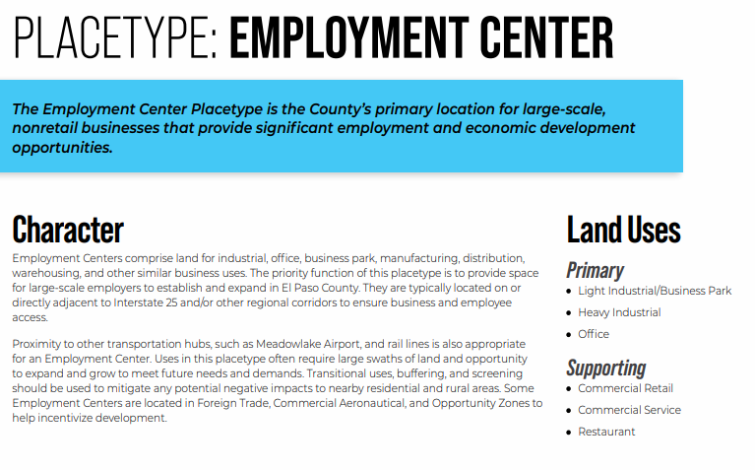

Area of Change Designation:
Description:
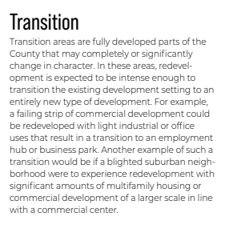

Key Area:
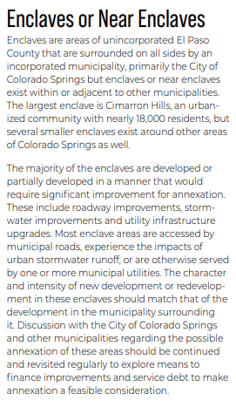
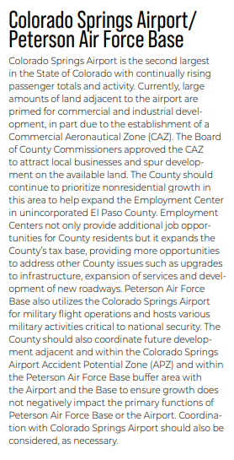

Parks Master Plan:
El Paso County Parks Department:

The El Paso County Parks Department has reviewed this rezone proposal for the Early Assistance meeting and has no objections to the rezoning of these parcels of land. The subject parcels show they are zoned I-3, which is an industrial zoning district. While it is unknown what the proposed zoning districts will be for the parcels of land tied to this EA meeting, the 2022 Parks Master Plan shows no impacts to existing or proposed parks, trails, or open space. Regional park fees will be assessed upon review of the forthcoming preliminary plans and final plat(s).

It is not necessary for EPC Parks staff to attend this early assistance meeting.

Helpful Links

Planning Website: https://planningdevelopment.elpasoco.com/

El Paso County Master Plan: https://planningdevelopment.elpasoco.com/#1510603950097-f5d985dc-35b2
Parks, Mineral and Water Master Plan: https://planningdevelopment.elpasoco.com/resources-and-references/#1516982531779-52cc0e87-01af

Forms and Templates: https://planningdevelopment.elpasoco.com/planning-development-forms/#1510677560407-ff8cfff5-69b2716b-00f9cbba-0c21

Land Development Code: https://library.municode.com/co/el_paso_county/codes/land_development_code

EDARP: https://epcdevplanreview.com/

Public GIS: https://elpasoco.maps.arcgis.com/apps/View/index.html?appid=5be6431018594c67b035ad0aad3e7e8a

Wrap Up
-If subdivision is proposed, recording fees, park and school fees and road impact fees apply.
-Fees are subject to change. The fees at the time of application apply.
-Pursuant to the adopted El Paso County Road Impact Fee Program (Resolution No. 12-382), a transportation impact fee, calculated on a per trip basis, may be due at the time of building permit issuance. Starting January 1, 2020 the transportation impact fee will be due for all new construction (Resolution No. 19-471).
-The fee for any additional waiver/deviation requests (more than two) - $550.00 each. Please note that requests for waivers and/or deviations may result in additional processing/review delay.
-All items requested must accompany the submittal for it to be complete, prior to payment request or the submittal will not be complete and ready for review agencies.
-A temporary use permit shall be applied for and approved for any staging area associated with development, such as a sales office, construction trailer, or contractor's equipment yard, prior to scheduling of the pre-construction meeting with El Paso County Planning and Community Development. If a Planned Unit Development is proposed, the temporary staging area should be shown on the development guideline and phasing plan.
-All prospective timelines for review are subject to departmental staffing and workload.
-Early Assistance is valid for 12 months from submittal of the EA application. If a project submittal is not received within 12 months, a new EA meeting may be required. An audio/video copy of the meeting is available in EDARP within the EA folder.

- Applications scheduled for public hearings may be heard as a regular item at the request of staff or a hearing body member.

- Any comments or commitments made by any member of the County Staff during this early assistance meeting are only preliminary in nature and should not be relied upon by the applicant. All prospective applicants should be informed that formal comments cannot be made by staff until after the application is submitted.

