Early Assistance Meeting Number: EA2586
Project Name: Rowley Property
Project Location: Mark Sheffel and Future Co Tech Dr
Project Parcel Nos. 5405000033 5405000049 5405000050 5405000055 5405001004
Project Description: Sketch Plan Mixed use
Meeting Date: Wednesday 5th 3pm

El Paso County Planning & Community Development Planning Checklist

Request – Map Provided by Applicant
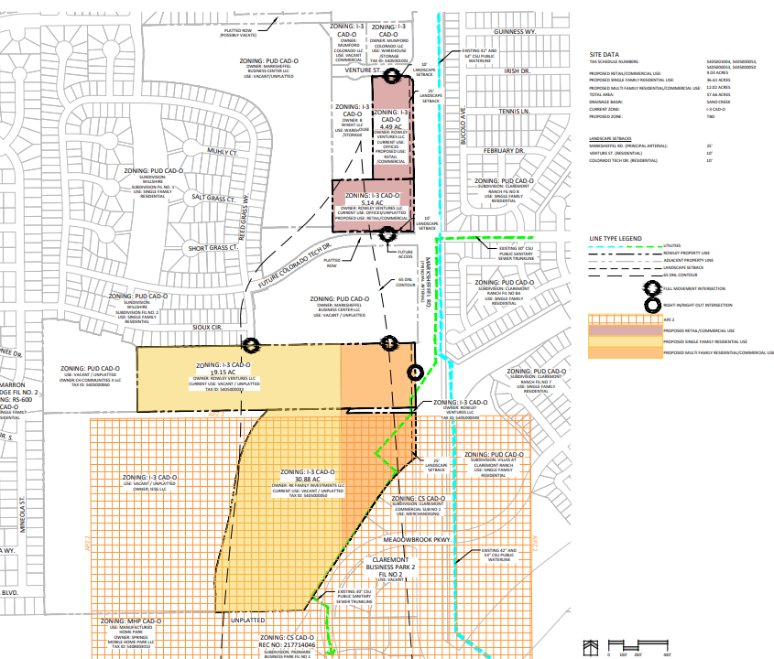

Zoning
Existing Zone(s)
Zone |  | Name
I-3
Proposed Zone(s)
Zone |  | Name
Commercial and Residential SF and MF |  | CS or CR and RS5000 and RM30

Zoning Analysis

Single-family west of channel matches single-family. Industrial uses adjacent to Marksheffel, south of Co Tech is likely if appropriate buffers are incorporated from to the west and north. Access may be isolated and not run through internal neighborhoods. Multi-family and or commercial mixed-use north of Co. Tech Drive would be anticipated to provide a transition from the residential properties to the west and further to the east. PUD is not necessary conventional zoning options allow for mixed-use developments.
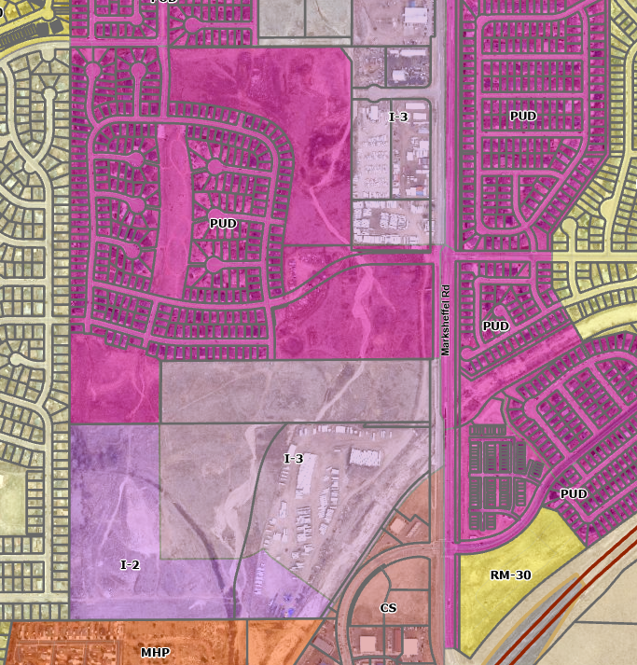
City controls Marksheffel Road Access

Zoning District Requirements (density, lot size, lot design standards, building setbacks)
Current setbacks:
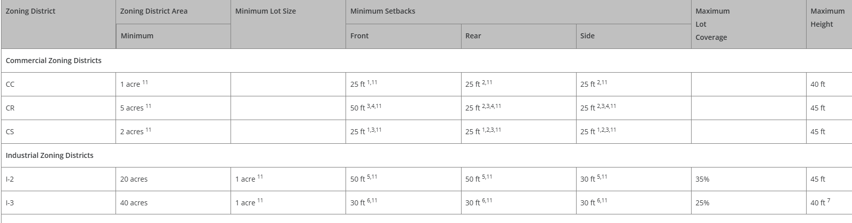
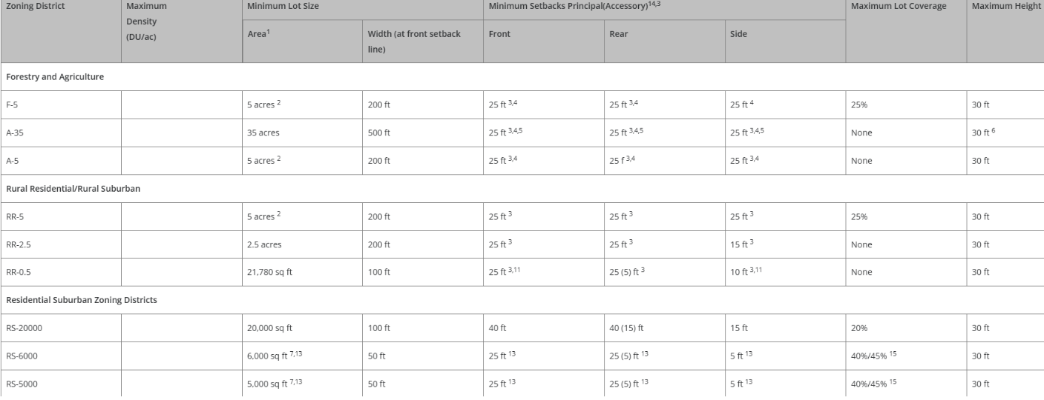

Plat Map or Parcel Map (conditions of approval):
N/A

Application Type(s) Hearing: Required/ Optional/ No
Sketch Plan & Special District & Rezone | YES
Subdivision | Yes

Approval Criteria:
Sketch Plan 7.2.1
(c)Criteria for Approval. In approving a sketch plan, the BoCC shall find that:
• The proposed subdivision is in general conformance with the goals, objectives, and policies of the Master Plan;
• The proposed subdivision is in conformance with the requirements of this Code;
• The proposed subdivision is compatible with existing and proposed land uses within and adjacent to the sketch plan area;
• The water supply report provides sufficient information to identify probable compliance with the water supply standards and identifies any need for additional water supplies;
• Services are or will be available to meet the needs of the subdivision including, roads, police and fire protection, schools, recreation facilities, and utility service facilities;
• The soil is suitable for the subdivision;
• The geologic hazards do not prohibit the subdivision, or can be mitigated;
• The subdivision will not interfere with the extraction of any known commercial mining deposit [C.R.S. §§ 34-1-302(1), et seq.];
• The design of the subdivision protects the natural resources or unique landforms;
• The proposed methods for fire protection are adequate to serve the subdivision; and
• The subdivision is appropriate and the design is based on mitigating the constraints of topography, soil types, geologic hazards, aggregate resources, environmental resources, floodplain, airplane flight overlays, or other constraints.

Rezone Sec. 5.3.5
• The application is in general conformance with the El Paso County Master Plan including applicable Small Area Plans or there has been a substantial change in the character of the neighborhood since the land was last zoned;
• The rezoning is in compliance with all applicable statutory provisions, including but not limited to C.R.S. § 30-28-111 § 30-28-113, and § 30-28-116;
• The proposed land use or zone district is compatible with the existing and permitted land uses and zone districts in all directions; and
• The site is suitable for the intended use, including the ability to meet the standards as described in Chapter 5 of the Land Development Code, for the intended zone district.

Preliminary Plan Sec. 7.2.1.D.2
• The proposed subdivision is in general conformance with the goals, objectives, and policies of the Master Plan;
• The subdivision is consistent with the purposes of this Code;
• The subdivision is in conformance with the subdivision design standards and any approved sketch plan;
• A sufficient water supply has been acquired in terms of quantity, quality, and dependability for the type of subdivision proposed, as determined in accordance with the standards set forth in the water supply standards [C.R.S. § 30-28-133(6)(a)] and the requirements of Chapter 8 of this Code (this finding may not be deferred to final plat if the applicant intends to seek administrative final plat approval);
• A public sewage disposal system has been established and, if other methods of sewage disposal are proposed, the system complies with state and local laws and regulations, [C.R.S. § 30-28-133(6) (b)] and the requirements of Chapter 8 of this Code;
• All areas of the proposed subdivision, which may involve soil or topographical conditions presenting hazards or requiring special precautions, have been identified and the proposed subdivision is compatible with such conditions. [C.R.S. § 30-28-133(6)(c)];
• Adequate drainage improvements complying with State law [C.R.S. § 30-28-133(3)(c)(VIII)] and the requirements of this Code and the ECM are provided by the design;
• The location and design of the public improvements proposed in connection with the subdivision are adequate to serve the needs and mitigate the effects of the development;
• Legal and physical access is or will be provided to all parcels by public rights-of-way or recorded easement, acceptable to the County in compliance with this Code and the ECM;
• The proposed subdivision has established an adequate level of compatibility by (1) incorporating natural physical features into the design and providing sufficient open spaces considering the type and intensity of the subdivision; (2) incorporating site planning techniques to foster the implementation of the County's plans, and encourage a land use pattern to support a balanced transportation system, including auto, bike and pedestrian traffic, public or mass transit if appropriate, and the cost effective delivery of other services consistent with adopted plans, policies and regulations of the County; (3) incorporating physical design features in the subdivision to provide a transition between the subdivision and adjacent land uses; (4) incorporating identified environmentally sensitive areas, including but not limited to, wetlands and wildlife corridors, into the design; and (5) incorporating public facilities or infrastructure, or provisions therefore, reasonably related to the proposed subdivision so the proposed subdivision will not negatively impact the levels of service of County services and facilities;
• Necessary services, including police and fire protection, recreation, utilities, open space and transportation system, are or will be available to serve the proposed subdivision;
• The subdivision provides evidence to show that the proposed methods for fire protection comply with Chapter 6 of this Code; and
• The proposed subdivision meets other applicable sections of Chapter 6 and 8 of this Code.

Final Plat Sec. 7.2.1.D.3
• The subdivision is in conformance with the goals, objectives, and policies of the Master Plan;
• The subdivision is in substantial conformance with the approved preliminary plan;
• The subdivision is consistent with the subdivision design standards and regulations and meets all planning, engineering, and surveying requirements of the County for maps, data, surveys, analyses, studies, reports, plans, designs, documents, and other supporting materials;
• Either a sufficient water supply has been acquired in terms of quantity, quality, and dependability for the type of subdivision proposed, as determined in accordance with the standards set forth in the water supply standards [C.R.S. § 30-28-133(6)(a)] and the requirements of Chapter 8 of this Code, or, with respect to applications for administrative final plat approval, such finding was previously made by the BoCC at the time of preliminary plan approval;
• A public sewage disposal system has been established and, if other methods of sewage disposal are proposed, the system complies with State and local laws and regulations, [C.R.S. § 30-28-133(6)(b)] and the requirements of Chapter 8 of this Code;
• All areas of the proposed subdivision which may involve soil or topographical conditions presenting hazards or requiring special precautions have been identified and that the proposed subdivision is compatible with such conditions [C.R.S. § 30-28-133(6)(c)];
• Adequate drainage improvements are proposed that comply with State Statute [C.R.S. § 30-28-133(3)(c)(VIII)] and the requirements of this Code and the ECM;
• Legal and physical access is provided to all parcels by public rights-of-way or recorded easement, acceptable to the County in compliance with this Code and the ECM;
• Necessary services, including police and fire protection, recreation, utilities, and transportation systems, are or will be made available to serve the proposed subdivision;
• The final plans provide evidence to show that the proposed methods for fire protection comply with Chapter 6 of this Code;
• Off-site impacts were evaluated and related off-site improvements are roughly proportional and will mitigate the impacts of the subdivision in accordance with applicable requirements of Chapter 8;
• Adequate public facilities or infrastructure, or cash-in-lieu, for impacts reasonably related to the proposed subdivision have been constructed or are financially guaranteed through the SIA so the impacts of the subdivision will be adequately mitigated;
• The subdivision meets other applicable sections of Chapter 6 and 8; and
• The extraction of any known commercial mining deposit shall not be impeded by this subdivision [C.R.S. §§ 34-1-302(1), et seq.]

Processing Issues and Options
For adjacent developments to connect to Rowley property, sec. 8.4.1.E:
Continuation of Roads and Other Linear Facilities. Divisions of land shall be designed to accommodate the continuation of roads, trails, pedestrian access, utilities and drainage facilities into adjacent property unless there is sufficient justification for an alternative design. The connection shall provide a logical, safe and convenient circulation link for vehicular, bicycle, pedestrian, or equestrian traffic with existing or planned circulation routes and, in particular, to destinations such as schools, parks and business or commercial centers.

Sketch Plan must be approved prior to Special District being sdcheduled for PC

CS Airport Advisory Board will review application

Relevant Past History:
ADM2236 – determination of lot legality and stormwater issues
EA2233 – meeting with County staff regarding code enforcement

Design and Landscaping

Site Design/Layout (Lot pattern, circulation/road design, open space, preservation of natural features, compatibility internally and with adjacent land uses)
8.4.1. Planning Considerations
The following planning considerations shall be adhered to when dividing land:
(A)Land Found Unsuitable for Development. Land unsuitable for development due to physical constraints shall not be divided unless methods authorized by this Code are used to mitigate the problems created by the unsuitable land conditions.
(B)Safe for the Intended Purpose. Land shall be divided in a manner that allows it to be used safely for the intended purpose without danger to the public health, safety or welfare or peril from fire, flood, geologic hazards or constraints, or other hazards. Building sites shall not be located in areas subject to geologic hazards or constraints as determined by the CGS or a Geologic Report unless such hazard or constraint has been appropriately mitigated as determined by the PCD Director; or in a 100-year floodplain unless in compliance with the Floodplain Regulations.
(C)Topography to be Considered. Consideration shall be given to topography. Building sites shall not be located on land with a slope of 30% or greater.
(D)Planning Required for Remainder Parcels. A remainder parcel shall be at least 35 acres, platted as a tract, identified as a future phase consistent with the preliminary plan, or exempted in accordance with Chapter 7. A remainder parcel is not eligible for use or building permits unless specifically approved by BoCC action.
(E)Continuation of Roads and Other Linear Facilities. Divisions of land shall be designed to accommodate the continuation of roads, trails, pedestrian access, utilities and drainage facilities into adjacent property unless there is sufficient justification for an alternative design. The connection shall provide a logical, safe and convenient circulation link for vehicular, bicycle, pedestrian, or equestrian traffic with existing or planned circulation routes and, in particular, to destinations such as schools, parks and business or commercial centers.
(F)Lot Layout, Design and Configuration. Divisions of land shall be designed to provide for lots that are of an appropriate size and configuration for the site characteristics and intended uses; adequate buffering from the adverse impacts of adjoining uses through lot orientation, setbacks, landscaping or other appropriate methods; conservation of water, land and energy resources; conveniently located recreation facilities within the development; minimal grading, road cuts and fills; and a road system designed to preserve the integrity and function of the arterial and local roadway network. Lots shall have reasonable access to open space, trails, park land or recreation facilities that are set aside for either homeowner use or use by the general public.
(G)Preservation of Natural Landscape. The primary importance of the preservation and enhancement of the natural landscape and vegetation shall be considered. The layout and design of lots, blocks, and rights-of-way shall provide desirable settings for structures by making use of natural features, unique or distinctive topographic features including buttes and rock outcroppings; existing vegetation; drainage; riparian and wetland areas; significant wildlife habitats; identified aquifer recharge areas; and aesthetic features. Alteration of features shall be kept to a minimum and shall be based on practical engineering considerations.
(H)Preservation of Historical and Archaeological Sites. Alterations of historical or archaeological sites shall be avoided. Emphasis should be placed on reuse of historical structures and incorporation of historical and archaeological sites into the park and open space system. If disturbance of sites is unavoidable, the applicable public agency shall be provided the opportunity to excavate, purchase, or record the site before alteration takes place.

Landscaping
☒ | Expressway, Principal arterial area depth – 25’-Trees required 1 per 20’
☒ | Urban interchange/Intersection area depth – 25’- N/A
☒ | Minor arterial area depth 20’ – Trees required 1 per 25’
☒ | Non-arterial area depth 10’ – Trees required 1 per 30’
☒ | Parking lot landscaping required
☒ | Buffer between non-residential and residential districts separated by a non-arterial road or public alley

Depict perimeter buffers and land use buffers on SKP; depict trails OS max densities max units and land uses Utility pieces, substation, lift pump stations.

Signage:
Master Sign Plan may be submitted at Prelim Plan

Parking Requirements:
6.2.5. Parking, Loading and Maneuvering Standards

Lighting:
6.2.3. Lighting- depict street lighting on CDS and on site dev plans as well as preliminary plans
Photometric Plan Required | ☒

Site Characteristics\ Constraints\ Environmental Standards: Work with USACE for channel or wetland disturbance
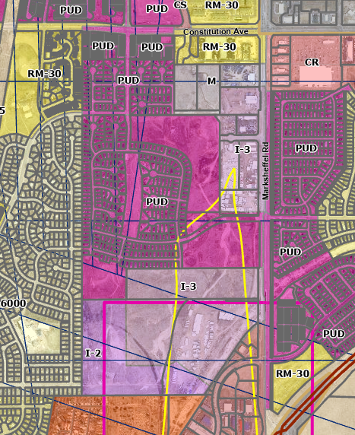
Property located in APZ-2 (pink line) and ADNL (yellow line) subzone.
F7460 height analysis impact thru FAA- applicant put in coordinates and height for Part 77.
Based on elevation data and distance to runway, the applicant will need to file Federal Aviation Administration (FAA) Form 7460-1 “Notice of Proposed Construction or Alteration” for any new vertical development at this site, including temporary construction equipment, and provide FAA documentation to the Airport before the commencement of construction activities; FAA’s website (https://oeaaa.faa.gov/oeaaa/external/portal.jsp).

ADNL Rezoning. Land should not be rezoned to a residential or multifamily district which allows a higher density than the current zoning of the property. In the event of a rezoning or variance action to allow a residential zoning with a higher density than the current zoning of the property, the BoCC shall include specific findings relative to airport noise within the approval resolution and shall require appropriate noise mitigation measures.

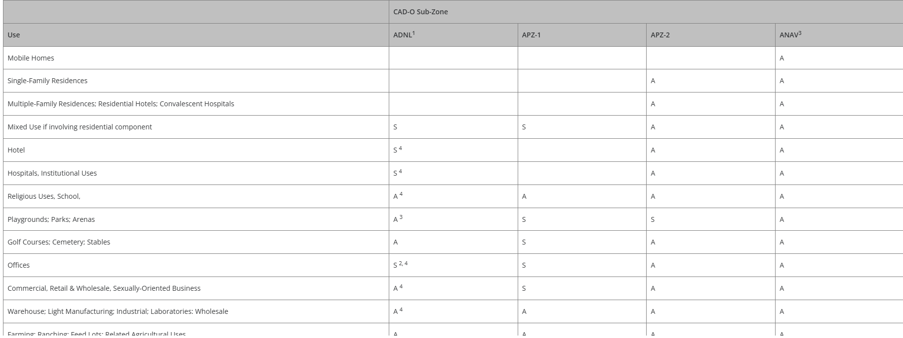

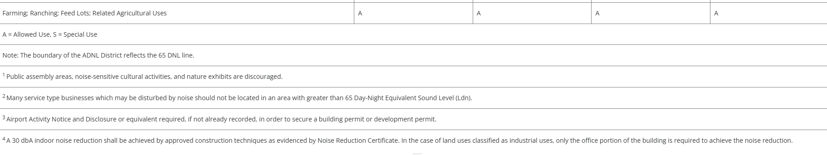

☐ | 30% or greater slope | Topography:
☒ | CGS review required (separate fee to CGS) | Soils/geology: |  | 8.4.9 of Code
☒ | Floodplain | Floodplain comment: |  |  | LOMR  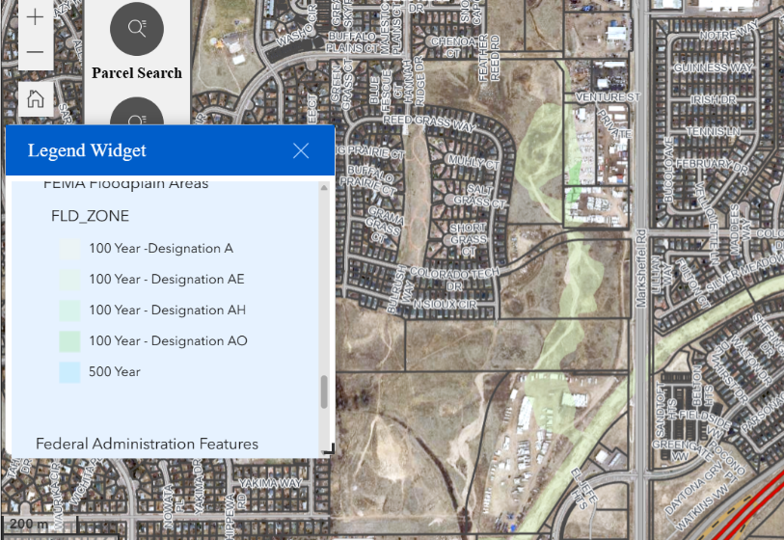
☒ | Noise mitigation required | Noise comment: |  |  |  | If residential or mixed use proposed in ADNL; do recommend using City’s latest airport study and a memo from local noise engineer for whole development to meet criteria for SKP
☐ | Preble’s mouse  Environmental no concerns – Nancy P. | 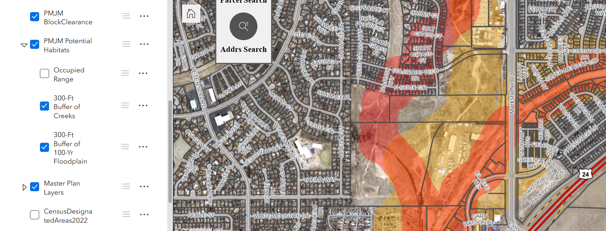

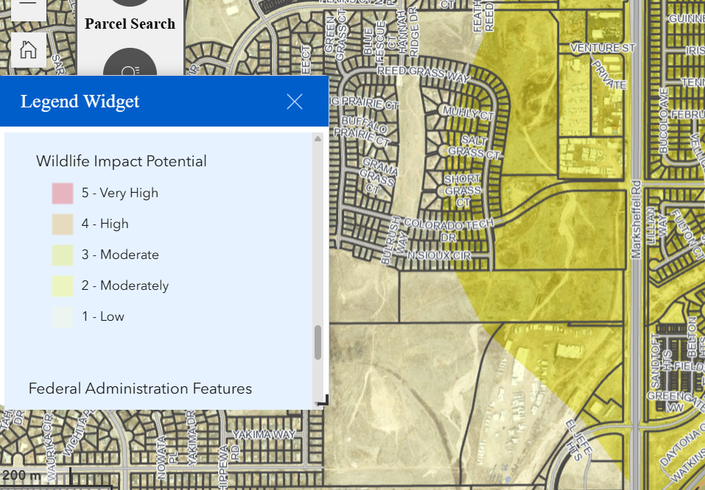

Districts
Taxing Entities – North Property
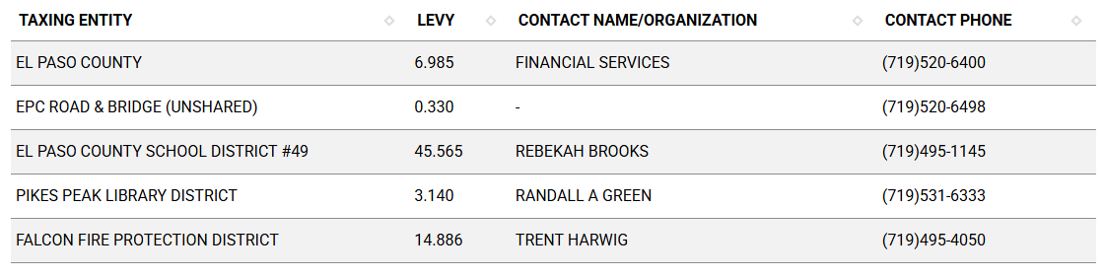

Taxing Entities – South Property
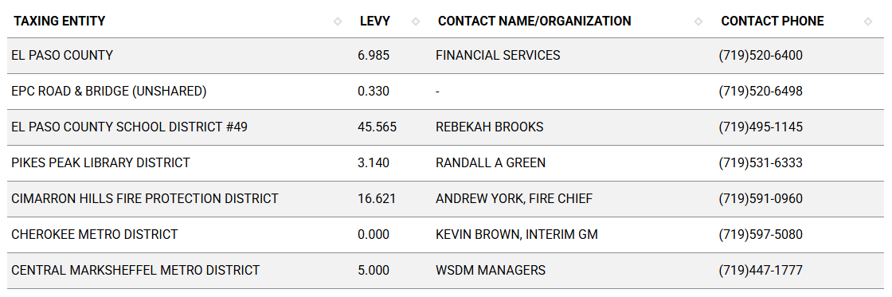

Proposed source of water |  |  | Proposed method of wastewater disposal
☒ | Central System |  | ☒ | Central System
District Name: |  | Cherokee | District Name: |  | Cherokee

Water/wastewater comments
(B)
Water Resource Report.
(1)
General.
(a)
Purpose. The purpose of the water resources report is to provide the data necessary for the Planning Commission and the BoCC to determine whether the proposed water supply is sufficient in terms of quality, quantity and dependability for the proposed subdivision.
(b)
Water Resources Report Required. A water resources report as required by this Section shall be submitted with sketch plan, preliminary plan, final plat, and any subdivision applications which will create a new lot. A copy of the report will be kept on file in the El Paso County PCD.
(c)
Prepared by Qualified Professional. The water resources report shall be prepared by a qualified hydrogeologist, hydrologist, licensed civil engineer, qualified groundwater geologist, or other qualified professional with appropriate experience.
(d)
Document Adequate Water Supply. The Water Resources Report shall include adequate documentation that the proposed water supply is sufficient in terms of quantity, dependability, and quality for the proposed subdivision.
(e)
Enforcement. In addition to any other remedies provided by law or this Code, the BoCC shall have the right to enforce compliance with the provisions of this Section, including any agreement provided pursuant to this Section, by means of withholding building permits within the subject subdivision or withholding plat approvals for additional development phases within the subject subdivision pending full compliance or other resolution.
(2)
Description Report Contents and When Required.
(a)
Sketch Plan Report. The initial water resource report submitted with the sketch plan may be of a general nature, may be based on published and unpublished data and reports, and need not include site-specific hydrogeologic data. The purpose of the report included with the sketch plan is to identify probable compliance of the proposed subdivision with the water supply standards and to identify the need for additional water supplies which will be required for the subdivision.

8.4.8. Wastewater Disposal

(A)General.
(1)Purpose. The purpose of this Section is to establish the wastewater disposal provisions at the sketch plan or preliminary plan stage of subdivision development and ensure conformance of wastewater disposal with this Code at the time of approval of the final plat.
guaranteed by the wastewater provider or which are not the responsibility of the wastewater provider shall be included in the construction surety estimate required by the ECM and this Code.(E)Report Requirements.
(1)General.
(a)Wastewater Disposal Report Required. All sketch plans, preliminary plans, and final plats submitted for review shall be accompanied with a wastewater disposal report. The requirements of the preliminary plan report shall not be deferred or postponed until the final plat application.
(a)Sketch Plan Report. The following information shall be included in the wastewater report submitted with the sketch plan application:
• Map showing relative location of point of connection to an existing system;

• Map showing relative location of the existing or proposed treatment facility;

• Estimate of projected population, units, and density, as related to wastewater production on an average daily basis;

• Capacity of the existing treatment plant and current utilization;

• Anticipated capacity of any proposed treatment plant; and

• Letter of commitment from the wastewater provider proposed for service, with identification of whether the sketch plan area is within the service boundaries of the proposed provider.

Fire District:
Falcon Fire, Lt Kauffman, fire marshal, ckauffman@falconfirepd.org

A fire protection report will be required for any subdivision application.

Wildland Fire and Hazard Mitigation Plan:
This project is not currently in a wildfire area and will not be in a wildfire area when the Colorado Wildfire Resiliency Code is adopted.
MF does require sprinkled systems.

Preliminary Fire Protection Report in LOI ok for Sketch Plan. Hydrants Cherokee MD.

Road Impact Fee Program (PID Inclusion):
Will be subject to fee

Your El Paso Master Plan

Placetype:
North Property
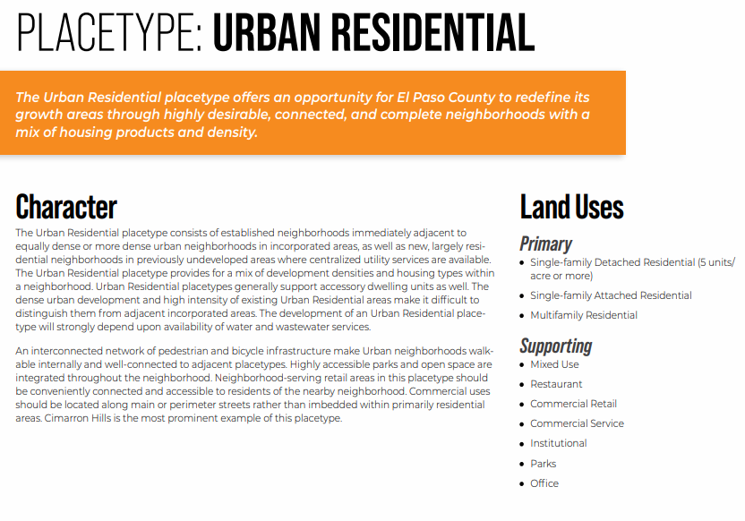
South Property


Area of Change Designation:
Description:
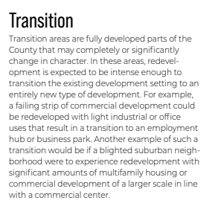

Key Area:
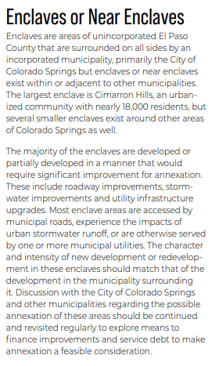
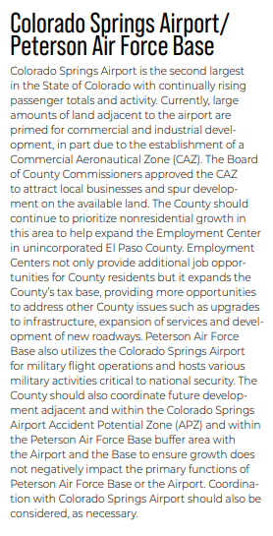

Parks Master Plan:
El Paso County Parks Department: Strongly encourages neighborhood parks for residential development- Park will apply a fee to commercial and industrial properties. No trails are depicted on the Master Plan for this area.
Applicant Pocket Park w/ PPA perhaps. Is adj. developer proposing a Park?

Helpful Links

Planning Website: https://planningdevelopment.elpasoco.com/

El Paso County Master Plan: https://planningdevelopment.elpasoco.com/#1510603950097-f5d985dc-35b2
Parks, Mineral and Water Master Plan: https://planningdevelopment.elpasoco.com/resources-and-references/#1516982531779-52cc0e87-01af

Forms and Templates: https://planningdevelopment.elpasoco.com/planning-development-forms/#1510677560407-ff8cfff5-69b2716b-00f9cbba-0c21

Land Development Code: https://library.municode.com/co/el_paso_county/codes/land_development_code

EDARP: https://epcdevplanreview.com/

Public GIS: https://elpasoco.maps.arcgis.com/apps/View/index.html?appid=5be6431018594c67b035ad0aad3e7e8a

Wrap Up
-If subdivision is proposed, recording fees, park and school fees and road impact fees may apply.

-Fees are subject to change. The fees at the time of application apply.

-Road Impact Fees
Please see the following website for information on the EPC Road Impact Fee Project. https://publicworks.elpasoco.com/road-impact-fees/ to include fee schedule.
As of December 15, 2016, per Resolution 16-454, on and after January 1, 2020, property in the unincorporated area of the county that receives a Land Use Approval either in a public hearing or administratively, is subject to the payment of Road Impact Fees. After December 31, 2024, in accordance with BoCC Resolution 24-377 the fee is paid for new residential and non-residential uses and structures and expansions of non-residential uses and structures. Road Impact fees are typically paid at time of building permit. If no building permit is being obtained for a particular Land Use application, then Road Impact Fees must be paid at the time of Site Development Plan or Special Use approval. If there are questions about EPC Road Impact program or fees, please contact DPW Development Review Services and the Engineer of the Day.

- Engineering Criteria Manual (ECM) Deviations.
The fee for any additional ECM deviation requests (more than two per land use application) - $1483.00 each per current Fee Schedule. Please note ECM deviation requests may result in additional processing and project review time. ECM Deviations should be submitted prior to the initial Site Development Plan or Final Plat submittal to preclude changes having to be made to engineering plans and documents if the deviation is not approved. Submission of an ECM deviation request does not imply or guarantee that the deviation will be approved. An ECM Deviation form must be submitted to include complete exhibits and justification excluding cost with supporting engineering criteria. If there are questions about ECM Deviation requests, please contact DPW Development Review Services and the Engineer of the Day.

-The fee for any additional waiver/deviation requests (more than two) - $550.00 each. Please note that requests for waivers and/or deviations may result in additional processing/review delay.

-All items requested must accompany the submittal for it to be complete, prior to payment request or the submittal will not be complete and ready for review agencies.

-A temporary use permit shall be applied for and approved for any staging area associated with development, such as a sales office, construction trailer, or contractor's equipment yard, prior to scheduling of the pre-construction meeting with El Paso County Planning and Community Development. If a Planned Unit Development is proposed, the temporary staging area should be shown on the development guideline and phasing plan.

-All prospective timelines for review are subject to departmental staffing and workload.

-Early Assistance is valid for 12 months from submittal of the EA application. If a project submittal is not received within 12 months, a new EA meeting may be required. An audio/video copy of the meeting is available in EDARP within the EA folder.

- Applications scheduled for public hearings may be heard as a regular item at the request of staff or a hearing body member.

- Any comments or commitments made by any member of the County Staff during this early assistance meeting are only preliminary in nature and should not be relied upon by the applicant. All prospective applicants should be informed that formal comments cannot be made by staff until after the application is submitted.

