NOTICE OF PUBLIC HEARING

This notice provides options to access the Board of Adjustment public hearing on the following Quasi-Judicial land-use matter. The following item is scheduled for the Board of Adjustment (BOA) Public Hearing on Wednesday, January 24, 2024, beginning at 9:00 A.M. The BOA hearing will be held in the Second Floor Hearing Room of the Pikes Peak Regional Development Center located at 2880 International Circle, Colorado Springs. You may attend the public hearings in-person or remotely, following the procedures below.

BOA235 HOWSER
DIMENSIONAL VARIANCE
KNECHT LOT SIZE VARIANCE

A request by Jon Knecht for approval of a dimensional variance to allow a lot size of 1.05 acres where 35 acres is required in the A-35 (Agricultural) zoning district.

Type Of Hearing: Quasi-Judicial Planner: RyanHowser@elpasoco.com

Watch The Live Hearings Remotely
If you are interested in watching the hearing live, please go to https://cloud.castus.tv/vod/elpasoco/video at the scheduled time of the hearing. Any testimony or comments you wish to provide may be done in-person or by following the “Participate Remotely” procedures listed below.

Participate Remotely
If you would like to provide testimony on an item being heard by the Board of Adjustment remotely, please email PCDhearings@elpasoco.com with your name, your phone number, and the project’s file number/name. Include any documents you would like provided to the Board as part of the official record. When it’s time for public testimony on the item for which you’d like to testify, you will receive a phone call at the number you provided and will be brought into the meeting remotely to address the Board. NOTE: New exhibits are not permitted via email the day of the hearing. All exhibits must be emailed to PCDhearings@elpasoco.com no later than one day prior to the above listed hearing. Whether you are attending remotely or in-person, kindly note there is a three (3) minute time limit on public comments and/or presentations.

Please visit https://epcdevplanreview.com/Public/ProjectDetails/192336 view the Staff Report and all other documents related to this hearing item. This notice was mailed on: December 27, 2023.

Planning and Community Development
2880 International Cir. Suite 110
Colorado Springs, CO 80910

NOTICE OF PUBLIC HEARING


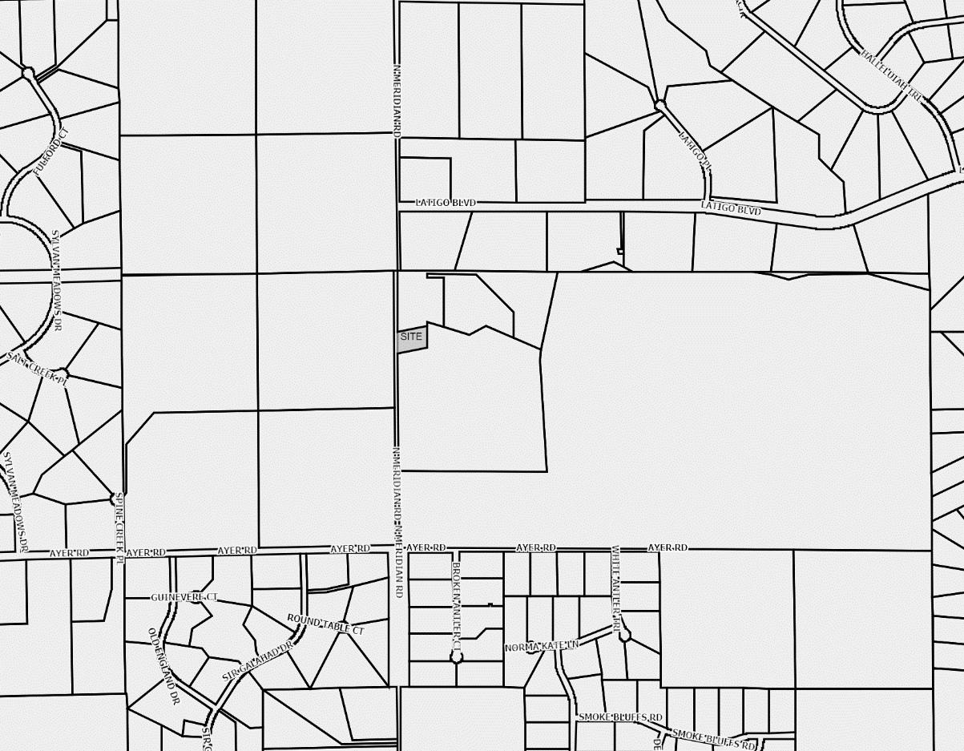
EL PASO COUNTY PARCEL INFORMATION

FILE NAME: BOA235
PARCEL: 4218000002
NAME: KNECHT JON
ADDRESS: 12375 N MERIDIAN RD

