BRADLEY POINT FILING No 1 - MINOR SUBDIVISION
Letter of Intent

APPLICANT /CONSULTANT INFORMATION:
OWNER (APPLICANT)
HIGHWAY85-87 PROPERTIES, LLC
2010 FOX MOUNTAIN POINT
COLORADO SPRINGS, CO 80906

ENGINEERING/SURVEYING
MS CIVIL CONSULTANTS
102 E. PIKES PEAK, 5TH FLOOR
COLORADO SPRINGS, CO 80903

PLANNING
KIMLEY-HORN & ASSOCIATES
2. NORTH NEVADA AVENUE, SUITE 300
COLORADO SPRINGS, CO 80903

SITE/BACKGROUND INFORMATION
Parcel ID No.: 6503400040 (4.61 AC) & 6503400038 (4.89 AC)
Combined Parcel Acreage: 9.5 AC
Zone District: M (Industrial)

SITE LOCATION: The 9.5-acre site is located north of the intersection formed by Highway 85/87 and South Academy Boulevard.
SITE DESCRIPTION: The site is currently zoned M (Industrial). The proposed uses of outside storage are permitted in this zone; therefore, no zone change is required or requested for the proposed use of the property. Topographically, the site is relatively flat, and drains from the north to the south. There are four Colorado Springs Utilities (CSU) easements that generally run along the northerly/southerly boundaries of the property that include: a 75 foot electric easement with existing overhead lines, a 20 foot sludge easement with underground transmission lines, a 10 foot sludge easement with underground lines, and a fiber easement that runs around the perimeter of the existing southern lot with previously removed underground lines and appurtenance. Constraints in the terms of the electric easement preclude placement of structures on the site and restrict the ability to plant trees that may, in the future, interfere with the existing electric lines.

There are two properties located west of this parcel. One is zoned CC, the other is used as right of way for CDOT. The land to the north is Zoned M and is used as a stockpile area as part of an aggregates processing facility and batch plant. The land immediately to the east is a BN&SF RR right-of-way approximately 100 feet in width. The railroad tracks are elevated above the subject site by approximately 5 feet. To the east of the BN&SF right-of-way is land zoned A-5 CAD O and is owned by Aggregate Industries. A sliver of land that forms the southeastern boundary of this site is owned by the railroad and is vacant. The property that forms the rest of the south border is zoned M, is owned by #9 Properties, LLC, and is part of property otherwise developed as a mini storage facility.

REQUEST
The owner/applicant requests approval of a two (2) lot “dry” minor subdivision to create legal zoning lots to initiate construction vehicle and heavy equipment storage yards on each future lot which will not use water or sewer services and a site development plan for improvements and uses on Lot 1. The Development plan for Lot 1 includes stormwater and access improvements for the entire subdivision (Lots 1 & 2)

Waiver Request #1: “Dry Subdivision”
A waiver is requested to Section 8.43.7A (2) Water Supply Standards regarding adequate water supply. A dry subdivision is requested for this project. Bottled water and a portable toilet will be provided for convenience use in the respective yards which will only be occupied during limited business hours. A water truck will be supplied for watering the proposed landscape trees and shrubs.

Section 8.4.7.A.3, Water Supply Standards, General, Exceptions, of the Land Development Code, excepts subdivisions from meeting the requirements of the Water Supply Standards which meet the following criteria:
- Subdivisions which will not use water; [and,]

- A proposed subdivision which, by reason of the nature, type and extent of the proposed development, will not require a water supply as prescribed herein. Subdivisions meeting this requirement are not designed or developed for permanent occupation or habitation. The determination shall be made by the BoCC, following recommendations by the OCA, PCD Director, or County Hydrogeologist, on a case-by-case basis, and shall be based on a specific request and supporting evidence presented by the applicant along with recommendations of the Planning Commission. If exempted by the BoCC, any subsequent change in the subdivision as approved may require compliance with this Section.

The proposed “dry” subdivision plat will include all required drainage and public utility easements. Should the property be developed in the future with uses which require water/wastewater services, the required easements will be available to facilitate placement of the required service lines. No uses requiring water/wastewater services may be conducted on the site unless an amended plat for a change in water supply has been approved by the El Paso County Board of County Commissioners. At that time, all groundwater decrees and determinations, together with all associated documents, plans, and necessary reports shall be submitted for review by the State Engineer’s Office, County Attorney’s Office, and County Department of Health which are necessary to review proposed water demand and supply and for the Board of County Commissioners to make the required findings of sufficiency.
Waiver Approval Criteria
- The waiver does not have the effect of nullifying the intent and purpose of this Code;
Dry Subdivision: The Dry Subdivision and associated waiver request is an adopted Code process which itself protects and promotes the intent and purpose of the Code by defining a process whereby qualifying subdivisions and uses may be legally established in conformance with the County subdivision/zoning ordinances.

- The waiver will not result in the need for additional subsequent waivers;
Dry Subdivision: No additional waivers are anticipated or needed to implement planned uses within the proposed “dry subdivision”.

- The granting of the waiver will not be detrimental to the public safety, health, or welfare or injurious to other property;
Dry Subdivision: Approval of the waiver will not be detrimental to the public health, safety, welfare, or have a negative impact to adjacent properties. All other requisite subdivision findings relating to the overall public impact have been satisfactorily met.
- The conditions upon which the request for a waiver is based are unique to the property for which the waiver is sought and are not applicable to other property;
Dry Subdivision: The overburden of utility easements on the property and the resulting diminished building area limit conventional development which generally requires a development footprint which encroaches into multiple easement restricted areas.

- A particular non-economical hardship to the owner would result from a strict application of this Code;
Dry Subdivision: Non-economic hardships include limitations to viable land uses which can be productive on the site amid easement restrictions impacting the narrow/irregularly shaped property.

- The waiver will not in any manner vary the zoning provisions of this Code; and
Dry Subdivision: No zoning provisions of the Code are varied by the “dry subdivision” waiver.

- The proposed waiver is not contrary to any provision of the Master Plan.
The proposed waivers are not contrary to any provision of the Master Plan.

WATER MASTER PLAN COMPLIANCE
The Bradley Point Filing No. 1 is consistent with the following goals and policies of the El Paso County Water Master Plan:
- Goal 6.0 – Require adequate water availability for proposed development.
- Policy 6.0.10 – Encourage land use proposals to expressly declare water source(s), quality, quantity, and sustainability in terms of years and number of single-family equivalents.
- Policy 6.0.11– Continue to limit urban level development to those areas served by centralized utilities
- Policy 6.0.1 – Continue to require documentation of the adequacy or sufficiency of water, as appropriate, for proposed development.
- Policy 6.0.2 – Encourage developments to incorporate water efficiency principles.
The subdivision is “dry” which will not require a water supply for the proposed uses. As a dry development there will not be any demand on the Security and Widefield Water and Wastewater District Supplies. When a use may be proposed on the site which requires a public water supply, additional water and wastewater resources reporting will be provided. Additionally, an amended plat to change the water supply will be required with supporting Water Master Plan analysis will be provided, and both PC and BOCC findings of conformance with the Water Master Plan will be required. Landscaping will be irrigated manually with non-potable water during the establishment period.
The development area is in REGION 7 as identified on the El Paso County Water Master Plan Planning Regions Map and is within the Security and Widefield Water and Sanitation District Service Area. According to the Plan:
“Region 7 could experience the largest demand growth in the County by 2060. Areas projected to develop by 2040 are located south of Fountain on the north and south sides of Link Road. Areas northwest of Fountain along the east and west sides of Marksheffel Road are also expected to grow by then, as well as the area south of Fountain on the west side of I‐25. Directly west of Fountain, areas north and south of Squirrel Creek Road are expected to grow by 2060. One large development is expected south of Fountain by 2060, along the west side of I‐25. Another is expected in the northeast corner of Region 7, along both sides of Bradley Road. This dry subdivision is outside of these projected growth areas.”
“Water supplies in Region 7, and specifically from CMD, should be sufficient to meet the current development demand; however, additional resources will be required to meet the full projected development demand within the Region by the 2060 target build out date. Additional water resources are planned through regional collaboration with partner and/or neighboring water providers.”
The subdivision is being developed as a dry subdivision which will not use water in its daily operations. The project introduces a productive light industrial land use on a narrow irregularly piece of land which would require a disproportionate amount of utility infrastructure to support. Existing service lines are adjacent to the site which provide water service to adjacent and nearby uses. Should a permitted or allowed water dependent use be found for the site in the future, the water supply can be amended to incorporate use of the available services required at that time.
ZONING COMPLIANCE
The proposed uses on the site will adhere to the bulk and dimensional requirements of the M (Industrial) Zone, required roadway and use/zone district buffer and landscape requirements, and the requirements for outside storage as follows:
Setbacks
- Front/Rear Yard Setbacks: Fifteen Feet (15’)
- Side Yard Setbacks: 0’
- Maximum Lot Coverage: N/A
- Maximum Structural Height: Fifty Feet (50’)
Landscaping/Screening:
- Roadway Landscaping
Ex./Prop. Road | Roadway Classification | Landscaping Buffer/Setback | Req. Trees*/ Linear Foot of Frontage
Hwy 85/87 (AKA: E. Las Vegas St/CanAM HWY) | Expressway, Principal Arterial | 25 feet | 1 per 20 feet
*(min. 1/3 trees shall be evergreen)

- Outside Storage Area Landscaping Requirements:
  - PCD Director approval of site-specific landscaping is required for establishing an outside storage area. Installation of approved site-specific landscaping is required prior to utilizing an outside storage area
  - The site-specific landscaping shall reflect a combination of berms, shrubs, trees, fences or walls which will provide, at maturity, a minimum 6 foot high, 100% opaque screening for the outside storage area

- Outside Storage Area Landscaping Requirements:
  - Materials to be Stored and Principal Use Required. Outside storage may include vehicles, raw materials, supplies, finished or semi-finished products or equipment used in conjunction with, and specifically accessory to, an allowed principal use conducted on the premises unless listed as a principal use.
Outside storage will be the principal use on the site. Construction/heavy equipment, vehicles, and construction materials, supplies, and/or associated products (finished/semi-finished) will be stored within designated areas and depicted on subsequent site development plans.

  - Materials Screened by Solid Fence or Vegetation. Outside storage shall be enclosed and concealed by a solid fence or wall at least 6 feet in height or any combination of berming, shrubs, trees fencing or walls which will provide at maturity a minimum of 6 feet of height and 100% opaque screening for the area utilized for outside storage.
A six-foot concrete screen wall will be placed against the HWY 85/87 frontage in a manner consistent with roadway screening on the adjacent Martin Marietta site and Helton Mini Storage Facility.

  - Outside Storage Not to Exceed Height of Screening. Outside storage or stacked materials shall not exceed the height of the screening fence except for operable vehicles, trailers, or other equipment designed to be towed or lifted as a single component.

  - Storage of Equipment and Vehicles Exceeding Height of Fence. All equipment and vehicles exceeding the height of the fence shall be stored on the rear ⅓ of the property except when adjacent to a residential zoning district, in which case the equipment or vehicles shall be a minimum 50 feet from the residential zoning district boundary.

  - Storage Adjacent to Road. Outside storage is allowed within the required setback area from a road provided that the storage area does not occupy more than 50% of the lineal frontage at the right-of-way.

  - No Storage in Required Landscape Area. Outside storage shall not be allowed within any required landscaped area.

  - Screening Fence Waived Between Adjacent Storage Areas. When outside storage areas abut each other and are not visible from public areas, administrative relief may be sought from the requirement for a solid fence between the outdoor storage areas

  - Landscaping Requirements to be Met. Outside storage shall comply with the landscaping requirements

JUSTIFICATION
- The subdivision is in conformance with the goals, objectives, and policies of the Master Plan;
The El Paso County Policy Plan (Policy 6.1.7) encourages “infill development which compliments existing uses, is consistent with Small Area and other adopted plans”. The proposed dry subdivision for construction vehicle and heavy equipment storage is complementary of surrounding land uses adjacent to the property which include:

Mini-warehouse storage (including use on dry subdivision lot), mineral extraction & processing, non-conforming mobile home park, garbage service company (transfer/recycling facility), wastewater treatment/storage facility.

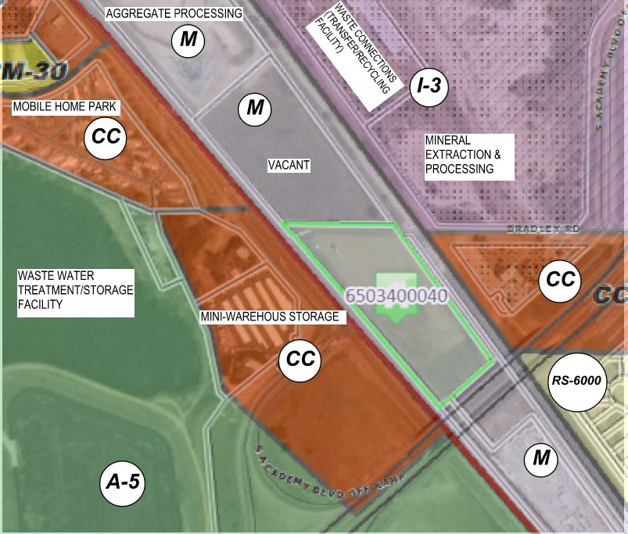

- The subdivision is in substantial conformance with the approved preliminary plan;
No preliminary plan is required.

- The subdivision is consistent with the subdivision design standards and regulations and meets all planning, engineering, and surveying requirements of the County for maps, data, surveys, analyses, studies, reports, plans, designs, documents, and other supporting materials;
The subdivision is consistent with the County subdivision standards and requirements including, but not limited to plans, reports, other supporting materials and documentation and as otherwise affected by the proposed waiver.
- A sufficient water supply has been acquired in terms of quantity, quality, and dependability for the type of subdivision proposed, as determined in accordance with the standards set forth in the water supply standards [C.R.S. § 30-28-133(6)(a)] and the requirements of Chapter 8 of this Code;
Per the request, no water supply is proposed to serve the use. Activities on the site will be limited to the storage of construction vehicles and equipment for use off site. Occupancy of the site will be to transport and store vehicles and equipment.

- A public sewage disposal system has been established and, if other methods of sewage disposal are proposed, the system complies with State and local laws and regulations, [C.R.S. § 30-28-133(6)(b)] and the requirements of Chapter 8 of this Code;
No public or private sewage disposal system is proposed. A portable restroom facility will be provided for driver/transporter use while on site.

- All areas of the proposed subdivision which may involve soil or topographical conditions presenting hazards or requiring special precautions have been identified and that the proposed subdivision is compatible with such conditions [C.R.S. § 30-28-133(6)(c)];
No areas which contain or exhibit hazardous soils or topographical conditions which would prohibit or preclude development of the site for storage of construction vehicles and equipment (heavy).

- Adequate drainage improvements are proposed that comply with State Statute [C.R.S. § 30-28-133(3)(c)(VIII)] and the requirements of this Code and the ECM;
Proposed drainage improvements follow state statute and the requirements of County Land Use Code and ECM.

- Legal and physical access is provided to all parcels by public rights-of-way or recorded easement, acceptable to the County in compliance with this Code and the ECM;
Access is via State Highway 85/87 from an existing paved driveway extending along the northern property line from the western property boundary (SH 85/87 frontage) to the eastern boundary. Secondary access is available from the eastern boundary via unimproved portion of Bradley Road. All required access permits shall be obtained prior to initiation of any ground disturbing activities.

- Necessary services, including police and fire protection, recreation, utilities, and transportation systems, are or will be made available to serve the proposed subdivision;
Police protection is provided by the EL Paso County Sheriff. Fire protection and EMS emergency services are provided by Security Fire Protection District. Electric service is provided by CSU. The proposed use will not include the use of natural gas services.
- The final plans provide evidence to show that the proposed methods for fire protection comply with Chapter 6 of this Code;
The plans comply with applicable provisions of Chapter 6 for fire protection and access. Water supply demands for fire suppression will be coordinated with the Security Fire Protection District.
- Off-site impacts were evaluated and related off-site improvements are roughly proportional and will mitigate the impacts of the subdivision in accordance with applicable requirements of Chapter 8;
Offsite impacts and required mitigation have been evaluated and found to be roughly proportionate to impacts generated by the proposed development.
- Adequate public facilities or infrastructure, or cash-in-lieu, for impacts reasonably related to the proposed subdivision have been constructed or are financially guaranteed through the SIA so the impacts of the subdivision will be adequately mitigated;
All required subdivision improvements are financially guaranteed through the SIA to adequately mitigate the subdivision impacts.
- The subdivision meets other applicable sections of Chapter 6 and 8; and
The subdivision meets all other applicable Code sections of Chapter 6 and 8.

- The extraction of any known commercial mining deposit shall not be impeded by this subdivision [C.R.S. §§ 34-1-302(1), et seq.]
No extraction of any known commercial mining deposits will be impeded by this subdivision.

