PYRAMID MOUNTAIN
BY CASCADE RESORT COMMUNITIES, INC.
PUD DEVELOPMENT GUIDELINES
AS AMENDED
GENERAL DEVELOPMENT PLAN
El Paso County, Colorado
AS AMENDED
GENERAL DEVELOPMENT PLAN
EL PASO COUNTY, COLORADO
OCTOBER 2025
ONLY FOR FORMER LOTS 1–11
NOW LOTS 1,2,6,7,8 & 9
PAGES AMENDED: Text underlined
- Page 1
- Page 15, line 22

Prepared by:
Andy Mullet
8450 Uintah Bluffs Pl
Colorado Springs, CO 80904
719.419.2300
Prepared for:
Robert Wallstad, owner
4551 Pyramid Mountain Rd.
Cascade, CO 80809
719.243.5851
PYRAMID MOUNTAIN
GENERAL DEVELOPMENT GUIDE
El Paso County, Colorado
April, 2010
I. BACKGROUND
A. THE PROPERTY
Pyramid Mountain (the “Property”) is located on the south and southwest facing slope of Ute Pass in western El Paso County, Colorado, northeast of existing development in Cascade, Colorado. The Property is located within portions of Sections 23 and 24, T13S, R68W, of the 6th PM. The Property contains approximately 288.691 acres of land and is currently undeveloped. The property is zoned for a planned unit development consisting of eighteen 2.5+ acre single family residential lots and a maximum of six 35+ acre single family residential parcels. Also included within the planned unit development are 167.90 acres that have been placed in conservation easements conveyed to El Paso County. The Property is adjoined on the north and east sides by the U.S. Forest Service.
B. SITE ANALYSIS
Vegetation on the Property is comprised primarily of scrub oak, ponderosa pines, spruce and aspen. The elevation ranges from a low of 7600 feet to a high of 8600 feet. Several ridges and gullies traverse the site with the summit of Pyramid Mountain (8180 feet) being located in the approximate center of the Property. The Property enjoys vistas of Ute Pass and Cheyenne Mountain with those portions of the Property located above 7800 feet having views of the north slope of Pikes Peak above timberline.
Water for all eighteen lots will be provided by the Cascade Metropolitan District No. 2 (“District No. 2”) through an intergovernmental agreement with Cascade Metropolitan District No. 1 (“District No. 1”). District No. 1 purchases bulk, treated water from the City of Colorado Springs. Water for the 35+ acre parcels will be provided by individual wells. Waste water will be provided by utilizing individual on-site septic systems.
Pyramid Mountain will be a gated community with access at two locations on Pyramid Mountain Road, an existing County maintained road. On-site roads will be owned and maintained by District No. 2. District No. 2 will also own and maintain all open/common space, storm-water facilities, recreation easements and trails. Trails are an integral aspect of the development with numerous trails leading onto Forest Service property, including several connecting to Waldo Canyon and Rampart Range.
II. STATEMENT OF PURPOSE AND INTENT
Pyramid Mountain is a planned residential community consisting of a maximum of eighteen single family residential lots and six parcels containing a minimum of thirty-five acres each. The minimum lot size for the single family residential lots is 2.5 acres. Pyramid Mountain’s development standards are intended to carry out the goals of El Paso County, the Ute Pass Comprehensive Plan and this planned community. These standards are written to ensure a unified quality development, through creativity in design, sensitivity to the characteristics of the site and compatibility of land uses.
The Pyramid Mountain subdivision is located in the relatively steep, mountainous area of El Paso County and as such utilizes certain design standards, visual impact criteria and mitigation measures for streets, driveways, lot/siting, natural hazards and other natural features that are unique in comparison to the typical County subdivision. These specific development guidelines and mitigation measures are set forth in Section V below.
The following principles will be used in guiding development towards a planned community which can respond to market conditions:
- Encourage flexibility in site design with respect to building spacing, heights and density of buildings, open space and off-street parking.
- Allow a variety of creative solutions to permit design that may not be possible through the strict application of traditional zoning and subdivision regulations;
- Encourage innovations in land use that result in the availability of attractive development opportunities;
- Maximize the unique physical features of the Property to strengthen the feeling of rural residential community;
- Create development patterns and project designs that further the goals and policies of the Ute Pass Comprehensive Plan and El Paso County; including the clustering of lots and building sites, resulting in more open space than would be provided in the existing five acre, R-T Residential Topographical Zoning on the surrounding property;
- Provide appropriate transitions between external and internal land uses while encouraging an overall community focus;
- Provide wildlife habitat; and
- Reduce wildfire hazards.
III. AUTHORITY
These standards are adopted pursuant to the Planned Unit Development Act of 1972, C.R.S. 24-67-101, et seq., and the El Paso County Land Development Code, and shall apply to all property contained in the approved Pyramid Mountain Planned Unit Development Plan. The regulations and requirements shall become the governing standards for review, approval and modification of all development activities occurring on the Property. The subdivision and zoning regulations for El Paso County shall apply where the provisions of this document or the Development Plan do not address a specific subject.
IV. LAND USE SUMMARY
The maximum total residential units which may be constructed within the Property shall not exceed 24 units unless the Planned Unit Development Plan is amended in accordance with applicable El Paso County rules and regulations. Eighteen of the single-family units are located on 57.51 acres of the Property, which includes 2.91 acres to be dedicated to Cascade Metropolitan District No. 2, Tract “A”, and 2.21 acres being held for future development, Tract “B”. The six potential thirty-five plus acre parcels are located on 231.18 acres of the Property with a net density of 38.53 acres per parcel. 167.90 acres of which are subject to conservation easements that have been conveyed to El Paso County. The permitted uses on the areas located within the conservation easements include:
- Open space, non-motorized trails, ponds, picnic shelters/recreational uses, sledding hill, drainage facilities, utilities, community roads, water storage tank, road maintenance and storage facility, and thirty-five plus acre parcels with a maximum of one-acre building envelope each.
Tract “B” contains 2.21 acres and is set aside for use in conjunction with the possible development of adjoining property not presently part of the Pyramid Mountain Planned Unit Development. No single-family homes or other structures requiring building permits shall be permitted on Tract “B” unless constructed as part of a Planned Unit Development approved by the Board of County Commissioners of El Paso County for the adjoining property. In no event shall the minimum building setbacks for lots utilizing portions of Tract “B” be less than those set forth herein.
V. DEVELOPMENT GUIDELINES
Six design elements are addressed in these guidelines. Discussion of each begins with a statement and description of the design objective, followed by the specific design guidelines. The three elements are as follows:
A. Site organization / lot siting
B. Permitted Uses, building height, setbacks, minimum lot size, required landscaping
C. Visual Impact Mitigation
D. Streets
E. Fire mitigation
F. Wildlife Protection Measures
A. SITE ORGANIZATION / LOT SITING
Development Objective:
Elements of the plan for the Pyramid Mountain PUD, including housing, utilities, streets and drainage, are designed and arranged to produce an efficient, cohesive, functionally organized development.
Development Guidelines:
- Buildings, streets, and open space areas shall be situated to maximize the amount and quality of views and natural light.
- The natural features of the site have been identified and incorporated into the development plan. The plan utilizes the drainage areas, drainage structures, slopes and existing vegetation to their best advantage and further enhances these elements to create a quality environment in which to live.
- Subject to the considerations and requirements of the Wildfire Mitigation Measures contained in Appendix A hereto, buildings should be located on lots in such a way to minimize damage to existing vegetation. The lots shall be maintained in the natural state as nearly as possible subject to such fire thinning and disease management plans that may be adopted by Cascade Metropolitan District No. 2 from time to time.
- No pre-construction land disturbances will be allowed beyond public facilities until a plot plan is approved by the El Paso County Development Services Department.
- In those lots where high ground water and/or shallow bedrock exist, siting of the septic system shall occur prior to the dwelling unit siting to ensure that a suitable location for a septic system is available.
- All structures and accessory structures shall be located within approved building envelopes as illustrated within the approved Pyramid Mountain PUD Development Plans.
B. PERMITTED USES, BUILDING HEIGHT, SETBACK, MINIMUM LOT SIZE, SLOPE RESTRICTIONS
Development Objective:
Promote a variety of building heights and setbacks related to the individual lots and market demands to present a stylized lot development appearance within the overall community.
Development Guidelines:
- Single-family homes shall be the only permitted principal use with accessory uses being those as defined in the El Paso County Land Development Code as amended for single-family homes. The entire development shall not exceed a gross residential density of 12.02 acres per lot. No manufactured or multi-family dwellings are permitted. Private stables and the keeping of horses is expressly not allowed on lots or parcels less than 35 acres in size. Private stables and the keeping of horses is allowed on lots 35 acres in size subject to the prior written approval of the Design Review Board as established in the Covenants, Conditions and Restrictions for Pyramid Mountain.
- Accessory buildings shall conform to the minimum building setbacks outlined in Development Guideline No. 5 below.
- Maximum building heights for the single family residential development shall not be greater than thirty (30) feet. Calculation of building heights shall be as defined in the El Paso County Land Development Code.
- The minimum residential lot sizes shall be 2.5 acres.
- The following residential building setbacks shall serve as a guideline to minimum setbacks for the development:
  - Front – 25 feet
  - Side – 15 feet
  - Rear – 25 feet
- Variances from the suggested setback guidelines must be approved by both the Design Review Board and the El Paso County Development Services Department in accordance with Section VI, Plot Plan Approval. Setbacks shall be measured from property line to the foundation line for any building. Setback variances of the required PUD perimeter setback of the Property shall necessitate an amendment to the PUD Development Plan.
- Garages or other accessory buildings will not be erected to dominate the street-scape. Further, accessory buildings should not be located closer to the road than the main buildings without a variance from both the Design Review Board and the El Paso County Development Services Department in accordance with Section VI, Plot Plan Approval.
- No buildings, as defined in the El Paso County Land Development Code, shall be permitted on areas where slopes are greater than thirty percent (30%). The Planned Unit Development Plan shall be utilized to identify slopes in excess of thirty percent.
- Because of existing slopes and soils types, all building foundations shall be designed by a registered professional engineer.
- Because of existing slope and soils types, a grading and drainage plan, prepared by a registered professional engineer shall be provided with all plot plan approval requests. Prior to the El Paso County Development Services Department’s authorization for a certificate of occupancy, a registered professional engineer shall certify that the property has been developed in accordance with grading and erosion control plans.
- Because rockfall hazards have a potential impact on portions of the area designated for thirty-five acre parcels, rockfall mitigation measures designed and approved by a geological and soils engineering firm licensed to practice in Colorado and approved by the Design Review Board shall be provided with all plot plan approval requests for homes located in areas of historic and potential run-out zones as mapped by Entech Engineering, Inc. and shown on the approved PUD Plan. Prior to the El Paso County Development Services Department’s authorization for a certificate of occupancy on any homes located in areas of historic and potential run-out zones a geological and soils engineering firm, licensed to practice in Colorado and approved by the Design Review Board shall certify that the property has been developed in accordance with the required mitigation measures. Rock Fall Zones (RFS1 and RFS2), as shown on the approved Pyramid Mountain PUD Development Plans, shall be considered no-build areas. All rock fall hazard mitigation not specifically related to individual structures shall be designed and installed by Developer. Thereafter, all such rock fall hazard mitigation shall be maintained by Cascade Metropolitan District No. 2.
- Nothing herein shall be interpreted to preclude the rezoning/overlay of the Rural Land Use Plan Overlay Zone (“RLUP-O”) on a portion or all of the property located in this Planned Unit Development. The RLUP-O shall be considered a permitted use in the Pyramid Mountain PUD. The overlay of the RLUP-O zone on this PUD may necessitate additional or amended engineering requirements and conditions.
C. VISUAL IMPACT MITIGATION
Development Objective:
In order to preserve the natural beauty of Pyramid Mountain and its setting, to maintain Pyramid Mountain as a pleasant and desirable environment, to establish and preserve a harmonious design for the community, and to protect and promote the value of the Property, all exterior design, landscaping and use of all new development and additions, changes or alterations to existing use, landscaping and exterior design and development shall be subject to design review by the Design Review Board as established in the Covenants, Conditions and Restrictions for Pyramid Mountain. The design review process shall be conducted with the following objectives in mind for Pyramid Mountain:
- Preventing excessive or unsightly grading, indiscriminate earthmoving or clearing of Property, removal of trees and vegetation which could cause disruption of natural watercourses or scar natural landforms;
- Ensuring that the location and configuration of structures are visually harmonious with the terrain and vegetation of the land and with surrounding lots, structures and open space, and do not unnecessarily block scenic views from existing buildings or tend to dominate any general development or the natural landscape; the siting of all structures shall comply with the general design theme, specific siting requirements and construction procedures promulgated and contained in the Design Standards and Construction Procedures promulgated and published by the Design Review Board.
- Ensuring that the architectural design of structures and their materials and colors are visually harmonious with Pyramid Mountain’s over-all appearance, history and cultural heritage, with surrounding development, with natural landforms and native vegetation, and adheres to or complies with development plans, zoning requirements, and other restrictions officially approved by the Declarant, the Design Review Board, Cascade Metropolitan District No. 2, El Paso County or any other government or public authority; if any, for the sites in which the structures are proposed to be located; the construction of all structures shall comply with the general design theme, specific design requirements and construction procedures contained in the Design Standards and Construction Procedures promulgated and published by the Design Review Board. Said Design Standards shall address specific colors (homes to be earth tones with non-reflective roofs), designs for buildings, permitted building materials, and other visual impact criteria (exterior light fixtures to be concealed or shielded).
- Ensuring that plans for the use of open spaces blend harmoniously with the natural landscape.
- Ensuring that revegetation of disturbed areas with native plant materials be accomplished as quickly as possible. Disturbed areas that are to be permanently revegetated shall be seeded and mulched within twenty-one (21) days after construction activity or grading ends if season allows (between April and September). If season does not allow seeding, the disturbed areas shall be mulched until seeding can be completed. If necessary, the soil shall be conditioned for plant growth by applying stockpiled topsoil, soil amendments or treatments. Seeding shall be applied using mechanical type drills on areas equal to or flatter than 3:1. Hydraulic mulching shall be used where slopes are steep or access is limited. Mats or blankets shall be used to stabilize steep slopes and drainage channels. The permanent seed mix will include grasses and wildflowers, and shall be based on the appropriate vegetation community as established by the Design Review Board and the Cascade Metropolitan District No. 2. Where applicable, the seed mix shall also comply with the County approved Natural Resources Assessment and Erosion Control Plans.
D. STREETS
Development Objective:
Establish a street hierarchy system that responds to the specific development and traffic movement needs of this mountain development. Promote street designs that are compatible with neighborhood and community standards and needs. Design street widths in response to specific criteria such as traffic volumes, needs of fire and other emergency responders, size of vehicles using the streets, density, topography, drainage system, utility placement, parking requirements, turning and turn-around movements, and market preference.
Development Guidelines:
- The primary street section standards, common driveway section standards and driveway section standards for Pyramid Mountain are included in Appendix C hereto.
- All streets and common driveways (as shown on the PUD Plan) will be maintained by Cascade Metropolitan District No. 2. The streets will be public and owned by District No. 2.
- The long range image of the development is impacted by the character of the entry and primary roads. Landscaped plantings along each side of the primary roads are intended to enhance the entry aspects of the development. Minimal clearing of existing trees is planned. Any landscaping within any publicly owned right of way shall be subject to the approval of the Design Review Board, Cascade Metropolitan District No. 2 and the El Paso County Department of Transportation.
E. WILDFIRE MITIGATION
Development Objective:
The developer of Pyramid Mountain is responsible for planning and developing the lots in a manner consistent with contemporary wildfire hazard mitigation techniques utilizing the Wildfire Mitigation Measures included in Appendix A hereto and applicable Cascade Fire Protection District, Colorado State Forest Service, and El Paso County techniques and requirements. The home builder is responsible for designing and constructing homes which are sensitive to the environmental hazards existing within or nearby the proposed building site. The homeowners and the Cascade Metropolitan District No. 2 are ultimately responsible for the maintenance of their homes and home sites in a manner consistent with the adopted Wildfire Hazards Mitigation Plan, the Cascade Fire Protection District’s regulations and recommendations and rules and regulations adopted by Cascade Metropolitan District No. 2.
F. WILDLIFE PROTECTION
Development Objective:
The developer of Pyramid Mountain is responsible for planning and developing the lots in a manner consistent with contemporary wildlife protection techniques utilizing the Wildlife Protection Measures included in Appendix B hereto, as recommended by the Colorado State Division of Wildlife. The homebuilder and homeowner are responsible for designing and improving the dwelling and lot in a manner consistent with the measures and restrictions contained in Appendix B hereto, the CC&Rs for Pyramid Mountain, and such other rules and regulations promulgated by the State of Colorado or other governmental entity with jurisdiction over the Property.
VI. PLOT PLAN APPROVALS
- The El Paso County Land Development Code requires plot plan approval for a structure on any lot or tract within a PUD zone before a building permit may be issued. In addition to the submittal requirements for Plot Plans contained in the Land Development Code, all Plot Plans for structures on lots in the Pyramid Mountain Subdivision shall contain the following:
a. Location and size of all existing trees and brush to remain within 30’ of the proposed structure and brief statement describing how the remaining trees and brush are in compliance with the Wildfire Mitigation requirements contained in Section E above.
b. Location of all utilities, including water, electric, natural gas, telephone and individual wastewater facilities.
- For homes located in areas of historic and potential rock run-out zones, a copy of the required rockfall mitigation measures set forth in Section V.B.10 hereof.

APPENDIX B
WILDLIFE PROTECTION MEASURES
- No harassment of wildlife shall be permitted. With the exception of bird feeders, the feeding, baiting, salting or other means of attracting wildlife to individual yards or Common Elements shall be prohibited. Bird feeders, suet feeders, and hummingbird feeders should be placed so they are inaccessible to bears, raccoons, skunks and other wildlife species that might cause damage or threaten human safety.
- No fences, walls or other barriers shall be permitted for the purpose of enclosing or demarcating any property boundaries. Fencing permitted in the immediate building envelope or area surrounding a residential unit shall be of a smooth wire construction with a maximum top height of 42".
- No person shall allow any dog owned or controlled by such person to roam within Pyramid Mountain unattended. Dogs shall either be contained indoors or enclosed in a dog run or kennel constructed for the purpose of confinement in a manner approved by the Design Review Board. It is recommended that kennels be constructed with a top to prevent dogs becoming prey to mountain lions and other wildlife. At all other times, dogs shall be on a leash and under the direct control and supervision of their owners.
- Cats must be restricted to the domicile unless a bell is worn on the cat’s collar to alert nesting birds of their presence.
- Pet food should be kept within the domicile, garage or similar substantive storage facility and should be provided to pets outside for brief periods only to prevent serving as an attractive nuisance to bears, raccoons, skunks and other wildlife species. Pet food should never be left outside for extended periods of time.
- Trash should be kept in bear-proof containers, in a garage, or similar storage facility until the day of pick-up/disposal to prevent serving as an attractive nuisance to bears, raccoons, skunks, dogs and other wildlife and domestic species.
- No motorcycle, motorbike, snowmobile, or other motorized recreational vehicle shall be operated within Pyramid Mountain Common Elements except for licensed motorcycles and motorbikes that are driven on the roadways.

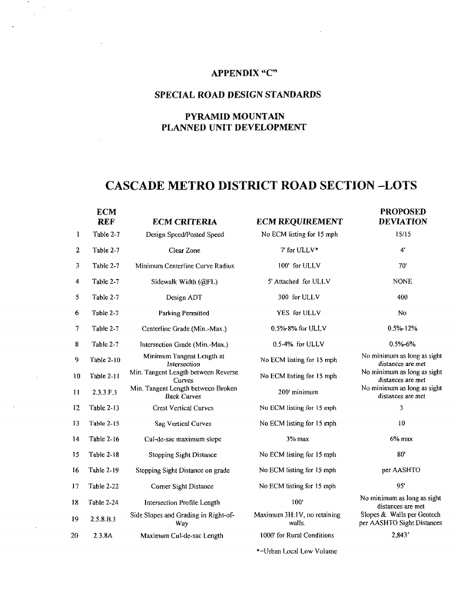

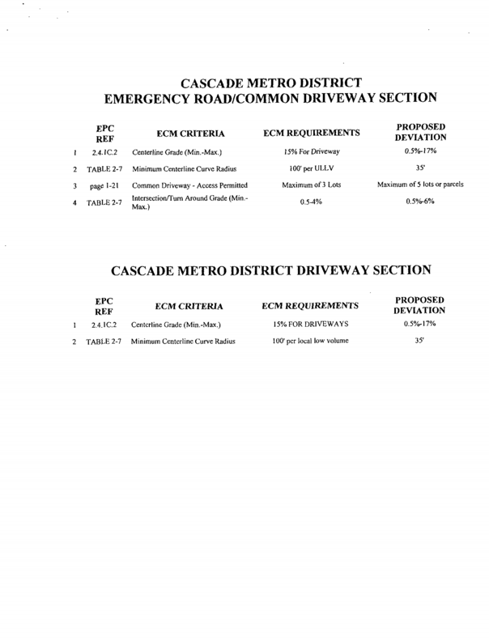
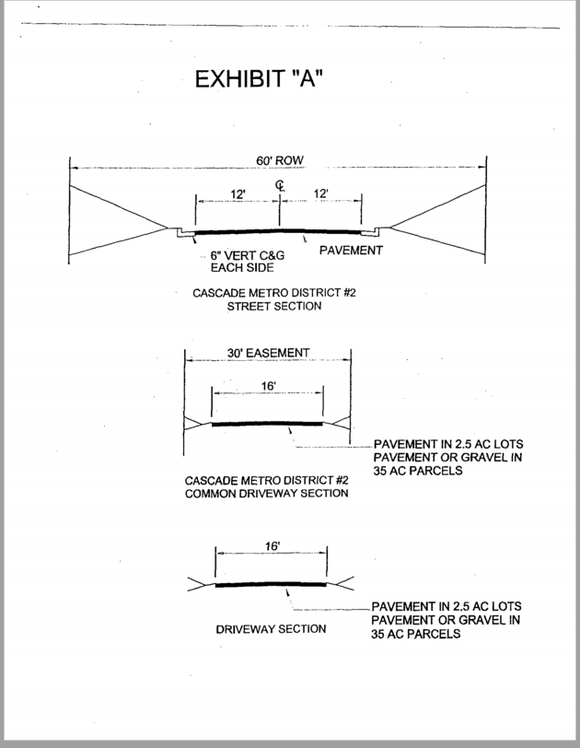
APPENDIX “A”
WILDFIRE MITIGATION MEASURES
RELATIONSHIP TO OTHER PLANS AND DOCUMENTS
The intent of these Wildfire Mitigation Measures is to summarize the wildfire mitigation components involved in the development of the Pyramid Mountain Subdivision. Implementation of the specific plan components are further detailed and defined in numerous plans and documents including: the PUD Development Guidelines, the Declaration of Covenants and Restrictions, and the rules and regulations of the Cascade Metropolitan District No. 2.
WILDFIRE HAZARD MITIGATION MEASURES:
- All roofing material shall be noncombustible or fire resistive class A, B, or C rated. Some wood shakes can be treated to attain a C rating. However, since the effectiveness of this treating declines with age, wood shake shingles will not be allowed within the Pyramid Mountain Subdivision.
- All roofs, as well as rain gutters, to be inspected annually for fuel accumulation.
- Exterior wall materials such as stucco, rock, and brick shall be encouraged.
- All undereave vents shall be located near the roof line rather than near the wall. All eaves shall be boxed and minimum overhangs shall be encouraged. Roof vents in structure overhangs (soffits) to be secured at six points of contact instead of four, particularly where the positioning of the roof vents will not be readily accessible for regular maintenance.
- All windows and patio doors shall be made of tempered safety glass or double pane glass. Exterior fire-resistive shutters and interior fire resistant drapes or blinds shall be encouraged.
- Masonry patios and/or one hour fire rated decks shall be encouraged to create a setback safety zone. All ground level decks be required to be sealed off and enclosed in order to prevent the accumulation of flammable debris underneath them.
- No on-street parking will be permitted.
- Turnouts and turnarounds to be provided on all streets, and common driveways at the direction of the Cascade Fire Protection District.
- All oak brush, if present, to be removed within ten feet of all streets on the downhill side.
- Water hydrants to be located at the direction of the Cascade Fire Protection District.
- The Cascade Metropolitan District No. 2 to perform and enforce ongoing forestry plan, including thinning treatments and removal of dead trees.
- All structures to be reviewed for wildfire risk prior to submittal of the Plot Plan to El Paso County. A written review shall be included as part of the subdivision’s architectural review process.
- The three wildfire safety zones around the structures as recommended in the Wildfire Hazard and Mitigation Report be enforced as part of the architectural review process and the annual enforcement by the Cascade Metropolitan District No. 2.
- All homes shall have a 30 foot safety zone or primary fuel break in all directions. All brush within 10 feet of the house shall be removed and replaced with an irrigated greenbelt (including grasses, shrubs, and/or flowers) or noncombustible materials such as rock or gravel. Grasses to be trimmed to 2 inches and well watered. Firewood to be stacked uphill and at least 10 feet from structures. Dead limbs, leaves and grass clippings to be removed from all areas.
- All large trees within the 30 foot safety zone shall be thinned to eliminate overlapping crowns. Trees within two tree heights of the house shall be pruned of all dead limbs. Prune live branches to 10 feet from at least half of the trees within the 30 foot safety zone. Trim all branches which extend over or under the eaves of the roof.
- All driveways shall be readily identifiable and maintained unobstructed at all times.
- All house addresses shall be clearly visible from the street.
- All chimneys shall be equipped with a mesh spark arrester and inspected and cleaned on a regular basis.
- On site burning of trash, leaves, and weeds shall be prohibited.
- Fireworks of any kind shall be prohibited.
- All homes shall be equipped with smoke detectors and a minimum of one 2.5 pound fire extinguisher maintained in accordance with the manufacturer’s recommendations.
- All homes, including those on 35 acre parcels, shall be equipped with residential fire sprinkler systems. A cistern may be provided in lieu of a residential fire sprinkler system for the 35-acre parcels. Construction of cisterns shall be acceptable to the El Paso County Fire Marshal and shall meet National Fire Protection Association (NFPA) standards. All other single-family residential structures shall be equipped with residential fire sprinkler systems. All Lots will adhere to Fire protection District Design Standards.
- Cascade Metropolitan District No. 2 shall develop and conduct fire risk reduction and treatment from wildfire foremost in the community’s mind. The District shall schedule cleanup days in the spring and fall after pine needle drop.

