Early Assistance Meeting Number: EA2618
Project Name: Mule Haven Rezoning EMD Conversion Support
Project Location: Janitell Road
Project Parcel No. 6433401007
Project Description: Requesting an Early Assistance Meeting for a rezoning from A-5 (Agricultural) to Commercial Community (CC). The purpose of the rezoning is to satisfy CDOT zoning requirements associated with an already-approved digital billboard (EMD) conversion. El Paso County has approved the EMD conversion; however, CDOT requires the property to be zoned commercial or industrial. No site development, buildings, utilities, access changes, or change in land use are proposed as part of this request. The property will remain in agricultural use.
Meeting Date: February 26, 2026 at 1:00 PM

El Paso County Planning & Community Development Planning Checklist

Request – Map Provided by Applicant
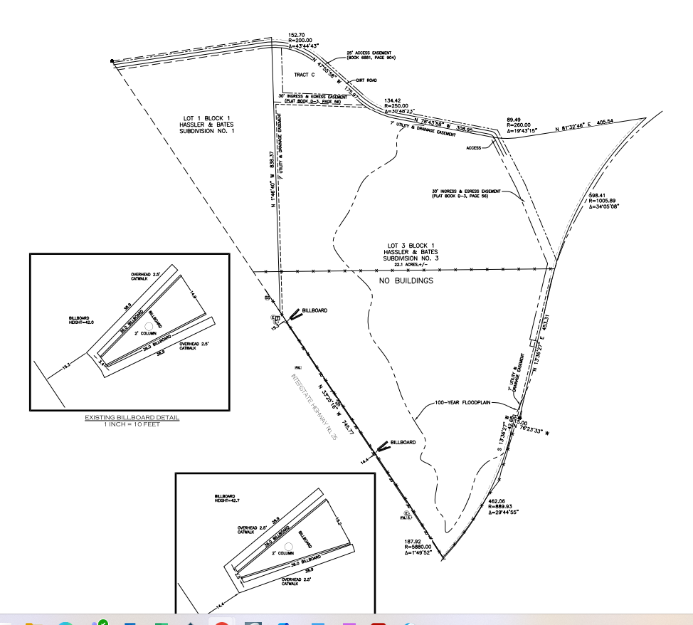

Zoning
Existing Zone(s)
Zone |  | Name
A-5 |  | Agricultural
Proposed Zone(s)
Zone |  | Name
CC |  | Commercial Community
Zone Map (existing conditions of approval)
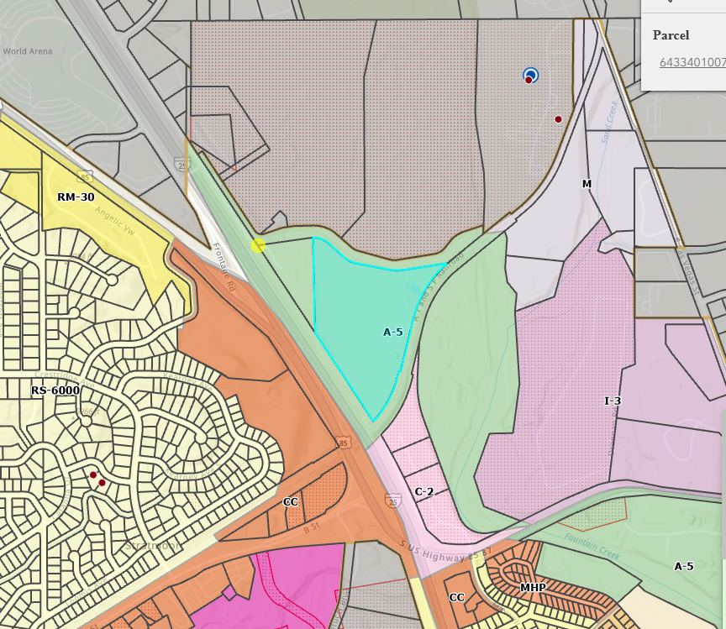

Zoning Analysis
- CC, Commercial Community District. The CC zoning district is intended to accommodate retail sales and service establishments that generally require freestanding or small center type buildings and that primarily serve adjoining neighborhoods.

- CR, Commercial Regional District. The CR zoning district is intended to accommodate regional centers providing ease of pedestrian and vehicular circulation, unity of architectural design, and best serving the convenience of the public and aesthetic enhancement of the community and region.

- CS, Commercial Services District. The CS zoning district is intended to accommodate retail, wholesale or service commercial uses that serve the general public.

Zoning District Requirements (density, lot size, lot design standards, building setbacks)
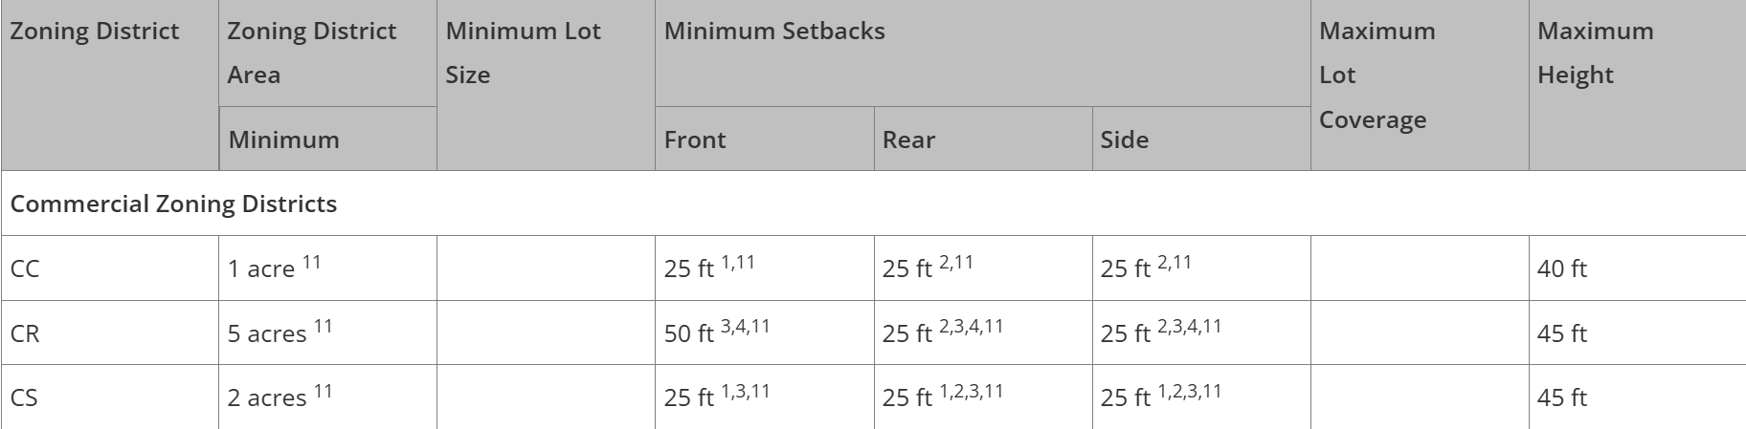

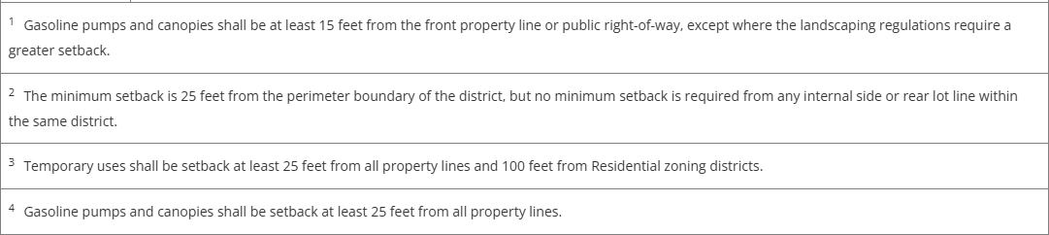

Plat Map or Parcel Map (conditions of approval):
Plat 04615 (in EDARP)

Application Type(s)
Map Amendment (Rezone) | Public Hearing is Required

Approval Criteria:
Land Development Code Section 5.3.5. Map Amendment (Rezoning)
(B) Criteria for Approval. In approving a Map Amendment, the following findings shall be made:
- The application is in general conformance with the El Paso County Master Plan including applicable Small Area Plans or there has been a substantial change in the character of the neighborhood since the land was last zoned;
- The rezoning is in compliance with all applicable statutory provisions, including but not limited to C.R.S. § 30-28-111 § 30-28-113, and § 30-28-116;
- The proposed land use or zone district is compatible with the existing and permitted land uses and zone districts in all directions; and
- The site is suitable for the intended use, including the ability to meet the standards as described in Chapter 5 of the Land Development Code, for the intended zone district.

Processing Issues and Options
- Review the Commercial zoning districts available, and consider possible future uses of the site. Look at Table 5-1 in the land use code for permitted uses in each zoning district. I.E., would Commercial Regional be a more appropriate district for the proposed use, as the purpose includes vehicular circulation?
- Suggest that letter of intent should discuss access. Even though that is not a review criteria, it is something the board will likely ask about, so include a statement talking about how the site is currently accessed, how that isn’t proposed to changed, and any future uses would require access upgrades.
- Suggest letter of intent should discuss existing property easements/agreements – 2012 recorded agreements require negotiation with parties before building permit issuance, for example. I confirmed with an engineer that County does not require renegotiation for stormwater management / levee maintenance. Any other agreements recorded on the property should be mentioned, to confirm rezoning is appropriate.

Relevant Past History:
Approval of AL2416

Site Design/Layout (Lot pattern, circulation/road design, open space, preservation of natural features, compatibility internally and with adjacent land uses)

The project description indicates no change in use or structures being added at this time. If any changes are anticipated in the future, a site development plan will be required. Elements such as landscaping, parking, lighting, etc. will be reviewed with that application type.

Districts

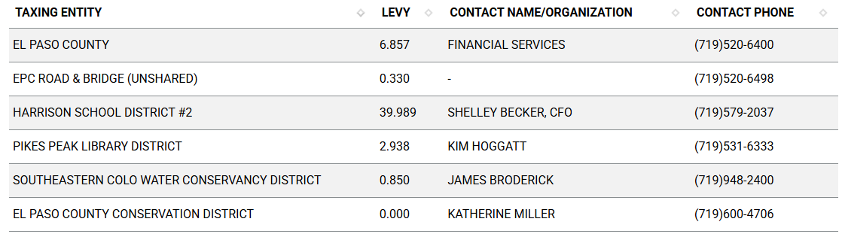

Proposed source of water |  |  | Proposed method of wastewater disposal
☐ | Central System |  | ☐ | Central System
District Name: |  | well | District Name: |  | septic

Water/wastewater comments
Water/wastewater not reviewed with a rezoning.

Fire District:
They have a contract in place for FP

Wildland Fire and Hazard Mitigation Plan:
Current data indicates low wildland fire risk, and state Wildfire Resiliency Code maps to be adopted in April also indicate low risk. Wildland Fire and Hazard Mitigation Plan likely not required.

Commissioner District: 5

Parks and trails:
Comments were not received, although generally no action required with a rezoning application.

Annexations/Intergovernmental/ Jurisdictional Access issues:
- CDOT will be a reviewing agency on the application.
- Colorado Springs will be a reviewing agency because of annexation area potential, although no comments were received from COS prior to EA that indicated concerns.
- Fort Carson military reservation buffer: FC will be a reviewing agency because of inclusion within 2-mile notification buffer.

Wildlife impact
There is a moderate wildlife impact potential.

Your El Paso Master Plan

Placetype:
Character: Unannexed Island, Employment Center
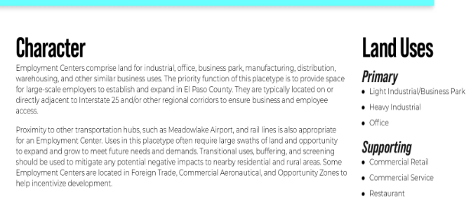

Area of Change Designation:
Description: Transition
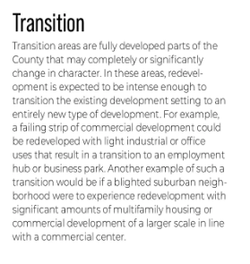

Key Area:
Not within a Key Area as defined by the Your El Paso Master Plan.

Helpful Links

Planning Website: https://planningdevelopment.elpasoco.com/

El Paso County Master Plan: https://planningdevelopment.elpasoco.com/#1510603950097-f5d985dc-35b2
Parks, Mineral and Water Master Plan: https://planningdevelopment.elpasoco.com/resources-and-references/#1516982531779-52cc0e87-01af

Forms and Templates: https://planningdevelopment.elpasoco.com/planning-development-forms/#1510677560407-ff8cfff5-69b2716b-00f9cbba-0c21

Land Development Code: https://library.municode.com/co/el_paso_county/codes/land_development_code

EDARP: https://epcdevplanreview.com/

Public GIS: https://elpasoco.maps.arcgis.com/apps/View/index.html?appid=5be6431018594c67b035ad0aad3e7e8a

Wrap Up
-If subdivision is proposed, recording fees, park and school fees and road impact fees may apply.

-Fees are subject to change. The fees at the time of application apply.

-Road Impact Fees
Please see the following website for information on the EPC Road Impact Fee Project. https://publicworks.elpasoco.com/road-impact-fees/ to include fee schedule.
As of December 15, 2016, per Resolution 16-454, on and after January 1, 2020, property in the unincorporated area of the county that receives a Land Use Approval either in a public hearing or administratively, is subject to the payment of Road Impact Fees. After December 31, 2024, in accordance with BoCC Resolution 24-377 the fee is paid for new residential and non-residential uses and structures and expansions of non-residential uses and structures. Road Impact fees are typically paid at time of building permit. If no building permit is being obtained for a particular Land Use application, then Road Impact Fees must be paid at the time of Site Development Plan or Special Use approval. If there are questions about EPC Road Impact program or fees, please contact DPW Development Review Services and the Engineer of the Day.

- Engineering Criteria Manual (ECM) Deviations.
The fee for any additional ECM deviation requests (more than two per land use application) - $1483.00 each per current Fee Schedule. Please note ECM deviation requests may result in additional processing and project review time. ECM Deviations should be submitted prior to the initial Site Development Plan or Final Plat submittal to preclude changes having to be made to engineering plans and documents if the deviation is not approved. Submission of an ECM deviation request does not imply or guarantee that the deviation will be approved. An ECM Deviation form must be submitted to include complete exhibits and justification excluding cost with supporting engineering criteria. If there are questions about ECM Deviation requests, please contact DPW Development Review Services and the Engineer of the Day.

-The fee for any additional waiver/deviation requests (more than two) - $550.00 each. Please note that requests for waivers and/or deviations may result in additional processing/review delay.

-All items requested must accompany the submittal for it to be complete, prior to payment request or the submittal will not be complete and ready for review agencies.

-A temporary use permit shall be applied for and approved for any staging area associated with development, such as a sales office, construction trailer, or contractor's equipment yard, prior to scheduling of the pre-construction meeting with El Paso County Planning and Community Development. If a Planned Unit Development is proposed, the temporary staging area should be shown on the development guideline and phasing plan.

-All prospective timelines for review are subject to departmental staffing and workload.

-Early Assistance is valid for 12 months from submittal of the EA application. If a project submittal is not received within 12 months, a new EA meeting may be required. An audio/video copy of the meeting is available in EDARP within the EA folder.

- Applications scheduled for public hearings may be heard as a regular item at the request of staff or a hearing body member.

- Any comments or commitments made by any member of the County Staff during this early assistance meeting are only preliminary in nature and should not be relied upon by the applicant. All prospective applicants should be informed that formal comments cannot be made by staff until after the application is submitted.

