File No. EA2618; JANITELL RD
EA2618 DRAFT Engineering Checklist Mule Haven Rezoning
Engineering Meeting Notes

EA Meeting Date/Time: | Thursday, 2/26/2026 1:00
Parcel Number: | Parcel 6433401007
Address/Plat No./Acre: | I-25 & JANITELL RD / Plat No. NA R04615  / 22.14 Acre
Project Manager/Phone: | Jen Uhler (719) 520-7952
Development Services Engineer/Phone: | Jalal Saleh, PE (719) 520-7550
Stormwater Engineer/Phone | Zachary Jannusch (719) 500-3170
Application/Land Use Type: | Rezone from R-4 zoning district (obsolete) to CS zoning district without any modification to current use.

IMPORTANT NOTE:
These Engineering meeting notes are based on the information provided by the Applicant and reasonable preliminary research. The County requirements and policies in effect at the time of the meeting may change prior to the project submittal date, and the requirements and policies in effect at the date of submittal shall apply. Based on the applicant-provided information and preliminary research, these notes are the best estimate of the requirements expected to be met by the Applicant. The actual requirements may change based on project revisions, new information, or constraints that were unavailable or overlooked at the time of the Early Assistance meeting. It is solely the Applicant’s responsibility to research and be familiar with state and federal laws and permitting requirements; the County’s regulations, codes and criteria; the requirements of other applicable local, state or federal agencies; and any governing documents that apply to the project, including previous drainage and transportation studies and previous land use approvals and conditions. Reference links are provided at the end of this document.

REQUEST:
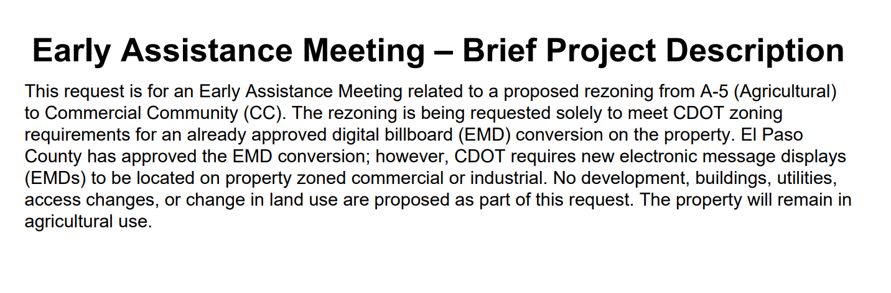

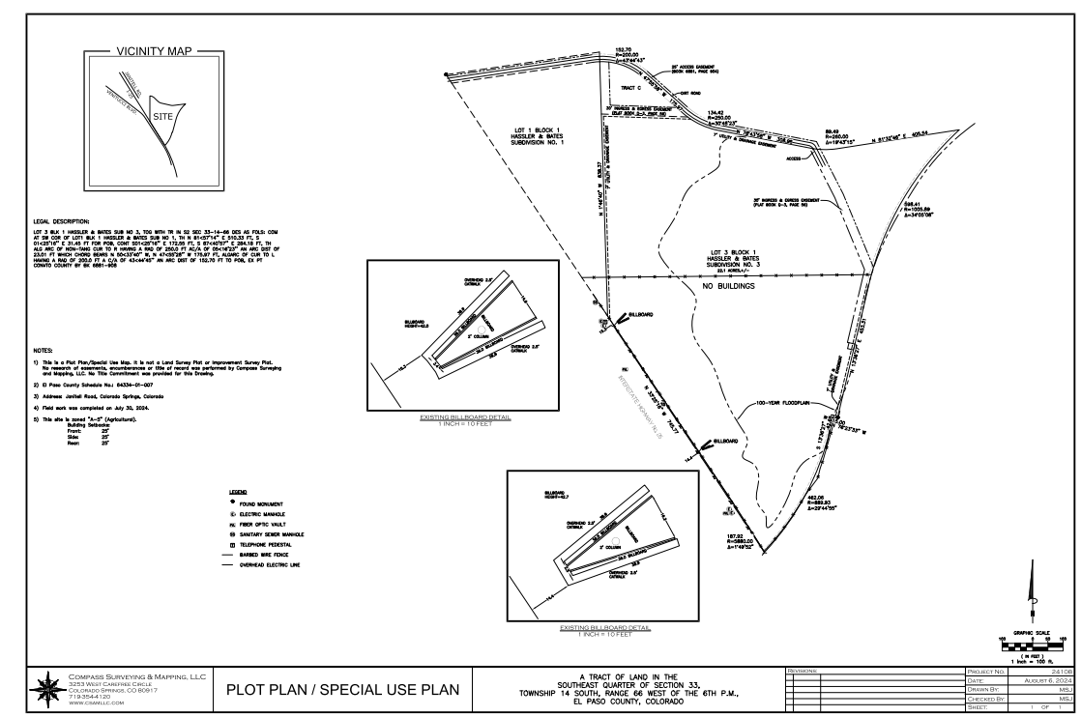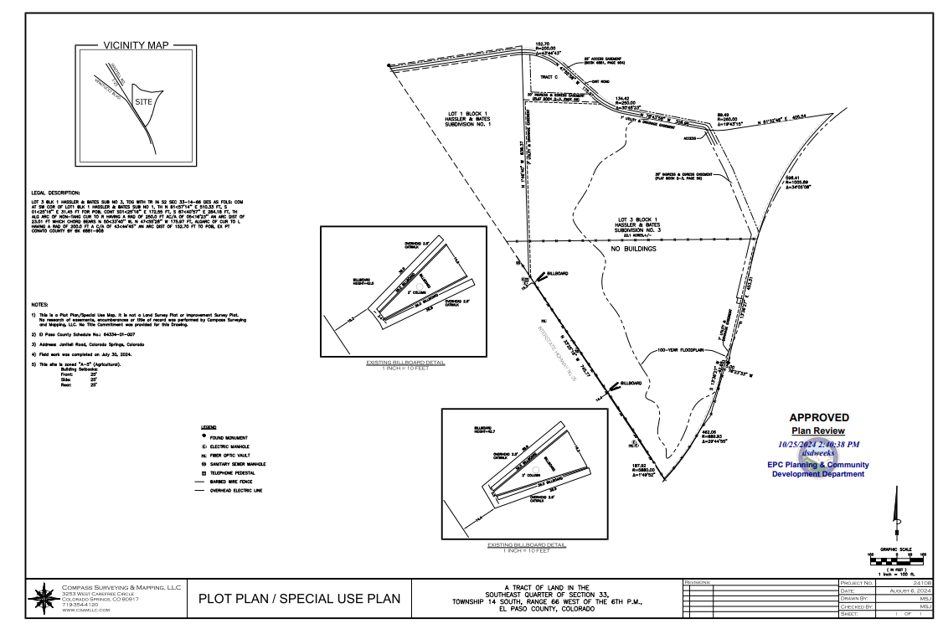

PLAT: Plated

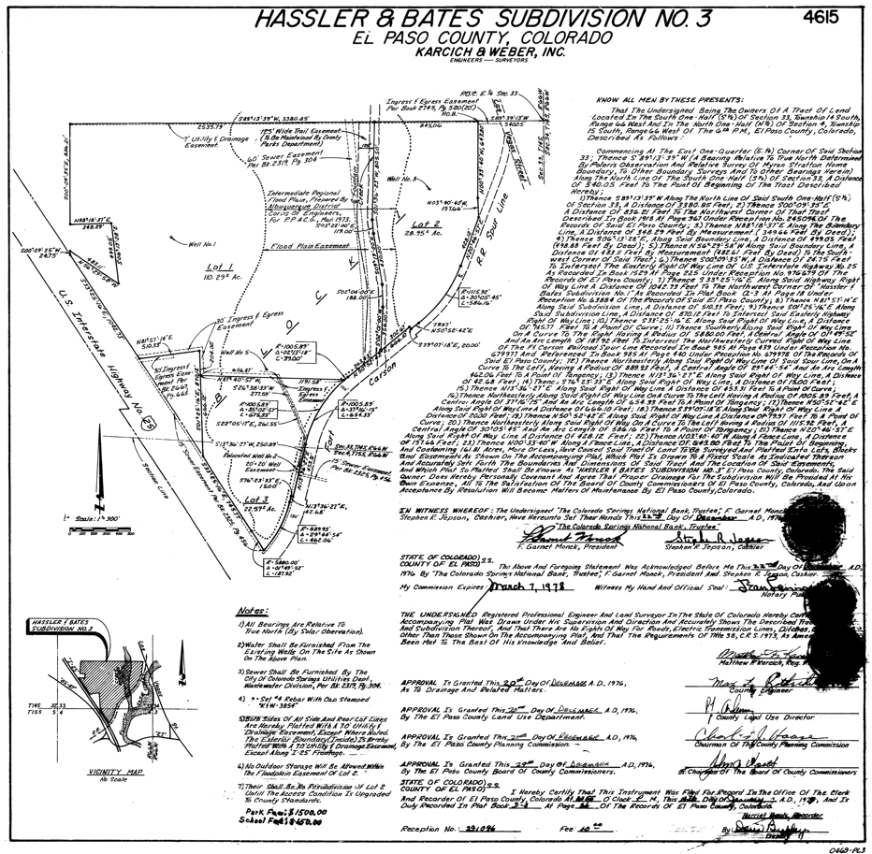

Drainage Impacts

Drainage Notes: No impact

Traffic Impacts

Traffic Notes: No impact

Recommendation:
- DS - Engineering has no objection.
- Stormwater has no objection / No disturbance (Zach).

