Early Assistance Meeting Number: EA2521
Project Name: 19790 CO-83
Project Location: Northeast (near woodmoor area)
Project Parcel Nos. 6100000495 6100000497
Project Description: Proposal to subdivide two existing parcels into approximately 20 2.5 acre lots. See attached sketch.
Meeting Date:

El Paso County Planning & Community Development Planning Checklist

Request – Map Provided by Applicant
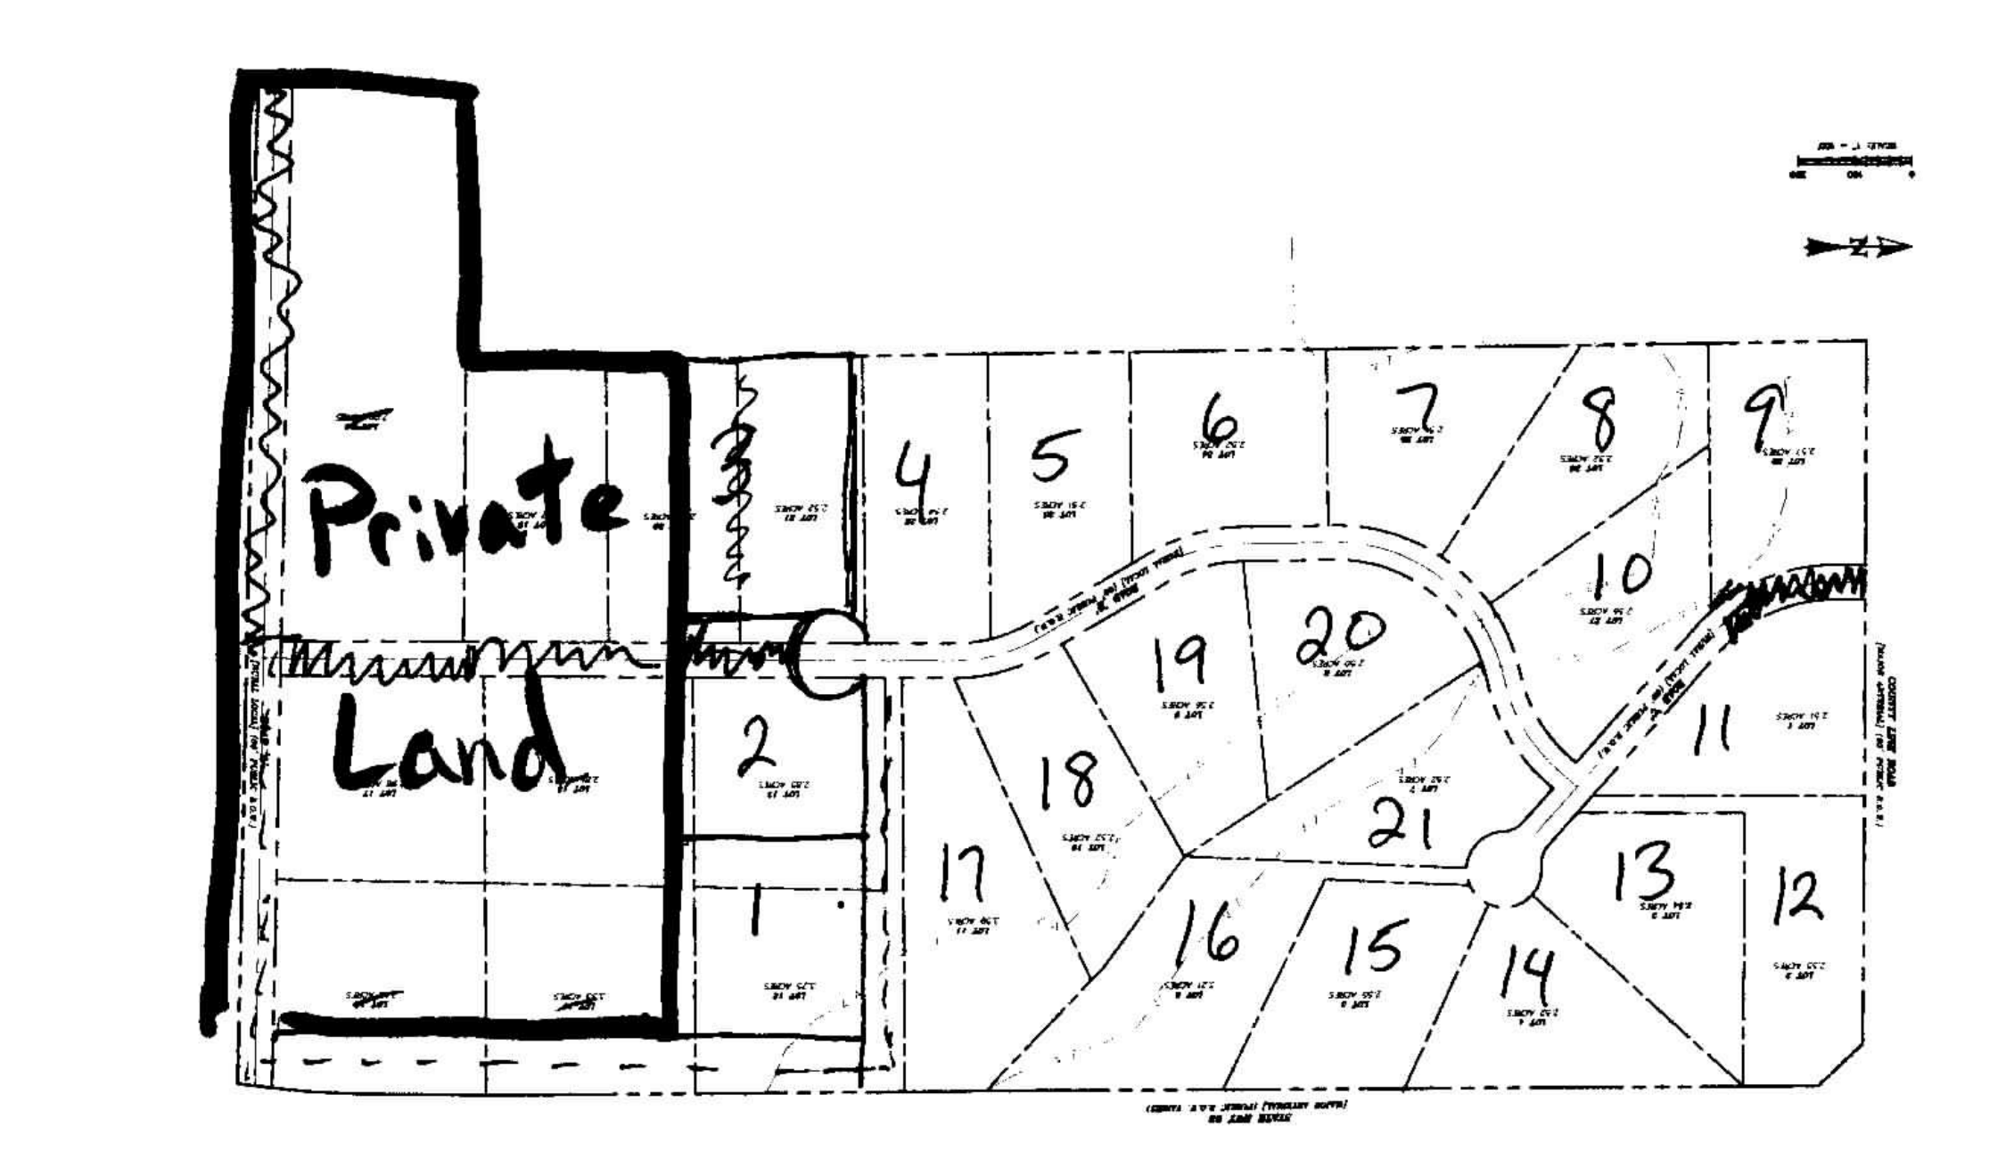

Zoning
Existing Zone(s)
Zone |  | Name
RR-5 |  | Residential Rural
Proposed Zone(s)
Zone |  | Name
RR-2.5 |  | Residential Rural

Zone Map (existing conditions of approval)
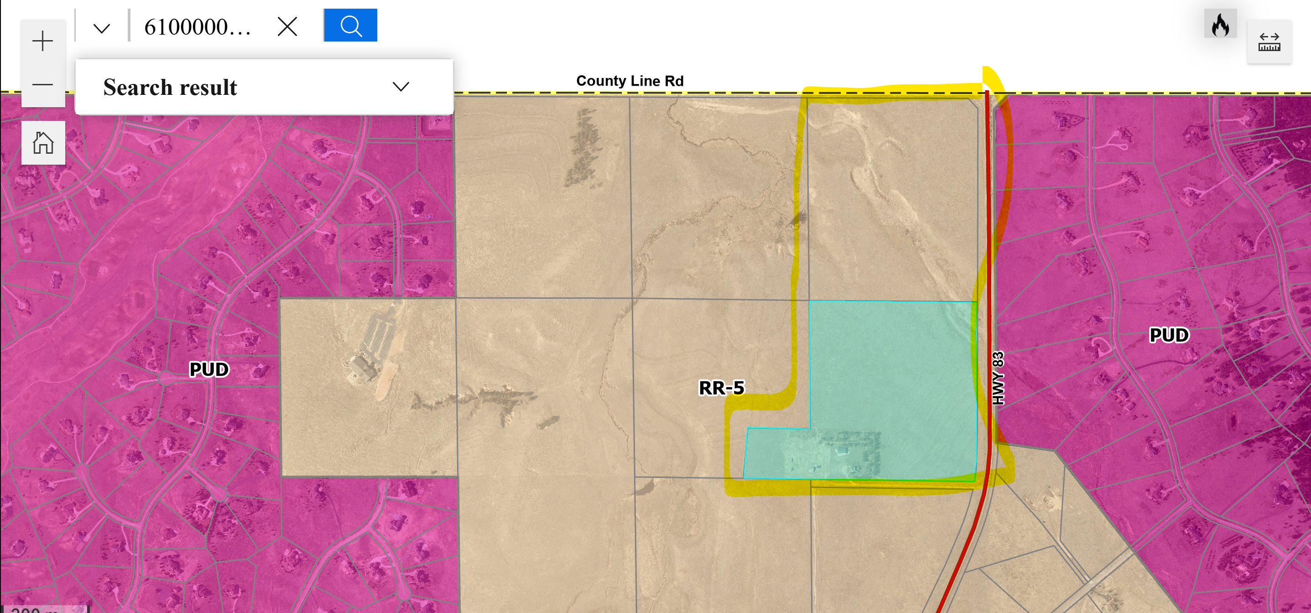

Zoning Analysis
-rr-5 within the area
-PUDs with smaller lot sizes
.PUD to the east (Hawk Ridge) – range of sizes 2.5 up to 5 acre lots
.PUD to the west (Kings Deer Highlands) – mix of lot sizes from 2.5 acre up to 7 acre lot sizes
-proposing rr-2.5 would not be considered “spot zoning”
-would be consistent due to PUD established with same lot sizes found within neighboring PUD’s

Zoning District Requirements (density, lot size, lot design standards, building setbacks)
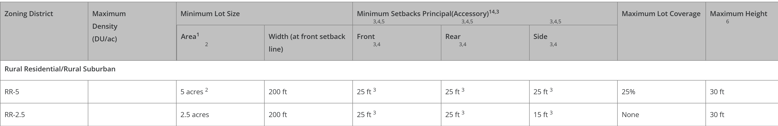

Application Type(s)
Rezone | Hearing: Required
Final Plat | Hearing: Required

Approval Criteria:
5.3.5. Map Amendment (Rezoning)
(A)
Purpose. The purpose of zoning is to locate particular land uses where they are most appropriate, considering public utilities, road access, and the established development pattern. In addition to categorizing land by uses such as residential, commercial, and industrial, the LDC also specifies such details as building setback lines, the height and bulk of buildings, the size and location of open spaces, and the intensity to which the land may be developed. The zoning of parcels of land generally conforms to and promotes the County's Master Plan. Zoning protects the rights of property owners while promoting the general welfare of the community. By dividing land into categories according to use, and setting regulations for these categories, zoning governs private land use and segregates incompatible uses.
Generally, rezoning is justifiable under one of the following circumstances:
• When the requested rezoning is in general conformance or consistency with the County's Master Plan;
• If inconsistent with the Master Plan, a material change in the character of the area since the date of the current zoning is demonstrated;
• When there was an error or oversight in the original zoning of the property; or
• The zone change is necessary for the general health, safety, or welfare of the community.
(B)
Criteria for Approval. In approving a Map Amendment, the following findings shall be made:
• The application is in general conformance with the El Paso County Master Plan including applicable Small Area Plans or there has been a substantial change in the character of the neighborhood since the land was last zoned;
• The rezoning is in compliance with all applicable statutory provisions, including but not limited to C.R.S. § 30-28-111 § 30-28-113, and § 30-28-116;
• The proposed land use or zone district is compatible with the existing and permitted land uses and zone districts in all directions; and
• The site is suitable for the intended use, including the ability to meet the standards as described in Chapter 5 of the Land Development Code, for the intended zone district.
(C)
Conditions on Rezoning Authorized. Conditions of approval may be included in the resolution approving a rezoning request. Where any approved condition would impact the permitted uses or density and dimensional standards of the rezoned property, the existence of the conditions shall be noted on the Zoning Map. Any amendment to the conditions placed upon a rezoning is considered a new zoning action. Conditional zoning shall not be used to circumvent the intent or requirements of this Code, shall be exercised sparingly and in exceptional situations, and the burden of proof shall be upon the applicant to demonstrate the need.
(D)
Updates of Maps. The PCD Director is responsible for producing all updates of the County Zoning map.
(E)
County Initiated Zoning. The County may initiate the rezoning of any property within the unincorporated area of the County.

(3)
Final Plat.
(a)
Description of Final Plat. The final plat is the last step in the approval process for a division of land. The final plat process will review the final engineering plans, the SIA, financial assurance, CC&Rs (if applicable), the plat, and any other documents, reports, or studies as necessary; and may also review issues such as building height, landscaping, and building envelopes which have been deferred.
The purpose of this Section is to detail the approval review and approval criteria for a final plat, engineering plans, SIA, and other legal requirements for platting a division of land. During this step, there may be public hearings before the Planning Commission and BoCC.
(f)
Criteria for Approval. In approving a final plat, the approving authority shall find that:
• The subdivision is in conformance with the goals, objectives, and policies of the Master Plan;
• The subdivision is in substantial conformance with the approved preliminary plan;
• The subdivision is consistent with the subdivision design standards and regulations and meets all planning, engineering, and surveying requirements of the County for maps, data, surveys, analyses, studies, reports, plans, designs, documents, and other supporting materials;
• Either a sufficient water supply has been acquired in terms of quantity, quality, and dependability for the type of subdivision proposed, as determined in accordance with the standards set forth in the water supply standards [C.R.S. § 30-28-133(6)(a)] and the requirements of Chapter 8 of this Code, or, with respect to applications for administrative final plat approval, such finding was previously made by the BoCC at the time of preliminary plan approval;
• A public sewage disposal system has been established and, if other methods of sewage disposal are proposed, the system complies with State and local laws and regulations, [C.R.S. § 30-28-133(6)(b)] and the requirements of Chapter 8 of this Code;
• All areas of the proposed subdivision which may involve soil or topographical conditions presenting hazards or requiring special precautions have been identified and that the proposed subdivision is compatible with such conditions [C.R.S. § 30-28-133(6)(c)];
• Adequate drainage improvements are proposed that comply with State Statute [C.R.S. § 30-28-133(3)(c)(VIII)] and the requirements of this Code and the ECM;
• Legal and physical access is provided to all parcels by public rights-of-way or recorded easement, acceptable to the County in compliance with this Code and the ECM;
• Necessary services, including police and fire protection, recreation, utilities, and transportation systems, are or will be made available to serve the proposed subdivision;
• The final plans provide evidence to show that the proposed methods for fire protection comply with Chapter 6 of this Code;
• Off-site impacts were evaluated and related off-site improvements are roughly proportional and will mitigate the impacts of the subdivision in accordance with applicable requirements of Chapter 8;
• Adequate public facilities or infrastructure, or cash-in-lieu, for impacts reasonably related to the proposed subdivision have been constructed or are financially guaranteed through the SIA so the impacts of the subdivision will be adequately mitigated;
• The subdivision meets other applicable sections of Chapter 6 and 8; and
• The extraction of any known commercial mining deposit shall not be impeded by this subdivision [C.R.S. §§ 34-1-302(1), et seq.]

Processing Issues and Options
- Both applications can be submitted and reviewed at the same time
- Rezone application must be approved first prior to any approvals for the final plat
- Public Roads are required (Section 8.4.4.C)
- 3 or more lots triggers a road, since this would create 20 lots we will require a road

Design and Landscaping

Site Design/Layout (Lot pattern, circulation/road design, open space, preservation of natural features, compatibility internally and with adjacent land uses)
Section 8.4.3 – Design
https://library.municode.com/co/el_paso_county/codes/land_development_code?nodeId=CH8SUDEIMDE_8.4DECOST

Landscaping
☒ | Expressway, Principal arterial area depth – 25’-Trees required 1 per 20’
☐ | Urban interchange/Intersection area depth – 25’- N/A
☒ | Minor arterial area depth 20’ – Trees required 1 per 25’
☒ | Non-arterial area depth 10’ – Trees required 1 per 30’
☐ | Parking lot landscaping required
☐ | Buffer between non-residential and residential districts separated by a non-arterial road or public alley

-larger style lots will not require large amounts of landscaping
-due to requirements for roads and this site being along 83, roadway landscaping will be required

https://library.municode.com/co/el_paso_county/codes/land_development_code?nodeId=CH6GEDEST_6.2DESTANFAAC

Site Characteristics\ Constraints\ Environmental Standards:
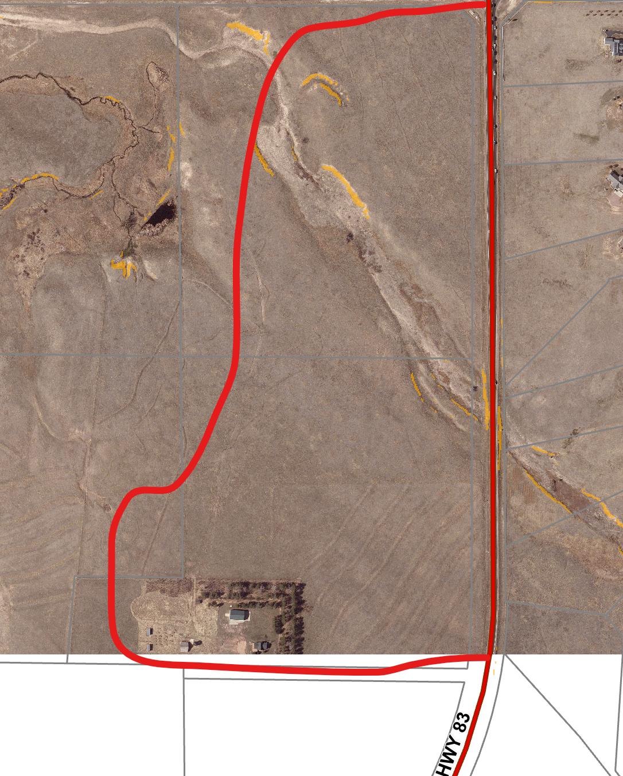
-minimal slope

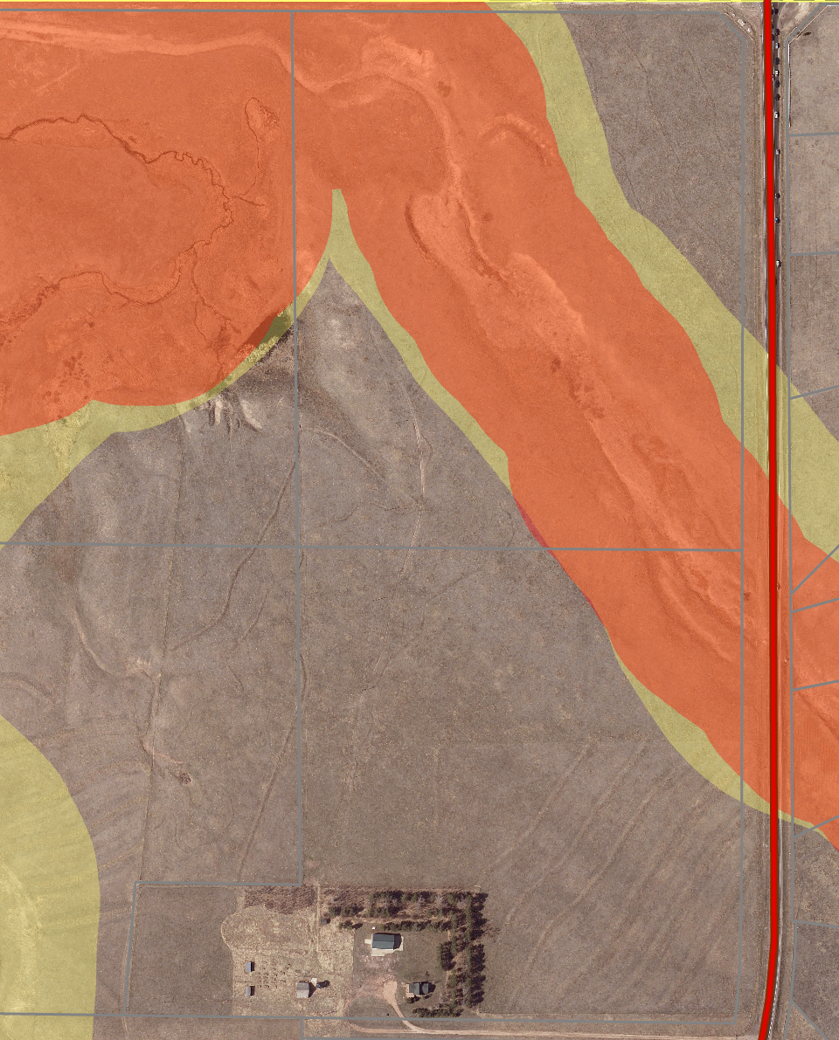
-buffer zones to floodplain
-outside block clearance

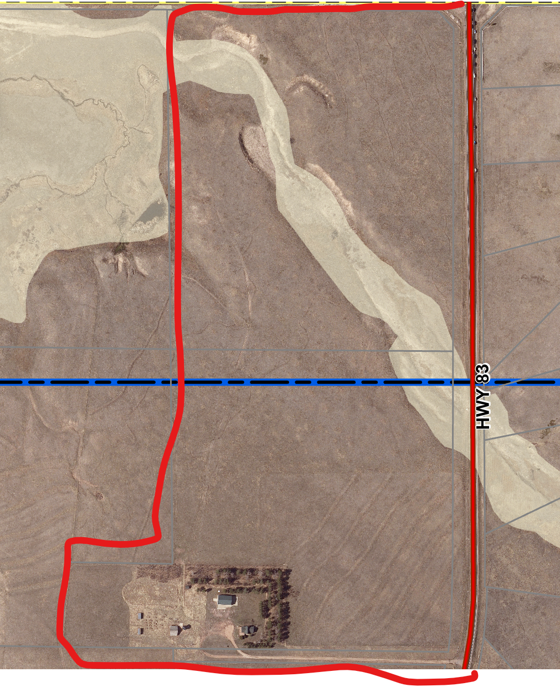
-floodplain runs through property

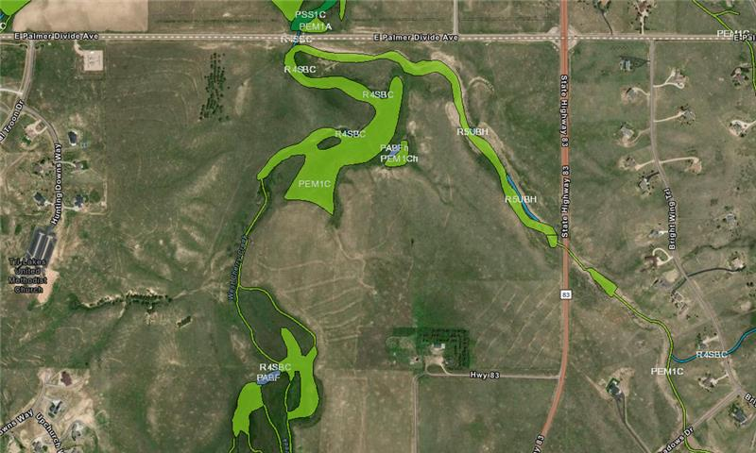
-jurisdictional wetland on property
.natural features report
.natural landforms, vegetation, and riparian analysis
.wetlands analysis report

☒ | 30% or greater slope
☒ | CGS review required (separate fee to CGS)
☒ | Floodplain | Floodplain comment: | Floodplain A (unstudied)
☒ | Preble’s mouse

Taxing Entities
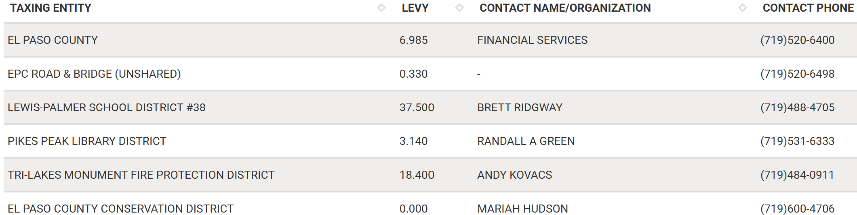

Proposed source of water |  |  | Proposed method of wastewater disposal
☐ | Central System |  | ☐ | Central System
District Name: |  |  | District Name:

Water/wastewater comments
Section 8.4.7 of LDC

Verify that wells can support for future use of a large scale subdivision
-state: 100 yr water finding
-county: 300 yr water finding
Section 8.4.2.b
**well and septic**
- Section 8.4.7
water resource report/state required summary form
- Section 8.4.8
On site treatment:
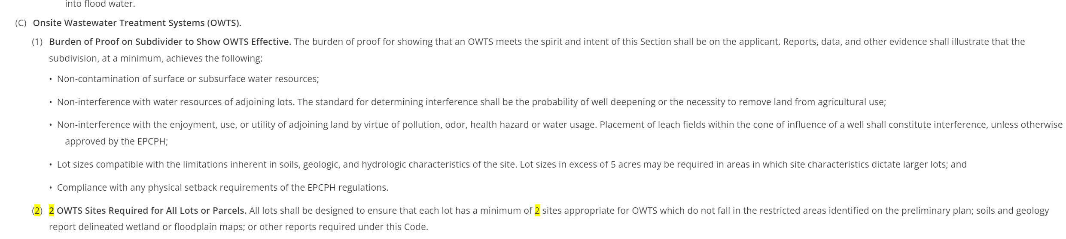

Fire District:
Tri Lakes Fire Protection District
-Fire Protection Report is required
-Section 6.3.3 of the LDC

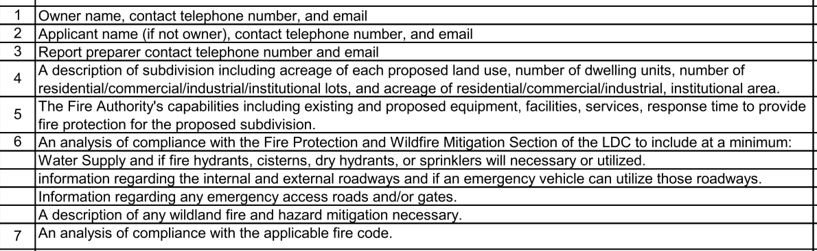

Commissioner District: 1

Code Waivers:

Parks and trails:
-Community services parks division
719 520 6375
-any planned trails near the property/adjacent to the property

Annexations/Intergovernmental/ Jurisdictional Access issues:
-CDOT will be on the review due hwy 83
-Cherry Creek

Your El Paso Master Plan
Placetype: Large Lot Residnetial
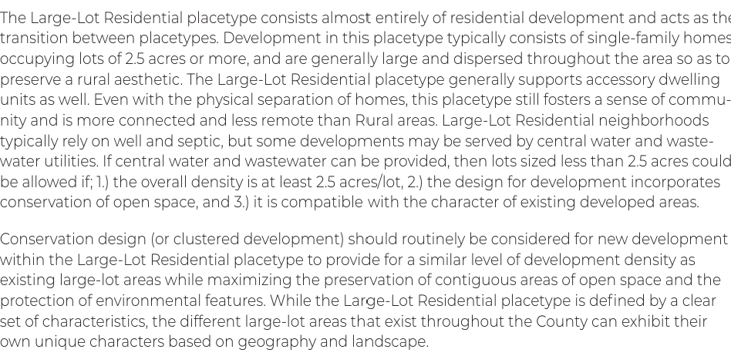

Recommended Land Uses:
- 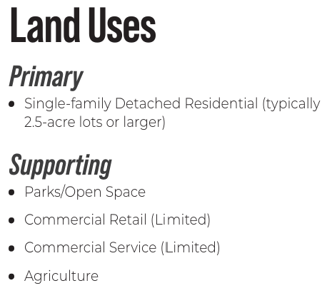

Goals, Objectives, Strategies:


Area of Change Designation:
Description:
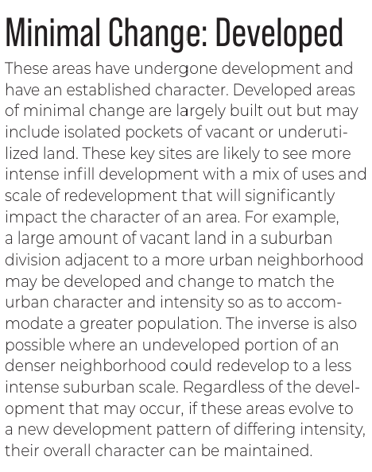

Goals, Objectives, Strategies:
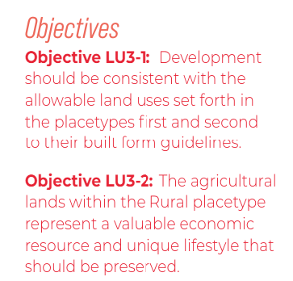

Key Area:

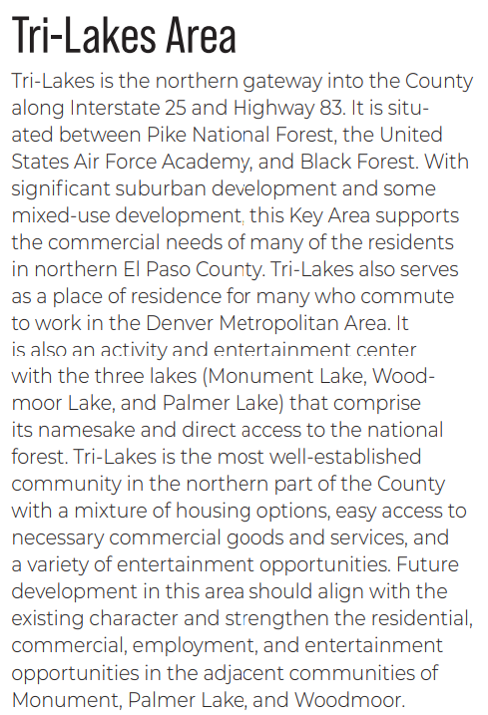

Water Master Plan Area: 2
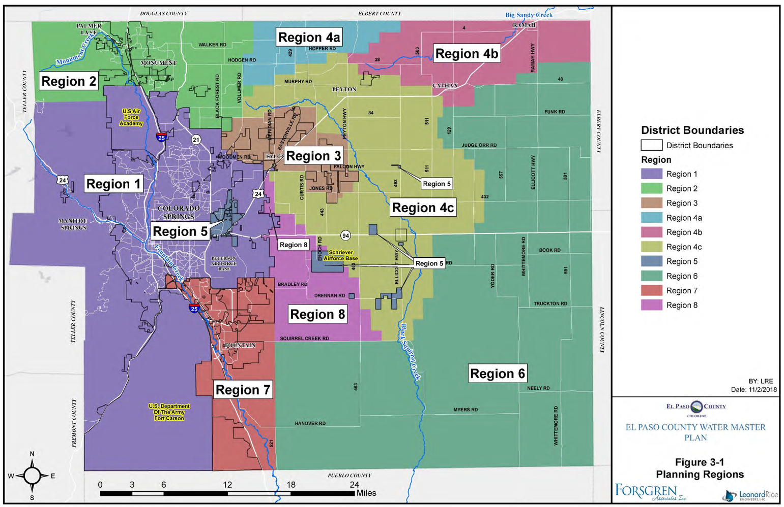

Recommendations:
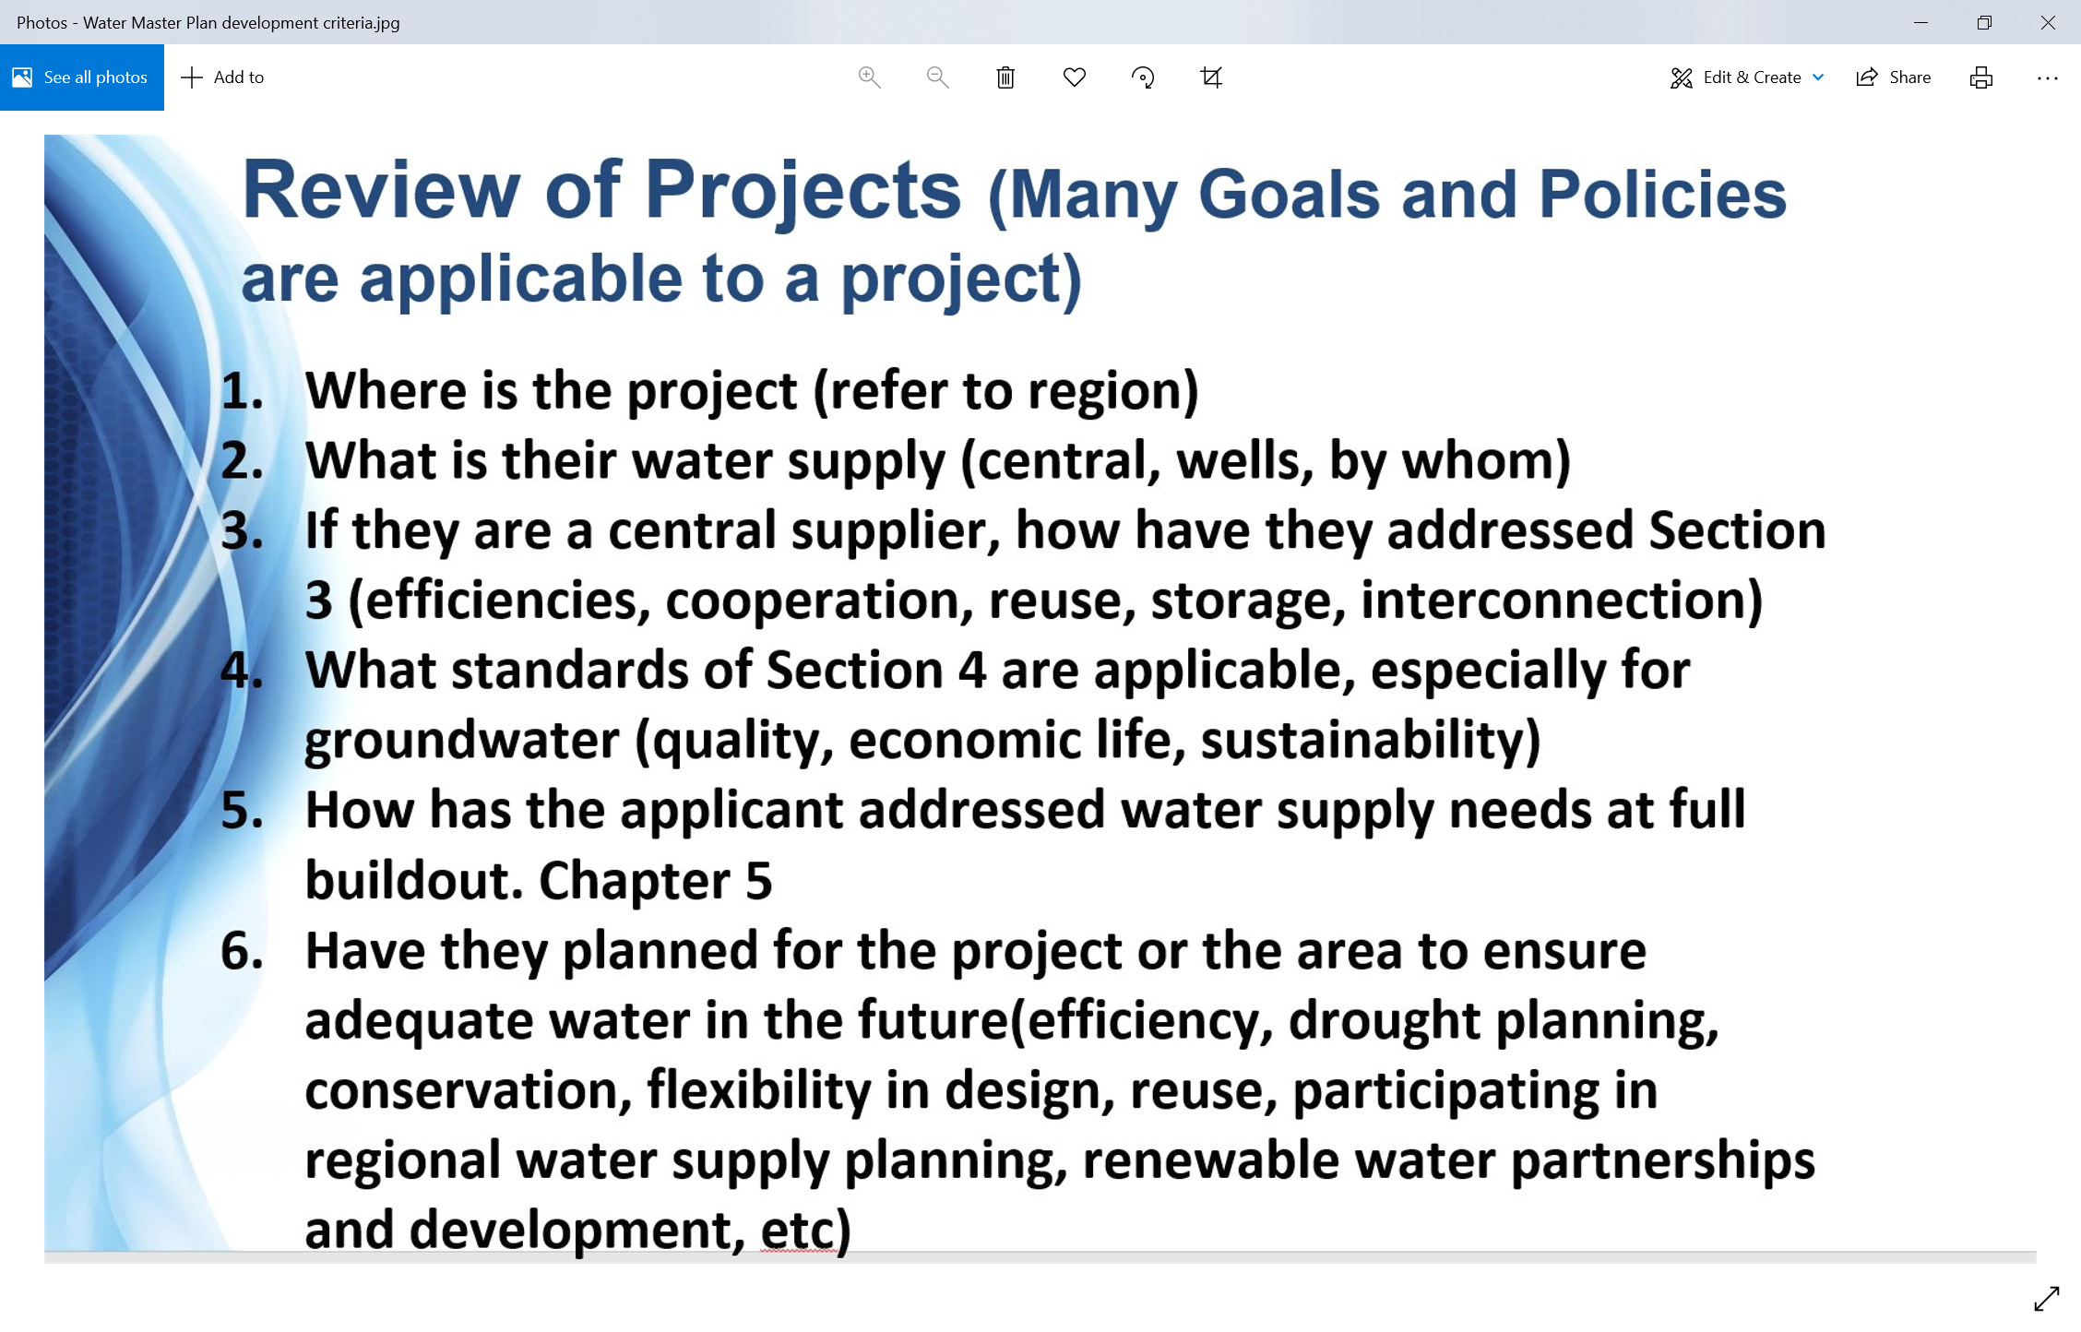
-Please depict answers to #1-6 in the letter of intent
-Applicant required to account for water availability for the next 300 years. This may include working with a water attorney an the Colorado Water Court to meet the County’s mandate.
https://assets-planningdevelopment.elpasoco.com/wp-content/uploads/WaterMasterPlan2018/Water-Master-Plan-2018-A-Copy.pdf

Wildlife impact
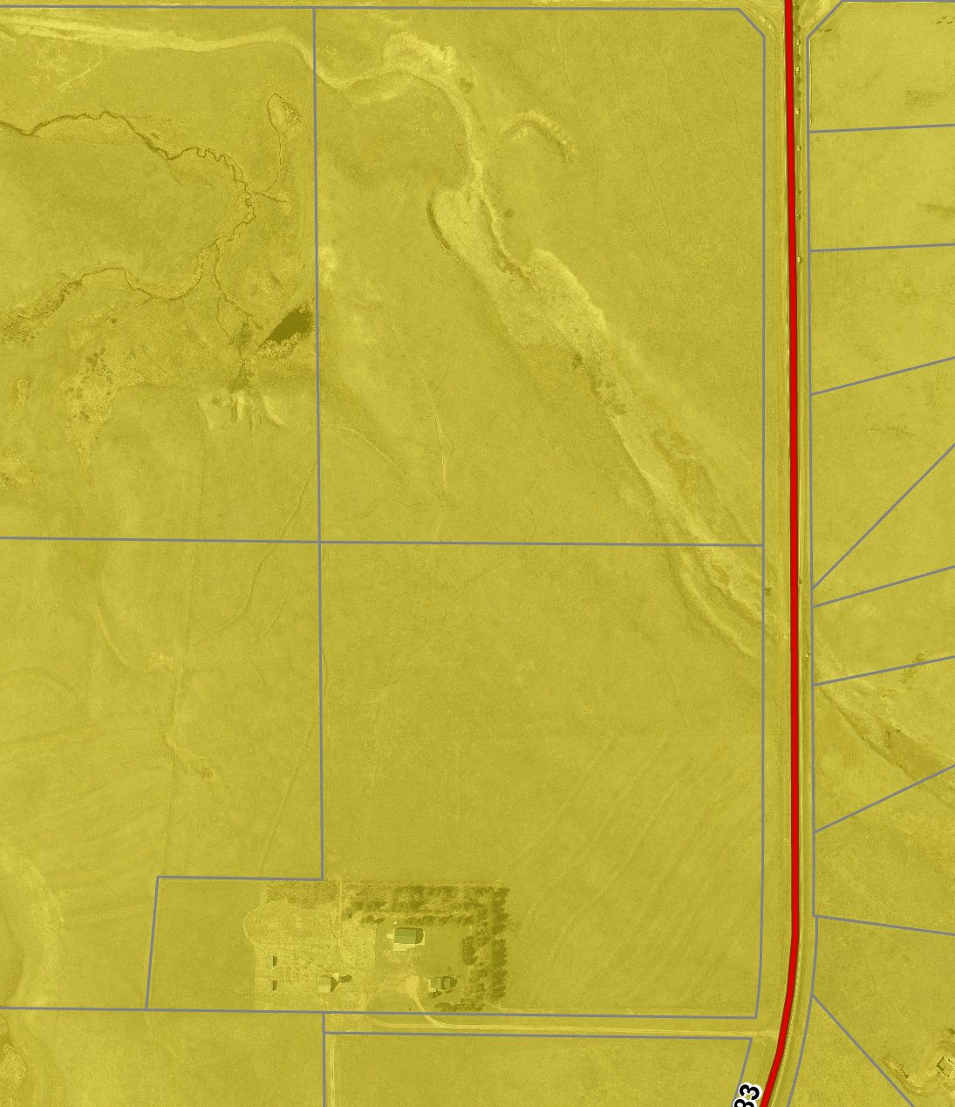
- 3 – moderate
- natural features report

Parks Master Plan:
Parks Administration Office
(719) 520-7529
Parks@elpasoco.com

https://communityservices.elpasoco.com/parks-planning/

Helpful Links

Planning Website: https://planningdevelopment.elpasoco.com/

El Paso County Master Plan: https://planningdevelopment.elpasoco.com/#1510603950097-f5d985dc-35b2
Parks, Mineral and Water Master Plan: https://planningdevelopment.elpasoco.com/resources-and-references/#1516982531779-52cc0e87-01af

Forms and Templates: https://planningdevelopment.elpasoco.com/planning-development-forms/#1510677560407-ff8cfff5-69b2716b-00f9cbba-0c21

Land Development Code: https://library.municode.com/co/el_paso_county/codes/land_development_code

EDARP: https://epcdevplanreview.com/

Public GIS: https://elpasoco.maps.arcgis.com/apps/View/index.html?appid=5be6431018594c67b035ad0aad3e7e8a

Wrap Up
-If subdivision is proposed, recording fees, park and school fees and road impact fees apply.
-Fees are subject to change. The fees at the time of application apply.
-Pursuant to the adopted El Paso County Road Impact Fee Program (Resolution No. 12-382), a transportation impact fee, calculated on a per trip basis, may be due at the time of building permit issuance. Starting January 1, 2020 the transportation impact fee will be due for all new construction (Resolution No. 19-471).
-The fee for any additional waiver/deviation requests (more than two) - $550.00 each. Please note that requests for waivers and/or deviations may result in additional processing/review delay.
-All items requested must accompany the submittal for it to be complete, prior to payment request or the submittal will not be complete and ready for review agencies.
-A temporary use permit shall be applied for and approved for any staging area associated with development, such as a sales office, construction trailer, or contractor's equipment yard, prior to scheduling of the pre-construction meeting with El Paso County Planning and Community Development. If a Planned Unit Development is proposed, the temporary staging area should be shown on the development guideline and phasing plan.
-All prospective timelines for review are subject to departmental staffing and workload.
-Early Assistance is valid for 12 months from submittal of the EA application. If a project submittal is not received within 12 months, a new EA meeting may be required. An audio/video copy of the meeting is available in EDARP within the EA folder.

- Applications scheduled for public hearings may be heard as a regular item at the request of staff or a hearing body member.

- Any comments or commitments made by any member of the County Staff during this early assistance meeting are only preliminary in nature and should not be relied upon by the applicant. All prospective applicants should be informed that formal comments cannot be made by staff until after the application is submitted.

