Early Assistance Meeting Number: EA2698
Project Name: Proposed Lot Size Reduction (Administrative Relief) and Boundary Line Adjustment for 13050 Holmes Rd
Project Location: 13050 &13030 HOLMES RD
Project Parcel Nos. 6212000013 6212000014
Project Description: To discuss a proposed Boundary Line Adjustment and subsequent Administrative Relief request for my property located at 13050 Holmes Rd, Colorado Springs, CO 80908 (currently an 8.4-acre parcel zoned RR-5). Prior to finalizing a pending real estate transaction to acquire an adjacent 0.77-acre parcel, I am seeking staff’s preliminary guidance on a proposed subdivision configuration designed to maximize compliance with the RR-5 dimensional standards. The proposed conceptual plan involves combining my current 8.4-acre lot with the adjacent 0.77-acre lot (totaling 9.18 acres) and subdividing the new footprint to create the following: 1. West Lot (Vacant): A 100% conforming 5.0-acre parcel with frontage on Crump Rd. 2. East Lot (Existing Residence): A 4.18-acre parcel containing the existing primary residence, well, and septic system with frontage on Holmes Rd.
Meeting Date: 08/20/26

El Paso County Planning & Community Development Planning Checklist

Request – Map Provided by Applicant
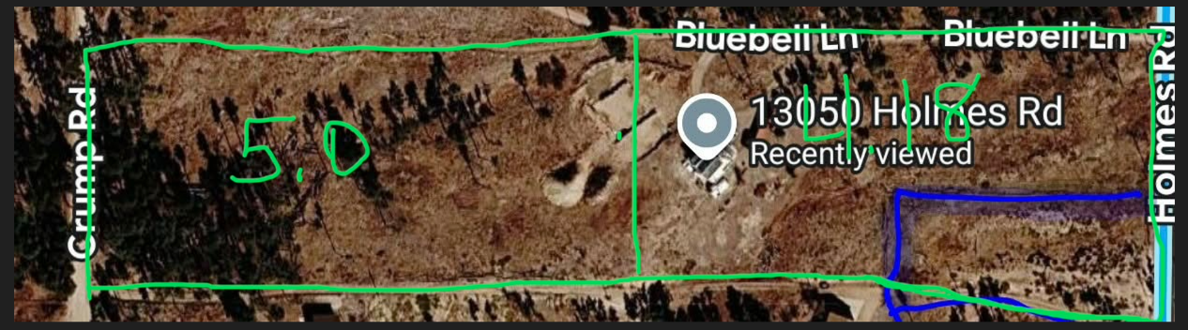

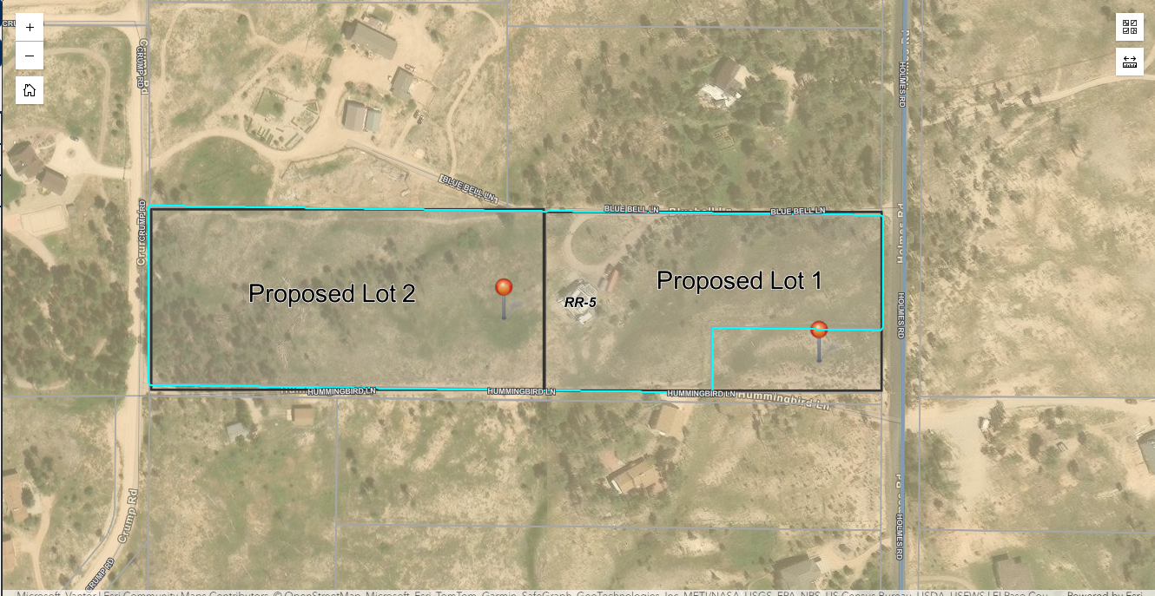

Zoning
Existing Zone(s)
Zone |  | Name
RR-5 |  | Residential Rural
Proposed Zone(s)
Zone |  | Name
RR-2.5 |  | Residential Rural

Zone Map (existing conditions of approval)
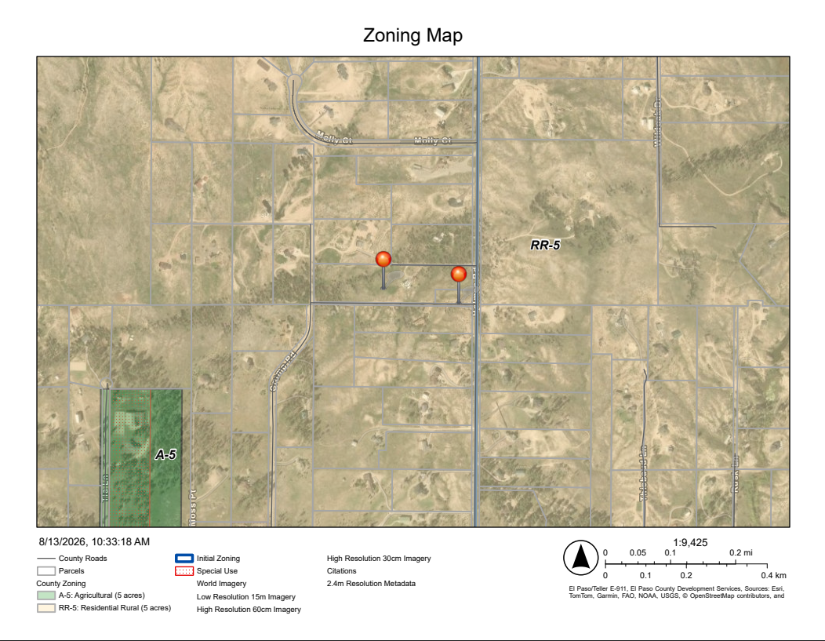

Parcel/Zoning Analysis
EP7305094 1973 Board of Adjustment dimensional variance request “To allow a single family dwelling on a approx. ¾ of an acre where 5 acres required”. There is no approval resolution or letter of approval. This request was denied, however the EDARP project file is incomplete and does not contain an outgoing denial letter.

EP7503024 1975 Board of Adjustment dimensional variance request “To allow a dwelling on approx. ¾ acre where 5 acres are required”. The request was denied. 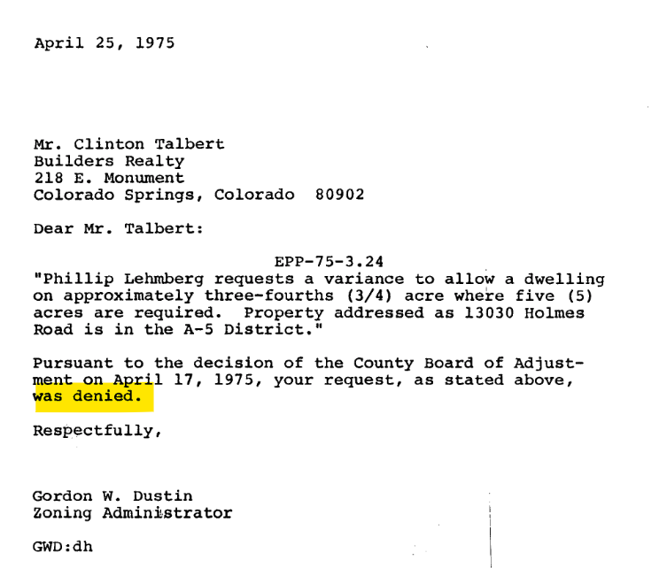

BOA91007 1991 Board of Adjustment dimensional variance request to build a house on a parcel where 5-acres are required. Request was denied.

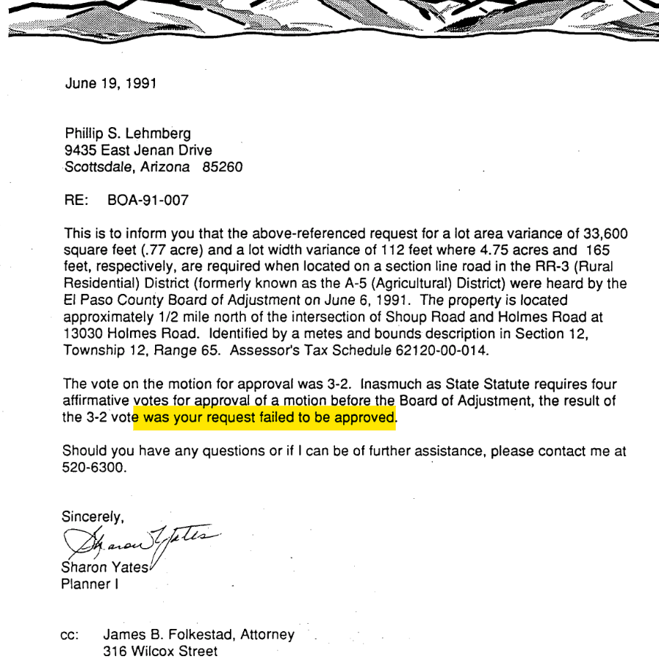

BOA92003 1992 Board of Adjustment dimensional variance due to 5-acre lot size requirement per RR-3 (5-acre zoning). Request was denied. The parcel size was increased to 1.36 acres which is not reflected today. At some point the parcel was reduced to it original .77 acre configuration.
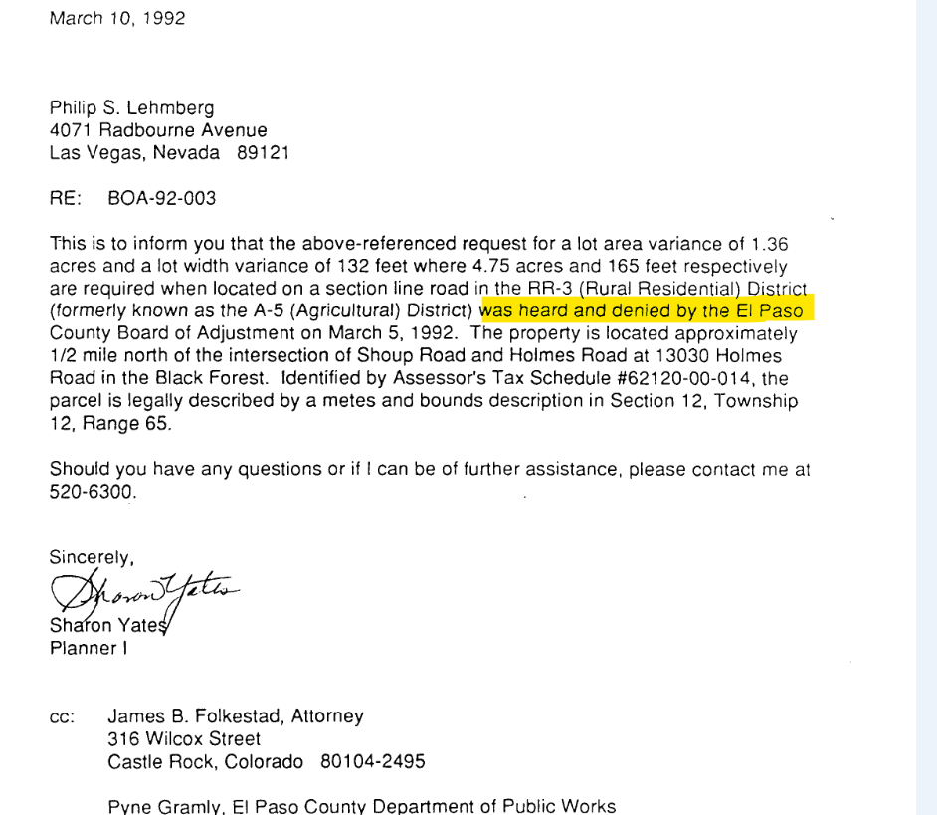

BOA95044 1995 Board of Adjustment dimensional variance due to 5-acre lot size requirement. Request was denied.
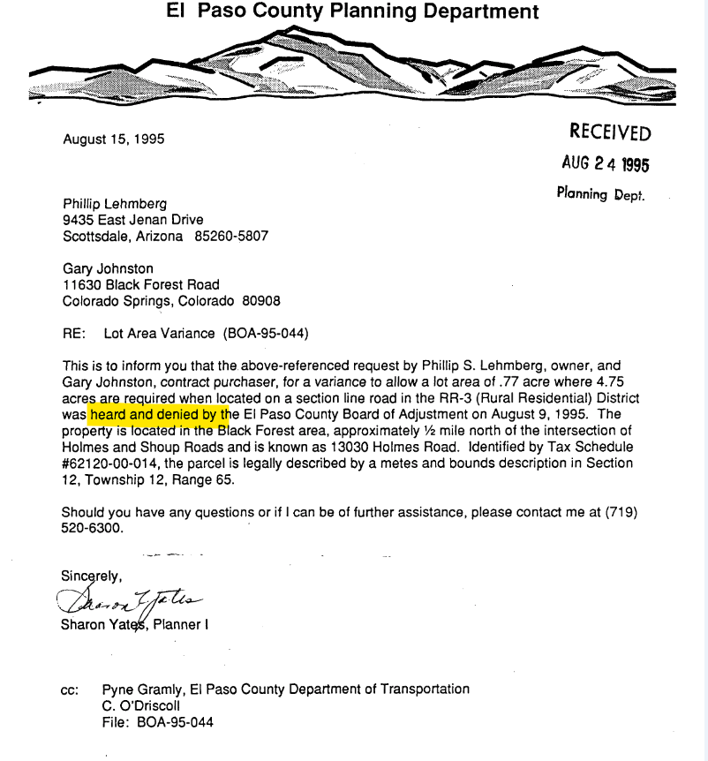

The RR-5 zoning district has a minimum 5-acre lot size requirement but does permit 4.75 if located on a section line road. This property has historically been in 5-acre lot size minim zoning districts.

5.5.1. Administrative Relief
- Purpose. The purpose of this Section is to provide for flexibility in the application of regulations when a standard is inapplicable or inappropriate to a specific use or design proposal or a minor problem arises with the strict application of development standards.

- PCD Authorized to Grant Administrative Relief. The PCD Director may approve administrative relief to the requirements for lot area, front, side and rear setbacks, and height limitation. Administrative relief shall be for the purpose of relieving difficulties or hardships due to narrowness, shallowness, shape or topographic condition of a specific piece of property, or to provide limited flexibility to lot standards when it is determined that no substantial detriment to the public good nor harm to the general purpose and intent of this Code will be caused by the administrative relief granted.

(D) Findings Necessary to Grant Administrative Relief:
(1) Criteria to be Met. To grant administrative relief, all of the following criteria shall be met, in addition to the compliance with the other applicable development standards:
• The strict application of the standard in question is unreasonable or unnecessary given the development proposal or the measures proposed by the applicant; or that the property has extraordinary or exceptional physical conditions that do not generally exist in nearby properties in the same zoning district;
• The intent of this Code and the specific regulation in question is preserved;
• The granting of the administrative relief will not result in an adverse impact on surrounding properties; and
• The granting of the administrative relief will not allow an increase in the number of dwelling units on a parcel.

Compelling evidence must be provided as to how this criterion is being met. To start, the allowance of admin relief would increase the number of dwelling units on a parcel thus not being in conformance with the approval criteria.

Rezoning will be required.

Zoning District Requirements (density, lot size, lot design standards, building setbacks)
^{2 RR-5} In the event that the land to be partitioned, platted, sold or zoned abuts a section line County road, the minimum lot area for lots abutting the road shall be 4.75 acres and minimum lot width shall be 165 ft. 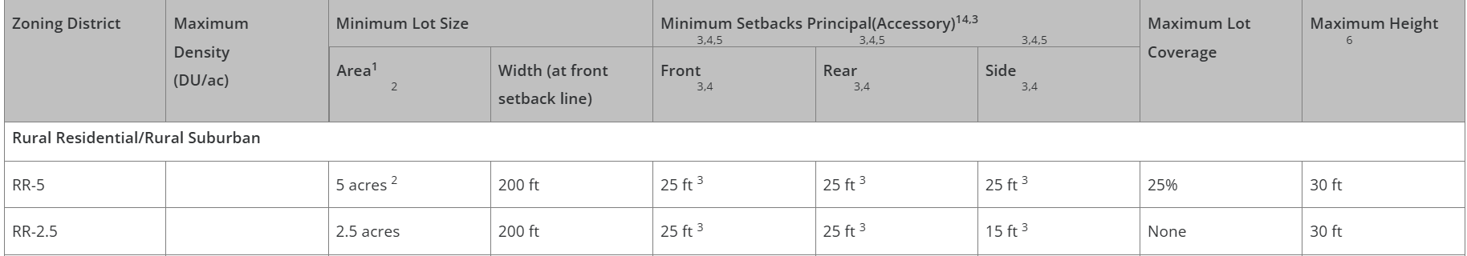

Plat Map or Parcel Map:
The properties are not platted and defined in metes and bounds. Upon research from the Assessor parcel deed record system I could not verify when the two parcels were created. Specifically to this proposal the legal lot status does not impact development because the two parcels are being combined and must meet today’s LDC regulations.

Application Type(s) Hearing: Required/ Optional/ No
Rezoning (Map Amendment) | Yes
Final Plat (Subdivision) | Yes

Approval Criteria:
Land Development Code Section 5.3.5. Map Amendment (Rezoning)
(B) Criteria for Approval. In approving a Map Amendment, the following findings shall be made:
- The application is in general conformance with the El Paso County Master Plan including applicable Small Area Plans or there has been a substantial change in the character of the neighborhood since the land was last zoned;
- The rezoning is in compliance with all applicable statutory provisions, including but not limited to C.R.S. § 30-28-111 § 30-28-113, and § 30-28-116;
- The proposed land use or zone district is compatible with the existing and permitted land uses and zone districts in all directions; and
- The site is suitable for the intended use, including the ability to meet the standards as described in Chapter 5 of the Land Development Code, for the intended zone district.

Final Plat/Preliminary Plan approval criteria:
- The proposed subdivision is in general conformance with the goals, objectives, and policies of the Master Plan.
- The subdivision is consistent with the purposes of the Land Development Code (“Code”).
- The subdivision is in conformance with the subdivision design standards and regulations and meets all planning, engineering, and surveying requirements of the County for maps, data, surveys, analysis, studies, reports, plans, designs, documents, and other supporting materials.
- A sufficient water supply has been acquired in terms of quantity, quality, and dependability for the type of subdivision proposed, as determined in accordance with the standards set forth in the water supply standards [C.R.S. § 30-28-133(6)(a)] and the requirements of Chapter 8 of the Code.
- A public sewage disposal system has been established and, if other methods of sewage disposal are proposed, the system complies with state and local laws and regulations, [C.R.S. § 30-28-133(6) (b)] and the requirements of Chapter 8 of the Code.
- All areas of the proposed subdivision, which may involve soil or topographical conditions presenting hazards or requiring special precautions, have been identified and the proposed subdivision is compatible with such conditions. [C.R.S. § 30-28-133(6)(c)].
- Adequate drainage improvements complying with State law [C.R.S. § 30-28-133(3)(c)(VIII)] and the requirements of the Code and the Engineering Criteria Manual (“ECM’”) are provided by the design.
- The location and design of the public improvements proposed in connection with the subdivision are adequate to serve the needs and mitigate the effects of the development.
- Legal and physical access is or will be provided to all parcels by public rights-of-way or recorded easement, acceptable to the County and in compliance with the Code and the ECM.
- The proposed subdivision has established an adequate level of compatibility by (1) incorporating natural physical features into the design and providing sufficient open spaces considering the type and intensity of the subdivision; (2) incorporating site planning techniques to foster the implementation of the County's plans, and encourage a land use pattern to support a balanced transportation system, including auto, bike and pedestrian traffic, public or mass transit if appropriate, and the cost effective delivery of other services consistent with adopted plans, policies and regulations of the County; (3) incorporating physical design features in the subdivision to provide a transition between the subdivision and adjacent land uses; (4) incorporating identified environmentally sensitive areas, including but not limited to, wetlands and wildlife corridors, into the design; and (5) incorporating public facilities or infrastructure, or provisions therefor, reasonably related to the proposed subdivision so the proposed subdivision will not negatively impact the levels of service of County services and facilities.
- Necessary services, including police and fire protection, recreation, utilities, open space and transportation system, are or will be available to serve the proposed subdivision.
- The subdivision provides evidence to show that the proposed methods for fire protection comply with Chapter 6 of the Code.
- The proposed subdivision meets other applicable sections of Chapters 6 and 8 of the Code.
- Off-site impacts were evaluated, and related off-site improvements are roughly proportional and will mitigate the impacts of the subdivision in accordance with applicable requirements of Chapter 8 of the Code.
- Adequate public facilities or infrastructure, or cash-in-lieu, for impacts reasonably related to the proposed subdivision have been constructed or are financially guaranteed through the SIA so the impacts of the subdivision will be adequately mitigated.
- The extraction of any known commercial mining deposit shall not be impeded by this subdivision [C.R.S. §§ 34-1-302(1), et seq.].
*Please note this is not a full list of the code provisions, expectations, and requirements, including fire code regulation. Please refer to the full Land Development Code.

Processing Issues and Options
Access easements and maintenance for other lot owners must be clearly defined on the plat/maintenance agreements etc.

Design and Landscaping

Site Design/Layout (Lot pattern, circulation/road design, open space, preservation of natural features, compatibility internally and with adjacent land uses)

Site Characteristics\ Constraints\ Environmental Standards:
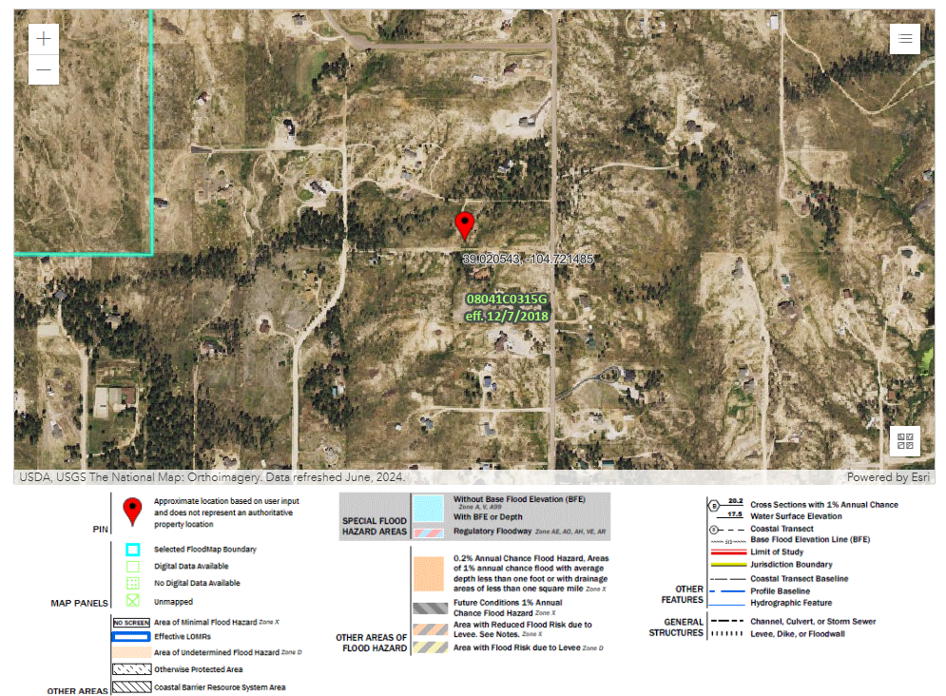
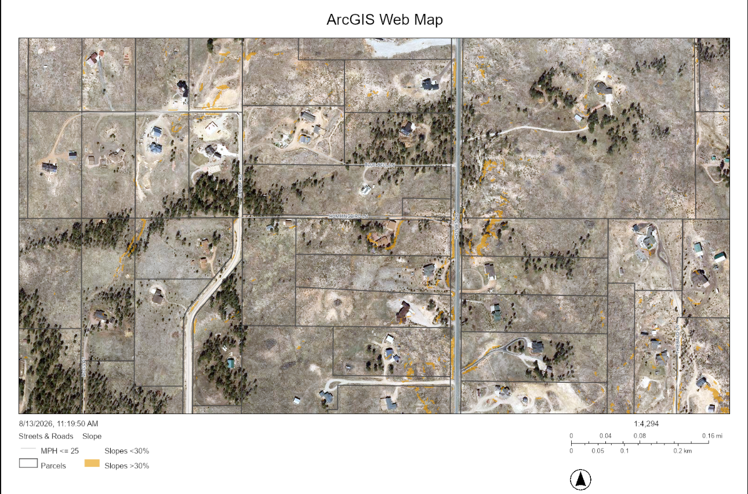

☐ | 30% or greater slope | Topography:
☒ | CGS review required (separate fee to CGS) | Soils/geology: |  | A soils and geology report is required. The report will be reviewed by EPC staff and the Colorado Geological Survey.
☐ | Floodplain | Floodplain comment: |  | No floodplain
☐ | Noise mitigation required | Noise comment:
☐ | Preble’s mouse

Districts
Taxing Entities
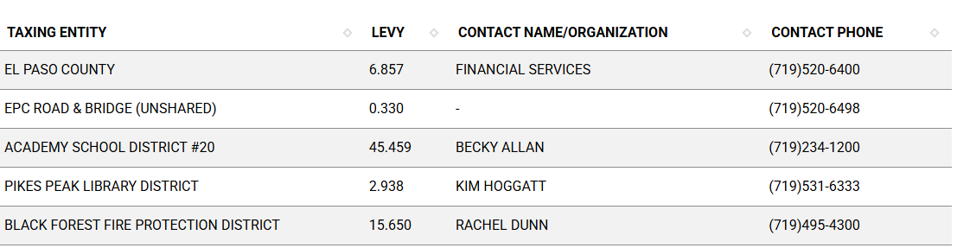
Proposed source of water |  |  | Proposed method of wastewater disposal
☐ | Central System |  | ☐ | Central System
District Name: |  |  | District Name:

Water/wastewater comments
The State of Colorado required a 100-year water sufficiency finding and El Paso County requires a 300-year water sufficiency finding for each new lot being created. HOA or covenants are required to demonstrate how the water rights are being conveyed. Lastly, the water must be shown to be of acceptable drinking quality and receive endorsement from the EPC Public Health Department.

8.4.7 (4)(a) General Provisions.
The Planning Commission shall, as part of its deliberations, make a recommendation regarding the sufficiency of the proposed water supply. The BoCC shall determine the sufficiency of the proposed water supply in terms of quantity, dependability, and quality based on the information presented and the recommendation of the Planning Commission.

In determining the sufficiency of a proposed water supply, the BoCC shall, at a minimum, consider the Water Resources Report, data and recommendations from the State Engineer's Office, CAO, EPCPH, and the County staff, the recommendations of the Planning Commission, and public comment. In all cases the burden of proof in demonstrating sufficiency rests with the applicant, and it shall be the applicant's sole responsibility to document in the Water Resources Report that the proposed water supply is sufficient in terms of quantity, dependability, and quality.

8.4.7 (B)(1) Water Resource Report.
(b) Water Resources Report Required. A water resources report as required by this Section shall be submitted with sketch plan, preliminary plan, final plat, and any subdivision applications which will create a new lot. A copy of the report will be kept on file in the El Paso County PCD.
(c) Prepared by Qualified Professional. The water resources report shall be prepared by a qualified hydrogeologist, hydrologist, licensed civil engineer, qualified groundwater geologist, or other qualified professional with appropriate experience.
(d) Document Adequate Water Supply. The Water Resources Report shall include adequate documentation that the proposed water supply is sufficient in terms of quantity, dependability, and quality for the proposed subdivision.

(c) Final Plat and Replat Report. The water resource report submitted with the final plat shall include all of the data needed to determine whether the proposed water supply is sufficient in terms of quality, quantity and dependability for the type of subdivision proposed. The report shall be based on engineering calculations and site-specific data and shall include a detailed discussion of the water demand, supply, quality, dependability, and supply facilities for the proposed subdivision.
A water resources report is not required if the BoCC made a finding that the proposed water supply plan of the preliminary plan was sufficient in terms of quantity, quality and dependability. However, an amended water resources report is required if there is a substantial change in either the water supply or the estimated water demand.

8.4.7(B)(5) Finding of Sufficient Dependability. The proposed water supply shall meet the following criteria to be found sufficient in terms of dependability:
- The supply is of sufficient quantity to meet the needs of the proposed subdivision for 300 years;
- The proposed water supply system and water supply is capable of meeting the average annual and peak daily demand of the proposed subdivision; and
The applicant has provided adequate evidence of ownership or the right of acquisition or use of existing or proposed water rights sufficient in quantity, dependability, and quality to serve the proposed uses within the subdivision; and (1) the legal capability to accomplish any changes in the uses or points of diversion of the rights with quantities and dependability necessary to serve the proposed subdivision without material injury to vested water rights; or (2) adequate evidence that the public or private water provider can and will supply the proposed subdivision with water of adequate quality, quantity and dependability.

8.4.8 Wastewater Disposal
(B) Minimum Standards.
(b) Compliance with EPCPH Regulations. All wastewater disposals systems shall comply with the EPCPH regulations and the CDPHE guidelines, as applicable.
i. An OWTS with design capacity less than or equal to 2,000 GPD must comply with regulations adopted by El Paso County Board of Health (EPCBoH) pursuant to this regulation and the OWTS Act. Within the jurisdiction of EPCBoH and EPCPH, the regulations promulgated by the EPCBoH govern all aspects of OWTS permits, performance, location, construction, alteration, installation, and use.
ii. An OWTS with design capacity greater than 2,000 GPD must comply with this regulation, site location and design approval in section 25-8-702, C.R.S., and the discharge permit requirements in the Water Quality Control Act, 25-8-501, et seq. C.R.S. OWTS with design capacity greater than 2,000 GPD must also comply with Appendix B of this Code.

(c) Favorable Recommendation from EPCPH Required. The EPCPH is considered the County's expert concerning the adequacy of a proposed sewage treatment system. No sketch or preliminary plan or final plat shall receive the approval of the BoCC unless EPCPH has made a favorable recommendation regarding the proposed method of sewage disposal.

(2) 2 OWTS Sites Required for All Lots or Parcels. All lots shall be designed to ensure that each lot has a minimum of 2 sites appropriate for OWTS which do not fall in the restricted areas identified on the preliminary plan; soils and geology report delineated wetland or floodplain maps; or other reports required under this Code.

8.4.3.B.f Lots Using OWTS.
(i)Lots Designed to Use an OWTS. Lots which will utilize an OWTS shall have a minimum area of 2.5 acres.
(ii)Minimum Buildable Area for Lots Using an OWTS. A minimum of 1 acre of buildable area is required for lots proposed to utilize an OWTS.

Fire District:
Black Forest Fire Protection District
(719)495-4300
https://www.bffire.org/

Wildland Fire and Hazard Mitigation Plan:
The 2025 Colorado Wildfire Resiliency Code Map is used to determine the fire intensity
classification for a given location. The 2025 Colorado Wildfire Resiliency Code Map replaces the Vegetation Map/Fire Hazard Vegetation Classification layer in GIS as of July 1, 2026. Link to the map:
https://experience.arcgis.com/experience/34c113129c044004bc672ca5493378de/page/Page

The fire intensity classifications consist of low, moderate, and high.
- Low intensity areas (Yellow areas on the map) must meet Class I requirements of the WRC.
- Moderate and high intensity areas (Orange and Red areas on the map) must meet Class I and Class II requirements of Appendix E.

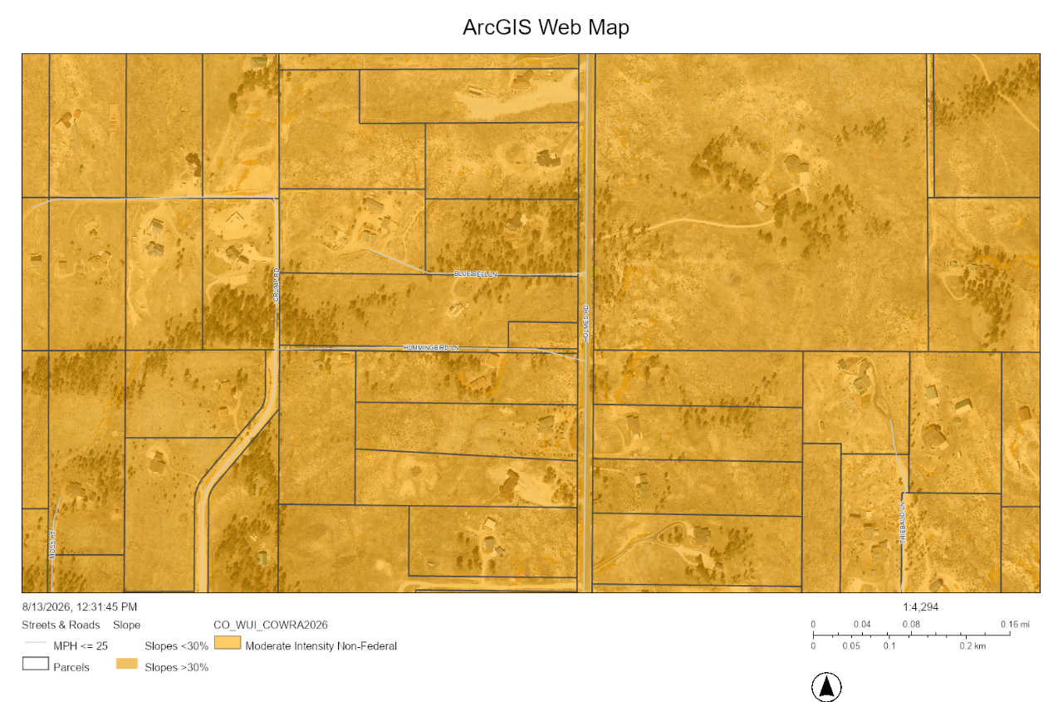
A Wildland Fire & Hazard Mitigation Plan is required.

Emergency Services Issues:

Commissioner District: 1

Code Waivers:
Subdivision waivers are approved by the BoCC and are requested within the letter of intent at time of application submittal.

7.3.3. Criteria for Approval of Waivers
A waiver from standards shall be approved only upon the finding, based upon the evidence presented in each specific case, that:
- The waiver does not have the effect of nullifying the intent and purpose of this Code;
- The waiver will not result in the need for additional subsequent waivers;
- The granting of the waiver will not be detrimental to the public safety, health, or welfare or injurious to other property;
- The conditions upon which the request for a waiver is based are unique to the property for which the waiver is sought and are not applicable to other property;
- A particular non-economical hardship to the owner would result from a strict application of this Code;
- The waiver will not in any manner vary the zoning provisions of this Code; and
- The proposed waiver is not contrary to any provision of the Master Plan.

Parks and trails:
The 2022 El Paso County Parks Master Plan shows no impacts to existing or proposed parks, trails, or open space. As such no trail easement dedications will be necessary for this project. Regional park fees will be assessed upon review of the forthcoming platting actions.
It is not necessary for EPC Parks staff to attend this early assistance meeting.
Thank you!
Ashlyn Mathy
Parks Planner
Park Planning Division
El Paso County Parks Department
Office 719.520.6978

Road Impact Fee Program (PID Inclusion):
The road impact fee is a development fee administered by EPC Public Works Department. Typically, this fee is required at time of building permit.

Your El Paso Master Plan

Placetype: Large-Lot Residential
Character:
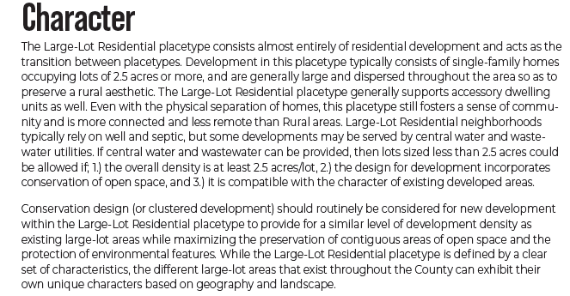

Recommended Land Uses:
- 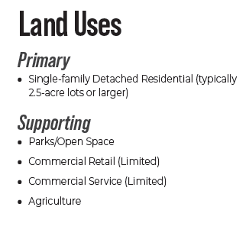

Goals, Objectives, Strategies:
The focus of Large-Lot Residential is intertwining residential uses with the County’s treasured natural environment without disruption or degradation.

2.5-acre lot recommendation.

Area of Change Designation: Minimal Change: Undeveloped
Description:
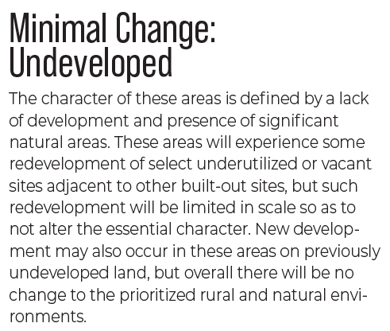

Goals, Objectives, Strategies:
The Minimal Change: Developed areas are likely to see more intense infill development with a mix of uses and scale of redevelopment that will significantly impact the character of an area. Regardless of the development that may occur, if these areas evolve to a new development pattern of differing intensity, their overall character should be maintained.

Key Area: Forested Aea

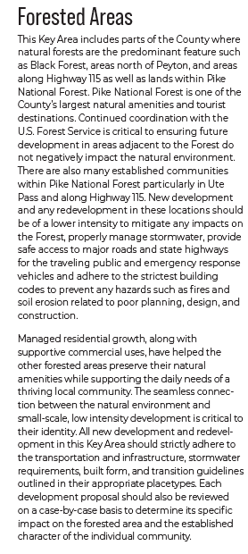

Goals, Objectives, Strategies:
All new development and redevelopment in the Forested Area should strictly adhere to the transportation and infrastructure, stormwater requirements, built form, and transition guidelines outlined in their appropriate placetypes. Each development proposal should also be reviewed on a case-by-case basis to determine its specific impact on the Forested Area and the established character of the individual community.

New development and any redevelopment in Forested Areas should be of a lower intensity to mitigate any impacts on the Forest, properly manage stormwater, provide safe access to major roads and state highways for the traveling public and emergency response vehicles and adhere to the strictest building codes to prevent any hazards such as fires and soil erosion related to poor planning, design, and construction.

Water Master Plan Area:
Region 2

Recommendations:
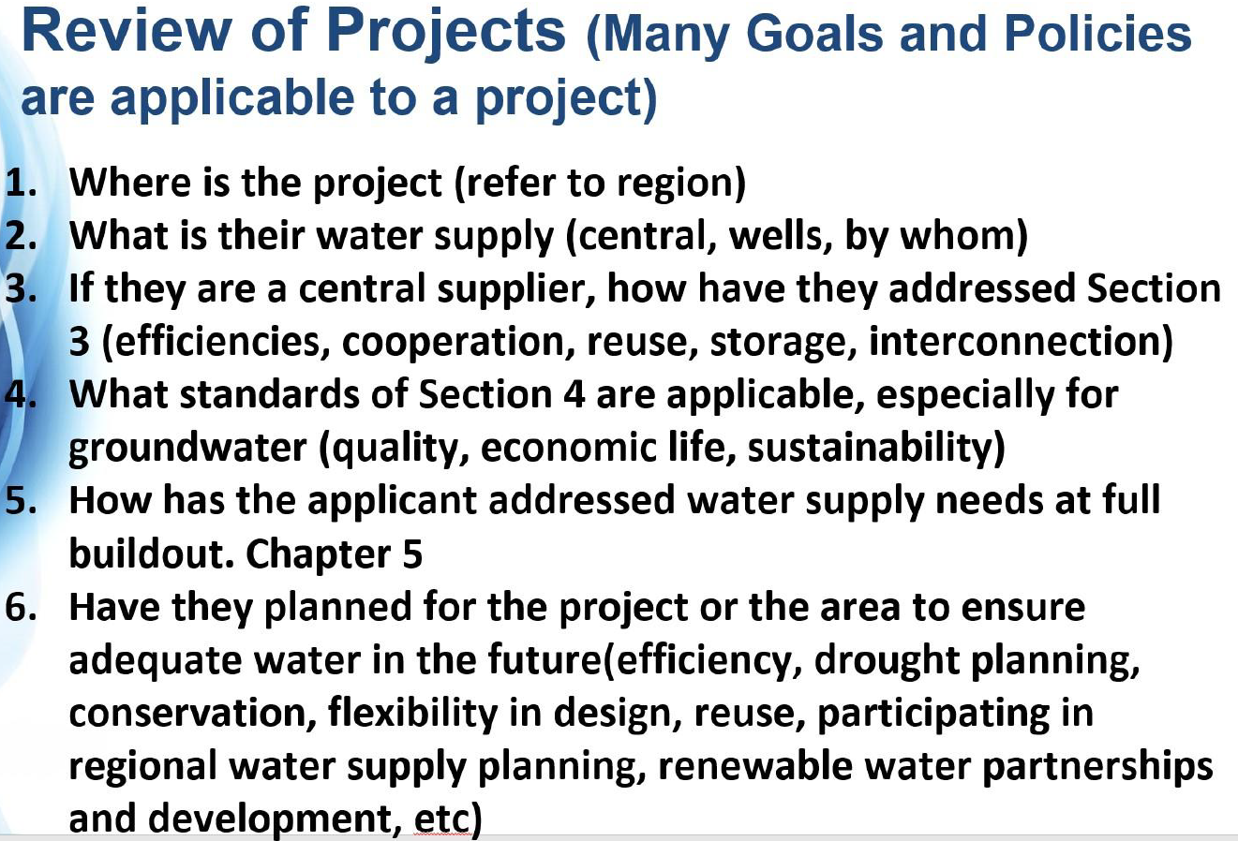

Wildlife impact
1-Low

Helpful Links

Planning Website: https://planningdevelopment.elpasoco.com/

El Paso County Master Plan: https://planningdevelopment.elpasoco.com/#1510603950097-f5d985dc-35b2
Water Master Plan: https://planningdevelopment.elpasoco.com/#1515613078151-9a697e85-b1a7
Parks Master Plan: https://parks.elpasoco.com/parks-and-recreation/park-planning/
Mineral Extraction Master Plan: https://planningdevelopment.elpasoco.com/#1515613078151-9a697e85-b1a7

Forms and Templates: https://planningdevelopment.elpasoco.com/forms-and-affidavits/

Applications and Checklists: https://planningdevelopment.elpasoco.com/applications-and-checklists/

Land Development Code: https://library.municode.com/co/el_paso_county/codes/land_development_code

EDARP: https://epcdevplanreview.com/

Public GIS: https://experience.arcgis.com/experience/94cea8ccda3d4806a3fd500d2b5a4433?draft=true

Wrap Up
-If subdivision is proposed, recording fees, park and school fees and road impact fees may apply.

-Fees are subject to change. The fees at the time of application apply.

-Road Impact Fees
Please see the following website for information on the EPC Road Impact Fee Project. https://publicworks.elpasoco.com/road-impact-fees/ to include fee schedule.
As of December 15, 2016, per Resolution 16-454, on and after January 1, 2020, property in the unincorporated area of the county that receives a Land Use Approval either in a public hearing or administratively, is subject to the payment of Road Impact Fees. After December 31, 2024, in accordance with BoCC Resolution 24-377 the fee is paid for new residential and non-residential uses and structures and expansions of non-residential uses and structures. Road Impact fees are typically paid at time of building permit. If no building permit is being obtained for a particular Land Use application, then Road Impact Fees must be paid at the time of Site Development Plan or Special Use approval. If there are questions about EPC Road Impact program or fees, please contact DPW Development Review Services and the Engineer of the Day.

- Engineering Criteria Manual (ECM) Deviations.
The fee for any additional ECM deviation requests (more than two per land use application) - $1483.00 each per current Fee Schedule. Please note ECM deviation requests may result in additional processing and project review time. ECM Deviations should be submitted prior to the initial Site Development Plan or Final Plat submittal to preclude changes having to be made to engineering plans and documents if the deviation is not approved. Submission of an ECM deviation request does not imply or guarantee that the deviation will be approved. An ECM Deviation form must be submitted to include complete exhibits and justification excluding cost with supporting engineering criteria. If there are questions about ECM Deviation requests, please contact DPW Development Review Services and the Engineer of the Day.

-The fee for any additional waiver/deviation requests (more than two) - $550.00 each. Please note that requests for waivers and/or deviations may result in additional processing/review delay.

-All items requested must accompany the submittal for it to be complete, prior to payment request or the submittal will not be complete and ready for review agencies.

-A temporary use permit shall be applied for and approved for any staging area associated with development, such as a sales office, construction trailer, or contractor's equipment yard, prior to scheduling of the pre-construction meeting with El Paso County Planning and Community Development. If a Planned Unit Development is proposed, the temporary staging area should be shown on the development guideline and phasing plan.

-All prospective timelines for review are subject to departmental staffing and workload.

-Early Assistance is valid for 12 months from submittal of the EA application. If a project submittal is not received within 12 months, a new EA meeting may be required. An audio/video copy of the meeting is available in EDARP within the EA folder.

- Applications scheduled for public hearings may be heard as a regular item at the request of staff or a hearing body member.

- Any comments or commitments made by any member of the County Staff during this early assistance meeting are only preliminary in nature and should not be relied upon by the applicant. All prospective applicants should be informed that formal comments cannot be made by staff until after the application is submitted.

