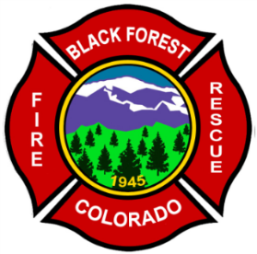
Black Forest Fire Rescue Protection District
11445 Teachout Road
Colorado Springs, Colorado 80908
Ph-719.495.4300
Fax 719.495.7504
Web- www.bffire.org

“Always Ready, Always Forward, Always Learning.”

FIRE PROTECTION REPORT
Friday, December 27, 2019

Mr. Brett Louk
SMH Consultants
411 South Tejon St. Suite I
Colorado Springs, Co, 80903

Mr. Louk,

The property located at 13235 Vollmer Road and the proposed lots at the address are within the boundaries of the Black Forest Fire/Rescue Protection District response area. Black Forest Fire/Rescue Protection District will continue to provide fire and emergency services to this development.
The Black Forest Fire Rescue Protection District is a participating member of a regional coalition of fire departments called the North Group. This group was designed to provide enhances response capabilities to all hazard incidents, including structure fires, using automatic and mutual aid agreements. The group consists of Black Forest Fire, Falcon Fire, Donald Wescott Fire, Tri-Lakes Monument Fire, Air Force Academy Fire, Colorado Springs Fire, Larkspur Fire and Palmer Lake Fire. The automatic and mutual aid agreements are solidified through an intergovernmental agreement between all entities. The initial response for a structure fire will be three 1250 GPM pumpers, 3 Tenders carrying 8500 gallons of water and one ladder truck. Additional apparatus will be called as needed from all our surrounding fire department partners.
Black Forest has an ISO rating of 5 overall and a 4 if within 1000 ft of a hydrant and 5 road miles from a station. Your property would be an ISO of 5 at this time. Your Primary response station would be BFFR station 1 which is located at 11445 Teachout road, approximately 3.7 miles from the station with a travel time of 4-5 minutes.

Any Questions may be directed to the Fire Chief or Deputy Fire Chief at 719-495-4300.

Respectfully,

James Rebitski
James Rebitski,
Deputy Chief
Black Forest Fire Rescue

