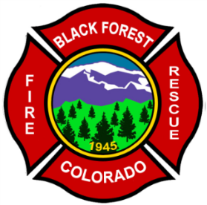
Black Forest Fire Rescue Protection District
11445 Teachout Road
Colorado Springs, Colorado 80908
Ph-719.495.4300
Fax 719.495.7504
Web- www.bffire.org

“Always Ready, Always Forward, Always Learning.”

FIRE COMMITMENT LETTER
Thursday, December 12, 2019

Brett Louk
SMH Consultants
411 South Tejon St. suite I
Colorado Springs, Co, 80903

Mr. Louk,

The Black Forest Fire Rescue Protection District currently provides fire protection and suppression services to approximately 50 square miles within the Black Forest to include your project on Vollmer Road. We will continue to provide emergency response and support for your project and the proposed 4 lots within the project.

Any Questions may be directed to the Fire Chief or Deputy Fire Chief at 719-495-4300.

Respectfully,

James Rebitski
James Rebitski,
Deputy Chief
Black Forest Fire Rescue

