Early Assistance Meeting Number: EA2644
Project Name: E. Las Vegas St. Land
Project Location: 2775 E. Las Vegas St
Project Parcel Nos. 6433400004
Project Description: The anticipated land purchaser (PLE, Inc.) desires to develop the site for as contractor yard with outdoor storage of contractor materials.
Meeting Date: 4/15/26 3:30

El Paso County Planning & Community Development Planning Checklist

Request – Map
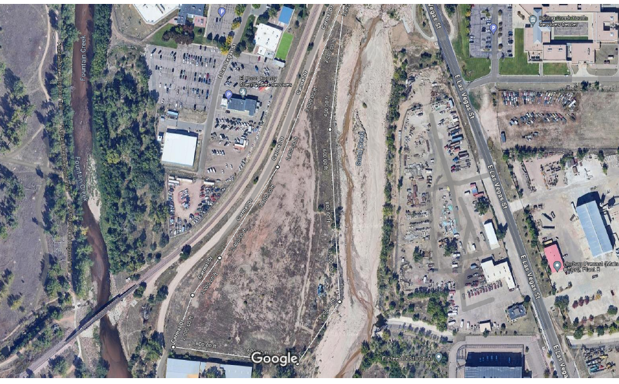
0’ Side
0’ Side
15’ front setback line
20’ rear setback

Zoning (check conditions of approval)
Existing Zone(s)
Zone |  | Name
M |  | Industrial (obsolete)
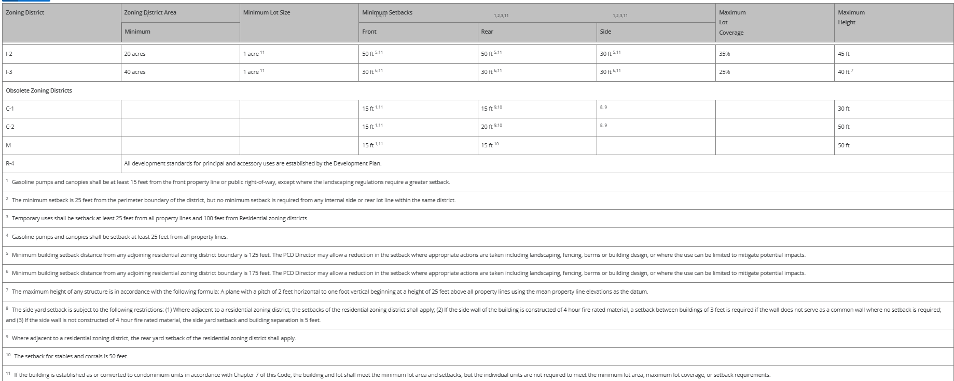

Zone Map
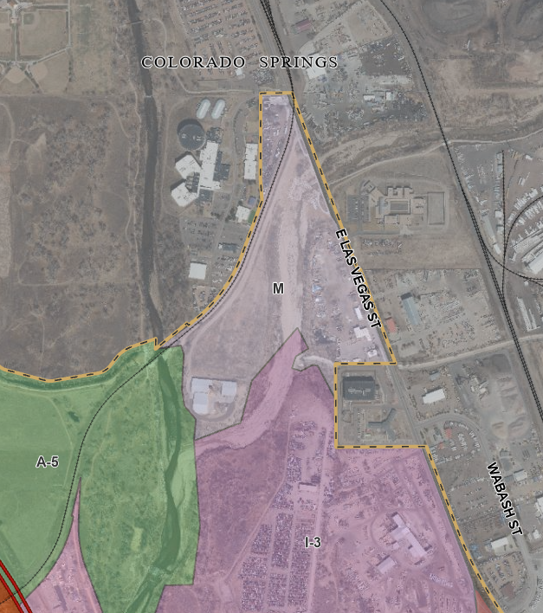

Zoning Analysis
Contractors Equipment Yard & Outside Storage is an allowed use in the M zoning district.

Per Section 4.1.4. Obsolete Zoning Districts
The C-1, C-2, M, and R-4 zoning districts have been declared to be obsolete. Landowners are encouraged to rezone land from an Obsolete Zoning district classification. The BoCC may offer incentives, such as modified application fees in order to accomplish this goal.

Zoning District Requirements (density, lot size, lot design standards, building
setbacks) 50’ height building; 15’ front & 20’ rear- no sides
fencing can be as tall as needed as long as it meets setbacks

See Section 5.2.37 of the LDC for the rules and regulations regarding outside storage. Must also meet M zone requirements.

Section 5.2.40 Outside Storage requirements.
(B) Outside Storage Standards. Outside storage shall meet the following standards.
(1) Materials to be Stored and Principal Use Required. Outside storage may include vehicles, raw materials, supplies, finished or semi-finished products or equipment used in conjunction with, and specifically accessory to, an allowed principal use conducted on the premises unless listed as a principal use. Outside storage of inoperable vehicles or equipment in a location other than the salvage yard is only permitted to the extent allowed in the Parking, Storage and Repair of Vehicles and Machines, Personal Section of Chapter 5 of this Code, provided the standards of that section are met. Employee or customer parking or outdoor sales and display areas shall not be considered outside storage.
(2) Materials Screened by Solid Fence or Vegetation. Outside storage shall be enclosed and concealed by a solid fence or wall at least 6 feet in height or any combination of berming, shrubs, trees fencing or walls which will provide at maturity a minimum of 6 feet of height and 100% opaque screening for the area utilized for outside storage.
(3) Outside Storage Not to Exceed Height of Screening. Outside storage or stacked materials shall not exceed the height of the screening fence except for operable vehicles, trailers, or other equipment designed to be towed or lifted as a single component.
(4) Storage of Equipment and Vehicles Exceeding Height of Fence. All equipment and vehicles exceeding the height of the fence shall be stored on the rear ⅓ of the property except when adjacent to a residential zoning district, in which case the equipment or vehicles shall be a minimum 50 feet from the residential zoning district boundary.
(5) Storage Adjacent to Road. Outside storage is allowed within the required setback area from a road provided that the storage area does not occupy more than 50% of the lineal frontage at the right-of-way.
(6) No Storage in Required Landscape Area. Outside storage shall not be allowed within any required landscaped area.
(7) Screening Fence Waived Between Adjacent Storage Areas. When outside storage areas abut each other and are not visible from public areas, administrative relief may be sought from the requirement for a solid fence between the outdoor storage areas. Alternative fencing likely: security with vinyl slats expected here as its isin heavy industrial area; adj to jail and Rail road.

(8) Salvage Yards and Solid Waste Landfills. Salvage yards and solid waste landfills are not regarded as outside storage, but salvage yards are required to meet the screening standards of this Section.
(9) Temporary Storage. Administrative relief from the outside storage standards may be sought in association with approved temporary uses.
(10) Landscaping Requirements to be Met. Outside storage shall comply with the landscaping requirements in this Chapter. Alternative plan- employee area creekwalk landscaping (internal landscape & parking); site is not adjacent to roads. Private driveway serves this parcel.
(C) Relationship to Site Development Plan. Outside storage areas shall be so identified on the site development plan prior to the establishment of the outside storage use.

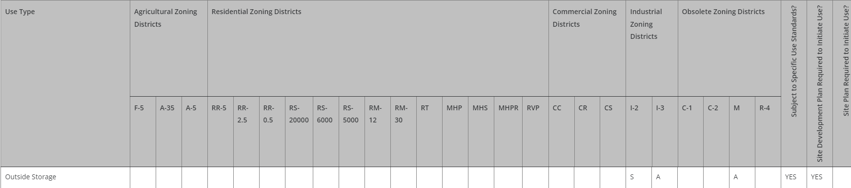

Map of Platted Lot/ Tract (check plat notes & conditions of approval):
Unplatted tract. EX74003 – subdivision exemption found that the tract is exempt from the requirements of Senate Bill 35 of 1972. No subdivision plat is required.

Application Type(s) Hearing: Required/ Optional/ No
Site Development Plan | No

Processing Issues and Options
Option exists to rezone but not required.
Sent request for review for potential annexation by City.

Phased PPR; outside storage/contractors' yard and then building possibly. CSU water connection; wastewater verses well and septic. Does have high producing water right 100g/m for industrial uses.

Relevant Past History:
Earliest property information through county assessor identifies property as created in April 1973.

EX74003 – subdivision exemption found that the tract is exempt platting requirements.

https://epcdevplanreview.com/Public/ProjectDetails/10868 property to the south site dev plan

Design and Landscaping

Site Design/Layout (Lot pattern, circulation/road design, open space, preservation of natural features, compatibility internally and with adjacent land uses)
Utilities are provided by Colorado Springs Utilities for gas and electric.

Landscaping
☐ | Expressway, Principal arterial area depth – 25’-Trees required 1 per 20’
☐ | Urban interchange/Intersection area depth – 25’- N/A
☒ | Minor arterial area depth 20’ – Trees required 1 per 25’
☐ | Non-arterial area depth 10’ – Trees required 1 per 30’
☐ | Parking lot landscaping required
☐ | Buffer between non-residential and residential districts separated by a non-arterial road or public alley  Zone Boundary Buffer

Section 5.2.40.B.10 – Landscaping required.

Revised Landscaping plan which was approved by the Board of County Commissioners earlier this year can be found here: https://epc-assets.elpasoco.com/wp-content/uploads/sites/12/LDC-Resolution/LDC-Clean-Final.pdf

Note – Section 6.2.1.C.1 – Fences and walls within a 100-year floodplain shall comply with the requirements of the Floodplain Regulations.

Section 6.2.1.D
(3) Fences and Walls Not to Disrupt Drainage. The fence and wall shall not be established where it would impede the drainage established by an approved drainage plan.
(4) Fences and Walls Not to Disrupt Use of Easement. The fence or wall shall not be established within an easement in a manner where the use of the easement is unnecessarily impeded.
Easements may be moved to discourage unhoused trespassing onto property.-ok

Section 6.2.1.F - Specific Fence Standards for Non-Residential Zoning Districts. The following requirements are applicable to fences within non-residential zoning districts:
(1) 7 Feet High Fences Allowed. Fences not exceeding 7 feet in height may be placed anywhere on the lot or parcel except no fence, wall or hedge shall exceed 30 inches in height when located within a sight distance triangle or as otherwise limited by Chapter 2 of the ECM.
(2) Security Fencing. Security fencing may include 3 strands of wire on top of the fence. The wires are not included in the height measurement.
(3) Subject to Parking, Landscaping, and Screening Standards. Walls and fences shall conform to the parking, landscaping, and screening standards of this Code.

(B) Outside Storage Standards. Outside storage shall meet the following standards.
(1) Materials to be Stored and Principal Use Required. Outside storage may include vehicles, raw materials, supplies, finished or semi-finished products or equipment used in conjunction with, and specifically accessory to, an allowed principal use conducted on the premises unless listed as a principal use. Outside storage of inoperable vehicles or equipment in a location other than the salvage yard is only permitted to the extent allowed in the Parking, Storage and Repair of Vehicles and Machines, Personal Section of Chapter 5 of this Code, provided the standards of that section are met. Employee or customer parking or outdoor sales and display areas shall not be considered outside storage.
(2) Materials Screened by Solid Fence or Vegetation. Outside storage shall be enclosed and concealed by a solid fence or wall at least 6 feet in height or any combination of berming, shrubs, trees fencing or walls which will provide at maturity a minimum of 6 feet of height and 100% opaque screening for the area utilized for outside storage. Alternative at 70% opaque expected here
(3) Outside Storage Not to Exceed Height of Screening. Outside storage or stacked materials shall not exceed the height of the screening fence except for operable vehicles, trailers, or other equipment designed to be towed or lifted as a single component.
(4) Storage of Equipment and Vehicles Exceeding Height of Fence. All equipment and vehicles exceeding the height of the fence shall be stored on the rear ⅓ of the property except when adjacent to a residential zoning district, in which case the equipment or vehicles shall be a minimum 50 feet from the residential zoning district boundary.
(5) Storage Adjacent to Road. Outside storage is allowed within the required setback area from a road provided that the storage area does not occupy more than 50% of the lineal frontage at the right-of-way.
(6) No Storage in Required Landscape Area. Outside storage shall not be allowed within any required landscaped area.
(7) Screening Fence Waived Between Adjacent Storage Areas. When outside storage areas abut each other and are not visible from public areas, administrative relief may be sought from the requirement for a solid fence between the outdoor storage areas.
(8) Salvage Yards and Solid Waste Landfills. Salvage yards and solid waste landfills are not regarded as outside storage, but salvage yards are required to meet the screening standards of this Section.
(9) Temporary Storage. Administrative relief from the outside storage standards may be sought in association with approved temporary uses.
(10) Landscaping Requirements to be Met. Outside storage shall comply with the landscaping requirements in this Chapter.
(C) Relationship to Site Development Plan. Outside storage areas shall be so identified on the site development plan prior to the establishment of the outside storage use.
(i) Site-Specific Landscaping Required. PCD Director approval of site-specific landscaping is required for establishing an outside storage area. Installation of approved site-specific landscaping is required prior to utilizing an outside storage area.
(ii) Site-Specific Landscaping Standards. The site-specific landscaping shall reflect a combination of berms, shrubs, trees, fences or walls which will provide, at maturity, a minimum 6 foot high, 100% opaque screening for the outside storage area.

Section 6.2.2.G.2.f - Limitations on Landscape Materials.
(i) The use of artificial vines, turf, or groundcovers as landscape material may be
allowed on a case-by-case basis where live landscaping materials may be at
risk or inappropriate due to land use, water availability, or location.

Signage:
6.2.10. Signs, On-Premise
(D) Regulations by Zoning District.
(2) Commercial and Industrial Zoning Districts.

Parking Requirements:
6.2.5. Parking, Loading and Maneuvering Standards
Vehicle Storage - 3 spaces minimum required;
Clearly depict parking for equipment types, employees, material types, loading areas, ADA

Lighting:
6.2.3. Lighting
Meet design standards and requirements listed in Section 6.2.3.B
Photometric Plan Required | ☒

Site Characteristics\ Constraints\ Environmental Standards:
Located in floodplain (see Engineering checklist for notes and requirements).

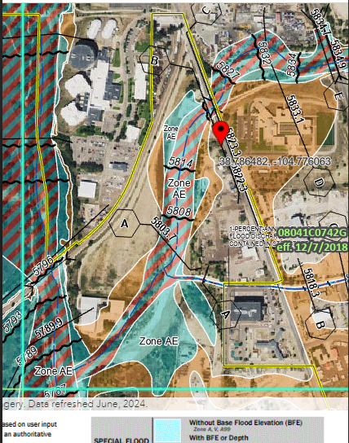

High Wildlife Impact Potential (Ranking – 4).

☐ | 30% or greater slope | Topography:
☐ | CGS review previous concerns discussed | Soils/geology:
☒ | Floodplain | Floodplain comment:
☐ | Noise mitigation required | Noise comment:
☐ | Preble’s mouse

Air/Visual Quality:
None. Similar surrounding land uses in higher intensity industrial area.

Districts

Taxing Entities
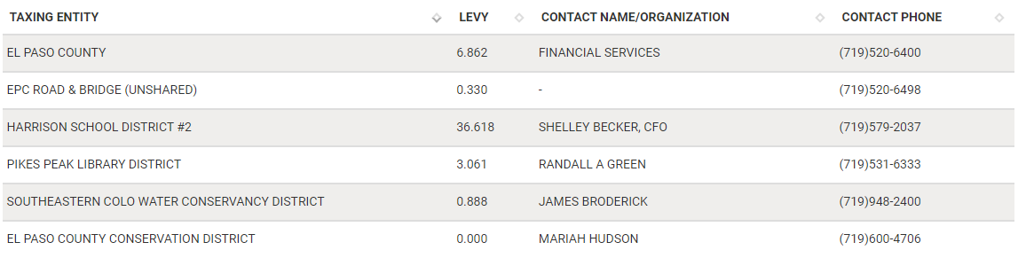
Road Impact Fees:
El Paso County Road Impact Fees apply to the property. See Engineering notes for traffic notes and requirements.

Proposed source of water |  |  | Proposed method of waste water disposal
☒ | Central System |  | ☒ | Central System
District Name: |  | CSU | District Name: |  | CSU

Fire District:
Colorado Springs Fire Department #11 (719) 385-5950 - contact to verify; El Paso County Fire Marshal (719) 4219564.

Fire District Design Concerns/Emergency Services Issues:
Access to site with security fencing; containment of any hazardous materials.

Wildland Fire Plan & Analysis by professional see PCD website not req by County per our map.. Check with CSFD on their requirements also. 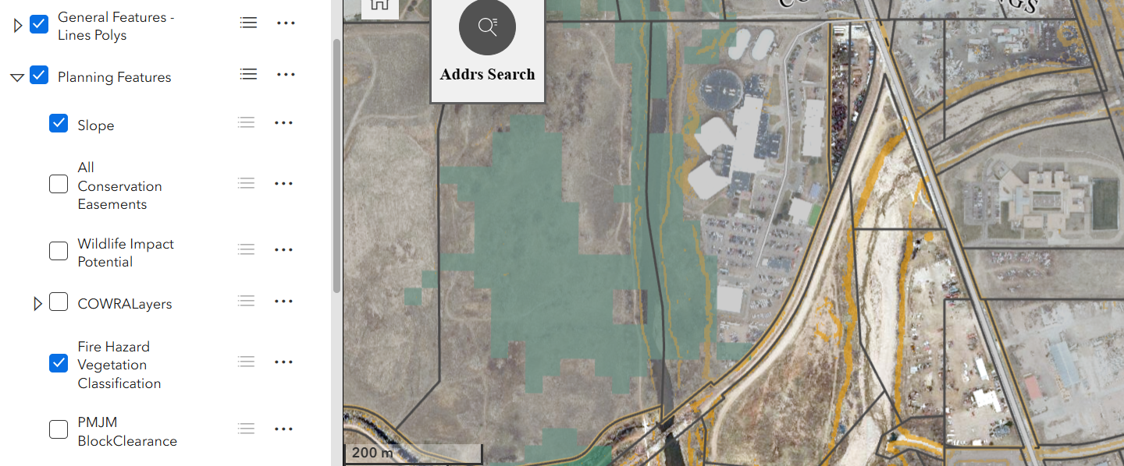
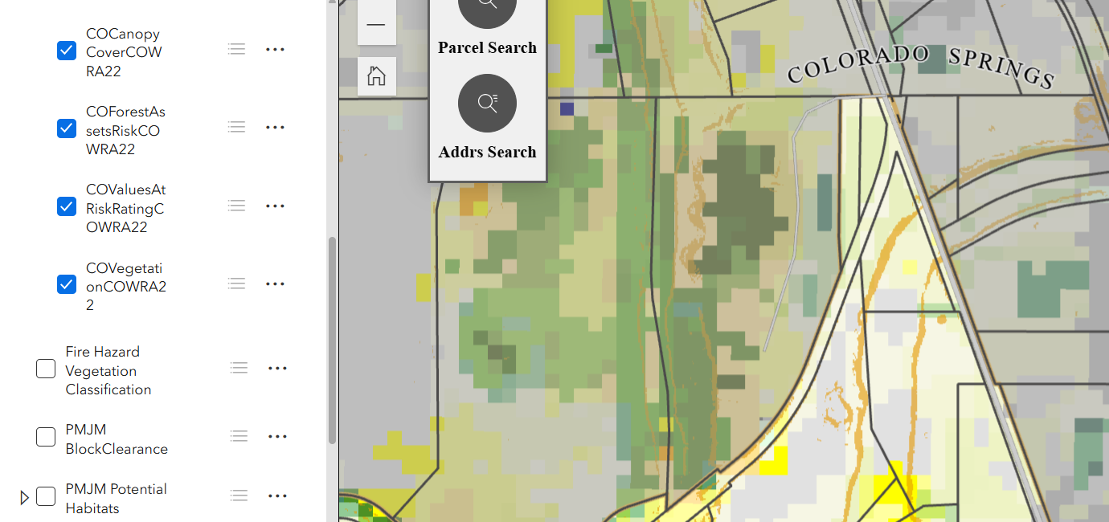
Commissioner District: 5

Parks and trails:
N/A

Annexations/Intergovernmental/ Jurisdictional Access issues:
Property is located adjacent to Colorado Springs jurisdiction. The City has been contacted regarding any interest in annexation.

Wrap Up
Helpful Links:

Engineering Docs: https://publicworks.elpasoco.com/department-public-works/county-engineer/

Stormwater Docs: https://publicworks.elpasoco.com/stormwater/

Planning Docs: https://planningdevelopment.elpasoco.com/planning-development-forms/#1510677560407-ff8cfff5-69b2716b-00f9cbba-0c21

Planning Website: https://planningdevelopment.elpasoco.com/

El Paso County Master Plan: https://planningdevelopment.elpasoco.com/#1510603950097-f5d985dc-35b2
Parks, Mineral and Water Master Plans: https://planningdevelopment.elpasoco.com/resources-and-references/#1516982531779-52cc0e87-01af

Land Development Code: https://library.municode.com/co/el_paso_county/codes/land_development_code

EDARP: https://epcdevplanreview.com/

Public GIS: https://elpasoco.maps.arcgis.com/apps/View/index.html?appid=5be6431018594c67b035ad0aad3e7e8a

Wrap Up:
- If subdivision is proposed, recording fees, park and school fees and road impact fees apply.
- Fees are subject to change. The fees at the time of application apply.
- Pursuant to the adopted El Paso County Road Impact Fee Program (Resolution No. 12-382), a transportation impact fee, calculated on a per trip basis, may be due at the time of building permit issuance. Starting January 1, 2020, the transportation impact fee will be due for all new construction (Resolution No. 19-471), as amended.
- The fee for any additional waiver/deviation requests (more than two) - $550.00 each. Please note that requests for waivers and/or deviations may result in additional processing/review delay.
- All items requested must accompany the submittal for it to be complete, prior to payment request or the submittal will not be complete and ready for review agencies.
- A temporary use permit shall be applied for and approved for any staging area associated with development, such as a sales office, construction trailer, or contractor's equipment yard, prior to scheduling of the pre-construction meeting with El Paso County Planning and Community Development. If a Planned Unit Development is proposed, the temporary staging area should be shown on the development guidelines and phasing plan.
- All prospective timelines for review are subject to departmental staffing and workload.
- Applications scheduled for public hearings may be heard as a regular item at the request of staff or the hearing body.
- Any comments or commitments made by any member of the County Staff during this early assistance meeting are only preliminary in nature and should not be relied upon by the applicant. All prospective applicants should be informed that formal comments cannot be made by staff until after the application is submitted.
- Early Assistance is valid for 12 months from submitting the EA application. If a project submittal is not received within 12 months, a new EA meeting may be required. An audio/video copy of this meeting is available in EDARP within the EA project folder.

