Early Assistance Meeting Number: EA2691
Project Name: Vollbracht Minor Sub
Project Location: 7335 Loch Fyne Ln
Project Parcel Nos. 5232201023
Project Description: Request for a minor subdivision of 4 Lots. Access from Loch Fyne Lane and Braemar Lane. Wells and septic systems. Propose three lots at 5+ acre and one lot at 13+ acres.
Meeting Date: Thursday, August 13, 2026 @ 10 am

El Paso County Planning & Community Development Planning Checklist

Request – Map Provided by Applicant
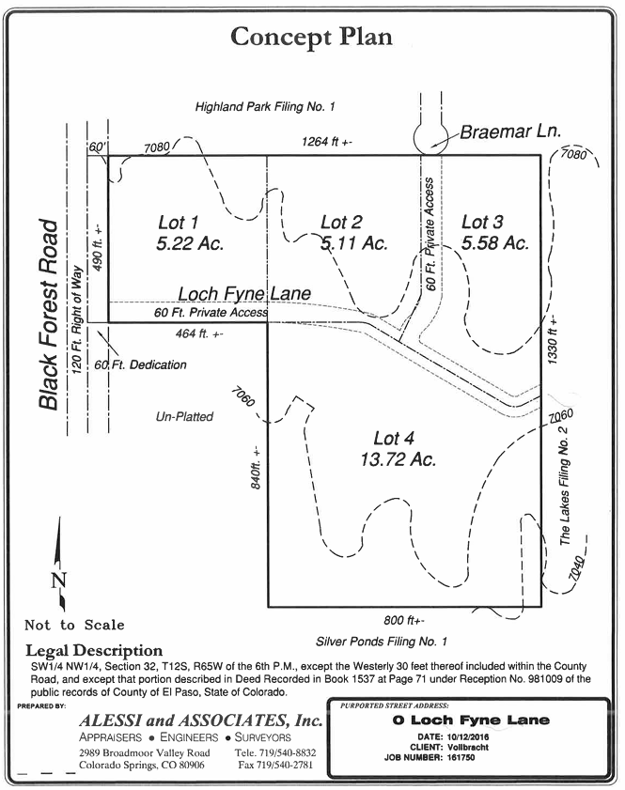

Zoning
Existing Zone(s)
Zone |  | Name
RR-5 |  | Rural Residential

Zone Map (existing conditions of approval)
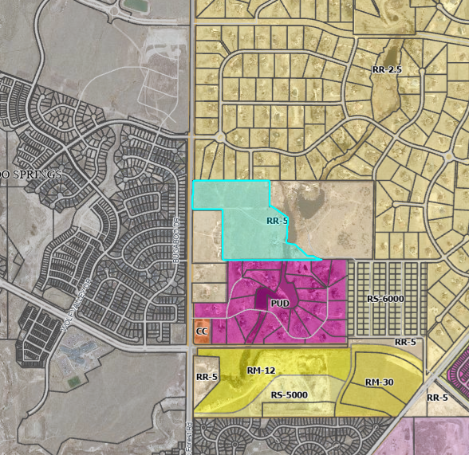

Zoning Analysis
RR-5, Residential Rural District. The RR-5 zoning district is a 5-acre district intended to accommodate low-density, rural, single-family residential development.
- All proposed lots are greater than 5-acres
- Commercial uses would not be allowed unless the parcels are rezoned

Zoning District Requirements (density, lot size, lot design standards, building setbacks)

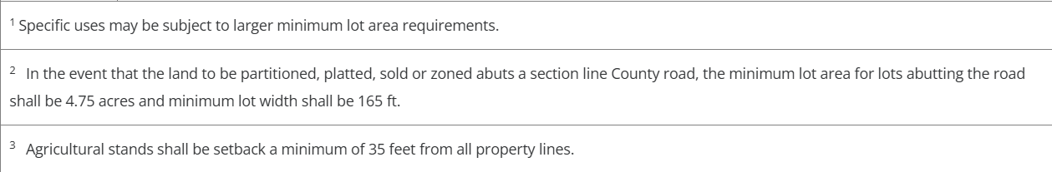

Plat Map or Parcel Map (conditions of approval):
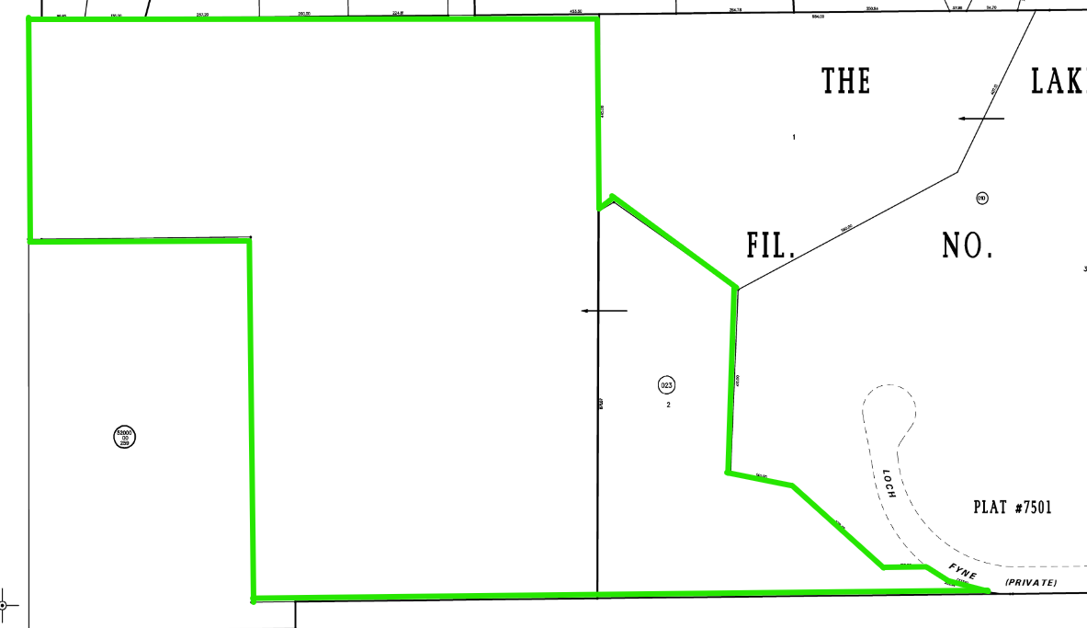
Assessor Parcel map
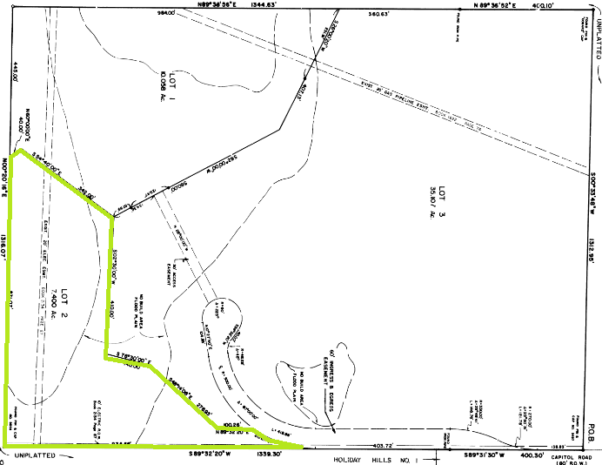
Plat 7501 (1986) for eastern portion of parcel
- Is this part of the proposed subdivision? It is not shown on the Site Map.

Application Type(s) Hearing: Required/ Optional/ No
Final Plat – Minor Subdivision | Yes - BoCC

Approval Criteria:
Final Plat: (21 day initial review cycle, 14 day subsequent review cycles)
7.2.1.D.3.f. Final Plat:
Criteria for Approval. In approving a final plat, the approving authority shall find that:
- The subdivision is in conformance with the goals, objectives, and policies of the Master Plan;
- The subdivision is in substantial conformance with the approved preliminary plan;
- The subdivision is consistent with the subdivision design standards and regulations and meets all planning, engineering, and surveying requirements of the County for maps, data, surveys, analyses, studies, reports, plans, designs, documents, and other supporting materials;
- Either a sufficient water supply has been acquired in terms of quantity, quality, and dependability for the type of subdivision proposed, as determined in accordance with the standards set forth in the water supply standards [C.R.S. § 30-28-133(6)(a)] and the requirements of Chapter 8 of this Code, or, with respect to applications for administrative final plat approval, such finding was previously made by the BoCC at the time of preliminary plan approval;
- A public sewage disposal system has been established and, if other methods of sewage disposal are proposed, the system complies with State and local laws and regulations, [C.R.S. § 30-28-133(6)(b)] and the requirements of Chapter 8 of this Code;
- All areas of the proposed subdivision which may involve soil or topographical conditions presenting hazards or requiring special precautions have been identified and that the proposed subdivision is compatible with such conditions [C.R.S. § 30-28-133(6)(c)];
- Adequate drainage improvements are proposed that comply with State Statute [C.R.S. § 30-28-133(3)(c)(VIII)] and the requirements of this Code and the ECM;
- Legal and physical access is provided to all parcels by public rights-of-way or recorded easement, acceptable to the County in compliance with this Code and the ECM;
- Necessary services, including police and fire protection, recreation, utilities, and transportation systems, are or will be made available to serve the proposed subdivision;
- The final plans provide evidence to show that the proposed methods for fire protection comply with Chapter 6 of this Code;
- Off-site impacts were evaluated and related off-site improvements are roughly proportional and will mitigate the impacts of the subdivision in accordance with applicable requirements of Chapter 8;
- Adequate public facilities or infrastructure, or cash-in-lieu, for impacts reasonably related to the proposed subdivision have been constructed or are financially guaranteed through the SIA so the impacts of the subdivision will be adequately mitigated;
- The subdivision meets other applicable sections of Chapter 6 and 8; and
- The extraction of any known commercial mining deposit shall not be impeded by this subdivision [C.R.S. §§ 34-1-302(1), et seq.]

Processing Issues and Options
- If the parcel to the east is not part of this subdivision, you will need to split it apart from the parcel being subdivided prior to the application being processed.

Relevant Past History:
- May 1986: Platted portion was platted as Lot 2 of The Lakes Fil No 2 at Plat #7501 (Reception #01393143)
- June of 1991: Current owners purchased Lot 2 (Deed at Book 5850 Page 378)
- 1992: 2-Story single family dwelling built on property
- June of 1994: Current owners purchased vacant parcel to the west (Deed at Book 6477 Page 429)
- January of 1997 : Combined to western unplatted piece (presumably for tax purposes, to get the residential tax rate on the larger vacant piece)
- October of 2011: Split again (reasons unknown, maybe intention to sell?)
- November of 2011: Combined again (presumably to get the lower tax rate before tax bills went out in January)
- October of 2016: Subdivision proposed but never submitted for review (PCD Fil No EA16116)
- August of 2026: EA requested for subdivision again

Design and Landscaping
** Landscaping requirements do not apply to Rural development

Site Characteristics\ Constraints\ Environmental Standards:
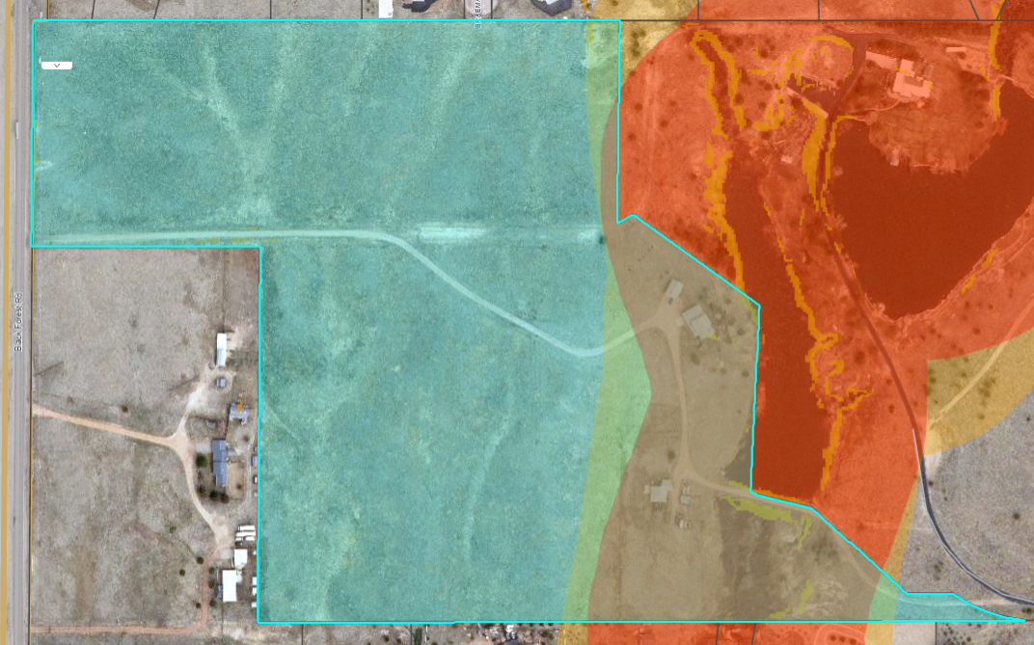
Red/Orange – 300-ft buffer of creeks (Potential Preble’s Mouse Habitat)

☐ | 30% or greater slope | Topography: | none
☒ | CGS review required (separate fee to CGS) | Soils/geology:
☒ | Floodplain | Floodplain comment: |  | Engineering to discuss
☒ | Preble’s mouse | Will need a clearance letter from US Fish and Wildlife

Districts

Taxing Entities
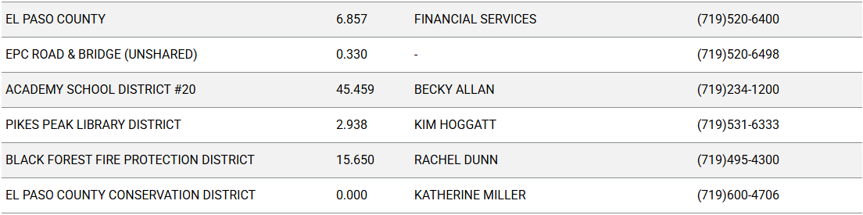
Proposed source of water |  |  | Proposed method of wastewater disposal
☐ | Central System |  | ☐ | Central System
District Name: |  | N/A (Well) | District Name: |  | N/A (Septic)

Water/wastewater comments
8.4. – DESIGN CONSIDERATIONS AND STANDARDS

The State of Colorado required a 100-year water sufficiency finding and El Paso County requires a 300-year water sufficiency finding for each new lot being created. Lastly, the water must be shown to be of acceptable drinking quality and receive endorsement from the EPC Public Health Department.

8.4.7 (4)(a) General Provisions.
The Planning Commission shall, as part of its deliberations, make a recommendation regarding the sufficiency of the proposed water supply. The BoCC shall determine the sufficiency of the proposed water supply in terms of quantity, dependability, and quality based on the information presented and the recommendation of the Planning Commission.

In determining the sufficiency of a proposed water supply, the BoCC shall, at a minimum, consider the Water Resources Report, data and recommendations from the State Engineer's Office, CAO, EPCPH, and the County staff, the recommendations of the Planning Commission, and public comment. In all cases the burden of proof in demonstrating sufficiency rests with the applicant, and it shall be the applicant's sole responsibility to document in the Water Resources Report that the proposed water supply is sufficient in terms of quantity, dependability, and quality.

8.4.7 (B)(1) Water Resource Report.
(b) Water Resources Report Required. A water resources report as required by this Section shall be submitted with sketch plan, preliminary plan, final plat, and any subdivision applications which will create a new lot. A copy of the report will be kept on file in the El Paso County PCD.
(c) Prepared by Qualified Professional. The water resources report shall be prepared by a qualified hydrogeologist, hydrologist, licensed civil engineer, qualified groundwater geologist, or other qualified professional with appropriate experience.
(d) Document Adequate Water Supply. The Water Resources Report shall include adequate documentation that the proposed water supply is sufficient in terms of quantity, dependability, and quality for the proposed subdivision.

(c) Final Plat and Replat Report. The water resource report submitted with the final plat shall include all of the data needed to determine whether the proposed water supply is sufficient in terms of quality, quantity and dependability for the type of subdivision proposed. The report shall be based on engineering calculations and site-specific data and shall include a detailed discussion of the water demand, supply, quality, dependability, and supply facilities for the proposed subdivision.
A water resources report is not required if the BoCC made a finding that the proposed water supply plan of the preliminary plan was sufficient in terms of quantity, quality and dependability. However, an amended water resources report is required if there is a substantial change in either the water supply or the estimated water demand.

ii) Additional Requirements for Lot Sizes Between 2½ and 5 Acres.
For lots of between 2½ and 5 acres where OWTS are proposed, the wastewater disposal report shall additionally address the following:
- Soil Investigation conducted for no fewer than 20% of the total number of lots in the filing. Investigation shall be evenly dispersed over the project area. In cases in which unique geologic, topographic, or soils conditions, such as depth to bedrock, depth to groundwater, slopes in excess of 30 percent, etc. are found, additional tests may be required by EPCPH; and
- An analysis of the availability of a central sewage system and the feasibility of service by a central sewage system. If there is a central sewage system within 1 mile of the proposed subdivision, or if the subdivision is within an organized sewage district or municipal service area, the applicant shall submit documentation that the district or municipality is incapable of serving the site or that the costs of service are prohibitive.

8.4.7(B)(5) Finding of Sufficient Dependability. The proposed water supply shall meet the following criteria to be found sufficient in terms of dependability:
- The supply is of sufficient quantity to meet the needs of the proposed subdivision for 300 years;
- The proposed water supply system and water supply is capable of meeting the average annual and peak daily demand of the proposed subdivision; and
The applicant has provided adequate evidence of ownership or the right of acquisition or use of existing or proposed water rights sufficient in quantity, dependability, and quality to serve the proposed uses within the subdivision; and (1) the legal capability to accomplish any changes in the uses or points of diversion of the rights with quantities and dependability necessary to serve the proposed subdivision without material injury to vested water rights; or (2) adequate evidence that the public or private water provider can and will supply the proposed subdivision with water of adequate quality, quantity and dependability.

8.4.8. Wastewater Disposal
(d) OWTS Report.
(i) General Requirements.
The following shall be fully addressed in or submitted with an OWTS Report. These requirements may be updated from time to time by EPCPH without corresponding amendments to this Code being approved. Any such updates by EPCPH shall control. The EPCPH may require the subdivider to submit additional engineering or geological applicant reports or data and to conduct a study of the economic feasibility of service by central sewage system prior to making its recommendations, which may be updated from time to time by EPCPH without.
• A map, drawn at the same scale as the preliminary plan, locating all lots, drainage-ways, floodplains, slopes in excess of 30%, surface and sub-surface soils hazards and constraints, natural and cultural features, geologic hazards and constraints, depth to bedrock, water table depth, current and historic land use, and other hazards;
• Soil conditions, NRCS soils classification, slope of the terrain, underground water table, subsurface rock, and limitations on site location of the system;
• Conditions which may cause deleterious effects to systems in the area, such as runoff or irrigation;
• The availability of a central sewage system and the feasibility of inclusion into the system;
• The proximity of water wells, lakes, streams, irrigation ditches, ponded water, and other water sources in the area being subdivided; and
• Soils investigation, including the following:
º Visual and tactile evaluation of 2 or more soil profile test pit excavations must be conducted to determine soil type as well as to determine whether a limiting layer is encountered;
º In addition to the 2 soil profile test pit excavations, percolation testing may be conducted to obtain additional information regarding the long-term acceptance rate of the soil;
º If the site evaluation includes both the visual and tactile evaluation of soil profile test pit excavations and percolation tests, and the results from these 2 evaluations do not coincide with the same LTAR (Long Term Acceptance Rate) as noted in Table 10-1 of the EPCPH Regulations, the designer must use the more restrictive LTAR in determining the size of the soil treatment area as listed below:
a) Evaluation of 2 or more soil profile test pit excavations must be performed to determine soil types, limiting layers, and best depth for the infiltrative surface, unless otherwise approved by EPCPH. (At least 1 of the soil profile test pit excavations must be performed in the portion of the soil treatment area anticipated to have the most limiting conditions).
b) The total number of soil profile test pit excavations required is based on the judgment of the competent technician who may require an additional soil profile test pit excavation in the area of the proposed alternate soil treatment area if deemed necessary.
c) The minimum depth of the soil profile test pit excavation must be to any limiting layer, or 4 feet below the infiltrative surface of the in-situ soil, whichever is encountered first.
d) Layers and interfaces that interfere with the treatment and dispersal of effluent must be noted. Thus, any limiting soil characteristic such as consistence also needs to be evaluated. The evaluation of consistence may also include an evaluation of excavation difficulty, rupture resistance, and/or penetration resistance.
e) The soil observations must be conducted at or immediately adjacent to the location of the proposed soil treatment area, but if possible, not under the final location of a trench or bed.
f) Each soil profile test pit excavation observed at the proposed soil treatment area must be evaluated under adequate light conditions with the soil in an unfrozen state.
g) The soil observation method must allow observation of the different soil horizons that constitute the soil profile.
h) Soil profile test pit observations must be conducted prior to percolation tests to determine whether the soils are suitable to warrant percolation tests and, if suitable, at what depth percolation tests must be conducted.
i) The soil type at the proposed infiltrative surface of the soil treatment area or a more restrictive soil type within the treatment depth must be used to determine the long-term acceptance rate from Table 10-1 or Table 10-1A. The treatment depth is 2 to 4 feet depending on the required thickness for the treatment level below the infiltrative surface from Item 4. Table 7-2.
j) Soils data, previously collected by others at the site can be used for the purposes of an OWTS design at the discretion of EPCPH. It is recommended that the data be verified, at a minimum, by performing an evaluation of a soil profile test pit excavation.
º Soil descriptions for determination of a limiting layer must include:
a) The depth of each soil horizon measured from the ground surface and a description of the soil texture, and structure of each soil horizon;
b) Depth to the bedrock;
c) Depth to the periodically saturated soil as determined by:
1. Redoximorphic features and other indicators of water levels, or
2. Depth of standing water in the soil observation excavation, measured from the ground surface, if observed, unless redoximorphic features indicate a higher level.
3. Any other soil characteristic that needs to be described to design a system, such as layers that will restrict permeability.

Site Design/Layout (Lot pattern, circulation/road design, open space, preservation of natural features, compatibility internally and with adjacent land uses)
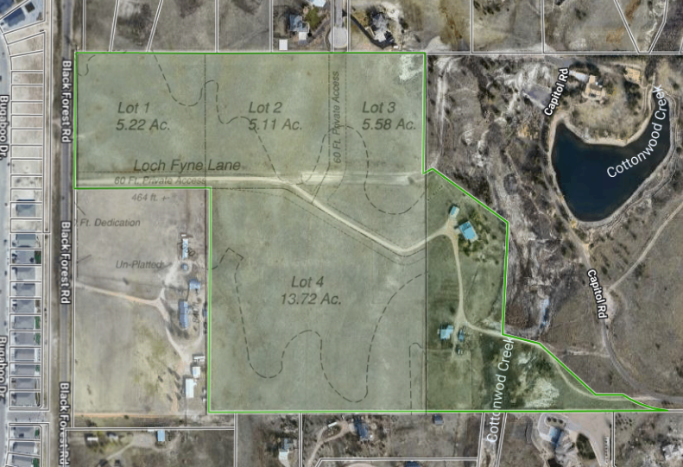
Overlay of proposed subdivision on current parcel

- Surrounding uses are mostly residential with a few home businesses and a church
- Continuation of Roads and Other Linear Facilities. Divisions of land shall be designed to accommodate the continuation of roads, trails, pedestrian access, utilities and drainage facilities into adjacent property unless there is sufficient justification for an alternative design. The connection shall provide a logical, safe and convenient circulation link for vehicular, bicycle, pedestrian, or equestrian traffic with existing or planned circulation routes and, in particular, to destinations such as schools, parks and business or commercial centers.
- Minimum Frontage. Lots shall have a minimum of 30 feet of frontage on and have access from a public road, except where private roads are approved by the BoCC pursuant to waiver granted under Section 8.4.4 (E).
- Private Roads Require Waiver. The use of private roads is limited and allowed only by waiver. In granting a waiver to allow private roads, the BoCC shall make written findings supporting the use of private roads and may require the owner to enter into a Private Road Maintenance Agreement or create covenants whereby the lot owners are required to maintain the private roads.
- (See waiver section of this list for info on applying for a waiver)

Site Characteristics\ Constraints\ Environmental Standards:
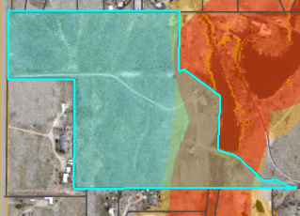
Red – 300 Ft Buffer of Creeks (potential Preble’s Mouse habitat)
- Will need clearance letter from US Fish and Wildlife
Orange – 300 Ft Buffer of 100-yr floodplain
- Engineering to discuss floodplain

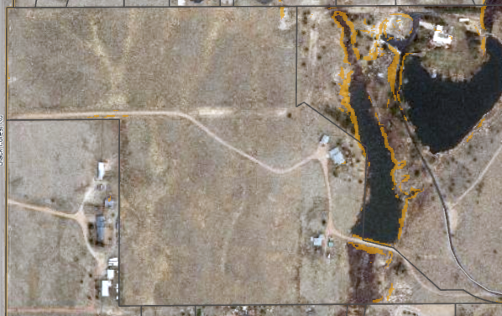
Orange - Areas of 30% Slope – Minimal

☐ | 30% or greater slope | Topography:
☒ | CGS review required (separate fee to CGS) | Soils/geology: |  | Pring Coarse Sandy Loam
☒ | Floodplain | Floodplain comment: |  | Engineering to discuss
☒ | Preble’s mouse

Districts

Taxing Entities
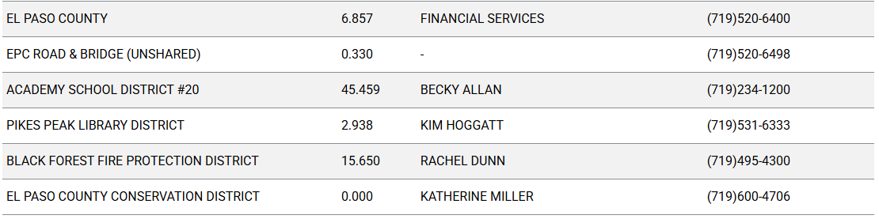
Proposed source of water |  |  | Proposed method of wastewater disposal
☐ | Central System |  | ☐ | Central System
District Name: |  | N/A (Well) | District Name: |  | N/A (Septic)

Water/wastewater comments
8.4.7 (4)(a) General Provisions.
The Planning Commission shall, as part of its deliberations, make a recommendation regarding the sufficiency of the proposed water supply. The BoCC shall determine the sufficiency of the proposed water supply in terms of quantity, dependability, and quality based on the information presented and the recommendation of the Planning Commission.

In determining the sufficiency of a proposed water supply, the BoCC shall, at a minimum, consider the Water Resources Report, data and recommendations from the State Engineer's Office, CAO, EPCPH, and the County staff, the recommendations of the Planning Commission, and public comment. In all cases the burden of proof in demonstrating sufficiency rests with the applicant, and it shall be the applicant's sole responsibility to document in the Water Resources Report that the proposed water supply is sufficient in terms of quantity, dependability, and quality.

8.4.7 (B)(1) Water Resource Report.
(b) Water Resources Report Required. A water resources report as required by this Section shall be submitted with sketch plan, preliminary plan, final plat, and any subdivision applications which will create a new lot. A copy of the report will be kept on file in the El Paso County PCD.
(c) Prepared by Qualified Professional. The water resources report shall be prepared by a qualified hydrogeologist, hydrologist, licensed civil engineer, qualified groundwater geologist, or other qualified professional with appropriate experience.
(d) Document Adequate Water Supply. The Water Resources Report shall include adequate documentation that the proposed water supply is sufficient in terms of quantity, dependability, and quality for the proposed subdivision.

(c) Final Plat and Replat Report. The water resource report submitted with the final plat shall include all of the data needed to determine whether the proposed water supply is sufficient in terms of quality, quantity and dependability for the type of subdivision proposed. The report shall be based on engineering calculations and site-specific data and shall include a detailed discussion of the water demand, supply, quality, dependability, and supply facilities for the proposed subdivision.
A water resources report is not required if the BoCC made a finding that the proposed water supply plan of the preliminary plan was sufficient in terms of quantity, quality and dependability. However, an amended water resources report is required if there is a substantial change in either the water supply or the estimated water demand.
8.4.7(B)(5) Finding of Sufficient Dependability. The proposed water supply shall meet the following criteria to be found sufficient in terms of dependability:
- The supply is of sufficient quantity to meet the needs of the proposed subdivision for 300 years;
- The proposed water supply system and water supply is capable of meeting the average annual and peak daily demand of the proposed subdivision; and
The applicant has provided adequate evidence of ownership or the right of acquisition or use of existing or proposed water rights sufficient in quantity, dependability, and quality to serve the proposed uses within the subdivision; and (1) the legal capability to accomplish any changes in the uses or points of diversion of the rights with quantities and dependability necessary to serve the proposed subdivision without material injury to vested water rights; or (2) adequate evidence that the public or private water provider can and will supply the proposed subdivision with water of adequate quality, quantity and dependability.

8.4.8.(C)(2) Onsite Wastewater Treatment Systems (OWTS).
2 OWTS Sites Required for All Lots or Parcels. All lots shall be designed to ensure that each lot has a minimum of 2 sites appropriate for OWTS which do not fall in the restricted areas identified on the preliminary plan; soils and geology report delineated wetland or floodplain maps; or other reports required under this Code.

Fire District:
Will need Fire Protection Report and Fire Commitment Letter from
Black Forest Fire Rescue
- 719-495-4300
- Contact Page

Wildland Fire and Hazard Mitigation Plan:
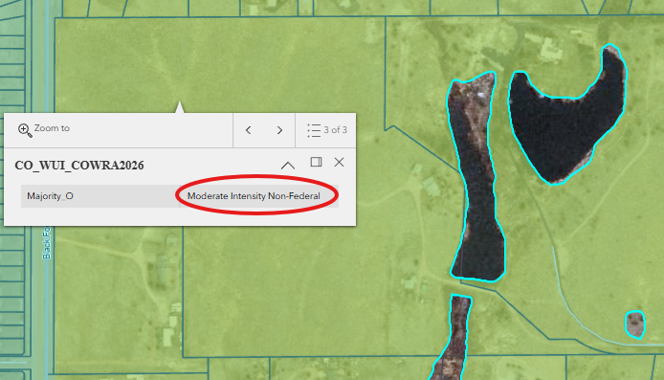
Wildland Urban Interface – Moderate Intensity
- Will may need a Wildland Fire and Hazard Mitigation Plan if fire district asks for it in the review process

Emergency Services Issues:
Access must meet applicable Fire Protection District standards for turnarounds, etc.

Commissioner District: 1
Code Waivers:
7.3. - WAIVERS
7.3.2. Authorization to Grant Waivers
(A) Planning Commission Recommendation. The Planning Commission will hear the request for a waiver from the standards and make recommendations to the BoCC.
(B) BoCC Authorized to Grant Waivers. After receiving a recommendation from the Planning Commission, the BoCC may approve a waiver from any of the subdivision design standards and requirements of this Code.

7.3.3. Criteria for Approval of Waivers
A waiver from standards shall be approved only upon the finding, based upon the evidence presented in each specific case, that:
• The waiver does not have the effect of nullifying the intent and purpose of this Code;
• The waiver will not result in the need for additional subsequent waivers;
• The granting of the waiver will not be detrimental to the public safety, health, or welfare or injurious to other property;
• The conditions upon which the request for a waiver is based are unique to the property for which the waiver is sought and are not applicable to other property;
• A particular non-economical hardship to the owner would result from a strict application of this Code;
• The waiver will not in any manner vary the zoning provisions of this Code; and
• The proposed waiver is not contrary to any provision of the Master Plan.

7.3.5. Waiver Application Requirements
The written request for a waiver shall state in detail the extent of the waiver, the grounds for the requested waiver and all of the facts relied upon by the applicant. The applicant shall have the burden of providing both the justification for their waiver requests and sufficient documentation to allow PCD to properly evaluate the engineering and planning impacts of the requested waiver.

Parks and trails:
The 2022 El Paso County Parks Master Plan shows no impacts to existing or proposed parks, trails, or open space. As such no trail easement dedications will be necessary for this project. Regional park fees will be assessed upon review of the forthcoming platting actions.
It is not necessary for EPC Parks staff to attend this early assistance meeting.
Ashlyn Mathy
Parks Planner, Park Planning Division
El Paso County Parks Department
Office 719.520.6978
Annexations/Intergovernmental/ Jurisdictional Access issues:
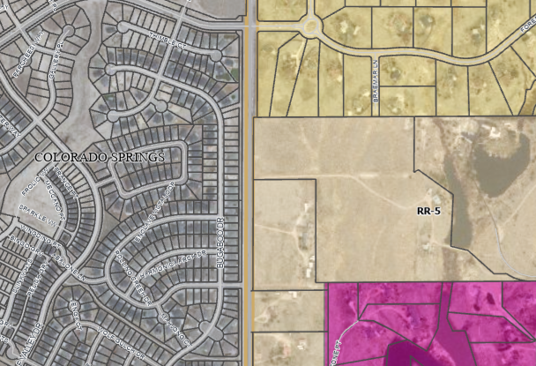
The City of Colorado Springs Planning department and Public Works were invited to attend due to close proximity to their planning jurisdiction. As of the date of this meeting, no response has been received.

Road Impact Fee Program (PID Inclusion):
Acknowledgement Form required. Engineering to discuss.

Your El Paso Master Plan:

Placetype - Suburban Residential
Suburban Residential is characterized by predominantly residential areas with mostly single-family detached housing. This placetype can also include limited single-family attached and multifamily housing, provided such development is not the dominant development type and is supportive of and compatible with the overall single-family character of the area. The Suburban Residential placetype generally supports accessory dwelling units. This placetype often deviates from the traditional grid pattern of streets and contains a more curvilinear pattern. Although primarily a residential area, this placetype includes limited retail and service uses, typically located at major intersections or along perimeter streets. Utilities, such as water and wastewater services are consolidated and shared by clusters of developments, dependent on the subdivision or area of the County. Some County suburban areas may be difficult to distinguish from suburban development within city limits. Examples of the Suburban Residential placetype in El Paso County are Security, Widefield, Woodmen Hills, and similar areas in Falcon.

Land Uses
Primary
• Single-Family Detached Residential with lots sizes smaller than 2.5 acres per lot, up to 5 units per acre
Supporting
• Single-family Attached
• Multifamily Residential
• Parks/Open Space
• Commercial Retail
• Commercial Service
• Institutional

**See pages 28 and 29 in the Master Plan for more info

Area of Change - Minimal Change: Undeveloped
The character of these areas is defined by a lack of development and presence of significant natural areas. These areas will experience some redevelopment of select underutilized or vacant sites adjacent to other built-out sites, but such redevelopment will be limited in scale so as to not alter the essential character. New development may also occur in these areas on previously undeveloped land, but overall there will be no change to the prioritized rural and natural environments.

Goals and strategies for specific elements listed above can be found in Chapter 14 of the Master Plan.
Water Master Plan Area:
Water Region 3 (Falcon Area)
Region 3 contains four growth areas west of Falcon projected to be completed by 2040. Other areas of 2040 growth are projected for the north‐central part of the region west of Highway 24 extending from Falcon to 4-Way Ranch. North of Falcon along Highway 24, growth is projected by 2060 on both sides of the highway. Just west of Falcon, another small development is projected by 2060 on the north and south sides of Woodmen Road. On the east side of Highway 24, three separate areas of growth are projected for development by 2060, with the largest of the three spanning from south of Judge Orr Road to east of Peyton Highway into Region 4c. This development will likely consist of 35-acre lots that will require individual wells to use Denver Basin groundwater. The other two growth areas will be located on the north and south sides of Falcon Highway directly east of Falcon. See Figure 5.5 for Region 3 growth map projections.

Wildlife impact
Level 4 – High
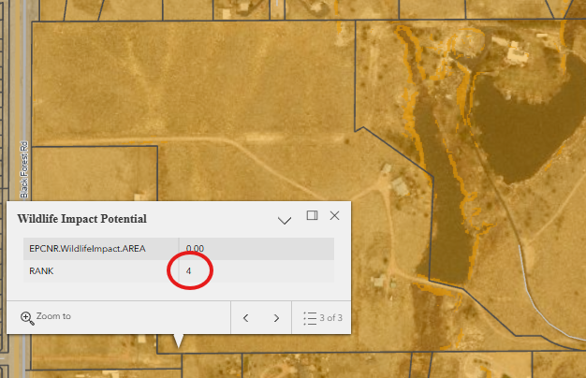
- Will need to provide a Wildlife Impact Report

Next Steps
The following documents will be requested for submittal with this Final Plat application. (I have provided links where we have them available for specific forms and checklists. Some documents will need to obtained from specific agencies or certified professionals.)
- Application/Petition Form
- Closures Sheet (Survey)
- Final Plat Drawings
- Legal Description (as a word doc)
- Letter of Intent
- Title Commitment (current within 1 year of submittal)
- Mineral Rights Certification
- PCM Applicability Form
- Electric Provider Commitment Letter
- Fire Commitment Letter
- Natural Gas Commitment Letter
- Drainage Report – Final
- Fire Protection Report
- Natural Features Report
- Noxious Weed Management Plan
- Soils & Geology Report
- Wastewater Treatment Report
- Joint Access Agreement
- Water Resources Report
- Water Supply Information Sheet
- Declaration of Covenants
- HOA articles of incorporation
- HOA bylaws
- Secretary of State Certification
- Wildlife Impact Report
- Clearance Letter from US Fish and Wildlife
- Financial Assurance Estimate Form
- Subdivision Improvement Agreement
- Construction Drawings
- Road Impact Fee Acknowledgement Form

List of qualified professionals for Water Resources Report
List of qualified professionals for Fire Protection Reports/Plans

- A submittal request will be sent for the documents listed above.
- Once all documents are received and accepted, a payment request will be sent for $5834.
- Once payment is made, a 21 day review cycle will initiate in which all documents will be sent out to various agencies for review and neighbors within 500 feet of the property boundaries will be notified of the proposed development and given opportunity to submit their input about it.
- Review comments will filter in over the 21 day period and on the 21st day, county staff will return their comments along with a resubmittal request for documents that need to be revised and resubmitted.
- Once we receive the resubmittal, a 2nd review cycle of 14 days will initiate and the process will repeat until all comments are resolved.
- Once all comments are resolved, you will be added to the hearing agenda for Planning Commission and Board of County Commissioners (6 to 8 weeks out from final submittal).
- Planning Commission will make a recommendation to the BoCC to approve or deny the project.
- BoCC will make the final determination to approve or deny
- If the project is denied, a disapproval resolution will be drafted and recorded
- If approval is granted, an approval resolution will be drafted and recorded along with the plat.

Helpful Links

Planning Website: https://planningdevelopment.elpasoco.com/

El Paso County Master Plan: https://planningdevelopment.elpasoco.com/#1510603950097-f5d985dc-35b2
Water Master Plan: https://planningdevelopment.elpasoco.com/#1515613078151-9a697e85-b1a7
Parks Master Plan: https://parks.elpasoco.com/parks-and-recreation/park-planning/
Mineral Extraction Master Plan: https://planningdevelopment.elpasoco.com/#1515613078151-9a697e85-b1a7

Forms and Templates: https://planningdevelopment.elpasoco.com/forms-and-affidavits/

Applications and Checklists: https://planningdevelopment.elpasoco.com/applications-and-checklists/

Land Development Code: https://library.municode.com/co/el_paso_county/codes/land_development_code

EDARP: https://epcdevplanreview.com/

Public GIS: https://experience.arcgis.com/experience/94cea8ccda3d4806a3fd500d2b5a4433?draft=true

Wrap Up
-If subdivision is proposed, recording fees, park and school fees and road impact fees may apply.

-Fees are subject to change. The fees at the time of application apply.

-Road Impact Fees
Please see the following website for information on the EPC Road Impact Fee Project. https://publicworks.elpasoco.com/road-impact-fees/ to include fee schedule.
As of December 15, 2016, per Resolution 16-454, on and after January 1, 2020, property in the unincorporated area of the county that receives a Land Use Approval either in a public hearing or administratively, is subject to the payment of Road Impact Fees. After December 31, 2024, in accordance with BoCC Resolution 24-377 the fee is paid for new residential and non-residential uses and structures and expansions of non-residential uses and structures. Road Impact fees are typically paid at time of building permit. If no building permit is being obtained for a particular Land Use application, then Road Impact Fees must be paid at the time of Site Development Plan or Special Use approval. If there are questions about EPC Road Impact program or fees, please contact DPW Development Review Services and the Engineer of the Day.

- Engineering Criteria Manual (ECM) Deviations.
The fee for any additional ECM deviation requests (more than two per land use application) - $1483.00 each per current Fee Schedule. Please note ECM deviation requests may result in additional processing and project review time. ECM Deviations should be submitted prior to the initial Site Development Plan or Final Plat submittal to preclude changes having to be made to engineering plans and documents if the deviation is not approved. Submission of an ECM deviation request does not imply or guarantee that the deviation will be approved. An ECM Deviation form must be submitted to include complete exhibits and justification excluding cost with supporting engineering criteria. If there are questions about ECM Deviation requests, please contact DPW Development Review Services and the Engineer of the Day.

-The fee for any additional waiver/deviation requests (more than two) - $550.00 each. Please note that requests for waivers and/or deviations may result in additional processing/review delay.

-All items requested must accompany the submittal for it to be complete, prior to payment request or the submittal will not be complete and ready for review agencies.

-A temporary use permit shall be applied for and approved for any staging area associated with development, such as a sales office, construction trailer, or contractor's equipment yard, prior to scheduling of the pre-construction meeting with El Paso County Planning and Community Development. If a Planned Unit Development is proposed, the temporary staging area should be shown on the development guideline and phasing plan.

-All prospective timelines for review are subject to departmental staffing and workload.

-Early Assistance is valid for 12 months from submittal of the EA application. If a project submittal is not received within 12 months, a new EA meeting may be required. An audio/video copy of the meeting is available in EDARP within the EA folder.

- Applications scheduled for public hearings may be heard as a regular item at the request of staff or a hearing body member.

- Any comments or commitments made by any member of the County Staff during this early assistance meeting are only preliminary in nature and should not be relied upon by the applicant. All prospective applicants should be informed that formal comments cannot be made by staff until after the application is submitted.

