

FALCON FIRE PROTECTION DISTRICT
Fire Prevention Division
7030 Old Meridian Road
Falcon, Colorado 80831
Business Number: 719-495-4050 Business Fax: 719-495-3112



Lieutenant/Fire Inspector II Curtis L. Kauffman
Email: ckauffman@falconfirepd.org Cell #: 719-641-2139

Date: April 7, 2025

To: EDARP
C/O: Lisa Elgin
Planning & Community Development
2882 International Circle, Suite 110
Colorado Springs, CO 80910
Phone Number; 719-520-6449
Email: LisaElgin@elpasoco.com

Project Name: J and J Ranch Subdivision
File Prefix: SF-Final Plat
Parcel/s: 5114000009
File Number: SF2511

A request for a final plat application. Approval od a 3-lot subdivision on 19.4 acers.

Section 505.1. Address Identification. New and existing buildings shall have approved address numbers, building numbers or approved building identification placed in a position that is plainly legible and visible from the street or road fronting the property. These numbers shall contrast with their background. Address numbers shall be Arabic numbers or alphabetical letters. Numbers shall be a minimum of five (5) inches (127 mm) high with a minimum stroke width of one half (0.5) inch (12.7 mm). Where access is by means of a private road and the building cannot be viewed from the public way, a monument, pole or other means of signage shall be used to identify the structure.”

*** I will need to verify that the house numbers are posted prior to occupancy of the home. Contact me when address numbers are installed.

Section 1402.1 Temporary Fire Access Road. Temporary access roads shall be an all-weather surface comprised of either the first lift of asphalt or concrete/compacted gravel to a thickness capable of supporting the imposed loads of fire department apparatus. A 20-foot minimum width shall be maintained unless the permanent road is designed less than 20 feet, in which case the temporary road shall be the intended width of the permanent road. Adequate street signs and fire lane signs shall be installed where applicable. Temporary access roads must be maintained in accordance with this section. Temporary roads serving as fire lanes shall not be in place more than 6 months without special approval from the fire department.”

FIRE LANES:

WIDTH: Fire apparatus access roads shall have an unobstructed width of not less than 20-feet except for approved security gates.

FIRE LANE SIGNS:
Roads Less Than 28 Feet in Width. Fire apparatus access roads less than 28 feet in width shall be posted on both sides as a fire lane.”

Roads more than 28 feet and less than 34 feet in width. Fire apparatus access roads more than 28 feet and less than 34 feet wide shall be posted on one side of the road as a fire lane.”

Fire apparatus access roads 34 feet in width or greater do not require marking as a fire lane.”

***Prior to occupancy of any homes for this project, all shall be installed as needed.

TURNING RADIUS:
A minimum turning radius of 33’ inside or 53’ outside shall be provided.

VERTICAL CLEARANCE: Fire apparatus access roads shall have an unobstructed vertical clearance of not less than 13-feet 6-inches.

LOADING: Fire apparatus access roads shall be designed, constructed and maintained to support the imposed loads of fire apparatus weighing at least 75,000-pounds.

SURFACE: Fire apparatus access roads shall be surfaced so as to provide all-weather driving capabilities by means of asphalt, concrete or other approved driving surfaces. Gravel roads or other alternatives may be acceptable; however, PE stamped engineered specifications for such alternatives, showing that the loading specifications and all-weather surface capabilities have been met or exceeded must be submitted to the Falcon Fire Department for review.

DEAD-END ACCESS: Dead-end fire apparatus access roads in excess of 150-feet shall be provided with a turnaround meeting the requirements of the International Fire Code.

D103.4 Dead ends. Dead-end fire apparatus access roads in excess of 150 feet (45 720 mm) shall be provided with width and turnaround provisions in accordance with Table D103.4.

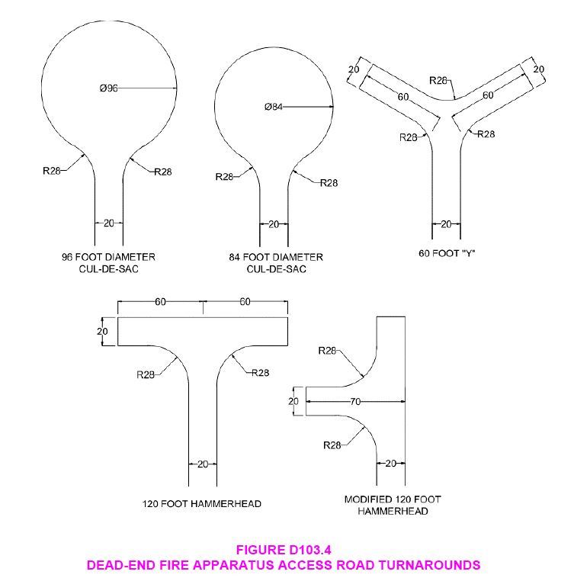
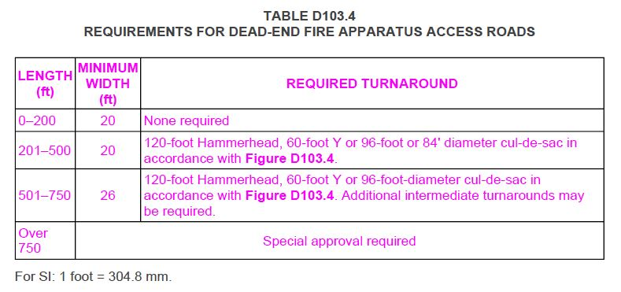

Section D105
AERIAL FIRE APPARATUS ACCESS ROADS

D105.1 Where required. Where the vertical distance between the grade plane and the highest roof surface exceeds 30 feet (9144 mm), approved aerial fire apparatus access roads shall be provided. For purposes of this section, the highest roof surface shall be determined by measurement to the eave of a pitched roof, the intersection of the roof to the exterior wall, or the top of parapet walls, whichever is greater.

Exception: Where approved by the fire code official, buildings of Type IA, Type IB or Type IIA construction equipped throughout with an automatic sprinkler system in accordance with Section 903.3.1.1 and having fire fighter access through an enclosed stairway with a Class I standpipe from the lowest level of fire department vehicle access to all roof surfaces.

D105.2 Width. Aerial fire apparatus access roads shall have a minimum unobstructed width of 26 feet (7925 mm), exclusive of shoulders, in the immediate vicinity of the building or portion thereof.

D105.3 Proximity to building. One or more of the required access routes meeting this condition shall be located not less than 15 feet (4572 mm) and not greater than 30 feet (9144) from the building, and shall be positioned parallel to one entire side of the building. The side of the building on which the aerial fire apparatus access road is positioned shall be approved by the fire code official.

D105.4 Obstructions. Overhead utility and power lines shall not be located over the aerial fire apparatus access road or between the aerial fire apparatus road and the building. Other obstructions shall be permitted to be placed with the approval of the fire code official.

GRADES: Grades for fire apparatus access roads shall be no more than 10% maximum grade.

TIMING OF INSTALLATION: Fire department access roads shall be made serviceable prior to and during the time of construction except when approved alternative methods of protection are provided.

ACCESS FOR FIREFIGHTING: Approved vehicle access for firefighting shall be provided to all construction/demolition sites. Vehicle access shall be provided to within 100-feet of temporary or permanent fire department connections (FDC). Vehicle access shall be provided by either temporary or permanent roads capable of supporting vehicle loading under all weather conditions. Vehicle access shall be maintained until permanent fire apparatus access roads are available.

STREET SIGNS: Temporary or permanent street signs shall be installed at each street intersection when construction of roadways allows passage by vehicles.

DEVELOPMENT/ACCESS PLAN REVIEW FEES:
The Falcon Fire Department collects a cost recovery fee of $429.00 for development plan reviews.

At the time of development/access plan review and/or fire hydrant/water plan review, payment shall be made to the Falcon Fire Protection District located at 7030 Old Meridian Road, Falcon Colorado 80831. Checks only, we cannot accept credit card payments. Please be advised, no construction materials can be on site until all fees are received.

NOTE:

- Permits – Insure all applicable permits are obtained from the Pikes Peak Regional Building Department (PPRBD) and the Colorado Springs Fire Department construction services.
- Follow the Colorado State Forest Service for all mitigation guidelines.

Please feel free to contact me if you have any questions.

Sincerely,

Curtis L. Kauffman

Curtis L. Kauffman
Fire Prevention Division
Lieutenant/Fire Inspector II

