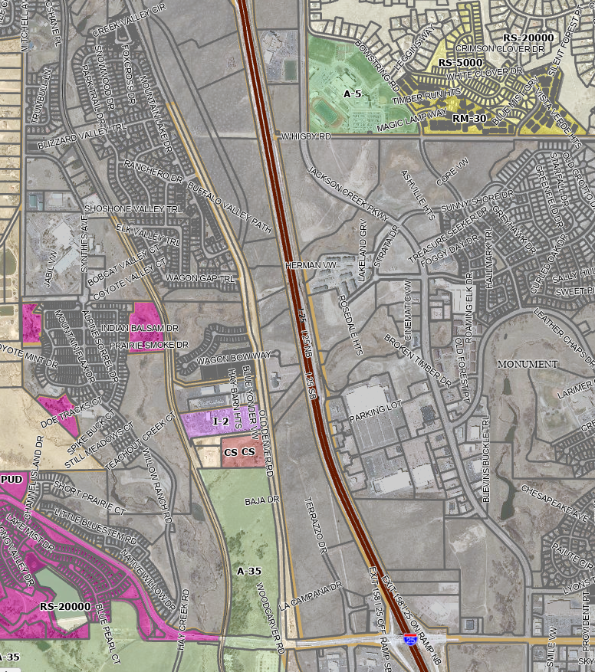
From Baptist Road to here
BAPTIST ROAD
Vicinity Map

