STORMWATER ACCESS AGREEMENT
This STORMWATER ACCESS AGREEMENT is hereby made this ______ day of ________, 2025, by and between Casas Limited Partnership #4 (hereinafter “Grantor”) and EL PASO COUNTY by and through the BOARD OF COUNTY COMMISSIONERS OF EL PASO COUNTY, Colorado (hereinafter “County”), whose address is 200 S. Cascade Avenue, Colorado Springs, CO 80903 (“Grantee”).

- Grant of Future Access Easement. As a condition of approval of the final plat (the “Plat”) for Eagle Rising Filing No. 1 (hereinafter “Subdivision”), the sufficiency of which consideration is hereby acknowledged, Grantor agrees that upon the earliest occurrence of a) approval of a final plat for any of the remaining property within the Eagle Rising Preliminary Plan, originally approved pursuant to Resolution No. 13-407 and most recently extended pursuant to Resolution No. 24-442, b) entry to the Cottonwood Creek drainageway adjacent to the Subdivision (“Drainageway”) being granted by that property owner in the event of an emergency threatening the public health, safety, or welfare, or c) commencement of construction of any stormwater facilities in the Drainageway, it shall grant to Grantee its successors and assigns a NON-EXCLUSIVE PERMANENT ACCESS EASEMENT (“Easement”) as set forth herein, along, over and across the following described premises:

See attached Exhibit A, Legal Description of Easement
See attached Exhibit B, Sketch of Easement

- Purposes; Limitations. The Easement shall for the following purposes: provide access through the Subdivision to allow Grantee to inspect, operate, clean, maintain, and repair stormwater facilities in Drainageway (the “Stormwater Facilities”), as such facilities may exist in the future. However, this grant of Easement does not expressly or implicitly impose on the Grantee a duty to so inspect, clean, repair or maintain the Stormwater Facilities or any appurtenant improvements. Grantee shall limit the use of the areas of the Easement outside of Tract A by trucks or other vehicles except as reasonably necessary for its work on the Stormwater Facilities.
- Improvements. Grantor shall not construct improvements in the Easement area that would unreasonably interfere with Grantee’s access to the Easement area. Any such improvements may be removed by Grantee without compensation or liability to Grantor.

- Property Restoration. No improvements in the Easement Area shall be made by Grantee. Upon completion of any work performed by Grantee or its contractors or other agents on the Easement area or the Stormwater Facilities, Grantee shall restore the Easement area to the condition that existed prior to Grantee’s activities as nearly as reasonably possible, excepting normal wear and tear on Eagle Wing View (Tract A).
- Warranty of Title. Grantor hereby covenants with the Grantee that it has good title to the afore-described premises, that it has good and lawful right to grant this Easement, that that it will warrant and defend the title and quiet possession thereof against the lawful claims of all persons whomsoever claiming through Grantor.
- Insurance. In the event that Grantee hires a third-party contractor or contractors, or other agents, to perform any activities on, or otherwise access, the Easement in accordance with this Stormwater Access Agreement, Grantee shall verify that the contractor or agent has obtained the insurance required by Grantee’s contract documents for work on the Stormwater Facilities, including general liability and worker’s compensation insurance and provide copies to the Eagle Rising Owners Association upon request.
- Liens. In no event shall Grantee allow any mechanic’s or materialmen’s liens to attach against the Easement area, nor the Subdivision property, for material supplied or work performed at the request of, or for the benefit of, Grantee, its contractors or subcontractors. Neither shall Grantor allow any mechanic’s or materialmen’s liens to attach against the Easement area in any manner which could be chargeable against Grantee for material supplied or work performed at the request of, or for the benefit of, Grantor, its contractors or subcontractors.
- Successors and Assigns. This Stormwater Access Agreement shall be binding upon Grantor and Grantee, and their respective successors and assigns. Grantee shall have the authority to assign all or part of its interest in this Easement without the prior approval of, but with notice to, Grantor or its successors in interest in the Subdivision property.
- Notices. A notice, demand, or other communication under this Stormwater Access Agreement by any party to the other shall be sufficiently given if it is dispatched by registered or certified mail, postage prepaid, return receipt requested, or delivered personally or by electronic mail with confirmation of receipt, addressed as follows:
If to Grantor: Casas Limited Partnership #4
_________________
_________________
Attn: ____________
E-mail: ________________

If to Grantee: El Paso County
200 S. Cascade Avenue
Colorado Springs, CO 80903
Attn: _______________
E-mail: ____________________

If to the Owners Association: Eagle Rising Owners Association
_________________
_________________
Attn: ____________
E-mail: ________________

or at such other address with respect to any such party as that party may, from time to time, designate in writing and forward to the other as provided in this section. Notice is deemed to be given on the date received (if mailed according to this section), or on the date delivered (if personally delivered or electronically mailed with confirmed receipt in accordance with this section).

- Governing Law; Venue. The laws, rules and regulations of the State of Colorado and El Paso County shall be applicable in the enforcement, interpretation and execution of this Agreement, except that Federal law may be applicable regarding solid waste or hazardous materials. Venue shall be in El Paso County District Court.

[Signatures on following page]

IN WITNESS THEREOF, the Grantor and Grantee have executed this Stormwater Access Agreement.

GRANTOR:

Casas Limited Partnership #4, a Colorado limited partnership.

By: MyPad, Inc.
Its: General Partner

By: _______________________________
Stephen Jacobs, Jr., President

State of Colorado )
)ss
County of El Paso )

The foregoing instrument was acknowledged before me this ____ day of _______________, 2025, by Stephen Jacobs, Jr., as President of MyPad, Inc., General Partner of Casas Limited Partnership #4, a Colorado limited partnership.

Witness my hand and official seal.

My commission expires: _________________ _________________________________
Notary Public

GRANTEE:

BOARD OF COUNTY COMMISSIONERS
OF EL PASO COUNTY, COLORADO

By: ________________________________
Meggan Herrington, Executive Director
Planning and Community Development
Authorized signatory pursuant to LDC

State of Colorado )
)ss
County of El Paso )

The foregoing instrument was acknowledged before me this ____ day of _______________, 2025, by Meggan Herrington, as Executive Director of the El Paso County Planning and Community Development Department.

Witness my hand and official seal.

My commission expires: __________________ _________________________________
Notary Public

Approved as to form:

_______________________________
County Attorney’s Office

Exhibit A

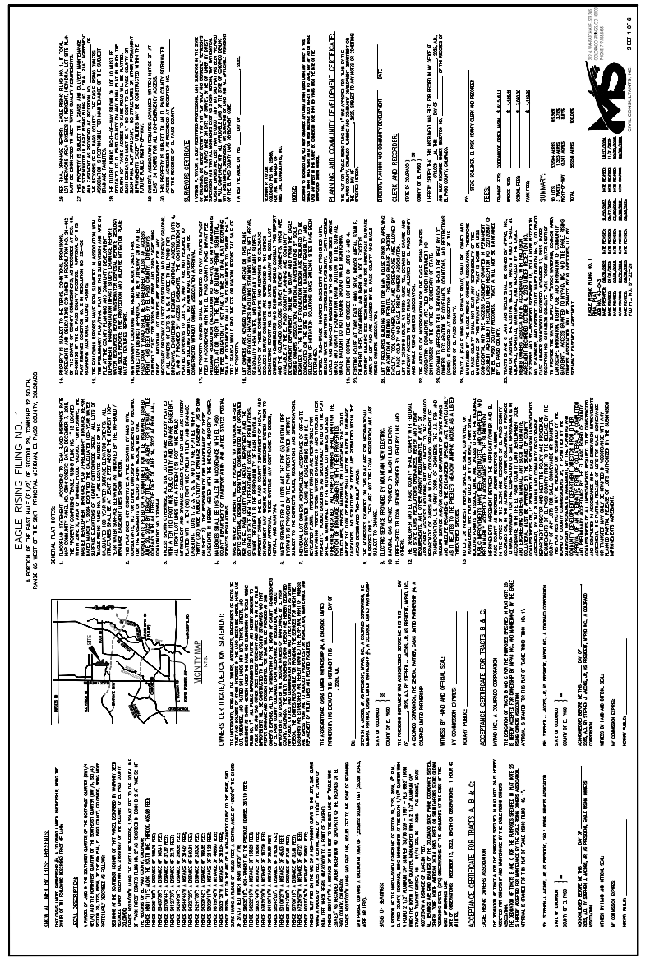

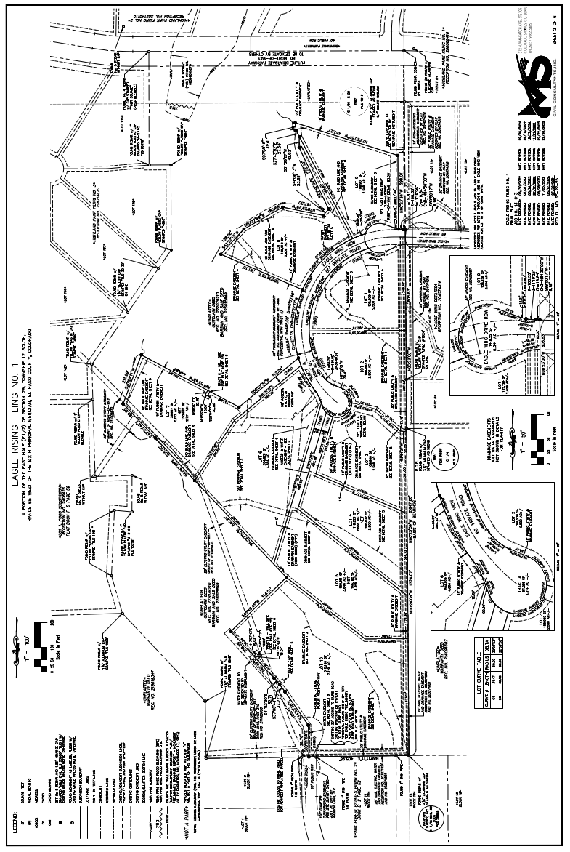
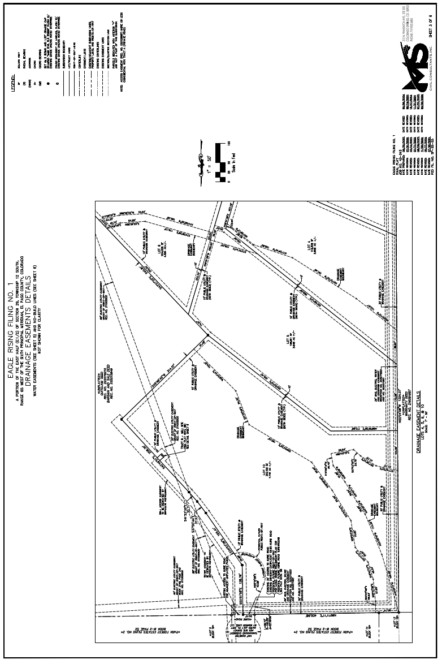
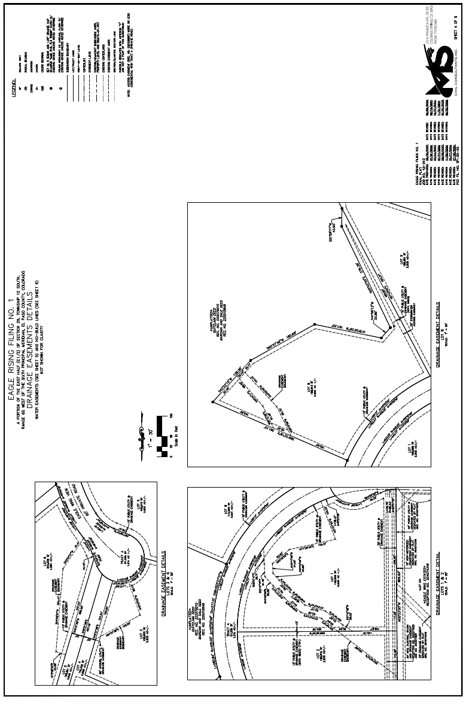
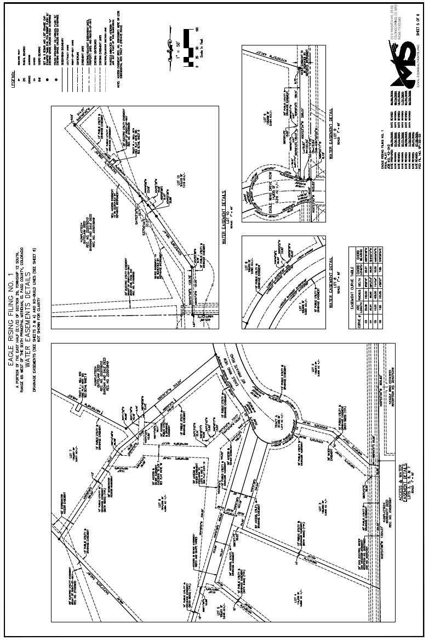
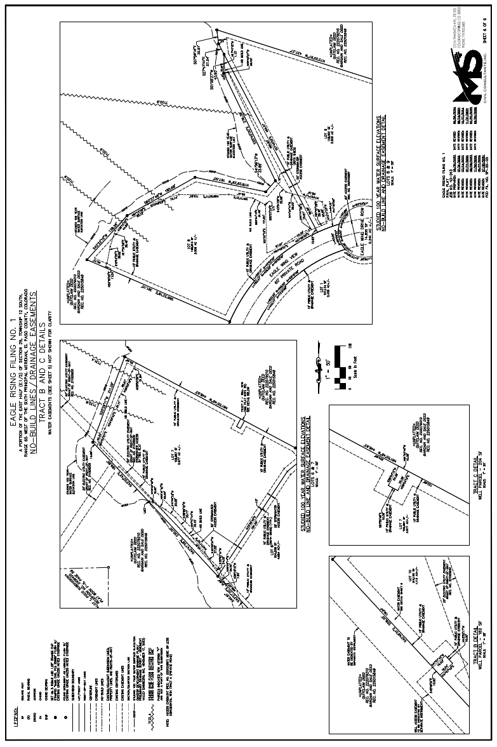

Exhibit B

Sketch of Easement

