GRASS AND CULVERT MAINTENANCE FOR STORMWATER IN EAGLE RISING FINAL PLAT FILING #1 AGREEMENT AND EASEMENT

This GRASS AND CULVERT MAINTENANCE FOR STORMWATER IN EAGLE RISING FINAL PLAT FILING #1 AGREEMENT AND EASEMENT (Agreement) is made by and between El Paso County by and through THE BOARD OF COUNTY COMMISSIONERS OF EL PASO COUNTY, COLORADO (Board or County), Mypad Inc., a Colorado corporation as General Partner of Casas Limited Partnership #4, a Colorado Limited Partnership (Developer), and Eagle Rising Owners Association (Association), a Colorado nonprofit corporation. The above may occasionally be referred to herein singularly as “Party” and collectively as “Parties.”

Recitals
A. WHEREAS, Developer is the owner of certain real estate (the Property) in El Paso County, Colorado, which Property is legally described in Exhibit A attached hereto and incorporated herein by this reference; and

B. WHEREAS, Developer desires to develop on the Property a land use to be known as Eagle Rising Filing No. 1 (the “Subdivision”); and

C. WHEREAS, the development of this Property will increase the volume of water runoff and will decrease the quality of the stormwater runoff from the Property, and, therefore, it is in the best interest of public health, safety and welfare for the County to condition approval of this land use on Developer’s promise to construct adequate drainage, water runoff control facilities, and stormwater quality structural Best Management Practices (“BMPs”) for the land use; and

D. WHEREAS, Chapter 8, Section 8.4.5 of the El Paso County Land Development Code, as periodically amended, promulgated pursuant to Section 30-28-133(1), Colorado Revised Statutes (C.R.S.), requires the County to condition approval of all subdivisions on a developer’s promise to so construct adequate drainage, water runoff control facilities, and BMPs in subdivisions; and

E. WHEREAS, the Drainage Criteria Manual, Volume 2, as amended by Appendix I of the El Paso County Engineering Criteria Manual (ECM), as each may be periodically amended, promulgated pursuant to the County’s Colorado Discharge Permit System General Permit (MS4 Permit) as required by Phase II of the National Pollutant Discharge Elimination System (NPDES), which MS4 Permit requires that the County take measures to protect the quality of stormwater from sediment and other contaminants, requires subdividers, developers, landowners, and owners of facilities located in the County’s rights-of-way or easements to provide adequate permanent stormwater quality BMPs with new development or significant redevelopment; and

F. WHEREAS, Section 2.9 of the El Paso County Drainage Criteria Manual provides for a developer’s promise to maintain a subdivision’s drainage facilities in the event the County does not assume such responsibility; and

G. WHEREAS, developers in El Paso County have historically chosen water runoff detention basins as a means to provide adequate drainage and water runoff control in subdivisions, which basins, while effective, are less expensive for developers to construct than other methods of providing drainage and water runoff control; and

H. WHEREAS, Developer desires to construct for the Subdivision roadside grass and native prairie vegetation buffers along with a culvert as stormwater quality BMP(s) (collectively “BMP”), as depicted on Exhibit D, as the means for providing adequate Subdivision drainage and stormwater runoff control and to meet requirements of the County’s MS4 Permit, and to operate, clean, maintain and repair such BMP; and

I. WHEREAS, Developer has substantially constructed the BMP on property that will be platted as Tract A, Eagle Rising Filing No. 1, as indicated on the final plat of the Subdivision, and as set forth on Exhibit B attached hereto; and

J. WHEREAS, Developer shall be charged with the duty of constructing the BMP and the Association shall be charged in the Subdivision’s Covenants with the duties of operating, maintaining and repairing all common areas and common structures within the Subdivision, including the BMP on the Property described in Exhibit B; and

K. WHEREAS, it is the County’s experience that subdivision developers and homeowners’ associations historically have not properly cleaned and otherwise not properly maintained and repaired these detention basins/BMPs, and that these detention basins/BMPs, when not so properly cleaned, maintained, and repaired, threaten the public health, safety and welfare; and

L. WHEREAS, the County, in order to protect the public health, safety and welfare, has historically expended valuable and limited public resources to so properly clean, maintain, and repair these detention basins/BMPs when developers and homeowners’ associations have failed in their responsibilities, and therefore, the County desires the means to recover its costs incurred in the event the burden falls on the County to so clean, maintain and repair the BMP serving this Subdivision due to the Developer’s or the Association’s failure to meet its obligations to do the same; and

M. WHEREAS, the County conditions approval of this land use on the Developer’s promise to so construct the BMP, and further conditions approval on the Owner’s promise to reimburse the County in the event the burden falls upon the County to so clean, maintain and/or repair the BMP serving this Subdivision; and

N. WHEREAS, the County could condition subdivision approval on the Developer’s promise to construct a different and more expensive drainage, water runoff control system and BMPs than those proposed herein, which more expensive system would not create the possibility of the burden of cleaning, maintenance and repair expenses falling on the County; however, the County foregoes such right upon the performance of Developer’s and the Association’s promises contained herein; and

O. WHEREAS, the County, in order to secure performance of the promises contained herein, conditions approval of this land use upon the Developer’s grant herein of a perpetual Easement over the Property for the purpose of allowing the County to periodically access, inspect, and, when so necessary, to clean, maintain and/or repair the BMP; and

P. WHEREAS, given that the Association could potentially avoid liability hereunder by dissolving and reforming as a different entity, and given the difficulties inherent in collecting an unsecured promise, the County, in order to secure performance of the promises contained herein, conditions approval of this Subdivision upon the Developer’s creation, by and through this Agreement, of a covenant running with the land upon each and every lot in the Subdivision.

Agreement

NOW, THEREFORE, in consideration of the mutual Promises contained herein, the sufficiency of which are hereby acknowledged, the Parties agree as follows:

1. Incorporation of Recitals: The Parties incorporate the Recitals above into this Agreement.

2. Covenants Running with the Land and Pro Rata Liability upon Individual Lot Owners: Developer and the Association agree that this entire Agreement and the performance thereof shall become a covenant running with the land, which land is legally described in Exhibit A attached hereto, and that this entire Agreement and the performance thereof shall be binding upon themselves, their respective successors and assigns, including individual lot owners within the Subdivision.

However, any liability imposed under this Agreement against an individual lot owner shall not be joint and several with the Developer and the Association, but shall be pro rated on a per-lot basis as determined by the following formula and illustration: each individual lot owner(s) shall be liable for no more than the total monetary amount of liability multiplied by a fraction in which the numerator is the number of lots in the Subdivision owned by a particular lot owner, and the denominator is the total number of lots in the Subdivision. As to any lot(s) owned by more than one person or entity, the liability among co-owners shall be joint and several for the pro rata obligation of that lot. The application of this Paragraph is best illustrated by the following example. Assume the following parameters: total liability is $10,000; total number of lots in the Subdivision is 100; Lot 1 is owned by persons A and B; person B also owns Lot 2. Liability is as follows: the Developer, $10,000; the Association, $10,000; Lot 1 is $100.00, joint and several as to A and B, Lot 2 is $100.00 owed solely by B. Thus person A’s total liability is $100.00 and person B’s is $200.00. Applying the principle that the County cannot collect more than it is owed, and assuming that the County cannot collect anything from the Developer and the Association, if the County collected the whole $200.00 from B, then it could not collect the $100.00 from A. Likewise, if the County collected the $100.00 from A, then it could only collect $100.00 from B.

3. Construction: Developer shall construct on that portion of the Property described in Exhibit B attached hereto and incorporated herein by this reference, one (1) BMP specifically as described in paragraph H above. Developer n has constructed the majority of the BMP during construction of the driveway access to 7495 Eagle Wing Drive house and barn. El Paso County Planning and Community Development Department (PCD) has approved in writing the plans and specifications for the BMP and this Agreement has been signed by all Parties and returned to the PCD. Developer shall complete construction of the BMP in substantial compliance with the County-approved plans and specifications for the BMP. Failure to meet these requirements shall be a material breach of this Agreement and shall entitle the County to pursue any remedies available to it at law or in equity to enforce the same. Construction of the BMP shall be substantially completed within one (1) year (defined as 365 days), which one year period will commence to run on the date the approved plat of this Subdivision is recorded in the records of the El Paso County Clerk and Recorder. In cases where a subdivision is not required, the one year period will commence to run on the date the Erosion and Stormwater Quality Control Permit (ESQCP) is issued. Rough grading of the BMP has been completed.

In the event construction is not substantially completed within the one (1) year period, then the County may exercise its discretion to complete the project and shall have the right to seek reimbursement from the Developer/Owner and its successors and assigns, for its actual costs and expenses incurred in the process of completing construction. The term actual costs and expenses shall be liberally construed in favor of the County, and shall include, but shall not be limited to, labor costs, tool and equipment costs, supply costs, and engineering and design costs, regardless of whether the County uses its own personnel, tools, equipment and supplies, etc. to correct the matter. In the event the County initiates any litigation or engages the services of legal counsel in order to enforce the Provisions arising herein, the County shall be entitled to its damages and costs, including reasonable attorney fees, regardless of whether the County contracts with outside legal counsel or utilizes in-house legal counsel for the same. The scope of liability therefor of the Developer, the Association, and the individual lot owners shall be as set forth in Paragraph Two (2) above.

4. Maintenance: The Developer and the Association agree for themselves, their respective successors and assigns, including individual lot owners within the Subdivision, that they will regularly and routinely inspect, clean and maintain the BMP, in compliance with the County-reviewed Operation and Maintenance Manual, attached hereto as Exhibit C and incorporated herein by reference, and otherwise keep the same in good repair, all at their own cost and expense. No trees or shrubs that will impair the structural integrity of the BMP shall be planted or allowed to grow on the BMP.

5. Creation of Easement: Developer and the Association hereby grant the County a nonexclusive perpetual easement upon and across that portion of the Property described in Exhibit B. The purpose of the easement is to allow the County to access, inspect, clean, repair and maintain the BMP; however, the creation of the easement does not expressly or implicitly impose on the County a duty to so inspect, clean, repair or maintain the BMP.

6. County’s Rights and Obligations: Any time the County determines, in the sole exercise of its discretion, that the BMP is not properly cleaned, maintained and/or otherwise kept in good repair, the County shall give reasonable notice to the Developer, the Association and their respective successors and assigns, including the individual lot owners within the Subdivision, that the BMP needs to be cleaned, maintained and/or otherwise repaired. The notice shall provide a reasonable time to correct the problem(s). Should the responsible parties fail to correct the specified problem(s), the County may enter upon the Property to so correct the specified problem(s). Notice shall be effective to the above by the County’s deposit of the same into the regular United States mail, postage pre-paid. Notwithstanding the foregoing, this Agreement does not expressly or implicitly impose on the County a duty to so inspect, clean, repair or maintain the BMP.

7. Reimbursement of County’s Costs / Covenant Running With the Land: The Developer and the Association agree and covenant, for themselves, their respective successors and assigns, including individual lot owners within the Subdivision, that they will reimburse the County for its actual costs and expenses incurred in the process of completing construction of, cleaning, maintaining, and/or repairing the BMP pursuant to the provisions of this Agreement; however, the obligation and liability of the Developer hereunder shall only continue until such time as the Developer transfers the entire management and operation of the Association to the individual lot owners within the Subdivision. Notwithstanding the previous sentence, the Association and the individual lot owners within the Subdivision shall always remain obligated and liable hereunder, and as per the provisions of Paragraph Two (2) above, provided that none of the Association or the individual lot owners will have any obligation for the initial construction of the BMP, which shall be the sole obligation of Developer.

The term “actual costs and expenses” shall be liberally construed in favor of the County, and shall include, but shall not be limited to, labor costs, tools and equipment costs, supply costs, and engineering and design costs, regardless of whether the County uses its own personnel, tools, equipment and supplies, etc. to correct the matter. In the event the County initiates any litigation or engages the services of legal counsel in order to enforce the provisions arising herein, the County shall be entitled to its damages and costs, including reasonable attorney’s fees, regardless of whether the County contracts with outside legal counsel or utilizes in-house legal counsel for the same. The scope of liability therefor of the Developer, the Association, and the individual lot owners shall be as set forth in Paragraph Two (2) above.

8. Contingencies of Land Use/Land Disturbance Approval: Developer’s and the Association’s execution of this Agreement is a condition of subdivision approval. Additional conditions of this Agreement include, but are not limited to, the following:

a. The County’s receipt of a copy of the Articles of Incorporation for the Association, as filed with the Colorado Secretary of State; receipt of the Certificate of Incorporation or other comparable proof for the same from the Colorado Secretary of State; a copy of the Bylaws of the Association; a copy of the organizational minutes or other appropriate document of the Association, properly executed and attested, establishing that the Association has adopted this Agreement as an obligation of the Association; and

b. A copy of the Declaration of Covenants, Conditions and Restrictions of the Subdivision (“Covenants”) establishing that the Association is obligated to inspect, clean, maintain, and repair the BMP; that the Association has adopted this Agreement as an obligation of the Association; and that a funding mechanism is in place whereby individual lot owners within the Subdivision pay a regular fee to the Association for, among other matters, the inspection, cleaning, maintenance, and repair of the BMP; and

c. A copy of the Covenants establishing that this Agreement is incorporated into the Covenants, and that such Agreement touches and concerns each and every lot within the Subdivision.

The County shall have the right, in the sole exercise of its discretion, to approve or disapprove any documentation submitted to it under the conditions of this Paragraph, including but not limited to, any separate agreement or amendment, if applicable, identifying any specific maintenance responsibilities not addressed herein. However, the scope of County’s review and approval or disapproval of such documentation shall be limited to the subject matter of this Agreement. The County’s rejection of any documentation submitted hereunder shall mean that the appropriate condition of this Agreement has not been fulfilled.

9. Distribution to Lot Purchasers: Upon the initial sale of any lot within the Subdivision, prior to closing on such sale, the Developer shall give a copy of this Agreement to the potential Buyer.

10. Agreement Monitored by El Paso County Planning and Community Development Department and/or El Paso County Department of Public Works: Any and all actions and decisions to be made hereunder by the County shall be made by the Director of the El Paso County Planning and Community Development Department and/or the Director of the El Paso County Department of Public Works. Accordingly, any and all documents, submissions, plan approvals, inspections, etc. shall be submitted to and shall be made by the Director of the Planning and Community Development Department and/or the Director of the El Paso County Department of Public Works.

11. Indemnification and Hold Harmless: To the extent authorized by law, Developer and the Association agree, for themselves, their respective successors and assigns, including the individual lot owners in the Subdivision, that they will indemnify, defend, and hold the County harmless from any and all loss, costs, damage, injury, liability, claim, lien, demand, action and causes of action whatsoever, whether at law or in equity, arising from or related to their respective intentional or negligent acts, errors or omissions or that of their agents, officers, servants, employees, invitees and licensees in the construction, operation, inspection, cleaning (including analyzing and disposing of any solid or hazardous wastes as defined by State and/or Federal environmental laws and regulations), maintenance, and repair of the BMP, and such obligation arising under this Paragraph shall be joint and several. Nothing in this Paragraph shall be deemed to waive or otherwise limit the defense available to the County pursuant to the Colorado Governmental Immunity Act, Sections 24-10-101, et seq. C.R.S., or as otherwise provided by law. However, the obligation and liability of the Developer hereunder shall only continue until such time as the Developer transfers the entire management and operation of the Association to the individual lot owners within the Subdivision.

12. Severability: In the event any Court of competent jurisdiction declares any part of this Agreement to be unenforceable, such declaration shall not affect the enforceability of the remaining parts of this Agreement.

13. Third Parties: This Agreement does not and shall not be deemed to confer upon or grant to any third party any right to claim damages or to bring any lawsuit, action or other proceeding against either the County, the Developer, the Association, or their respective successors and assigns, including any individual lot owners in the Subdivision, because of any breach hereof or because of any terms, covenants, agreements or conditions contained herein.

14. Solid Waste or Hazardous Materials: Should any refuse from the BMP be suspected or identified as solid waste or petroleum products, hazardous substances or hazardous materials (collectively referred to herein as “hazardous materials”), the Developer and the Association shall take all necessary and proper steps to characterize the solid waste or hazardous materials and properly dispose of it in accordance with applicable State and/or Federal environmental laws and regulations, including, but not limited to, the following: Solid Wastes Disposal Sites and Facilities Acts, §§ 30-20-100.5 – 30-20-119, C.R.S., Colorado Regulations Pertaining to Solid Waste Disposal Sites and Facilities, 6 C.C.R. 1007-2, et seq., Solid Waste Disposal Act, 42 U.S.C. §§ 6901-6992k, and Federal Solid Waste Regulations 40 CFR Ch. I. The County shall not be responsible or liable for identifying, characterizing, cleaning up, or disposing of such solid waste or hazardous materials. Notwithstanding the previous sentence, should any refuse cleaned up and disposed of by the County be determined to be solid waste or hazardous materials, the Developer and the Association, but not the County, shall be responsible and liable as the owner, generator, and/or transporter of said solid waste or hazardous materials.

15. Applicable Law and Venue: The laws, rules, and regulations of the State of Colorado and El Paso County shall be applicable in the enforcement, interpretation, and execution of this Agreement, except that Federal law may be applicable regarding solid waste or hazardous materials. Venue shall be in the El Paso County District Court.

IN WITNESS WHEREOF, the Parties affix their signatures below.

Executed this _________ day of _________________, 20___, by:
Mypad Inc., a Colorado corporation, General Partner of Casas Limited Partnership #4, a Colorado limited partnership.

By: __________________________________________
Stephen J. Jacobs, Jr., President

The foregoing instrument was acknowledged before me this _______ day of ______________, 20___, by Stephen J. Jacobs, Jr., President, Mypad Inc., General Partner of Casas Limited Partnership #4.

Witness my hand and official seal.
My commission expires: _____________________________________

__________________________________________
Notary Public

Executed this _________ day of _________________, 20___, by:
The Eagle Rising Owners Association, a Colorado nonprofit corporation.

By: __________________________________________
______________________, President

The foregoing instrument was acknowledged before me this _______ day of ______________, 20___, by ______________________, President, The Eagle Rising Owners Association, a Colorado nonprofit corporation.
Witness my hand and official seal.

My commission expires: _____________________________________

__________________________________________
Notary Public
Executed this ________ day of _______________________, 2024, by:

BOARD OF COUNTY COMMISSIONERS
OF EL PASO COUNTY, COLORADO

By: ______________________________________
Gilbert LaForce, Engineering Manager
Development Services, Department of Public Works
Designee of Joshua Palmer, County Engineer
Authorized signatory pursuant to Resolution No. 24-145

The foregoing instrument was acknowledged before me this _______ day of ______________, 2024, by __________________, Engineering Manager, El Paso County Department of Public Works.

Witness my hand and official seal.
My commission expires: ____________________

_________________________________________
Notary Public

Approved as to Content and Form:
______________________________________

Assistant County Attorney

EXHIBIT “A”

PROPERTY DESCRIPTION

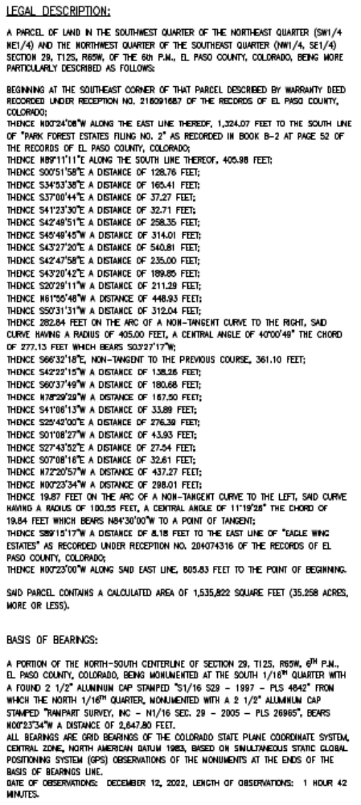
EXHIBIT B

TRACT A, EAGLE RISING FILING NO. 1.
.

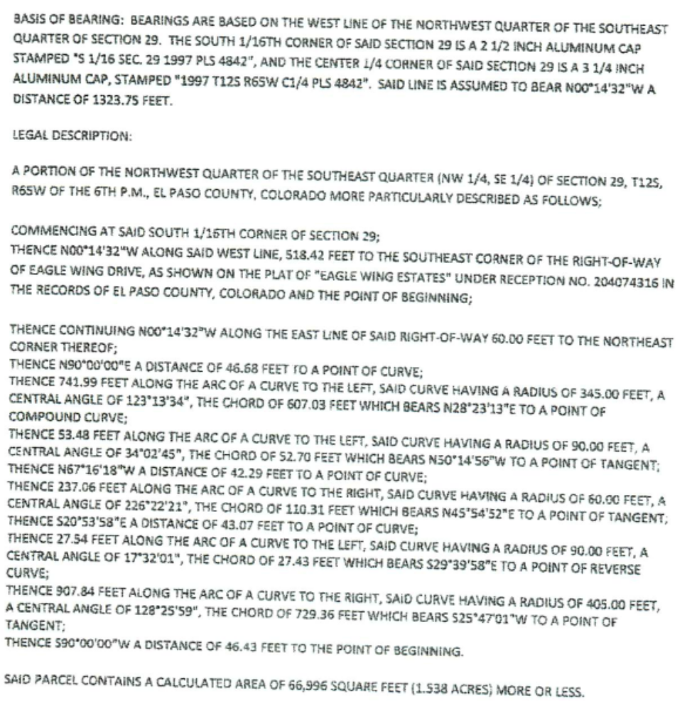

EXHIBIT “C”

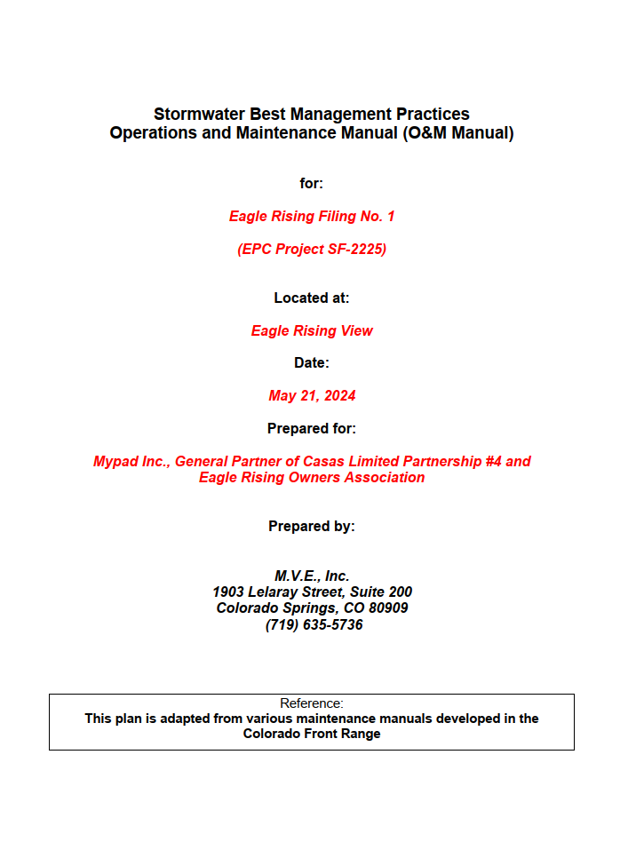

EXHIBIT “D”

