This PRIVATE DETENTION BASIN / STORMWATER QUALITY BEST MANAGEMENT
PRACTICE MAINTENANCE AGREEMENT AND EASEMENT (Agreement) is made by and
between EL PASO COUNTY by and through THE BOARD OF COUNTY COMMISSIONERS OF EL PASO COUNTY, COLORADO (Board or County) and FAL Realty, LLC. The above may occasionally be referred to herein singularly as “Party” and collectively as “Parties.”

Recitals

A. WHEREAS, Developer is the owner of certain real estate (the Property or Subdivision) in El Paso County, Colorado, which Property is legally described in Exhibit A attached hereto and incorporated herein by this reference; and

B. WHEREAS, Developer desires to plat and develop on the Property a subdivision/land use to be known as Church at Bent Grass Meadows Filing No. 1; and

C. WHEREAS, the development of this Property will substantially increase the volume of water runoff and will decrease the quality of the stormwater runoff from the Property, and, therefore, it is in the best interest of public health, safety and welfare for the County to condition approval of this subdivision/land use on Developer’s promise to construct adequate drainage, water runoff control facilities, and stormwater quality structural Best Management Practices (“BMPs”) for the subdivision/land use; and

D. WHEREAS, Chapter 8, Section 8.4.5 of the El Paso County Land Development Code, as periodically amended, promulgated pursuant to Section 30-28-133(1), Colorado Revised Statutes (C.R.S.), requires the County to condition approval of all subdivisions on a developer’s promise to so construct adequate drainage, water runoff control facilities, and BMPs in subdivisions; and

E. WHEREAS, the Drainage Criteria Manual, Volume 2, as amended by Appendix I of the El Paso County Engineering Criteria Manual (ECM), as each may be periodically amended, promulgated pursuant to the County’s Colorado Discharge Permit System General Permit (MS4 Permit) as required by Phase II of the National Pollutant Discharge Elimination System (NPDES), which MS4 Permit requires that the County take measures to protect the quality of stormwater from sediment and other contaminants, requires subdividers, developers, landowners, and owners of facilities located in the County’s rights-of-way or easements to provide adequate permanent stormwater quality BMPs with new development or significant redevelopment; and

F. WHEREAS, Section 2.9 of the El Paso County Drainage Criteria Manual provides for a developer’s promise to maintain a subdivision’s drainage facilities in the event the County does not assume such responsibility; and

G. WHEREAS, developers in El Paso County have historically chosen water runoff detention basins as a means to provide adequate drainage and water runoff control in subdivisions, which basins, while effective, are less expensive for developers to construct than other methods of providing drainage and water runoff control; and

H. WHEREAS, Developer desires to construct for the subdivision/land use one (1) detention basin/stormwater quality BMP(s) (“detention basin/BMP(s)”) as the means for providing adequate drainage and stormwater runoff control and to meet requirements of the County’s MS4 Permit, and to operate, clean, maintain and repair such detention basin/BMP(s); and

I. WHEREAS, Developer desires to construct the detention basin/BMP(s) on property that is or will be platted as Tract A as indicated on the final plat of the subdivision, and as set forth on Exhibit B attached hereto; and

J. WHEREAS, Developer shall be charged with the duties of constructing, operating, maintaining and repairing the detention basin/BMP(s) on the Property described in Exhibit B; and

K. WHEREAS, it is the County’s experience that subdivision developers and property owners historically have not properly cleaned and otherwise not properly maintained and repaired these detention basins/BMPs, and that these detention basins/BMPs, when not so properly cleaned, maintained, and repaired, threaten the public health, safety and welfare; and

L. WHEREAS, the County, in order to protect the public health, safety and welfare, has historically expended valuable and limited public resources to so properly clean, maintain, and repair these detention basins/BMPs when developers and property owners have failed in their responsibilities, and therefore, the County desires the means to recover its costs incurred in the event the burden falls on the County to so clean, maintain and repair the detention basin/BMP(s) serving this subdivision/land use due to the Developer/Owner’s failure to meet its obligations to do the same; and

M. WHEREAS, the County conditions approval of this subdivision/land use on the
Developer’s promise to so construct the detention basin/BMP(s), and conditions approval on the
Owner’s promise to reimburse the County in the event the burden falls upon the County to so clean, maintain and/or repair the detention basin/BMP(s) serving this Subdivision; and

N. WHEREAS, the County could condition subdivision/land use approval on the Developer’s promise to construct a different and more expensive drainage, water runoff control system and BMPs than those proposed herein, which more expensive system would not create the possibility of the burden of cleaning, maintenance and repair expenses falling on the County; however, the County is willing to forego such right upon the performance of Developer/Owner’s promises contained herein; and

O. WHEREAS, the County, in order to secure performance of the promises contained herein, conditions approval of this subdivision/land use upon the Developer’s grant herein of a perpetual Easement over a portion of the Property for the purpose of allowing the County to periodically access, inspect, and, when so necessary, to clean, maintain and/or repair the detention basin/BMP(s); and

Agreement

NOW, THEREFORE, in consideration of the mutual Promises contained herein, the sufficiency of which are hereby acknowledged, the Parties agree as follows:

1. Incorporation of Recitals: The Parties incorporate the Recitals above into this
Agreement.

2. Covenants Running with the Land: Developer/Owner agrees that this entire Agreement and the performance thereof shall become a covenant running with the land, which land is legally described in Exhibit A attached hereto, and that this entire Agreement and the performance thereof shall be binding upon itself, its successors and assigns.

3. Construction: Developer shall construct on that portion of the Property described in Exhibit B attached hereto and incorporated herein by this reference, one (1) detention basin/BMP(s). Developer shall not commence construction of the detention basin/BMP(s) until the El Paso County Planning and Community Development Department (PCD) has approved in writing the plans and specifications for the detention basin/BMP(s) and this Agreement has been signed by all Parties and returned to the PCD. Developer shall complete construction of the detention basin/BMP(s) in substantial compliance with the County-approved plans and specifications for the detention basin/BMP(s). Failure to meet these requirements shall be a material breach of this Agreement, and shall entitle the County to pursue any remedies available to it at law or in equity to enforce the same. Construction of the detention basin/BMP(s) shall be substantially completed within one (1) year (defined as 365 days), which one year period will commence to run on the date the approved plat of this Subdivision is recorded in the records of the El Paso County Clerk and Recorder. In cases where a subdivision is not required, the one year period will commence to run on the date the Erosion and Stormwater Quality Control Permit (ESQCP) is issued. Rough grading of the detention basin/BMP(s) must be completed and inspected by the El Paso County Planning and Community Development Department prior to commencing road construction.

In the event construction is not substantially completed within the one (1) year period, then the County may exercise its discretion to complete the project, and shall have the right to seek reimbursement from the Developer/Owner and its successors and assigns, for its actual costs and expenses incurred in the process of completing construction. The term actual costs and expenses shall be liberally construed in favor of the County, and shall include, but shall not be limited to, labor costs, tool and equipment costs, supply costs, and engineering and design costs, regardless of whether the County uses its own personnel, tools, equipment and supplies, etc. to correct the matter. In the event the County initiates any litigation or engages the services of legal counsel in order to enforce the Provisions arising herein, the County shall be entitled to its damages and costs, including reasonable attorney fees, regardless of whether the County contracts with outside legal counsel or utilizes in-house legal counsel for the same.

4. Maintenance: The Developer/Owner agrees for itself and its successors and assigns, that it will regularly and routinely inspect, clean and maintain the detention basin/BMP(s), and otherwise keep the same in good repair, all at its own cost and expense. No trees or shrubs that will impair the structural integrity of the detention basin/BMP(s) shall be planted or allowed to grow on the detention basin/BMP(s).

5. Creation of Easement: Developer/Owner hereby grants the County a non-exclusive perpetual easement upon and across that portion of the Property described in Exhibit B. The purpose of the easement is to allow the County to access, inspect, clean, repair and maintain the detention basin/BMP(s); however, the creation of the easement does not expressly or implicitly impose on the County a duty to so inspect, clean, repair or maintain the detention basin/BMP(s).

6. County’s Rights and Obligations: Any time the County determines, in the sole exercise of its discretion, that the detention basin/BMP(s) is not properly cleaned, maintained and/or otherwise kept in good repair, the County shall give reasonable notice to the Developer/Owner and its successors and assigns, that the detention basin/BMP(s) needs to be cleaned, maintained and/or otherwise repaired. The notice shall provide a reasonable time to correct the problem(s). Should the responsible parties fail to correct the specified problem(s), the County may enter upon the Property to so correct the specified problem(s). Notice shall be effective to the above by the County’s deposit of the same into the regular United States mail, postage pre-paid. Notwithstanding the foregoing, this Agreement does not expressly or implicitly impose on the County a duty to so inspect, clean, repair or maintain the detention basin/BMP(s).

7. Reimbursement of County’s Costs / Covenant Running With the Land: The Developer/Owner agrees and covenants, for itself, its successors and assigns, that it will reimburse the County for its costs and expenses incurred in the process of completing construction of, cleaning, maintaining, and/or repairing the detention basin/BMP(s) pursuant to the provisions of this Agreement.

The term “actual costs and expenses” shall be liberally construed in favor of the County, and shall include, but shall not be limited to, labor costs, tools and equipment costs, supply costs, and engineering and design costs, regardless of whether the County uses its own personnel, tools, equipment and supplies, etc. to correct the matter. In the event the County initiates any litigation or engages the services of legal counsel in order to enforce the provisions arising herein, the County shall be entitled to its damages and costs, including reasonable attorney’s fees, regardless of whether the County contracts with outside legal counsel or utilizes in-house legal counsel for the same.

8. Contingencies of Land Use/Land Disturbance Approval: Developer/Owner’s execution of this Agreement is a condition of land use/land disturbance approval. The County shall have the right, in the sole exercise of its discretion, to approve or disapprove any documentation submitted to it under the conditions of this Paragraph, including but not limited to, any separate agreement or amendment, if applicable, identifying any specific maintenance responsibilities not addressed herein. The County’s rejection of any documentation submitted hereunder shall mean that the appropriate condition of this Agreement has not been fulfilled.

9. Agreement Monitored by El Paso County Planning and Community Development
Department and/or El Paso County Department of Public Works: Any and all actions and decisions to be made hereunder by the County shall be made by the Director of the El Paso County Planning and Community Development Department and/or the Director of the El Paso County Department of Public Works. Accordingly, any and all documents, submissions, plan approvals, inspections, etc. shall be submitted to and shall be made by the Director of the Planning and Community Development Department and/or the Director of the El Paso County Department of Public Works.

10. Indemnification and Hold Harmless: To the extent authorized by law, Developer/Owner agrees, for itself, its successors and assigns, that it will indemnify, defend, and hold the County harmless from any and all loss, costs, damage, injury, liability, claim, lien, demand, action and causes of action whatsoever, whether at law or in equity, arising from or related to its intentional or negligent acts, errors or omissions or that of its agents, officers, servants, employees, invitees and licensees in the construction, operation, inspection, cleaning (including analyzing and disposing of any solid or hazardous wastes as defined by State and/or Federal environmental laws and regulations), maintenance, and repair of the detention basin/BMP(s), and such obligation arising under this Paragraph shall be joint and several. Nothing in this Paragraph shall be deemed to waive or otherwise limit the defense available to the County pursuant to the Colorado Governmental Immunity Act, Sections 24-10-101, et seq. C.R.S., or as otherwise provided by law.

11. Severability: In the event any Court of competent jurisdiction declares any part of this Agreement to be unenforceable, such declaration shall not affect the enforceability of the remaining parts of this Agreement.

12. Third Parties: This Agreement does not and shall not be deemed to confer upon or grant to any third party any right to claim damages or to bring any lawsuit, action or other proceeding against either the County, the Developer/Owner, or their respective successors and assigns, because of any breach hereof or because of any terms, covenants, agreements or conditions contained herein.

13. Solid Waste or Hazardous Materials: Should any refuse from the detention basin/BMP(s) be suspected or identified as solid waste or petroleum products, hazardous substances or hazardous materials (collectively referred to herein as “hazardous materials”), the Developer/Owner shall take all necessary and proper steps to characterize the solid waste or hazardous materials and properly dispose of it in accordance with applicable State and/or Federal environmental laws and regulations, including, but not limited to, the following: Solid Wastes Disposal Sites and Facilities Acts, §§ 30-20-100.5 – 30-20-119, C.R.S., Colorado Regulations Pertaining to Solid Waste Disposal Sites and Facilities, 6 C.C.R. 1007-2, et seq., Solid Waste Disposal Act, 42 U.S.C. §§ 6901-6992k, and Federal Solid Waste Regulations 40 CFR Ch. I. The County shall not be responsible or liable for identifying, characterizing, cleaning up, or disposing of such solid waste or hazardous materials. Notwithstanding the previous sentence, should any refuse cleaned up and disposed of by the County be determined to be solid waste or hazardous materials, the Developer/Owner, but not the County, shall be responsible and liable as the owner, generator, and/or transporter of said solid waste or hazardous materials.

14. Applicable Law and Venue: The laws, rules, and regulations of the State of Colorado and El Paso County shall be applicable in the enforcement, interpretation, and execution of this Agreement, except that Federal law may be applicable regarding solid waste or hazardous materials. Venue shall be in the El Paso County District Court.

IN WITNESS WHEREOF, the Parties affix their signatures below.

Executed this _________ day of _________________, 20___, by:
FAL Realty, LLC.
By: __________________________________________
Josh Brower, President
The foregoing instrument was acknowledged before me this _______ day of ______________, 20___, by Josh Brower, President, FAL Realty, LLC.
Witness my hand and official seal.
My commission expires: _________________
__________________________________________
Notary Public
Executed this ________ day of _______________________, 20___, by:
BOARD OF COUNTY COMMISSIONERS
OF EL PASO COUNTY, COLORADO
By: __________________________________
Gilbert LaForce, Engineering Manager
Development Services, Department of Public Works
Designee of Joshua Palmer, County Engineer
Authorized signatory pursuant to Resolution No. 24-145

The foregoing instrument was acknowledged before me this _______ day of ______________, 20___, by __________________, Engineering Manager, El Paso County Department of Public Works.
Witness my hand and official seal.
My commission expires: __________________
_________________________________________
Notary Public
Approved as to Content and Form:
______________________________________
Assistant County Attorney

Exhibit A
Exhibit B
EXHIBIT A

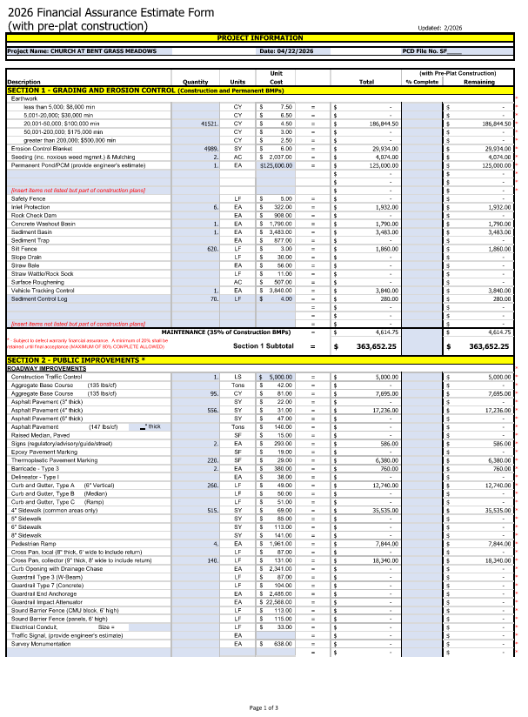

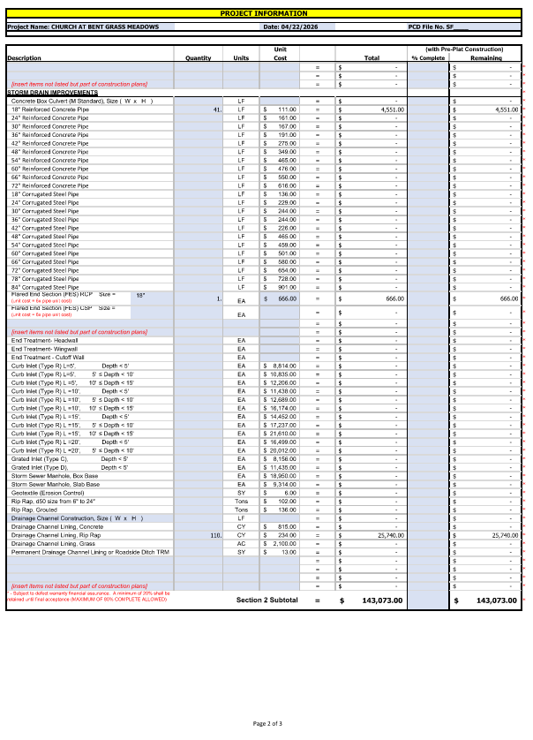
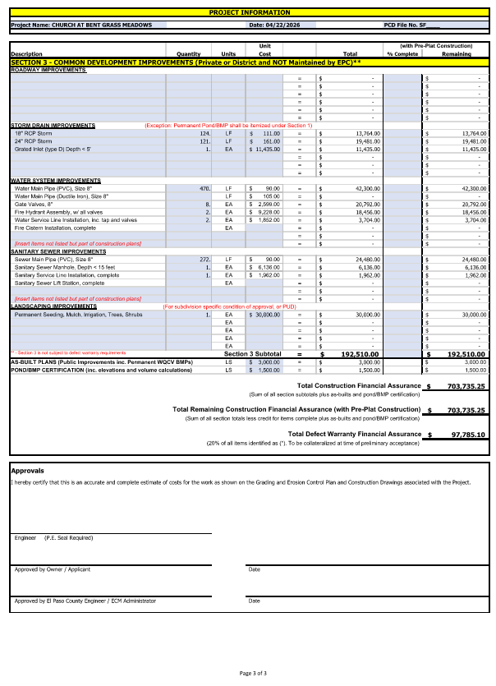

EXHIBIT B

